ACTIVITY
7

OXYGEN FOR LIFE
WHERE DOES THE OXYGEN THAT IS DISSOLVED IN WATER COME FROM?
CONCEPTS:
- The oxygen that is in water comes from air.
- The oxygen dissolved in water may vary depending on the conditions of the sample.
SCIENCE SKILLS:
- observing.
- measuring
- organizing
- inferring
- communicating

MATH AND MECHANICAL SKILLS PRACTICED:
- use of dissolved oxygen test kits
- computing averages

SAMPLE OBJECTIVES:
- Students will be able to follow instructions to test for dissolved oxygen.
- Students will be able to explain why experimental results from different sources vary.

INTRODUCTION:
Measuring dissolved oxygen is difficult, but rewarding. Oxygen is as important to the animals living in water as it is to those living on land. Oxygen in the water is DISSOLVED OXYGEN, not the oxygen atom in the water molecule. Plants may add dissolved oxygen when they photosynthesize. Much of it, however, comes from the air and enters the water at the surface. Oxygen DIFFUSES slowly in the water, 300,000 times more slowly than it does in air! Because of this, dissolved oxygen amounts may vary significantly from one place to another in aquatic habitats that are not constantly mixed. In this exercise students will prove that oxygen from air does enter or dissolve in water.

Dissolved oxygen may be measured in several different ways. One way is in parts per million (ppm) which is based on the weight of the oxygen versus the weight of the water. Oxygen in natural environments can range from no oxygen (0 ppm) which is very bad to 6-10 ppm which is sufficient for most animals to more than 15 ppm in some cases.

MATERIALS:
For each group:
- a clear plastic cup
- cold water
- sealed canning jar full to the top with boiled water(see Recipes)
- goggles for each child

Shared:
- dissolved oxygen test kits (see Recipes)
- kitchen baster or large syringe to transfer water read in units with one decimal place for additional accuracy (found in scientific supply catalogs)

LESSON PLAN:
BEFORE CLASS: This and all other dissolved oxygen exercises use the LaMotte Chemical Company dissolved oxygen test kit. This brand was chosen for two reasons: the results are numerical, and the kits are the kind most commonly available to teachers. The test for dissolved oxygen in these kits is the Winkler method, an old and very accurate one. Neither you nor the students need to understand the chemical transformations in this kit. You do need to understand what the results mean in terms of the natural world. The Recipes section gives you simplified directions for use of this kit. Make the modifications suggested.

After reading the exercise and assembling the materials, practice the oxygen test yourself. Then spend one science class having the students learn the techniques with tap water. Have the entire class work together under strict supervision for this first experience.

Boil and "can" water for this exercise at home. (See Recipes for details.) Allow the sealed jars to cool. Canning jars with rubber seals are needed. Jars such as mayonaise jars may break when boiled water is added.

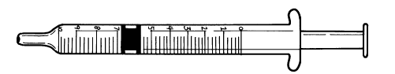

DURING CLASS:
METHODS: Have the students fill a transparent plastic cup with cold water early in the day and let it sit on their desks. Observe it occasionally. If you have short periods, do this half an hour before class.

When it comes time for the science lesson, ask the students what they observed as their cup of water sat on the desk. Some of the students should have noticed that tiny bubbles formed on the sides of the cup. What do they think the bubbles are? Air. Where did it come from? It was DISSOLVED in the water. What do animals need that is in air? OXYGEN. The air is 21% oxygen.
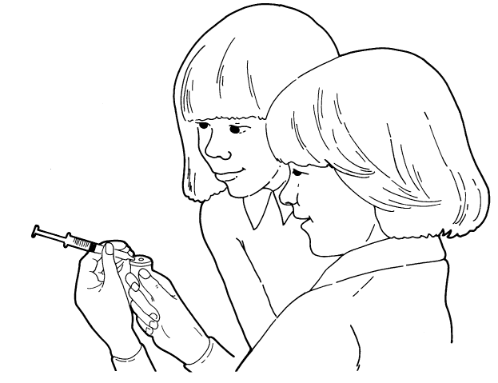

How can we prove that oxygen dissolves in water from the air? Distribute the sealed jars. Tell them that you have treated the water in the jar to remove most of the air. But they do not have to trust you. They can test the water for DISSOLVED OXYGEN themselves using a test kit. Make sure they understand that the color changes are INDICATORS of things that cannot be seen themselves but which cause the color changes.

Have the students working in groups take turns using the test kits following the instructions provided. Record their results. If students made serious errors that you can identify, you may choose to delete their data from the final chart. Make sure they understand that you are not just making sure that things come out right. Explain the nature of their error so that they can be careful to correct it.

Pour half the water out, put the lid on and shake the jar hard. Uncap and recap and shake several times. This speeds both diffusion and mixing. Now test the water for dissolved oxygen again.

RESULTS:
Compare the first oxygen measurements with the second. Make a table on the board or an overhead projector. Did everyone get the same results? No. Anytime a group of folks do a test, there is variation in the way they do it and the way they read it. That is one of the reasons that scientific tests must be repeated many times. Average the results for low oxygen and high oxygen.

CONCLUSIONS:
Where did the dissolved oxygen come from? From the air. Gases from the air dissolve in water.

USING YOUR CLASSROOM AQUARIUM:
Have your students observe the movement of water in your classroom aquarium. The air lift columns create a current that causes the water to circulate, exposing all of the water to the air and mixing the oxygen. What would happen if there were no circulation? Oxygen would be lower at the bottom if it were being used by some of the tank's inhabitants.

EXTENSIONS:
1. Oxygen normally enters at the surface of the water. Decomposers use oxygen and are frequently located at the bottom of a body of water. Oxygen must enter the water at the surface and diffuse downward. Diffusion in water is slower than diffusion in air. How long does it take for oxygen to get to the bottom of a lake? Try seeing how fast it travels in a fruit jar.
Uncap a quart fruit jar of boiled water. Test immediately after unsealing the jars. First sample the water from right at the surface and then the water from the very bottom. Do this very carefully so that the water is not stirred. Be careful not to add air by pouring or otherwise aggitating the water. Now what happens if the water comes in contact with air? Let it sit for 30 minutes and sample again.

You should get a differential, even over the shallow distance in a fruit jar. What does this mean in the real world? If the wind or a current is not stirring up the water in a lake or pond, there will be a good deal more oxygen in the surface water than in the water at the bottom if bottom-dwelling organisms are actively using oxygen.
2. Now consider what the impact of a stratified system in an estuary would be. Make a stratified system (layered) as in Activity 4 but use boiled and canned salt water for the bottom layer after testing it to see what itís original dissolved oxygen is. Use oxygenated, colored fresh water for the surface layer. Test the bottom layer several times during the day for dissolved oxygen, taking care to siphon a sample out without disturbing the layers. Test it until the layers are the same. How long did it take for oxygen to reach the bottom. For comparison, make another system at the same time that is just boiled salt water the same depth as the layered system and test it the same way at the bottom. What impact did the layering have versus plain diffusion with no layer?air by shaking and opening repeatedly

