ACTIVITY
3

SALTY OR FRESH?
WHICH IS HEAVIER, FRESH WATER OR SALT WATER?
CONCEPTS:
- If temperatures are the same, salt water is heavier than fresh water.
- Fresh water floats on salt water because it is lighter (less dense)

SCIENCE SKILLS:
- observing
- measuring
- predicting
- experimenting
- inferring
- communicating

MATH AND MECHANICAL SKILLS PRACTICED:
- use of spring scale, simple balance or triple
beam balance

SAMPLE OBJECTIVES:
- Students will be able to state experimental evidence proving that salt water is heavier than fresh water.
- Students will learn to control variables.
- Students will be able to compare relative weights.

INTRODUCTION:
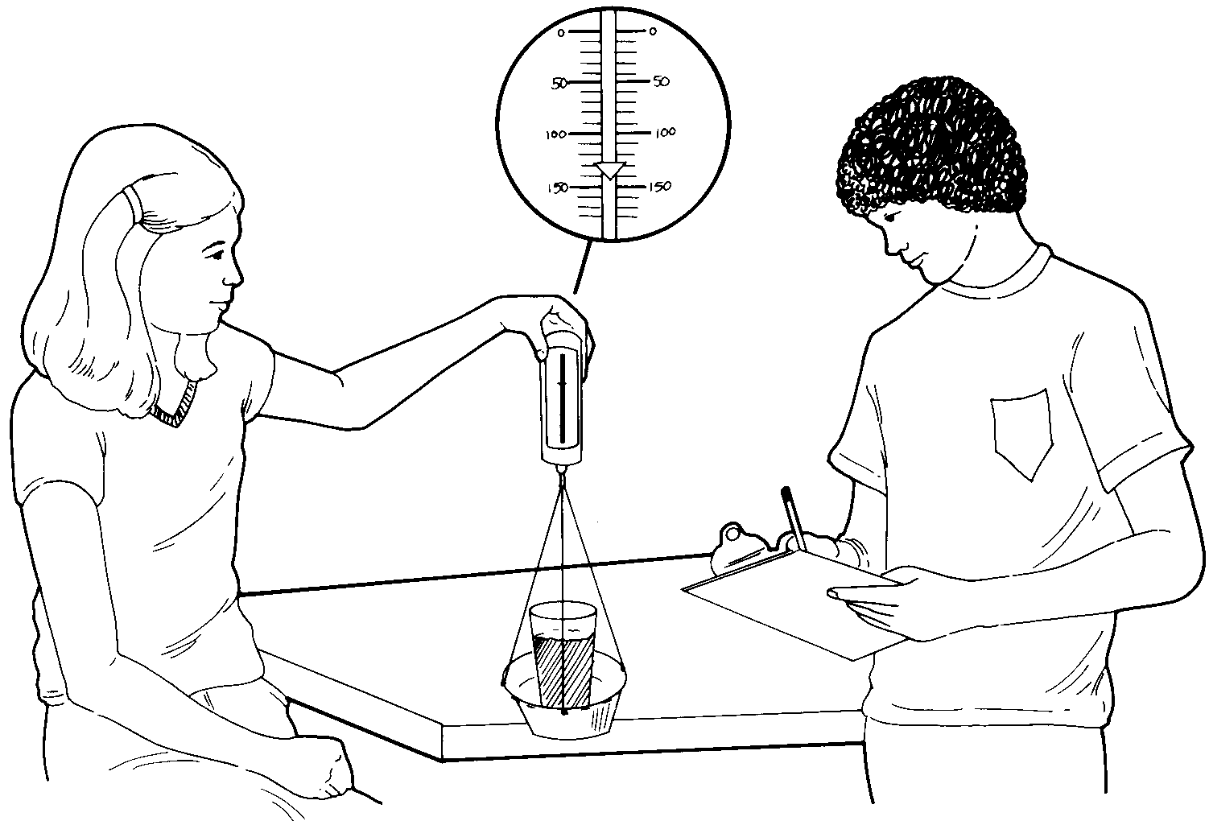
This exercise examines the relationship of salinity to weight (density) of solutions. Subsequent studies show how these relationships determine the distribution of fresh and salt water where a river enters the ocean and forms an ESTUARY.

MATERIALS:
FOR EACH GROUP:
- tape or marking pen
- food coloring in dropper bottle
- 4 clear plastic cups (9 oz cups)
- water - best results are achieved by using about 200 ml water/ 9 oz cup
- plastic teaspoon

FOR CLASS:
- measuring cups (1 or 2 cup graduated cup)
- plastic graduated cylinders (25 ml and 100 ml, if possible)
- simple balances (if you use triple beam balances instead, have a training session on use)
- simple 250 gm spring scales if available
- one gallon of salt water (1 cup salt per gallon) at room temperature
- one gallon of tap water (fresh water) at room temperature
- a heavy coffee mug or cup

LESSON PLAN:
BEFORE CLASS:
Assemble the materials and read the entire lesson. If you use triple beam balances, you will have to train students to use them ahead of time. Simple balances that compare two items at once may require some testing by students before they believe that the heavier item pulls its side down and lifts the other up. Simple spring scales may require a bit of practice with reading the scale. If the spring scales lack pans, make them from small aluminum or plastic pans (frozen meat pies) and three pieces of string which are tied equal distant around the rim through punched holes and tied in a loop at the top.

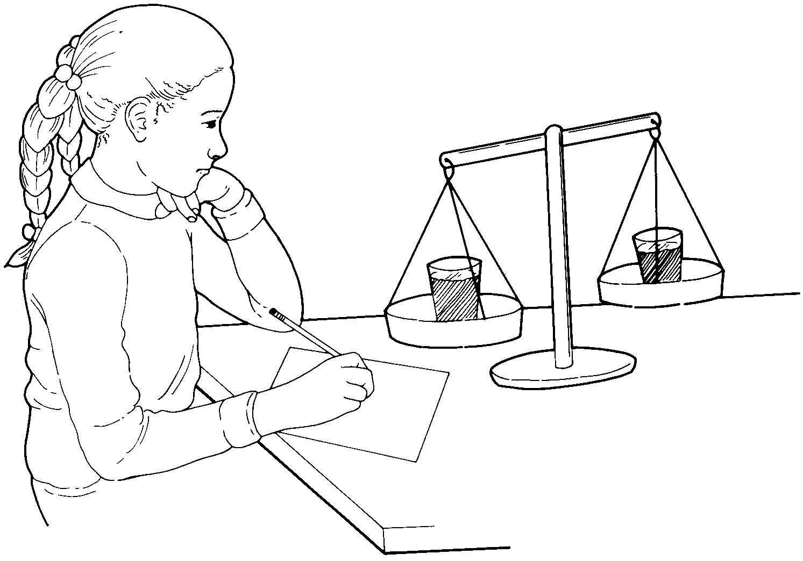

DURING CLASS:
METHODS: Start by asking the class how they would determine which was heavier: salt water or fresh water? They will probably suggest weighing the solutions. Use a balance and two clear plastic cups of water, one with twice as much water as the other to demonstrate. Ask them if this is ‘a "fair test". Why not? The students should be able to tell you that you must use the same amount or volume of water to tell which is heavier. Then demonstrate with a plastic glass and a heavy ceramic coffee cup filled with equal volumes of water. Is this a "fair test"? Again, they should say no and identify the difference in weight of the two containers as the problem. What rule would they have to follow for this to be a "fair test"? There can be only one difference between the two items tested, in this case, the amount of salt in the water.

Can your students do a "fair test" to answer the question you first asked: which is heavier, salt water or fresh water? Let individual groups try without telling them exactly what to do. Let them make mistakes and discuss these mistakes among themselves. They may compare equal volumes of salt and fresh water on a simple balance or they may weigh equal volumes with a scale or triple beam balance.

After most groups have answered the question, have everyone settle down and state his/her results. Salt water is heavier. If there are disagreements, have students carefully repeat work. What should become apparent is that the larger the volume they compared, the more accurate their measurement. The 100 ml cylinder was a better tool than the 25 ml. Also, they should recognize that the graduated cylinders are much more accurate than the kitchen measuring cups. A basic lesson from this exercise is that the tools you choose to use are important to the quality of work you do.

Now can the students predict what would happen when fresh water meets salt water? This happens where a river flows into the sea. Have them state their predictions. Now how can they test their predictions using clear plastic glasses, salt and fresh water, food coloring and a teaspoon? Give them these materials and let them experiment. Do not tell them what to do right away.

They may add food coloring to the salt water as a marker. Most will try pour one into the other. This may not give clear results. For a clearer outcome, see what happens when a little salt water is carefully laid on top of a cup of fresh water with the teaspoon. (See the illustration for technique. The spoon is lowered into the water and rotated out from under the salt water.) The salt water should sink to the bottom, indicating that it is heavier. Try the reverse with colored fresh water and plain salt water to prove that the food coloring is not causing the result.

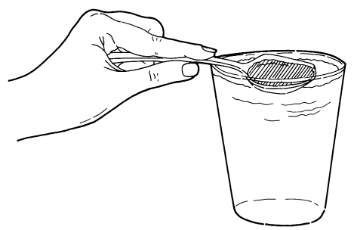

RESULTS:
If equal volumes of salt and fresh water are compared in containers that are identical, the salt water weighs more than the fresh water. When salt water is gently placed on the surface of fresh water, it can be seen to sink. Fresh water gently placed on the surface of salt water floats at the surface.

CONCLUSIONS:
Salt water is heavier than fresh water when both solutions are the same temperature. (Temperature as a variable will come in a later activity.) When two things of equal volume are compared, the heavier is said to be more DENSE.

USING YOUR CLASSROOM AQUARIUM:
Is your classroom aquarium fresh water or salt water? How could your students test the water to find out? It could be compared with fresh and salt water in the same tests done above.

