ACTIVITY
2

WATER, WATER EVERYWHERE
CLASSIFYING DIFFERENT KINDS OF AQUATIC HABITATS.
CONCEPTS:
- Characteristics observed about a thing allow you to find its name and to place it in a system that groups similar things.
- An introduction to aquatic habitats.
SCIENTIFIC SKILLS:
- classifying

MATH AND MECHANICAL SKILLS PRACTICED:
- following a flow chart
- using a key

SAMPLE OBJECTIVES:
- students will be able to classify different kinds of aquatic habitats.
- students will use a flow chart and/or a scientific key.

INTRODUCTION:
This activity introduces students to classification of habitats by using physical characteristics. This allows students to discover for themselves the different kinds of places that marine organisms live rather than sitting and listening to an aquatic lecture. Students use a FLOW CHART to visualize the process of classification. At each step they must choose between two characters in order to proceed to the next step. They may also use a scientific KEY to identify aquatic habitats. Students will learn about these habitats as they do the exercise.

MATERIALS:
- blow-up of habitat flow chart on blackboard or bulletin board
- duplicates of habitat cards (1 per student) (may use line drawings or may add photographs of appropriate aquatic habitats from magazines
- copies of flow charts and keys for students

Optional:
- salt water made with 35 gm (3 tbs.) table salt per liter (quart) water
- tap water for fresh water
- mix of tap water and salt water for brackish water
- small disposable paper cups for each child

INFORMATION:
When humans group and name things, they are CLASSIFYING them. Things that are classified are first named and then placed in larger groups of things that share similar characteristics. For example, many kinds of tables are lumped under the term "table”, as are many kinds of chairs under "chairs". Both tables and chairs belong to a larger category, furniture. The inclusion in ever-larger groups results in a hierarchical organization of groups.

Why bother with classifying things? Classification requires that we look for relationships among things which enhance our understanding of their functions and characters. Also, knowing that something belongs to a certain group means that you know something about it if you are familiar with the characteristics of the group.

LESSON PLAN
BEFORE CLASS:
Read the exercise and plan which parts you will do. Make habitat cards. You may just duplicate the cards at the end of this section. For nicer cards, glue them to one side of stiff paper and add pictures of the same habitat to the reverse side. Ask parents to donate magazines like National Geographic. Aides or students may cut out pictures. Laminate the cards to last for years. You might not find pictures of all of the habitats - it's OK to leave some out. Make duplicates of the most common ones. Duplicate the flow chart and key.

DURING CLASS:
METHODS:
Begin by asking if the students know what the word HABITAT means. It is the place where a plant or animal normally lives and is usually characterized by a dominant plant or a set of physical characters. Can they name any AQUATIC places (water habitats) where plants and animals live? Write their suggestions on the board. Can they tell you what kind of water each has?

Make sure that they know the terms SALT WATER, FRESH WATER and BRACKISH WATER. Salt water has the salinity of the oceans, fresh water has little or no salt (you cannot taste any) and brackish water is a mix of salty ocean water and fresh water so it tastes less salty than the ocean. If you would like, you can have your students taste samples of each. A sip of salty water made with table salt will not hurt though it does taste bad. To make your point about brackish water, mix the fresh water with the salt water while they watch.

Now each student is going to become a mystery aquatic habitat. Each will discover what he/she is by following a CLASSIFICATION system that divides habitats up by their CHARACTERISTICS. Students will know what their characteristics or traits are from cards that tell them what they are like.

Explain that when identifying things using a system of classification, one starts with the biggest category and begins to work down small groups. Here the first category is aquatic habitats, and the characteristic they have in common is that they all are in water. Use the flow chart on the board and have a student read one card aloud to demonstrate that at each stage, they must make a choice between two things until they come to a group in which all the things have the same characters and cannot be divided further. This is their aquatic habitat.

Pass out the cards and give all time to read them. Would they like to make a guess about what kind of habitat they are? Have them write their guess. Distribute flow charts and let them work until they have identified themselves. Trade cards for more practice until they have seen each one.
The key is harder to use. With younger children you may delete it. With older children you may repeat the same process of one demonstration followed by independent work that you used for the flow chart.

RESULTS:
Check results of following the flow chart or keying habitats out by comparing answers with the teacher's answers provided.

CONCLUSIONS:
Have the class make a list of the important characteristics used in this exercise to classify aquatic environments. These are some of them:

- salt or fresh water
- flowing or still water
- tides or currents or waves
- shallow or deep
- sandy, rocky or muddy bottom
- plants submerged or sticking out of the water
- near shore or away from land.

USING YOUR CLASSROOM AQUARIUM:
Discuss with your students the following questions:
- Which aquatic habitat most resembles your classroom aquarium?
- Does it have fresh or salt water?
- What kind of bottom does it have?
- Does the water flow or stand still?
Try keying it out. The gravel on the bottom might be a problem.

EXTENSIONS:
1. One way for students to test their own knowledge of aquatic habitats following this activity is to have the pictures of water habitats mounted on cards with a string long enough to hang behind the students' backs. The name of the habitat should be written on each card. Students must find out what kind of water habitat they are by asking other students yes/no questions about themselves.
2. Have each student write several paragraphs about how it would feel to be an animal that lived in his/her aquatic habitat. Include a discussion of some of the problems each would face in making a living. Make sure the student has a picture of the habitat to help with writing.
3. On a map of your state, help your students locate the aquatic habitats they may have seen locally. While landlocked states are limited to freshwater habitats or salt lakes, states like Florida have almost everything but kelp forests. A U.S. map with markings for depth in the ocean would help you locate the saltwater habitats.
4. Research naming in other societies. Different cultures use different degrees of refinement when they create categories of names. This degree of detail in naming is frequently based on the importance of the items in their culture. For example: the South American cowboys, gauchos, have some two hundred different words or names for horse colors, but divide all plants into only four categories depending on their use in ranching.
5. Compare common names and their local origins with scientific names. Scientists use a formal classification system in giving names to plants and animals which gives each kind of plant or animal a name consisting of two words which is unique to that species. An animal's scientific name is the same anywhere in the world. Since the scientific name is based on Latin and Greek words, most people give plants and animals a common name in their own language. Because these are arrived at informally, they vary from place to place and can be very confusing because the same animal may have several different common names.
6. To test student understanding of the principles governing classification and the construction of keys, have students classify groups of other things and make their own key. Creative choices of things might include keys to different groups of adventure toys, model collections or rock groups. Let them trade keys to test the quality of their work. There should be at least ten items in each key.

CARD ANSWERS

1. OCEAN OR SEA
2. SANDY BEACH
3. ROCKY INTERTIDAL
4. CONTINENTAL SHELF
5. KELP FOREST
6. CORAL REEF
7. ESTUARY
8. SEA GRASS BED
9. SALT MARSH
10. MANGROVE SWAMP
11. RIVER
12. STREAM OR CREEK
13. LAKE
14. POND
15. FRESHWATER MARSH
16. SWAMP
17. BOG
18. SALT LAKE

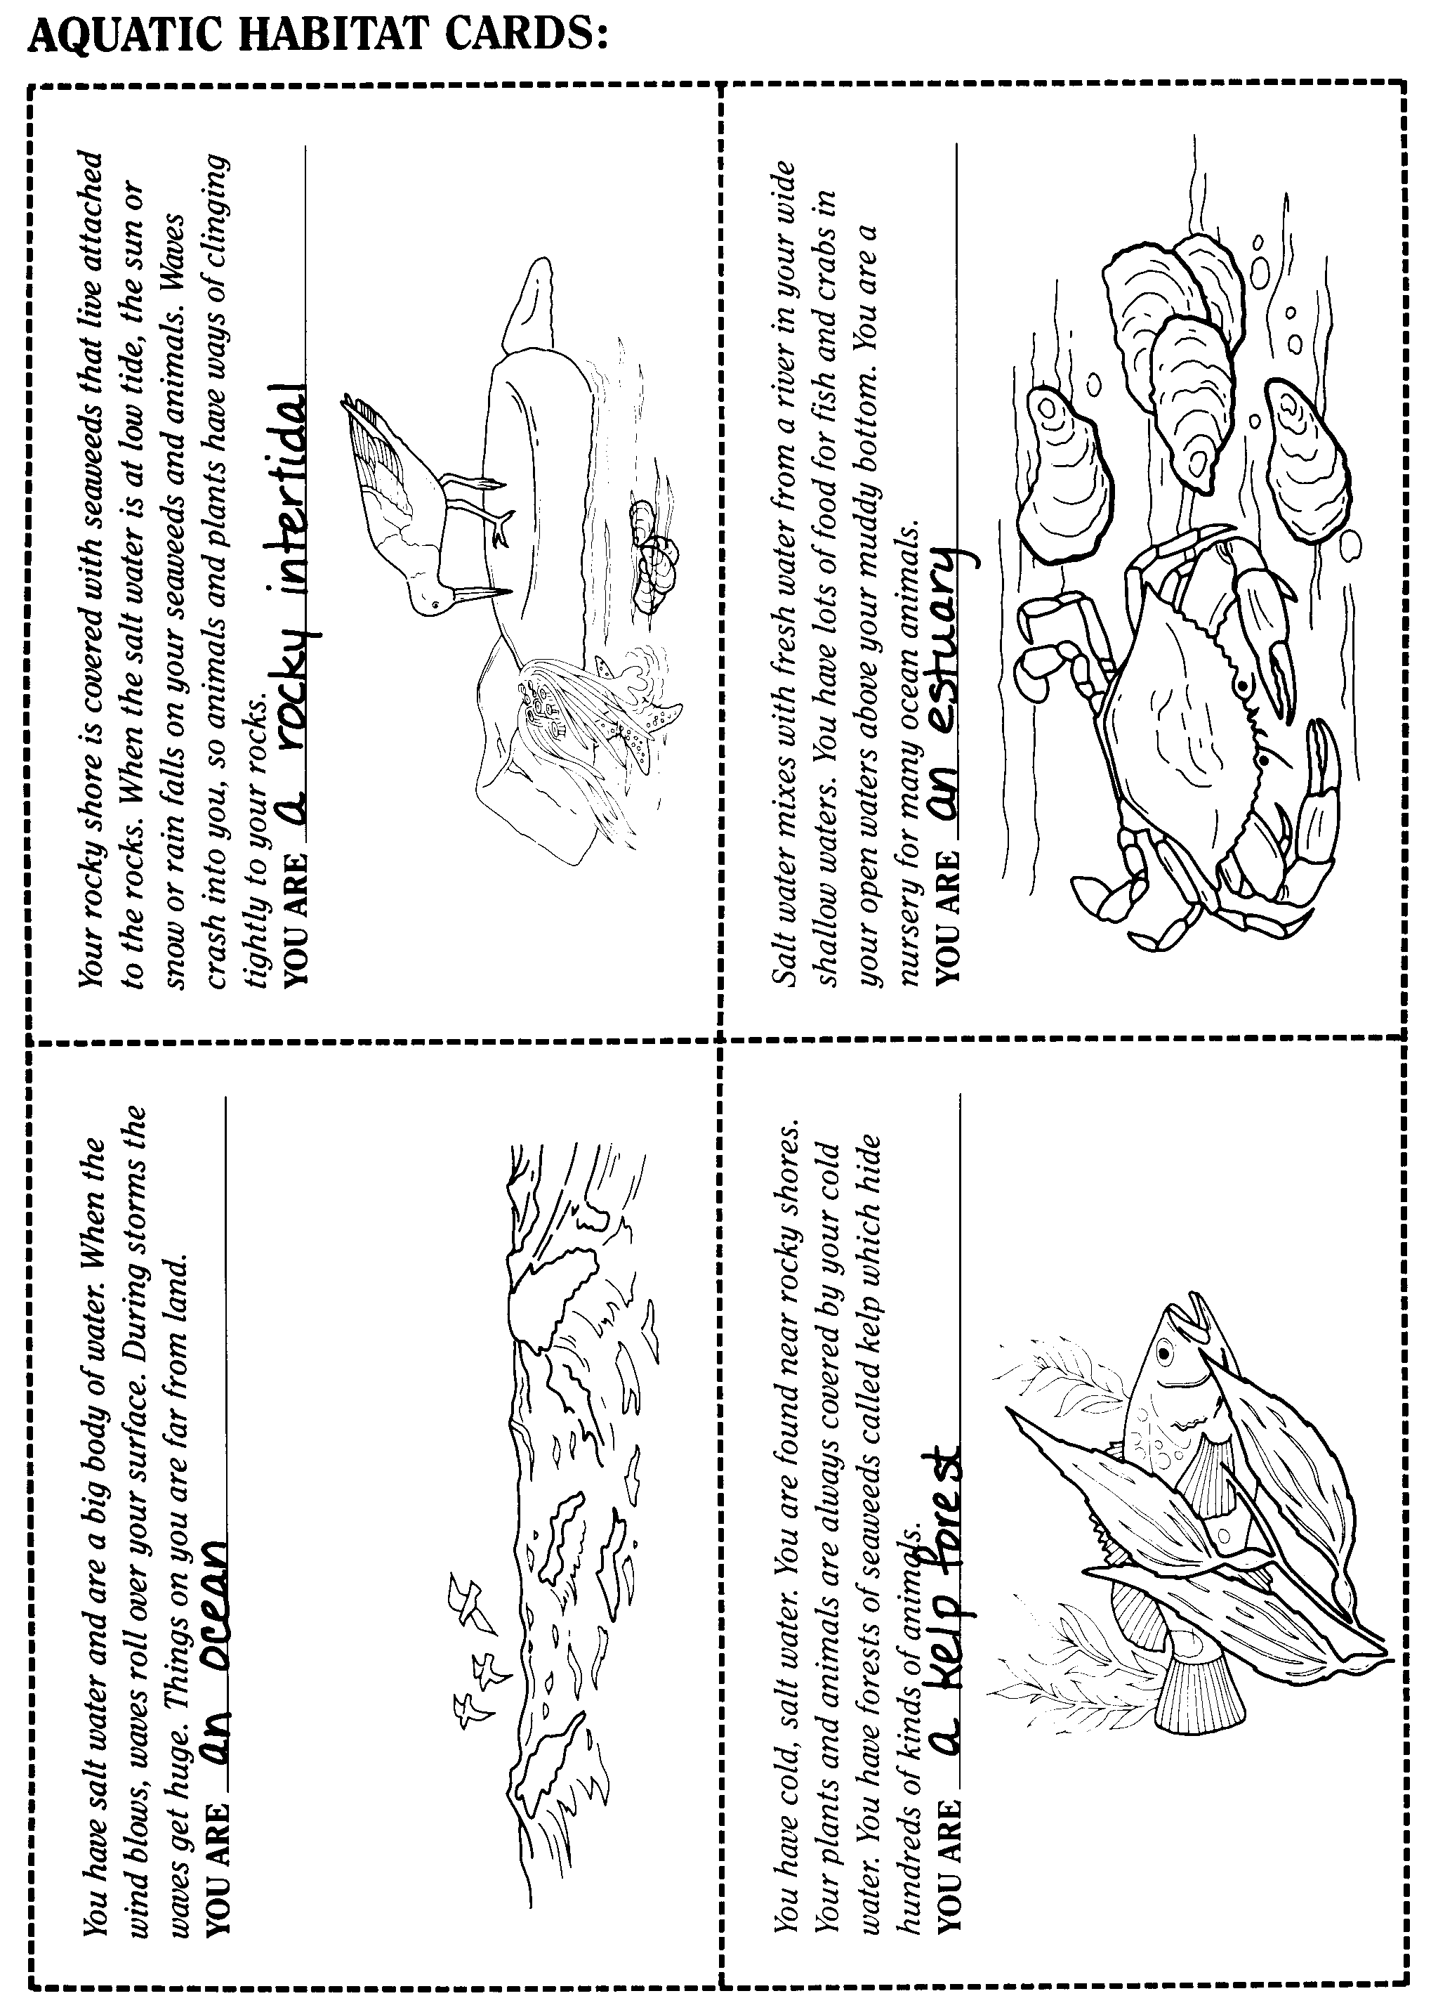
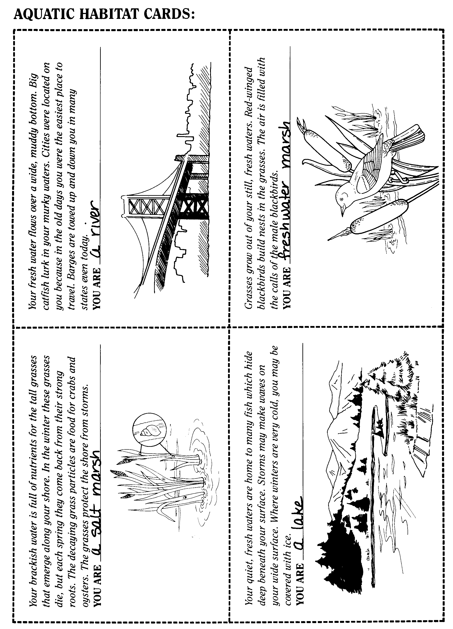
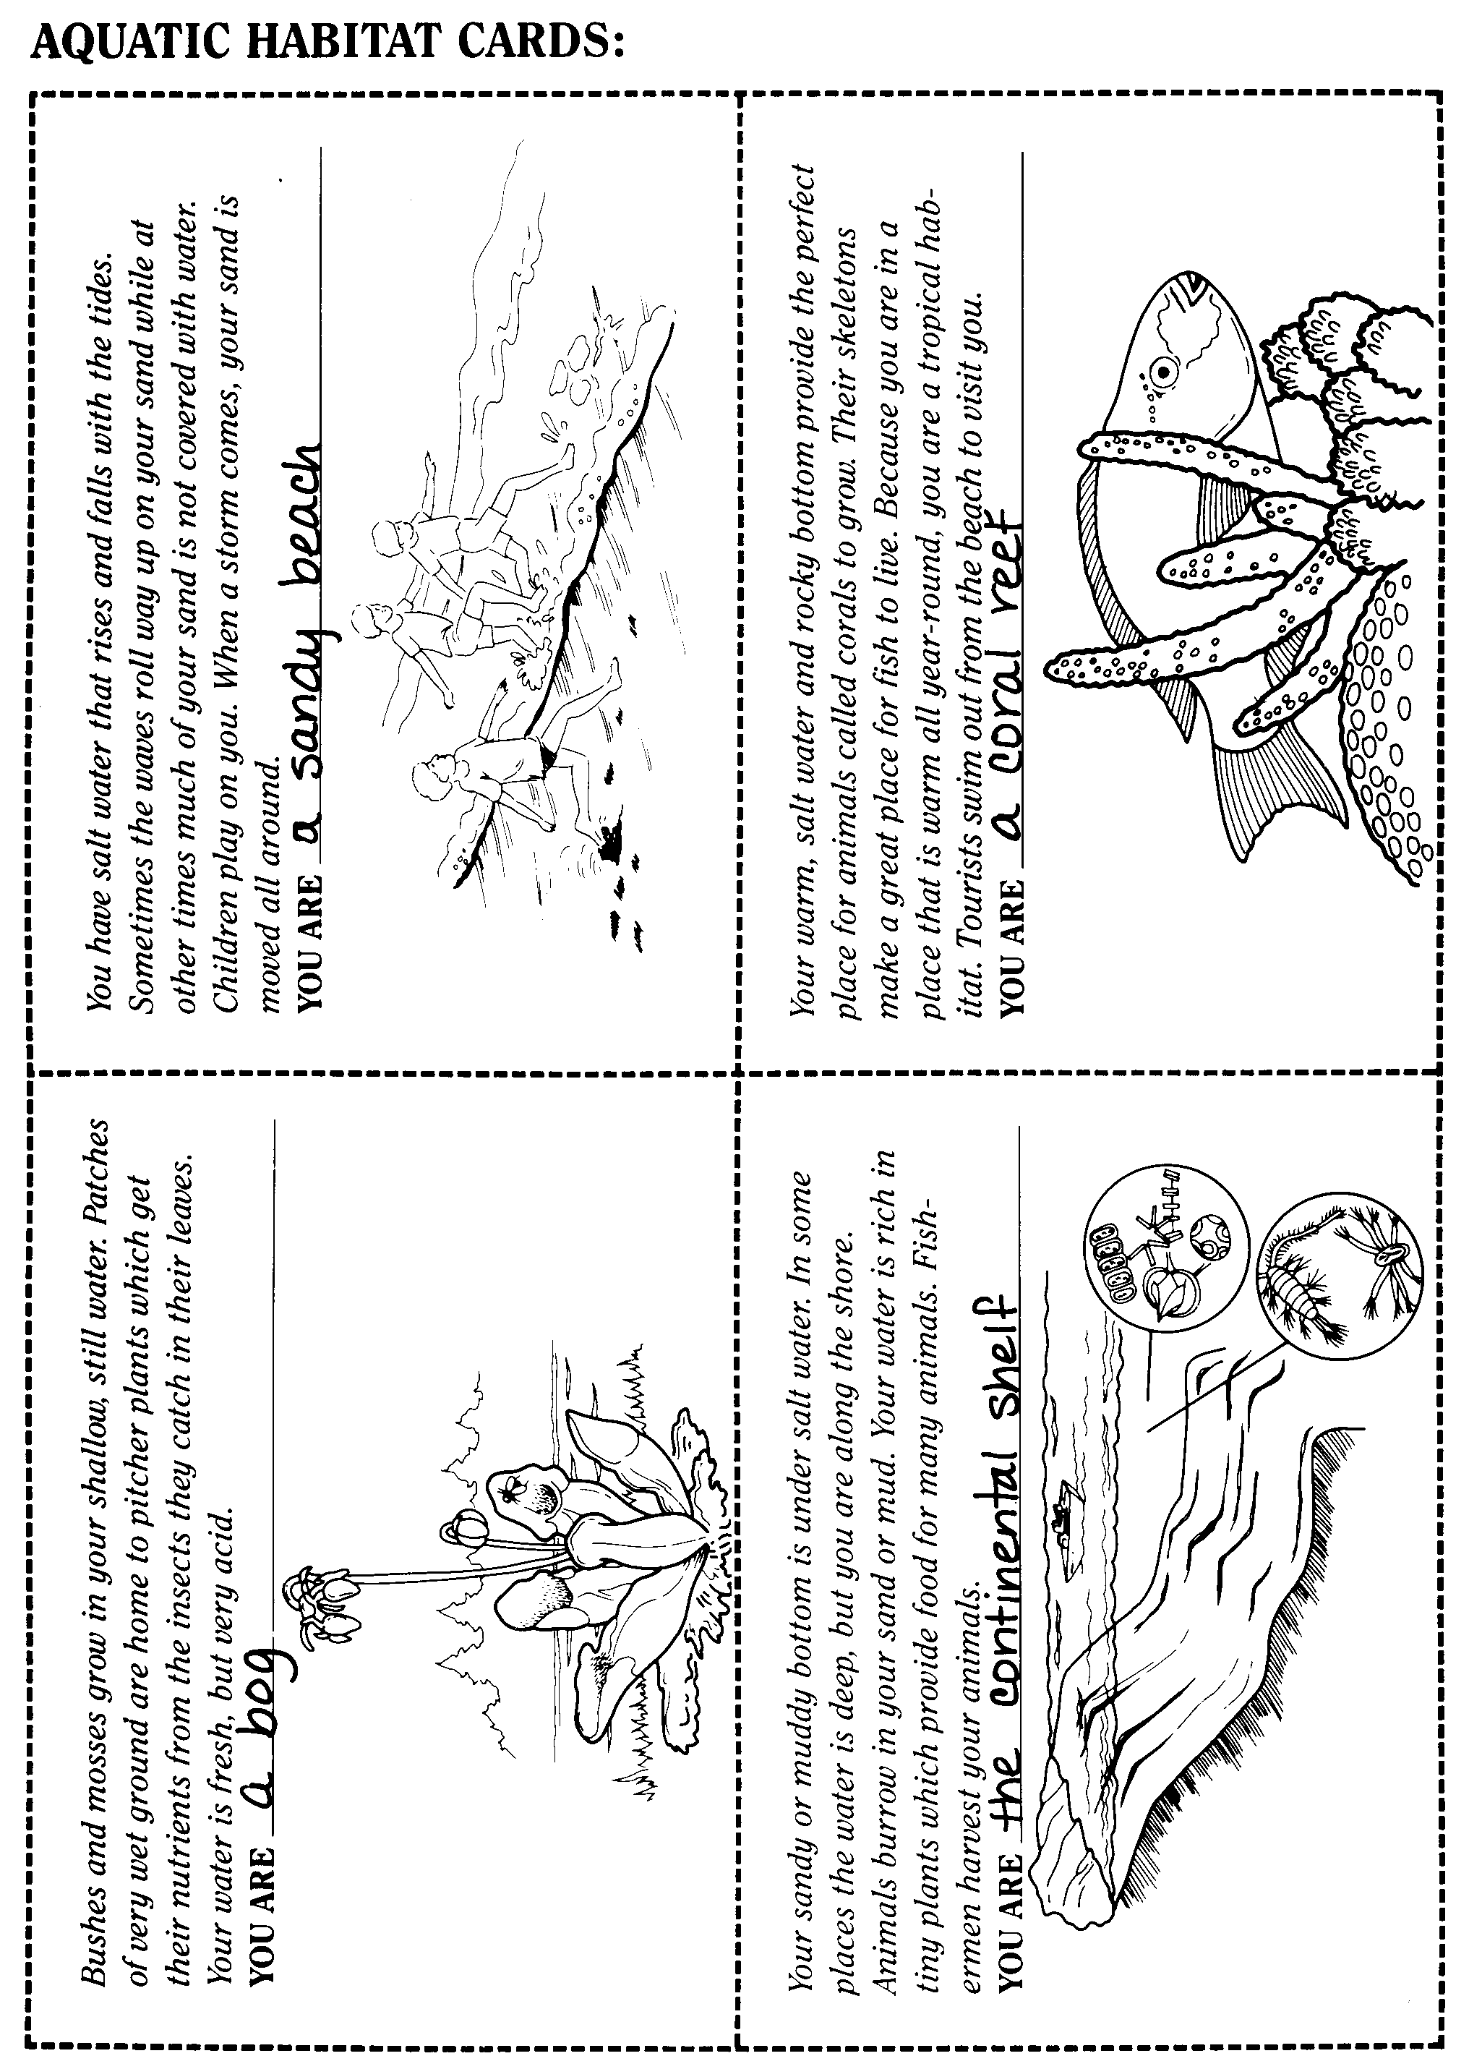
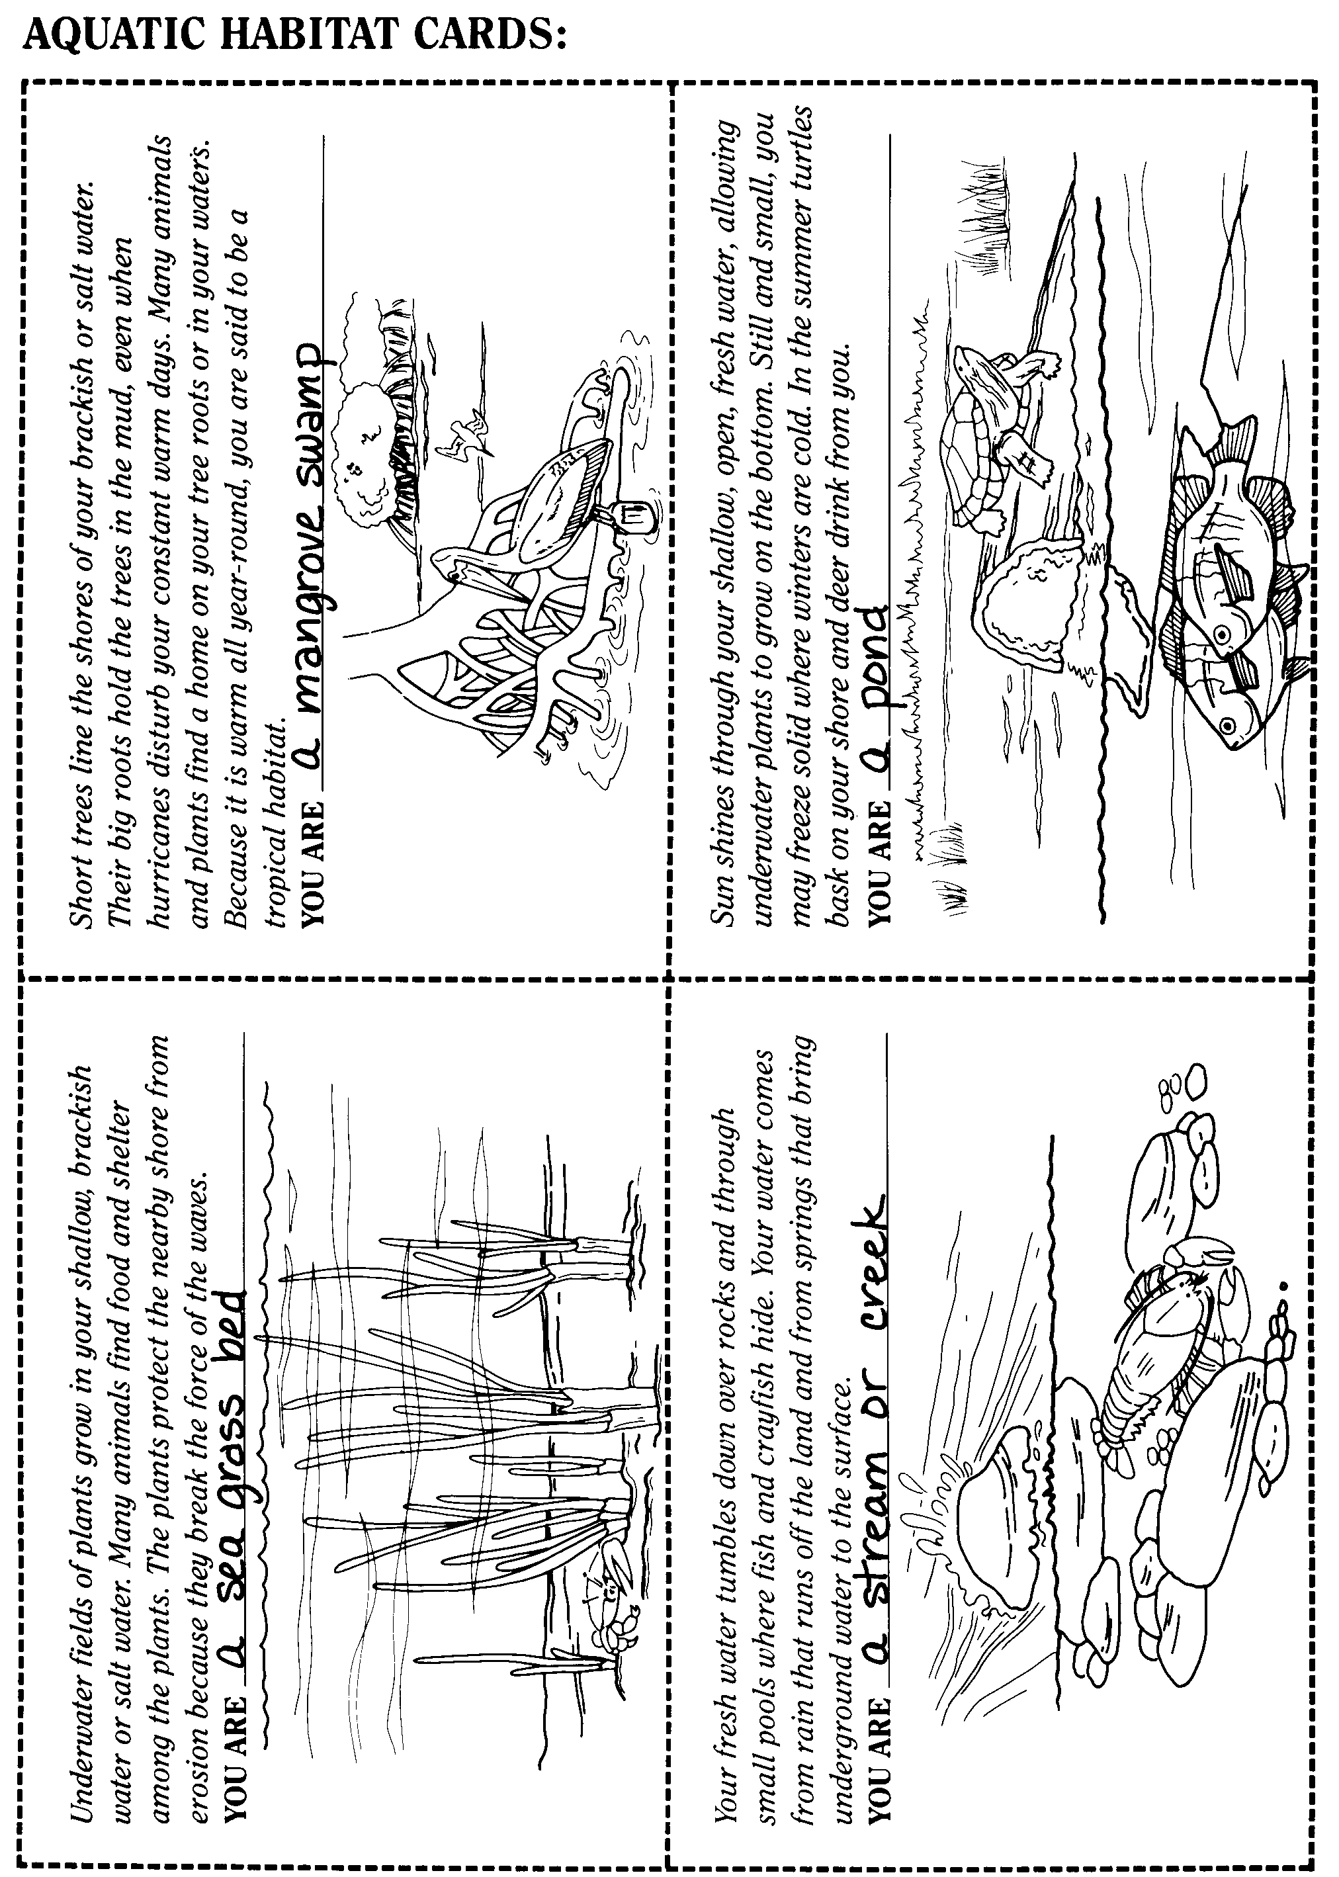
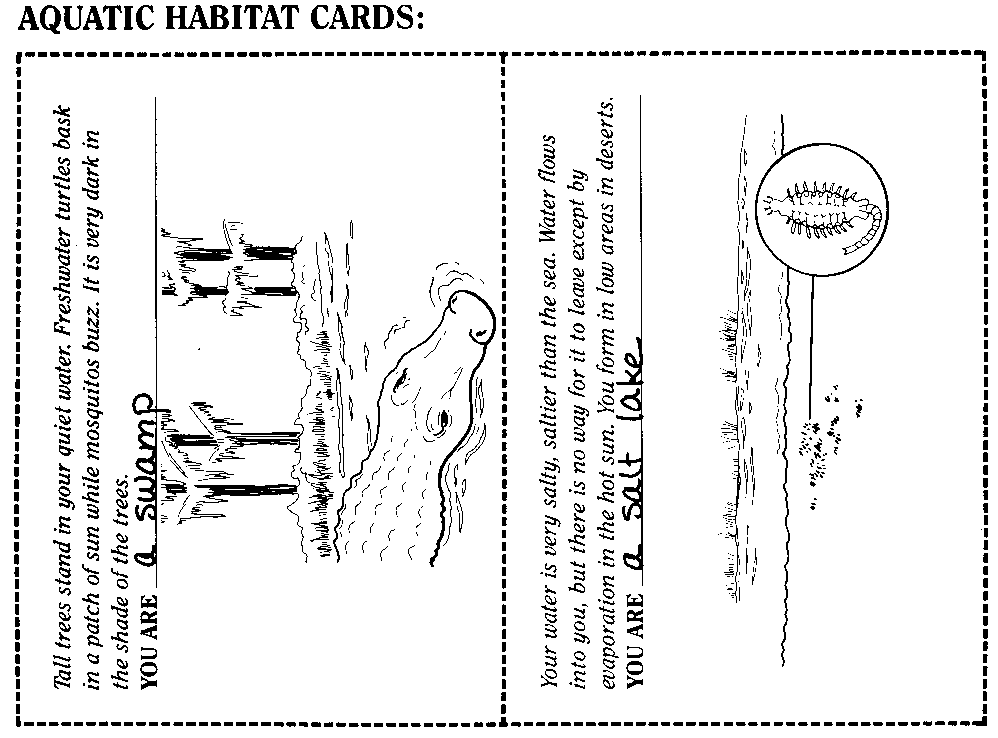
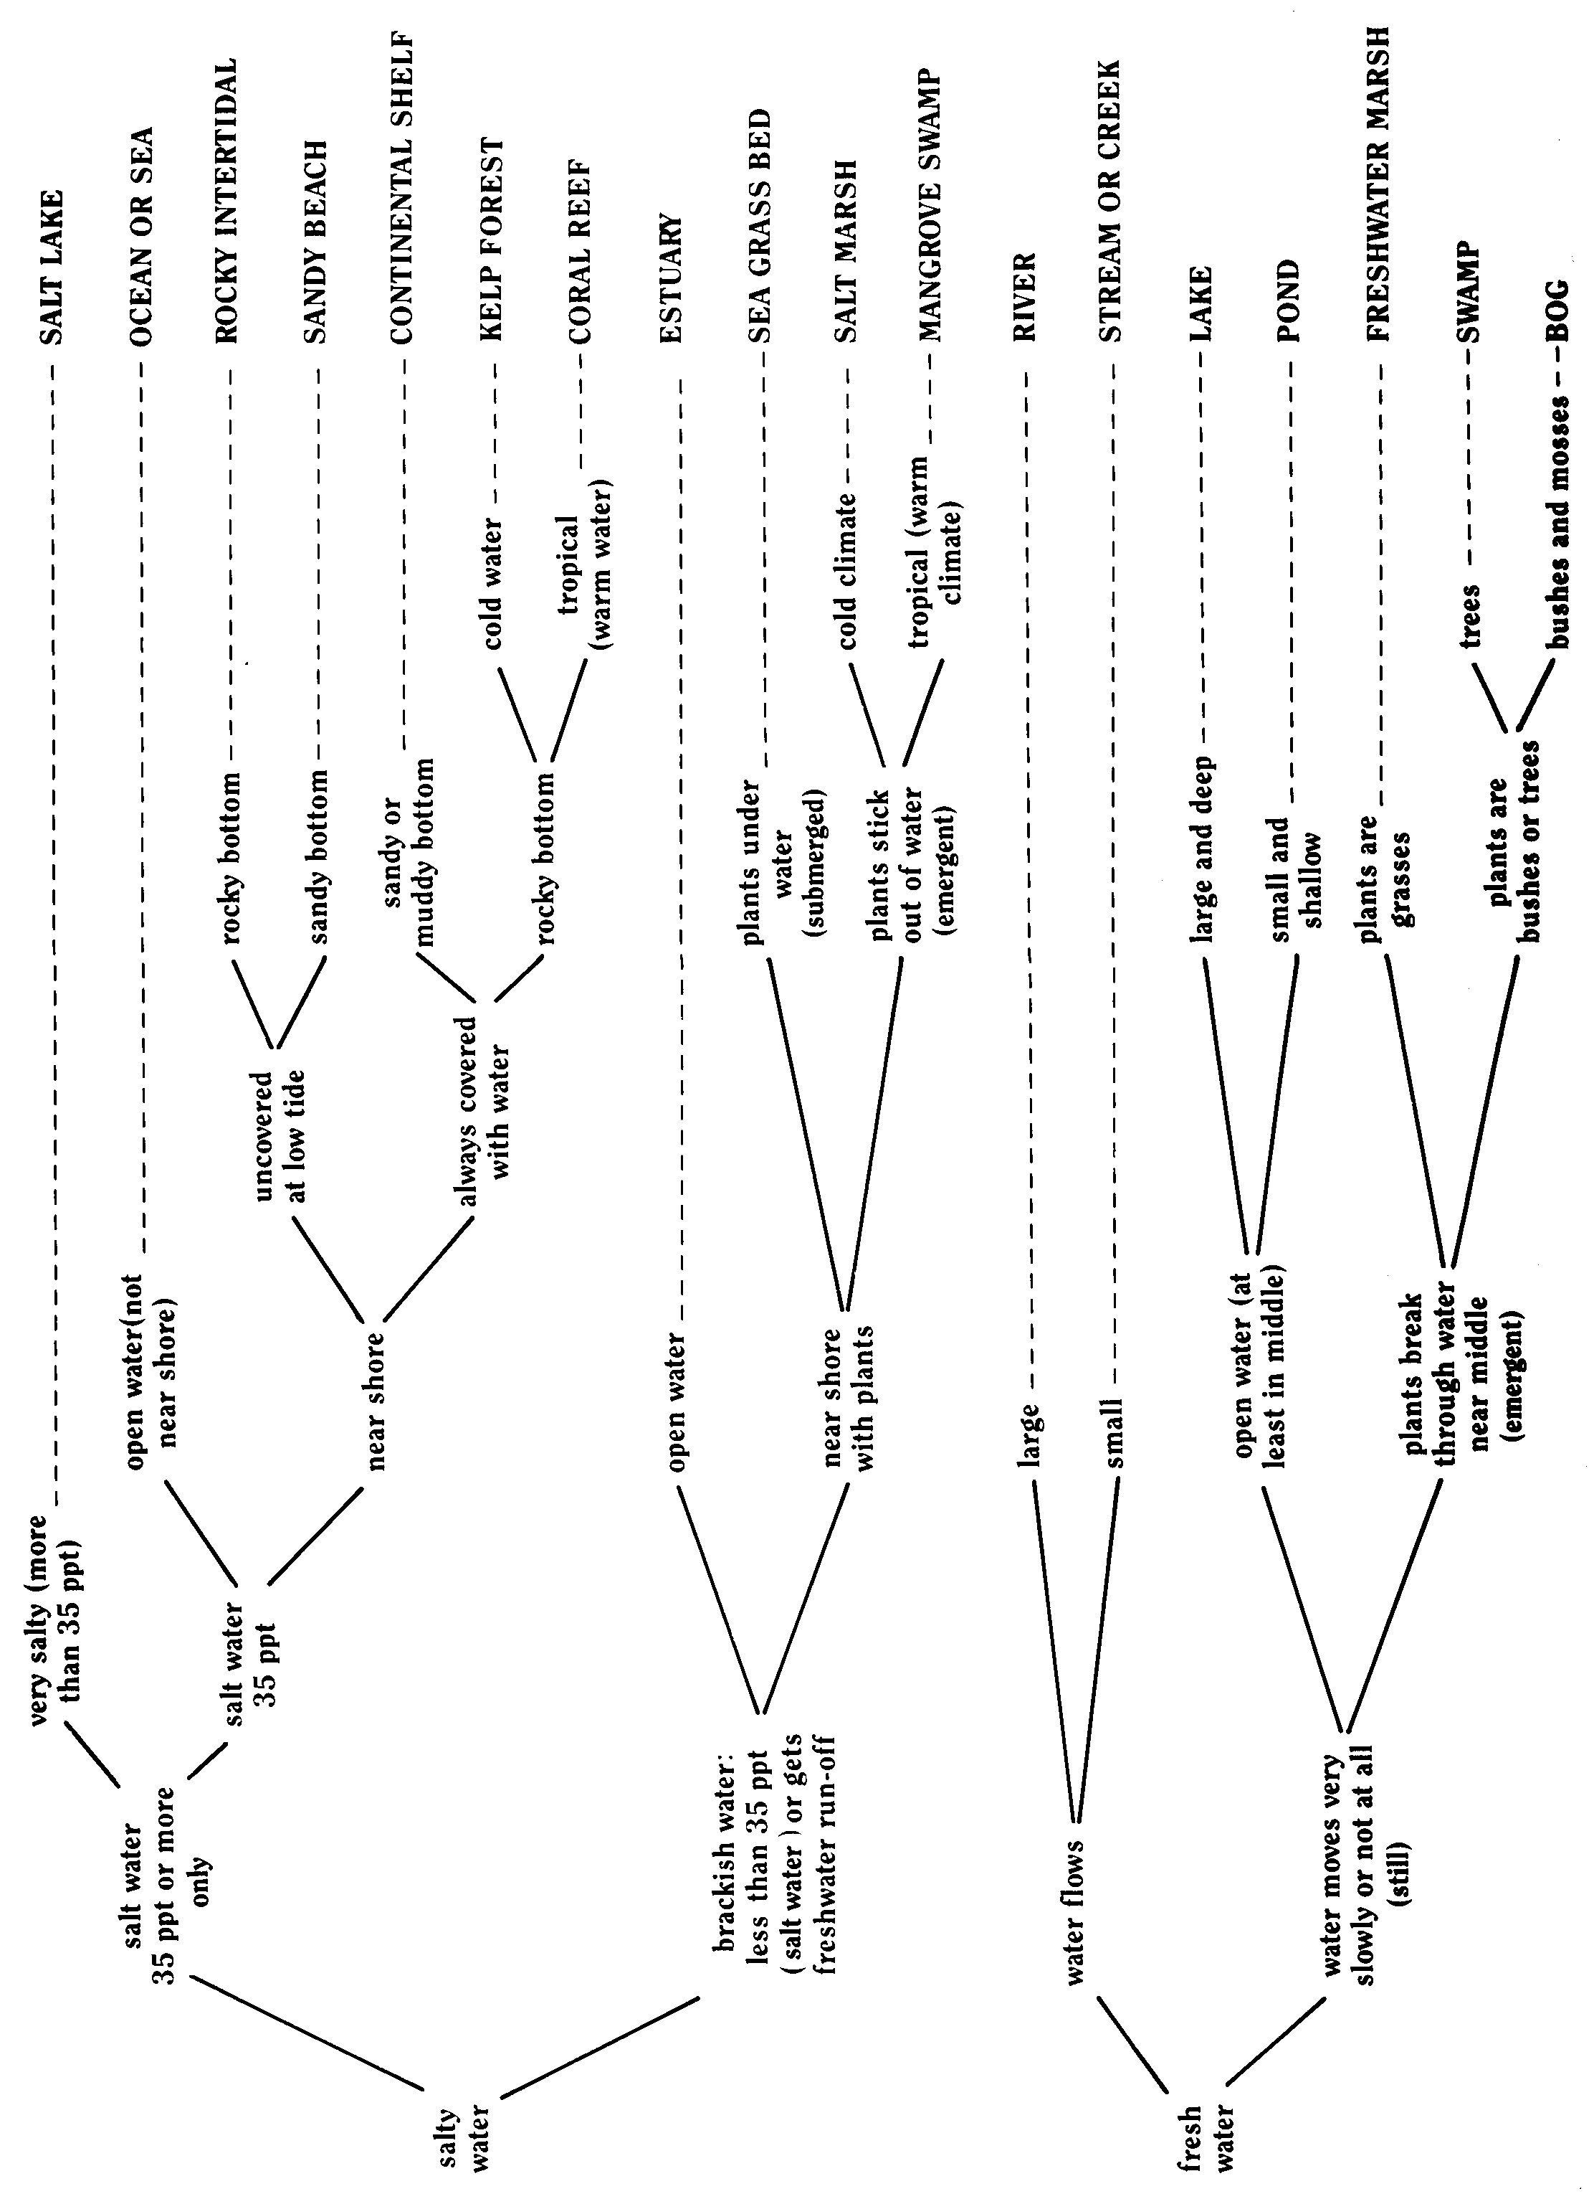

WATER HABITATS

1. Water is salty . . . . . . . . . . . . . . . . . . . . . . . . . . . . . . . . . . . . . . . . . . . . . . . . . . .. . . . . . 2
1. Water is fresh . . . . . . . . . . . . . . . . . .. . . . . . . . . . . . . . . . . . . . . . . . . . . . . . . . . . . . . . . . 12
2. Water is salt water (sea water) or saltier than sea water . . . . . . . . . . . . . . . . . . . . . . . . . 3
2. Water is brackish, less salty than the sea . . . . . . . . . . . . . . . . . . . . . . . . . . . . . . . . . . . . 9
3. Water is saltier than sea water . . . . . . . . . . . . . . . . . . . . . . . . . . . . . . . . . . . . . . . . SALT LAKE
3. Water is salt water, 35 ppt* . . . . . . . . . . . . . . . . . . . . . . . . . . . . . . . . . . . . . . . . . . . . . . . . . . . . 4
4. Open water, not near shore . . . . . . . . . . . . . . . . . . . . . . . . . . . . . . . . . . . . . . OCEAN OR SEA
4. Near shore . . . . . . . . . . . . . . . . . . . . . . . . . . . . . . . . . . . . . . . . . . . . . . . . . . . . . . . . . . . . 5
5. Part uncovered at low tide . . . . . . . . . . . . . . . . . . . . . . . . . . . . . . . . . . . . . . . . . . . . . . . . 6
5. Always covered with water . . . . . . . . . . . . . . . . . . . . . . . . . . . . . . . . . . . . . . . . . .
6. Sandy . . . . . . . . . . . . . . . . . . . . . . . . . . . . . . . . . . . . . . . . . . . . . . . . . . . . . . . SANDY BEACH
6. Rocky . . . . . . . . . . . . . . . . . . . . . . . . . . . . . . . . . . . . . . . . . . . . . . . . . ROCKY INTERTIDAL
7. Bottom of sand or mud . . . . . . . . . . . . . . . . . . . . . . . . . . . . . . . . . . CONTINENTAL SHELF
7. Bottom hard and rocky . . . . . . . . . . . . . . . . . . . . . . . . . . . . . . . . . . . . . . . . . . . . . . . . . . 8
8. Cold water and cold winters (temperate) . . . . . . . .. . . . . . . . . . . . . . . . . . . . . KELP FOREST
8. Warm waters and warm climate yearround (tropical) . . . . . . . . . . . . . . . . . . . . CORAL REEF
9. Open water . . . . . . . . . . . . . . . . . . . . . . . . . . . . . . . . . . . . . . . . . . . . . . . . . . . . . . . . ESTUARY
9. Near or at shore with green, rooted plants . . . . . . . . . . . . . . . . . . . . . . . . . . . . . . . . . . . 10
10. Plants are entirely under the water . . . . . . . . . . . . . . . . . . . . . . . . . . . . . . . SEA GRASS BED
10. Plants grow out of the water . . . . . . . . . . . . . . . . . . . . . . . . . . . . . . . . . . . . . . . . . . . . . 11
11. Climate is cold during winter (temperate) . . . . . . . . . . . . . . . . . . . . . . . . . . . . SALT MARSH
11. Climate stays warm all year (tropical) . . . . . . . . . . . . . . . . . . . . . . . MANGROVE SWAMP
12. Water flows in a definite bed. . . . . . . . . . . . . . . . . . . . . . . . . . . . . . . . . . . . . . . . . . . . . . . . . .13
12. Water appears not to move at all unless windy . . . . . . . . . . . . . . . . . . . . . . . . . . . . . . . . . . . 14
13. Large, flowing over muddy bottom . . . . . . . . . . . . . . . . . . . . . . . . . . . . . . . . . . . . . . . . RIVER
13. Small, flowing over sandy or rocky bottom . . . . . . . . . . . . . . . . . . . . .STREAM OR CREEK
14. Has open water although shores with plants are around it . . . . . . . . . . . . . . . . . . . . . . . . . . .15
14. Plants grow out of the water all over . . . . . . . . . . . . . . . . . . . . . . . . . . . . . . . . . . . . . . . 16
15. Large and deep; plants grow under water only near shore . . . . . . . . . . . . . . . . . . . . . . LAKE
15. Small and shallow; plants grow under water everywhere . . . . . . . . . . . . . . . . . . . . . . . .POND
16. Plants are grasses . . . . . . . . . . . . . . . . . . . . . . . . . . . . . . . . . . . . . . FRESHWATER MARSH
16. Plants have woody branches; they are trees or bushes . . . . . . . . . . . . . . . . . . . . . . . . . . . . . 17
17. Plants are trees with definite trunk . . . . . . . . . . . . . . . . . . . . . . . . . . . . . . . . . . . . . . .SWAMP
17. Plants are bushes; moss grows on ground . . . . . . . . . . . . . . . . . . . . . . . . . . . . . . . . . . . . . .BOG

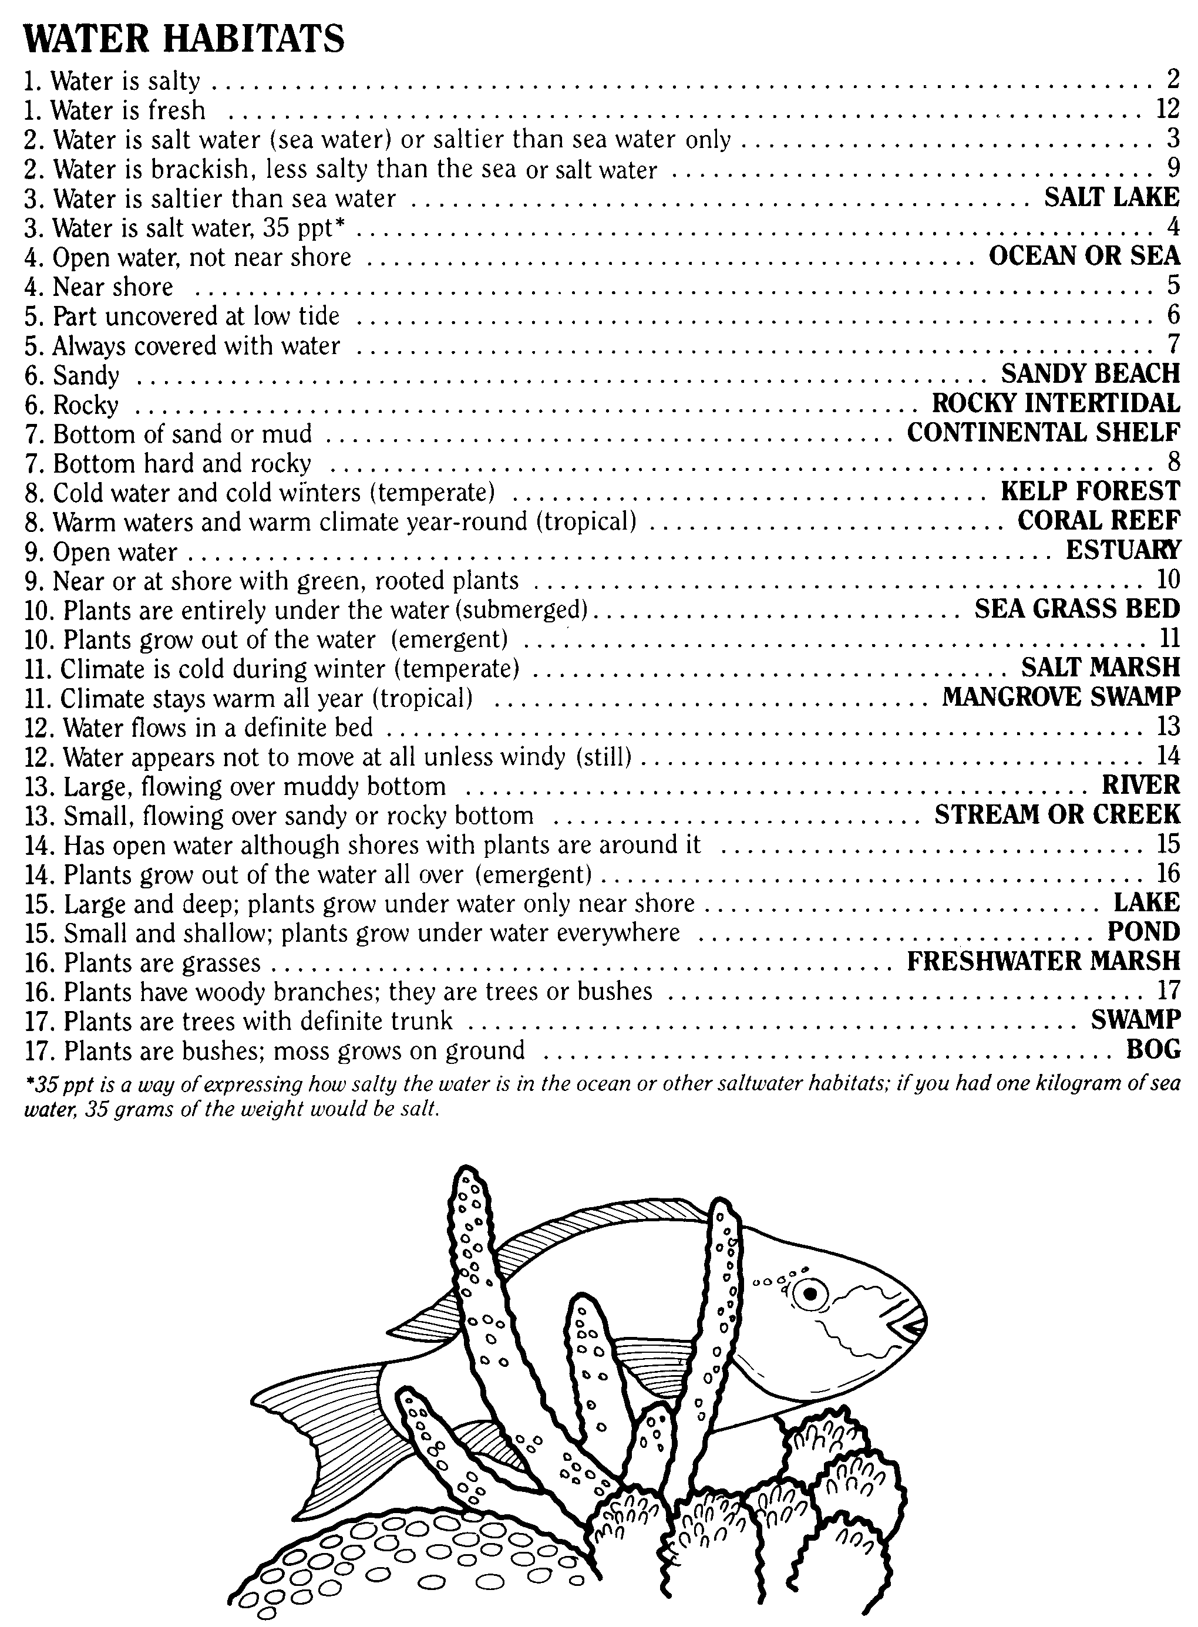
*35 ppt is a way of expressing how salty the water is in the ocean or other saltwater habitats; if you had one kilogram of sea water, 35 grams of the weight would be salt.

