ACTIVITY
1

THE DISAPPEARING ACT
WHAT HAPPENS WHEN DIFFERENT SUBSTANCES ARE ADDED TO WATER?
CONCEPTS:
- Many substances form a solution when mixed with water; some do not.
- Some substances go into solution faster than others.
SCIENCE SKILLS:
- observing
- measuring
- organizing
- inferring
- predicting
- experimenting
- communicating

MATH AND MECHANICAL SKILLS PRACTICED:
- bar graphing
- measuring volumes of fluids and powders

SAMPLE OBJECTIVES:
- Students will design and conduct an experiment to compare rates at which different substances dissolve in water.
- Students will compare different factors which affect rates at which some substances dissolve.
- Students will display data collected in a bar graph.

INTRODUCTION:
In this set of activities, students begin to explore the characteristics of water which relate to forming solutions and suspensions. Table salt and sugar are both among the substances which form a SOLUTION with water: that is, they DISSOLVE, mixing completely with the water and staying mixed. Some substances appear to mix completely, but do not go into solution. When they are allowed to sit undisturbed, they settle out. These compounds are said to form a SUSPENSION. Corn starch is a household compound that forms a suspension with water.
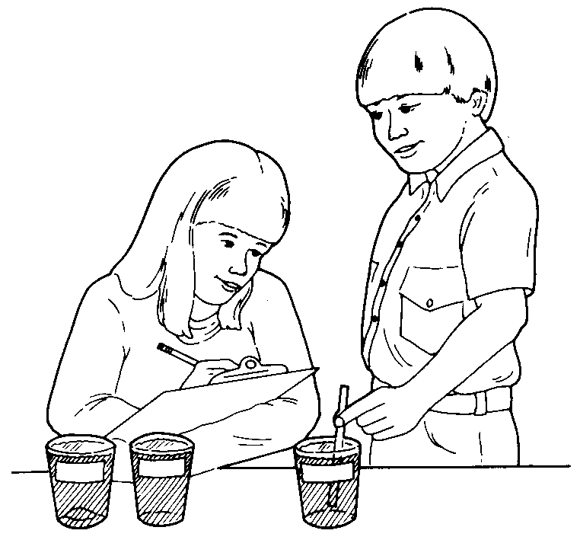

Note that the open-ended nature of the exercise allows each group the freedom to design its own experiment which also means that groups cannot pool data. This lack of standardization is intentional and is meant to generate student discussion about the need for uniform control of variables when doing an experiment. Future exercises will be standardized for this reason.

Teachers with particularly thoughtful students may want to encourage even more discussion by adding another set of variables besides amount of substance used. Some groups may be given kosher salt, some fine canning salt and some rock salt (all NaCl but with different crystal sizes). Superfine and regular sugar also have different crystal sizes. The outcome is that different groups will get different results. Making them identify reasons for the differences will clearly demonstrate to need for standardized experiments in future activities in order to pool data.

MATERIALS:
For class:
- water
- table salt (use canning or kosher salt; see Recipes for discussion)
- granulated table sugar
- corn starch
- large clear glass jar
- package of a dark flavor of unsweetened Kool-aid

For each group of students:
- 3 clear plastic glasses
- 3 plastic straws or stirrers
- a plastic teaspoon
- 3 pieces of tape or sticky labels
- a graduated measuring cup
- data sheets
- crayons or colored pencils

LESSON PLAN:
BEFORE CLASS: Read the lesson and gather the materials.

DURING CLASS:
METHODS: As a demonstration, show the students a large clear glass jar of water and a package of unsweetened Kool-aid. Ask them to predict what will happen if you pour the Kool-aid into the water. Do they all agree? Pour the Kool-aid in and see what happens. It should sink and then begin to dissolve and spread (diffuse) through the water. Can the students suggest a way to speed up the process of dissolving? Stirring is one approach. A second would be to use hot water. Introduce the word SOLUTION for the mixture and the word DISSOLVE for the process of mixing completely. Do not stir the jar. Let it sit and see what happens over time.

What other things can the students name which they would find around the house that dissolve in water? List them. Show the students the table salt, sugar and corn starch. Ask them to predict whether each will go into solution. If they predict that these substances go into solution, could they design a test of their prediction? Secondly, could the students design a test to discover which dissolves fastest?

Here is a test they might try. Each group should label one clear plastic cup each as salt, sugar and corn starch. Fill each of three plastic cups with about the same volume of water at room temperature. Leave about 1 in of space at the top. Add the equal amounts of salt, sugar and corn starch to the cup of water labeled with that substance. For example, 2 heaping teaspoons to each. Observe what happens for two minutes. Then stir each cup by making a circle around the edge of the cup with the stirrer ten times. Was there a change? Repeat stirring ten times in each until one has completely disappeared or dissolved. Record how many times it was stirred. Continue stirring and observing the other two to find out which dissolves next fastest. Last?

In order for this to be a "fair test" each cup has to be treated exactly the same way. The only thing that can be different is the substance added to each. This is referred to as controlling variables. How you discuss this concept depends on the age of your children.

RESULTS:
Each group should have three numbers which are the number of times each substance was stirred before it dissolved. How do you display such information? A bar graph would be a good way to compare three different things. Make the bar graph of the results. Now compare the results with the predictions. Were there any surprises? Sugar or salt may be faster depending on the size of the crystals in the particular brand you buy. If you intentionally gave them different crystal sizes, let them compare each other's chemicals to see if they can identify reasons for different outcomes. Did the fact that different groups used different amounts of chemicals make a difference? They controlled variables within their group, but not across groups. In the future, their goal will be to control variables uniformly so that they can compare their results fairly among groups and pool their data for analysis.

What happened to the corn starch can be the subject of heated debate. Some will say it is in solution and others may not. Do not throw all the solutions away when students clean up. Save two sets of solutions and place them in a safe place over night. When you check them a day later, you will have proof that the sugar and salt are completely mixed and are in solution while the corn starch was in suspension and has settled out.

CONCLUSIONS:
What conclusions can your students draw from their results? They should be able to state that not all substances go into solution. Corn starch forms a suspension which settles out. They should also be able to observe that some things dissolve faster than others.

EXTENSIONS:
1. Can your students design an experiment to test whether things go into solution faster in hot water? They should be able to state the question, design an experiment in which there is a test (hot water) and a CONTROL for comparison (room temperature water) and carry out their test.

2. Since you have some corn starch around, you might have fun with this demonstration of the fact that corn starch will mix with water when stirred to form a suspension but settles out when allowed to sit. Mix a quarter of a cup of corn starch with just enough water to form a ball. As long as you work it in your hand, it will remain a ball. Let it sit and it collapses into mush.

3. Children enjoy growing crystals, a way of demonstrating how to get substances out of solution by EVAPORATION of the water. Use very hot water to make a very concentrated solution of salt or sugar. Put the cooled solution in a jar and suspend a nail or nut tied to a string from the surface to the bottom. Put the solutions in a warm, dry spot and check them daily. For details see Science Scope, February-March, 1987, pages 8-9.

