Barnacle Beats - Testing an Animal's Response to Variations in Salinity
Lesson by Karen Mattick
Marine Science Center, Poulsbo, Washington

Key Concepts
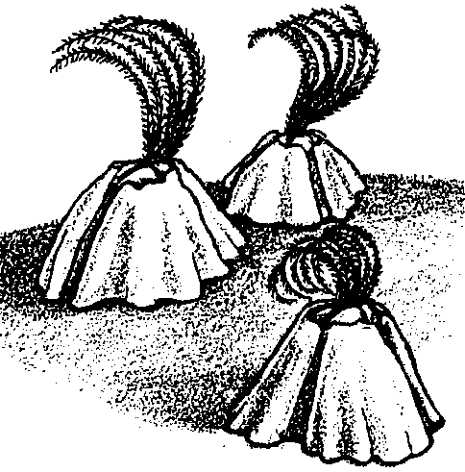
- There are limits to the range of salinities barnacles can tolerate.
- One can test a barnacle's responses to varying salinities of water by immersing the barnacles in waters of differing salinities and measuring the frequency of their cirri movements.
- There are several methods for measuring salinity of water.

Background
Barnacles are well adapted estuarine animals. In fact, they live in many marine intertidal habitats. As the tide goes out, they can hold a small amount of water in their shells, close their shell plates, and rest through severe environmental stresses until cool salt water returns. They can endure salinity changes, wide ranges in temperature, and long periods of exposure at low tide. Their toughness makes them good laboratory animals because they can do well even with a fair amount of stress and handling.

Barnacles also are fascinating to watch. When underwater, they repetitively extend their cirri, modified appendages, and sweep them through the water to trap plankton and to absorb oxygen. As students watch barnacles, they will find that barnacles can vary the way they move their cirri. Small barnacles often beat at different rates from large barnacles. Your students may even observe barnacles mating or releasing their young into the water.

The lesson "Still Hanging On" in Unit III: The Tides explores barnacles in greater detail than this lesson. Refer to teacher background in Unit III for more information about barnacles.

Materials
Part 1:

For each student or pair of students:
- 1 jar or beaker of salt water with a small clump of barnacles
Part 2:

For each student or pair of students:
- 1 beaker or jar with a small clump of barnacles
- access to salt and water
- a balance
- tools for the desired method for measuring salinity (hydrometers are most practical)

Teaching Hints
This section of the Estuaries unit explores how organisms cope with changing salinities in the estuary. It begins with "Barnacle Beats", a simple experiment that measures barnacles' responses to salinity changes. Students have the opportunity to observe barnacles and to learn several techniques for measuring salinity. This lesson also gives them a chance to create an experiment.
If your students have already done "Still Hanging On" in unit III, they will find that this lesson involves more sophisticated experimentation. If they have not done that activity, you may want to try it with your class either before or after "Barnacle Beats".

Part 1: Setting Up the Problem

Procedure:
- Ask your students to recall the layering and mixing of fresh and salt water that they observed in the "Estuary Currents" lab. Explain that estuarine animals must be able to endure wide ranges in salinity. The barnacle is one animal that inhabits estuaries. How wide a salinity range can it tolerate?

- Distribute a barnacle jar to each student or student pair. If the students have not done "Still Hanging On", give them time to observe the barnacles and make comments and ask questions. If this is the students' first time to observe the barnacles, ask students to brainstorm things they could measure about the barnacles. Accept any suggestions and then discuss which measurements would be easy to make in a few minutes. Typically, counting cirri movements is an obvious choice. If students have done "Still Hanging On", they will have experience counting cirri movements.

- Ask the students what they could change in the barnacle jar to test what range of salinity the barnacles can tolerate. It will not be difficult for them to see that they can add salt or fresh water to their jars to change the salinity. But it will be much more difficult for them to describe a precise experiment that controls the change in salinity and stays within salinity ranges the barnacle might really experience in an estuary. You have set the stage for "Measuring Salinity".

- Choose one or more of the following lessons to teach students how much salt typically is in salt water and how to measure salinity:
- "How Salty Is the Water?"'
- "Making Test Tube Hydrometers"
- "The Determination of Salinity- Hydrometer Method"
- "The Determination of Salinity- Titration Method"

Part 2: Doing the Experiment
When the students have a sense of how much salt is in salt water and can measure salinity, they can design and perform an experiment to test the range of salinities barnacles can withstand.
It is possible to have each team of students test a wide range of salinities or to have each team test one sample of water and compile the class results to find the tolerance range of the barnacles. The following lesson plan uses the latter approach.

Procedure:
- Ask each team of students to select a water sample to prepare. You may wish to post on the board or overhead a sign-up sheet with salinities ranging from, say, 20 ‰ up to about 40 ‰. Barnacles can withstand fresh water for a short time and can endure extreme saltiness, but a narrower range of salinities will convey to the students some care for the well being of the animals.

- Provide students with containers, balances, and salt and water to mix the solution they have chosen.

- After the teams have mixed their salt water solutions, have them trade containers and verify that the salinities are correct by measuring salinity with a test tube hydrometer, commercial hydrometer or titration. The hydrometer will be the most practical tool.

- Now have each team of students place a clump of barnacles in their salt water mixture and let the barnacles acclimate for at least five minutes.
- After the barnacles are acclimated, have the students count the number of cirri beats per minute of a barnacle. The more data your class can collect, the more easily you will be able to determine the range of salinities in which the barnacles are most active. Select a number of barnacles each team will count and the number of times each barnacle will be counted. Have students enter their data on the data sheet.

- Provide a place for students to display their counts so that the class can construct graphs of the results and interpret the barnacles' responses to the various salt water mixtures.

- You may wish to have the students answer the following questions as they interpret their data:

1. In what range of salinities were the barnacles most active?

(Student responses will vary, but, in general, barnacles will be most active in water with a salinity of about 30 ‰ - 32 ‰.)

2 a. Now that you know something about how barnacles respond to different salinities, how could you use barnacles to measure the salinity of a water sample?

(One could test salinity of water by counting barnacle cirri movements in a water sample and determining where the number of cirri beats falls on the graph the students created showing how cirri beats vary with salinity.)

b. How reliable do you think this method would be for determining salinity? Explain your answer.

(This method of determining salinity would vary in its effectiveness because barnacle behavior is affected by many factors in addition to salinity levels. The barnacle cirri beats may be much faster or slower than expected in water of a given salinity.)

Key Words
acclimate - to become accustomed to a new environment or climate
cirri - slender appendages serving as feet
hydrometer - instrument for measuring specific gravity (density) of a liquid, commonly consisting of a graduated tube weighted to float upright in the liquid whose specific gravity is being measured
intertidal zone - the region of a beach that is above the low water mark and below the high water mark
salinity - a measure of the salt concentration in a solution
Barnacle Beats -
Testing an Animal's Response to Variations in Salinity

Data Sheet

Team Members

Salinity of Water Cirri Beats per minute
barnacle 1 barnacle 2 barnacle 3
‰

Average
Combined Average

