The Boundary Bay Game
Written by Judy D'Amore, Marine Science Centers, Port Townsend and Poulsbo, WA. Adapted from The Lake Superior Game, by Barbara Liukkonen, printed in Lacustrine Lessons, Sea Grant Extension Program, University of Minnesota)

Key Concepts

1. An estuary is a place where freshwater streams and rivers enter saltwater bays. It is the marine environment most heavily used and populated by humans.
2. Each of us is constantly making decisions which affect the condition of our natural environment. Sometimes our decisions have consequences we can't foresee at the time. Often it is an innocent person or the environment itself that suffers the consequences. In the Puget Sound region, individuals, groups, and industries face complex economic decisions regarding whether to pollute or not.
3. Our economic system frequently rewards actions which bring short-term gain instead of behaviors which are in the long-term best interest of society as a whole.

Background
There is no more favored spot for human industry, commerce, fishing and recreation than the sheltered and biologically rich estuaries. This unit examines the estuaries, the places where freshwater streams and rivers meet saltwater.
The unit opens with "The Boundary Bay Game", an interactive game that will introduce your students to the place called an estuary and to the land use and water quality issues facing many communities.
This interactive game format has been used successfully to call attention to water quality issues in watersheds around Puget Sound and Lake Superior. It is presented here in a more generic form, featuring an imaginary bay, named "Boundary Bay", which is experiencing some regional issues and conflicts not too dissimilar from what many communities are facing in real life. Later, students may want to use the format of the Boundary Bay Game to create a game which highlights water quality issues of their own regions.
In The Boundary Bay Game, students participate in a simulation in which they assume roles of individuals who, like us all, use and have an impact on water. While fulfilling these roles, the students take actions appropriate to their roles, actions which alter the water quality in some simulated water bodies. One of these is a 10 gallon aquarium filled with water, representing the salt water bay in the game. Other props are water-filled plastic cups which represent rivers draining into this bay. Over the course of the game, the water quality will inevitably change, graphically illustrating the impact each of us has on our water resources.
During the course of the game contaminants will be introduced to "Boundary Bay" and its tributaries. Contaminants will include food coloring, dirt (representing siltation), confetti (trash) and a solution of ammonia and water (an invisible contaminant). At several points in the game students will need to test the water quality. Three different water quality tests will be used in the game:
Comparing a water sample to a pre-mixed color standard. When the water sample is darker than the standard, it is considered to be contaminated.
Lowering a secchi disk from the surface and recording at what depth it is no longer visible. A secchi disk is a standard piece of water quality equipment used for measuring the turbidity or cloudiness of the water.
Testing the pH of the water with litmus paper. As the ammonia solution is added, the pH will rise in Boundary Bay. For the purposes of this game, students do not need to understand the meaning of pH. This test is used strictly as a convenient method for sampling an invisible contaminant.
Some students will also have the opportunity to try catching fish. They will find that as Boundary Bay's water becomes darker, catching fish on the bottom becomes much more difficult.
The Boundary Bay Game is both whimsical and serious. Do not worry if your students take the game lightly as it is played. Its message will be clear no matter what choices are made, and regardless of the spirit in which it is played!

Materials

For a class of 32:
- An open, carpeted area indoors, or a flat, concrete area outside, on which a large representation of Boundary Bay and its tributaries can be drawn with chalk or masking tape. (A good alternative is to make a permanent map on a piece of plastic tarp. This is quite easy if you make a transparency of the original map, tape the tarp to a wall and trace around the projected image of the map on the tarp.)
- A 10-gallon aquarium, filled with clean water to represent Boundary Bay.
- Eight clear plastic cups, each labeled with the name of one of the rivers in the game.
- A bottle of blue food coloring, with dropper. Label this "Colored Contaminant."
- A solution of 1/2 cup ammonia in 1/2 gallon of water. Label this jar: "Clear Contaminant".
- A cup of fine dirt and a tablespoon measure.
- A couple tablespoons of paper "confetti," (made with a hole punch).
- A clear plastic or glass container (about 1 cup, or 250 ml) for taking water samples. Label this cup "Water Sample."
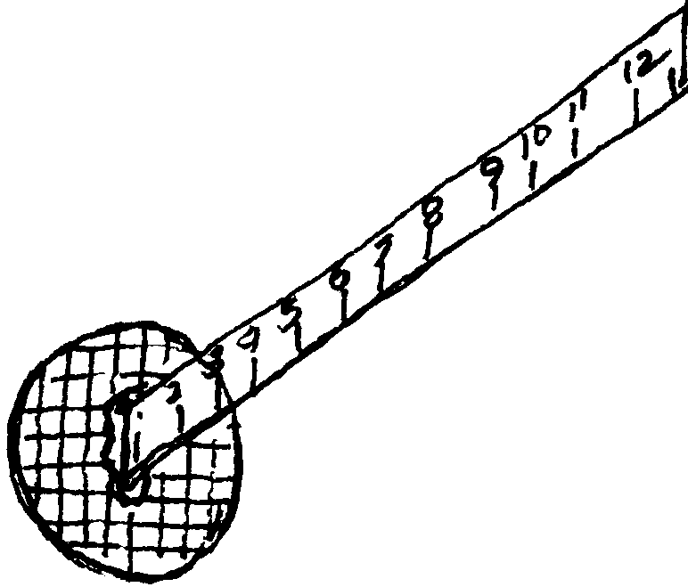
- An identical container of tinted water labeled "Water Quality Standard," to use as a standard for comparing the extent of pollution. One drop of food coloring in 1 1/2 quarts of water makes a good water quality standard.

- Miniature Secchi disk for measuring water turbidity. Run a sheet of transparency film through a xerox machine to print a simple pattern or small printed message faintly onto the film. Cut out a 2" circle of the film containing the printed pattern and use a thumb-tack to the zero-end of a wooden ruler.
- Litmus paper, range 6-10, with color key.
- "Fishing pole" made from a stick, a piece of string, and a paper clip bent to form a "hook." (Test the fishing pole yourself before the game to make sure the hook hangs at an angle that can catch a fish.)
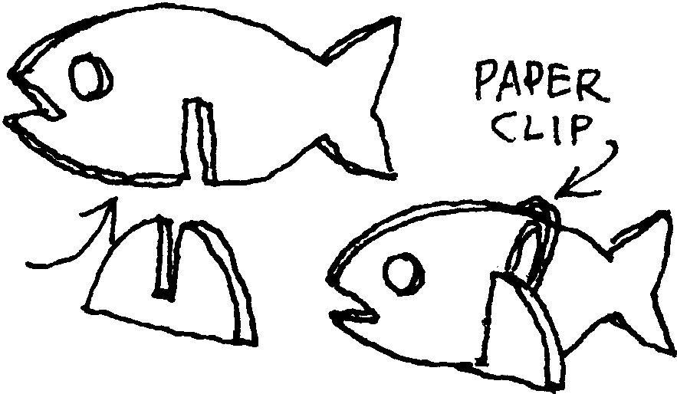
- 10 plastic "fish," cut from a coffee can lid or other piece of flexible plastic, and slotted to fit into bases so that they stand upright. (See diagram.) Punch a hole in each fish so that it can be caught from above with the hook. Weight each fish with a paper clip so it will sit on the bottom of the tank.
- A container labeled "Resource Savings Bank," or some other appropriate title. You will use the bank when collecting the students' payments.
- One set of student role cards.

For each student:
- 10 money units (M&Ms, Reese's Pieces, fish crackers, etc.) in paper cup or envelope. For a typical class one pound size bag of M&M's is sufficient, though you'll need 2 if you use M&M's Peanut. (Some teachers use paper certificates redeemable for candy at the end of the game.)
- Class set of Boundary Bay student questions

Teaching Hints

Before the activity:
1. Create the game setting. Have some of your students draw the game setting, the estuary map, on the floor with chalk or masking tape. Or, if you have made a map on a tarp, simply spread it on the floor.
2. Fill each plastic cup with water and place it on the appropriate river on the floor map.
3. Fill an aquarium with clean water, label it "Boundary Bay," and place it near the map. (Many teachers like to put it on a rolling cart so it can be easily moved aside if the game needs to be continued another day.) Arrange six fish on the bottom of the aquarium. Position the contaminants, the water quality testing equipment, the fishing pole and the remaining fish near the aquarium.
4. Prepare the Water Quality Standard: one drop of food coloring in about a quart and a half of water. Pour some into the cup labeled "Water Quality Standard".
5. Mix up Clear Contaminant: 1/2 cup of ammonia in 1/2 gallon of water.
6. Duplicate and cut the role cards if necessary.
7. Count "money units", place 10 per student in paper cups or envelopes.
8. Copy Boundary Bay student pages.

When students arrive:
1. Introduce your students to Boundary Bay, an estuary. Explain briefly that an estuary is a saltwater bay that has freshwater rivers or streams running into it. Boundary Bay is a beautiful salt water bay known for its excellent fishing, crystal clear streams and spectacular scenery. Tell them that over the years, as in so many other estuaries around the country, Boundary Bay's small towns have become cities, many new business have moved into the area, and people are buying property along its shorelines. They, the students, will be playing the roles of many of the people who live, work and play alongside Boundary Bay.
2. Point out each part of the setting and equipment for the Boundary Bay Game.
3. Explain and model each of the three water quality tests, noting the status of Boundary Bay's water before the game begins:
a. Take a water sample from the aquarium in the clear "Water Sample" cup. Compare it to the Water Quality Standard.
b. Lower the secchi disk into the water and see if you can see the disk 6 inches below the surface.
c. place a few drops of water on a piece of litmus paper and compare it to the color key.
3. Distribute a role card and 10 pieces of "currency" to each student. (If you have fewer than 32 students, assign some students more than one role.)
4. Have students read their cards silently and consider the decision and/or action they will take. Have them note the number on the corner of their card. This is the playing order of the game.
5. To play the game, each student, in turn, reads her role aloud and announces any decision she makes in that role. Then the student performs the action called for on the role card: polluting the water, paying money, sampling water, catching fish, calling for a class vote, etc.
6. Many issues will be raised as the cards are read. Feel free to take some time discussing them before moving on. Some issues may be familiar to students, but others might require clarification.
7. After playing the game, have students answer the questions on the Boundary Bay student page.
Note: The Boundary Bay Game takes approximately 90 minutes to complete. If your class periods are shorter, you will need to interrupt the game and save all props for the next day. Students cards and money can be saved in labeled envelopes, river cups and other materials can be stored on a cart, along with the aquarium. If you plan to do this activity with more than one class a day in periods of less than 90 minutes, you will need an aquarium and river cups for each class.

Extension
- After playing the Boundary Bay Game, have your class brainstorm and research issues which are specific to their own region or community. They can then write an interactive game of their own using the Boundary Bay Game as a model: i.e., the Great Salt Lake Game, the Delaware Bay Game, the Missouri River Game, etc. Developing a game based upon regional issues and then teaching it to younger students or other groups within the community can be a challenging and extremely rich experience for students.

Key Words
non-point source pollution - contaminants which enter the environment from diffuse sources, such as the actions of individuals
point source pollution - contaminants which enter the environment from a single source, such as the outfall of a city's sewage treatment plant or a factory
watershed - all the land which drains water into a river or other body of water whenever it rains or snows

Answer Key
- Answers may vary.
- Long term costs include loss of one's job or health because of water quality degradation.
- a. The sewage treatment plant in Randal and the manufacturing company on the Jango River are both examples of point source polluters.
b. Answers vary depending on your region.
- a. There are many examples of non-point pollution in the Boundary Bay Game: the person changing his oil, the backyard gardener, the dairy farmer, the furniture repair shop, the people at the beach party, the vegetable farmer, the person painting her sailboat, etc.
b. Answers vary depending on your region.
- Accept any thoughtful answer.
- Many ideas for improving water quality are suggested in the game: recycling waste oil, disposing of hazardous substances properly, cutting back on use of fertilizers and pesticides, etc.

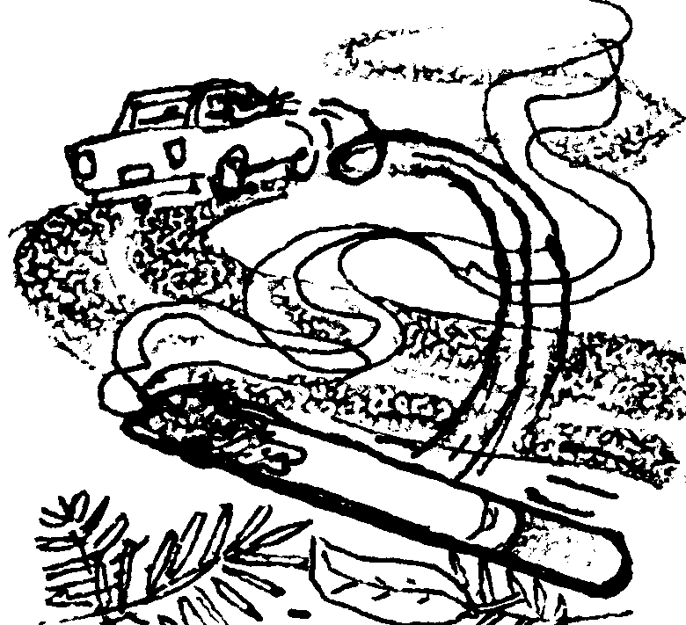
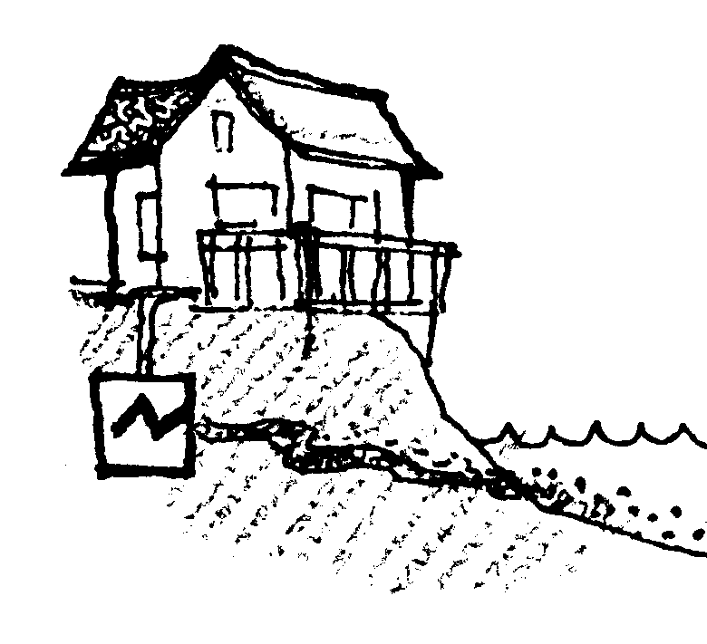
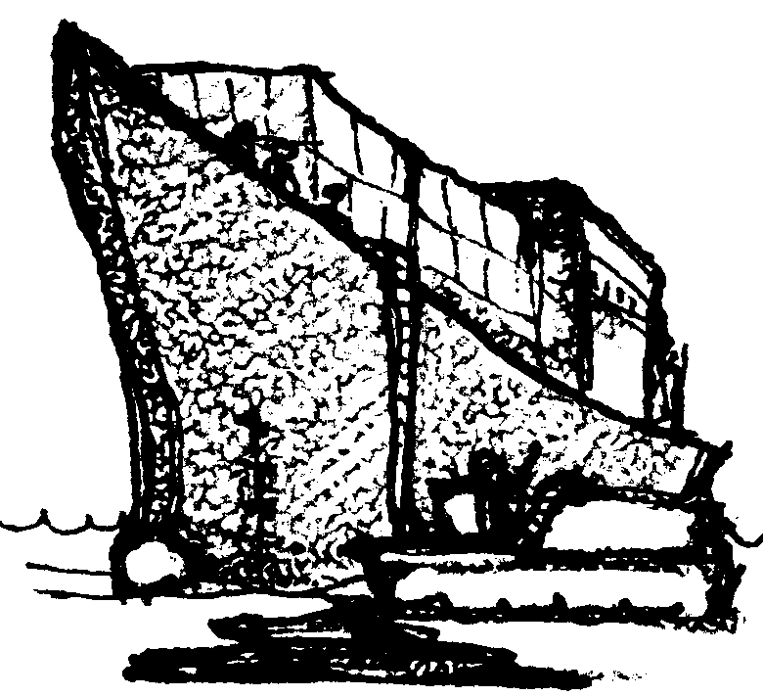
I am a tourist from Newport driving through the Mystic Peaks Wilderness Area. I carelessly throw a burning cigarette out my car window and start a major forest fire in the National Forest. Many trees are destroyed. Erosion is increased, and ashes and mud pollute the Ruby River watershed. Mud also washes into Boundary Bay.

(Add 1 tsp. dirt to the Ruby River watershed. Also add 1 tsp. of dirt to Boundary Bay.)

I am the owner of a ship which is carrying products made in Japan to Europe where they will be sold. I need to refuel the ship in Boundary Bay. I can either call a fuel barge to meet the ship inside Strawberry Spit, or I can have the ship travel the extra distance to a fuel dock in Burlington. It will cost my company $10,000 if I take the ship all the way to Burlington. On the other hand, I know that using a fuel barge may be riskier to the environment. With so many barges moving around the Bay, accidents are more likely to happen. It's hard to keep from spilling small amounts of fuel when we transfer it, and there's seldom any clean-up equipment nearby.
(If you choose to refuel at a well-regulated fuel dock, pay 5 pieces of "money". If you choose to risk spilling some oil into Boundary Bay, add 3 tsp. of clear contaminant to Boundary Bay.)

I live near the Jersey River. My septic tank is old, and it has been leaking into the river. This isn't a problem for me. The well I use for my household water supply still has plenty of clean water, but people downstream have to live with my septic waste. It would cost me $500 to repair my septic system. I could sure use this money for a vacation I'm planning to Acapulco. I must choose whether to pay to have my septic system fixed, or l save my money and continue polluting the river.

(Either pay 1 piece of "money" or add 2 drops of color to the Jersey River and 4 drops to Boundary Bay.)
1.

2.

3.

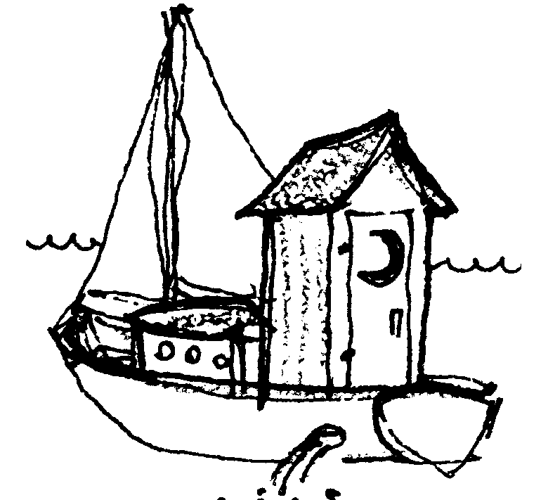
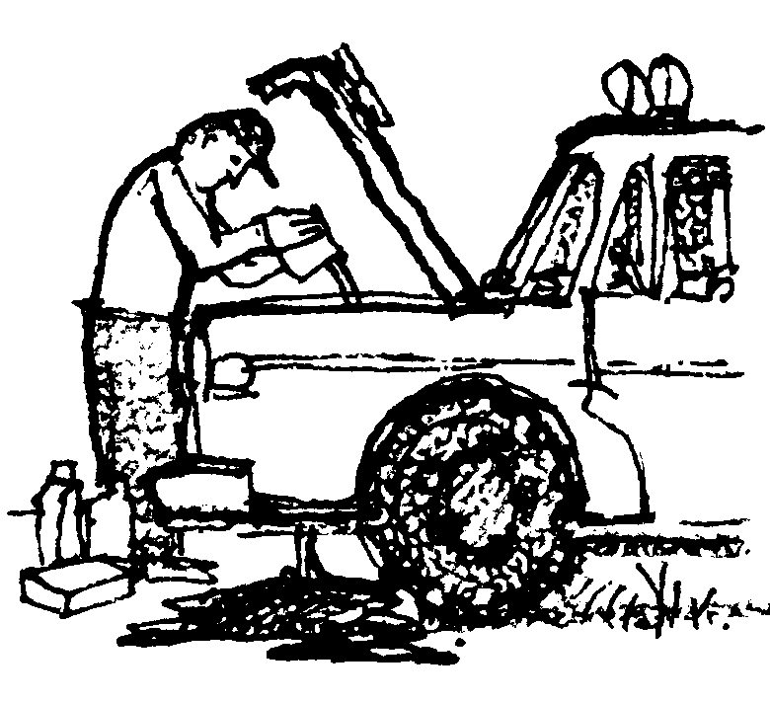

I live on Catalina Island and work in Burlington. I have a sailboat which I take out when I can take time off from my busy lifestyle. At the marina where I keep my boat, there is no sanitary pumpout station for emptying the holding tank from my head (nautical toilet). Since I'm not willing to make a special trip to one further away, I just flush it once I get on the water. It saves me lots of time.

(Add 3 drops of color to Boundary Bay.)

I live near Randal. When I change the oil in my truck I just let it run into the ground. It eventually seeps through the soil and pollutes the water in the Bay. I know that waste oil can be recycled at a service station nearby, but I'm too lazy to do it.

(Add 4 drops of color to Boundary Bay.)
I like to keep my lawn looking nice, so I use lots of fertilizer and weed killer on it. I also grow unusual ornamental shrubs in my yard which can't survive here without special insecticides to protect them from pests. I can't imagine what my yard would look like if I ever had to stop using these chemicals. I suppose it's all washing into the Lacey River, since that's the watershed I live in.

(Add 1/2 tsp. of clear contaminant to the Lacey River. Also add 1 tsp. to Boundary Bay.)
4.

5.

6.

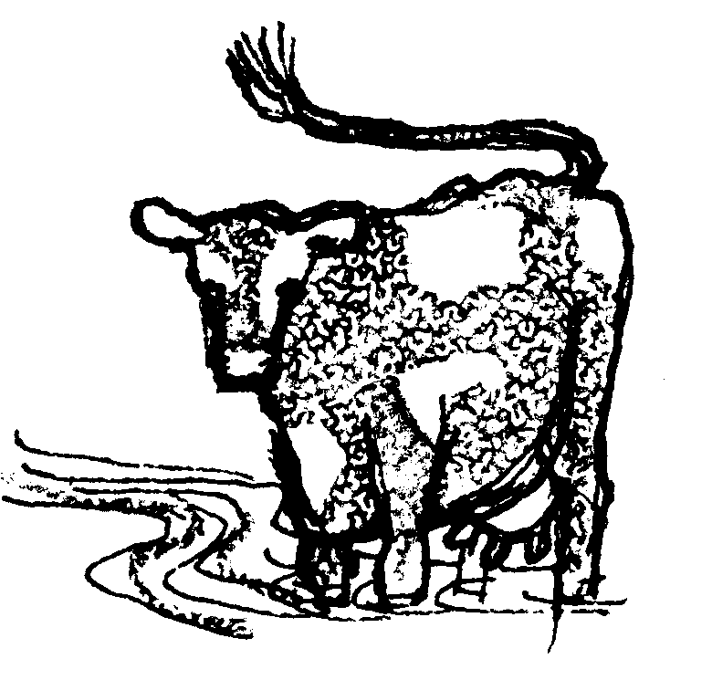
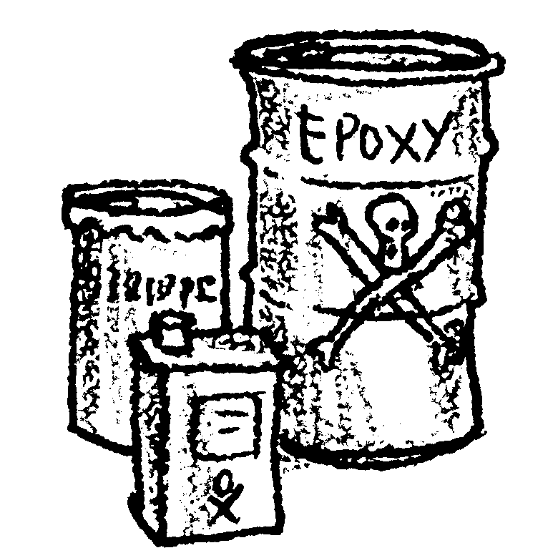
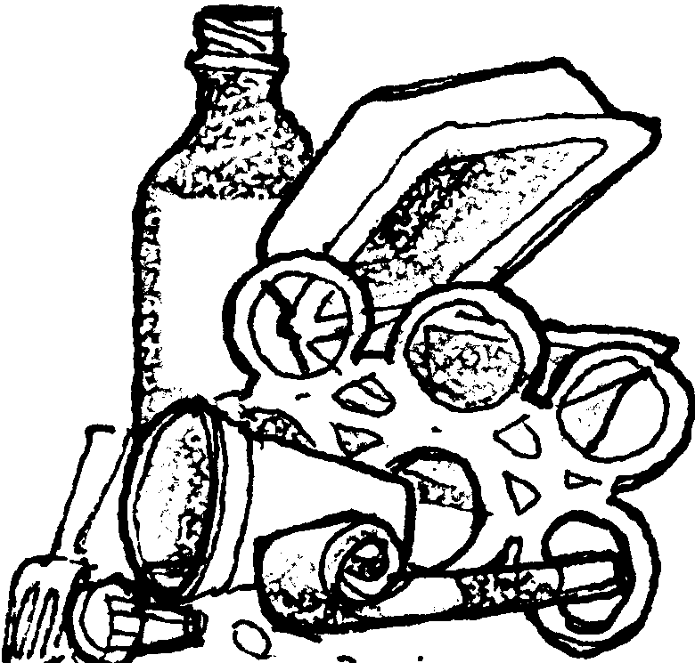
I have a dairy farm near the Sabine River. One of its tributaries runs through my pasture. I know I really shouldn't let my cows walk through the stream. Their manure gets into the water and their feet cause the banks to erode. But it's easier and cheaper for me to let the cows get their water from the stream than to pump water over to the pasture. If I decide to protect the stream it will cost me $1500 for fencing and a watering system for my cows.

(Either pay 2 pieces of "money" or add 2 drops of color to the Sabine River and 6 drops to Boundary Bay.)
I own a small business repairing and refinishing furniture in the town of Burley. I use a lot of chemicals like epoxy and paint strippers which are very toxic to people so they must be hazardous to the environment too. After I use them I have to throw them away somewhere. It's illegal to dump them into the ground, but on the other hand, it would cost me $200 each month to have them taken to a hazardous waste disposal site. I'm not sure my business can afford this expense.

(If you decide to have these chemicals disposed of properly, pay 2 pieces of "money". If you just dump them on the ground, add 2 drops of color to the Rosalie River and 2 drops to Boundary Bay.)
I have a waterfront home on Strawberry Spit. My friends and I hang out at the beach nearly all summer long. We have big parties with lots of food and drinks. Sometimes we're a little careless with our trash, and lately I've started seeing chunks of Styrofoam and plastic containers everywhere. Doesn't this stuff ever break down?

(Add a pinch of confetti to Boundary Bay.)

7.

8.

9.

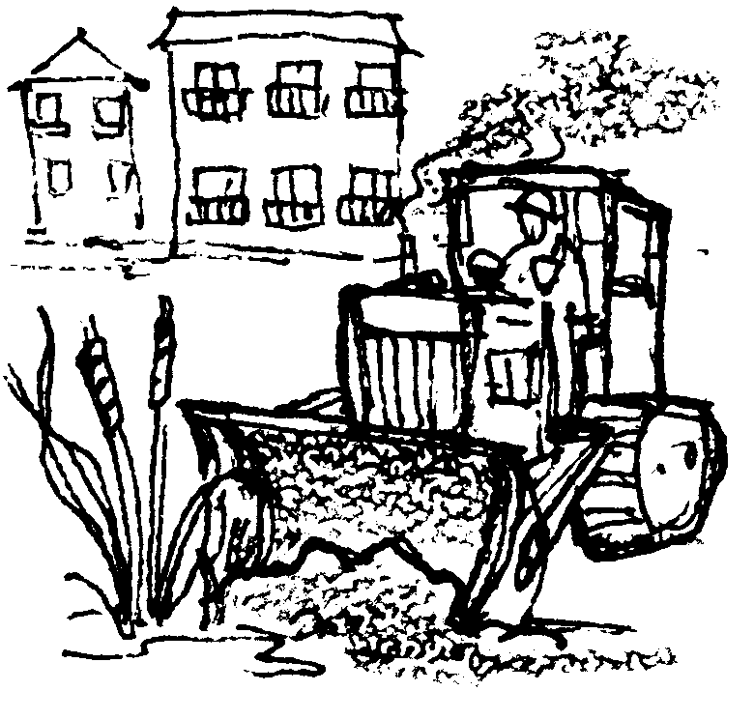
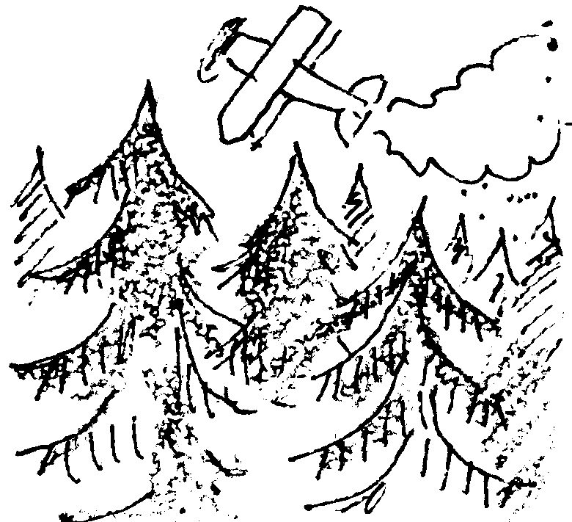
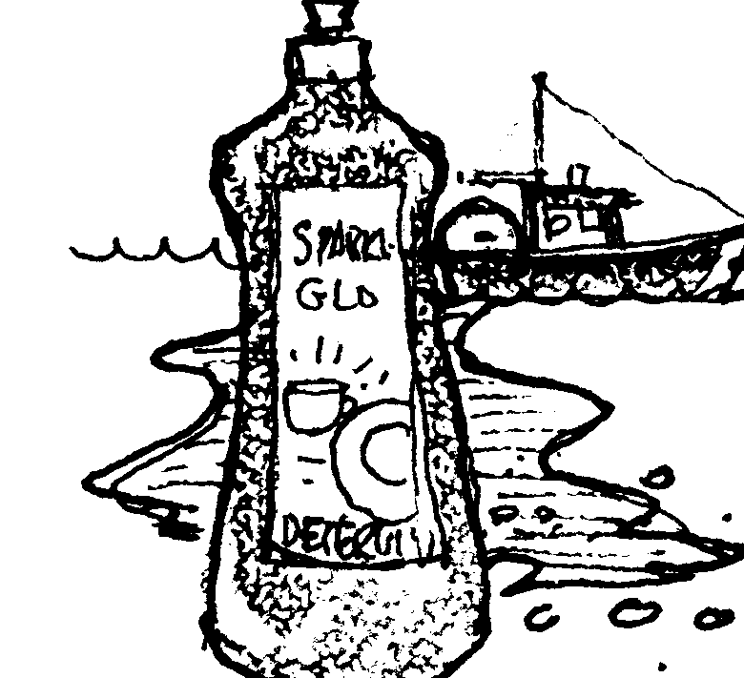
I am a developer. I make money by building and selling condominiums. People like to live along the water. I am interested in filling in some of the wetlands at the mouth of the Jersey River to build my condominiums. If I do this, it will take away habitat for fish and other wildlife.

(If you choose to build your condos, reach into the Bay and remove 1 fish. If you decide to protect them, pay the bank 3 pieces of "money")
I'm a commercial fisherman. The engine on my boat leaks oil into the bilge, the inside of my boat. Water also collects in the bilge, so I have to bump out this oily mess every so often. If the Coast Guard spotted my boat making an oil slick, it would fine me $5,000. Before I start up the bilge pump, I pour detergent into the oily bilge water. This makes the oil break up and mix with the water so nobody can see it. I know it's against the law to do this, but I sure don't want the Coast Guard catching me with an oil slick behind my boat.
I do wish there was some other place I could pump my bilge water, but if there is, you tell me about it!
(Add 2 tsp.of clear contaminant to Boundary Bay)
I work for a large timber company with timber holdings all along the west side of Boundary Bay. In managing our forests we often use herbicides to keep "weed trees" from competing with our cash crop. If we stopped using herbicides, our trees would grow more slowly, and fewer valuable trees could be harvested. But herbicides eventually wash into the water and pollute Boundary Bay. We must decide whether to continue using herbicides or give up some of our profits.
(If you choose to stop using herbicides, pay 5 pieces of "money". Otherwise, add 1 tsp. of clear contaminant to the Makaw, the Ruby, the Andara, and the Jersey Rivers. Add 3 tsp. to Boundary Bay itself.)

10.

11.

12.

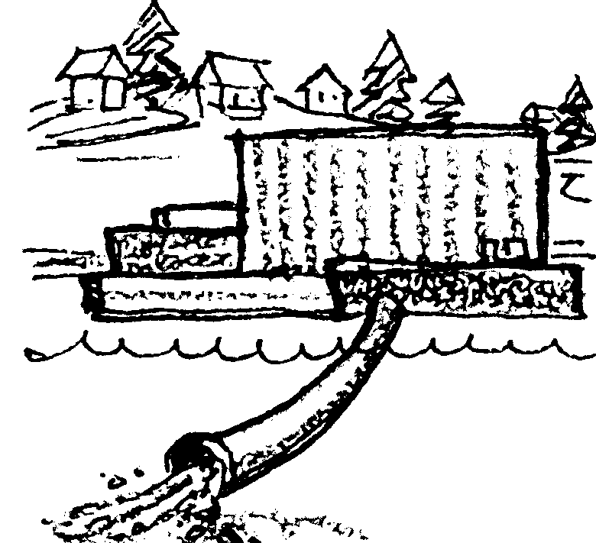
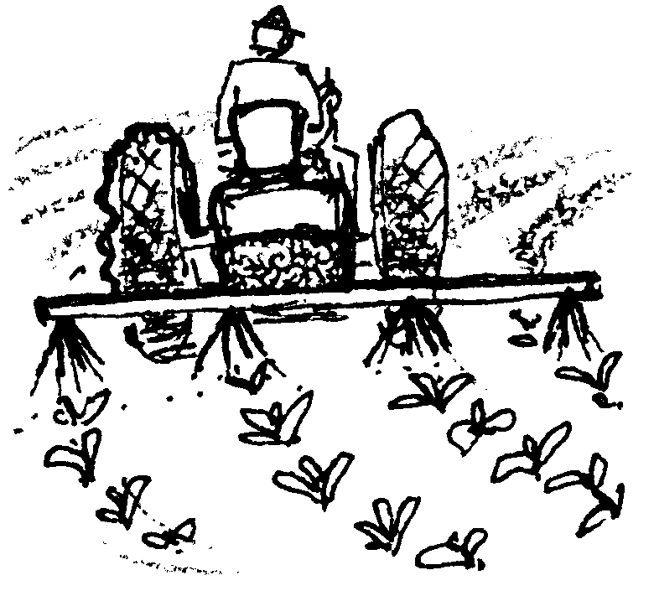
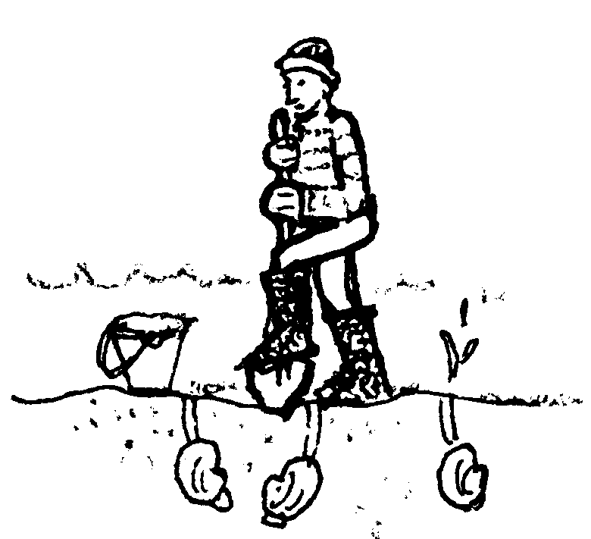
I help operate a primary sewage treatment plant for the city of Randal. A new secondary treatment plant would pollute the water less than our primary treatment plant does. But we doubt the citizens in our town would be willing to pay an extra charge to build a secondary sewage treatment plant.

(Many communities around Boundary Bay are facing this problem, so take a class vote. Would these citizens tax themselves 1 piece of "money" each to build better sewage treatment plants around the Bay? If the majority votes yes, each person in the class must pay the bank one piece of "money". If the class votes no, add 10 drops of color to Boundary Bay.)

I live on the water near Port Handy. I like to dig clams from my beach. If the water becomes polluted, the clams will be contaminated and my beach will be closed to shellfish harvesting.

(Take a water sample. Use a litmus paper strip to test the water. If it tests 8 or higher on the color scale, the water is contaminated and you may not dig the clams from your beach.)
I raise fruits and vegetables on my farm near the Andara River. I use chemical fertilizers and pesticides on my crops, and some of these chemicals wash into the river. I know some farmers have switched to organic farming methods, but I wonder if they're making as much money as I can by using these chemicals.

(If you decide to farm organically, pay 2 pieces of "money" for losses you may have to take when you first switch over. If you decide against it, add 1/2 tsp. of clear contaminant to the Andara River and 2 tsp. to Boundary Bay.)
13.

14.

15.

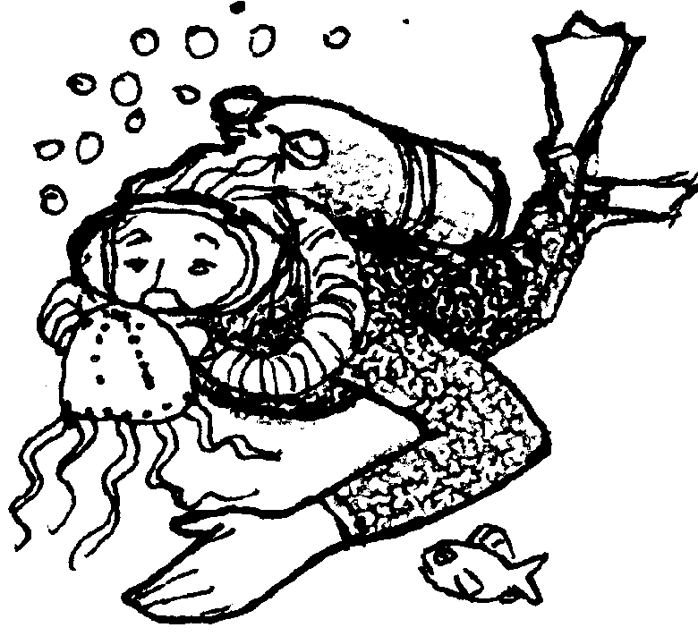
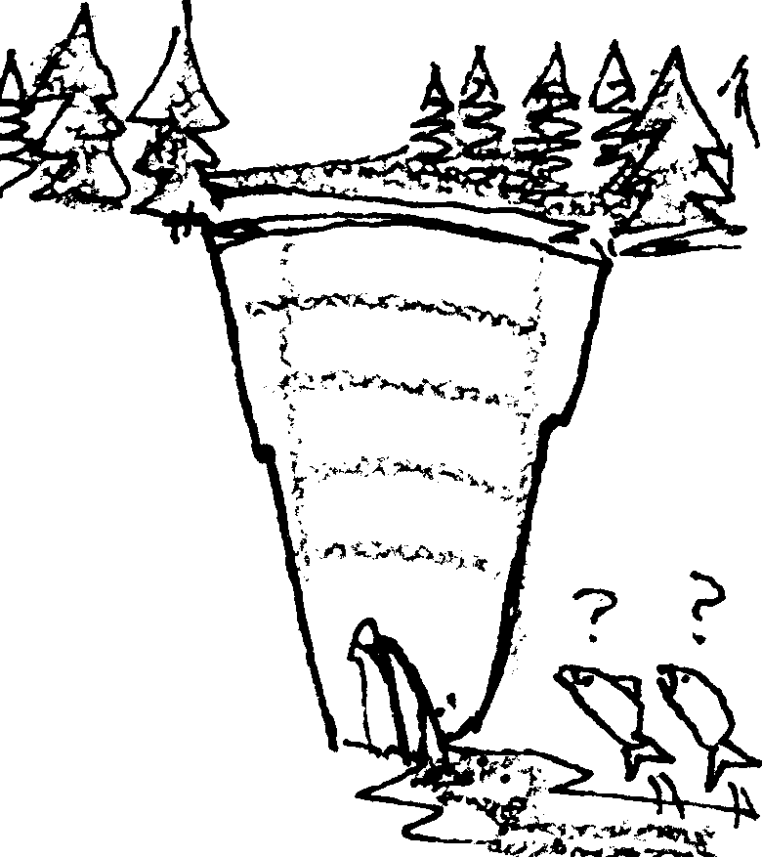
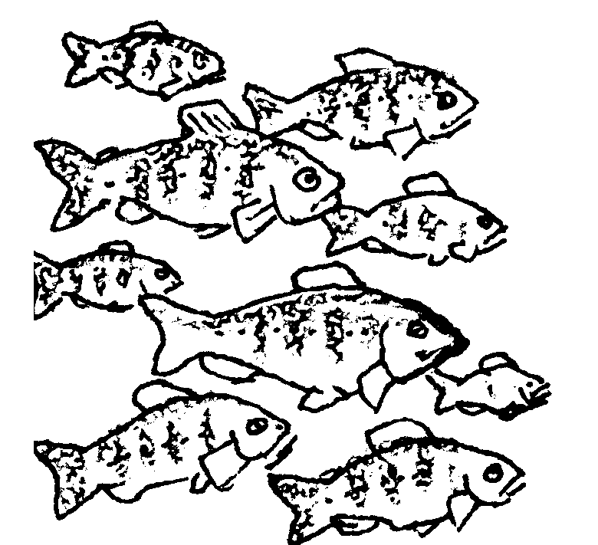
I work for a power company which wants to put a dam on the Makaw River. All that water is just going to waste, but it could be generating cheap power for people and businesses moving into the Boundary Bay area. A few salmon runs might be hurt, but wouldn't we rather have a strong economy?
(Have the class vote whether to dam the Makaw River. If the class votes yes, remove half the water from the Makaw River. Pour it out into a sink or waste bucket. Reach into Boundary Bay and remove 2 fish. If the class votes not to dam the Makaw River, turn off 1 light in the classroom.)
I am chief biologist for a fish hatchery on the Jersey River. We hatch and raise the fish in water from the river, and of course, the fish are released into the river when they are big enough. If the water is too polluted, the fish won't survive and they won't make it to Boundary Bay.
(Take a water sample from the Jersey River. Compare it with the water quality standard. If it is darker than the standard, the fish will not survive. Pay 3 pieces of "money" and look for another job. If it is lighter, add 2 fish to Boundary Bay.)

I live in Chicago and I love to scuba dive. I come to Boundary Bay because it has such interesting underwater life. If the places I like to dive become too polluted, I won't see as many interesting creatures and I'll look for another place to dive.

(Use the Secchi disk to test the water. Lower it in the water, and if you can't see the circle six inches from the surface, you won't be back to dive in the Bay anymore.)
16.

17.

18.

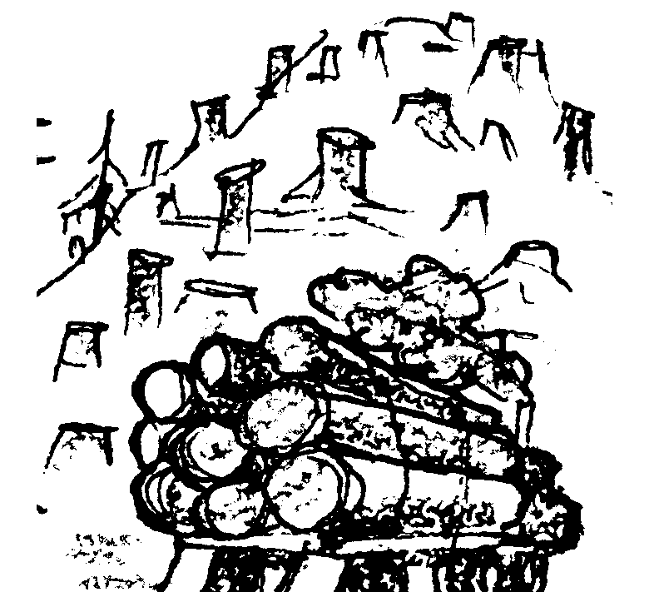
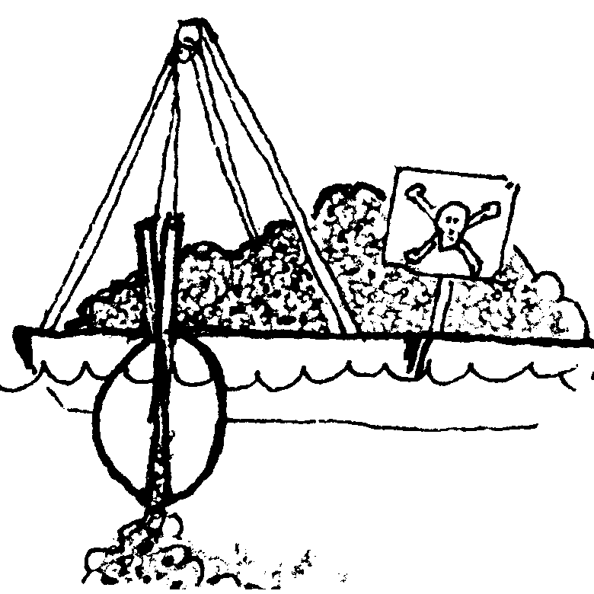
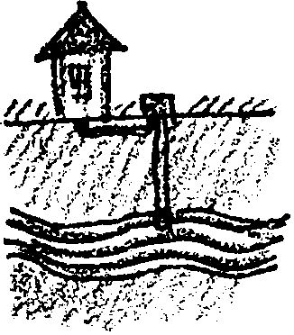
I work for a logging company which has been harvesting timber in several parts of the Boundary Bay area. We have been cutting on steep slopes and sometimes working too close to the streamside. Now that the winter rains are here, erosion and mud slides are carrying large amounts of silt into the river.

(Put 1 tsp. dirt into the Andara and the Makaw Rivers. Add 4 tsp. of dirt into Boundary Bay and stir gently.)

I am the manager of a harbor near Jefferson City. I want to dredge the harbor deeper to let bigger ships use our docks. The trouble is, the bottom sediment that needs to be removed is contaminated with toxic materials. It would cost us $1,000,000 to have it shipped to a toxic waste disposal site on land where it would be out of the water for good. If we did this we would have to charge the ships more money to stay in our harbor. I'm asking for permission get rid of it in a cheaper way, by putting it back in Boundary Bay somewhere else. This way more ships would use the harbor because they wouldn't need to pay as much, and I'll be able to create many new jobs for people in the area.
(Ask for a class vote to decide whether you will be allowed to dump the toxic sediment back into Boundary Bay -- and choose 5 classmates to receive high-paying jobs in the new shipyard. These people each receive 1 piece of "money" from the bank.. If the class votes yes, add 8 drops of color to Boundary Bay. If it votes no, you pay 5 pieces of "money" to dispose of the sediments more safely.)
I just bought a nice little place in the country alongside the Sabine River. I've decided to test the water in my well because I want to make sure it's safe for my family.

(The water in the Sabine and your well are connected. Water can move slowly through the ground between them. Take a water sample from the Sabine River. Compare it with the water quality standard. If it's darker than the standard, your water supply is polluted too. It's going to cost you $1000 to connect with a city water supply. Pay 3 pieces of "money".)
19.

20.

21.

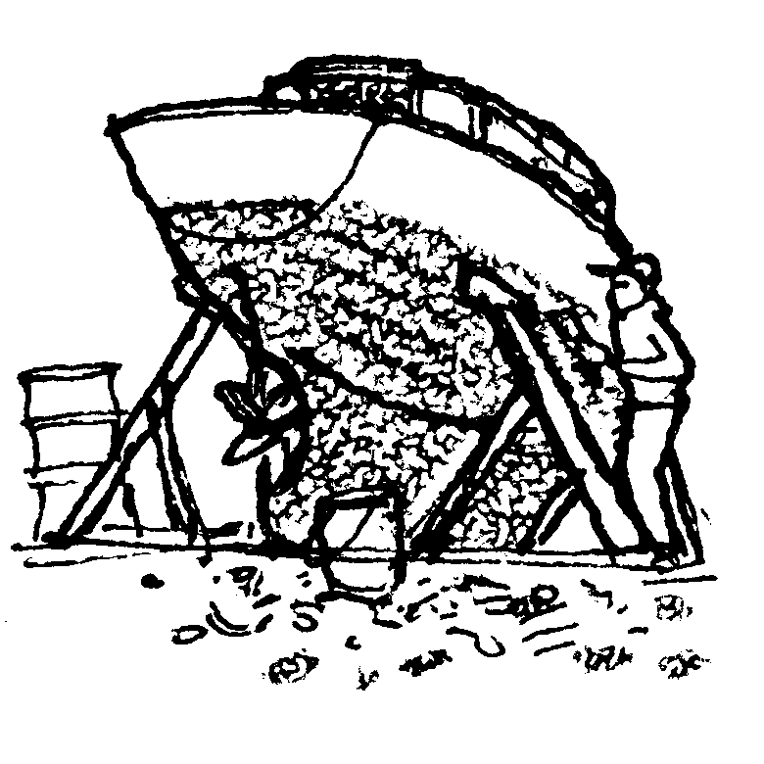
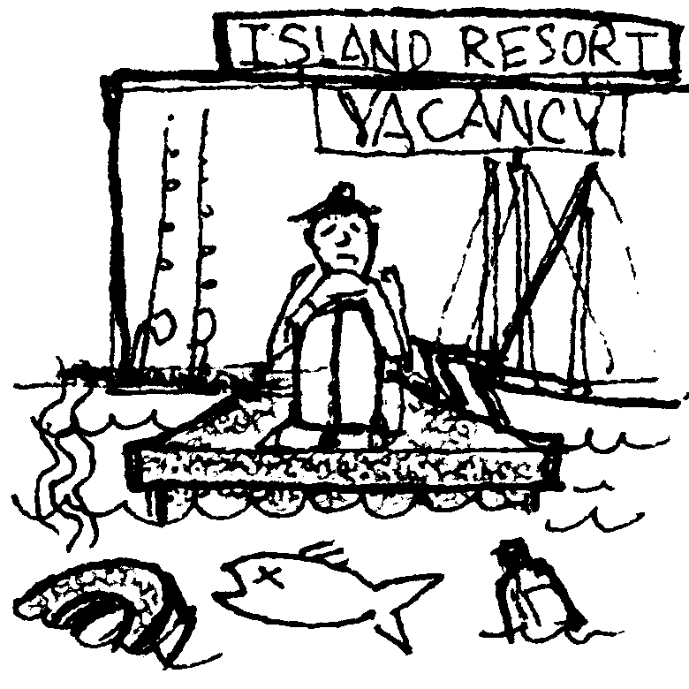
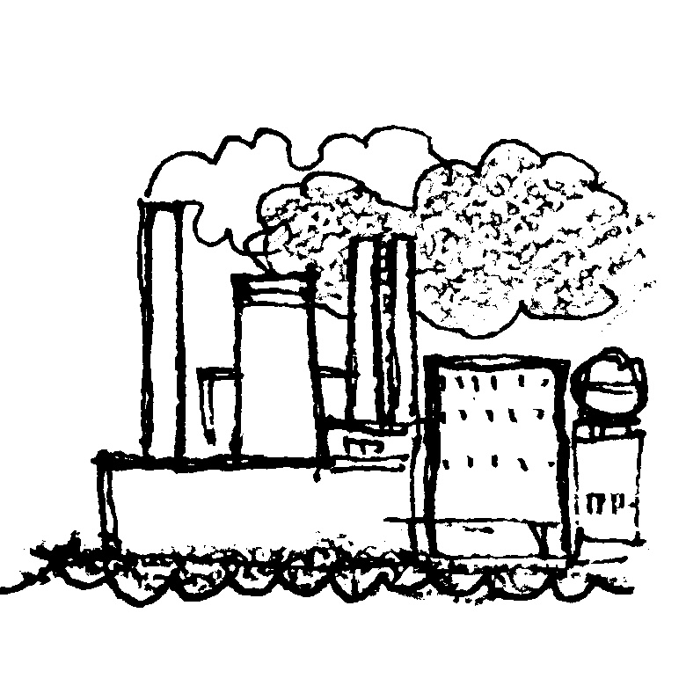
I just bought a sailboat which needs some work. I need to have it hauled out so I can repaint the bottom. I will have to scrape all the old paint off before I can put the new paint on. The paint has copper and other chemicals in it to keep barnacles from growing on the boat. When I scrape the old paint off, it just falls on the ground where it will just wash right back into the water.

(Either pay 1 piece of "money" for a tarp to go under your boat or add 1 tsp. of clear contaminant to Boundary Bay.)
I run a resort on the Kittery Island. People come from all over the country to spend their vacations sailing, fishing, and having a good time on the water. If the water is polluted, people will stop coming here and I'll go out of business.

(Use the Secchi disk to test the water. Lower it in the water, and if you can't see it 6 inches from the surface, turn in all of your "money". You go out of business.)

I am the manager of a copper smelter near Cascadia. Our refining process is polluting the air and water of Boundary Bay. To clean up our factory would cost us $1,000,000. If we have to pay that much, we will have to cut back our business and 250 people will lose their jobs. I have to choose whether to stop polluting but put workers out of a job, or to continue to operate the way we have been.

(Either pay 5 pieces of "money" or add 3 drops of clear contaminant to Boundary Bay.)

22.

23.

24.

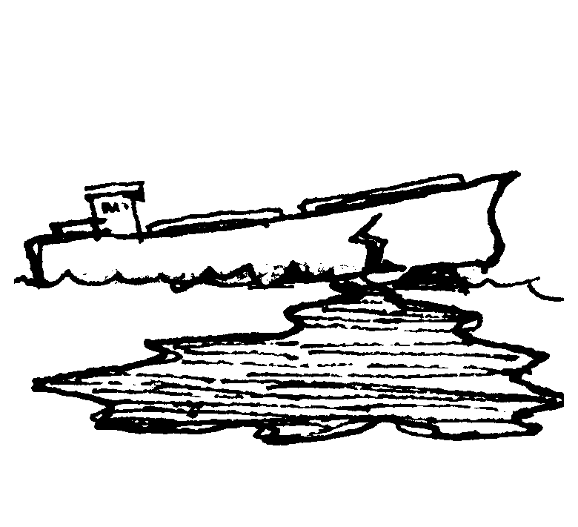
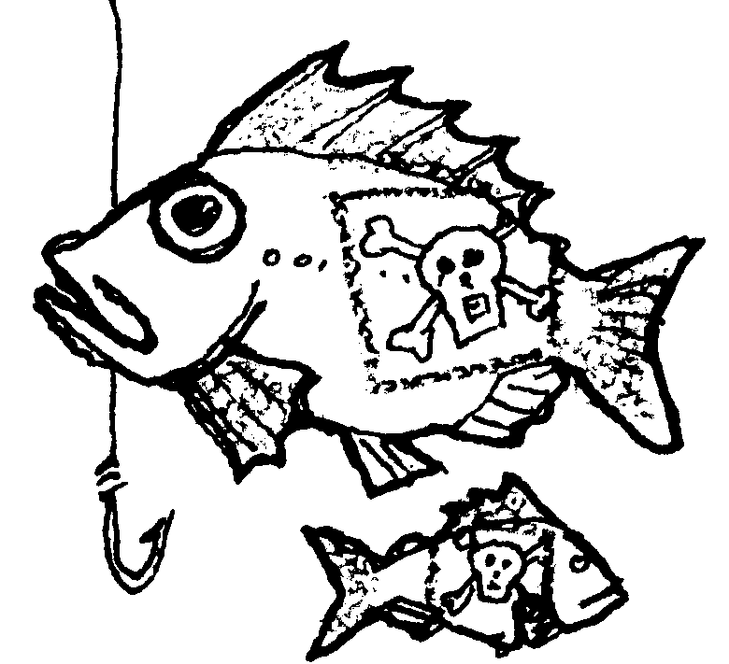

I am a commercial fisherman trying to catch bottom fish near Strawberry Spit. If I catch fish that contain toxic materials higher than federal standards, I cannot sell them to the public and I will not be able to make my boat payments. I will have to go out of business.

(Take a water sample from Boundary Bay. Compare it with the standard color. If it is darker than the standard, the fish are too contaminated to sell. Turn in all of your money" and go out of business. If the water is lighter than the standard, take 1 minute to try catching some fish.)
I am an executive for a company which ships crude oil to an oil refinery in Manchester. Some people are suggesting we replace our old tankers with new ships that have double hulls, with two layers of steel to hold the oil. They say this would prevent oil from escaping as easily in case of an accident. It would cost us millions to make this change, and naturally we would have to pass this cost on to our customers. Gas would cost more at the pump. We certainly aren't going to do this unless we're required to do it by law.
(Take a classroom vote. Would the people be willing to pay more to drive their cars in order to reduce the chance of a major oil spill in Boundary Bay? If they agree, each person pays 1 piece of "money". If they don't, add 15 drops of color to Boundary Bay.)

I raise oysters at the end of Sampa Lagoon. I sell my oysters to restaurants all around Boundary Bay. If the water in my bay becomes too polluted, the Health Department will close the bay to shellfish harvest. If I cannot sell my oysters, I will go out of business.

(Take a water sample from Boundary Bay. Use a litmus paper strip to test the water. If it tests 8 or higher on the color scale, your oysters are contaminated. Turn in all your "money" and go out of business.)
25.

26.

27.

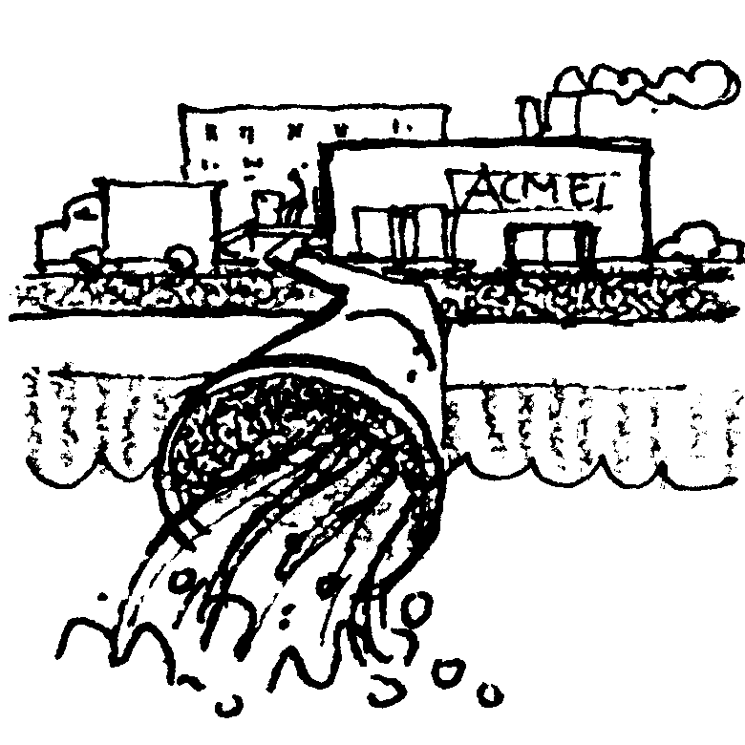
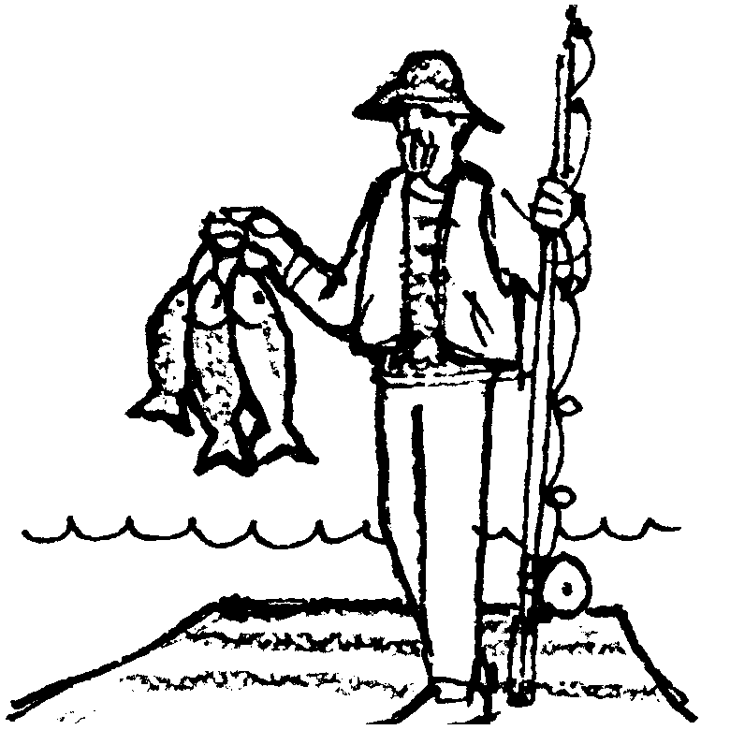
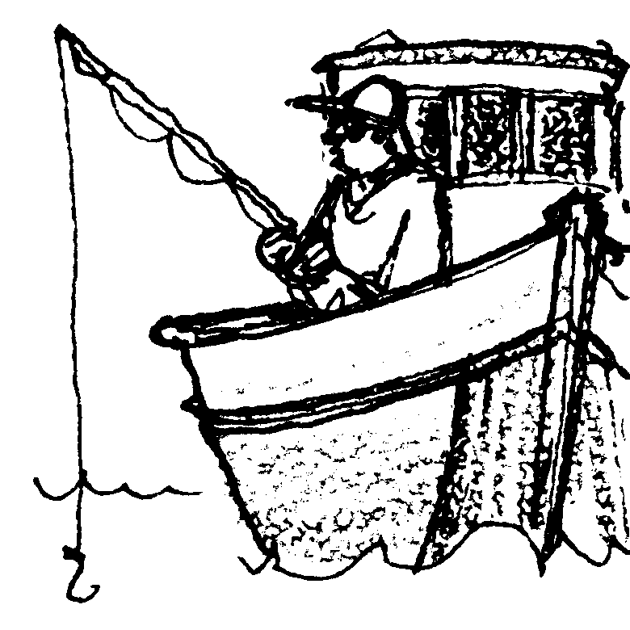
I live in Manchester. I can't afford a car, but I love to go fishing. Each weekend I ride the bus down to the waterfront to fish for flounder off the piers. I have always taken the fish I catch home to eat. Is the water so polluted that the fish I'm eating are contaminated?
(Take a water sample. Use a litmus paper strip to test the water. If the water tests less than 8 on the color scale, you are still healthy. But, if it tests 8 or higher on the color scale, you will get cancer from eating contaminated fish. Pay 10 pieces of "money" for your medical expenses, give away the rest to your friends and relations, and die!)
I have come from Boston to vacation in Boundary Bay. I have paid for a charter boat to take me out fishing. I also spend money to stay in motels and to eat in restaurants while I'm in town. If the water is too polluted and I can't catch any fish, I'll just take my money and vacation somewhere else.

(Try to catch fish. One minute will be allowed for fishing. If a fish is caught, everybody in the class receives 1 piece of "money"; because tourist dollars are flowing into the region.)

I represent a manufacturing company located on the Jango River. We use 400,000 gallons of clean water from the river every day in our manufacturing process. Then we return 200,000 gallons of polluted water to the river each day. To clean up our process so that we didn't pollute the water, it would cost $1,000,000.

If you continue to pollute the river, add 2 drops of color to the water in the river and 8 drops to Boundary Bay.) If you decide instead to "come clean," pay 5 pieces of "money".)
28.

29.

30.

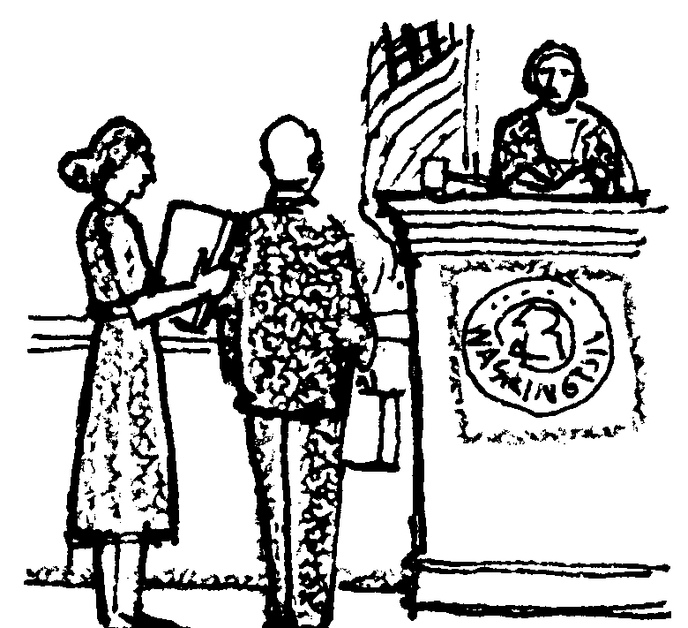
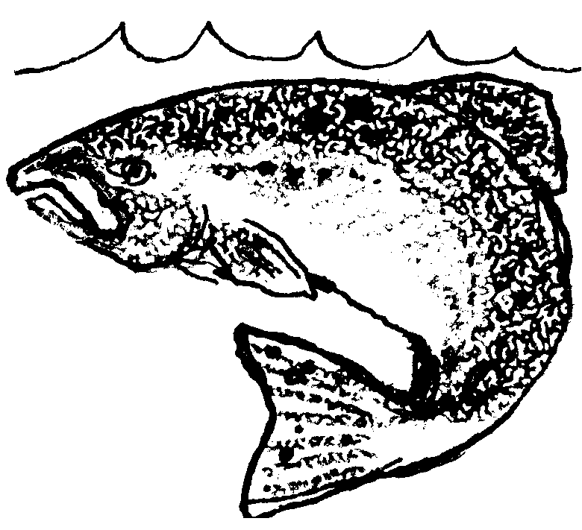
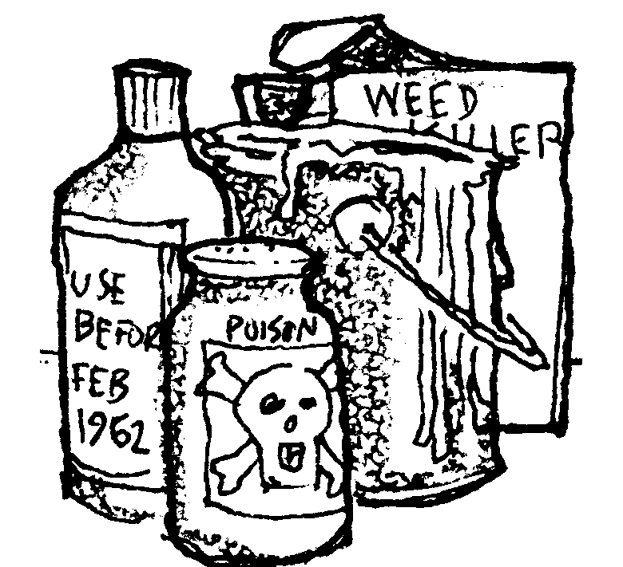
I am a pollution control agent. We do have laws to protect the environment, but sometimes they are violated. It takes people like me to enforce the law and take violators to court. And it takes tax money to pay my salary so I can do this work. But many people complain about taxes. Would you tax yourself so that there will be money to enforce clean water laws?
(Take a vote. If the class votes to tax themselves, everybody pays 1 piece of "money". If the class voted to hire you, you may then issue a fine to up to three people in the room who polluted during the game. Charge these violators 1 piece of "money" each. Naturally, you won't want to tell them this before they vote!)
I am a salmon living in Boundary Bay. I depend on Boundary Bay and its rivers to complete my life cycle. If Boundary Bay becomes polluted or its natural habitats are destroyed, I may not be able to get all the things I need from my environment. Then you may not see so many of me returning to Boundary Bay.

(Take a water sample. If it is darker than the standard, remove 2 fish from Boundary Bay. -If it is lighter, add 2 fish. There were 6 fish at the beginning of the game. How many fish are left?)
I just cleaned my basement. I discovered 10 cans of old paint and some very old pesticides and weed killers which I can't use. I know it's not legal, but it would be easy to just hide them in my garbage can with my other household waste and have them taken to the county landfill. At the landfill, these chemicals would eventually leach into the groundwater. Or I could spend a few minutes on the phone learning where I should take them, and then taking them to a place where they will be disposed of safely. I wonder whom I would call?
(If you decide to just hide them in your garbage can, add 2 tsp. of clear contaminant to Boundary Bay. If you decide instead to spend some of your valuable time disposing of these materials properly, pay one piece of "money". A call to your county health department or your county extension office would be a good place to start.)

31.

32.

33.

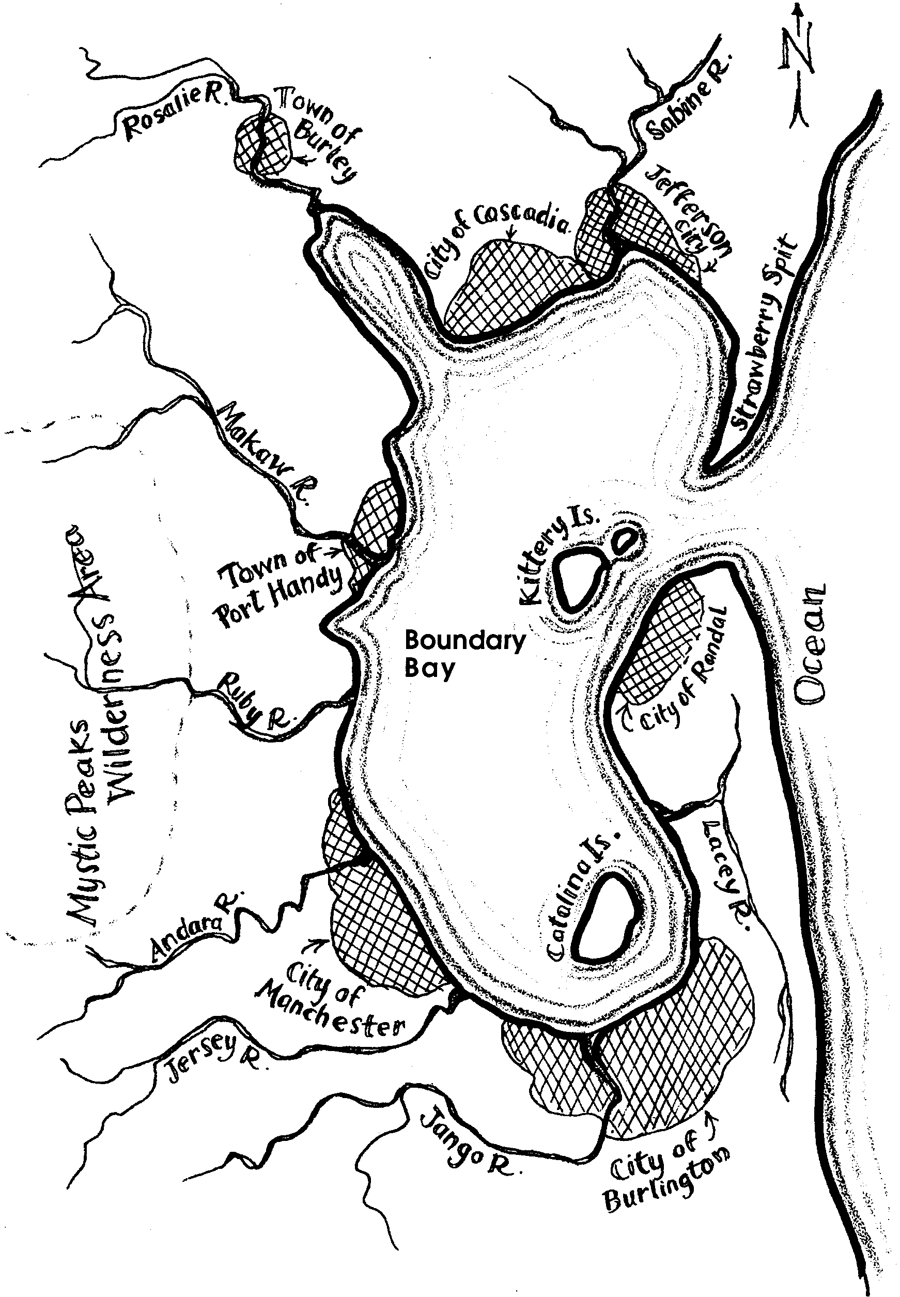

The Boundary Bay Game
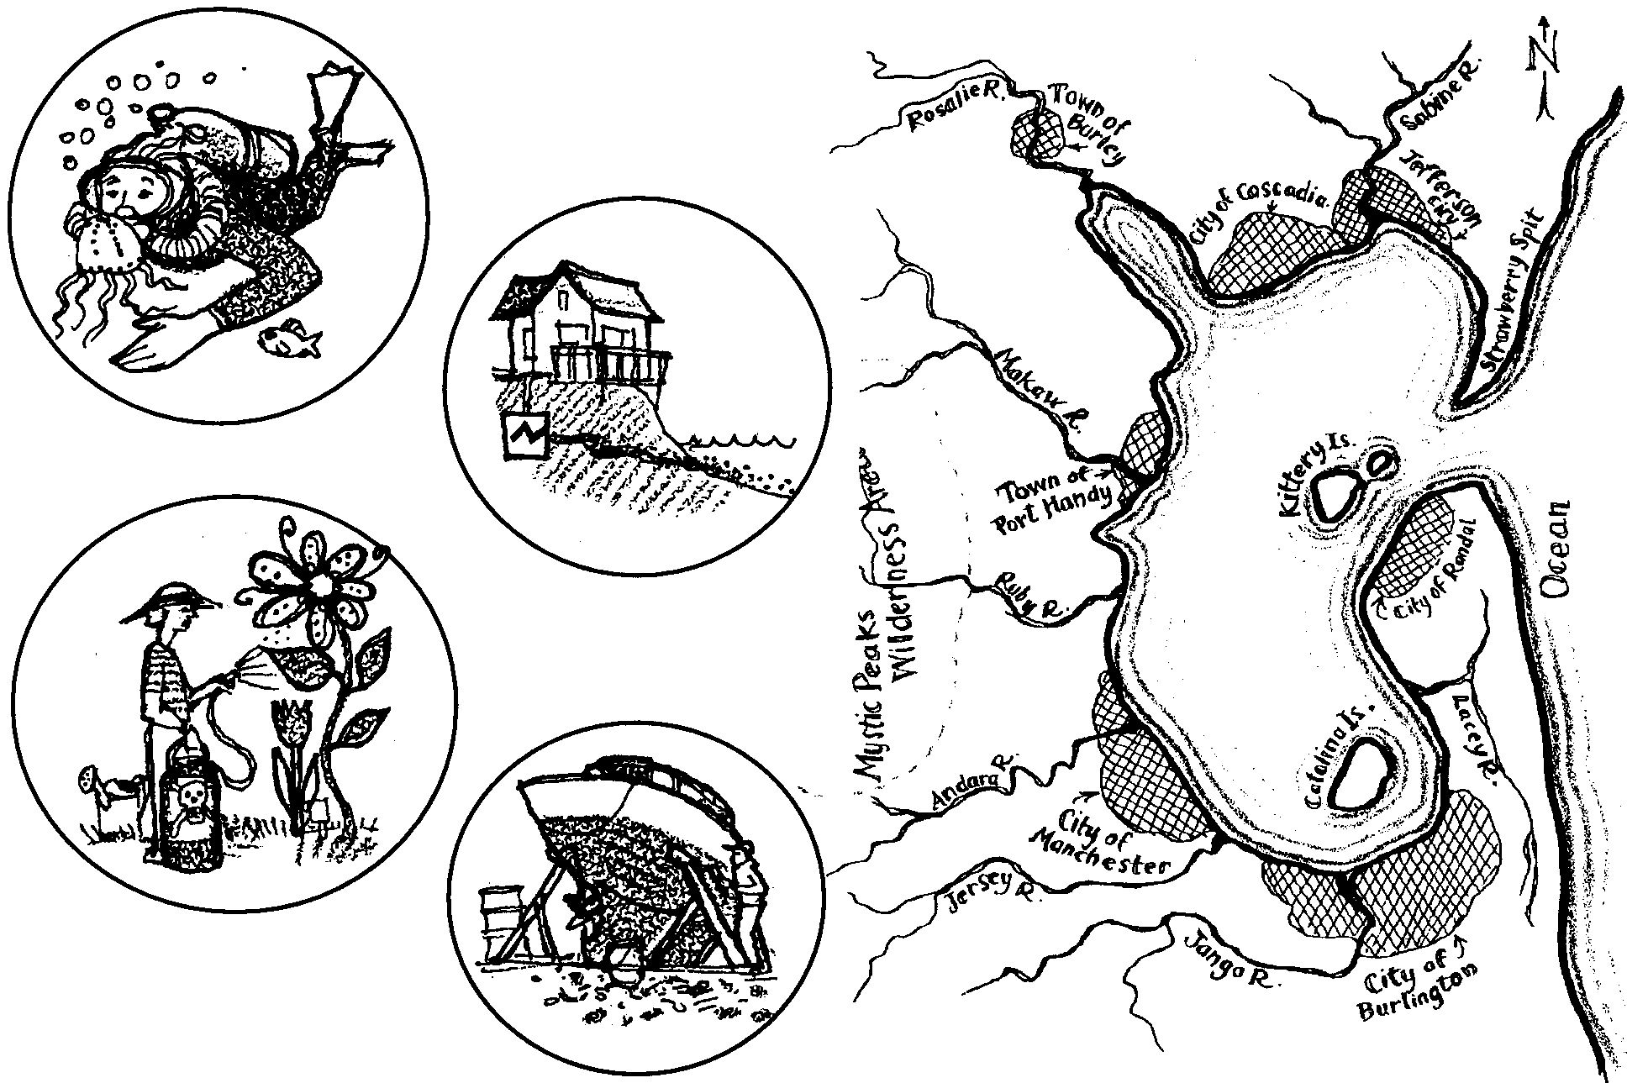
1. Why was it sometimes difficult for people to make decisions in favor of protecting the water quality in this game?

2. If players chose short term profits over protecting the environment, the water quality was likely to suffer. What were some long-term costs which individuals or society as a whole might end up paying for as a result of such decisions?
3. Pollution sources like the copper smelter in this game, which discharge large amounts of waste from a single point are called point sources of contaminants.

a. What is another example of a point source of pollution used in the Boundary Bay Game?

b. What is an example of a point source of pollution in the area in which you live?

4. Non-point source is the term for sources of contamination which are hard to locate, because they come from many places. Often, they are caused by the behaviors of individuals. The backyard gardener is an example of a non-point source in this game.

a. What is another example of a non-point source of pollution used in the Boundary Bay Game?

b. What is an example of a non-point source of pollution in the area in which you live?

5. In your opinion, what is the point, or message of the Boundary Bay Game?

6. What is something you or your family could do to improve the water quality where you live?

