Urchins
Lesson by Holly Anne Foley
Marine Science Center, Poulsbo, Washington

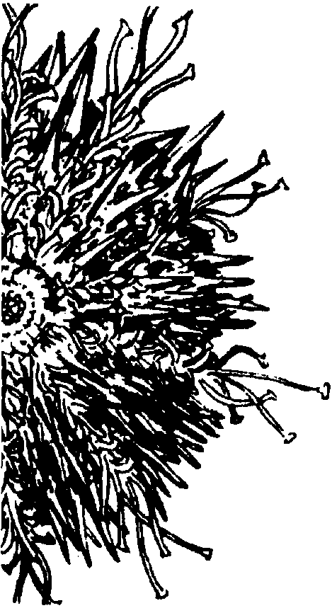
Key Concepts
1. Sea Urchins have penta-radial symmetry, tube feet for movement, protruding spines and pincher-like pedicellaria for protection, and a complex mouth used for chewing food.
2. Sea Urchins broadcast spawn, releasing eggs and sperm into the water where the sperm fertilize the eggs.
3. Sea urchin larvae are planktonic and change shape as they develop into mature sea urchins.

Background
Sea urchins are abundant in many areas off seacoasts throughout the world. While these highly armored creatures may seem to bear only slight resemblance to sea stars and sea cucumbers, the presence of tube feet, radial symmetry, and the five fold, star-like arrangement of body parts clearly show the relationship that exists between these animals.
Sea urchins are prized as edible delicacies, and, on the west coast of the United States and Canada, there is a small commercial fishery for urchins. Only the gonads of female urchins are eaten.
The sea urchin has been used extensively by biologists studying animal development because of the ease with which sea urchin eggs can be manipulated. The fertilization and early development of sea urchin eggs have been two of the most carefully studied events in the life of any animal. This activity can be used as a springboard for discussions about using larval development as an aid in classifying animals. You may want to point out the seeming paradox between cell division and cell differentiation. Cells divide to form identical daughter cells, yet organisms are not made of large masses of identical cells. When and how cells differentiate as an embryo develops is a new and growing field of biological research which may interest your students.

Materials
For each student team:
• live sea urchin
• sea water
• filtered sea water
• finger bowl
• dissecting microscope
• 250 ml. Flask
• 10 ml. Pipette
• sea urchin egg suspension
• sea urchin sperm suspension
• compound microscope

Teaching Hints
While this laboratory activity requires some special techniques, none of them is difficult. It is impossible to determine the sex of most sea urchins from their external appearance. Therefore you must obtain enough mature specimens to be reasonably sure of having at least one male and one female. The color of the gametes can be used to distinguish the sexes. The sperm are white; the eggs are red or orange.
Sea urchins are not “ripe” all year long. However, since different species are ripe at different times, there is no period during the year when mature individuals are unavailable. For example, the purple urchin (Strongylocentrotus purpuratus) is mature from December to May while Lytechinus pictus is ripe from June to September.
Sand dollars (Dendraster sps.) can be used in this lab as well and have been used successfully in a bioassay technique that is included as an extension after this lesson. Sand dollars need to be collected in the spring and can be artificially “ripened” by raising the aquarium temperature to simulate summer conditions. One can differentiate female and male sand dollars because female sand dollars have a more humped test which allows space for eggs.
If you are not able to collect your own sea urchins, sea urchin embryology kits may be obtained from the following sources:

Carolina Biological Supply Company Pacific Bio-Marine Supply Company
Powell Laboratories Division P.O. Box 285
Gladstone, Oregon 97027 Venice, CA 90293
phone (800) 334-5551 phone (213) 397-9702
Gametes may be obtained from mature adults by dissection. The obvious disadvantage to this technique is the demise of the urchin. Other techniques are available which permit the urchin to live again for another day of gamete production (they are actually ready to be reused after about three weeks). Electrical stimulation will cause gametes to be released. The procedure involves attaching wires to the electrodes of a 6-10 volt battery. The ends of the wires are touched to the shell of the urchin. Sperm or eggs will be exuded from small pores around the anal plate on the top surface of the urchin. The gametes may be collected in a finger bowl or beaker.
Perhaps the most widely used technique involves the injection of a 0.5 M solution of potassium chloride into the body cavity. The sea urchin is placed upside down in a beaker filled with sea water. 1.O milliliters of 0.5 M KCl solution (or O.5 ml of O.5 M KCl solution for sand dollars) is injected into the body cavity by inserting the full length of a syringe through the soft membrane surrounding the mouth (oral cavity of sand dollar). The needle should be of sufficient length to reach into the body cavity of the urchin. The urchin is placed, oral side down, on a clean surface. Ripe males will produce a milky white mass of sperm on the aboral side. Ripe females produce a cream to orange-red mass of eggs on the aboral side.
Stock egg suspensions may be prepared by filling a narrow 100 ml beaker or a finger bowl with filtered sea water. The female is inverted over the beaker to permit the eggs to drain into the water below.
The sperm is collected by inverting a male urchin in a sterile petri dish so that the sperm falls on the dry surface. The covered sperm may be refrigerated and will remain viable for about 24 hours. If you are not going to store the sperm, you can collect it over a 100 ml beaker of seawater. Return the sea urchins to salt water.
Duplicate the laboratory activity pages. One set is recommended per student. Caution your students beforehand to use good lab techniques. To avoid contamination, be sure to label the pipettes used for withdrawing samples from the stock egg suspension and the sperm container. If you fertilize eggs at various times in advance of the laboratory period, your students will be able to observe several different stages simultaneously. If room permits, have your students store their fertilized eggs in a refrigerator for observation of developing larvae at 24 and 48 hours. Sketches of different stages of development are shown below to aid you in identification.
Student sketches make an interesting bulletin board display which can not only teach but inspire interest from diverse segments of the school population.
Upon completion of the laboratory activities, provide time for a discussion of the procedure and to provide answers to the questions posed in the text. This is an interesting and informative experience for your students, capitalize on the discussion topics that will surface.

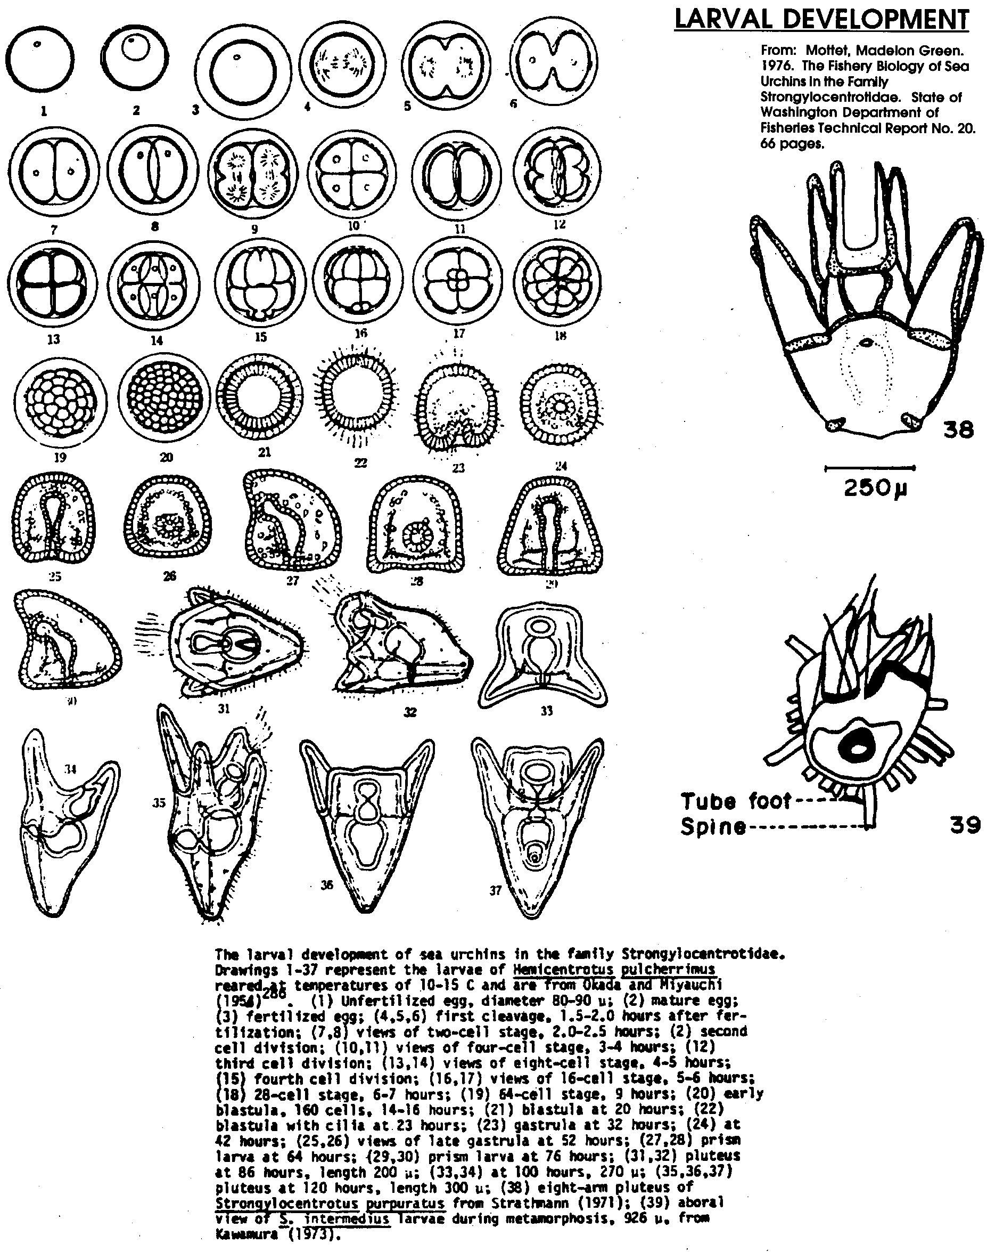

Key Words
aboral - opposite to, or away from, the mouth
blastula - early developmental stage of an animal consisting of a single, spherical layer of cells enclosing a hollow central cavity
echinoderm - a group of animals (phylum) characterized by radial symmetry and consisting of sea stars, sea urchins, sea cucumbers, and others
gastrula - developmental stage of an animal consisting of a cup-like body of two layers of cells
pedicellaria - minute jaw-like apparatus used for protection, cleaning and to capture small animals. In some sea urchins the pedicellaria contain poison glands.
podia - long, tube shaped structures with a flattened tip forming a sucker, part of the water-vascular system
pluteus - a free-swimming, bilaterally symmetrical larva of an echinoderm
radial symmetry - basic body plan in which the organism can be divided into similar halves by passing a plane at any angle along a central axis
range - in this case, the geographic area in which the urchin species is found
substrate - the base on which a nonmotile organism lives or grows
water vascular system - system of water-filled canals connecting the tube feet of echinoderms

Answer Key
Part I
1, 2, 3, 4 a. Answer depends upon the experimental observations.

4b. The teeth are used to scrape off and crunch encrusting growths like barnacles, hydroids, tube worms, sponges, and algae.

5a. Answer depends upon the experimental observations. Generally the spines will turn toward the intruding object to defend the urchin.

b. Possible benefits from sea urchin burrowing behavior include: protection from predators, protection from wave action, and protection from drying during the low tide since the cavity holds water. Your students will probably devise other possible benefits.

6. Podia may help sea urchins survive by attaching the urchins firmly to the bottom so that they are not washed away by waves and currents and so they are difficult for predators to pry loose. The urchins use the podia to crawl and to pick up food and move it to the mouth. Your students will have other suggestions.
7a. Three opposing “teeth” form the jaws on the pedicellariae.

b. The food captured by the pedicellariae may be transported from one pincher to the next, down to the mouth where it can be eaten. The pedicellariae are also used to keep the surface of the shell clean or, conversely, they may hold objects onto the surface of the test for either camouflage or shade.

8. Answer depends upon the experimental observations. The tube feet are both flexible and strong. The urchin often probes for a hard surface to which to attach, anchors its tube feet, and then pulls itself over.

Part II
1. To maintain a constant population size only two of the sea urchin eggs released and fertilized during the life of the sea urchin must reach maturity.

2. The answer to #1 above coupled with the number of eggs released would seem to indicate that the odds of any given fertilized egg reaching maturity must be very small.

Analysis and Interpretation
1. Since external fertilization is used by successful groups of animals it must be a successful adaptation. Similarly the case can be made that internal fertilization is successful. In addition, one must look at the difference between internal development and external development after internal fertilization. The disadvantages to external fertilization seem most obvious: large numbers of eggs and sperm must be produced to ensure fertilization; sperm and egg cells may be prevented from meeting by sudden currents or similar environmental changes, etc.; the gametes are subjected to the uncontrollable environmental effects of water temperature, salinity etc. The advantages seem to fall to the individual; once the gametes are released, their obligation is over. This question can provide for discussion of the idea that there are many ways an organism can successfully accomplish life.

2. The primary advantage to the drifting phase of development is that the drifting larvae are carried into new areas thereby extending the range of the sea urchin.

3. The answers will vary. Since the question asks for an opinion there is no “right” answer. The question is designed to provide an opportunity to discuss the danger of labeling one species as “good” and another as “bad”. It is important to remember that these organisms have coexisted for millions of years and that each, in some way, benefits from the actions of the other. With our present state of knowledge, we are in no position to make arbitrary decisions about the worth of other species.

4. There are several reasons sea urchin eggs are used in embryological studies. The principal reason relates to the ease with which they may be obtained and fertilized. Sea urchins are also intertidal residents, an area that often suffers more severely from human actions. You may wish to discuss the merits of studying possible deleterious effects only on “convenient” or “easy” animals like the sea urchin. The potential exists for selective effects from pollutants; the sea urchin may not be affected while other organisms around it suffer.
Urchins

No animal fills the bill of “spiny-skinned” better than the sea urchin. Sea urchins have been used for food since at least the days of ancient Greece. Sea urchin eggs are considered a delicacy in many parts of the world. Ancient Romans used sea urchins as medicine. The urchin, spines and all, was ground, mixed with a cup of wine or vinegar, and swallowed. In some cases, urchins were burned with snake skins and frogs and the ashes mixed with vinegar. Drinking one cup a day was said to improve eyesight.

In the following exercise, you will examine the external anatomy of the sea urchin and observe the fertilization and development of the sea urchin egg.

Materials
• live sea urchin
• sea water
• filtered sea water
• finger bowl
• dissecting microscope
• 250 ml. Flask
• 10 ml. Pipette
• sea urchin egg suspension
• sea urchin sperm suspension
• compound microscope
Part I - External Anatomy of a Living Sea Urchin

1. Obtain a living sea urchin and place it in a finger bowl of sea water. What color is your sea urchin?

2. Measure the diameter of your sea urchin and RECORD the diameter in centimeters.

cm.

3. The sea urchin body can be divided into oral (mouth) and aboral (away from the mouth) hemispheres which display the radial symmetry typical of echinoderms. Observe the aboral surface of the live specimen.

a. Are the spines of equal length?

b. If the spines are not of equal lengths, are the spines in one region longer than the spines of another region?

If so, where are they the longest?

4. Observe the oral surface of the live sea urchin. The mouth of the sea urchin contains a toothed structure called Aristotle’s Lantern. The tips of the teeth are just visible through the open mouth. The sea urchin uses these teeth to scrape off and crunch encrusting growths like barnacles, hydroids, tube worms, sponges and algae. These teeth wear away with constant use. The worn area is replaced from above by the downward shifting of the entire tooth as the tooth grows at the upper end.

a. How many teeth (points) make up Aristotle’s Lantern?

b. How do these teeth aid the sea urchin in feeding?

5. Gently touch the spines of the urchin with your finger or eraser. Describe their movement.

The purple urchin, Strongylocentrotus purpuratus, of the Pacific coast burrows into rocks. These urchins use a combination of spine rotation and chewing to wear away the rocks on which they live. Eventually, they excavate a cup shaped depression into the rock.

b. What is one possible benefit of this burrowing behavior?

6. Observe the tube feet or podia. The podia are long, tube shaped structures with a flattened tip forming a sucker. Podia are part of the water-vascular system. When the podia come into contact with a hard surface, the center of the sucker is withdrawn producing a vacuum and adhesion.

What are two ways in which the podia might help the sea urchin survive?

1.

2.

7. Observe your specimen with the aid of a dissecting microscope. Structures know as pedicellariae are found between the spines. Each pedicellaria bears a jaw-like apparatus used for protection and to capture small animals. In some sea urchins the pedicellariae contain poison glands.

a. How many opposing “teeth” form the jaws?

b. How might the food captured by the pedicellariae be transported to the mouth?

8. Gently turn over your sea urchin. (If possible, place the sea urchin on a sandy substrate.) Describe the action of the spines and tube feet as the animal rights itself.

Return your sea urchin.

Part II - Reproduction and Development

Sea urchins normally discharge gametes (eggs and sperm) into the sea and there fertilization occurs. This process called external fertilization, is very common among aquatic organisms. With luck, the fertilized eggs develop into free floating, pelagic (open sea) larvae. These larvae drift with currents and thus distribute the sea urchins population and extend the range (area in which the urchin species is found) of the species.

There are great risks inherent in this free-floating lifestyle. Many larvae may be carried to locations where the substrate is unsuitable for sea urchin growth. Many more larvae are eaten by larger animals. To compensate for these high mortality rates, millions of eggs are shed by each female and even more sperm is shed by each male.

1. How many sea urchin eggs must reach maturity to replace each pair of sea urchins and maintain a constant population size?

2. Are the odds very good that any given fertilized egg will reach maturity? What makes you think so?

Procedure:

1. Obtain a drop of unfertilized sea urchin egg suspension. (Your teacher will provide the suspensions or instructions regarding how to obtain them). Place the drop on a depression slide, cover and observe using a compound microscope. The eggs are spherical and surrounded by a jelly coat. Mature eggs will show a small clear nucleus and uniformly distributed pale yolk granules.

a. In the space to the right, sketch an unfertilized egg. Label the nucleus and jelly coat, if visible.

2. Obtain a drop of sperm suspension and place it on a depression slide. Cover with a coverslip and observe using a compound microscope. The sperm swims by agitating its whip-like flagellum. You may be able to see the flagellum if you decrease the amount of light transmitted through your microscope.

a. In the space below sketch a sperm cell. Label the nucleus and flagellum, if visible.

b. How does the size of the sperm cell compare with that of the egg cell?

3. Using separate pipettes (Caution: do not mix the pipettes) add one drop of the sperm suspension to one ml. of the egg suspension in a 250 ml. flask filled with filtered sea water. Mix well by swirling.

RECORD the time: Time ___________________

4. Pipette a drop of the egg-sperm mixture onto a depression slide. Seal a coverslip over the mixture using petroleum jelly (Vaseline) around the edges of the coverslip. Immediately examine the eggs under a microscope using low power (lOx). After locating eggs, switch to high power. Under the high power, sperm will be seen clustering around the egg. Sperm penetration can be seen very soon after the eggs and sperm are mixed. Normally, only one sperm cell will penetrate the egg. A fertilization membrane will form over the egg.

a. RECORD the time at which the membrane first appears.

b. How long a time elapsed between the mixing of the gametes and the formation of the fertilization membrane?

c. In the space below, sketch the fertilized egg. Label the fertilization membrane.

5. By placing the suspension in a refrigerator, you may save your fertilized egg-sperm suspension for observation of more advanced stages of development tomorrow and the following day.

6. Observe and sketch eggs fertilized earlier in the day by other classes or by your teacher. Label each sketch to show the number of cells present.

7. The next day and the day following that observe and sketch your fertilized egg. By about 10 hours following fertilization, the fertilized egg has become a hollow ball of cells called the blastula. The blastula becomes flagellated and free-swimming within twelve hours.

At about 32 hours the blastula becomes folded in upon itself to become the gastrula.
The gastrula undergoes continued cell division to become the planktonic-feeding pluteus larvae at about two days.
Development from the pluteus stage to the adult may take several months. The young urchin, now about 1 mm in diameter, sinks to the bottom as the skeleton forms and assumes the lifestyle of the adult.

SKETCHES
24 hours
48 hours

8. Place the sea urchin larvae in the container provided by your teacher.

9. Clean the glassware and equipment you have used.

Analysis and Interpretation

1. What is one advantage of external fertilization? What is one disadvantage of external fertilization.

2. Developing sea urchin larvae are highly susceptible to predation. Lots of animals would like to eat them. It would seem advantageous for them to hide, rather than to drift in open water. What is a primary advantage to the drifting phase of development?

3. Kelp harvesters view sea urchins as a threat to the kelp beds. Some harvesters would like to eliminate the sea urchin. In view of the fact that the kelp beds and the sea urchin have coexisted for thousands of years, how would you reply to these harvesters?

4. What is one possible reason scientists have used sea urchin eggs to study the effects of pollutants on embryological development?

