The Effect of Salinity on Living Tissue

- The Potato Lab
Lesson by: Jerry Mohar, Lyle High School, Lyle Washington

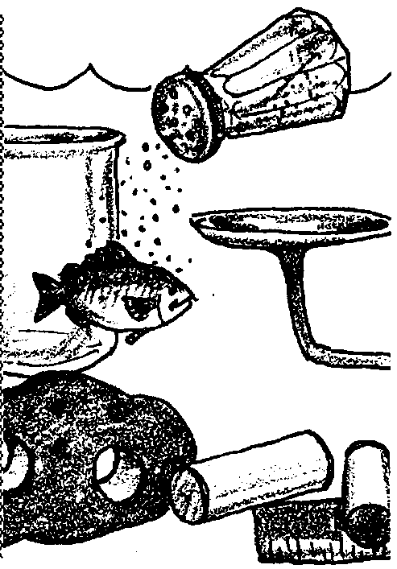
Key Concepts

- Water tends to flow into or out of living tissue to maintain an organism's osmotic balance.
- Living tissue in fresh water will tend to swell. Living tissue in salty water will tend to shrink.

Background
Living cells contain various salts suspended in a water solution. Called the cytoplasm or protoplasm, the chemically active mixture of salts and other complex substances dissolved or suspended in water is a minute aquatic environment. In a very real sense, we all carry our personal oceans with us wherever we go.
Organisms that live in a water environment face special challenges in regulating the movement of fresh water into or out of their tissues. Where molecules or particles are free to move in a liquid, diffusion, a migration of molecules, occurs from regions of higher concentration to regions of lower concentration. As a result there is a tendency for materials to move into and out of cells. However, the cell membrane which defines a cell's boundary is selective in what may pass through. Water tends to be the substance which most readily passes through the semipermeable cell membrane. The water tends to move into a solution where the solvent concentration is higher, thus equalizing the concentration of materials on either side of the membrane. This tendency of water to move through a semipermeable membrane is a special kind of diffusion called osmosis.
Osmosis and diffusion are generally regarded as "passive" processes. They occur because of the random motion of molecules which tend to move the molecules from areas of higher concentration to areas of lower concentration. Cells, however, are not noted for their passivity and engage in "active diffusion" which is the selective entry and excretion of salts and/or water from the cell through the cell membrane. Active diffusion requires energy. In other words, cell membranes are not sieves but are very selective as to what is permitted into or out of a cell. The concentrations of materials in a cell and the concentrations of the same materials in the cell's environment may be very different.
For aquatic organisms, the concentration of dissolved materials in their cells is often different from the concentration in their environment. Organisms cope with these differences in two principal ways. Some aquatic animals, called osmoregulators, maintain a constant internal salt concentration. These organisms have developed many ways (including active diffusion) to maintain a relatively constant salt concentration in their bodies regardless of changes in their environment. Other aquatic animals, called osmoconformers, do not maintain a relatively constant internal concentration; as conditions change these animals "go with the flow". Fish and marine mammals are examples of osmoregulators, maintaining their internal concentration of dissolved salts within a narrow range. Many invertebrates are osmoregulators whose internal salt concentrations vary as salt concentrations in their environment change.
Each aquatic organism has its own range of tolerance to salinity. Fresh water organisms live in a "hypotonic" solution, a solution which has a lower concentration of dissolved particles than the cytoplasm of their cells. In such a fresh water environment, water tends to flow into the living cells. As a result, many fresh water organisms have mechanisms that allow them to retain salts while excreting water. Salt water organisms face the opposite problem: they live in a "hypertonic" solution, a solution which has a higher concentration of dissolved particles than the cytoplasm of their cells. This salt gradient tends to cause water to move out of living cells. As a result, many salt water organisms have mechanisms which allow them to retain water and excrete salts.
Osmosis and diffusion are critical concepts in our understanding of cell and organismal biology. "The Effects of Salinity on Living Tissue"' and the following activity "Dealing with Salt" provide a simple introduction to these complex topics.
Additional background information is found in the activity "Dealing with Salt".

Materials

For each pair of students:
- 2 test tubes
- 1 test tube rack
- 2 potato cores
- salt water
- fresh water
- centimeter ruler
- balance
- optional- graduated cylinder
- labels

Teaching Hints
"The Effect of Salinity on Living Tissue" looks at the movement of water into and out of the living cells of a potato. Students use potato cores as a model to explore how living tissue is affected by changes in the salinity of the environment. Osmosis also may be demonstrated using live sea urchin eggs, hens' eggs with the shells dissolved away in dilute hydrochloric acid or red blood cells.
The student pages guide the students through the process of setting up the experiment and making preliminary and final measurements. It also is possible to omit the student pages and ask students to design their own experiment. Explain that, though students could measure changes in barnacle activity as the barnacles were exposed to waters of differing salinity, they could not look inside the barnacle shell and find out what exactly these types of water were doing to the barnacle. Why did the barnacles need to close at very low or very high salinities? Explain that we might gain some insight into what salinity changes do to living tissue by using plant tissue.
Show the students some sample potato cores and ask them how they think the cores will change in fresh water and in salt water. Ask them what specific things they could measure. Provide the students access to the lab materials and have them choose what to measure and how to set up the lab.
Whether you use the student pages or ask the students to create their own experimental design, you will need to provide potato cores. These can be made by inserting a cork borer or other cylinder with a diameter of about 1/4 of an inch into a potato to a depth of about one inch. With a little practice, uniform cores can be made.
The students can measure the change in mass of the potato cores using a balance. They get a sense of the size of the cores by measuring the length and diameter of the cores as well. They also may choose to measure volume in a graduated cylinder. Be aware that water will diffuse into and out of the potato core while in the water in the cylinder. This can be minimized if the measurements are done quickly. Demonstrate for your students how to read the water level in the cylinder with and without a potato core added.
Students may notice some small changes in their potato cores in a class period, but the changes will be much more dramatic if the cores soak for two or three days.

Key Words
adapt - in this case, the ability of an organism to change in response to its environment
anadromous - fish which live part of their lives in fresh water and part in salt water
concentration - given number of particles in a given volume
osmosis - the diffusion of water molecules through a membrane; in this case, the movement of water into and out of a cell
salinity - a measure of the salt concentration in a solution

Answer Key

Results and Interpretation
1. Answers depend on the experimental results. In this question, and those that follow changes in the weight or volume of the potato core are normally due to the differences between the concentration of salts and other dissolved substances in the cytoplasm of the potato cells and their concentration in freshwater (a hypotonic solution) or salt water (a hypertonic solution).
2. Answers depend on the experimental results.
3. The change in weight or volume most likely occurred because of the movement of water into or out of the potato core. You may wish to accept a wide variety of student responses since the question asked for their ideas.
4 a. Freshwater from the tank will move into the sea cucumberÕs cells in an effort to dilute the salt concentration of the cells. As a result of this movement the cells will swell and the sea cucumber will gain weight.
b. In a salt solution twice as concentrated as that of sea water, the water molecules within the cells of the sea cucumber will move out of the cells in an attempt to dilute the concentration of the salt solution in the tank. The sea cucumber will lose weight as the tissues decrease in size due to the water loss. The movement of water in osmosis tends to make the concentrations equal on both sides of the cell membrane to what ever degree possible.
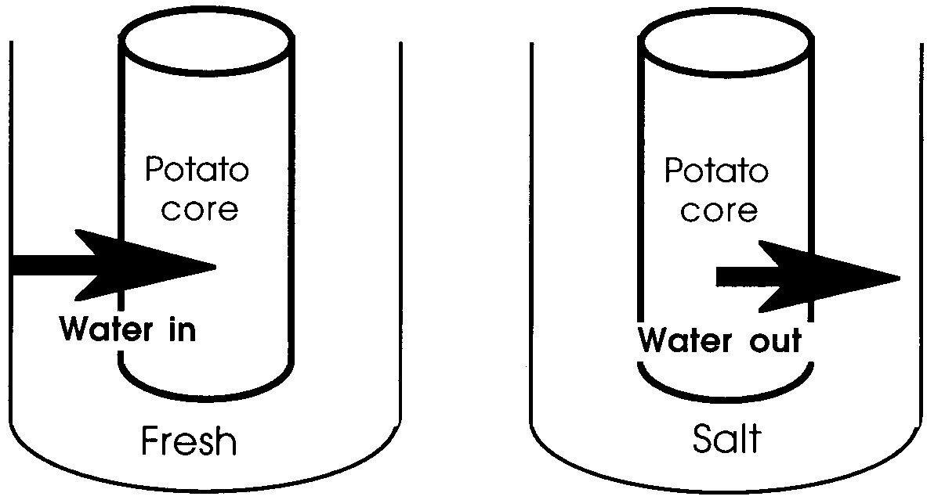
5 a.

5 b. In water saltier than their tissue fluids, organisms have to deal with dehydration. There is a tendency for water to move out of the cells and into the surrounding solution. The organism shrinks and loses weight. Fish have evolved many ways to deal with the problem of water loss. Some fish, for instance sharks, drink salt water. They are able to "distill" the water and excrete the salt through special structures. Regulation of the salt content of their tissues is a constant process for aquatic creatures.

c. In water less salty than their tissue fluids, fish have to deal with hydration. There is a tendency for water to move into the cells from the surrounding solution. The cells swell and the fish gains weight. Fish in fresh water face this problem constantly. Most of them deal with the problem by excreting the excess water through their well developed kidneys.

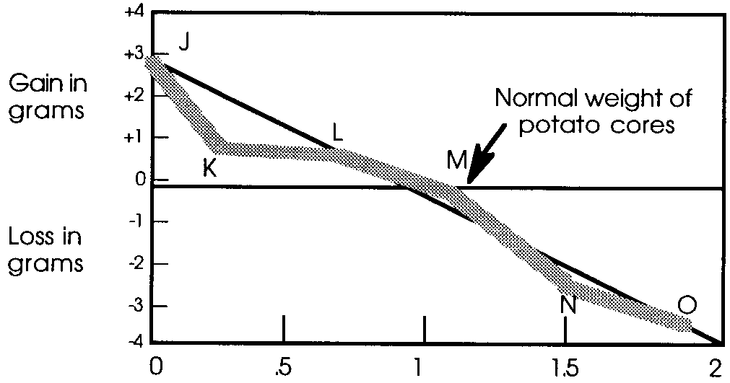
One Step Further......
The correct answers are those underlined below.

1. Cores J, K, and L are above the normal weight here because
A. there was a flow of water out of each core.
B. salt entered the cores and made them heavier.
C. water entered the cores and increased their weights.
D. all of these cores weighed more than three grams.

2. The best explanation for the dots not appearing on the normal weight line is that
A. there has been a movement of water.
B. there has been a change in the core's volume.
C. there has been a movement of salt.
D. a normal variation in experimental measurement occurred.

3. If there were no change in the weight of a potato core after immersion in salt solution it most likely means
A. water could not enter the core.
B. water could not leave the core.
C. salt concentration inside the core was equal to the concentration outside.
D. the membrane was not permeable to salt.

4. A potato core placed in a 5% salt solution would most likely
A. gain more weight than core J.
B. lose more weight than core 0.
C. behave like core M.
D. behave in a manner we cannot predict with the information we now have.

5. Potato core M had a salt concentration of:
A. O
B. 1.1
C. 1.8
D. the same as core N.

6. The dots J, K, L, M, N, and O represent
A. variables.
B. assumptions.
C. hypotheses.
D. data.

7. The best reason for drawing a straight line between but not connecting each dot is that
A. it assumes experimental error.
B. averaging results makes generalizations more meaningful.
C. the individual results are often wrong.
D. the dotted line is a fact, while each dot is an assumption.
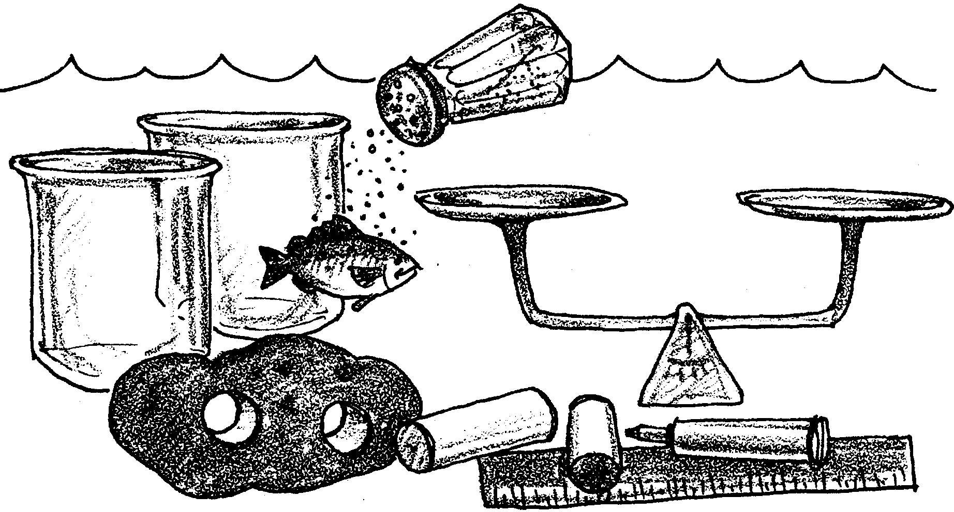
The Effect of Salinity on Living Tissue
–Potato Lab

Most marine plants and animals have to deal with small changes in the salinity of the waters in which they live. Organisms in estuaries, however, face great variations in salinity as the tides bring in salt water and rivers add fresh water. Barnacles are an example of a marine organism affected by changes in salinity, but also able to deal with those changes. As the salinity of the water changes, the barnacle changes the salinity inside its cells. But if the salinity becomes too low or too high, the barnacle can cease activity and seal itself within its shell.

Anadromous fish are an even more extreme example of organisms that must cope with salinity changes. Anadromous fish are fish that spend part of their lives in fresh water and part in salt water. Salmon, for instance, are born in fresh water streams, migrate to the sea where they mature, and return to the fresh water stream where they hatched to reproduce and die. How do these drastic salinity differences affect the salmon? How do they affect other estuarine plants and animals? Perhaps we can learn something about the process by observing the effect of different salinities on plant tissue.
These are the materials you will need for this activity:
• 2 test tubes or beakers
• test tube rack, if using test tubes
• 2 potato cores
• salt water
• fresh water
• centimeter ruler
• permanent marker
• balance or graduated cylinder
• labels

Procedure:
1. Obtain two empty test tubes or beakers. Label one “salt water” and the other “fresh water”.

2. Fill one container about 3/4 full with salt water and the other 3/4 full with fresh water.

3. Obtain two potato cores. Place a permanent marker dot on the skin end of one core; this will be core #1. Make preliminary measurements and record them on the data sheet.

4. Place potato core #1 in the tube or beaker of salt water. Place the other potato core in the tube or beaker of fresh water.

5. Place the two containers aside and let them stand for at least 1/2 hour. If possible, let them sit for two or three days and measure them again during another class session.

6. When the time has elapsed, remove the potato cores, take a second set of measurements on each core and record them on the data sheet.

7. Calculate how much each potato core changed. Be sure to note with a + or - whether each change was an increase or a decrease. Record your calculations on the data sheet and on the blackboard.

Analysis and Interpretation
1. Here’s how to calculate the percentage change in your potato core’s mass and size.
change in measurement x 100 = % change
starting measurement

or
(ending measurement - starting measurement) x 100 = % change
starting measurement

a. Did your potato core in salt water grow, shrink or stay the same?

b. Did your potato core in fresh water grow, shrink or stay the same?

2 a. Look at the data on the blackboard. Did your classmates’ potato cores follow the same trend as yours?

b. What did most cores in fresh water do?

c. What did most cores in salt water do?

3. What do you think happened to cause changes in the size of the potato cores?

4 a. Some well-meaning beachcombers collect a sea cucumber at a salt water beach and bring it home to their fresh water aquarium. What is going to happen to the tissue of the sea cucumber?
b. The beachcombers notice that their sea cucumber isn’t looking well. It occurs to them that it probably needs salt. Quickly, they add a pound of table salt. The resulting salt solution is about twice the concentration of sea water.

Assume that the sea cucumber is still living, what is going to happen now to the tissue of the sea cucumber?

5. In general, when the salt concentration in cells is higher than that in an organism’s environment, water flows into the cells to lower the salt concentration. Water flows out of cells when the cells have a lower salt concentration than that of the surrounding environment.

The movement of water into and out of living cells is called osmosis. Plants and animals living in aquatic environments have developed many specialized structures and behaviors to help them deal with the inflow and outflow of water.

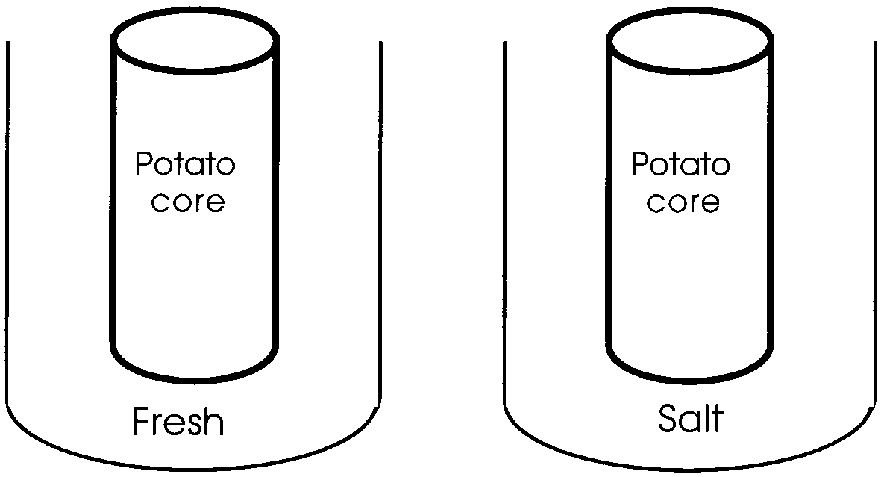
a. Use the diagram to show whether the water moved into or out of the potato.

b. In general, what is the problem marine life has to deal with in water saltier than its tissue fluids?

c. In general, what is the problem marine life has to deal with in water less salty than its tissue fluids?
Potato Lab Data Sheet

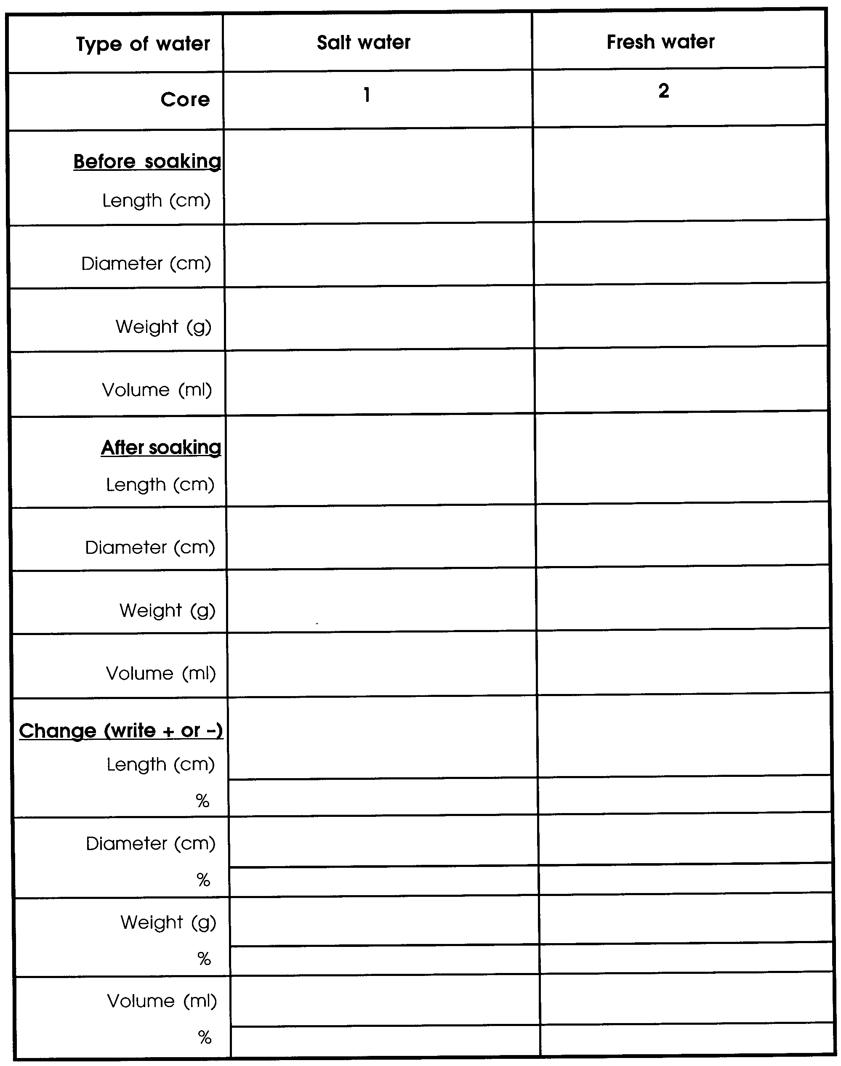
One Step Further..........
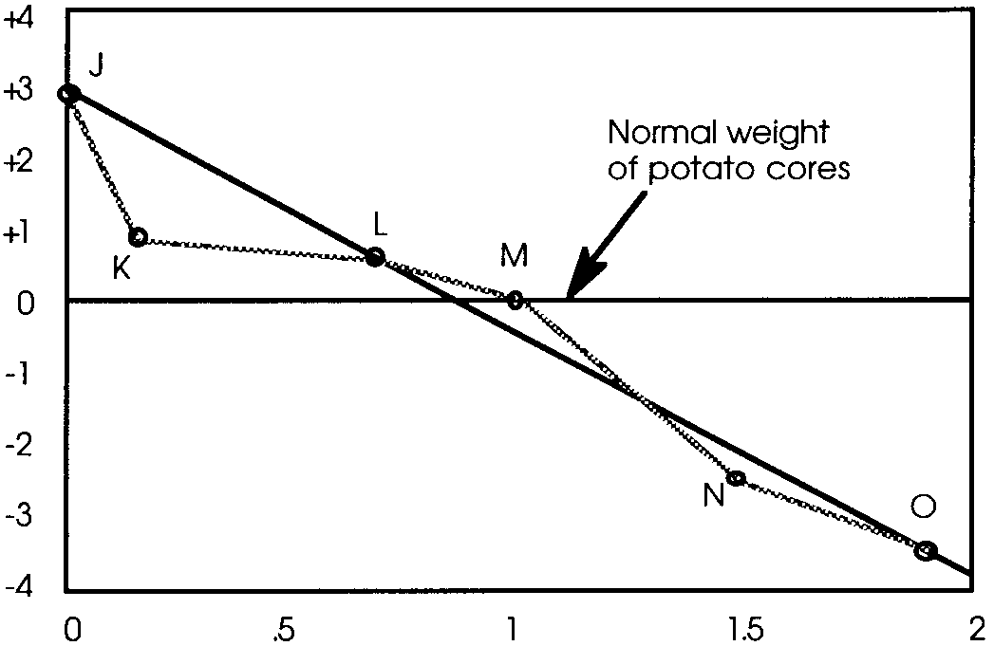
In order to further study the effect of salt on living tissue, a group of students performed the following experiment. They placed potato cores of uniform size in a series of different salt solutions from 0% to 2%. After waiting a half hour, the loss or gain of weight in grams was measured. Their results are shown graphically to the right. Use this information to answer the following questions.

1. Cores J, K, and L are above the normal weight here because
A. there was a flow of water out of each core.
B. salt entered the cores and made them heavier.
C. water entered the cores and increased their weights.
D. all of these cores weighed more than three grams.

2. The best explanation for the dots not appearing on the normal weight line is that
A. there has been a movement of water.
B. there has been a change in the core’s volume.
C. there has been a movement of salt.
D. a normal variation in experimental measurement occurred.

3. If there were no change in the weight of a potato core after immersion in
salt solution it most likely means
A. water could not enter the core.
B. water could not leave the core.
C. salt concentration inside the core was equal to the concentration outside.
D. the membrane was not permeable to salt.

4. A potato core placed in a 5% salt solution would most likely
A. gain more weight than core J.
B. lose more weight than core 0.
C. behave like core M.
D. behave in a manner we cannot predict with the information we now have.
5. Potato core M had a salt concentration of:
A. O
B. 1.1
C. 1.8
D. the same as core N.

6. The dots J, K, L, M, N, and O represent
A. variables.
B. assumptions
C. hypotheses.
D. data.

7. The best reason for drawing a straight line between but not connecting
each dot is that
A. it assumes experimental error.
B. averaging results makes generalizations more meaningful.
C. the individual results are often wrong.
D. the dotted line is a fact, while each dot is an assumption.

