Salinity
Lesson by: Holly Shewbridge
Monterey Peninsula School District, Monterey, California

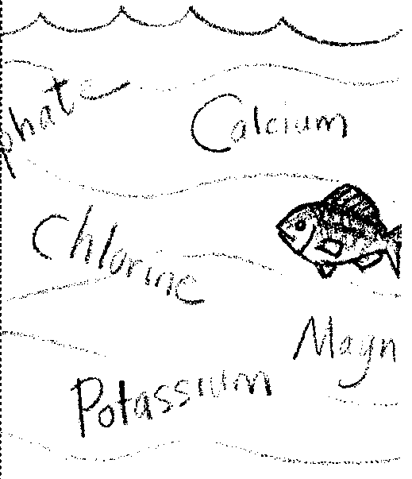
Key Concepts

- There are measurable differences between fresh water and salt water.
- Salts and dissolved minerals are constantly being added and removed from sea water through various biological, chemical, and physical processes.

Background
For billions of years, rains have washed into streams and rivers emptying into the sea. This moving water erodes salts and minerals from rocks and soils. These salts and minerals find their way into the seas. Over time, the concentration of these salts and minerals has increased, creating the salty ocean waters we know today.
Oceanographers measure the water's salt content, or salinity, in grams of salt per kilogram of sea water (g/kg) which is usually expressed as parts per thousand (ä). Average seawater salinity is approximately 35 grams of salt per thousand grams of water. Salinity values range from nearly zero at river mouths to over 40 parts per thousand in some areas of the Red Sea. Notice the variation of salinity in these bodies of salt water:
Red Sea = 40 ‰
Mediterranean Sea = 38 ‰
"Average" sea water = 35 ‰
Black Sea = 18 ‰
Baltic Sea = 8 ‰

Salinity is altered by biological, chemical and physical processes that add or remove salts or water from the sea. Salinities near shore vary due to the addition of fresh water by rivers and rainfall. Local conditions of temperature and water circulation may also increase or decrease salinity.
The primary mechanisms of salt and water addition or removal are evaporation, precipitation, river runoff, and the freezing and thawing of sea ice. In spite of the great volumes of water that are moved in these processes, the salinity of sea water in the open oceans is amazingly constant. On the other hand, salinity changes in local environments, such as bays and estuaries, can be dramatic.
Salinity is one of the factors which determines where animals and plants live in an aquatic habitat. Each organism has its own range of tolerance. Like land animals, aquatic animals must maintain a relatively constant salt concentration in their bodies. For example, fresh water fish have special adaptations allowing them to retain salts and excrete water so that the fresh water does not dilute their body fluids. Marine fish, on the other hand, excrete salts while retaining water so that they do not lose fluids to the salt water around them. Most marine fish cannot tolerate sudden changes in salinity.

Materials

For each student:
- a copy of the reading "Salinity"

Teaching Hints
The "Salinity" reading provides information about the ions that constitute sea salt and discusses sources of salts. Use the reading to supplement the lab activities in this section and to provide answers to questions students may have about what is in sea salt and what causes bays and oceans to be salty.
If students have additional questions, you or they may wish to consult more detailed references.
Students may need access to calculators for calculating salinity values.
You may wish to accompany the reading by having students use all of their senses to test the difference between unmarked samples of distilled, tap, and salty water.

Key Words
dehydration - in this case, the diffusion of water from cells and tissues
density - the amount of matter (mass) per unit volume
dissolve - to cause to go into solution
element - a substance made up of just one kind of atom
estuary - a partially enclosed coastal area where freshwater and saltwater mix
halocline - a zone in the water column where salinity changes rapidly with depth. In the ocean this zone is about 50m to 100m in depth
hydrometer - instrument for measuring specific gravity (density) of a liquid, commonly consisting of a graduated tube weighted to float upright in the liquid whose specific gravity is being measured
hydrothermal vents - deep-sea hot springs situated at seafloor spreading centers
ion - an electrically charged atom or group of atoms
leaching - the removal of materials by the action of a percolating fluid (e.g. water)
mineral - in this case, any naturally occurring solid substance in the earth's crust
osmosis - the diffusion of water molecules through a membrane
parts per thousand (‰) - in this case, the units used to express salinity
percolate - to filter through a porous substance or small holes
salinity - a measure of the salt concentration in a solution
seawater - water from the ocean that has relatively constant proportions of dissolved salts and minerals

Answer Key
1. Chlorine is the element found in greatest abundance (55.0%). The first two questions are to encourage use of the graphics in the text.
2. One would find 35 parts of salt per 1000 parts of water (35 ‰) in the sea water shown in the figure.
3. Over time, the salinity of the ocean remains constant due to the balance in the addition and removal of salts and dissolved minerals. Many students will answer that they would expect the salinity to increase because of the continual leaching of materials. Use this question to discuss the dynamic equilibrium that exists in the world ocean.
4 a. The salinity is the greatest at seven to eight meters in depth.
b. The salinity was the least at one to two meters in depth.
5. The salinity calculation is set up in the same manner as that shown in the text:
20 ‰ chlorides = 55.0% of the total salinity;
20 ‰ chlorides = .550 x (total salinity)
20 ‰ chlorides = (total salinity)
.550
36.3 ‰ = total salinity
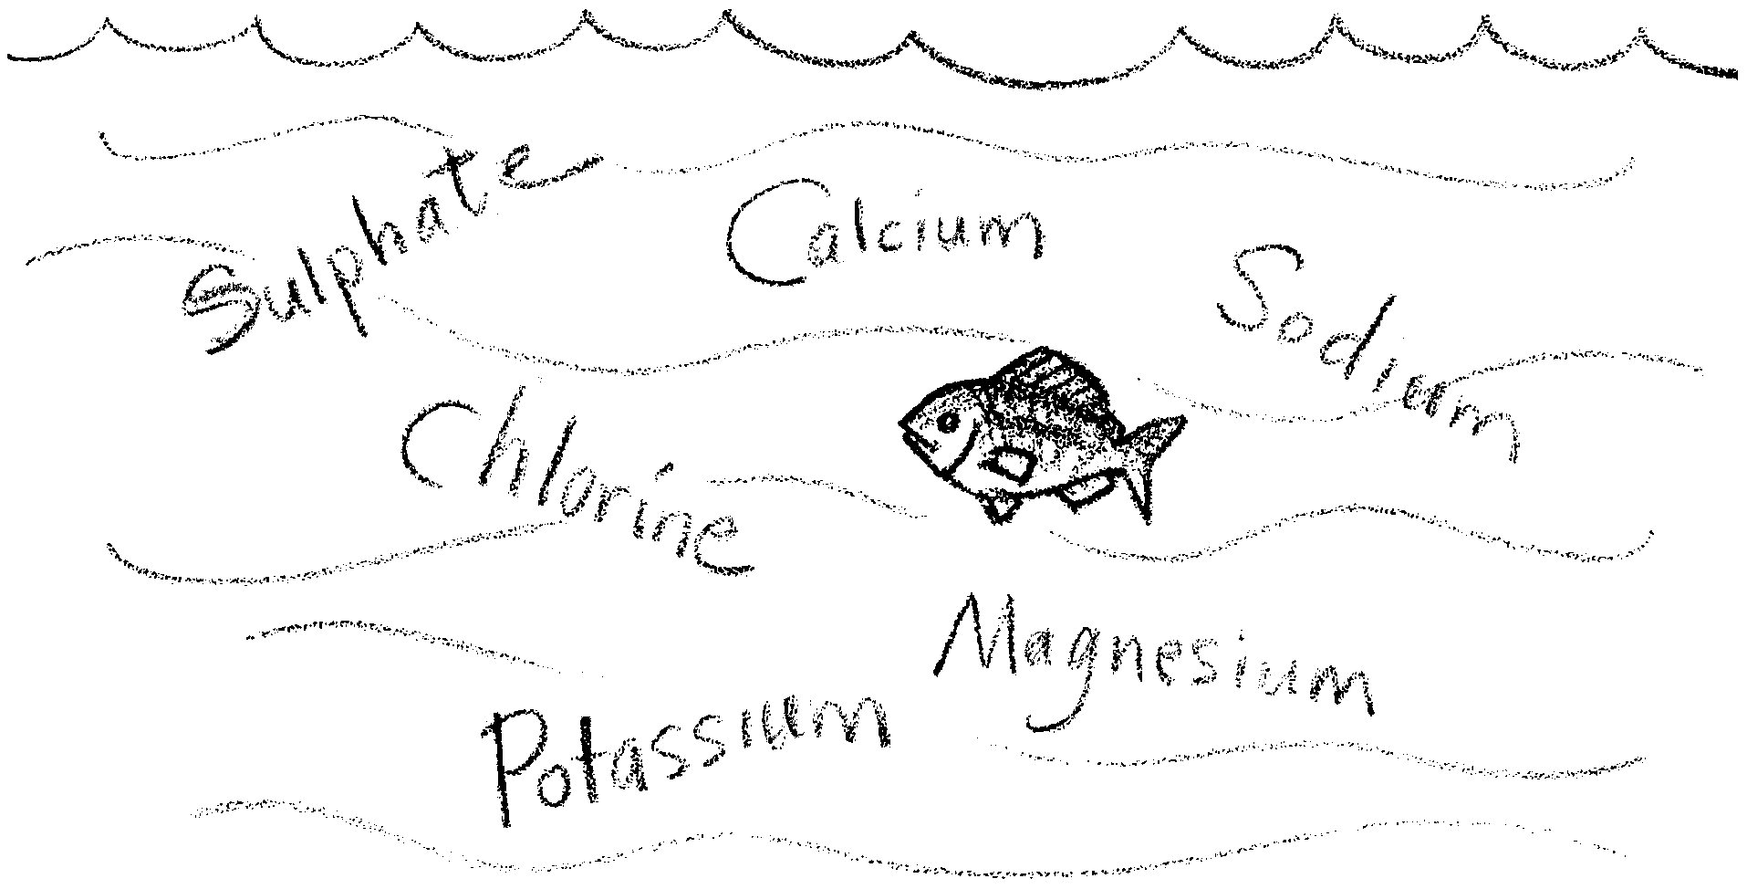
Salinity

Sea water contains a mixture of minerals, mostly salts. Salinity is the amount of dissolved materials in sea water. If you evaporate a sample of sea water, you end up with most of the naturally occurring elements known to humans. However, more than 99% of the dissolved substances that make the oceans “salty” are ions of only six elements: chlorine, sodium, magnesium, sulfur, calcium, and potassium. Ions are electrically charged atoms or groups of atoms.
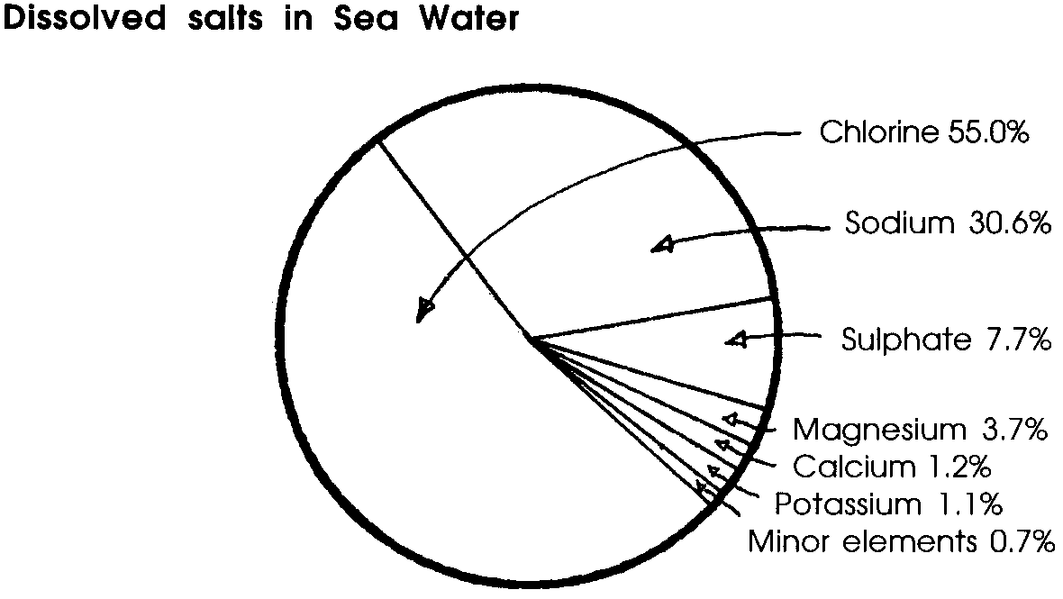
1. Which element is found in the greatest abundance in sea water?

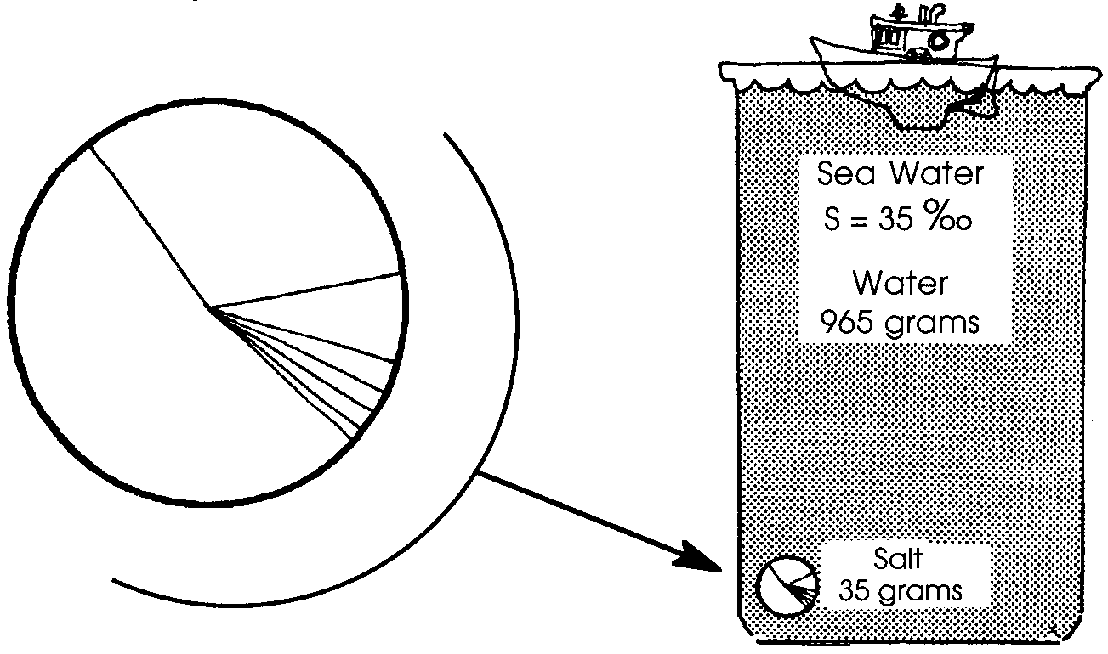
The proportions of the major ions are relatively constant throughout the world’s oceans. The average salinity (total amount of dissolved salts) of sea water is 35 parts per thousand (written as S = 35 ‰). This notation means that there are 35 grams of dissolved salts per 1000 grams of sea water. It also means that there are 35 tons of salt per 1000 tons of sea water. Sea salts are the important fertilizers of the sea, and they are necessary for animal and plant growth.

2. The symbol ‰ means parts per thousand. How many parts of salt per thousand parts of water would you find in the sea water shown in the figure above?

Oceanographers believe that the salinity of the oceans remains constant because the input of salts is balanced by the removal of salts. Water has the ability to hold large amounts of dissolved substances. Salts and other dissolved minerals are added to sea water by river discharge and hot spring (hydrothermal vent) cycling. Rivers flowing into the ocean add salts and other minerals leached from the land. Water circulating through hydrothermal vents of mid-ocean ridges is changed by the addition of some dissolved materials and the removal of others. All ocean water cycles through these hot springs every 8 to 12 million years. Salts and dissolved materials also may be removed from sea water through various biological, chemical, and physical processes. Calcium and silicon become incorporated in the shells of marine plants and animals. Dissolved iron may combine with sulfur to form iron-sulfur deposits when sea water circulates through hot hydrothermal vents. Materials may also become chemically trapped in marine sediments. Wind and wave action may remove materials at the ocean’s surface.
3. In 100,000 years, would you expect the salinity of the oceans to be less than, equal to, or greater than it is now? Why?

While the salinity variation is small in the oceans, the saltiness of sea water can vary considerably in areas such as estuaries and bays that are supplied with fresh water from rivers, streams or runoff. Plants and animals need special adaptations to withstand the changes of salinity found in estuaries. Seasonal variation in the fresh water flows from rivers which feed into such areas is one of the major causes of the fluctuation in salinity. Fresh water flow can also account for different levels of water having different salinities. The incoming flow may be concentrated at a certain level due to temperature or density differences. As a result, when testing for salinity levels in estuarine situations, samples must be taken at several depths.

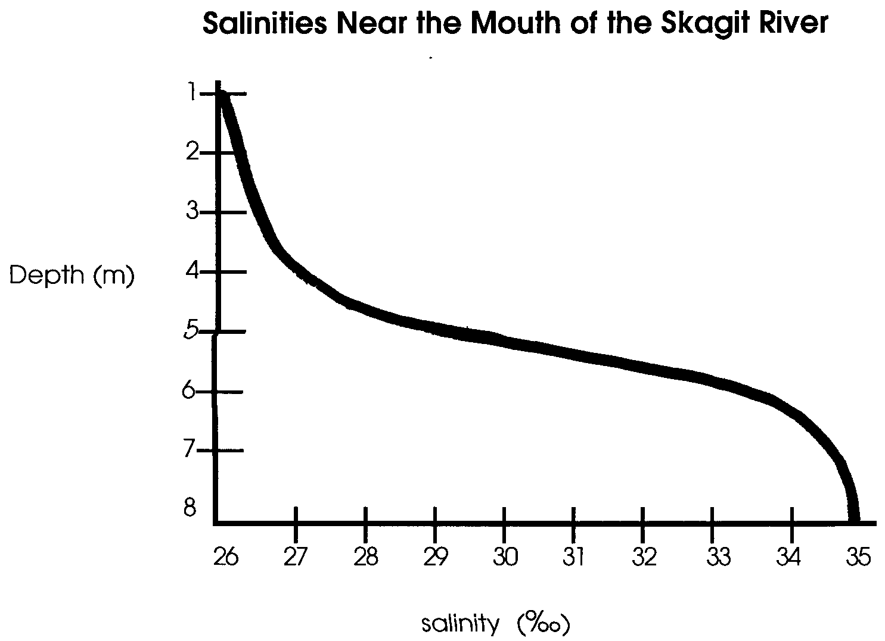
4. Fresh water is less dense than salt water. This means that there is less matter (material) in a milliliter of fresh water than there is in a milliliter of salt water. How can this observation explain the following results obtained near the mouth of the Skagit River?

a. Where was the salinity the greatest?

b. Where was the salinity the least?

c. The zone of rapid change is called the halocline (halo = salt + cline = change, slope). Label the halocline on the above graph.

Although salinity may vary slightly from ocean to ocean, the internal ratio of salts is always constant. In other words, whether the salinity is 32 ‰ or 35 ‰ we would find that 55% of the salts were chlorides. If the ratio of salts is always the same, we only need to determine the concentration of one of the elements present to know the concentration of all of the elements.
The total of these concentrations is the salinity. Usually the chloride ion (Cl-) is the element that is measured when this procedure is used. For example, if the water sample has 19 parts of chloride per 1000 parts of water, the overall salinity will be approximately 34.5 ‰. How did we arrive at that figure?
Well,
19 ‰ chlorides = 55.0% of the total salinity;

or, 19 ‰ chlorides =. 550 x (total salinity);

or, 19 ‰ chlorides = (total salinity).
.550

or, 34.5 ‰ = total salinity.

5. What would be the salinity of a sample having 20 ‰ chlorides?
Please show your work.

