The Determination of Salinity

- Titration Method

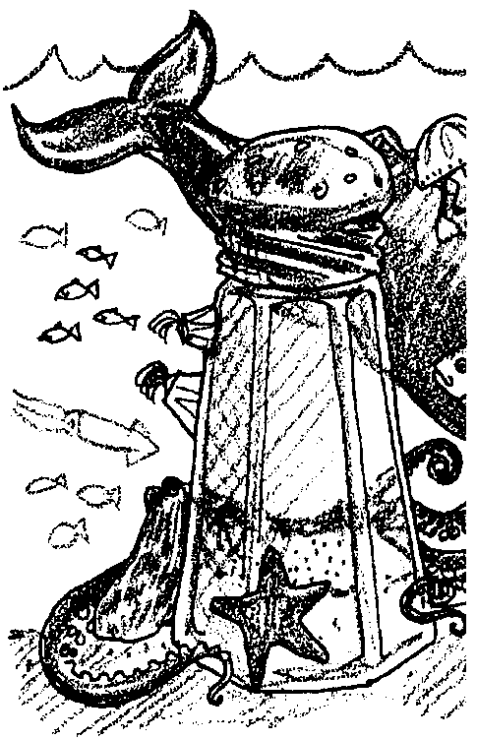
Key Concepts

- The titration technique can be used to correctly determine the salinity concentration of a water sample.
- The titration test depends on color change as a means for determining salinity.

Background
Most tests used to determine the concentrations of dissolved substances in seawater fall into one of two distinct categories: colorimetric tests or titrametric tests. Both of these categories depend upon color change as a means for determining the concentration of an unknown substance in the sample which is being analyzed. In colorimetric tests, the intensity of the color which develops is related to the concentration of the unknown substance in the water sample. In titrametric tests such as the following test for salinity, a chemical reagent is slowly added to an exact volume of a water sample which has been previously treated in some specified manner. At some point when the reagent is being added, there will be a distinct color change called the "end point". The volume of the reagent (titrant) which must be added to bring about this color change is directly related to the concentration of the substance in the water sample being tested.

Materials

For each lab group of 2 - 3 students:
- 4-6 plastic beads
- 50 ml burette
- 125 ml Erlenmeyer flask with a stopper
- AgN0₃ titrant solution*
- 6-12 drops of K₂CrO₄ indicator solution**
- 120 ml Distilled H₂0
- 20 ml seawater (20° Celsius)

(Materials - Cont.)
- 50 ml beakers (2)
- 10 ml pipette
- safety glasses or goggles
- waste jar (or several for the whole class)
* Preparation of the AgNO₃ titrant:
Measure 49 grams of crystalline AgN0₃. Dissolve the crystals in approximately .5 L of ion-free water (distilled). Be sure all crystals have completely dissolved. Fill with more ion-free H₂0 to the one liter mark.
This solution must be stored in a dark brown bottle. If several bottles are used, the contamination of one will be a lesser problem. Each buret filling requires about 50 ml of AgN0₃ solution. One liter will fill 20 burettes (with care).
** Preparation of the K₂CrO₄ indicator:
Add 3.5 grams of K₂CrO₄ yellow crystals to 100 ml of distilled H₂0.

Teaching Hints
"How Salty Is the Water?", "Making Test Tube Hydrometers", and "The Determination of Salinity- Hydrometer Method" have introduced students to several ways of measuring the salinity of seawater. "The Determination of Salinity- Titration Method" gives students practice with one more technique for measuring salinity.
Encourage careful and accurate laboratory techniques. Circulate around the room as the titrations are performed looking for possible dangers and problems with procedure. Plan to spend some time after completion of the activities in the discussion of the results and procedures.
The accuracy of titrametric tests depends upon several factors. The sample seawater must be cold (approx. 20° Celsius). The strengths and volumes of solutions used must be carefully measured. Glassware must be clean and the graduations must be accurate to obtain good results. Although your students may not appreciate the fine points of titration, they can easily detect the color change, measure the titrant used and correctly determine the salinity concentration. Reasonable care in technique will assure results that will provide ample material for discussion and consideration.
The students should be made thoroughly aware of the safety problems to be encountered in any exercise using chemicals. Silver nitrate stains clothing, skin and other items. Spills must be cleaned, rinsed and dried. Tall burettes filled with titrants topple easily. The resulting mess is often wide-spread.
Overflows and spillages over the top of the burette are at eye-level or above. Eyes must be protected at all times. Be sure your students WEAR EYE PROTECTION!
Once silver nitrate is prepared, deterioration of the solution begins with exposure to light, evaporation and air borne contamination. Fresh solutions yield the best results. As the titration proceeds, the clumps of silver chloride formed should be reduced by periodic, vigorous agitation. The addition of 2 or 3 small plastic beads to the reacting vessel is helpful in breaking clumps.
Although the pH determination of the sample is not made a part of this exercise, good results require a pH of 7-10. Adjust samples of pH below 7 with 0.l M NaOH.
Students must be able to read the meniscus in order to correctly do this exercise.
To dispose of silver nitrate after the lab, pour sodium chloride (NaCl) into the waste liquid. Pour off the liquid and throw away the salts. To clean the burettes, first rinse them with dilute nitric acid (add 66 ml of concentrated nitric acid (HNO₃) to 134 ml distilled water). Next, rinse burettes with distilled water.
Reference
The student titrations and calculations are a modified version of standard procedures used to determine the salinity of water samples.
For those who wish to pursue the subject in more detail, the theory and background of the standard technique is available by consulting:
Strickland, J.D.H. and T.R. Parsons, 1972, A practical Handbook of Seawater Analysis, Fisheries Research Board of Canada: Bulletin 167, Ottawa.

Key Words
burette - a calibrated glass tube with a stopcock, used for accurate fluid dispensing
calibration - graduations of a quantitative measurement
chloride ion - a chlorine atom that has gained an additional electron
end point - the point in a titration usually noting the completion of a reaction and marked by a change of some kin, as of the color of an indicator
indicator - a substance that indicates the presence, absence, or concentration of another substance by means of a characteristic change, especially in color
meniscus - the curved upper surface of a liquid in a container
pipette - a calibrated glass tube used to transfer small volumes of liquid
precipitate - to chemically cause a solid substance to be separated from a solution; also the solid substance so separated
reagent - a substance used in a chemical reaction used to measure other substances
stopcock - a valve that regulates the flow of liquid through a burette
titrant - the reagent added in a titration
titration - a method of determining the concentration of a substance in a sample solution. This is done by adding a reagent of known concentration until a reaction of known proportion is completed as shown by a change (e.g., color). The unknown concentration can then be calculated.

Answer Key
1. Answer depends upon experimental results.

2. The second sample provides a check. If the results are widely different, the experimenter is alerted to look for a problem.

3. The best estimate will most likely be the average.

4. The best estimate is the average since it tends to minimize any errors in good technique.

5. If a volume of seawater other than 10 ml is used, the correction used is:

10
volume of seawater x volume of silver nitrate

6. In theory, it would be possible to introduce a known number of chloride ions (either by weight of solid NaCl or by volume of a known concentration) and retitrate. In practice, it's best to throw out the sample and begin again.

7. The freshwater outflow can be traced by measuring the salinity gradient from the mouth of the river to the point where you reach the salinity of the open ocean.
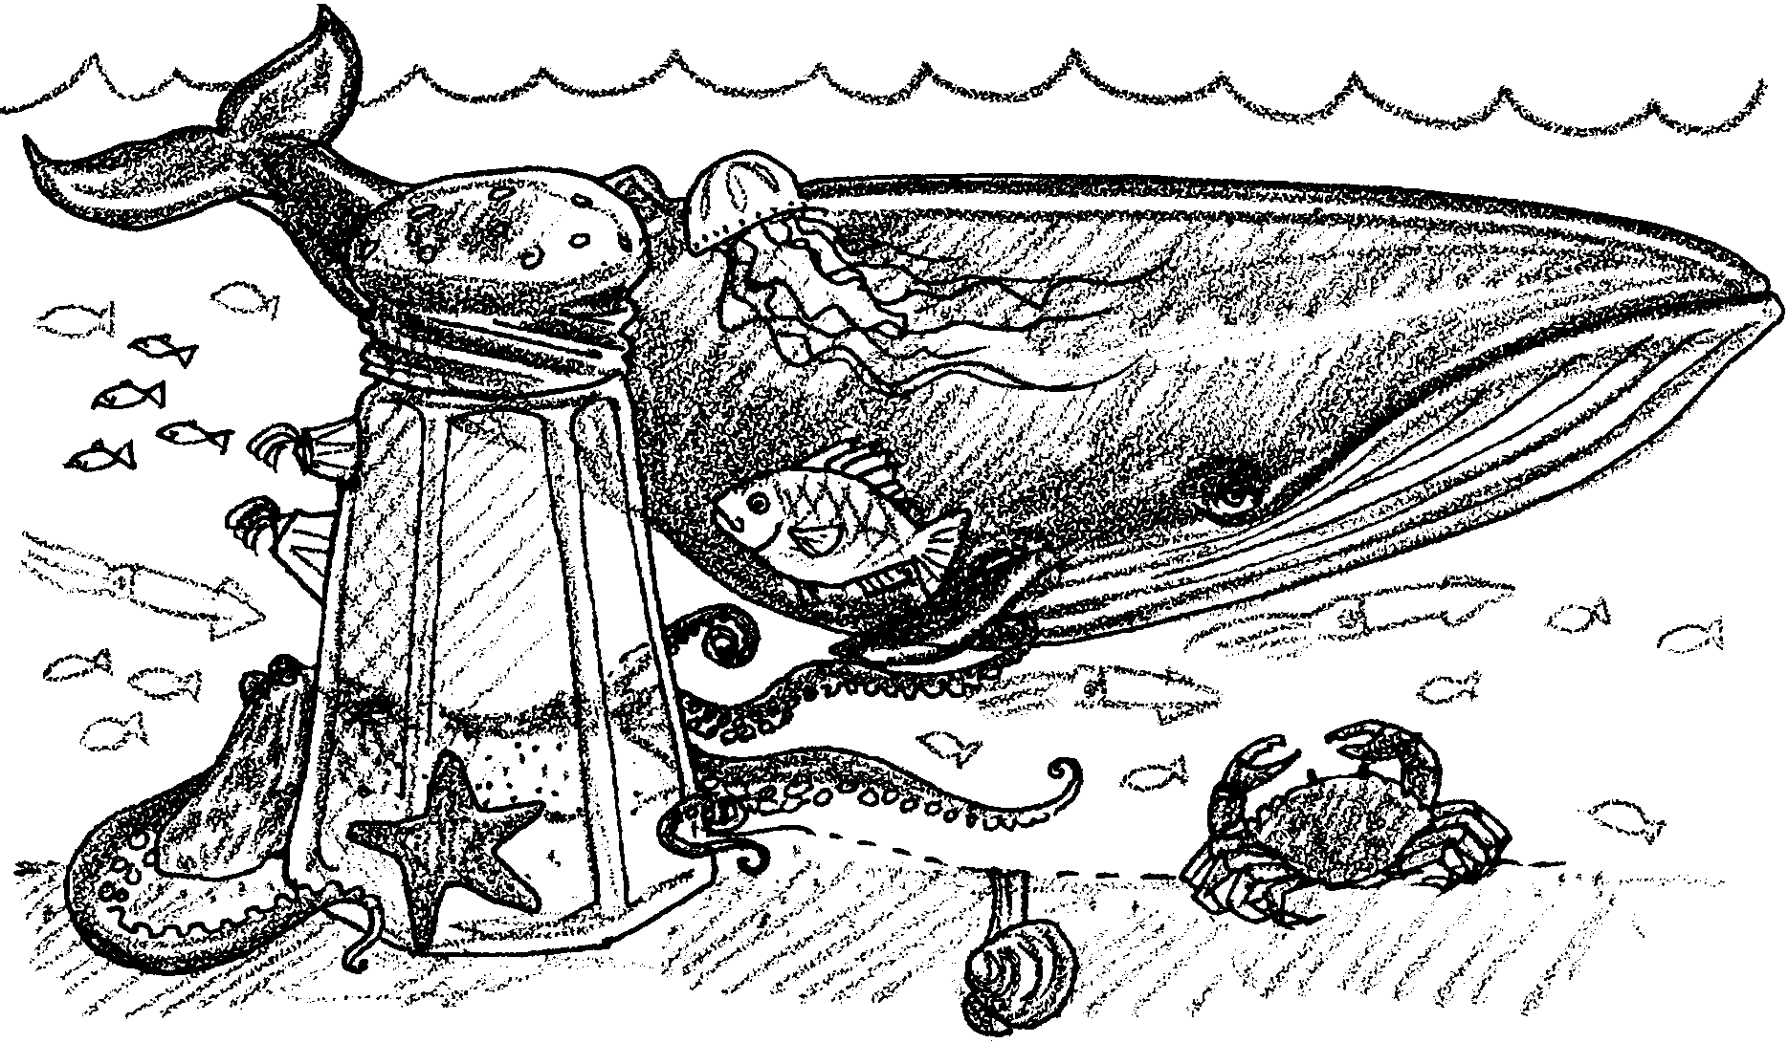
The Determination of Salinity
–Titration Method

Salinity is an important factor in the life of the sea. Seawater surrounds the plants and animals that live in the sea. The concentration of the salts in this seawater determines whether the organism has to safeguard against dessication (excessive loss of water) or hydration excessive inflow of water). In this activity you will determine the salinity of seawater using a titration technique.

In a titration test, a chemical reagent (a substance used to measure another substance) is slowly added to an exact volume of a water sample which has been previously treated. At some point when the reagent is being added, there will be a distinct color change called the “end point”. The volume of the reagent (called the titrant) which must be added to bring about this color change is directly related to the concentration of the substance in the water sample being tested.

This activity requires care. You will be using silver nitrate (AgN03) in the technique. Although silver nitrate is colorless, it will stain desk tops, clothes and skin. Begin by wiping the work area with a wet paper towel. Dry the area. Wear safety glasses for eye protection. Wipe up any spills as they occur.
Materials
• 4-6 plastic beads
• 50 ml buret
• 125 ml Erlenmeyer flask with a stopper
• AgN03 titrant solution
• 6-12 drops of K2CrO4 indicator solution
• 120 ml Distilled H20
• 20 ml seawater (20° Celsius)
• 50 ml beakers (2)
• 10 ml pipette
• safety glasses or goggles
• waste jar

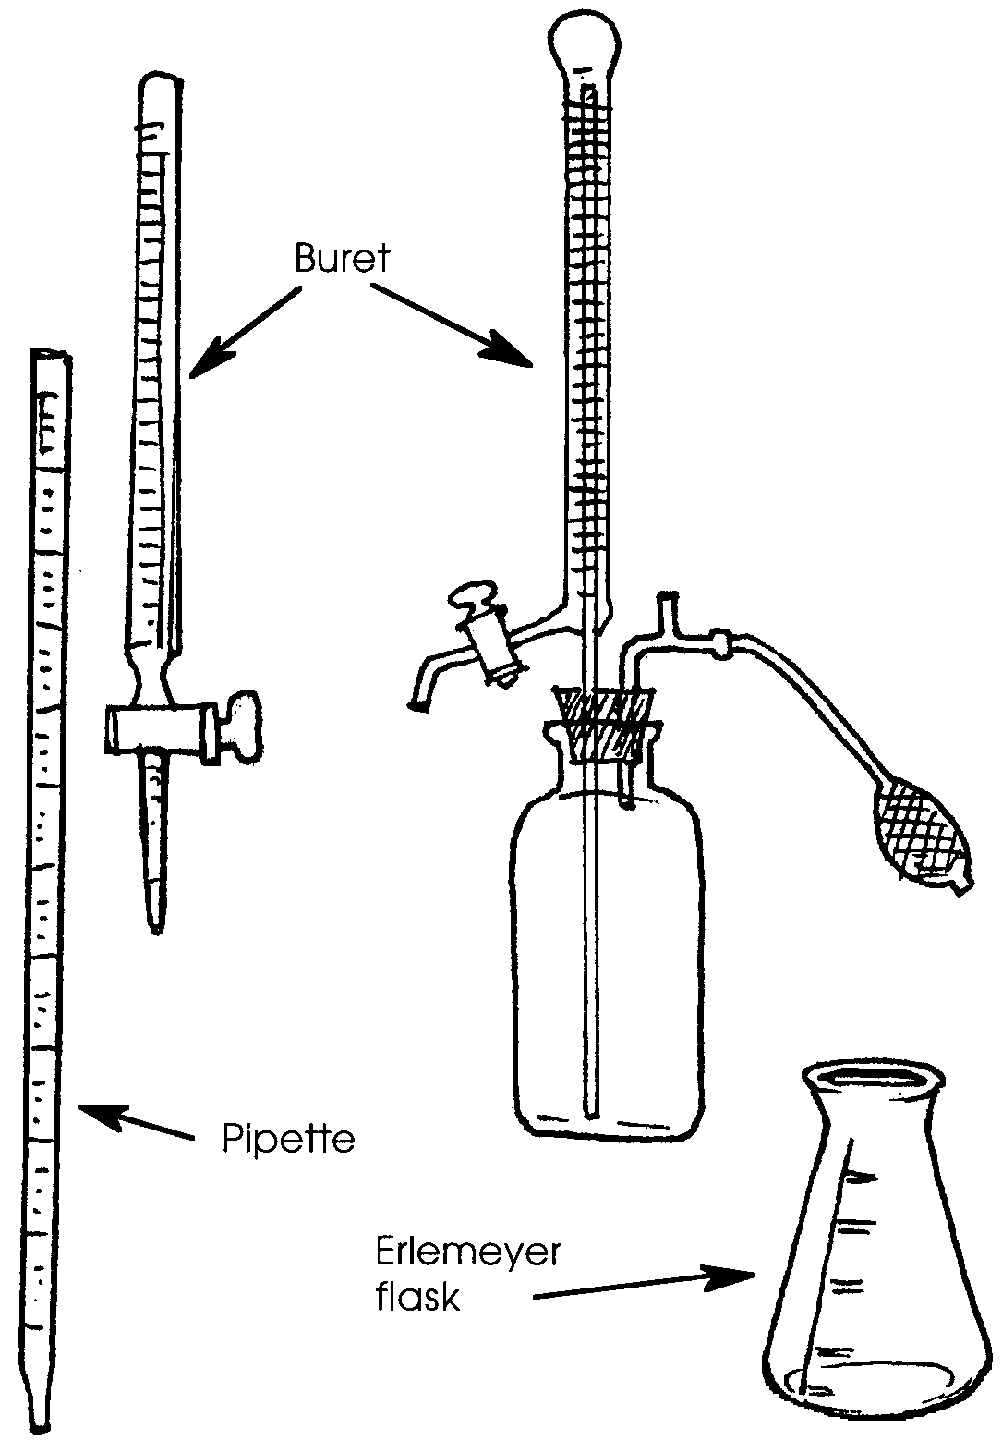
Procedure:
1. Arrange the work area for maximum usability and minimum clutter.
Once titration begins, nothing should interfere.

2. Fill buret with distilled H20. Drain buret in short spurts. Try to adjust the stopcock so as to deliver drops and a single drop on demand. Now is the time to learn the idiosyncrasies of the stopcock. Be sure it operates without leaking.

The instructor should be informed about an inoperative buret assembly immediately.

3. Pipette 10 ml of seawater into the 125 ml flask. Add about 10 ml of distilled H20. Add 2 or 3 plastic beads. Label this “Sample Number 1”.
4. Put 4-6 drops of K2CrO4 solution into the flask. This is the indicator. The indicator will change color at the “endpoint”.

5. Fill a 50 ml beaker with AgN03.

6. Pour about 5 ml of AgN03 into the buret. Drain into the other 50 ml beaker. Pour this into a waste jar.

7. Partially fill the buret with AgN03. Turn stopcock to fill the buret exactly to “0” or exactly to “50” (the top reading). This is time consuming.

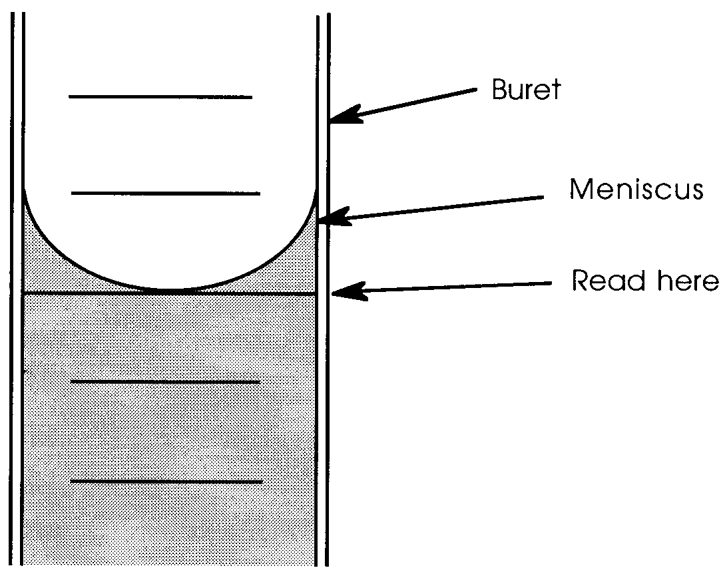
8. On your data sheet RECORD the reading at the start (read meniscus;
see diagram below). The buret either has “50” or “0” or both as the top graduation. In either case record the starting and ending graduations. Subtract the smaller from the larger to find the volume of AgN03 used in milliliters. Most burettes can be read to the tenth of a milliliter.

How To Read the Meniscus

9. Slowly let the silver nitrate solution drain from the buret while constantly swirling the flask. Periodically stop adding silver nitrate solution.

10. Agitate (gently swirl) the flask. DO NOT LOSE ANY LIQUID. Use a stopper to prevent spillage.

11. Repeat steps 9 and 10 until the first pink-orange color appears.

12. Agitate well. The clumps of precipitate must be reduced to very small particles. The flask contents should return to the original color.
13. Add AgN03 drop by drop while agitating the flask contents sufficiently to keep the precipitate particles small. When the pink color reappears, “catch” the hanging drop. Stopper the flask. Shake vigorously. If the pink color remains, this is the end point. Otherwise, repeat Step 13.

RECORD the ending buret reading on your data sheet.

14. Once the end point is reached calculate the volume of AgN03 used.
(Larger reading) - (smaller reading) = volume of AgN03 used
RECORD the volume on your data sheet.
This volume is the chlorosity of the water sample.

15. Use the conversion table found on the next page to find the salinity.

How to use the table:
a. The column marked Cl/liter(20) shows different chlorosities. Read down the column until you find the number that matches your experimental results.

b. Next, read the number on the same line, but one column to the right under the heading S ‰. This figure is the salinity corresponding to the chlorosity you determined experimentally.

An example is blocked in for you. If you determined a chlorosity of 19.55, then your salinity is 34.47 parts per thousand.

c. RECORD your salinity for sample number 1.

Note: This table assumes a temperature of 20°C. If your determination was performed at a different temperature, the salinities you read on the chart will not be completely accurate. For this activity, assume your working temperature was 20°C.

16. Repeat steps l to 15 on a second sample of water from the same
location. This is sample number 2.

17. Complete your data sheet. RECORD the difference, the average,
and the percent error.

18. Clean your glassware and your work area.
Analysis and Interpretation

1. List your results on the chalkboard with all other students who titrated the same seawater sample. What is the average salinity of all of these titrations?

2. Why is it a good idea to make two titrations of the same sample?

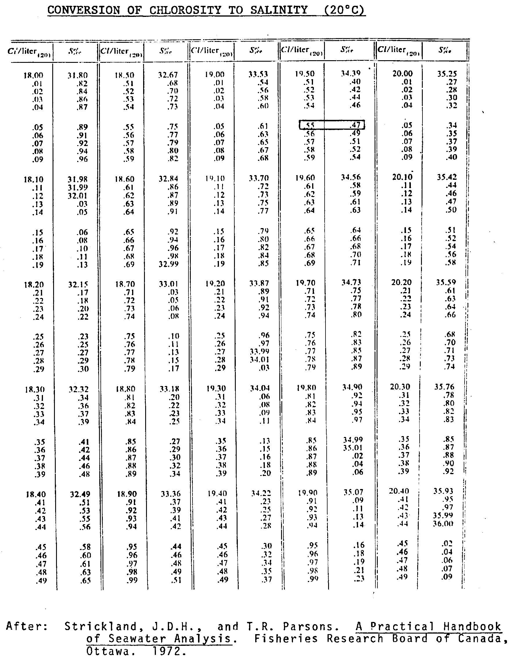

3. What is the best estimate for the salinity of your sample using your data alone? Explain your choice.

4. What is the best estimate for the salinity using the data gathered by the whole class? Explain your choice.

5. If a sample fraction with more or less than 10 ml were used (e.g.15 ml), what additional computations must be made?

6. Assume that too much AgNO3 was added to the contents of the flask. How could the experiment be “saved”?

7. How can the fresh water outflow from a stream be traced at sea?
Data Sheet

Salinity Determination
Titration Method

Name: Date: Time: 24 Hour clock

Water depth of sample: Water temperature: °C

Air temperature: Wind speed: Wind direction:

Tidal conditions: Flooding Ebbing Slack

Low 1st quarter Half 3rd quarter High

Sample #1 Sample #2

Buret readings: Buret readings:
Start Start
Finish Finish
Number of mls Number of mls
of AgNO3 used of AgNO3 used
Salinity Salinity
Correction Correction
Corrected Corrected
Salinity Salinity

(A) Difference between the two samples ‰

(B) Average salinity of the two samples ‰

You can find the average by using this formula:

(corrected salinity #1) + (corrected salinity #2)
= ‰
2

(C) Percent error (A)
x 100 = %

(B)

