The Determination of Salinity

- Hydrometer Method

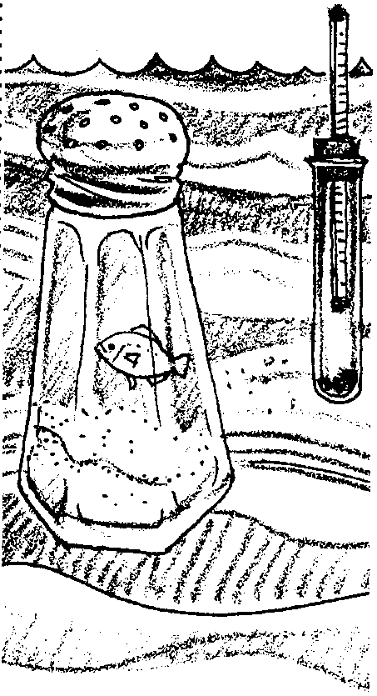
Key Concepts
1. Warm water is less dense that cold water, fresh water is less dense that salt water.
2. The density (the mass per unit volume) of a water sample is affected by the salinity and temperature.
3. For a given sample of water, a hydrometer is an instrument used to measure density, and a thermometer is used to measure temperature.
4. It is possible to determine the salinity of a water sample once the density and the temperature of a sample have been measured.

Background
Since the salty taste is the most obvious difference between fresh water and salt water, the determination of salinity is a good place to begin a look at the things that make salt water "salty". It is possible to determine the amount of dissolved salts and minerals (salinity) of a sample without performing chemical tests or evaporation. If water density and temperature are measured, salinity can easily be determined. The hydrometer is a standard tool for the measurement of water density. The higher the hydrometer floats in a sample of water, the more dense the sample is. Density is the mass per unit volume of a water sample. The density of a sample is in turn affected by the salinity, or amount of dissolved salts and minerals present, as well as the temperature. Salty water is more dense than fresh water, and warm water is less dense than cold water. So once the variables of density and temperature are measured, salinity can be determined.

Materials
For each lab group of 2-3 students:
- a hydrometer
- a Celsius thermometer
- two 450 ml salt water samples with different salinities
- 500 ml graduated cylinder
- copy of each chart: Density-water temperature, Salinity-corrected density temperature

Teaching Hints
"The Determination of Salinity - Hydrometer Method" introduces students to the measurement of salinity through the use of commercial hydrometers. This activity is best performed by small groups. The number of students working in a group depends upon the number of thermometers and hydrometers available. Hydrometers are available in aquarium shops for a reasonable sum. They are also used during the process of making wine, and, as such, can be purchased from winery supply stores. If you can only obtain one or two hydrometers, you may choose to set this lab up as a station while students do another assignment.
Ideally, you will obtain two water samples using a water sampling device such as a Van Dorn bottle. One sample should come from one meter below the surface and the second should come from the bottom. If you cannot obtain the samples in this manner, you can still use the activity by making your own salt water. For example, the top sample can be made by dissolving 29 grams of table salt (sodium chloride) or rock salt in enough water to make 1000 grams of saltwater. The bottom sample can be made by dissolving 31 grams of salt in enough water to make 1000 grams of saltwater.
Hydrometers are fragile. Caution your students and demonstrate their care and handling. Provide any assistance necessary during the investigation. Circulate between groups to be sure everyone understands the procedure. Allow time for clean up. After the activity is completed, plan to spend time in a discussion of the results and their interpretation while providing answers to the questions found within the activity.
Part II uses the data gathered in Part I, but treats it in a slightly different manner. The two approaches may give slightly different results. This situation can provide an opportunity for a discussion of precision - just how precise do you need to be in determining salinity? The answer, of course, depends upon what you plan to do with the data once you have it in hand.

Key Words
buoyancy - the power of a fluid to push upward or keep afloat a body immersed in it
density - the amount of matter (mass) per unit volume
hydrometer - instrument for measuring specific gravity (density) of a liquid, commonly consisting of a graduated tube weighted to float upright in the liquid whose specific gravity is being measured
parts per thousand (‰) - in this case, the units used to express salinity
salinity - a measure of the salt concentration in a solution

Answer Key

Part I
Interpretation and Analysis
- The salinity estimates will most likely not be exactly the same.
- There are many sources of error including, but not limited to:
a. differences between hydrometers
b. errors in reading hydrometers
c. errors in recording hydrometer readings on paper
d. errors in recording hydrometer readings on board
e. differences between thermometers
f. errors in reading thermometers
g. errors in recording temperature, etc.
It might be helpful to point out to your students that what we see here is two large classes of variation: one group is due to errors within the equipment, the second is due to experimenter errors.

- Answers depend upon the experimental results.
- It is possible, but unlikely, that the average is exactly the same as one of the estimates.
- Answer depends upon the experimental results.
- Answer depends upon the experimental results, most likely the answer is yes.
- Conditions that might help account for a range in salinities include differences in rainfall, river outflow, differences in evaporation and differences in rate and degree of mixing.
- Lowest salinities would be found in areas with high rainfalls and large river outflows.
- Highest salinities would be found in areas with high evaporation rates and low rainfalls and low river outflows or where seawater has settled in a layer below fresher water.
Part II
Interpretation and Analysis
- The answers will vary, but generally students find the graph method the easier to use.
- The densities determined using the two techniques will probably not be exactly the same.
- Answers will depend upon experimental results.
- Since the charts were the original source of data, they should be more accurate. Changing the charts to graphs introduces the possibility of errors in recording, interpretation, etc.
- The charts should be used when a high degree of certainty is required. They are more cumbersome to use, but provide more accurate information. The graph would be used for routine salinity determinations where great precision is not required. If the salinity determination was going to be used to make important management decisions, the charts would be preferred.

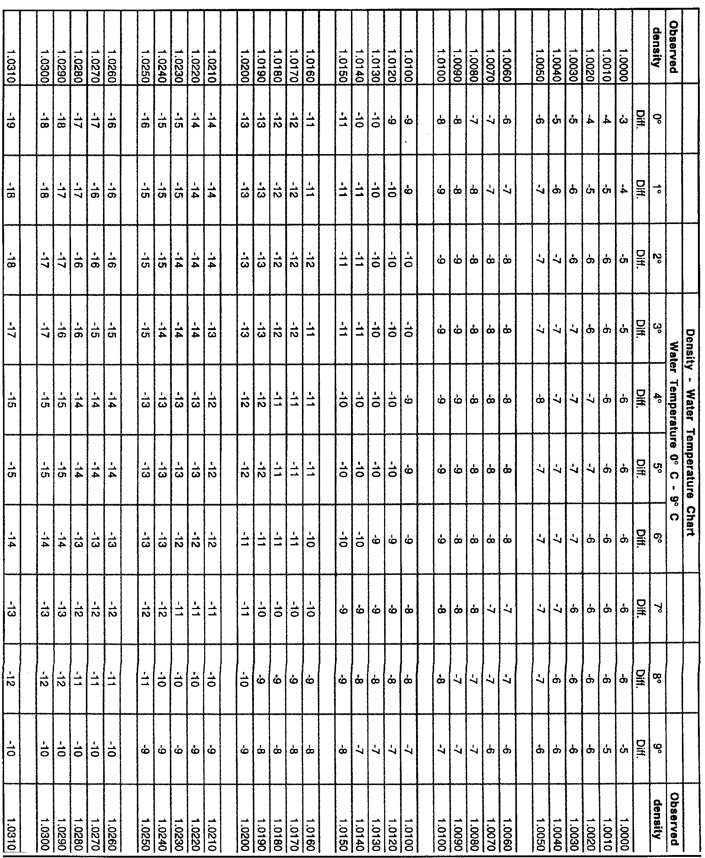

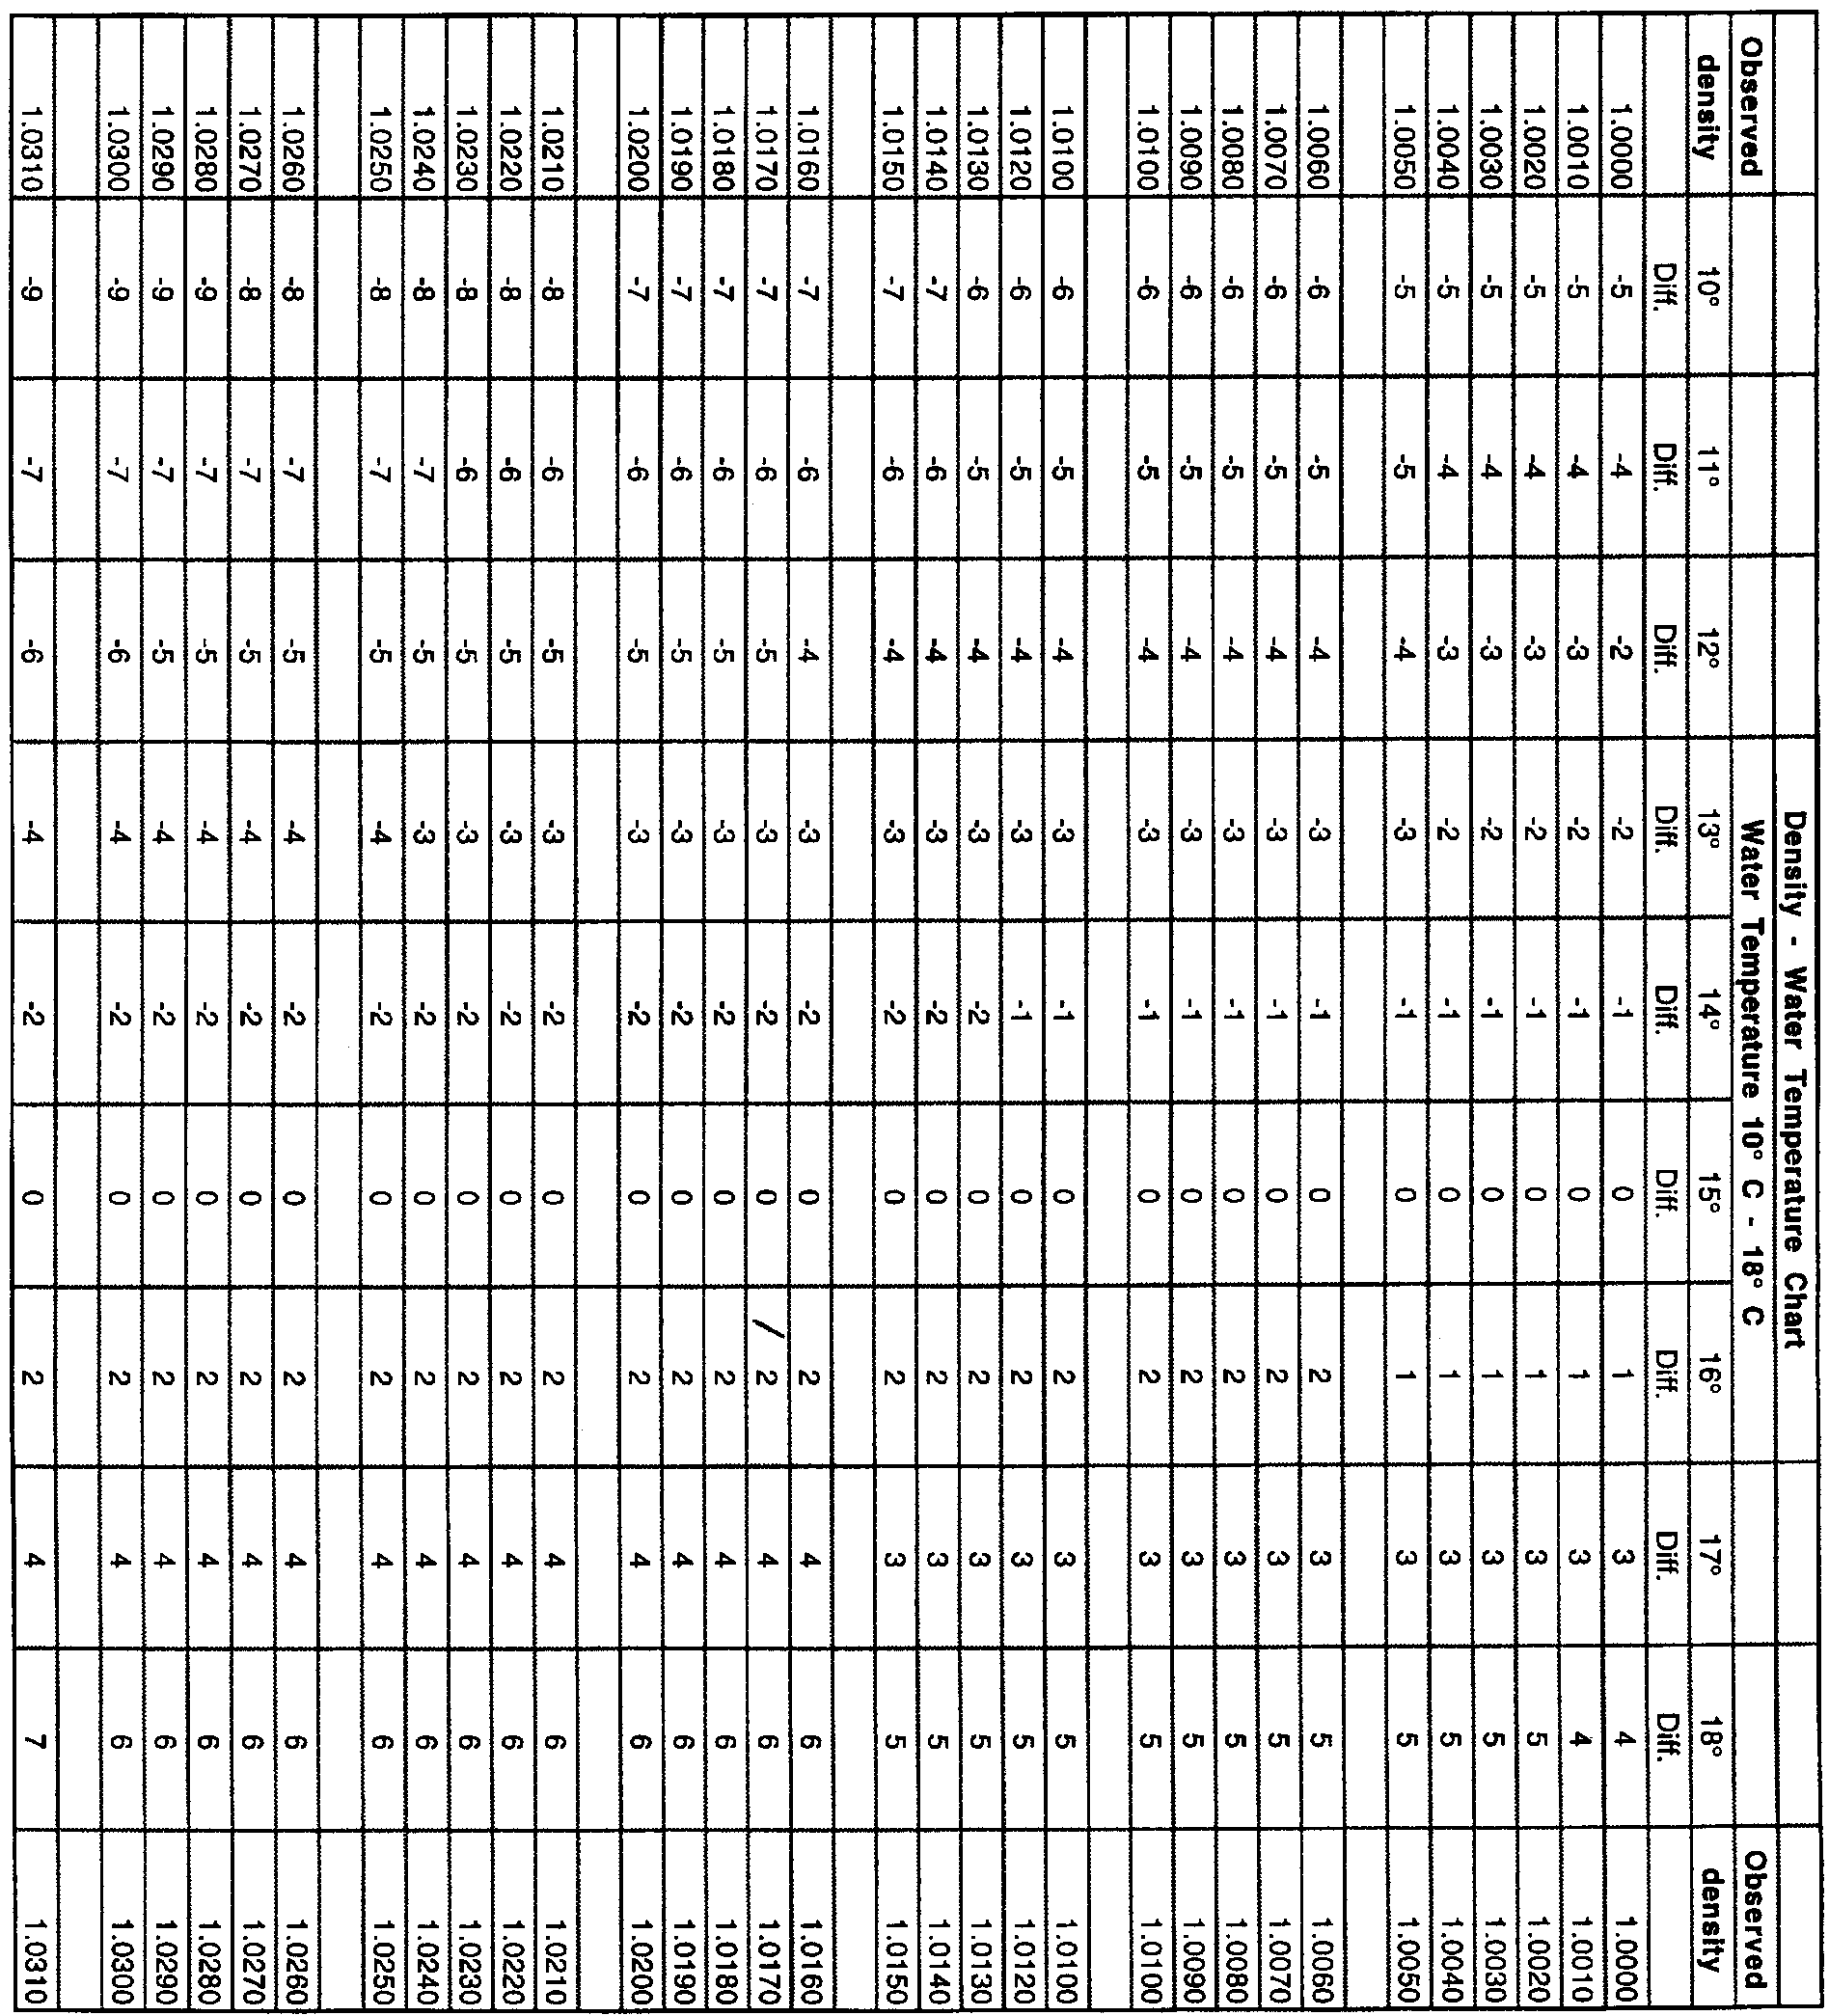

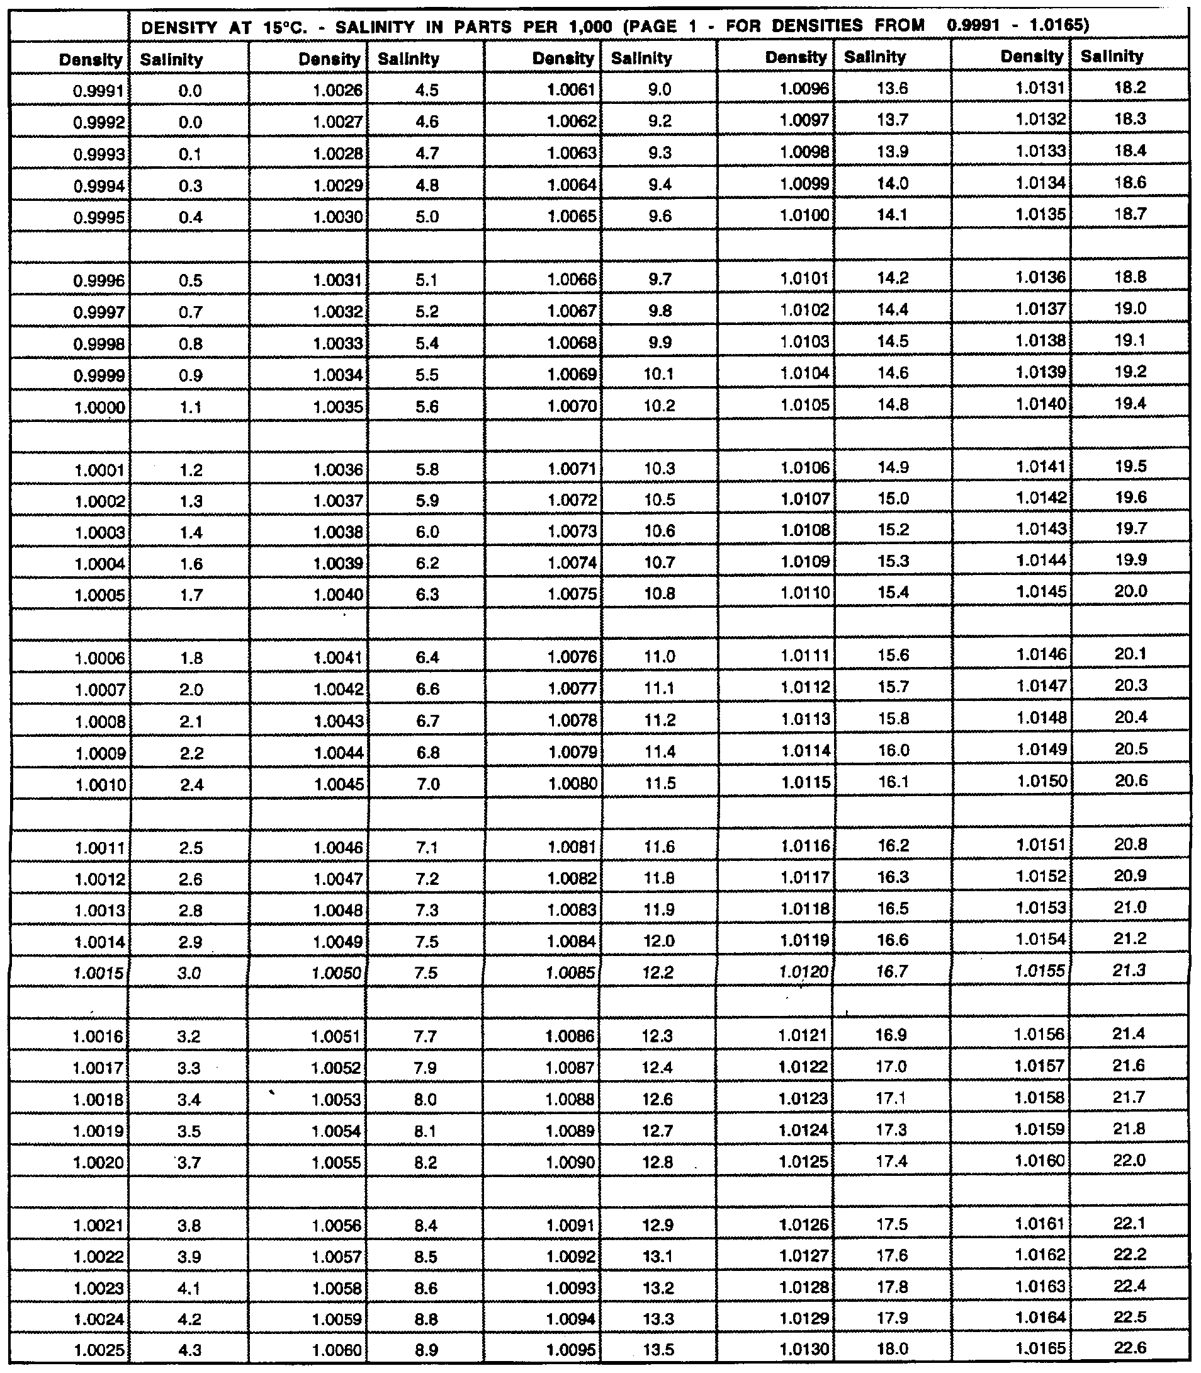

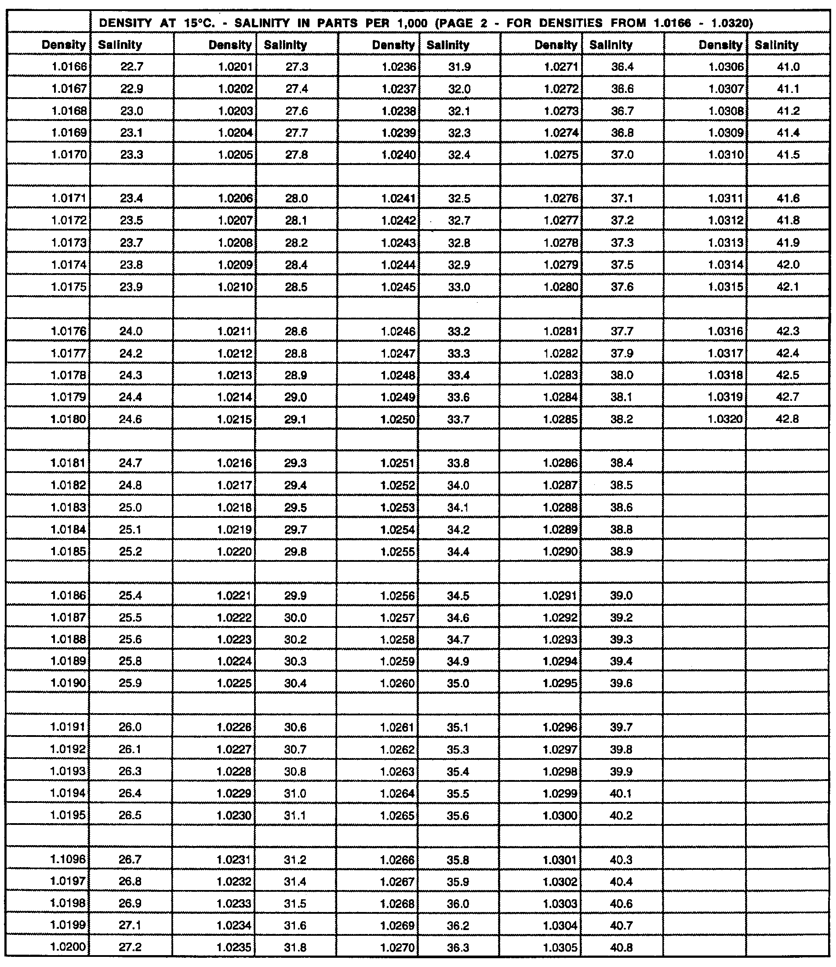

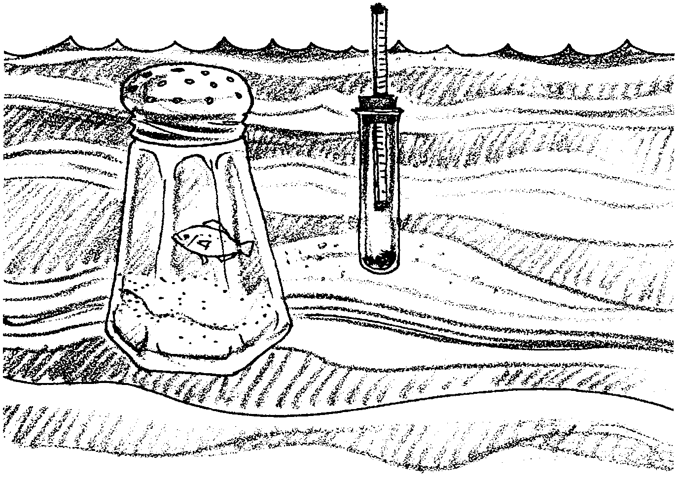
The Determination of Salinity
–Hydrometer Method

Salts make sea water different from fresh water. The concentrations of the salts affect everything that comes in contact with sea water. Living organisms have to deal with this salinity. To measure the salinity of sea water, oceanographers have developed several techniques. People observed that the saltier the water, the higher something floats in it. Marine scientists use this buoyancy (flotation) information to determine salinity rapidly, with an instrument called a hydrometer. One type of hydrometer is a weighted glass cylinder with a thin glass tube at the top. The thin tube contains a printed scale (see diagram). The higher the salinity, the higher the tube floats and the larger the number that lines up with the water’s surface. Pure water at 4°C is given a density of 1.0000. In this activity you will use a hydrometer and thermometer to determine the salinity of salt water samples.

Materials
• Salt water solutions
• Thermometer °C
• Hydrometer
• Density- water temperature chart
• Salinity - corrected density chart
• Temperature / salinity graph
• 500 ml graduated cylinder
Part I
Procedure:
1. Fill graduated cylinder with 450 ml of your salt water sample.

2. Record water temperature with centigrade thermometer.
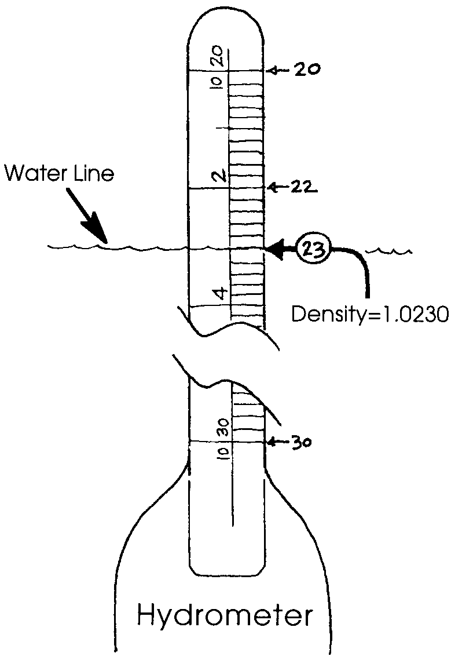
3. Using the hydrometer, measure the density of your sample. The diagram to the right will help you read the hydrometer.

Record the density

4. Correct density using density-water temperature chart and record.
Example: density = 1.0230 water temperature = 10°

Find 1.0230 under “Observed density” on the Density-Water Temperature Chart.

Move across to the column marked “10°” under “Temperature of water in jar”.

Read: -8. The -8 is the correction factor and is really -.0008.
Thus:
1.0230
-.0008
1.0222 = the corrected density reading

Record the corrected density for your sample.
5. Read salinity from salinity-corrected density chart and record.

Example: Find 1.0222 in the density column.
Read 30.0 in the salinity column to the right of the density 1.0222.
Record the salinity for your sample ‰.

6. RECORD YOUR SALINITY ON THE BLACKBOARD as directed by your
teacher.

Repeat the above steps for each salt solution provided.

Interpretation and Analysis
1. Look at the salinity determinations for salt solution number 1. Are all of the salinity estimates for a particular solution the same?

2. If you see differences in the estimates, list three possible sources of this variation.
a.

b.

c.

3. Scientists have found that they can obtain more accurate results if they repeat a procedure several times and take an average. The average figure that they obtain has a better chance of being the real (correct) figure than does any of the individual figures.

Calculate the average salinity for each of the salt solutions tested. (Hint: This is easy! Take all of the salinity estimates for a given solution and add them together. Divide this sum by the number of estimates. The answer is your average. In other words,
average salinity
estimate for solution X)

=
sum of salinity estimates for solution X

number of salinity estimates for solution X

Please show your work in the space below:
4. Are any of the estimates on the board exactly the same as the calculated average?

5. Which solution was the saltiest?

6. The salinity of sea water ranges from about 25 parts salt per thousand parts of water (25 ‰) to about 35 parts per thousand (35 ‰). Did either or both solutions fall in this range? If yes, which one(s)?

7. What are two conditions that might help account for a range (from 25 ‰ to 35 ‰) in water salinities rather than a single uniform salinity?
a.

b.

8. Where would you expect the lowest salinities to be found? Explain.

9. Where would you expect the highest salinities to be found? Explain.
Part II
Using the density-water temperature chart and the salinity-corrected chart can be tedious. To make things a bit quicker scientists have developed a hydrometer-temperature graph which corrects for differences in temperature. Using this graph you will again determine the salinities that correspond to the hydrometer densities you discovered.

Procedure:
1. Use the hydrometer-temperature graph to read the salinity.
EXAMPLE: To Find Salinity:

a. Find correct water temperature on graph.

b. Follow temperature line over until you meet correct hydrometer density line.

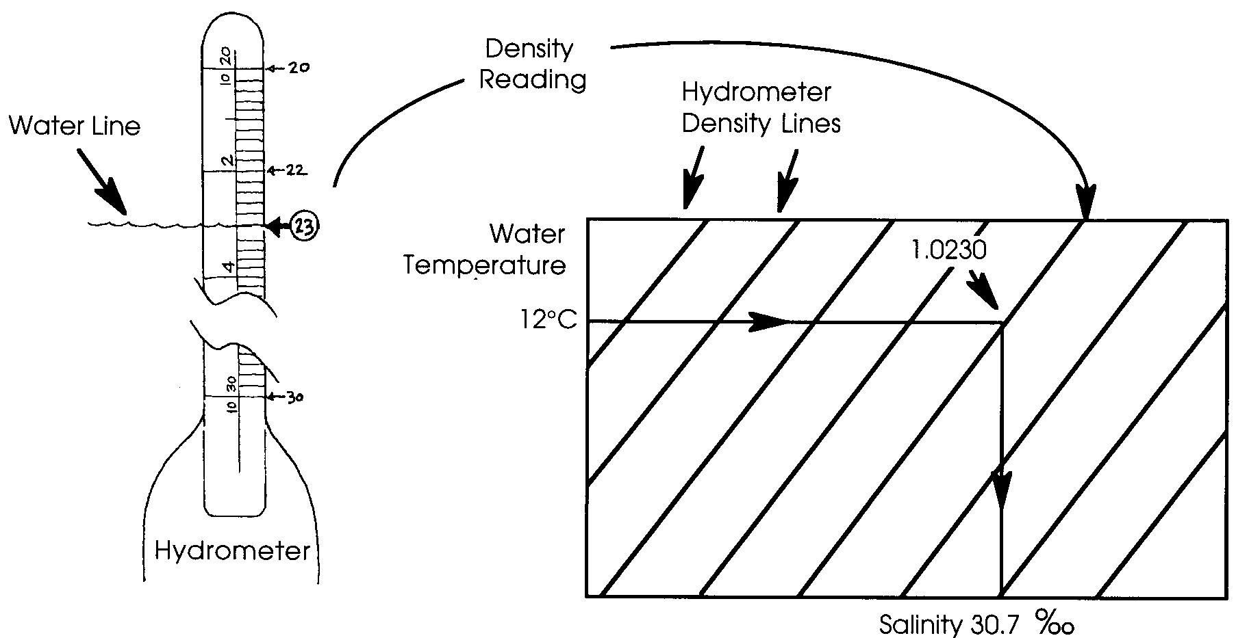
c. From this point drop straight down and read off correct salinity of your sample in parts per thousand (‰).

Record your salinity:

Salinity for sample # is ‰.
Interpretation and Analysis
1. Which method of determining salinity from density data did you find easier?
Why?

2. Were the densities you determined using the charts exactly the same as those that you determined using the graph?

3. By what percentage does the graph salinity determination for the first sample differ from the chart salinity determination?

(HINT: % difference = (chart salinity) - (graph salinity) x 100)
chart salinity

Please show your work in the space below:

4. The graph was constructed from the charts. Which do you think is more accurate? Why?

5. When might you want to use the chart method and when might it be most appropriate to use the graph method?

