Making Test Tube Hydrometers
Lesson by Judy D'Amore, Marine Science Centers, Port Townsend and
Poulsbo, Washington for Puget Sound Project Curriculum, Marine Science
Center, Poulsbo, Washington.
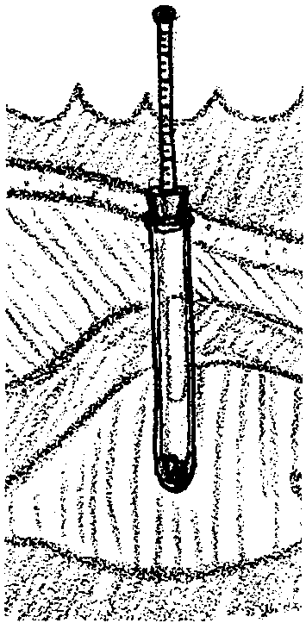

Key Concepts

1. Objects float higher in water with higher salinity.

2. Calibrated test tube hydrometers can be used to determine the salinity of water samples.

Background
Evaporating sea water, as in "How Salty is the Water?", is a time-consuming, messy and potentially dangerous way of measuring the salt content of water. Since salinity changes the density of sea water, it is possible to use a hydrometer, which floats at different levels in waters of different densities, to measure salinity.

Materials
For each lab group:

- 1 test tube
- 1 single hole stopper to fit the test tube
- 1 piece of glass tubing with a diameter of 4 mm, 12 cm in length or 1 disposable pipette, at least 10 cm in length
- 1 salinity scale
- 1 copy of the student worksheet "Making Test Tube Hydrometers"
For the whole class:

- 1 small package of plasticine clay
- 2 lbs. of BB's or zinc plated shot
- scissors
- fine-pointed mechanical pencils (optional)
- 8 tall plastic or glass jars (10" or taller)
- 3-4 plastic squirt bottles of distilled water
- 1 laboratory quality hydrometer
- water samples to test (e.g. distilled, tap water, sea water)

Teaching Hints
In "Test Tube Hydrometers" students construct a test tube hydrometer so that they will thoroughly understand how to use a commercial hydrometer in "The Determination of Salinity- Hydrometer Method".
If you have never used a hydrometer before, spend some time becoming familiar with one prior to this activity. Practice putting together a test tube hydrometer yourself before having your students make them.
A hydrometer is read by placing it into a transparent container, such as a glass graduated cylinder or jar, that is filled with a water sample. The hydrometer must float free of the sides of the transparent cylinder or jar for an accurate reading. Sight horizontally through the cylinder to determine the level of the solution on the hydrometer scale.
You can introduce this lesson by asking students if they have had experience swimming in the Great Salt Lake or in very salty ocean water. This experience can be simulated by placing a potato in a gallon jar of water. Gradually increase the salinity of the water by stirring in salt. Eventually the potato will bob to the surface.
Discuss this phenomenon and explanations for it. When salt or other substances dissolve in water, there is no increase in the water's volume, but there is an increase in the water's density. This change in density is what allows us to measure how much salt is present. Explain that there is nothing mysterious about a hydrometer. It is simply an object which floats in a solution but has a scale for recording exactly how high it floats.
In this lesson, students will assemble, "weight," and calibrate the hydrometers. Have your students work in pairs. Show them the materials they will have to work with, and challenge them to make a working hydrometer from these. Here are three different approaches to choose from in introducing this task. Pick the one which best suits your teaching style and the abilities of your students.
- You can pass out the instruction sheets and materials to pairs of students and let them work through the activity step by step.
- Before turning them loose with the materials, you can have them help you go through the process of making one. Put out the materials needed to make one hydrometer but not the instruction sheet. Have the students figure out what you should do at each step. This will involve them in actively thinking through how the hydrometer needs to be put together to work, and at the same time it will help them avoid some of the difficulties they might encounter in trying to do the activity on their own.
- For gifted students, you can give them the materials without the instruction sheets and challenge them to figure out how to make working hydrometers on their own. You will need to raise such questions as "How should they float to be useful in both fresh water and salt water?", "What can we do so that all of our hydrometers give us the same information?" and "What substance could we use to give us a known reference salinity for our hydrometers?" You could even challenge them to calibrate their own salinity scales from blank paper strips by having them create standard reference solutions.
Assembling hydrometers is relatively simple, but weighting them is more difficult. The students will need to adjust the buoyancy of the hydrometer by adding or removing weight so that the water sample level falls along the glass tube both when the hydrometer is floating in fresh water and when it is in the most salty water. They will discover that since objects float deeper in fresh water than in salty water, the water line must be fairly high along the hydrometer stem in fresh water in order to have room for the scale in salty water.
Your students will need frequent access to both fresh and salty water for making these adjustments. Set up at least four stations with two graduated cylinders (or large jars) each, one with distilled water and one with water at 40 ‰ salinity.
After the students have adjusted the weights of their hydrometer, they will insert one paper salinity scale into their hydrometer so that standardized readings are possible. You will find a master page with four copies of the salinity scale included in this lesson. The use of fine-tipped mechanical pencils allow for more accurate scale markings. Some students may need extra copies of the salinity scale.

Key Words
buoyancy - the power of a fluid to push upward or keep afloat a body immersed in it
density - the amount of matter (mass) per unit volume
hydrometer - instrument for measuring specific gravity (density) of a liquid, commonly consisting of a graduated tube weighted to float upright in the liquid whose specific gravity is being measured
parts per thousand (‰) - in this case, the units used to express salinity
salinity - a measure of the salt concentration in a solution
specific gravity - the ratio of the density of a solid or liquid to the density of water

Answer Key
- A hydrometer will float higher in salty water.
- 0 parts per thousand.
- In distilled water the hydrometer will sink to its deepest point (the water level will be highest). This is the "zero" point on the salinity scale. All salt solutions will cause the hydrometer to float higher, so the scale only needs to be labeled from zero downwards. The students should have discovered that the numbers running down the scale represent positive salinity readings.

Making Test Tube Hydrometers
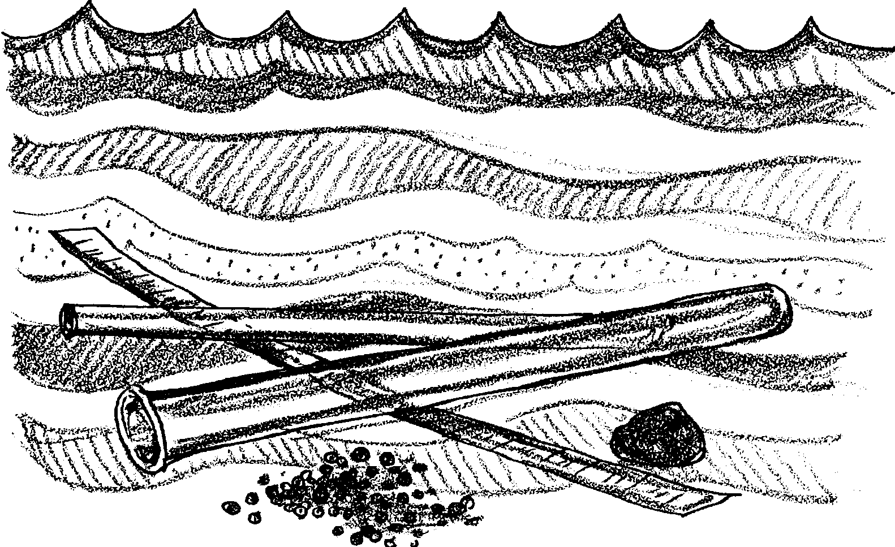
Part 1. Making a Test Tube Hydrometer
When a substance like salt is dissolved in water, the water becomes more dense. A hydrometer is a tool which measures the density of a fluid, by allowing you to measure how deeply it floats—or sinks—in the fluid.
A laboratory hydrometer is a weighted and sealed glass tube, but hydrometers can also be made from other things. Your challenge today is to make a hydrometer from the following materials:
• a test tube
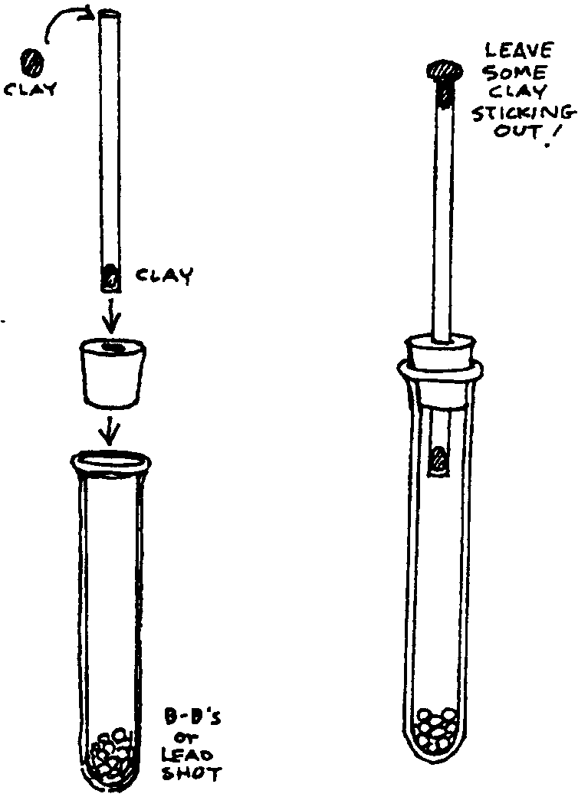
• a rubber stopper
• some b-b’s or lead shot
• a piece of glass tubing
• a small piece of oil-base clay
• a salinity scale strip

Putting It All Together:
Use the picture at the right to help you put it together. Gently, but firmly, press the tubing into the stopper and the stopper into the test tube. Put a dab of clay over the top of the glass tubing to seal out the water. Eventually you will also place the paper salinity scale inside the glass tubing, but first you must fine-tune the way it floats.
How many b-b’s should you put into the test tube? You will need to experiment a bit to find out. First place your hydrometer in a cylinder of fresh water provided by your teacher. You need it to float deep in the water so that the water level is above the stopper, somewhere along the piece of tubing. The top of the tubing, however, must not be below the surface. Add or remove weights until you can make it do this.
Now consider what will happen when your hydrometer is placed in salt water.

1. Will it float higher or lower than in fresh water?

What adjustments must you make to your hydrometer so that in salt water, the water level will also be above the stopper and along the glass tube?

Make these adjustments then test your prediction by placing your hydrometer in the container of salt water.

You may find that you still need to add or subtract some weight so that the water level will always be somewhere along the tube, whether the hydrometer is in fresh water or in salt water. Adjust it so that the water line is no closer than 1cm from either end of the tubing in salt or fresh water.

Marking a Scale:
You will soon be using your hydrometer to compare water of different salinities. You need a way of comparing different “floating levels” along the glass tube. A paper salinity strip, inserted into the tube will help you do this.

Remove the clay plug and slide your salinity strip into your hydrometer tube. The strip should stick out the top of the tube slightly. Carefully float your hydrometer in the cylinder of distilled water, without getting water over the top.

Note: If your glass tube is open on the bottom end, first remove the tube from the stopper and place a small clay plug in the lower end to keep the paper strip from falling through into the test tube!
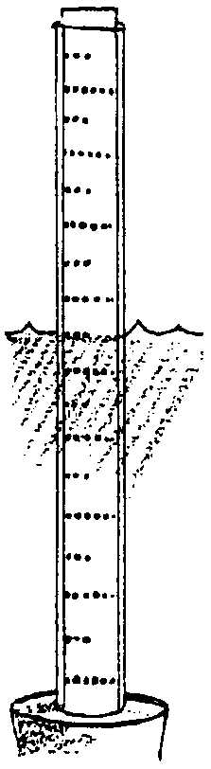
2. Now find the line on the salinity scale closest to the distilled water level around the hydrometer. What salinity does this line represent on your scale?

You will need to take the salinity scale out of the hydrometer to label this line, so how will you know which is the right line?

One way is to count the lines down from the top or up from the bottom. Do this a couple of times until you are sure.

Now take the hydrometer out of the water and pull out the salinity scale. Darken this line slightly with a fine pencil and label it as 0.

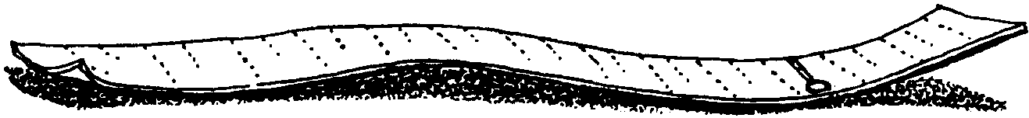
Before going on, reassemble the hydrometer and test it again in distilled water to be certain that the 0 line is correct.

Now place your hydrometer in the salt solution. This solution is 40 parts salt to 1,000 parts water, or 40 parts per thousand. This can also be written as 40 ‰.

Find the float line on your salinity scale in water of 40 ‰ salinity. Pull the paper strip out of your hydrometer tube, darken this line and label it 40.

Find the place that is exactly midway between the 0 and the 40 on your salinity scale. You can do this with a ruler or by carefully folding the strip. Label this line 20.

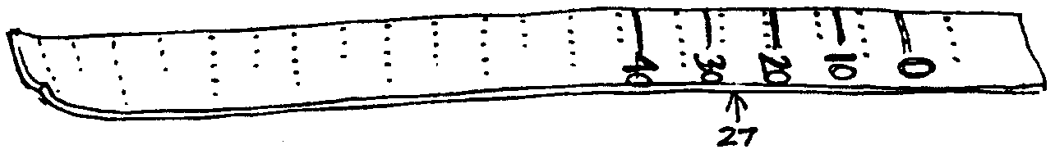
In a similar way, find the midpoints between 0 and 20, then 20 and 40. Label these points 10 and 30 respectively.

The small units on your salinity strip will not necessarily to exact units of salinity. You will need to use your powers of estimation to read values such as 26 or 27 with this tool.
3. Why do you only need to label the scale from 0 downward?

Insert the strip back into the hydrometer tube and snip off the extra paper. Seal the top of the tube again with clay. Put the hydrometer back into the water and see whether the water line is still at “0”. If it’s a little off, add or remove some clay to the top to make it exactly hit the mark.

Part 2. Testing the Water
Now put your hydrometer to work on these problems:

Problem 1: Does tap water have measurable salinity using your hydrometer?
a. First, predict what you would expect, and why.

Now test your prediction. Fill a tall jar with tap water, leaving 4 cm. at
the top.

b. Record the salinity you measure in tap water.

c. How would you explain your result?

Problem 2: How will adding salt to this water change the recorded salinity?

a. Predict the salinity of this water after one level tablespoon of salt is added to the tall jar.

b. Test your prediction. After making the addition, record the result.
c. Now predict the salinity after adding a second level tablespoon of salt.

d. Test your prediction. After making the addition, record the result.

e. How successful were you in predicting the effects of each of these additions?

