How Salty Is the Water?
Lesson by Holly Shewbridge, Monterey Peninsula School District, Monterey, California
and Karen Mattick, Marine Science Center, Poulsbo, Washington

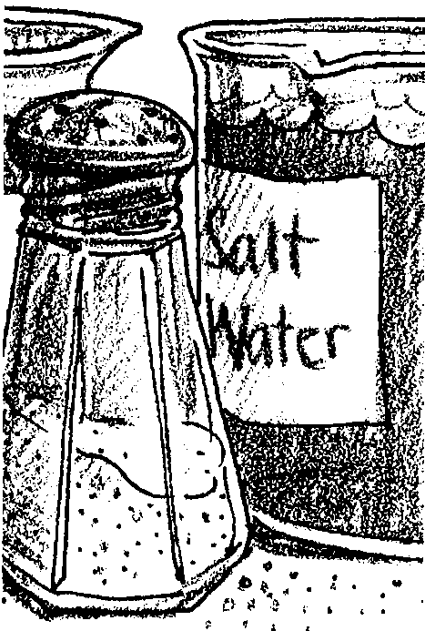
Key Concepts
- By evaporating a 1000 ml sample of sea water, the amount of salts and dissolved minerals present in the sample can be measured in grams.
- The resulting measurement can be used to determine the salinity of the sea water sample.

Background
Background for "How Salty Is the Water?" is found in the activities "Barnacle Beats" and "Salinity".

Materials

For each class:
- 1 plastic sandwich bag per person
- 1 or more large bags of table salt

For each group of students:
- 1000 grams of salt water
(If you mix your own, make sure it has a salinity typical of sea water, about 31 ppt.)
- enough beakers to hold the 1000 grams of saltwater
- a thermometer
- beaker tongs
- heat resistant tray or counter top
- balance
- graduated cylinder (50 ml)
- hot plate (or Bunsen burner setup)
- stopwatch or timer
- safety glasses or goggles

Teaching Hints
If your students are to create an experiment in "Barnacle Beats" to find out the range of salinities barnacles can tolerate, then they must have some sense of how salty salt water typically is. In "How Salty is the Water?", students boil 1000 grams of salt water and measure how many grams of salt is left behind. Students will discover how much salt is in salt water and will have concrete experience with what "parts per thousand" means.

When your students arrive:
- Begin "How Salty Is the Water?" by showing your students a jar with 1000 grams of seawater. Ask them how much salt they think is in the water. Distribute plastic bags and salt and ask the students to put in a bag the amount of salt they think equals the salt in the jar of salt water. Have them record the amount of salt they put in the bag on their student pages or on the bag itself, whichever you prefer.

- Now ask the students to brainstorm ways to actually measure the salt content of the water. Accept their suggestions. If a student suggests evaporating the water and measuring the salt left behind, use that idea as an introduction to the following lab.

- The students are now ready to evaporate a sample of sea water and measure the actual salt content.

This lab may be run as a station along with other salinity activities such as "Hydrometer Salinity" or it can be performed by a whole class in teams. It also works very well as a demonstration.

If you need to mix your own salt water, place 31 grams of salt in a container and add enough tap water to make 1000 grams of salt and water total.

Safety is an important issue in this lab, so be sure to demonstrate and review equipment use and procedures as needed. The careful use of Bunsen burners or hot plates is critical. Note the "CAUTION" in the student text. Do not let the beakers boil dry on the hot plate. They may crack even though they are heat-resistant Pyrex glass. Have students reduce temperature at this point. Remind students to use beaker tongs rather than bare hands to touch heated beakers. It is helpful to slightly tilt the beaker to reduce the spattering of salt. This portion of the procedure requires careful technique since all of the moisture must be removed from the salt while keeping the beaker whole.

Key Words
evaporate - to change from the liquid to vapor state
residue - matter remaining after a physical or chemical change
salinity - a measure of the salt concentration in a solution
salt - in this case, colorless or white crystalline solid, primarily sodium chloride
seawater - water from the ocean that has relatively constant proportions of dissolved salts and minerals.

Answer Key

Analysis and Interpretation
- Student responses will vary.

- The answers will depend upon the experiences your students had in performing the experiments. One improvement might be to use an oven to dry the sample thoroughly.

- Answers may vary. This question stresses the value of averaging repeated observations. Repetition shows obvious errors and gives results more likely to be correct.

- The salt concentration of the remaining solution increases.

- The salinity of the water in an estuary will increase when there is no or little rainfall and when stream and river flows are low. This might happen in summer and in times of drought. The salinity of areas typically dominated by river water may increase when storms mix the estuarine surface waters with deeper, saltier waters.
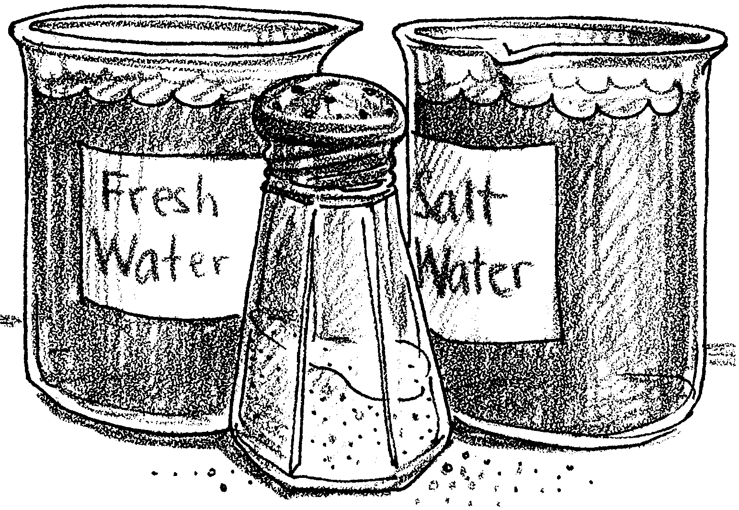
How Salty Is the Water?

1. Take a look at a jar with a 1000 grams of salt water. That’s about one liter of salt water. How much salt do you think is in that water?

Obtain a plastic bag and some salt from your teacher. Put in the bag the amount of salt you think equals the amount of salt dissolved in the 1000 grams of sea water. Record here the amount of salt you predict is in 1000 grams of sea water:

2. What ways can you think of to find out how much salt is in that salt water?

One technique is to evaporate the water from a sample of salt water and measure the salt left behind.
These are the materials you will need:

Materials:
• beakers to hold 1000 grams of sea water (about 1000 ml)
• thermometer
• salt water (1000 ml)
• beaker tongs
• heat-resistant tray or counter top
• balance and weights
• hot plate (or Bunsen burner setup)
• stopwatch or timer
• safety glasses or goggles

Procedure:

1. Use the balance to weigh the empty beakers. Record the total weights of all the empty beakers.
grams.

2. Measure 1000 grams of salt water using the balance. Pour it into the beakers.

3. Place the beakers on hot plate (or burner) and carefully heat the sea water. Wear safety glasses while heating the beakers.

CAUTION: Don’t let the beakers boil completely dry as beakers will crack. You do, however, want to evaporate all of the water.

4. When the water is evaporated, turn off the hot plate (or burner).

CAUTION: The beakers will be hot, so use the beaker tongs to remove the beakers from hot plate (or burner) and place them on the heat-resistant tray or counter. Let the beakers cool as needed.

5. Weigh the beakers with dry salt residue left in them. Record the weight in grams. Weight of beakers and salt:
grams

6. To find the weight of salt, subtract the weight of the empty beakers (#l) from the weight of the beakers plus the salt residue (#5).
beaker and salt residue (#5) grams
subtract empty beaker (#1) — grams
Weight of Salt = grams
7. The salinity of ocean water is commonly expressed as so many parts of salt material per 1000 parts of water. We use the symbol ‰ to express parts per thousand.
What is the salinity of your sea water sample in parts per thousand?
‰ (Hint: How many grams of salt were in your 1000 grams of salt water?)

Analysis and Interpretation:
1. How does the amount of salt in your plastic bag compare with the amount of salt you found in the sea water sample?

2. You have determined salinity by using the process of evaporation. What is one way in which you could improve the techniques used in this lab?

3. Scientists originally determined the salinity of sea water by evaporation. The investigators performed the experiment several times on samples of sea water from the same area. Why do you suppose they repeated the experiment rather than accept the first results without question?

4. As you evaporate the water, what happens to the concentration of the salt in the remaining solution?

5. Describe what might cause the salinity in an estuary to increase.

