Estuary Currents
Lesson by Karen Mattick
Marine Science Center, Poulsbo, WA.

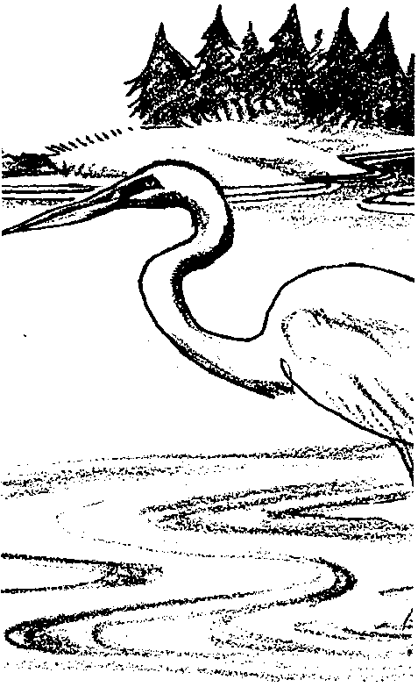
Key Concepts

- Salt water is more dense than fresh water.
- Differing densities of water sources in an estuary create water layers.
- The fresh water and salt water that meet in an estuary bring minerals and organic material to the estuary.

Background
How fresh water and salt water behave when they come in contact in an estuary determine many of the characteristics of that estuary. The fresh water streams pick up minerals and decaying matter as they travel from mountain tops, through forests, and across meadows, grasslands or swamps. Salt water accumulates detritus from the wastes and decaying bodies of plankton and other marine organisms. The fresh water and salt water tend to layer when they meet, driving slow currents that accumulate and then distribute these minerals and detritus. These two types of water sources and the ways they behave create an incredibly rich environment that teems with the seafood resources humans prize.

Materials

For each lab group of 2 - 4 students:
- one large, clear bowl or other container (about 12 inches across or so)
- two paper cups
- two straight pins
- two colors of food coloring
- copies of the "Estuary Currents" student pages

Teaching Hints
"Estuary Currents" examines how freshwater and saltwater behave when they come in contact with each other as happens in estuaries. This experiment works well as a demonstration or as a lab activity. If you choose to do it as a demonstration, use larger materials. Use a 10 gallon aquarium in place of the glass dish and two 2 liter pop bottles in place of the paper cups. You will need dissecting needles, ice picks or some other larger sharp points in place of the straight pins.

Procedure:
- Show students the map of Boundary Bay and remind them that Boundary Bay is an example of an estuary, a place where rivers meet the sea.
Ask the students to describe what they think might be in the river water. Ask them to think about all the places through which the river water may have traveled and the surfaces it may have scoured in its journey to the bay. What substances might be dissolved in the water? Explain that rivers carry decaying leaves, grass, insects and other organic matter and they carry minerals from rocks and soil.
Then ask the students to describe what might be in the salt water. If they have studied deep sea environments, remind them of the marine snow, the detritus, that falls in deep salt water.
Explain that students will model mineral and nutrient-rich fresh water rivers and detritus laden ocean salt water meeting in an estuary. Tell them to watch what the water does. Explain that, ultimately, the class will be trying to understand how these interactions between two types of water shape the lives of the organisms that live in the estuary.

- Fill a clear dish with salt water. (The water level in the dish must be lower than the height of the paper cups because you will be placing the paper cups in the dish of water later and you don't want the saltwater to spill into them.) Explain that this dish represents Boundary Bay or some other estuary.

- Fill a paper cup quite full with fresh water. Explain that this cup represents a river. Add a few drops of food coloring to the cup so that students can trace the movement of the water in the experiment. Make sure students understand that the food coloring resources are limited and that, when they do this, they only need a few drops in their model rivers.

- Place the cup inside the clear dish, to one side. (The paper cup will have to be full enough so that it will rest on the bottom of the dish instead of floating.) Insert a straight pin into the cup in the top half of the cup.

- Ask students to draw on their own paper or on a copy of the "Estuary Currents" data sheet what they think the waters in the dish will do when you remove the straight pin.
- Explain that you will be providing students with materials to duplicate the setup you have made, and that they will be removing the pin on the model they make at their tables. Ask them to record what really does happen when they remove the pins from their cups in their set-ups.
- Now ask them to model other situations.
a. Have them add a second cup in the other side of their dish with colder, saltier ocean water that flows into Boundary Bay. They should color this water a new color. Before removing the pin, they should draw a prediction of what will happen. After removing the pin, they should draw their results.

b. Have them model rainfall entering their dish. Some students may elect to punch holes in their freshwater cup and allow the fresh water literally to rain on their bay.

c. When students have a dish with distinct layers of colored water, have them add wind to their bay. They should blow across the surface of their dish until they see a distinct change in their bay. (The surface fresh water should begin to pile up on the opposite side of the dish and travel down to the bottom. The cold salt water layer on the bottom should begin to rise to the surface on the side near the student who is blowing.)

- Ask students to complete their data sheets, clean-up their materials and answer the analysis questions.

Key Words
density - the amount of matter (mass) per unit volume

dissolve - to cause to go into solution

salinity - a measure of the salt concentration in a solution

salt - in this case, colorless or white crystalline solid, primarily sodium chloride

Answer Key
- Salt water is more dense than fresh water. For example, students will see fresh water from their paper cup river resting on top the salt water in their dish.
- River water tends to float on top of salt water when it enters a bay. It creates what biologists call a "fresh water lens" in the water.
- The perch probably was swimming in river water that was layering on top the salt water as the river flowed into the bay. The cod was swimming in its natural salt water below the river flow.

- Student responses will vary. Estuary organisms must be able to tolerate wide variations in salinity. Rainfall and river flow decrease salinity while incoming ocean water increases salinity. These waters with differing salinities may layer at some times and then mix in stormy weather and change the overall salinity in the estuary.

- Windy, stormy weather mixes bay, river and ocean water together, distributing the minerals and organic matter throughout the water.

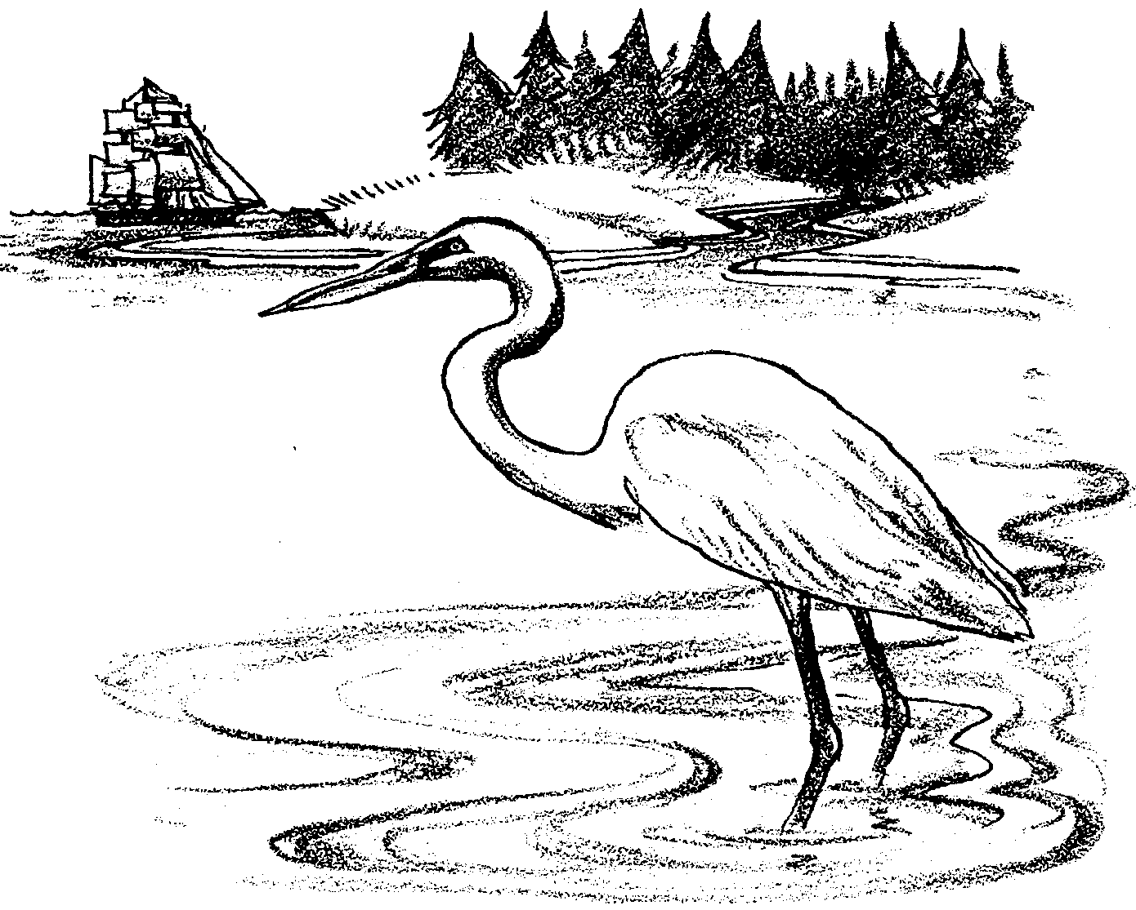
Estuary Currents

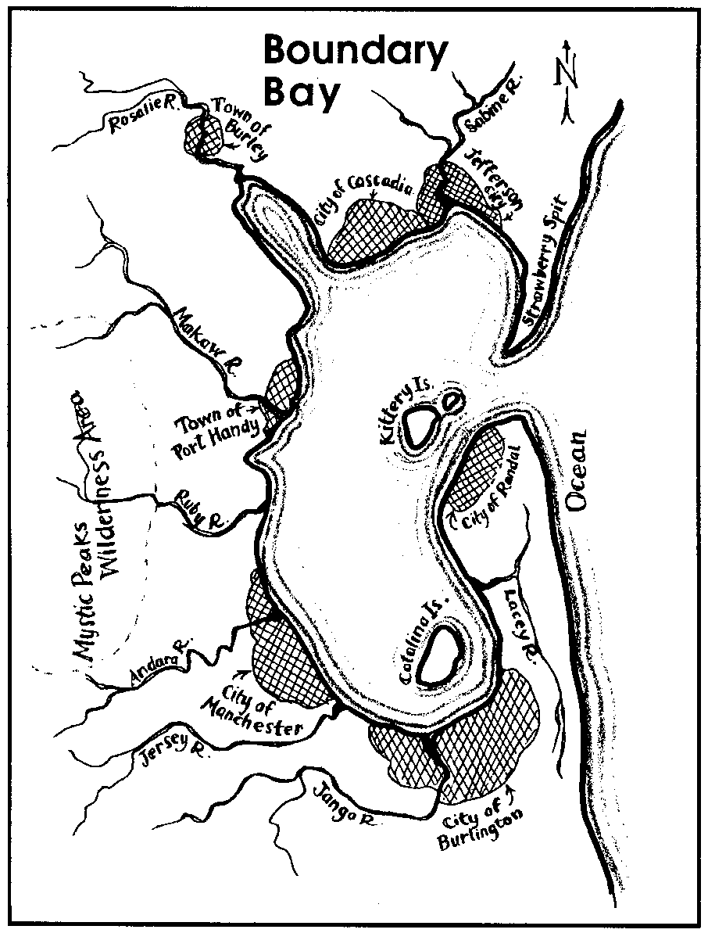

An estuary is a place where rivers meet the sea. The rivers carry minerals and decaying matter m the land to the salt water. These nutrients mix with the detritus in the salt water to make an incredibly rich environment.

In this activity, you will model fresh water and salt water meeting in the estuary. How these waters meet and mix in the estuary shapes the lives of the animals that live there.

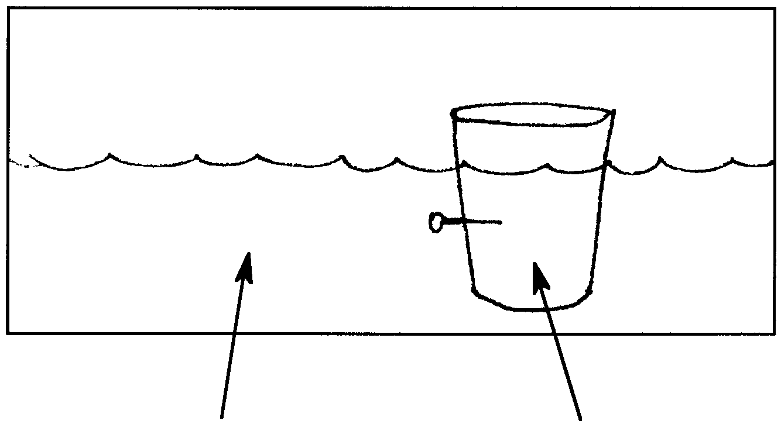
1. A model of a freshwater river entering a saltwater bay:
Circle the
River OR Estuary
Freshwater OR Saltwater
River OR Estuary
Freshwater OR Saltwater
correct answers:

Add arrows to the drawing above to show where you think the water will go when you pull the pin out.
Pull the pin out. Draw arrows to show where the fresh water went.
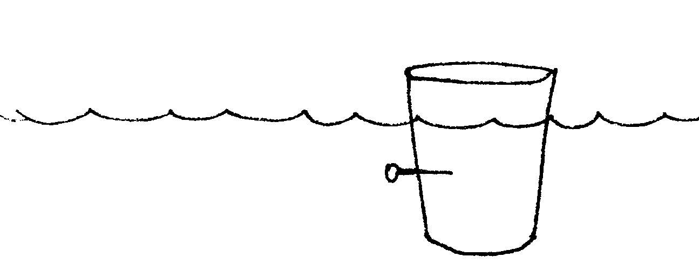

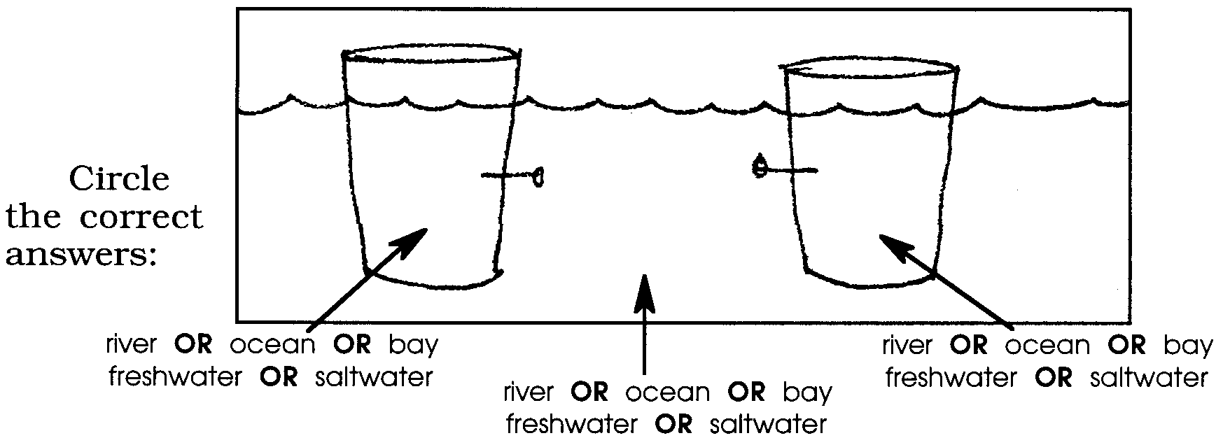
2. A model of fresh river water and very salty ocean water entering a saltwater bay.

Add arrows to the drawing above to show how you think the water will flow when you pull the pins out.

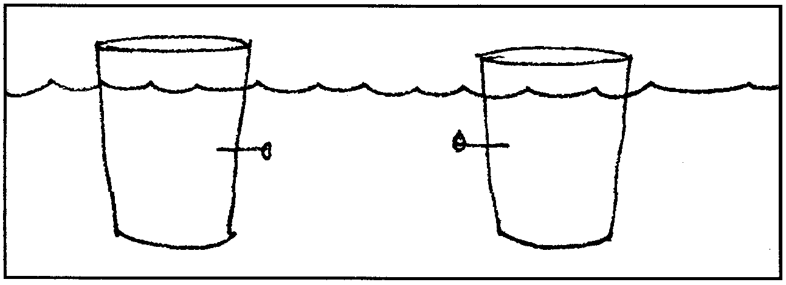
Remove the pins and observe the water flow. Draw below what the water currents actually did.

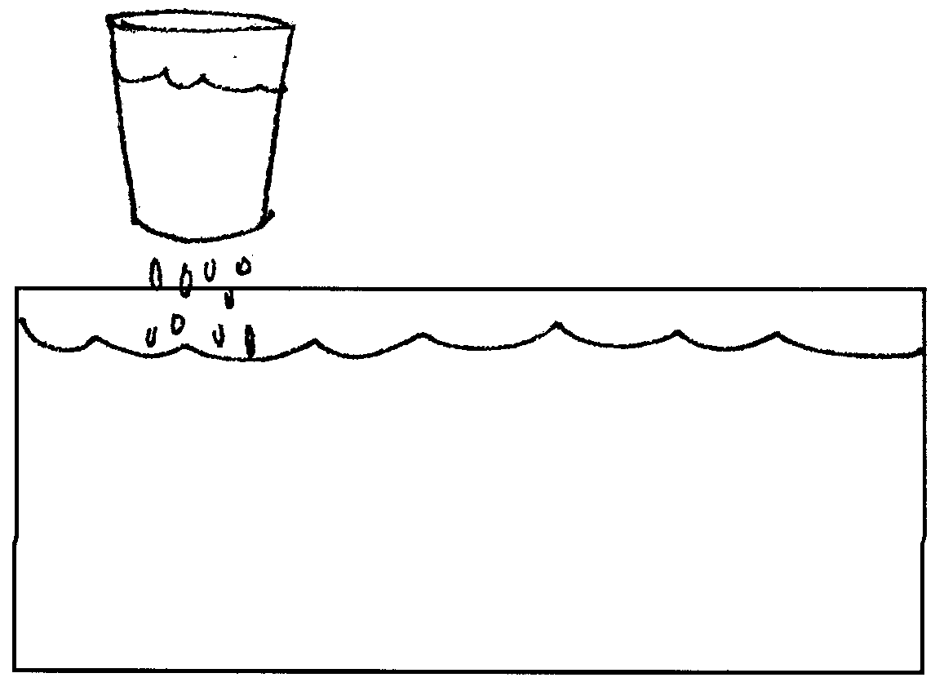
3. A model of rainwater falling on a saltwater bay.

Add arrows to the above drawing to show where you think the rainwater will go after it falls on the salt water.

Try this model and draw what the rainwater really does.

Do not disturb the dish and try the next model.
4. A model of wind driven currents in an estuary.

Blow gently but steadily across the surface of your bay until a pattern in the water movement is evident. Have a partner observe and describe to you how the fresh rainfall behaves as the wind blows across the surface.

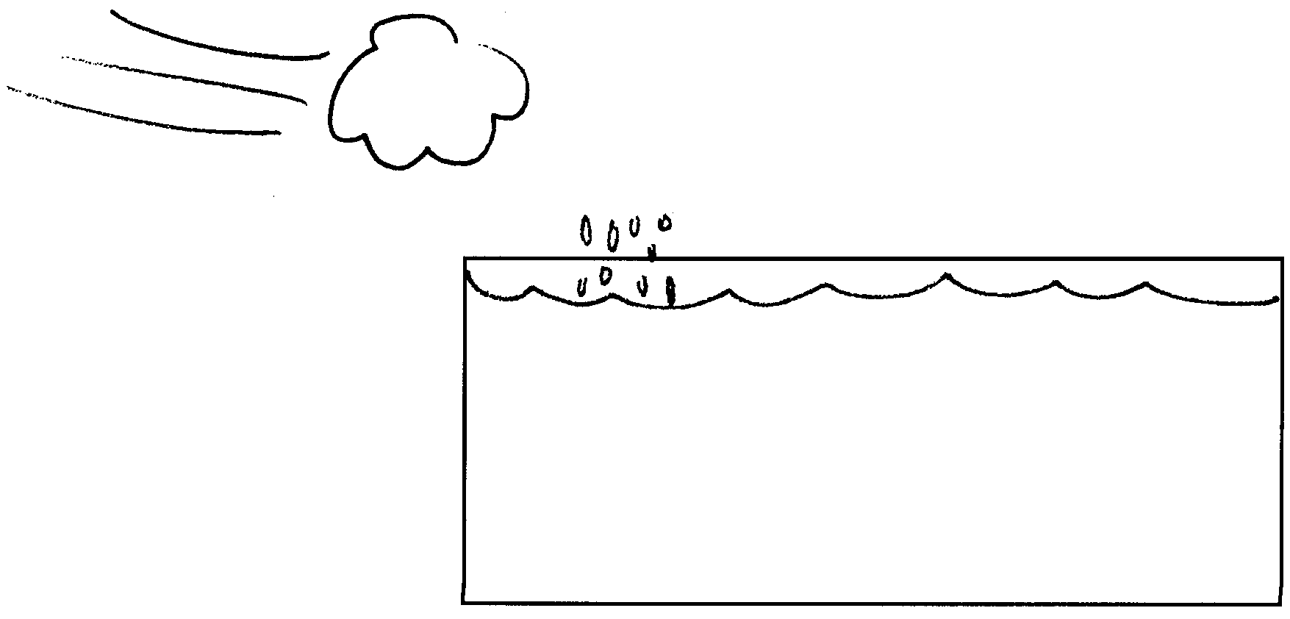
Sketch below how the rainwater moved as the wind blew across the surface of the water.

Analysis Questions

1. Is salt water more or less dense than fresh water? In other words, is a quantity of salt waver heavier or lighter than the same quantity of fresh water? Give an example of something in your experiments that demonstrated this.
2. Where does river water go when it flows into a saltwater bay or ocean?

3. A man was fishing near the mouth of a river. He caught a freshwater perch that was swimming about five feet down. Later that day he caught a saltwater cod that was thirty feet down. He is amazed that he was able to catch a freshwater fish and a saltwater fish at the same fishing place and has decided to tell all his friends about his good fortune. How would you explain the occurrence of these two species of fish in the same area?

4. What special stresses would you imagine estuary animals face living where rivers meet the sea?

5. Under what weather conditions would you expect there to be the most nutrients available to organisms throughout the estuary? Explain your reasoning.

