Water Quality Monitoring:
The Big Picture


Key Concepts
1. Each water quality test provides a little bit of information about the state of the waters that have been tested.
2. Since the factors tested in determining water quality don't operate independently, scientists like to look at the water quality test results as a whole in determining the "health" of the water.

Background
By now your students have been exposed to a range of water quality tests. It is quite likely, however, that they are wondering what all of these results mean. Just what do their results tell them about the health of local waters? In an effort to integrate these water quality tests, “The Big Picture” uses a “Water Quality Index” devised by the National Sanitation Foundation and found in Field Manual for Water Quality Monitoring by Mark K. Mitchell and William B. Stapp (1986. 2050 Delaware, Ann Arbor, Michigan, 48130). The index compares the results from nine water quality tests by weighting the relative importance of each of the nine factors measured.
In developing the “Water Quality Index”, the developers ranked the nine tests and determined weighting factors which, they felt, reflect the relative importance of each factor in terms of overall water quality. A “Weighting Curve Chart” and a “Weighting Factor” were developed for each of the water quality parameters. The series of charts and factors is presented in the student text along with stepwise directions for their use in determining the “Overall Water Quality Index” for the sampled waters.
Calculating the “Water Quality Index” yields a number between 0 and 100. The higher the number, the higher the water quality. An index number above 80 indicates relatively good water quality, a number below 65 indicates relatively poor water quality. A major benefit of the “Water Quality Index” is that it provides a common basis for readily comparing water quality in different areas.

Materials
For each student or team of students:
• one copy of “Water Quality Monitoring: The Big Picture” student pages
• copy of student water testing data

Teaching Hints
“Water Quality Monitoring: The Big Picture” provides a technique and background information for integrating results from nine water quality tests to determine a “Water Quality Index”, which is used as a measure of the health of the waters tested. The activity involves both reading and plotting graphs. Since not all students are facile in interpreting data presented graphically, circulate through the classroom as the activity is performed, offering the appropriate assistance as required.

Key Words
index number - a number or formula expressing some property of something indicated, in this case, water quality
parameter - element or aspect; in case, an individual water quality test
“Q” value - in this case, a calculated value derived for each of nine water quality tests from graphs prepared by Mitchell, Stapp, and National Sanitation Foundation.
Water Quality Index - guidelines for comparing water quality developed by Mitchell, Stapp, and National Sanitation Foundation who ranked nine water quality tests and determined weighting factors which, they felt, reflect the importance of each factor in terms of overall water quality
weight - in this case, the relative importance of a water quality test

Answer Key
1. Scientists like to look at the water quality test results as a whole because the factors tested in determining water quality do not operate independently.

2. Rank order assigned by your students will vary depending upon their knowledge of the importance of each of the factors measured to the water quality. Use the discussion generated by the varying rankings to provide a rationale for the choices made by the developers of the “Water Quality Index.” The rank order numbers noted in the blanks below reflect the status assigned by the developers. The most important factor is ranked as number 1.
a. 1 dissolved oxygen

b. 5 temperature

c. 8 turbidity

d. 2 fecal coliform

e. 7 nitrates

f. 9 total solids

g. 3 pH

h. 6 total phosphorus

i. 4 B.O.D.

3. Two benefits in using the “Water Quality Index” include that it:
a. provides a common basis for comparing water quality in different areas, and
b. integrates the different water quality tests.

4 a. Site I (Q=87.05) has the highest water quality.

b. Site II (Q=67.34) merits additional, more sophisticated testing because of its relatively poor water quality rating.

c. Sites I, II, and III (Q=78.03) merit on-going testing because the scope and nature of activities affecting water quality change over time.

Analysis and Interpretation
1.- 5. Answers will vary depending upon experimental results. It is important to have your students speculate about the factors that might be responsible for the outcomes they observed and that they outline some action steps they might take to improve or maintain the water quality in their area.

Water Quality Monitoring:
The Big Picture

Dissolved oxygen, total suspended solids, phosphates...how can we make sense out of all of these water quality tests? What do they tell us about the health of our waters?
Each water quality test provides a little bit of information about the state of the water. But the factors we test in determining water quality don’t operate independently. Temperature affects the concentration of dissolved oxygen, total dissolved solids affect turbidity and so on. Because of these interactions, scientists like to look at the water quality test results as a whole in determining the “health” of the water.

1. Why do scientists like to look at the water quality test results as a whole?

In an effort to integrate these water quality tests, the National Sanitation Foundation has devised the following “Water Quality Index”. The index compares the results from nine water quality tests by weighting the relative importance of each of the nine factors measured.
2. You already know something about the importance to the water quality of each of the factors measured. Use your knowledge to rank the nine factors tested from most important to least important. Write the rank order numbers in the blanks provided. Rank the most important factor as number 1.
a. dissolved oxygen
b. temperature
c. turbidity
d. fecal coliform
e. nitrates
f. total solids
g. pH
h. total phosphorus
i. B.O.D.

Just as you did, the creators of the “Water Quality Index” sat down and ranked the nine tests. They also decided how much more important one factor is than another in terms of overall water quality. For example, while both total solids and dissolved oxygen are important, dissolved oxygen is considered more important because of its immediate impact on life in the water.
Using the following directions in calculating the “Water Quality Index” yields a number between 0 and 100. The higher the number, the higher the water quality. An index number above 80 indicates relatively good water quality, a number below 65 indicates relatively poor water quality. A major benefit of the “Water Quality Index” is that it provides a common basis for comparing water quality in different areas.

3. What are two benefits in using the “Water Quality Index?”

a.

b.

4. Students sampling in three different areas found the following overall “Water Quality Index” figures:

site I - 87.05

site II - 67.34

site III - 78.03
a. Which site has the highest water quality?

b. Which site(s) merit additional, more sophisticated testing?

c. Which site(s) merit on-going testing?

To determine the “Water Quality Index” you must first compute something called the “Q” value of your results for each parameter. The graphs below will enable you to compute the Q-values for your water sampling results.

For example, a coliform count of 1,000 was measured at one of your sites.

Here’s how to compute the Q-value for this test and sample:
• locate the weighted “Fecal Coliform Test Results” chart.
• find 10,000 on the horizontal axis and
• follow the line up until it intersects the curved line.
• draw a horizontal line from the point of intersection to the left vertical axis.
• read and record “10” on the vertical axis.
• this number, “10”, is your Q-value which you enter in the correct spot on your data sheet. The Q-value is next multiplied by the weighting factor of .16 and recorded in the Total Column.

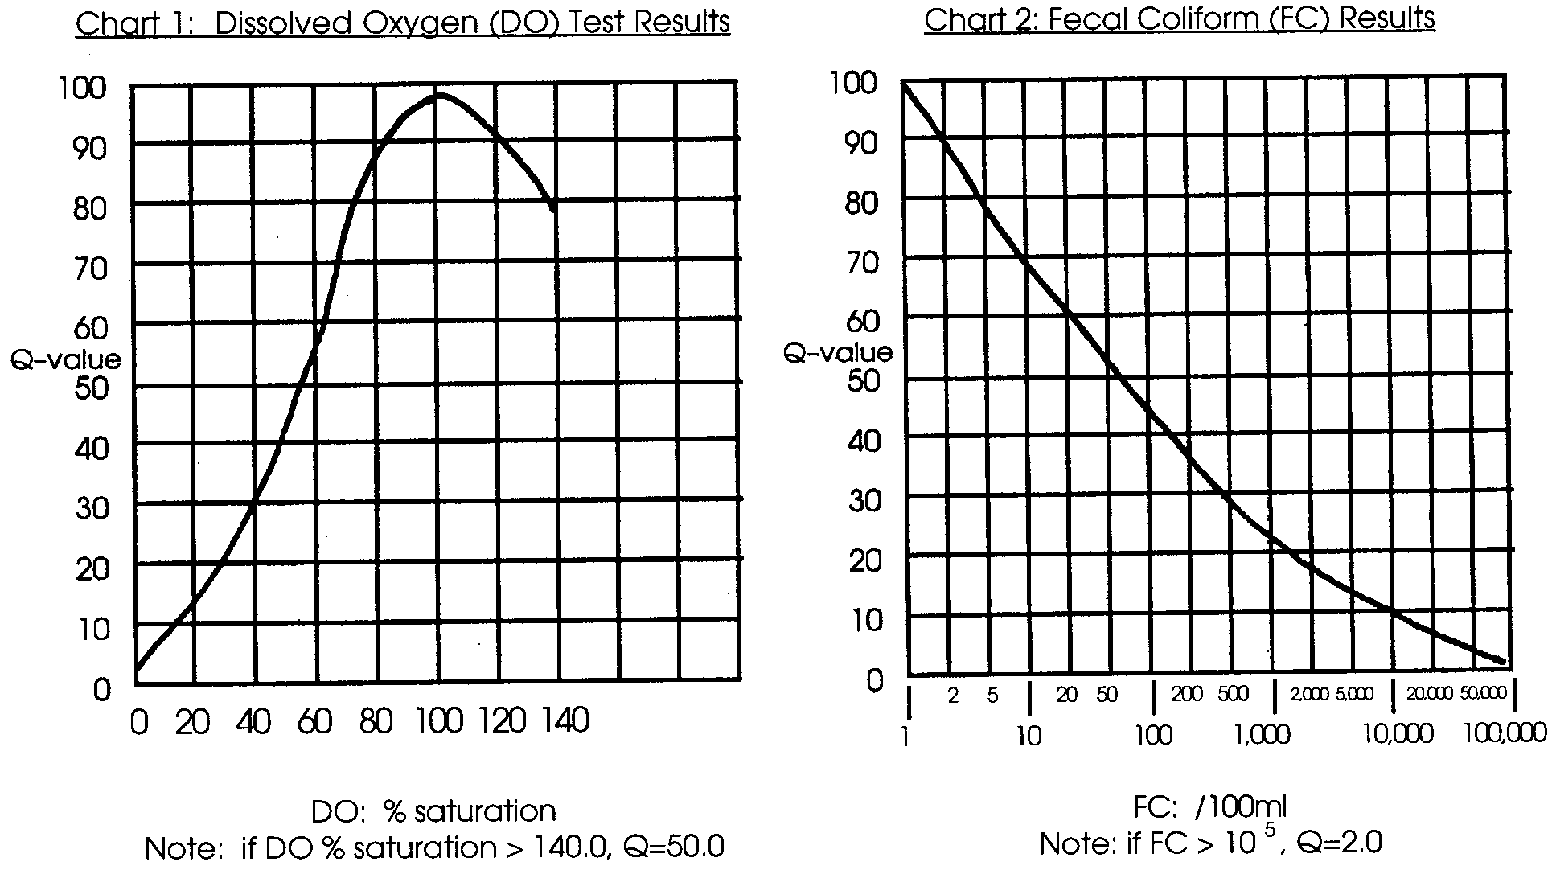
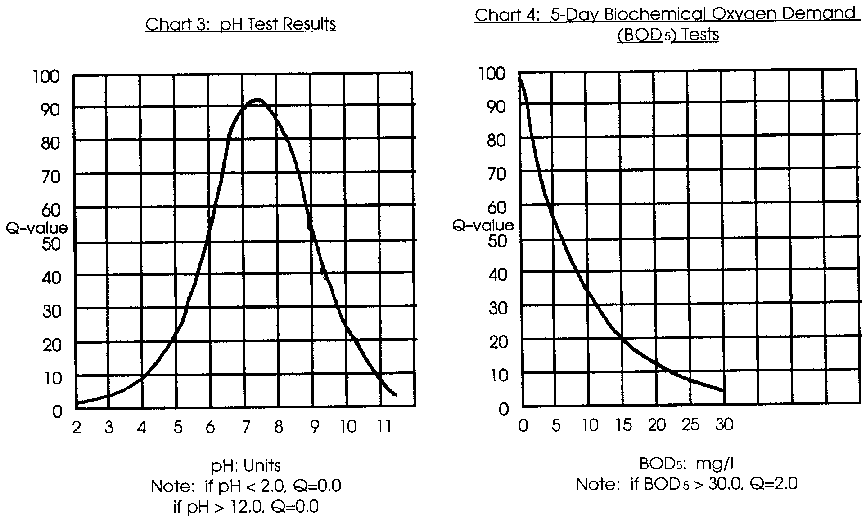

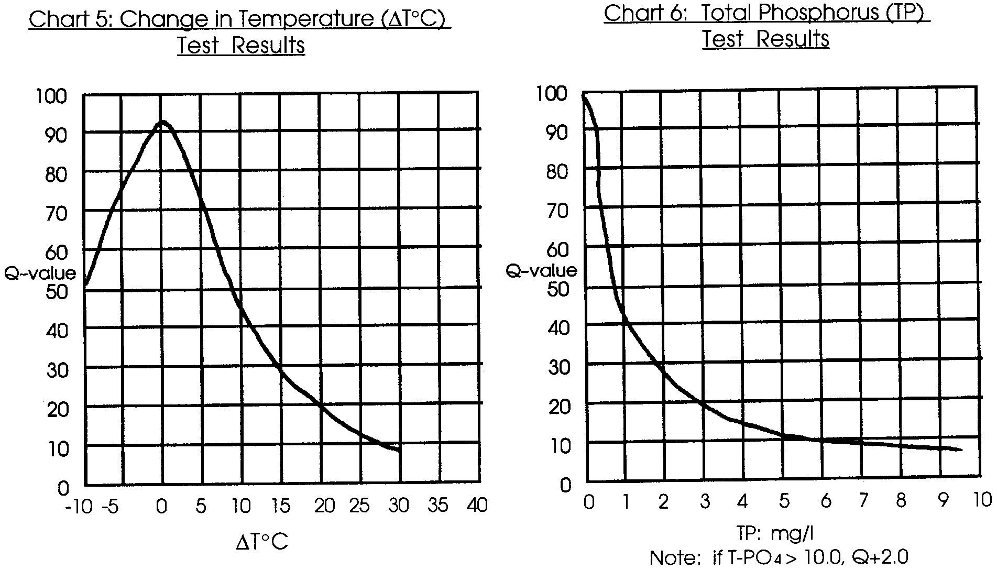
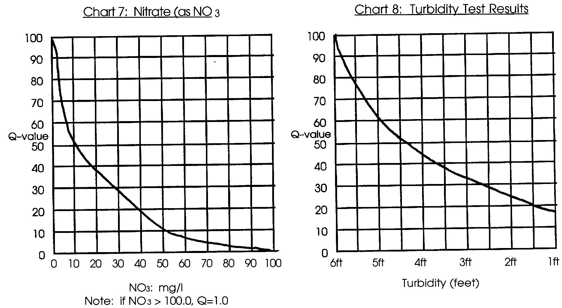
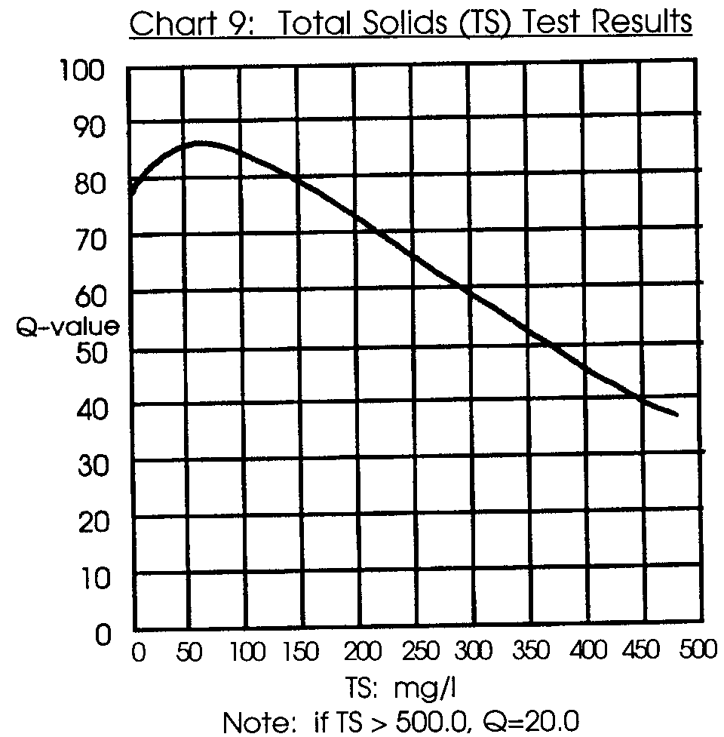
After the nine tests are completed and the results of each test recorded, the Water Quality Index (WQI) for your site can be computed. As in the example, you must first compute the Q-value of your results for each parameter. To do that, follow these steps:

1. Take the test results from one of the nine parameters and find the weighting curve for that parameter.

2. Locate your test result value on the bottom (horizontal) axis of the chart.

3. Interpolate your test result value to the Q-value on the left hand side of the chart (vertical axis), using the following steps:

a. From your test result value at the bottom (horizontal axis) of the chart, draw a vertical line up until it intersects the weighting curve line.

b. From this point of intersection, draw a horizontal line to the left hand side of the chart.

c. Where the horizontal line intersects the left hand side of the chart, read off the value. This is the Q-value, and should be recorded for this parameter on the WQI data chart.

4. Repeat these steps and find the Q-values for each parameter using the respective weighting curves or scale.

The weighting curve value for each parameter should then be multiplied by the weighting factor listed on the chart for that particular parameter. Record this value in the Total Column of the WQI data chart.
When you have completed each value of the nine tests, add the total score for the Water Quality Index.
Water Quality Index (WQI) Data Chart

Date Time

Test Location

Weather Conditions
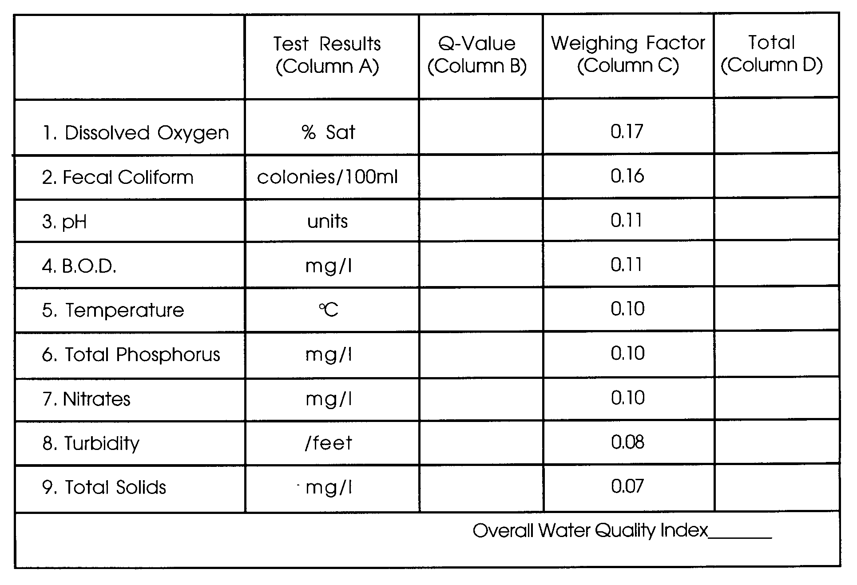

Instructions:

1. Record the water quality data in Column A

2. Record the Q Value (from the charts) in Column B

3. Multiply the values in Column B by the weighting factor in Column C and record the results in Column D

4. Add the values Column D to get the Overall Water Quality Index
Analysis and Interpretation
1. What was the Overall Water Quality Index for your site?

2. Recall that the higher the number, the higher the water quality. Use your Overall Water Quality Index to make a statement about the quality of water at your site.

3. What are some of the human activities occurring in the area in which you collected the sample?

a.

b.

c.

4. How do these activities relate to your “Overall Water Quality Index”?

5. If you have a low Water Quality Index rating, what are some steps you might take to improve the water quality in your area?

