Water Quality Monitoring:
Coliform Bacteria

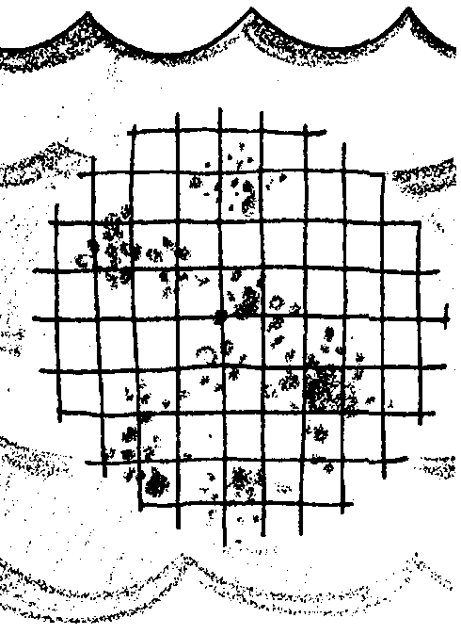
Key Concepts
1. The presence of coliform bacteria in water is used as an indicator of sewage pollution.
2. Micro-organisms in sewage can cause diseases that harm humans.
3. Large numbers of bacteria can reduce the dissolved oxygen available for fish and other aquatic life.

Background
One of the parameters used to monitor water quality is the measurement of fecal coliform bacteria levels.
Fecal coliform are naturally occurring bacteria in the intestines of mammals, including marine mammals and humans. Many strains are not harmful and some are beneficial, assisting in digestion or outcompeting more harmful microorganisms. Some coliform bacteria, however, can be toxic. Contamination of hamburger with a strain of coliform bacteria in 1993 led to severe illness and, in some cases, death.
High levels of fecal coliform in water may include toxic bacteria but, perhaps more important, high levels of coliform bacteria indicate the presence of untreated sewage which may contain far more dangerous pathogens such as the hepatitis virus. It is difficult to detect viruses because they are so small; measurement of fecal coliform bacteria levels is a more practical way to predict the presence of pathogens.
Since time immemorial, cities located along lakes, rivers, or the ocean have disposed of their sewage and industrial wastes by dumping them into these bodies of water. We are no different in this respect from our ancestors. Today, the wastes may be pumped directly on to the beach, discharged into shallow waters just offshore, or discharged into deeper waters (50-200 feet) a few miles offshore. Treatment of the wastes range from none to chlorination, bacterial decay, settling and oxidation of organic materials. Waters, in general, and the ocean in particular, can handle a reasonable burden of wastes. Waves, tides, and currents mix the wastes and dilute their toxicity. Unfortunately, we are now seeing evidence that these bodies of water including the ocean are unable to keep pace with waste overloading.
Materials
• water sample(s)
• Millipore filtration unit with hand pump
• Petri dishes, 47 mm
• Millipore filters with absorbent pads, HAWG 47 mm, 0.45
• sterile forceps, blunt
• 70% alcohol for sterilizing
• media - ampoule containing 2 ml MF-ENDO Medium (pink)
• ampoule breaker
• sterile pipette, 1 ml in 1/10
• sterile pipette, 50 ml or 100 ml
• graduated cylinder
• distilled or sterile dechlorinated water
• incubator
• binocular scope, hand lens or colony counter
• boiling water
• tongs
• alcohol lamps and matches
• marking pens
• tape
• safety glasses
• copies of “Water Quality Monitoring: Coliform Bacteria” student pages

Teaching Hints
“Analysis of Water for Coliform Bacteria Pollution” focuses on techniques for detecting the presence of coliform bacteria. Health departments use similar techniques to determine whether waters are safe for shellfishing, swimming and other uses.
This lab is most easily completed by using the following schedule:
Activity 1 -“Water Quality Monitoring: Coliform Bacteria” student pages
Activity 2 - Preparation for the lab
Activity 3 - Completion of the lab

Activity 1: Student reading

Familiarize yourself with the operation of the Millipore apparatus. The Sterifil apparatus is durable and relatively inexpensive. It can be used for a number of water and air quality experiments. While the apparatus is provided from the manufacturer with a “User’s Guide”, instructions for use are also included in the student text.
Distribute the student reading and discuss the questions in the reading.
Activity 2: Preparation for the Lab
Gather all the materials except the water samples to be tested.
It is not necessary for each group to have a Sterifil apparatus. While four Sterifil filters per class of 30 is convenient, a class of 30 can do this activity with one Sterifil filter by combining this activity with “Microscopic Forms: Marine Bacteriology” or “Glowing in the Dark: Bioluminescence”. Groups of four are practical for this experiment.
Safety practices when using HAWG filters on the Millipore equipment:
Millipore filters will “flash burn” if accidentally ignited. Caution students to let the forceps cool for a few seconds after flaming but before they use them to pick up the filter. This pause will prevent the filter from being scorched.
If there is any residual moisture on the filter base, it will dampen the filter slightly, but this does no harm.
MF-ENDO Medium - This medium will STAIN skin, clothing, etc. if it comes in contact with same.
It is highly recommended that you do a pre-lab session with students to cover the following points which will facilitate a smooth performance of this lab:
1. Distribute student text, and read the procedures together, highlighting important information.
2. Identify the names and function of the equipment: Sterifil filtration apparatus, Millipore pads and filters, MF-ENDO medium, etc.
3. Demonstrate how to flame forceps kept soaking in 70% alcohol and explain safety precautions to prevent flash burn. Minimize risk of fire by having forceps and alcohol separated by some distance from the alcohol lamp.
4. Demonstrate method to extinguish fires or burning alcohol.
5. Note that the blue wax paper discs in the filter envelopes are part of the packaging and should be discarded. White, absorbent pads are also found in filter box.
6. Divide students into teams of four. Teams should decide who will be responsible for the following jobs:
a. One person to obtain and operate the Sterifil filtration apparatus.
b. One person to obtain the previously collected water and the distilled water. This person also adds sample and distilled water to funnel.
NOTE: If you have water samples representing more than two sources, assign student teams accordingly.
c. One person to prepare the Petri dish for one of the two water samples and label the dish with the source of the water.
NOTE: While one Petri dish per team for each sample is adequate when the data is pooled, each member of the team will have a filter to count if each team filters each of the two samples two times.
d. One person to prepare the Petri dish(es) for a second water sample and label dish(es) with the source of the water.
7. Perform a dry-run of the lab allowing each student to explain their part and to handle equipment where appropriate.
REMIND STUDENTS OF THE PROPER TECHNIQUES
FOR HANDLING BACTERIA.

Activity 3: Completion of the Lab

Obtaining water samples: Water samples may be obtained from your local sewer plant, sloughs or estuaries (at low tide) where boats are kept or along coastlines where factories or fish processing plants are located.
NOTE: E. coli does not survive seawater exposure for more than a few hours so this may affect where and when you collect samples.
Making an “insurance culture”: You may wish to make one of the water samples a “mystery sample”, made to insure a coliform count. To make a “mystery sample”, complete the following:
1. Prepare 200 ml of nutrient broth.
2. Place 50 ml of nutrient broth in each of four Erlenmeyer flasks, plug and sterilize.
3. Allow the broth to cool to room temperature.
4. Inoculate two of the flasks with a loop of E. coli.
NOTE: A slant of E. coli may be obtained from a local college or a science supply house.
5. After 24 hours, check for growth. The nutrient medium will be cloudy.
Counting the colonies: To facilitate colony counting, place the dried filter between 2" x 3" slides (hinged with tape) and examine for coliform colonies under a 5-10X stereo microscope. The illumination should be nearly perpendicular to the filter from above. Count all coliform (green sheen) colonies on the filter. Ideally, the number of colonies should be between 20 and 80. If over 200 colonies are present, the water sample should be diluted as described in student text. Express results in terms of coliform per 100 ml of sample water.

Number coliform/100 ml = Number of coliform colonies observed x 100
Volume of original sample filters (ml)

Cleaning up of equipment: While it is unlikely that pathogenic bacteria have established themselves on the Petri dishes, it is possible. Destroy the bacteria colonies by incineration of the filter and pads or by soaking in bleach. Sterilize the Petri dishes as detailed below. It is important to destroy the colonies to demonstrate to your students the proper technique and regard for potential pathogenic infection.

Resterilization of Petri dishes: Petri dishes for the Millipore technique are made of transparent plastic with close-fitting covers to keep the media from drying out. They are sterile as supplied and cannot be boiled without affecting the plastic. However, they can be re-sterilized by the special soaking technique described below:

1. Use forceps to carefully remove the Petri dish covers. Put the covers and dishes (with cultures) into a large pan containing liquid household bleach (straight from the bottle).

2. After 10 minutes, remove the Petri dishes using tongs or a rubber glove and rinse well under running water. Discard wet pads and filters .

3. Immerse the dishes and covers in a solution of 70% alcohol for 10 minutes (you can use ordinary rubbing alcohol).

4. Remove the Petri dishes and assemble on a clean surface. They are now ready for use.

Key Words
aliquot - a sample which is a known fraction of the whole
coliform bacteria - a group of generally benign bacteria normally found in the digestive tracts of people and other vertebrates; see fecal coliform bacteria
colony - a visible aggregation of microorganisms on a nutrient medium caused by the reproduction of a single microorganism
decomposer - organism that cannot produce its own food but breaks down dead material from which it derives its needed energy and nutrients
dysentery - an infectious disease of the lower part of the bowels accompanied by diarrhea; also used generically to refer to diseases with similar symptoms
fecal coliform bacteria - a group of generally benign bacilli commonly found in the intestines of humans and other vertebrates and used as an indicator of sewage pollution in water
feces - solid waste matter discharged from the intestines
monitoring - the act of observing, recording, or detecting with instruments that have no effect upon the object observed; watching closely
nutrients - minerals and other substances needed for life and growth
typhoid fever - an infectious, often fatal, disease characterized by intestinal inflammation caused by typhoid bacillus which is often introduced through ingestion of contaminated water
Answer Key
1. Decomposers are organisms that break down organic material thereby releasing nutrients necessary for the growth of plants. The decomposers are the recyclers of the ecosystem.

2. Many factors influence the number and kinds of bacteria present in natural waters. These include: the source of the water, its temperature, the types and concentrations of dissolved minerals present, and the types and concentrations of dissolved organic materials (sewage, etc.).

3. Large numbers of bacteria can affect normally balanced water ecosystems by reducing the oxygen available for fish and other aquatic life. The reduction in oxygen levels can cause death.

4. Coliform bacteria are normally found living in the digestive tract of people and other mammals. They get into water supplies through improper disposal of sewage and from agricultural and urban runoff carrying animal wastes.

5. People are interested in monitoring the number of coliform bacteria in drinking water because the coliform bacteria are a good indicator of pollution since fecal coliform do not normally reproduce outside of the digestive tract. The presence of large numbers of coliform bacteria shows the almost certain presence of other harmful bacteria.

6. Water quality experts sample water for coliform bacteria rather than for pathogenic organisms like Salmonella typhosa because coliform are always present in sewage and more difficult to kill than the other organisms. If coliform bacteria are not present in the test sample, we can be reasonably sure that no other-bacteria due to sewage pollution are there either.

7. The following is the proper sequence for the steps of the Millipore Membrane Method:
5 a. The number of coliform bacteria colonies are counted.
1 b. A water sample is collected in a sterile container.
3 c. The filter from the Millipore apparatus is placed in a Petri dish with a pad that has been soaked with a prepared culture medium.
2 d. The water sample is filtered using the Millipore apparatus.
4 e. The Petri dishes are incubated while the bacteria colonies can grow.

8. The green sheen color distinguishes coliform bacteria colonies from other bacteria colonies growing on the MF-ENDO medium. The other colonies are red.
9. The total number of coliform bacteria colonies present in the Petri dish is determined by counting the number of green sheen colonies on the Petri dish. This question re-emphasizes the fact that the necessary information is obtained by a simple counting of the green sheen colonies.
Activity 3 - Analysis and Interpretation:
1. Answers depend upon experimental results.

2. Answers depend upon experimental results. This question is designed to give your students a chance to see what their results mean in terms of water quality standards.

3. Sterile water was used for dilution so that no additional coliform bacteria would be introduced into the sample through the dilution process.

4. Dechlorinated water was used for dilution so that the bacterial would not be killed by the chlorine. Chlorine is added to the water to kill bacteria.

5. Averaging results from groups using the same water samples tends to give more reliable results: the very high and the very low counts tend to balance each other. This may be a good point for discussion of the merits of pooling data.

6. Answer depends upon the experimental results, but one would not expect the individual results to be exactly the same as the class average.

7. There are many possible explanations for differences between individual results and the class average. These include: the bacteria may not have been uniformly distributed in the sample, the sample size aliquots were not of identical size, the pad may have become contaminated during the process, the filter paper may not have made good contact with the medium soaked pad, the filter may have become contaminated during handling, the glassware may have contained coliform, the dilution water may have contained coliform or chlorine, etc. Your students will suggest other sources of error. Many of the sources suggested are controllable. Solicit ideas regarding how to control these potential sources of error and how likely each source is to occur.
8. The absence of coliform bacteria in a particular sample does not guarantee that no coliform bacteria were originally present. It is possible that the 0.5 ml sample did not contain coliform while the remainder of the solution did. For this reason, several samples are taken to increase the faith one can place in the results. We cannot say for certain that no coliform are present in a sample, but we can say it is unlikely that any are present.
9. Your students will have many suggestions. Coliform numbers can be reduced by reducing the sewage outflows or by increasing the treatment of the effluent waters to reduce bacteria levels. This question may serve as a springboard for a discussion of the ways in which your community deals with waste waters and sewage.
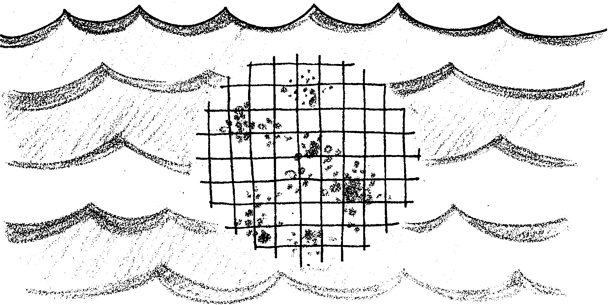
Water Quality Monitoring:
Coliform Bacteria

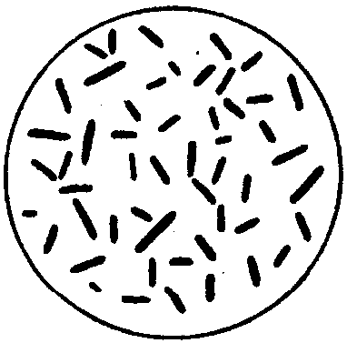
Bacteria, as part of the food web, play an important role as the “decomposers”. They break down organic material, releasing nutrients necessary for the growth of plants. Parasitic bacteria, also found in waters, serve to remove weakened organisms. In cases of overcrowding of a particular species, parasitic bacteria can cause epidemics which tend to keep populations in check.

1. How are decomposers important in the food web?

To a large extent, the number and kind of bacteria present depend upon the source of the water, its temperature, and the types and concentrations of dissolved minerals present. Artesian wells and springs have a lower bacteria count than shallow ponds and streams. Sewage and water heavily polluted with organic materials contain millions of bacteria per milliliter. If the sewage enters rivers, bays or other natural waters, the bacteria enter also and continue to grow on the rich nutrient medium provided by the sewage.
2. What three factors help determine the number and kinds of bacteria present in natural waters?

a.

b.

c.

Millions of dollars are being spent in programs to clean up the rivers, lakes and smaller streams in the United States. Aside from the fact that sewage pollution is a disease hazard, it is of broader ecological importance in that it may bring abnormally large numbers of bacteria to an otherwise normally balanced water ecosystem. Some bacteria use significant amounts of oxygen in their life processes. These bacteria remove oxygen from the water. The oxygen, then, becomes unavailable for fish and other aquatic life. Periodic fish kills can often be traced to this sudden oxygen depletion.

3. How can large numbers of bacteria affect normally balanced water ecosystems?

The established method of detecting sewage pollution of water involves a growth test for the presence of coliform bacteria. Coliform bacteria are normally found in the digestive tracts of people and other mammals. Coliform bacteria are expended by the billions in feces (solid waste matter) and find their way into the water supply with sewage.

4. How do coliform bacteria get into water supplies?

Though coliform are usually not harmful themselves, their presence is a good indicator of sewage pollution since fecal coliform do not normally reproduce outside of the digestive tract. In a coliform growth test, bacteria from a water sample are grown under controlled conditions. The presence of large numbers of coliform bacteria shows the almost certain presence of other bacteria that are harmful to people.

5. Why do people monitor (keep track of) the number of coliform bacteria in drinking waters?
In densely populated areas, water pollution by sewage is an ever-present hazard. Several serious diseases can be traced to polluted drinking water. Among them, typhoid fever and a group of intestinal disorders generally lumped under the name of “dysentery”. The actual disease causing organisms, such as Salmonella typhosa, may be extremely hard to detect. Instead of testing for these bacteria directly, authorities routinely check for the presence of coliform bacteria, which are an indicator of water pollution. Coliforms, always present in sewage, are much harder to kill in treatment plants than the actual disease producers. If coliform bacteria are not present in the test sample of waste water, we can be reasonably sure that no other bacteria due to sewage pollution are there either.

6. If water quality experts are interested in the presence of disease organisms, why don’t they sample water for these organisms, like Salmonella typhosa, instead of for coliform bacteria?

Sewage laden rivers and streams flow into coastal waters. Analysis of water for bacteria pollution is an important step in monitoring the quality of waters along our coastlines. In this activity, you will test various water samples for coliform bacteria as an indicator of sewage pollution.
To determine the total coliform bacteria concentration in a water sample, you will use the Millipore Membrane Method. This method involves filtering a water sample through a “membrane filter” (a filter that contains billions of microscopically uniform holes per square centimeter). The filter is then placed in a petri dish in which a pad has been soaked in a prepared culture medium. Containing food nutrients, culture medium is the “soil” for growing micro-organisms. The culture medium used is called MF- ENDO Medium. Each coliform bacteria present on the filter produces an easily recognizable colony on the culture medium. Remember: The number of coliform colonies is equal to the number of coliform bacteria present in the original water sample.

7. Organize the following steps of the Millipore Membrane Method in their proper sequence. Write the number of the step in the blank space.
a. The number of coliform bacteria colonies are counted.
b. A water sample is collected in a sterile container.
c. The filter from the Millipore apparatus is placed in a petridish with a pad that has been soaked with a prepared culture medium.
d. The water sample is filtered using the Millipore apparatus.
e. The petri dishes are incubated while the bacteria colonies can grow.
MF-ENDO Medium is the “soil” used to verify the presence of coliform bacteria, and how it does so is a perfect example of microbiological detective work. Years ago, researchers learned that coliform bacteria have a unique quality to break down a complex sugar called lactose, forming a definite sequence of simpler substances. Some of these, showing up about 36 hours after the process starts, are called aldehydes.
The MF-ENDO Medium contains lactose and other nutrients, and also a stain - basic fuchsin - which is normally deep red but has been made pale pink by the addition of sodium sulfite. The first action of bacteria (in fact, of the air itself) is to partly reverse the effect of the sulfite, making the whole surface of the medium red. Most colonies growing there also become red, but nothing distinguishes one species from another until the aldehydes are formed. When this happens, the unchanged fuchsin-sulfite complex (plenty of it is still around) attaches itself to the aldehyde molecules and forms a shiny green coating. Because no micro-organisms make aldehyde out of lactose except members of the coliform family, “green sheen” colonies are coliform bacteria, and the sample is proved guilty of pollution by sewage. All bacteria colonies that have a green sheen are counted as coliform.

8. What distinguishes coliform bacteria colonies from other bacteria colonies growing on the MF-ENDO Medium?

9. How would you determine the total number of coliform bacteria colonies present in your petri dish?

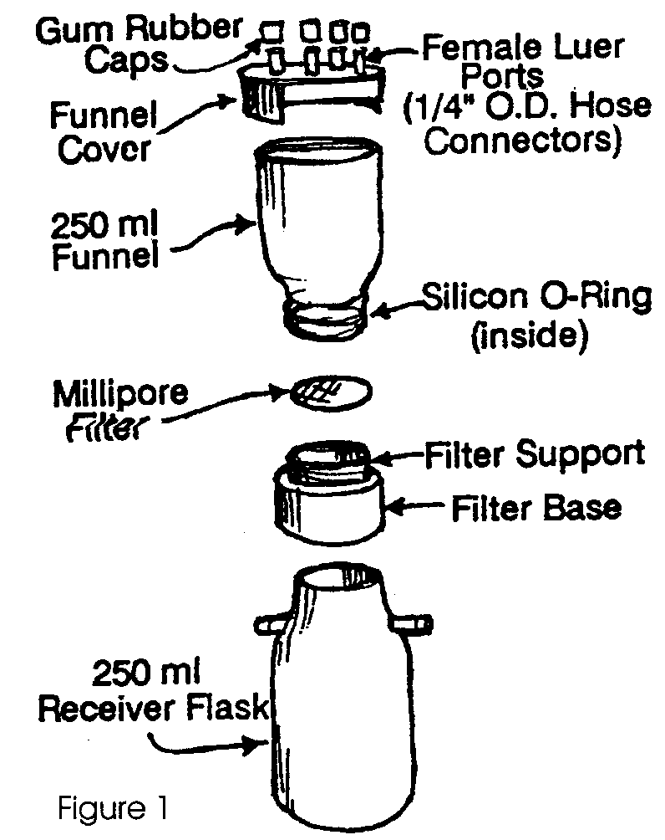

Analysis of Water for Coliform Bacteria Lab Procedures:
The Sterifil Filtration Apparatus is the central piece of equipment used in these experiments. Its component parts are shown in Figure 1.

NOTE: To avoid adding additional coliform bacteria to the water sample, sterile technique is practiced. Before each water sample is filtered, the funnel and filter base must be sterilized. The receiver flask does not require sterilization.
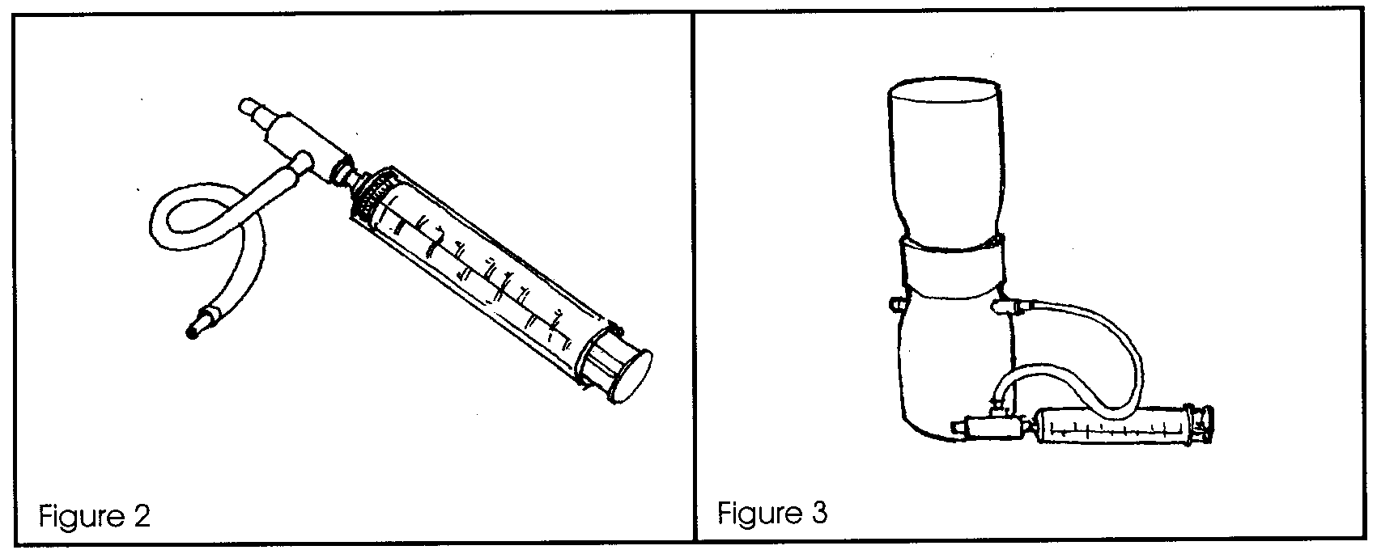
The Vacuum System, used to operate the filtration unit, consists of a plastic syringe, a length of rubber tubing, and a two-way valve. One end of the tubing carries a small nylon adapter. Slip the other end tightly over the side vent of the valve, and attach the valve to the syringe (Figure 2). Insert the nylon adapter into one side arm of the Sterifil receiver flask (Figure 3), and close the other side arm with a gum rubber cap.

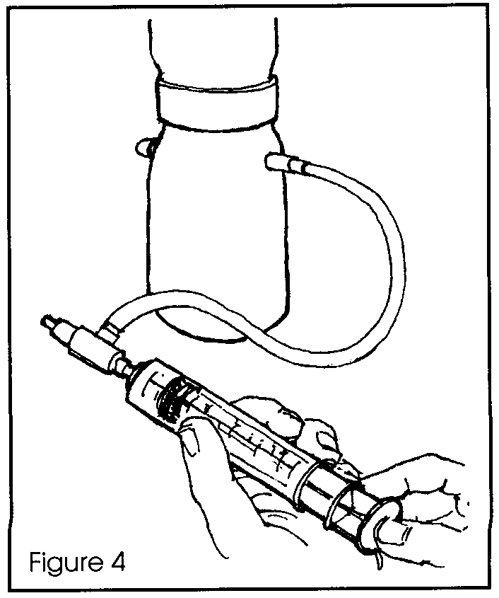

When the syringe plunger is worked (Figure 4), air will be drawn out of the receiver flask and vented through the valve outlet. This will quickly create sufficient vacuum inside the receiver flask to start and maintain the filtering process, perhaps with an occasional “boost” from the syringe.

Materials:
• water sample(s)
• Millipore filtration unit with hand pump
• Petri dishes, 47 mm
• Millipore filters with absorbent pads, HAWG 47 mm, 0.45,
• sterile forceps, blunt
• 70% alcohol for sterilizing
• media - ampoule containing 2 ml MF-ENDO Medium (pink)
• ampoule breaker
• sterile pipette, 1 ml in 1/10
(materials list continued on next page)
• sterile pipette, 50 ml or 100 ml
• graduated cylinder
• distilled or sterile dechlorinated water
• incubator
• binocular scope, hand lens or colony counter
• boiling water
• tongs
• alcohol lamps and matches
• marking pens
• tape
• safety glasses

Procedure:
1. Collect a sample of salt water at the site specified by your teacher, using a sterilized container that can be capped shut during transportation.

2. Prepare the Sterifil Filtration Apparatus:

a. Sterilize the funnel and the filter base by immersing both in rapidly boiling water for 3 minutes.

b. After boiling, lift the funnel out of the water with tongs and place it upside down on its larger rim on a clean paper towel. Do not touch the inside of the funnel.

c. Lift the filter base out of the water with tongs and place it with the filter support area up on a clean paper towel. Do not touch the top of the filter support with your fingers.

d. Allow the pieces to drain for a moment or two, then press down the filter base firmly over the top of the receiver flask.

NOTE: The O-ring may tend to fall out of its groove during boiling. If this happens, place the O-ring back in the groove using sterile forceps. Then screw the blue filter base into the funnel until the O-ring seats properly.
3. Install the HAWG filter. DO NOT TOUCH THE HAWG FILTER WITH YOUR HANDS.

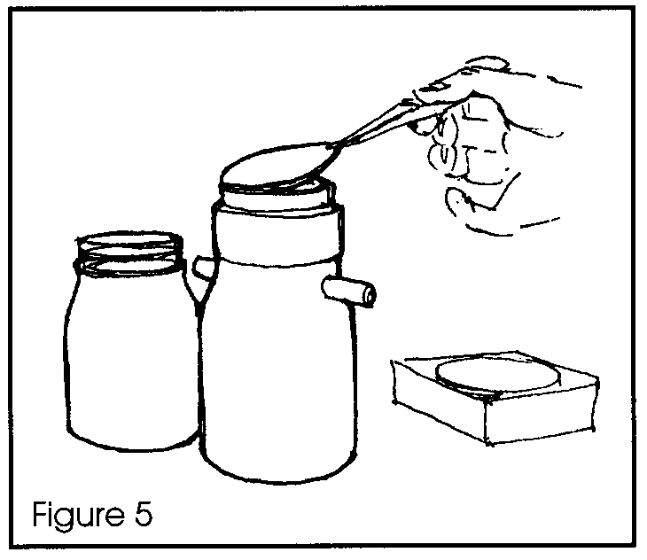
a. Sterilize the forceps: dip the tips in alcohol and, while still coated with a thin layer of alcohol, pass the tips quickly through the flame of the alcohol burner.

b. LET THE FORCEPS COOL BRIEFLY, then use sterile technique to place a white membrane filter (grid side up) on top of the white filter support screen (Figure 5).

NOTE: The blue wax paper discs in the envelope are merely part of the packaging and should be discarded.
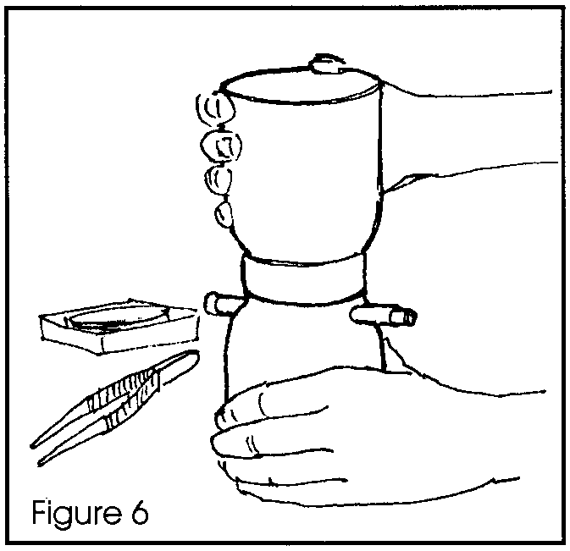

c. Carefully screw the funnel down on to the filter base (Figure 6). BE CAREFUL not to use too much force or the filter itself might get torn and be rendered useless.

d. Place the funnel cover on top of the funnel.

4. Prepare one petri dish and pad with MF-ENDO Medium (pink):

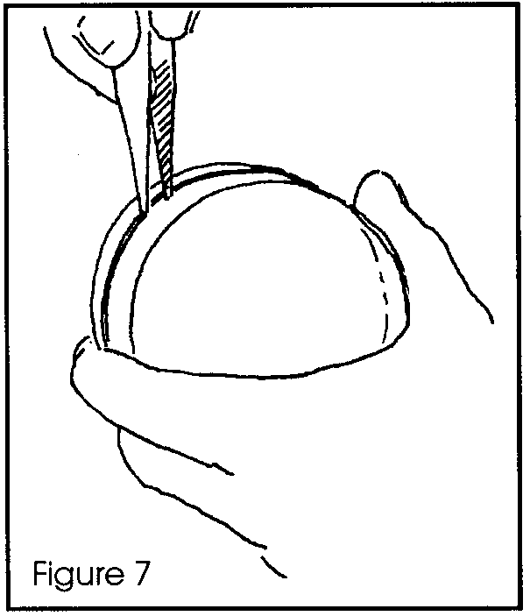
a. Open a petri dish by inserting a forceps blade between the sections and prying with a twisting motion (Figure 7). Be careful not to touch the inside surface of either section.
b. Use flamed forceps to place a 47 millimeter absorbent pad in the bottom section (Figure 8) to receive the selected culture medium.

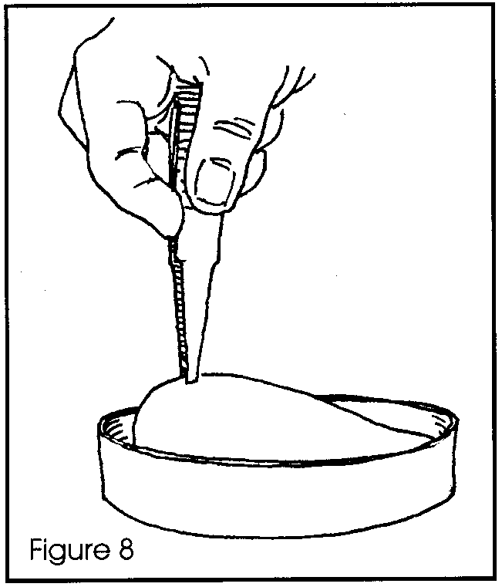
NOTE: The white absorbent pads are in the box with the HAWG filters.

NOTE ALSO: Treat the face with raised lettering as the bottom, keeping the clear face as the top for easier observation of growth.

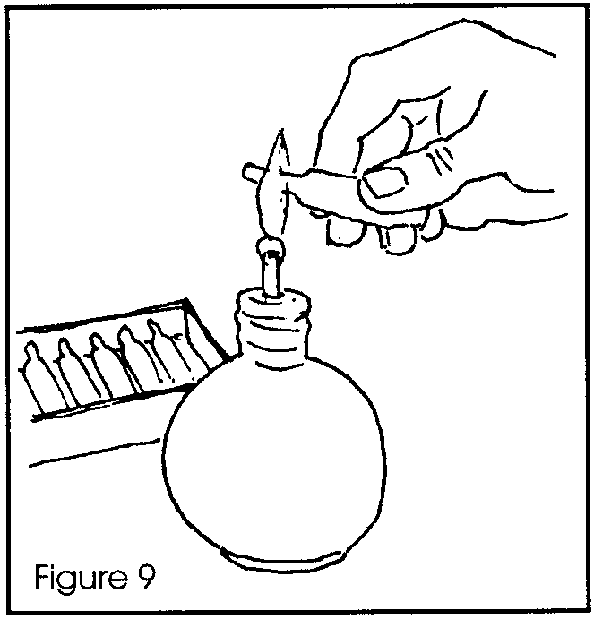
c. If your teacher elects to open the glass ampoule (a small, sealed vial), go to step (f) below. If your teacher does not elect to open the glass ampoule, obtain a sealed glass ampoule of MF-ENDO Medium.

d. Sterilize the neck of the ampoule by holding as is shown in Figure 9 and quickly passing it through the flame while turning it so that all sides of the extended neck are sterilized.

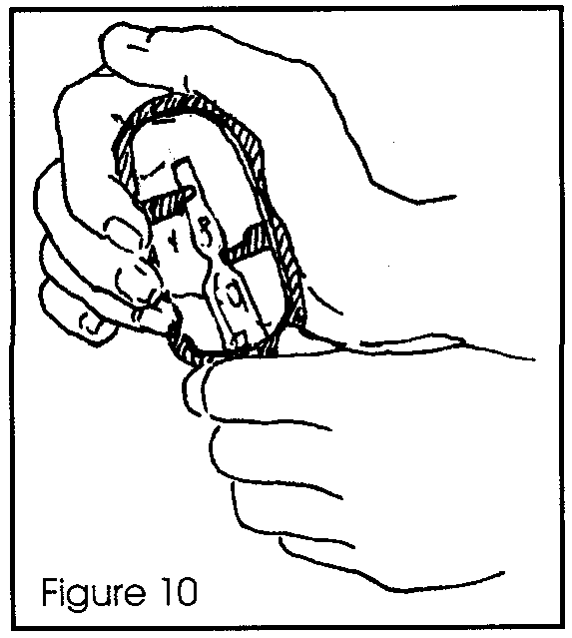
e. Insert the ampoule into the ampoule breaker, and holding the bottom of the ampoule, squeeze the sides of the breaker together to snap the neck (Figure 10). Not too much force is needed.
f. Pour the contents of the ampoule evenly over the absorbent pad in the Petri dish, making sure that the entire pad is saturated (Figure 11).
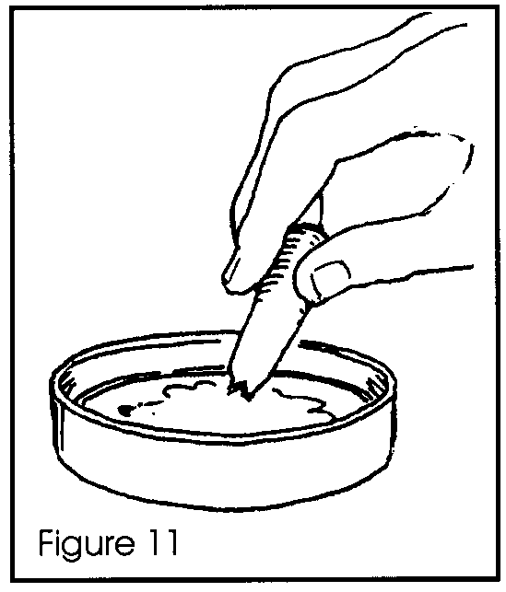
NOTE: If the medium does not flow evenly due to the small opening, shake gently to release the medium.
NOTE ALSO: If (as sometimes happens) a small shred of glass from the broken ampoule gets into the pad, simply lift it off with flamed forceps, then replace the petri dish cover loosely until sample filtration has been completed.

YOU ARE NOW READY TO FILTER YOUR WATER SAMPLE.

5. Filter the water sample:

a. Using the 50 ml pipette or a 100 ml graduated cylinder, place 50 ml of distilled water into the Sterifil funnel.

b. Pipette a 0.5 ml sample of the sample water into the Sterifil funnel, and gently swirl the funnel to mix the sample with the sterile dilution water.

c. Filter the diluted water sample, using the vacuum apparatus.

d. Place another 50 ml of distilled water into the funnel.

e. Filter the second 50 ml to prevent the bacteria from clumping.

f. Remove the vacuum pump tubing from the side-arm of the Sterifil receiver flask.
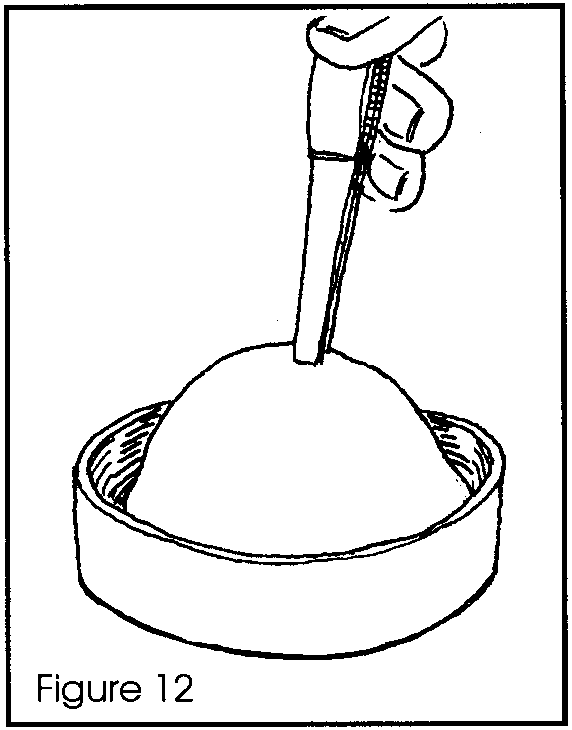
9. Unscrew the funnel.
g. Flame forceps to sterilize. Cool the forceps and transfer the filter (gridded side up) from the Sterifil base on to the saturated absorbent pad in the Petri dish. Carefully line up the filter with one edge of the petri dish and then set it down with a slight rolling motion (Figure 12), so that it is evenly centered.
h. Replace the cover, tape closed, and invert (turn over) the petri dish. LABEL the side of the dish with your name.

6. Incubate and count the cultures:

a. Allow the culture to incubate for 48 hours at normal room temperature, or 24 hours at 37 degrees C if you have an incubator.

b. After incubation, remove the test filter with flamed forceps and allow it to dry on a clean blotter for 1/2 hour.

c. With a hand magnifier, or colony counter, scan the surface of the filter for colonies having a shiny, greenish surface. Count the total number of these “green sheen” colonies appearing on the filter. This is the number of coliform bacteria present in the 0.5 ml sample of untreated water.

RECORD THIS NUMBER ON YOUR DATA SHEET. Multiply this by 2 to find the number in one ml of the same water, and RECORD THE NUMBER OF COLIFORM BACTERIA per ml on your data sheet.

NOTE: If the number of coliform bacteria in your sample is too numerous to count, your water is heavily polluted. In this case, repeat the above procedure using a 1/4 ml sample instead of a 1/2 ml sample. Multiply the count by 4 to determine the number of bacteria per ml.

d. Compare your results with the other teams that used an aliquot (a measured sample) from the same water sample. HINT: This can be easily done if each team records its results on the blackboard. Determine a class average for your sample. RECORD this average on your data sheet.

e. Disassemble and clean the Sterifil and syringe in warm water and detergent. NOTE : If the filter base is too tight to be easily removed, screw the funnel part back onto the blue filter base and rock the two parts in opposite directions while pulling apart.

f. Finally, and most importantly, WASH YOUR HANDS.
Analysis and Interpretation:
1. Coliform population limits have been set by federal and state health services. These limits vary with the designated use of the water supply. The U.S. Public Health Service has set a national standard for drinking water of no more than 1 coliform colony per 100 ml. While standards now vary with area, it is generally felt that the following criteria are useful for fecal coliform populations (Table 1).

Table 1

Water Quality Criteria with Respect to Fecal Coliform Population

Kind of Water Recommended Numbers of Fecal Coliforms

A. Water designated for Primary A. Should not exceed an average of 200/100 ml
Contact Recreation

B. Water other than for Primary B. Should not exceed a mean of 1000/100 ml
Contact Recreation

C. General recreation surface C. Average not to exceed 2000/100 ml
water

Primary Contact Recreational Activities are defined as those activities in which there is a prolonged and intimate contact with the water involving considerable risk of ingesting water quantities sufficient to pose a significant health hazard.
The Food and Drug Administration recommends that the surface waters above shell fish beds shall not have fecal coliform counts above 70/100 ml.
In terms of number of colonies/100 ml, how do your samples compare with the U.S. Public Health Service standards for drinking water?

2. According to Table 1, these water samples are suitable for:

3. Why was sterile water used to dilute the sample in steps 5(b) and 5(f)?
4. Why was the water used for dilution dechlorinated?

5. In step 6(d), what is the reason for averaging the class results?

6. How does your count compare with the class average?

7. What are four reasons that your results might differ from the class average?

8. If your results showed no coliform bacteria present, can you be safe in saying that there were none in your water sample? Explain.

9. What things can be done to reduce the number of coliform bacteria in coastal waters?
Your Name
Team Members

Total Coliform Analysis Data Sheet

Millipore Membrane Method
1. Date:
2. Sample location:
3. Number of coliform colonies per .5 ml:
4. Number of coliform colonies per 1.0 ml:
5. Average number of coliform colonies from same water sample:
6. Coliform test results are usually expressed as #/100 ml. Calculate the number of coliform colonies per 100 ml for your sample:

From Table 1:

This water sample is suitable for:

