Water Quality Monitoring:
Moving Up the Chain


Key Concepts
1. Factors such as toxic chemicals that affect one kind of organism may affect many other organisms as well as they move through the food chain.
2. Human activities which cause damage to an estuary may also pose a health risk for humans.

Background
Living things are connected. Through the food chain, factors that affect one kind of organism, end up affecting many other plants or animals as well. Threats are posed to human health from many contaminants. A field of study called “risk assessment” determines if repeated consumption of small amounts of toxic chemicals poses a human health risk. The concept of “risk assessment” seems foreign to many people. With some justification, they may feel that if the contaminants are harmful, then get rid of them or, at least, don’t eat them.

Materials
For each student:

• “Water Quality Monitoring: Moving Up the Chain” Student Pages

Teaching Hints
“Water Quality Monitoring: Moving Up the Chain” is a reading activity that looks at how contaminants are concentrated in the food chain. The concept of risk assessment may be foreign to your students. Encourage discussion about how to establish “acceptable risks” of exposure to toxics and about who should be responsible for determining their acceptability.

Key Words
bivalve shellfish - molluscs which possess two shells such as clams, oysters, and mussels
fecal coliform bacteria - a group of generally benign bacilli commonly found in the intestines of humans and other vertebrates and used as an indicator of sewage pollution in water
food chain - outline of who eats whom showing path of energy transfer in an ecological community
nutrients - minerals and other substances needed for life and growth
Paralytic Shellfish Poisoning - paralysis or other symptoms caused from eating shellfish which have concentrated toxins contained in certain dinoflagellate plankton; mistakenly called red tide
phytoplankton - plant plankton; the primary producers of the sea
phytoplankton bloom - rapid growth of phytoplankton due to favorable conditions and resulting in a dense mass of plankton often visible to the unaided eye
risk assessment - a method for rating the potential danger of a compound or situation based, among other things, on the assumption that the more a person consumes of a toxic chemical or encounters the situation, the more likely the person is to develop health problems
toxic - having the effect of a poison

Answer Key
1. Answers may vary. The “risk over time” of eating contaminated seafood refers to the fact that some materials while not toxic in small quantities, have a cumulative affect when eaten over a long period of time. The question is posed to focus students on the term “risk over time”. The answer to this question is really found in the subsequent paragraph.

2. Risk assessment is based on the assumption that the more a person consumes of a toxic chemical, the more likely she is to develop health problems. (The two correct words are in bold-face type.)

3. In assessing the risks of toxic chemicals, scientists

a. test the potency of each chemical.

b. estimate the effects on humans of contaminants consumed at various rates.

c. estimate how much contaminated seafood people eat.

d. calculate the likelihood of adverse health effects such as cancer.

(Correct answers are shown in bold face type.)
4. This question calls for your students’ opinions regarding who should decide “acceptable levels of risk”, those levels of contamination permitted in seafood. Choices may vary from scientists to politicians to individuals. Justification of choices can provide fertile ground for discussion.

5. The bacteria and viruses originate from sewage treatment plant outfalls, failing septic tanks and runoff waters from urban and agricultural areas. The question asks for an opinion and is included to focus students’ reading of the next paragraph.

6. Coliform bacteria are normally found living in the digestive tract of humans and other animals.

7. People are interested in monitoring the number of coliform bacteria in drinking waters because, though coliforms generally are not harmful themselves, their presence is a good indicator of sewage pollution since fecal coliforms do not normally reproduce outside of the digestive tract.

8. “Pathogenic” means disease causing.

9. Answers may vary but good choices for areas worth monitoring fecal coliform bacteria include areas near sewage outfalls, rural population centers and near the mouth of rivers and streams entering the estuary with runoff from agricultural areas.

10. Overall, wise land use and well-thought-out community development (especially proper siting and maintenance of on-site sewage disposal systems, implementation of best management practices for animal-keeping operations, careful siting of sewage treatment plant outfalls, and urban stormwater control) have the best potential to control contamination from bacteria and viruses.

11. It is dangerous to eat shellfish that have been taken from the waters with toxic plankton because they bioaccumulate the toxins. Numbers imbibed by swimmers are insignificant by comparison with the numbers concentrated by shellfish and passed on to unwary consumers.

12. This question calls for speculation on the part of your students. They are likely to answer that an increase in the areas where significant amounts of toxic plankton were found may be the result of pollution. The question is designed to help focus the reading which follows.
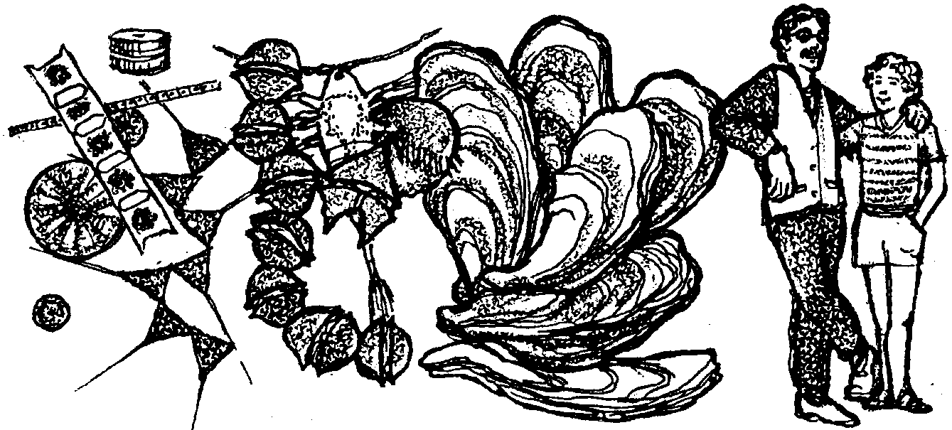
Water Quality Monitoring:
Moving Up the Chain

Living things are connected. Factors that affect one kind of organism, end up affecting many other plants or animals as well. Many of the connections are made through the food chain. A food chain shows who eats whom. A simple food chain might be:

Phytoplankton → zooplankton → oyster → human.

Let’s look at the last two links of this food chain and ask what then is the impact of contaminated shellfish beds and pollution on humans? If the only food humans ate were oysters, a decline in the number of oysters would cause a decline in the human population. The answer, however, is not so clear and simple. Most human consumption of shellfish and fish is occasional. Evaluating the effects of consumption of contaminated seafood is a matter of assessing the risk over time.

1. What do you think is meant by the “risk over time” of eating contaminated seafood?

Risk assessment determines if the repeated consumption of small amounts of toxic chemicals poses a health risk. Scientists test the potency of each chemical. Then they estimate the effects on humans of contaminants consumed at various rates. They also estimate how much contaminated seafood people eat. From the toxicity of a chemical and how much people are eating of that chemical in their seafood, scientists calculate the likelihood of adverse health effects such as cancer. Very small amounts of toxic chemicals may be harmful if consumed frequently over one’s lifetime.
2. Risk assessment is based on the assumption that the more/less a person consumes of a toxic chemical, the more/less likely she is to develop health problems. (Circle the two correct bold-face words.)

3. Complete the following sentences:
In assessing the risks of toxic chemicals, scientists:
a. test
b. estimate the effects on humans
c. estimate how much
d. calculate the

4. Scientists can provide the information about the risks involved in eating shellfish. In your opinion, who should decide “acceptable levels of risk”, those levels of contamination permitted in seafood? Why did you choose that group or individual?

Studies indicate that toxic chemicals in seafood are potentially harmful to human health. County Health Departments in many heavily populated and industrialized areas have recommended that people avoid eating fish and shellfish (including crabs). In general, fishing and shellfishing from industrial areas should be avoided.
Toxic chemicals aren't the only kind of pollution that affects humans through the food chain. Bacterial and viral contamination of shellfish can cause a variety of illness. Some of the diseases are merely irritations such as skin rashes. Some are more serious such as hepatitis.

5. Where do you think the bacteria and viruses originate?

Some of the bacteria and viruses come from sewage treatment plant outfalls and failing septic tanks. Others are carried into the estuary in runoff waters from urban and agricultural areas. The variety of bacteria and viruses make it difficult to test the waters and shellfish for all the potential disease causing organisms.
Instead of testing for disease causing organisms directly, authorities routinely check for the presence of coliform bacteria. Coliform bacteria are normally found living in the digestive tract of humans and other animals. Coliform bacteria are expended by billions in feces (solid waste matter) and find their way into the water supply with sewage. Though coliforms generally are not harmful themselves, their presence is a good indicator of sewage pollution since fecal coliforms do not normally reproduce outside of the digestive tract.

6. Where are coliform bacteria normally found?

7. Why are people interested in monitoring (keeping track of) the number of coliform bacteria in drinking waters?

Again, fecal coliform bacteria are not themselves pathogenic but are indicators that disease causing bacteria and viruses associated with warm-blooded animals may be present.

8. What is meant by “pathogenic”?

9. In what areas would you choose to monitor fecal coliform bacteria? Why?

Areas of estuaries most affected by bacterial (and possibly viral) contamination generally coincide with areas of limited flushing and/or with proximity to:
• sources such as sewage treatment plant outfalls,
• urban runoff,
• agricultural runoff,
• failing on-site sewage disposal systems, or
• boat discharges.

10. What can we do to control contamination from bacteria and viruses?

(Overall, wise land use and well-thought-out community development have the best potential to control contamination from bacteria and viruses. Proper siting and maintenance of on-site sewage disposal systems, implementation of best management practices for animal-keeping operations, careful siting of sewage treatment plant outfalls, and urban stormwater control).

No list of human health problems from marine waters would be complete without mention of paralytic shellfish poisoning. Paralytic shellfish poisoning, PSP for short, is caused by blooms of toxic phytoplankton. The phytoplankton blooms are called “red tides.” The plankton produce a powerful “neurotoxin”, a nerve poison. Another food chain illustrates the potential problems.

toxic phytoplankton → oyster → human.


The PSP toxin is concentrated within bivalve shellfish (clams, oysters, and mussels) as they feed. Bivalves consume and digest the toxic algae and retain the toxin in their flesh. Otherwise, the bivalves are unaffected by it because they lack the nerves it affects. This means a bivalve might be a time-bomb for a human consumer. Worse yet, cooking shellfish does not remove the toxin. People who eat PSP-contaminated shellfish may experience a tingling sensation in the lips and tongue, followed by numbness, paralysis, and possibly death. A high price to pay for an oyster dinner.
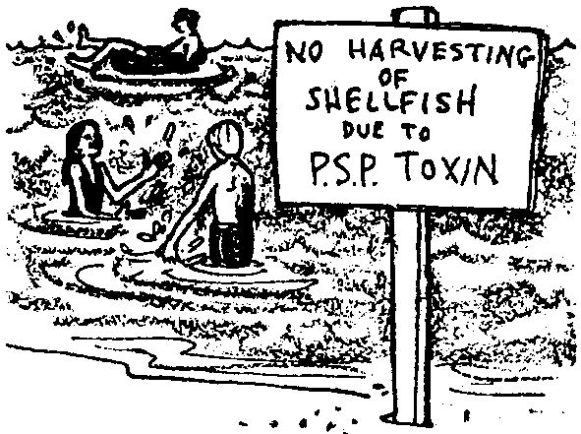
11. People often swim in waters loaded with toxic plankton. They may even swallow some of these phytoplankton with no signs of ill effects. If this is so, why is it dangerous to eat shellfish that have been taken from the same waters?

12. Areas in which large numbers of toxic plankton are found seem to have increased over time. What might have caused an increase in the areas where significant amounts of toxic plankton were found?

“Red tides” that cause PSP are a natural phenomena. It is unclear whether human activities have increased their spread. Research seems to indicate that, in some situations, the addition of nutrients (“fertilizer”) by human activity increases the frequency and intensity of the toxic phytoplankton blooms.
Toxic phytoplankton are widespread in marine waters. The phytoplankton is very long-lived. As a result, it is not likely that the PSP problem will disappear in the foreseeable future. Are we doomed to play “Russian roulette” with our shellfish consumption? Yes and no. While the PSP phytoplankton is widespread, we can reduce our risk of consuming significant quantities of the toxin. One important service in this regard is hotlines in coastal areas which provide information on beach closures due to PSP. Until then, happy eating!

