Water Quality Monitoring:
Total Solids

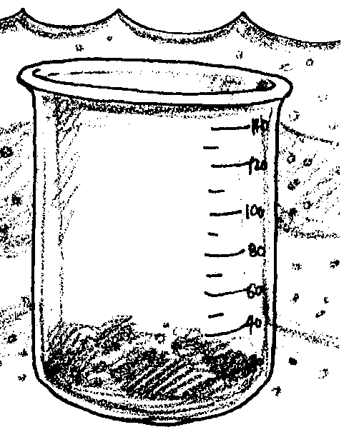
Key Concepts
1. Point sources and non-point sources of pollution add solids including silt and clay particles from soil runoff, plankton, industrial wastes, and sewage to water.
2. Suspended solids clog the gills of fish and invertebrates, reduce the amount of light available to plankton, and bind toxic contaminants.

Background
A constant level of materials, normally thought of as solids and essential for the maintenance of aquatic life, is dissolved in water. Dissolved materials include calcium, bicarbonate, nitrogen, phosphorus, iron, and sulfur. In “normal” concentrations, these materials are beneficial; in excessive concentrations they may become toxic to living things. Certain human activities add vast quantities of total solids to natural bodies of water.

Materials
For each team of 2 students:
• glass bottles that hold at least 100 ml water
• 300 ml or larger glass beakers (large porcelain or aluminum dishes are even better)
• Bunsen burners are helpful
• tong to handle the beakers or dishes
• oven or incubator that will reach 103°C
• Mettler balance or balance that will measure to 0.0001 grams

Teaching Hints
“Water Quality Monitoring: Total Solids” discusses some of these ways in which solids are added to our waters and introduces the water quality test for total solids.
The test for total solids involves drying a water sample and weighing the residue. Since the quantity of total solids may be low in the waters sampled, a balance that will measure to .0001 grams is desirable. Mettler balances or other precision instruments are often available in high school chemistry labs. Larger water samples require a less precise balance but much greater time in the evaporative process. Provide instruction in the use of the instrument available to you.
Most, if not all, of the equipment required would probably be available in a high school chemistry laboratory. An oven such as the ones in a home economics class might be used although centigrade will have to be converted to Fahrenheit. Local colleges and sewage treatment plants may allow the use of their sensitive balances if there are none at your school.

Key Words
non-point source pollution - contaminants which enter the environment from diffuse sources, such as the actions of individuals
nutrients - minerals and other substances needed for life and growth
point source pollution - contaminants which enter the environment from a single source, such as the outfall of a city’s sewage treatment plant or a factory
silt - fine earth, sand or the like carried by moving water and deposited as sediment
total solids - materials, normally thought of as solids, dissolved in water including calcium, bicarbonate, nitrogen, phosphorus, iron, and sulphur

Answer Key
1. Two point sources of solids entering estuaries include: sewage treatment plants, road construction, improper logging, some industrial by-products and wastes.

2. An increase in dissolved nitrates and phosphates is likely to increase phytoplankton growth, at least initially. Excessive nitrates and phosphates can lead to local eutrophication as outlined in the activity “Nitrates and Phosphates”.

3. Noted in the introductory paragraph, three ways these solids affect the estuarine ecosystem are:

a. Clogging the gills of fish and invertebrates.

b. Decreasing water clarity and phytoplankton production.

c. Binding and circulating toxic contaminants.
Water Quality Monitoring:
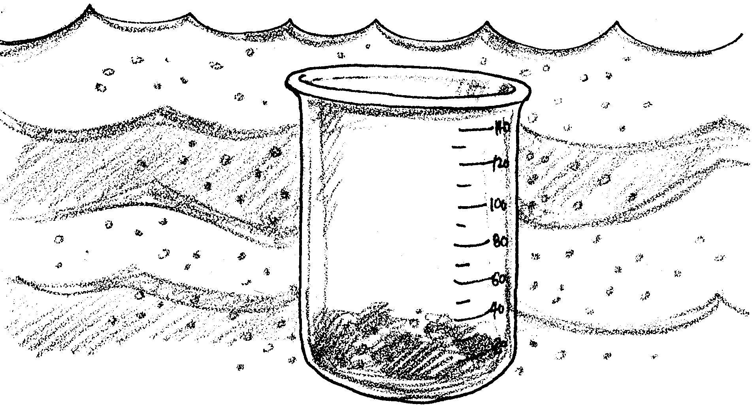
Total Solids

The rivers and creeks that flow into an estuary add solid particles to the saltwater. Human activities often add even more solids to the estuary. Suspended solids include silt and clay particles from soil runoff, plankton, industrial wastes, and sewage. These suspended particles clog the gills of fish and invertebrates. Particles also reduce the amount of light available to phytoplankton. In addition, toxic contaminants tend to bind to the particles, circulating with the suspended particles.

1. What are two point sources of solids that may enter an estuary?

Material normally thought of as solids may dissolve in water. Dissolved materials include calcium, bicarbonate, nitrogen, phosphorus, iron, and sulfur. A constant level of these materials is essential for the maintenance of aquatic life. The density of total solids affects the flow of water in and out of the cells of living organisms. Also, many of these dissolved ions of elements such as nitrogen, phosphorus, and sulfur are building blocks of molecules necessary for life.

2. Phytoplankton are dependent upon nitrates and phosphates dissolved in the water. How is an increase in dissolved nitrates and phosphates likely to affect the phytoplankton?
3. What are three ways these solids affect the estuarine ecosystem?

a.

b.

c.

Total Solids Testing Procedure
The measure of total solids, in parts per million (ppm), indicates the supply of nutrients available to the biological community.
This water quality measure (also referred to as total residue) includes:
1.dissolved solids (non-filterable residue) or that portion of the materials in water which pass through a filter;
2.suspended solids (filterable residue) which is that portion of the total retained by a filter.

Sampling Procedure
Using the technique described by your teacher, obtain representative water samples. Water samples should be taken midway between the surface and bottom if possible or at least beneath the surface. If a sampling device is not available, reach from shore as far as possible; be careful that the bottom is not disturbed when sampling from shore.

Test Equipment
For this test the following equipment is required:
1. Glass bottles that hold at least 100 ml of water;
2. 300 ml or larger glass beakers (large porcelain or aluminum dishes are even better);
3. Bunsen burners are helpful;
4. Tongs to handle the beakers or dishes;
5. Oven or incubator that will reach 103°C, and;
6. A Mettler balance or balance that will measure to .0001 grams.

Test
1. Place a glass-stoppered bottle (that holds at least 100 ml) about halfway to the bottom if sampling from shore without a sampling device. Open the bottle and fill; stopper the bottle and remove from the water. Remove any large floating particles or submerged masses from the sample.

2. In the laboratory, clean a 300 ml beaker (a 300 ml beaker provides a reasonable surface area) and dry in a 103° C oven for one hour. The beaker may also be placed over a burner with low heat.

3. Remove beaker from heat with tongs and allow it to cool, then weigh. Do not touch the beaker with bare hands because body moisture will be transferred to it, thereby changing the weight of the beaker. Use tongs, if available, or otherwise pads or gloves.

4. Transfer the measured sample into the 300 ml beaker.

5. Rinse the bottle several times with small amounts of distilled water, and add to sample in the beaker. Make sure all matter has been transferred from the bottle to the beaker.

6. Evaporate the sample, dry the beaker and the resulting residue in a 103°C oven overnight. Allow the beaker to cool, then reweigh it. It is important not to touch the beaker with your hands.

7. Subtract the new weight from the original weight of the beaker to obtain the increase in weight, or the weight of the residue (in grams).
The formula for determining total solids is:

Increase in weight x 1,000,000 = Parts per million of
ml of sample (100) Total Solids (ppm)

EXAMPLE:
Calculate increase in weight as follows:

Weight of beaker and residue 48.2982 grams

Minus weight of beaker 48.2540g

Weight of residue .0442g

Recall that:

Increase in weight x 1,000,000 = Parts per million of
ml of sample (100) Total Solids (ppm)

0.0442 grams x 1,000,000
100 ml = 442 ppm total solids

8. Use the above example to calculate your results.
Record Total Solids ppm

