Water Quality Monitoring: Turbidity
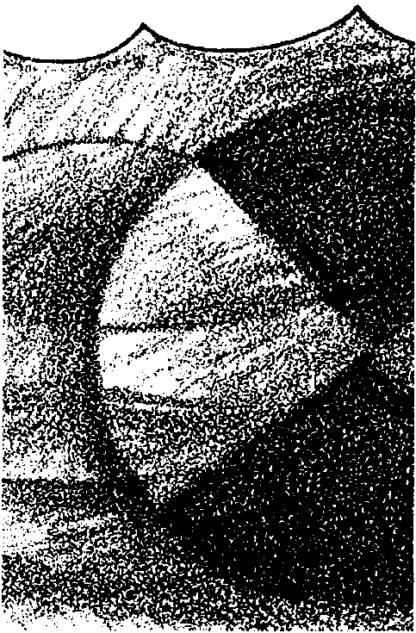

Key Concepts
1. Productivity of phytoplankton is affected by the turbidity of the water.
2. Human activities can alter the turbidity of bodies of water.

Background
Turbidity is a measure of the clarity of water. The more turbid or cloudy water is, the shorter the distance the light can penetrate below the surface. Turbidity is influenced by the presence of suspended matter, such as clay, silt, finely divided organic matter, and microscopic plankton. Turbidity directly affects phytoplankton growth and thereby indirectly affects all marine life.
Of all the parameters of water analysis, turbidity determination is perhaps one of the most difficult for which to establish a satisfactory procedure. For field studies, the Secchi disc and photometrics have been used successfully.

Materials
For each team of 2-4 students:
• Secchi disk
• map
• field notebook

Teaching Hints
“Water Quality Moitoring: Turbidity” provides students with practice in the use of the Secchi disk to determine water clarity. Secchi discs vary in diameter between 8" (20 cm) and 7.5 feet (237 cm). Many commercially produced ones are about 12" (30-33 cm) in diameter. One side is white. While the other side is either black or black and white marked in quadrants. General Biological Supply House (Turtox), Chicago, Illinois; and Gilson Slide Rule Co. of Stuart, Florida, now market a smaller Secchi disc of about 8" in diameter (22 cm). A workable Secchi disc may be “homemade” by employing the drawing in the student section as a construction plan from which to make your own Secchi disc from aluminum or plastic.
Duplicate the activity pages. One set is recommended per student. The first section of the activity serves as background and is an introduction to turbidity. This activity depends upon access to a body of water. This activity lends itself well to a field excursion in which a battery of activities are planned. Be sure that students record the depth as the disc disappears and as it reappears when raised and lowered slowly. Plan to devote some time to a discussion of the activity and the “Analysis and Interpretation” sections.

Key Words
benthic - referring to the bottom of the sea
hydroplane - in this case, skim over the water in the manner of a hydroplane
phytoplankton - plant plankton; the primary producers of the sea
quadrant - a quarter of a circle
Secchi disc - a device, consisting of a disk usually divided into quadrants alternately painted black and white, used to determine the clarity of a body of water
silt - fine earth, sand or the like carried by moving water and deposited as sediment
turbidity level - a measure of the particles suspended in water

Answer Key
Text Questions

1. Oceanographers are interested in turbidity because of its effect on primary production by plants. Turbidity is also studied for information about sediment movement and the deposition of fine silts and wastes.

2. As you increase the number of suspended particles, the amount of light seen from the side increases (more is scattered) up to the point where the scattering is so severe that the original light source is no longer visible.

3. The deeper the depth at which the object can no longer be seen, the less turbid the water (shallow depth = more turbidity).

4. Either of two answers are possible for this question:

a. The deeper an object is when it disappears, the less turbid is the water; or

b. The shallower an object is when it disappears, the more turbid is the water.

5. Ultra-clear waters are referred to as “marine deserts” because of the low plankton numbers which result in a correspondingly low number of other organisms.

Analysis and Interpretation:
1. If possible, make a chart of the area sampled available for plotting Secchi disc readings.
2. A turbidity contour could give information on the distance sediments are carried from rivers, it could give information on the productivity of a given area, or it could be used to trace the flow of turbid effluents from industrial sites or sewage treatment plants.

3. An hourly sampling would show changes due to changes in river inflow, waste inflow, tidal flow, or vertical migration of plankton among others.

4. One possible reason for the abundance of organisms in shallow water might be that the concentration of phytoplankton growth in the shallow lighted zone allows for a higher concentration of other organisms.

5. You would expect to find the greatest turbidity near rivers with a large outflow of silty water and near sewage treatment plants and industrial sites with a large outflow.

6. Students may propose a number of techniques for verifying the presence of light at a given depth. These might include: lowering a recording photometer and observing the results. Photosensitive paper encased in glass could be lowered to different depths and then exposed to determine the extent of the lighted zones. As an aside, light penetration is generally less than 200 meters in the deep oceans. Most estuaries are more shallow than this depth.
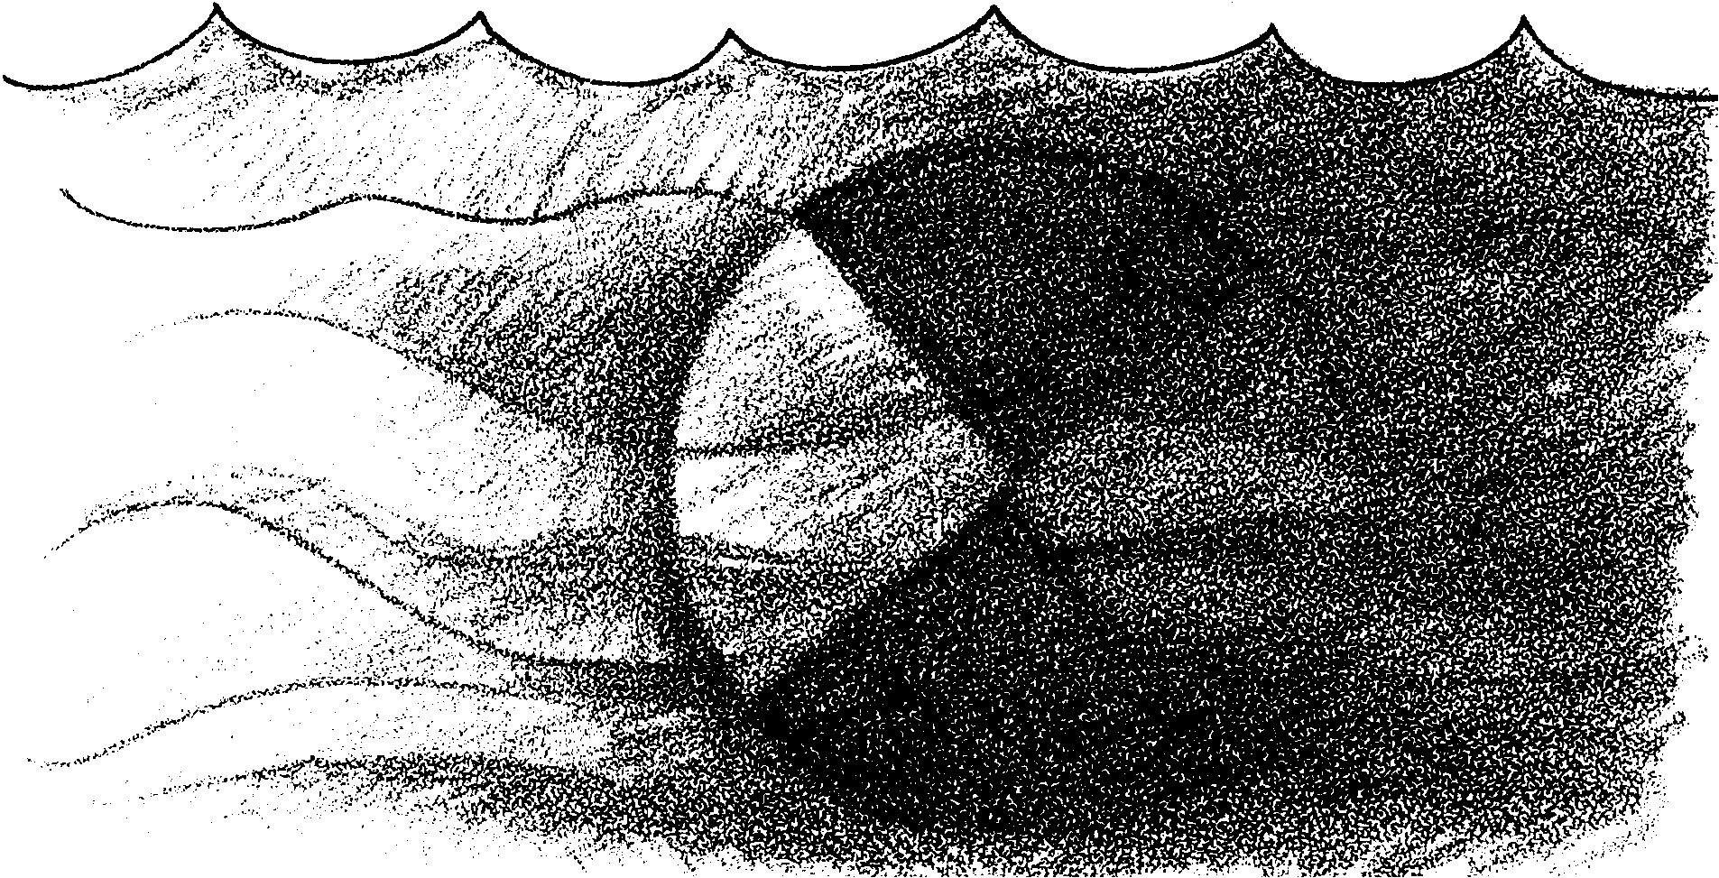
Water Quality Monitoring: Turbidity

Marine life depends largely upon the growth of microscopic green plants called phytoplankton. The growth of these green plants depends on sunlight. The amount of food produced in marine waters, then, is limited by the light penetration. Where light penetration is low, production of food is also low. What factors reduce light penetration?
Moving water can carry fine dirt particles called silt. The suspended silt reduces the amount of light that can penetrate the water. Suspended silt is highest in regions near the mouths of large rivers. Oddly enough, the growth of phytoplankton also reduces the amount of light penetration. High growth of plankton at the surface reduces light penetration to lower depths. The “cloudiness” of the water is referred to as turbidity.
1. Why would an oceanographer be interested in turbidity?

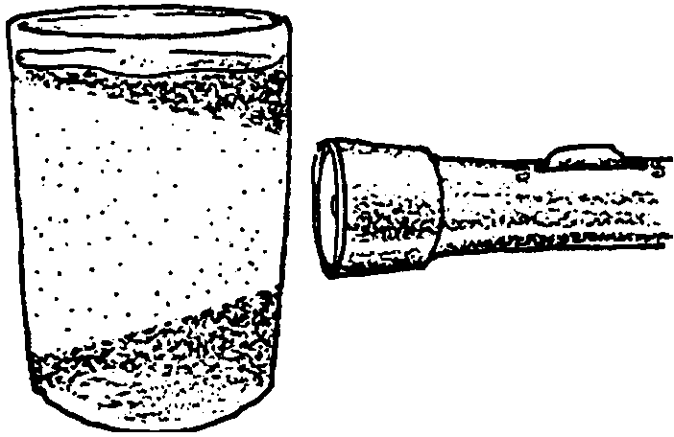
Turbidity is the opposite of transparency. These are physical properties of water. Materials in the water that are not dissolved, but are held in suspension, produce a milky appearance. A light beam is scattered so that it can be seen from any angle. Each tiny particle reflects a minute bit of light. Since the particles are randomly oriented, the beam shows from every angle. Light that is apparent at the side angles is therefore subtracted from the light arriving at the aimed destination.
2. As you increase the number of suspended particles, what happens to the amount of light that you can see from the side?

When enough suspended particles are between the source of light and the receiver of light, the object is no longer seen. If an object is lowered underwater until it can no longer be seen (the vanishing point), the depth at which this takes place is related to the turbidity of the water.

3. How is the depth at which the object can no longer be seen related to turbidity?

4. The (deeper/shallower) an object is when it disappears, the (more/less) turbid is the water. (Circle the correct pair of answers.)

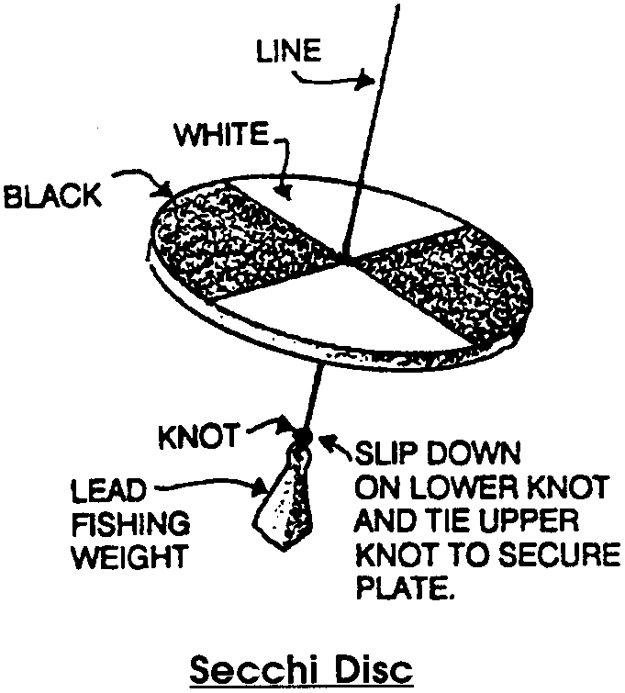
A device based on the concept of the vanishing point was developed and first used in 1865. The apparatus, called the Secchi disc, is shown below. Even today, it is in use for measurements by oceanographers around the world.

Is there a biological significance to turbidity? An emphatic YES! Egg laying species depend upon the waters to remove carbon dioxide (CO2) by diffusion and to provide oxygen (O2) for absorption by the developing embryos. If these eggs are covered with a layer of silt, clay or industrial waste, the embryo development stops. In turbid waters, benthic (bottom dwelling) invertebrates that feed by “pumping” water have slower growth rates. In very turbid waters, the bottom dwellers may die.
Turbidity may be the result of soil erosion, waste discharge, urban runoff, dredging, turnover, and plankton growth. Since plankton are the foundation of the marine food chain, turbidity caused by a high plankton count is often an indicator of a very favorable environment.

5. Why are ultra-clear waters often referred to as “marine deserts”?
In this activity you will measure the turbidity of water with the Secchi disc.

Materials
• Secchi disc
• maps
• field notebook

Procedure:
To measure the turbidity of water:
1. The point of entry of the Secchi disc into H₂O should be in a shadow during a sunny day. Reflected sunlight on the surface obscures the vanishing point of the Secchi disc. There are those who can see a “sharper” vanishing point with the alternate white and black quadrants up. There are others who can do better with the white side uppermost. Try both.
Lower the Secchi Disk into the water and RECORD the distance from the surface of the water to the disk at the point at which the disk just disappears from view.
Raise the disc to the point at which the disc just reappears. RECORD the distance from the surface of the water to the disc in meters.

2. Determine the average distance between these two values. RECORD.

3. Repeat the procedure two more times as above. If the results from the trials are different, average the results.

4. Move to next site. Repeat readings of underwater line length. (Caution: The Secchi disc tends to “hydroplane” when the current is strong. Make all readings when the line is vertical.)

5. If other analyses are to be done back at the lab, a bottled water sample should be taken at each Secchi reading site.

Analysis and Interpretation
1. If a chart of the area sampled is available, plot the Secchi disc readings on the chart.

2. Why might an oceanographer be interested in connecting similar Secchi disc readings with a continuous line similar to the contour line of a relief map?
3. What information might be gathered by taking readings at a single spot every hour during the day?

4. What is one possible reason that you might find lots of plants and animals in a shallow water area?

5. In which parts of an estuary would you expect to find the greatest degree of turbidity? The least?

For Further Thought ...

8. Using a Secchi disk is one way to find out something about how far light penetrates below the surface of the water. What technique(s) might be used to verify the presence of light at a given depth?

