Water Quality Monitoring: pH Determination of Water

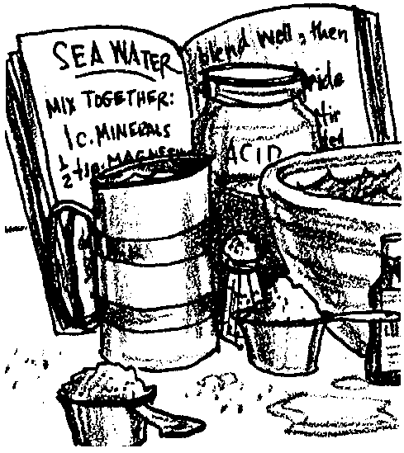
Key Concepts
1. Changes in the acidity of water subject aquatic organisms to considerable stress.
2.Within a moderate range, plants and animals can maintain a constant hydrogen ion concentration, beyond this range changes may be lethal.

Background
The “soup” which is an estuary is a water solution containing many interacting chemical elements, compounds, and ions. pH is an important chemical factor influencing life. Natural bodies of water are a mixture of solutes (dissolved substances) in the distilled water solvent. The final pH depends upon the excess of hydrogen (H+) or hydroxyl (OH-) ions in solution.
All species of marine plants and animals have a pH tolerance. Some organisms have a “broad” tolerance, (i.e. pH values of 8.0+1.5); and some have an extremely “narrow” pH tolerance. Fortunately, the negative ions of “weak” acids present in sea water tend to resist large changes in pH. These ions tend to “buffer” the sea water solution and moderate change for aquatic organisms.
Freshwater lakes and streams, however, may experience significant pH changes. They lack the salts that buffer pH in saltwater. If your students are testing freshwater, pH will be an important test. If they are testing saltwater, they quickly will find out that the pH rarely changes.
Many factors influence the pH of water. For example, water with large numbers of water plants tends to have higher pH values than those without. On the other hand, waters having dissolved clays generally have lower values.

Materials
For each team of 2-4 students:
• pH color comparator test kit
• pH test papers
• clean labware
• distilled water and water samples
Teaching Hints
“pH Determination of Water” provides students with experience in determining the acidity/alkalinity of water samples. For students who have studied chemistry, much of the background material will be familiar. Otherwise, this exercise should extend and reinforce the acid-base relationship.
If you employ the pH meter technique, keep in mind the fact that your own pH meter has specific characteristics. The instructions accompanying the instrument should be followed in preference to these. Most instruments and student titrations should produce accuracies of +1 pH. Standard solutions prepared with saline solvents will induce a more accurate pH instrument standardization. The buffers should bracket the expected pH of 8. A single buffer at a pH of 7, 8 or 9 may be used.
While pH meters are often available in high schools, be sure to try them first on saline water of know pH. This activity may be completed using pH paper, or other available pH kits. pH hydrion paper covering the range of sea water is available. Which ever method you employ, recall that: standardized solutions must be carefully prepared and stored; clean glassware is essential; and, solutions become contaminated easily.
Be aware that the pH of sea water has idiosyncrasies differing from water solutions containing a single dissolved substance. The O2, CO2, CO3-, HCO3-, H+, OH-, the metallic ions (K+, Na+, Ca+2) and waste product ions make this sea water mixture as complex as our own body fluid. Indeed, it has often been compared to blood. Thus, to seek out one relationship between only two related ions (H+, OH-) is a gross simplification.
Recommended test equipment for use in the tests below is:

Wide Range pH Test Kit, Model 17-N, Catalog No. 1470-11 (Hach Equipment Co.).

Duplicate the activity pages. One set per student is recommended. Encourage careful experimentation to achieve reproducible results. If you do not have immediate access to natural sea water, you can prepare artificial sea water using the following recipe:

Synthetic Sea Water

Dissolve:
• 310 g. of analytic reagent quality sodium chloride (NaCl)
• 100 g. or analytical reagent quality magnesium sulphate (MgSO4. 7H2O)
• 0.50 g. of sodium bicarbonate (NaHCO3. H2O) in 10 liters of distilled water.

Alternatively, you can purchase ready to mix sea salts for marine aquaria from an aquarium shop. Follow the manufacturer’s instructions.
The idea of pH and logarithms can be confusing for your students. Be prepared to offer further explanation as needed.
The prevailing relationship between H+ and OH- is shown in two ways.
1. H+ + OH- → H2O and H2O → H+ + OH-
2. The number of H+ times the number of OH- ions equals a constant number at a given temperature pressure and volume of water.

Looking again at number 2 above, write [H+] . [OH-] = .00000000000001 = 10-14 as the constant. If your students are familiar with the principles of scientific notation, you might have them recall from algebra that X4 . X3 = X7 and X-4 . X-3 = X-7. Therefore, if the hydrogen ion concentration, [H+], can be written as 10 raised to some power and the hydroxyl ion, [OH-], is done likewise, then [H+] [OH-] = 10-14 can be done by adding the powers of ten. Since the “powers” system is designed for dilute solutions, the actual power of ten is usually negative (less than one). For economy of effort, we change the sign on the power to plus (we algebraically invert the equation). For example, [H+] = 1/10 mole per liter (.1g) = 10-1 is now called pH = 1 (the “p” is for “power”) while pOH = 13 so that pConstant = 14. HENCE, pH + pOH = 14.
Provide additional solutions for pH determination. Plan to allow time for a discussion of the experimental results and the “Analysis and Interpretation” section.

Key Words
buffer - a substance that, added to a solution, is capable of neutralizing both acids and bases without appreciably changing the original pH of the solution; used to maintain a relatively constant pH in a solution
hydrogen ion - a positively charged ion of hydrogen found in all aqueous solutions of acids (H+)
hydroxyl ion - a negatively charged ion found in all basic aqueous solutions (OH-)
indicator - a substance that indicates the presence, absence, or concentration of another substance by means of a characteristic change, especially in color
pH - the symbol, used to express acidity or alkalinity of a solution on a scale of 0-14, for the logarithm of the reciprocal of the hydrogen ion concentration in gram atoms per liter; less than 7 represents acidity, 7 neutrality, and greater than 7 alkalinity
titration - a method of determining the concentration of a substance in a sample solution. This is done by adding a reagent of known concentration until a reaction of known proportion is completed as shown by a change (e.g., color). The unknown concentration can then be calculated.

Answer Key
Text questions

1. Two of the “other materials” which enter water from human activities may be chosen from the following:
a. petroleum products (oil, gasoline)
b. pesticides

c. fertilizers

d. plastics

e. industrial wastes

2. The correct terms are matched below:
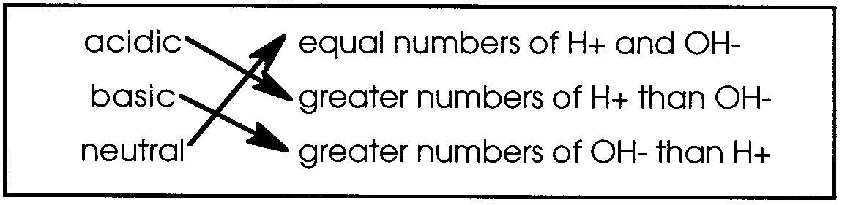
3. A pH 2 solution has 100 time the H+ ion concentration of a pH 4 solution.

4. The pH of human blood is about 7.4.

5. Animals and plants living in pH 6.5 water have to contend with 100 times more acidity than plants and animals living in pH 8.5 waters. A reworded repeat of question 2, this question is included to reinforce the concept that each change of one pH unit reflects a 10 fold increase in H+ concentration.

6. Plants and animals deal with a range of pH from 6.5 to 8.5 through their internal buffer systems.

7. a. The greatest impact on plants and animals from the acid spill would be in the creek closest to the spill. The impact would be expected to diminish with distance from the spill.

b. A decrease in pH number would indicate that the waters sampled were affected by the acid spill.

8. Lowering the pH makes the water more acidic. A confusing concept to most students: the lower the pH number, the higher the acidity.

Analysis and Interpretation
1. Answers depend upon experimental results. The pH of sea water is slightly alkaline, usually about 8.0.

2. Answers depend upon experimental results. The merit of pooling data and replicating samples deserves discussion here.

3. Answers depend upon experimental results. There are many possible sources of error, from recording errors to technique errors to sampling errors. Use this question as a spring board for discussion about sources of error and how to minimize these sources in an experimental situation.

4. We could use pH to help locate animals by finding areas with a pH that would be similar to that preferred by the animal. Theoretically, we could herd and capture animals by changing the pH and driving them into certain areas.
5. A comparison of stream pH with the pH of effluent from the plant could help identify the culprit. This would not normally be sufficient evidence to indict! A discussion of environmental detective work via chemistry might prove interesting at this point.

6. Answers depend upon experimental results. This question is included to encourage your students to look at activities in your neighborhood in terms of their potential impact on water quality.
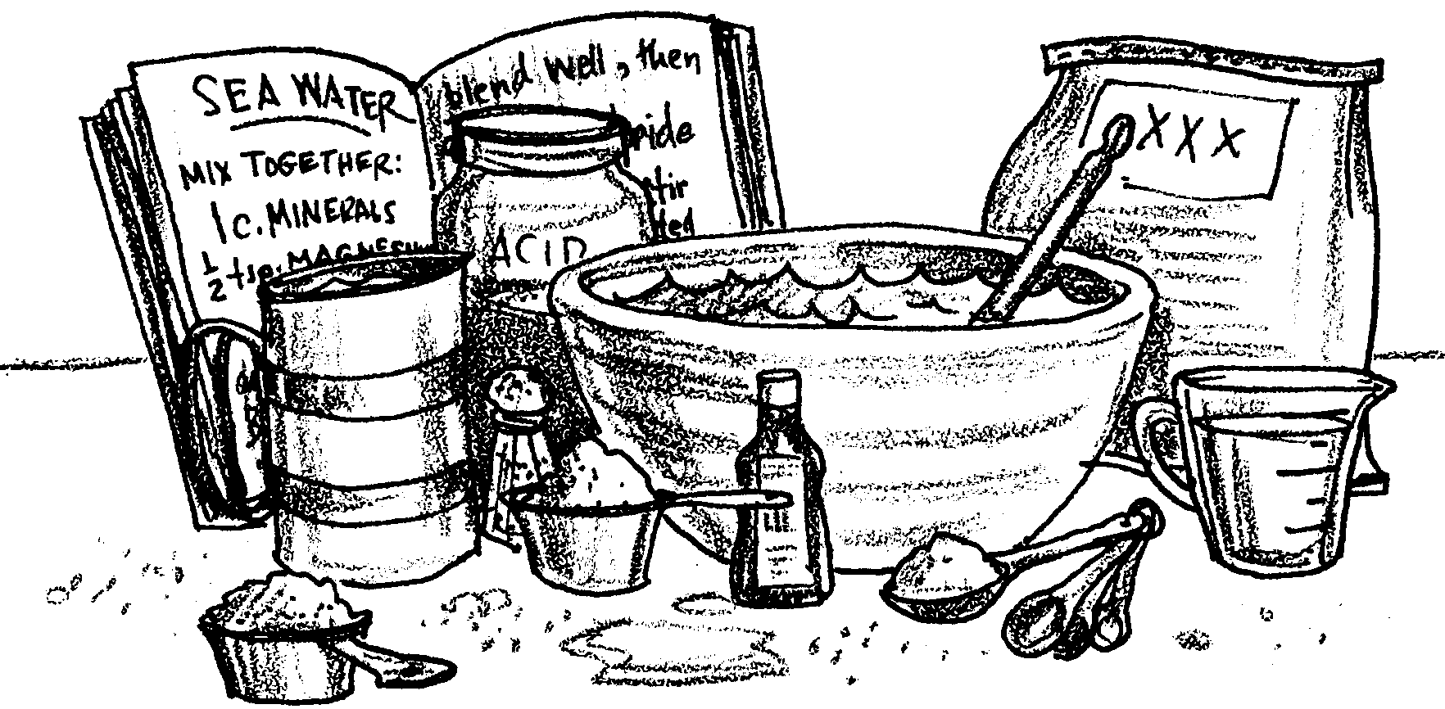
Water Quality Monitoring: pH Determination of Water

Seawater is distilled water that contains dissolved rocks, soils, minerals and organic (plant and animal) materials. These materials enter the water during its downhill rush to the sea. Other materials enter water from a wide variety of human activities.
1. What are two of the “other materials” which enter water from human activities?
a.

b.

Water is an interesting substance. Pure distilled water disassociates (“breaks”) into hydrogen (H+) and hydroxyl ions (OH)- of equal number. If water contains a concentration of H+ greater than the OH- concentration, the solution is acidic. If water contains a H+ concentration less than the OH- concentration, the solution is considered alkaline or basic. Equal numbers of OH- and H+ in a solution makes the solution “neutral”.
2. Match the correct terms below:

acidic equal numbers of H+ and OH-
basic greater numbers of H+ than OH-
neutral greater numbers of OH- than H+
Everyone who uses the term “pH” has an idea that it has to do with the degree of acidity. Not all realize that a change of one pH number is a change of the H+ ion concentration by a factor of 10. That is : A pH of 5 has 10 times the H+ ion concentration of a pH of 6. In a like manner a pH value of 7, although it represents “neutrality” is 1000 times as acidic as a pH of 10.

3. How many more H+ ions are in a pH 2 solution than in a pH 4 solution?

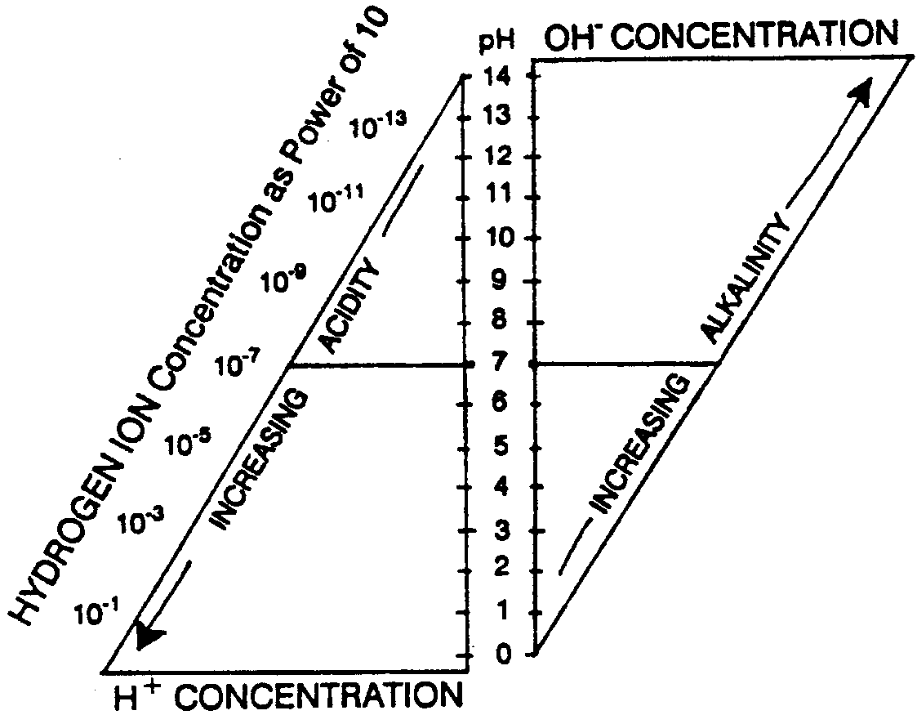
The pH scale, then, is a logarithmic scale. Each pH number differs from the next by a factor of 10. The neutral position is 7 on a 14 scale. The numbers 1 to 7 indicate the acid range, and the numbers above 7 to 14 represent the alkaline range. Keep in mind that by the use of a logarithmic scale, a unit change in pH corresponds to a tenfold change in the hydrogen ion and hydroxyl ion concentrations.

4. What is the pH of human blood?

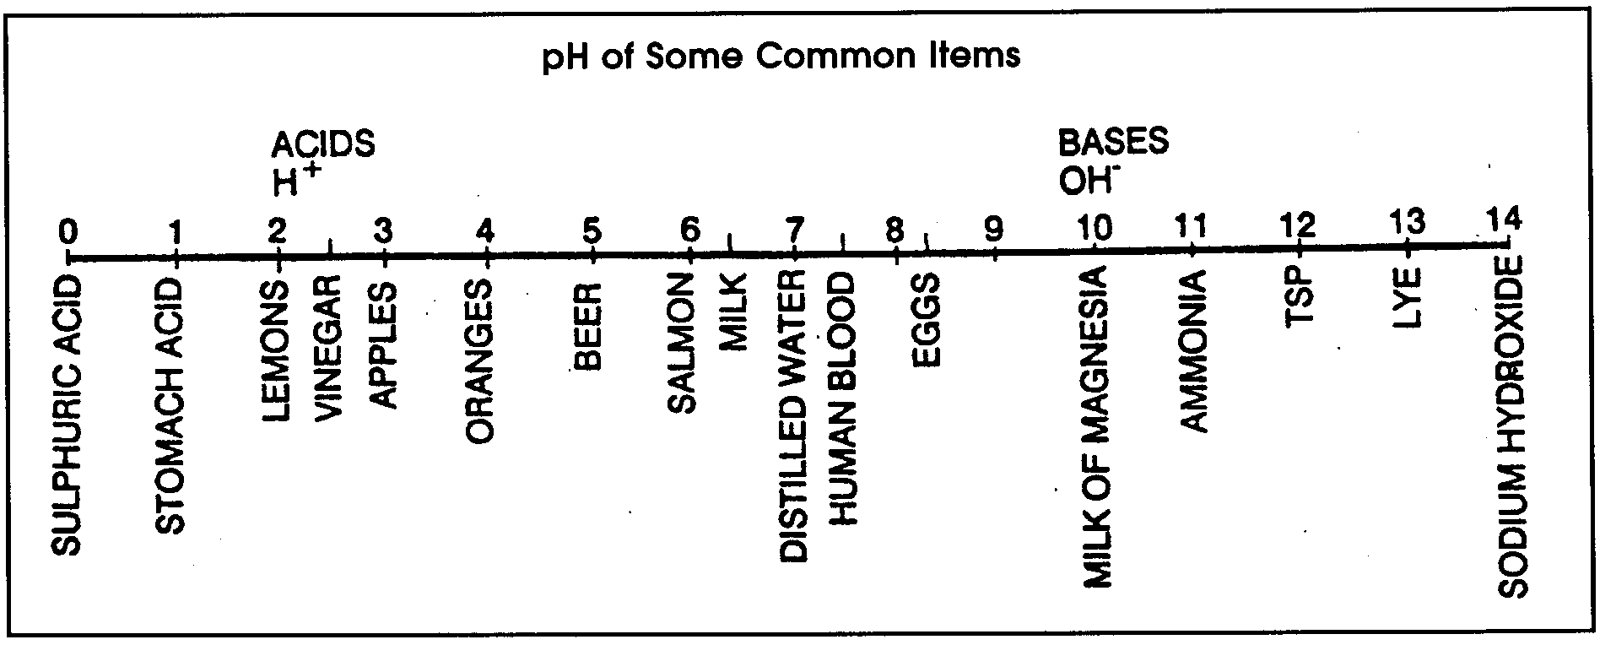

Why is pH important? 75% of the earth`s surface is best operated at a pH of 8 to 8.3. Your own blood must also have a constant pH. Organisms are subject to considerable change if there are changes in the acidity (or alkalinity) of their waters. The chemical processes that occur in living cells are carried on in solutions near to neutrality.

5. The pH of water in the oceans, lakes and rivers is usually between 6.5 and 8.5. With how much more acidity do plants and animals living in pH 6.5 water have to contend than plants and animals living in pH 8.5 waters?

The cells of plants and animals have special mechanisms to maintain a constant hydrogen ion concentration. These mechanisms are called buffers. These buffer systems keep the fluids relatively constant. These buffer systems, however, have no control over the external environment. The pH of an organism’s surroundings often changes. The buffer system within the organism must be able to keep the internal environment constant in the face of these external changes.

6. How do plants and animals deal with the range of pH from 6.5 to 8.5 found in natural waters?

Variations in the kinds of rocks and soil over which water flows and variations in plant and animal activity have always caused “normal changes” in pH. Normal changes in pH are now accompanied by local drastic changes. For example, many industrial plants discharge pollutants that lower the pH of the waters. The pH is oftentimes lowered below the point where many organisms can live. It, therefore, becomes important to measure the external environment in terms of acidity and alkalinity. The nature of the pH limits the kinds of organisms which can exist.

7. An acid spill in a storage yard runs into a creek which empties into an estuary.

a. Where would you expect the greatest impact on plants and animals?

b. Measuring the pH of the waters will give scientists some idea of the extent of the damage. What kind of a change in pH would indicate that the waters sampled were affected by the acid spill?

8. If industrial plants lower the pH of waters, are they making the waters more acidic of more basic?
Several techniques can be easily employed to measure the pH of sea water. In the following activities two techniques are presented which will enable you to determine the pH of sea water.

Materials
• pH color comparator test kit
• pH test papers
• clean labware
• distilled H₂O and samples

pH Testing Procedures
Sampling Procedure
Follow the sampling guidelines provided by your teacher. pH must be measured immediately after sampling because changes in the temperature of the sample can change the measured pH.

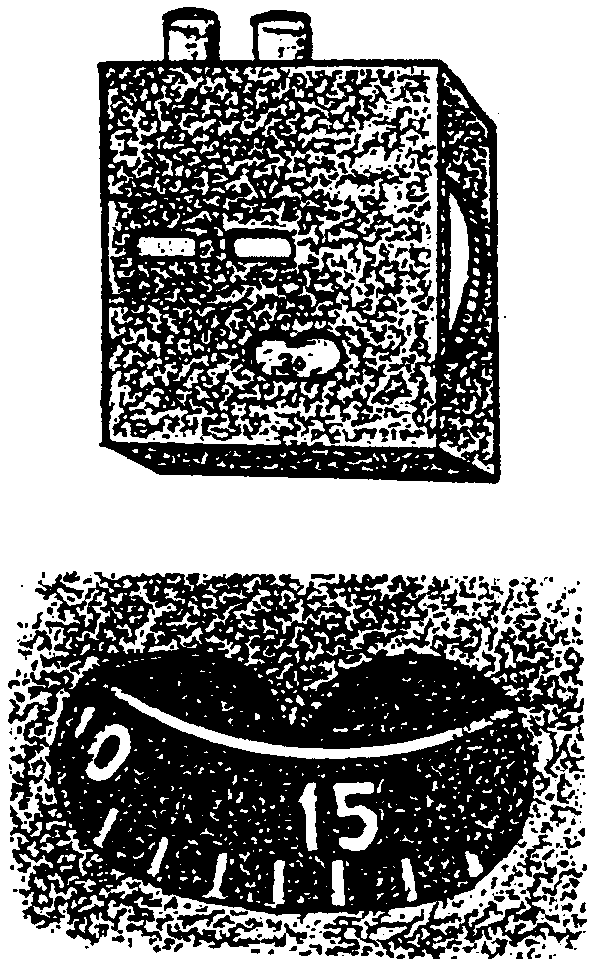
pH Color Comparator Test
1. Fill both viewing tubes with sample water to the first line.

2. Add 6 drops of pH indicator solution into one tube and twirl to mix. This is your prepared sample.

3. Place the tube of prepared sample into the right opening (nearest to the center) of the comparator wheel. The other tube is placed into the left opening.

4. Hold the comparator up to the light, and rotate the wheel to obtain a combined color and density match with the prepared sample. The pH value of the sample can then be read through the window.

5. Record the pH value .

Please wash your hands after this water test is completed.

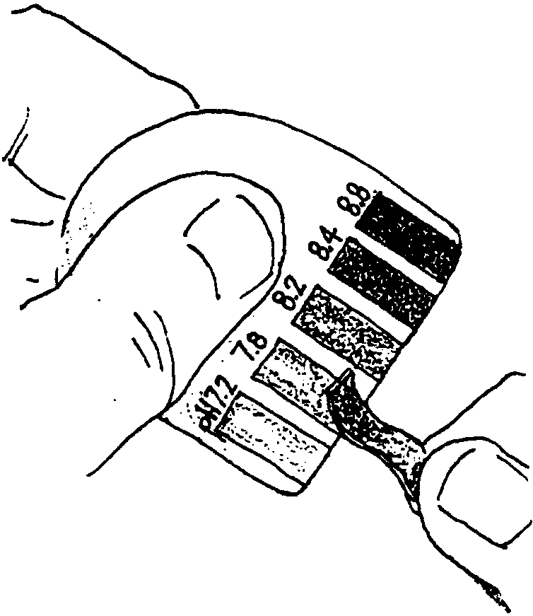
pH Paper Test
1. Tear off 2 inches (5cm) of pH paper.

2. With a clean pipette place 2-3 drops of the water sample on one end of the pH paper.

3. Visually compare the wetted end with the chart standard accompanying the pH paper.

4. Record results on your data sheet.

5. Repeat steps 1-4 with a second sample from the same location

The use of pH papers is largely confined to determining large variations in acidity. The pH meter is most often used where the pH determination is required for a detailed analysis. If we were interested in determining if the water in a swimming pool was “safe”, we could use pH papers. On the other hand, if we wanted to know how the addition of a certain chemical to water affected the pH, we would want to use a pH meter.

Analysis and Interpretation
Complete the following data record for your sample:

Sample number: Date:
Depth:
Note inhabitants (plants and animals):

Collector:
Hour: pH sample 1 sample 2
Temperature:
Climatic conditions:
1. What was the average pH of your samples?

2. Obtain data from other students by writing your results on the blackboard. What was the class average?

3. Was your average the same as that of the class? If not, what are two possible sources of the difference (variation) in results?

4. pH affects where animals and plants can live. How might an aquarium biologist use pH to help locate and capture animals?

5. Two industrial plants are located upstream from a “fish-kill” on a river. How could a pH study identify which plant is the culprit?

6. What human activity near where you live might change the pH of your local waters?

