Water Quality Monitoring: Nitrates and Phosphates


Key Concepts
1. Nitrates and Phosphates, often present in limited quantities, are two of the principal nutrients necessary for life.
2. Overfertilization may cause excessive growth of aquatic plants.

Background
“Nitrates and Phosphates” are two nutrients necessary for phytoplankton and algae growth in water and which are often added in over abundance via fertilizers and sewage. Through our daily activities, most of us contribute nitrates and phosphates to the water. Partly because of the availability of nutrients, phytoplankton and algae growth varies with the season. The addition of nitrates and phosphates can increase the growth of phytoplankton. At first glance, this seems like a benefit to the system. Up to a point it is, but excess amounts of sewage discharge and fertilizer runoff into bays and harbors can cause the overfertilization of the water. Over-fertilization may cause the growth of undesirable quantities and types of aquatic plants. Excessive growth of aquatic plants due to overfertilization is called eutrophication.
In undisturbed saltwater ecosystems, nitrates are limited, so an addition of nitrates may enable a prolific bloom of new plant life. Phosphates generally are abundant enough in saltwater so that they do not limit plant growth. In saltwater, then, nitrates are the most important nutrient to monitor. In freshwater, on the other hand, phosphates are typically the most limited and so are most important to monitor.

Materials
For each student:
• one copy of “Water Quality Monitoring: Nitrates and Phosphates” student pages
For each team of 2-4 students:
• Total Phosphorous Test Kit
• Nitrate Test Kit (see cautions about hazardous waste disposal below)
• protective rubber gloves
• safety glasses

Teaching Hints
“Water Quality Monitoring: Nitrates and Phosphates” introduces testing procedures for determining the concentration of these nutrients in water samples. In conducting the total phosphorous test, caution your students to be especially careful in handling the “acid-washed” glassware and in the use of the heat cube or stove as a heat source.
Be aware that it is quite possible the results will not mean much in absolute terms to your students. It may be useful to offer some comparisons, average ocean water concentrations of total phosphates range from 1 to 70 parts per billion (.001 to .07 mg/l or ppm) while nitrates range from 1 to 600 parts per billion (.001 to .6 mg/l or ppm). Clearly, the normal range for these nutrients is very great. Concentrations beyond this range are an indication of the addition of excess nitrogen and phosphorous.
The water quality tests described in the student text utilize the following equipment

Total Phosphorus Test Kit, Model PO-24, Catalog No. 2250-01, Hach Equipment Co.
Low Range Nitrate Test Kit, Model NI-14, Catalog No. 14161-00, Hach Equipment Co.

Note: This test kit uses cadmium. Use the test only if your school has a system in place for disposing hazardous waste. We have been unable to find an effective test without cadmium; you may choose to do the reading and omit the test.

Key Words
eutrophication - excessive growth of aquatic plants due to overfertilization
limiting factors - environmental factors which limit the size of an animal population
nitrates - in this case, compounds containing the NO3- group which act as fertilizers in aquatic ecosystems
nutrients - minerals and other substances needed for life and growth
phosphates - in this case, compounds containing the PO4-- group which act as fertilizers in aquatic ecosystems
photosynthesis - a process which occurs in the presence of sunlight in which six carbon dioxide molecules (CO2) and six water molecules (H20) are combined to yield one molecule of a simple sugar (C6H1206) and six molecules of oxygen (02)
phytoplankton - plant plankton; the primary producers of the sea

Answer Key
1. Nitrates and phosphates are two of the principal nutrients in fertilizers.
2. Nitrates and phosphates are used by plants in the process of photosynthesis and used to create plant tissues.
3. The two months which show the highest nutrient levels in the upper water layers are:
a. January
b. February
4. During the month of February phytoplankton growth and sunlight begin to increase.

5. Nutrients begin to decrease first.

6. In the late fall, nutrient levels begin to increase and phytoplankton growth decreases. While there is a burst of phytoplankton growth in mid-November as nutrient levels rise, the burst is short lived because of decreasing day length. Since phytoplankton are not consuming the nutrients in vigorous growth during the period of short days, the nutrients are able to increase.

7. Students may offer a variety of ideas. The principal reasons why the increase in nutrients in November is not followed by an increase in phytoplankton growth in December are the decreased light available for photosynthesis and the lower water temperatures which slow metabolic activities.

8. The text indicates that, aside from eroded rocks, one additional source of phosphates and nitrates is fertilizer.

9. “Eutrophication” is the excessive growth of aquatic plants due to overfertilization. Eutrophication is often coupled with decreases in oxygen concentration as the excess aquatic plants use up oxygen at night and, as they die, in decomposition.
During periods of heavy rain, raw sewage may enter the water from sewage systems in which rainwater and sewage flow in the same pipes. In rural areas, failing septic systems also add sewage to the water. What ever the source, the sewage adds nutrients to the water. Removal of natural vegetation, for farming and construction of roads and buildings, strips the soil cover which previously held phosphates and nitrates. Rain erodes this soil, carrying the nutrients into the water.

10. Nitrates and phosphates settle to the bottom in the bodies of dead animals and plants. As such, dredging, removing sand, silt and mud from the bottom, increases nutrients in the water.

11. Answers will vary regarding actions students can take right now to help reduce the amount of phosphates and nitrates that flow into the water. The list provided in the text provides some suggestions including:
a. reduce or eliminate use of lawn fertilizers that drain into waterways;

b. encourage farmers to practice low-till farming in order to reduce soil erosion. All farmers should test their soil so the amount of fertilizer applied can be matched with soil needs; this action would decrease phosphates and nitrates in runoff. Farms with cattle (dairy and beef farms) should build storage areas or collecting areas for feedlots so that manure is not carried away with surface runoff;

c. preserve natural vegetation near shorelines. Preservation of wetlands is vital in order to absorb nutrients and maintain water levels. Enact strict ordinances to prevent soil erosion;

d. supporting measures (including taxes) to improve nutrients removal by wastewater treatment plants and septic systems. Treatment of storm sewer wastes may also be necessary to limit nutrient inputs. Waterfront homeowners may need to consider investing in a community sewer system; and

e. requiring particular industries to pretreat their wastes before sending item to a wastewater treatment plant.

Nitrate Testing Procedure
10 a.-c. Answers will vary depending upon the experimental results. Numbers higher than the averages given, can provide fertile (sorry) ground for discussion. Individual actions possible will also vary. If concentrations of these nutrients are within average ranges, you might choose to discuss which conditions could alter the results.
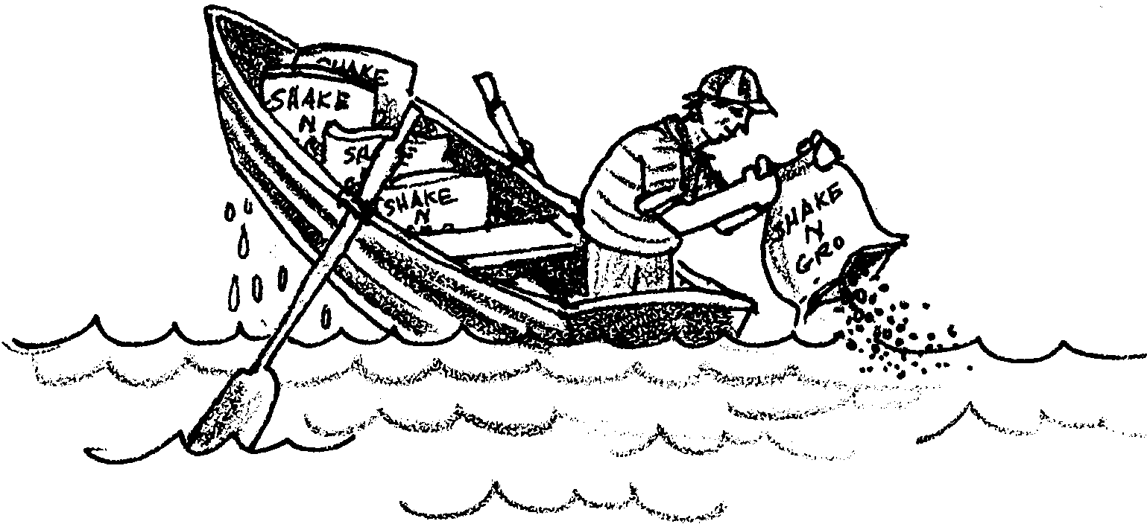
Water Quality Monitoring: Nitrates and Phosphates

Ah, spring is in the air! Time to begin that gardening project. Time to sharpen the plow and turn the soil on the ol’ farm.
Both the home gardener and the farmer want to increase their plant growth. Just how do they get those luscious green plants?
Many home gardeners and farmers use fertilizers to improve plant growth. Nitrates and phosphates are two of the principal nutrients in fertilizers. Nitrates and phosphates are forms of nitrogen and phosphorous, two elements necessary for life. They are taken up by plants in the process of photosynthesis and used to create plant tissues.
Like land plants, marine plants also require nitrates and phosphates. The growth of marine plants is often limited by the lack of one or both of these nutrients.

1. What are two of the principal nutrients in fertilizers?

2. How are nitrates and phosphates used by plants?
Partly because of the availability of nutrients, phytoplankton and algae growth in water varies with the season. The figure below shows the simplest type of seasonal cycle in the growth of phytoplankton.
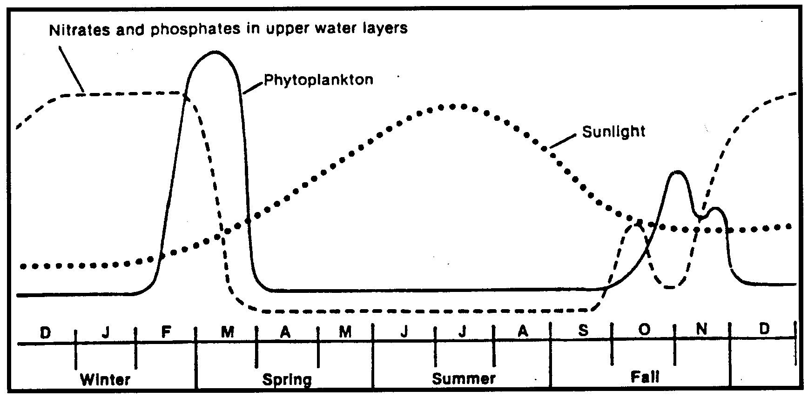
Use the figure to answer the following questions.

3. Which two months show the highest nutrient levels in the upper water layers?

a.

b.

4. During which month does phytoplankton growth and sunlight begin to increase?

5. In March, both phytoplankton growth and nutrient levels decrease dramatically. Which one of these two begins to decrease first?

6. What is happening to nutrient levels and phytoplankton growth in the late fall?

The phytoplankton multiply rapidly in the early spring, when the nutrient level is high and there is an increasing amount of sunlight. In the wake of rapid phytoplankton growth, the nutrients soon decrease. In spite of greater amounts of sunlight, phytoplankton growth is low because of low nutrient levels. The nutrients are acting as a limiting factor on phytoplankton growth. During the late spring and summer, nutrients may sink to the bottom where they are not available to the plants growing in the sunlight near the surface. Vertical movements of water and increased wave action bring nutrients to the surface in the late fall and winter.
7. In the figure above, nutrient increases in September are followed by phytoplankton growth in October. What is one possible reason why the increase in nutrients in November is not followed by an increase in phytoplankton growth in December?

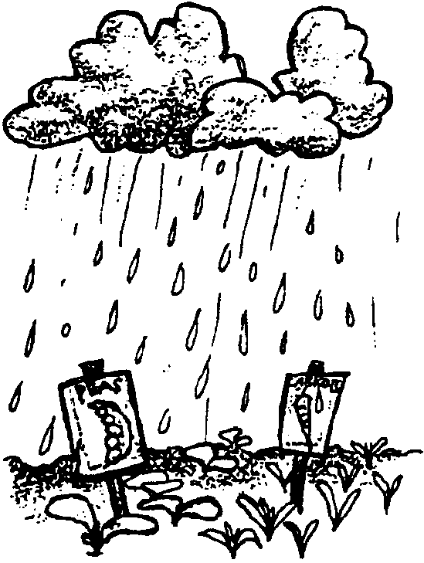
Seems like the phytoplankton could benefit from a little of the fertilizer that gardeners and farmers use on their plants. How do nitrates and phosphates find their way into the water?

Eroded from rocks, some nitrates and phosphates normally enter the water in rainwater runoff. Large quantities of phosphates and nitrates enter the water from other sources as well.

8. From the above, what might be one additional source of phosphates and nitrates?

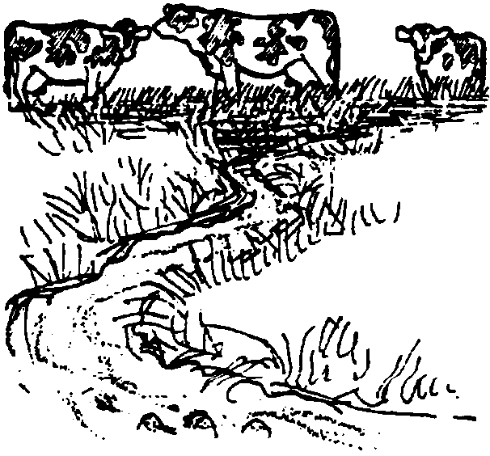
Human sewage and animal manure are rich in phosphates and nitrates. Excess amounts of sewage discharged into bays and harbors can cause the overfertilization of the water. Overfertilization may cause the growth of undesirable quantities and types of aquatic plants. Excessive growth of aquatic plants due to overfertilization is called eutrophication.

9. What is meant by the term “eutrophication”?

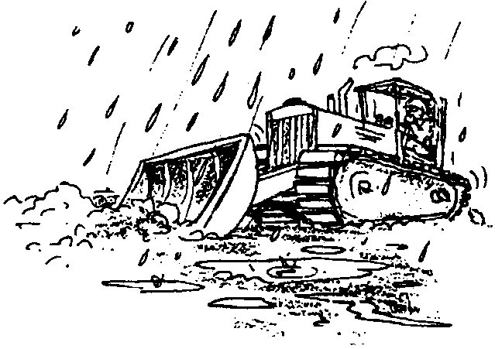
During periods of heavy rain, raw sewage may enter the water from sewage systems in which rainwater and sewage flow in the same pipes. In rural areas, failing septic systems also add sewage to the water. Whatever the source, the sewage adds nutrients to the water. Removal of natural vegetation, for farming and construction of roads and buildings, strips the soil cover which previously held phosphates and nitrates. Rain erodes this soil, carrying the nutrients into the water.

10. How might dredging, removing sand, silt and mud from the bottom, increase nutrients in the bodies of water?

How can we prevent or reverse the effects of eutrophication? We can reverse and prevent eutrophication. The following measures can help protect aquatic ecosystems:
a. reduce or eliminate our use of lawn fertilizers that drain into waterways;
b. encourage farmers to practice low-till farming in order to reduce soil erosion. All farmers should test their soil so the amount of fertilizer applied can be matched with soil needs; this action would decrease phosphates and nitrates in runoff. Farms with cattle (dairy and beef farms) should build storage areas or collecting areas for feedlots so that manure is not carried away with surface runoff;
c. preserve natural vegetation near shorelines. Preservation of wetlands is vital in order to absorb nutrients and maintain water levels. Enact strict ordinances to prevent soil erosion;
d. supporting measures (including taxes) to improve nutrients removal by wastewater treatment plants and septic systems. Treatment of storm sewer wastes may also be necessary to limit nutrient inputs. Waterfront homeowners may need to consider investing in a community sewer system; and
e. requiring particular industries to pretreat their wastes before sending item to a wastewater treatment plant.

11. What action can you take right now to help reduce the amount of phosphates and nitrates that flow into local waters?
Total Phosphorus Testing Procedures
Materials:
• Total Phosphorous Test Kit
• protective rubber gloves
• safety glasses

For this water quality test, it is important that glassware used for measuring total phosphorus be “acid-washed”; that is, soaked in dilute HCl and then rinsed thoroughly with distilled water. Please wear protective gloves when handling this glassware.

Test
1. Fill one square mixing bottle with water sample to the 20 ml mark.

2. Pour the water sample into a clean 50 ml Erlenmeyer flask.

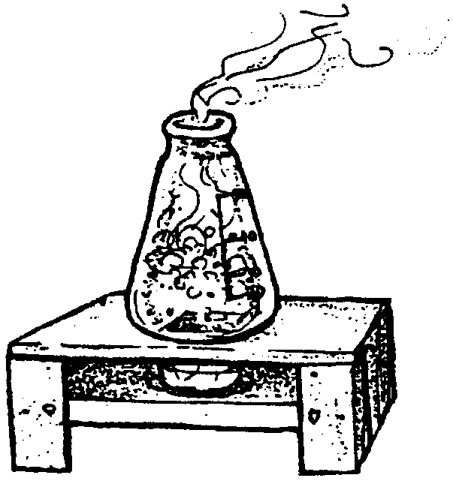
3. Add potassium sulphate powder pillow. Also add 2 ml 5.25N sulfuric acid.

4. Set up the boiling apparatus. You will use approximately four heat cubes (one at a time, to keep the sample boiling for 30 minutes). Replace heat cube before previous cube is extinguished. A small backpacking stove is a more effective heating method than using heat cubes.

CAUTION: Once the match is touched to the cube, it usually starts to heat immediately!

5. Boil sample for 30 minutes adding a little demineralized water occasionally to keep the volume near 20 ml. Be certain not to bring volume above the 20 ml mark near the end of the 30-minute period. Do not boil to dryness.

6. Allow to cool.

7. Add 2 ml of 5N sodium hydroxide solution by filling the dropper exactly to the 1 ml mark and discharging twice into the sample.

8. Return the sample to the square mixing bottle with 20 ml mark. If the volume is less than 20 ml, add demineralized water to return the volume to 20 ml. Proceed to orthophosphate test.
Orthophosphate Test (low range, 0-1 mg/1 phosphate)
9. Add contents of one PhosVer III Phosphate Reagent powder pillow, and swirl to mix. This must be mixed immediately and thoroughly.

10. Allow two minutes for color development. If phosphate is present, a blue-violet color will develop. (Color should be compared to color disk after two, but not more than 10 minutes).

11. The black box with the color disk inside is used for color comparison in the following manner:

a. Set box on flat surface with two circular openings for test tubes facing up. Fill one test tube (with line marked on it) with sample all the way to the top. Insert stopper in such a way as to obtain a leak-free seal. Wipe tube dry and insert in opening toward center of box.

b. Obtain another water sample and fill second test tube to overflowing. Insert stopper in such a way as to obtain a leak-free seal. Wipe tube dry and insert into other opening.
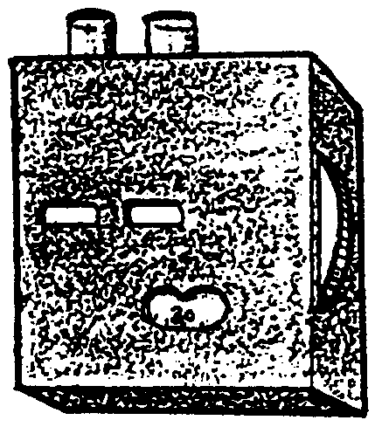
c. Pick up color comparator box and hold it up to a light source. Rotate color disk on underside until a combined color and density match is obtained (considering both color and light intensity). Divide the reading obtained from the scale window by 50 to obtain mg per liter phosphate.

Record the phosphate concentration mg/l.

NOTE: If color is darker than that indicated on the color comparator, use the following method.

d. Take samples from step 9 above out of the black box with color disk inside. Remove enough from sample to bring level to line marked on tube. Place prepared sample in the right opening of the color comparator box. Place untreated sample in the left opening of the box.

e. Hold color comparator up to a bright light and rotate disk until color match is obtained. Divide the reading from the scale window by 10 to obtain the mg/liter total phosphate (accurate up to 5mg/1).

Record the Phosphate concentration: mg/l

Please wash your hands after this water test is completed.
Nitrate Testing Procedure
Use the following procedure for nitrate nitrogen in the 0 to 1 mg/liter range:

Sampling Procedure
Again any sampling device might be used for this water quality test to obtain representative samples. It is also important to soak glassware in dilute HCl and rinse with demineralized water. Distilled water contains ammonia (NH3+) ions which will interfere with the test. Always use demineralized water during the nitrate test. Demineralized water will come with the Hach kit if you don’t have a set-up to demineralize water.

Test
1. Fill one of the color viewing tubes to the mark with the sample to be tested. Stopper the tube and shake vigorously. Empty the tube and repeat this procedure.

2. Fill the color viewing tube to the mark with the sample. Nitrite is readily oxidized to nitrates so proceed as if nitrite is not present.

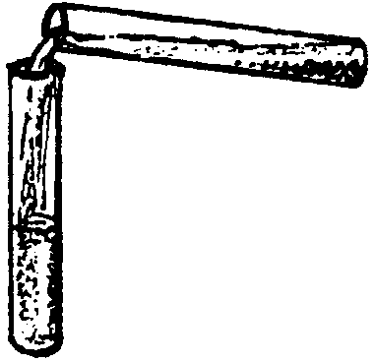
3. Use the clippers to open one NitraVer 6 Nitrate Reagent powder pillow. Add the contents of the pillow to the sample to be tested. Stopper the tube and shake vigorously for three minutes. Allow the sample to stand undisturbed for an additional 30 seconds. Unoxidized particles of cadmium metal will remain in the sample and settle to the bottom of the viewing tube.

4. Carefully pour the prepared sample into a second color-viewing tube so that the cadmium particles remain in the first tube. The cadmium particles remaining in the tube should be properly disposed of upon returning to the classroom.

5. Use the clippers to open one NitriVer 3 Nitrite Reagent powder pillow. Add the contents of the pillow to the sample. Stopper the tube and shake for 30 seconds. A red color will develop if nitrate is present. Allow at least 10 minutes but no more than 20 minutes, before completing steps 6-8.

6. Insert the tube containing the prepared sample into the right top opening of the color comparator.

7. Rinse the unoxidized cadmium metal from the color viewing tube used in step two into a clearly marked container. Arrangements should be made with toxic material handlers for safe disposal. Please wash your hands after this water test is completed. Fill to the mark with the original water sample and place in the left top opening of the comparator.

8. Hold the comparator up to a light source such as the sky, a window, or lamp and view through the openings in front. Rotate the disk to obtain a combined color and density match. Read the milligrams per liter nitrate nitrogen (N) through the scale window. To obtain the results as milligrams per liter nitrate (NO3-) multiply the reading on the scale by 4.4.


9. Record nitrate nitrogen concentration: mg/l.

10. Okay, so now you’ve found the concentration of nitrates and phosphates in your water. But what do these numbers mean? It may be useful to offer some comparisons, average ocean water concentrations of total phosphates range from 1 to 70 parts per billion (.001 to .07 mg/l or ppm) while nitrates range from 1 to 600 parts per billion (.001 to .6 mg/l or ppm). Clearly, the normal range for these nutrients is very great. Concentrations beyond this range are an indication of the addition of excess nitrogen and phosphorous.

a. How does the phosphate concentration of your water sample compare with the averages given?

b. How does the nitrate concentration of your water sample compare with the averages given?

c. If the numbers you found are higher than the averages given, to what can you contribute the increase? (Hint: what activities are occurring in your area that might increase the flow of nitrates and phosphates into local waters?)

d. If the numbers you found are higher than the averages given, what things might you do to help change the situation you have found?

