Water Quality Monitoring: BOD –
Biochemical Oxygen Demand
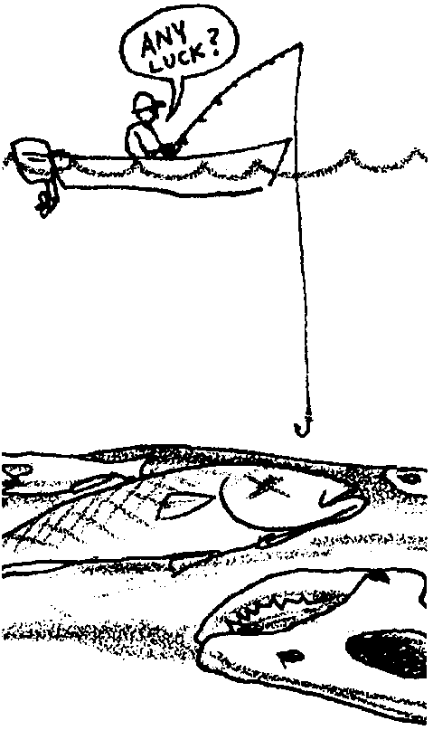

Key Concepts
1. Oxygen levels in water affect the kinds and numbers of living plants and animals.
2. Dissolved oxygen concentrations are affected by factors such as temperature, salinity, and dissolved organic matter.

Background
While oxygen is seldom in short supply for terrestrial organisms, the same is not true for aquatic organisms. Living things and the natural processes of decomposition compete for oxygen. Aquatic systems can decompose reasonable amounts of organic wastes without harmful effects. Excessive amounts of sewage or other organic wastes, on the other hand, reduce oxygen levels and productivity.
Biochemical oxygen demand (BOD) is a measure of the organic matter in water. The concentration of oxygen in the water sample is tested when the sample is taken and then again after five days of incubation in the dark at 20° C. The BOD is calculated by subtracting the dissolved oxygen concentration in the sample after incubation from the dissolved oxygen concentration before incubation.
In the sealed, darkened sample, organic matter is decomposed by the bacteria normally found in the water. The bacteria require oxygen for decomposition. Thus, the more organic matter present in the water sample, the more dissolved oxygen will be consumed by the bacteria over the five-day test period.

Materials
Part 1
For each team of 2-4 students:
• 2 clear containers such as beakers, flasks, test tubes or jars, 100-250 ml works well
• tap water
• 1 package yeast
• a tablespoon or two of powdered milk
• methylene blue
• stirring rod
Part 2
For each team of 2-4 students:
• 2 teaspoons powdered milk
• 2 teaspoons yeast
• 1 teaspoon measuring spoon
• methylene blue
• 2 jars or small beakers
• 3 test tubes in a test tube rack or resting in a jar
• stirring rod
Part 3- BOD (Biochemical Oxygen Demand) Testing
For each team of 4 students:
• 1 glass-stoppered dissolved oxygen bottle
• 1 glass-stoppered dissolved oxygen bottle covered with black plastic, foil or electrical tape
• Dissolved Oxygen Test Kit
• safety goggles

Teaching Hints
“Water Quality Monitoring: BOD—Biochemical Oxygen Demand” provides students with experience with a hands-on technique to assess the impact of organic matter on water quality. The Biological Oxygen Demand test is easy to conduct and provides your students with a first hand glimpse of the impact of organic pollution. As your students transfer water samples, recall that mixing increases the DO concentration and instead of pouring the sample, siphon the water whenever it is transferred into or out of the sample bottle.
Part 1 and 2 - “Using a Model System to Study the Oxygen Demand of Sewage” is adapted from a Biochemical Oxygen Demand activity of the same name by H. Weiss and M. Dorsey found in Investigating the Marine Environment Volume 2, p. 491.
Parts 1 and 2 - “Using a Model System to Study the Oxygen Demand of Sewage” employs a simple model using yeast, powdered milk, and methylene blue, instead of actual sewage, to study the effect of sewage on dissolved oxygen concentrations. Yeast represent the decomposers present in sewage and natural waters. Powdered milk contains sugar which represents the nutrient-rich wastes of sewage. Methylene blue is an indicator dye, blue when oxygen is present and colorless when oxygen is absent.
Part 1 is a very simplified model that concretely demonstrates that the presence of large amounts of food for the microorganisms reduces oxygen levels. Part 2 is a more complex version in which students test the effects of different quantities of model sewage. While it is tempting to move right to Part 2 when students have not completed Part 1, they tend to get lost in measuring ingredients and miss the point of the activity. Experience with Part 1, which may be used alone, will help them understand Part 2.

Key Words
Biochemical Oxygen Demand - a measure of the organic matter in water related to the oxygen required by aerobic organisms for metabolic processes
decomposer - organism that cannot produce its own food but breaks down dead material from which it derives its needed energy and nutrients
dissolved oxygen - oxygen which enters the water directly from the atmosphere (air) above the water; and, from plant photosynthesis during daylight hours
nutrients - minerals and other substances needed for life and growth

Extensions
1. Sewage usually contains many substances. Have your students try enriching the mini-system with other ingredients. They may wish to try soda, sugar, vinegar, baking soda, honey, Karo syrup, etc. For each substance, have them compare the results with those they obtained with milk.

2. Visit a nearby sewage treatment plant. What kind of sewage does it receive? How does it treat sewage? What happens to the treated sewage?

3. Have interested students carry out the experiment in flasks using four times the amount of each ingredient. Monitor dissolved oxygen concentration in the flasks. Does the methylene blue correctly indicate the presence or absence of oxygen?

Answer Key
1. An increase in any of the sources for dissolved organic matter tends to decrease the amount of oxygen the water can hold. (The bold face word correctly completes the sentence.)

2. Two sources of dissolved organic matter in runoff from urban areas may be selected from: pet wastes from streets and sidewalks, nutrients from lawn fertilizers, leaves, grass clippings, and paper from residential areas.

3. Two sources of dissolved organic matter in runoff from agricultural areas may be selected from: soil from eroded fields, manure from farms, failing septic systems, and agricultural fertilizers.
Part 1
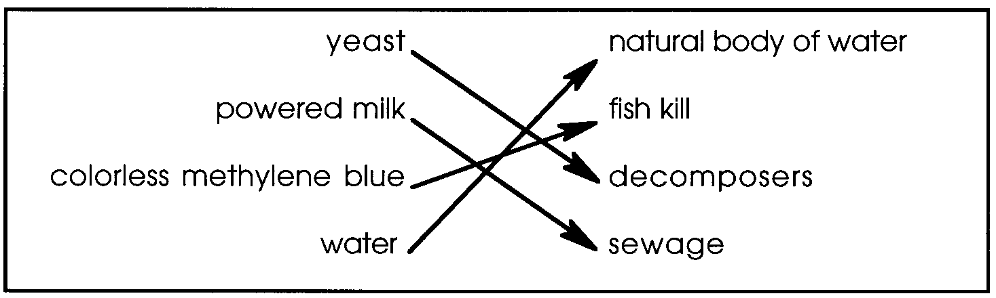
4. The arrows shown connect the model elements with the components they represent.

5 a. A mixture of water and yeast would, in this lab, model a body of water with decomposers, but no sewage.

b. A mixture of water, yeast and powdered milk would, in this lab, model a body of water with decomposers and sewage.

6 a. Answers will vary depending on students’ ideas.

b. Answers will vary depending on students’ ideas.

7 a. The mixture without powdered milk should have stayed mostly blue. There should have been very little for the yeast to decompose. The yeast, therefore, are not using an appreciable amount of oxygen.

b. The mixture with powdered milk should have turned mostly clear. The yeast were using oxygen as they became active in the presence of the powdered milk food source and increased their respiration, decreasing the concentration of dissolved oxygen.

8. Dissolved oxygen levels go down in natural bodies of water when raw sewage is present because the decomposers increase their respiration rate, taking in oxygen as they decompose the sewage.

Part 2
7. Student predictions will vary.

Part 2: Analysis
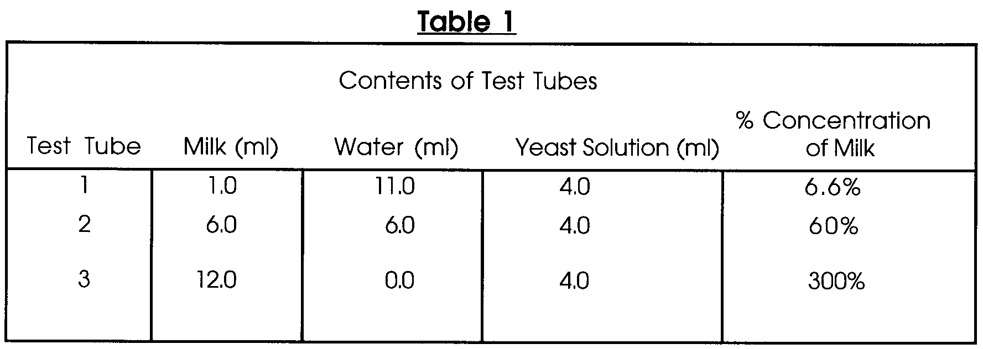
1 a. A completed Table 1 showing the percent of milk contained in each of the three test tubes is shown below:
b. Test tube #3 contained the most food for the decay organisms (decomposers).

c. Test tube #1 had the least food.

2. A ring of blue color at the surface of the test tubes, even after the remainder of the liquid had changed color, might be due to oxygen entering the sample at the boundary between the solution and the air.

3. Usually, the change occurs most rapidly in tube #3. Expectations may vary.

4. Explanations that account for the differences in time needed for the change to occur in each of the three tubes are likely to say that the time for the change is decreased by an increase in food for the yeast. The yeast can more readily find and consume food particles.

5. Shaking the tubes rapidly so that air is mixed with the liquid re-oxygenates the solution causing the indicator to change color again.

6. Up to a point, an increase in temperature would likely increase the speed of the reaction on these mini-systems. However, since the yeast cells are living, a dramatic increase in temperature will cause their death. Your students could find out by duplicating the experiment with a higher temperature, something you might wish to encourage.

7. If more decomposers (yeast) had been present at the beginning of your experiment, the time needed to see the color change would be decreased.

8. If the decay organisms began to multiply, the dissolved oxygen in water would decrease.

Part 3 - Biochemical Oxygen Demand (BOD) Testing
Biochemical Oxygen Demand (BOD) is an important measure of the health of our waters. The procedure presents a standard protocol which will enable your students to measure BOD in water they sample and compare the results with samples from other areas.
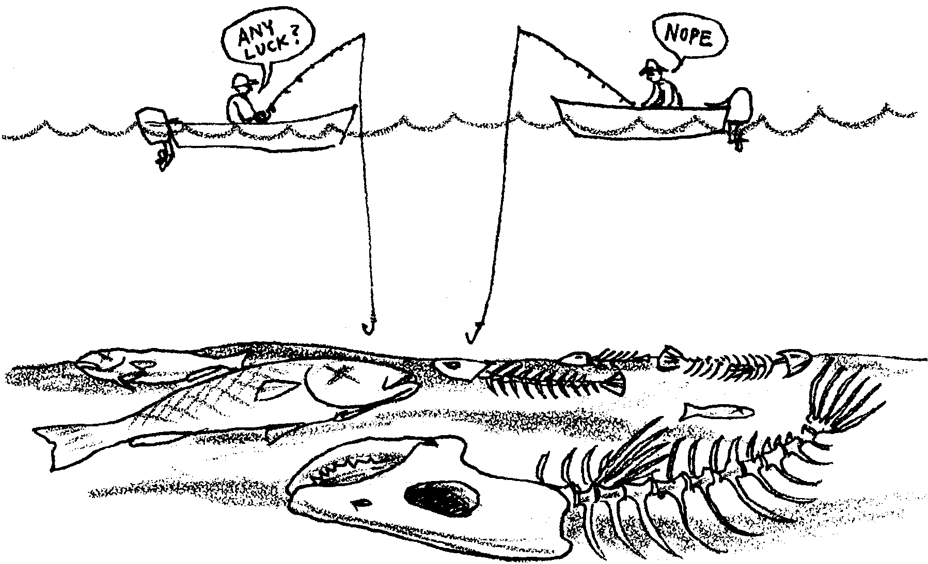
Water Quality Monitoring: BOD –
Biochemical Oxygen Demand

Oxygen levels in water affect the kinds and numbers of living plants and animals. Animals from plankton to salmon are affected by changes in oxygen levels. What influences the concentration of oxygen dissolved in water?
Dissolved oxygen concentrations are affected by factors such as temperature, salinity and dissolved organic matter. Dissolved organic matter enters water in:
• sewage,
• waste water from sewage treatment plants,
• urban and agricultural runoff,
• wastes from food processing industries, meatpacking plants, and dairies
• wastes from lumber mills, paper plants and other industries, and
• decaying aquatic plants and animals.

All of these waters are “nutrient-rich”, containing proteins, carbohydrates and fats. Once in the water, these materials are attacked by decomposers which use them for food. Decomposers are often bacteria and fungi. In the process of breaking down the nutrients, decomposers use a great deal of oxygen. If there are lots of wastes and decomposers, the oxygen dissolved in the water may be used up by the decomposers. This leaves no oxygen for other animals and plants. Under these conditions, many organisms die. To make matters worse, their decaying bodies are fed upon by the decomposers.
1. Look at the list of sources for dissolved organic matter. An increase in any of these factors tends to increase/decrease the amount of oxygen the water can hold. (Circle the word which correctly completes the sentence.)

2. What are two sources of dissolved organic matter in runoff from urban areas?
a.

b.

3. What are two sources of dissolved organic matter in runoff from agricultural areas?
a.

b.

Using a Model System to Study the Oxygen Demand of Sewage
You could learn a lot by studying actual sewage wastes, but these can be dangerous since they may contain disease-causing microorganisms. Therefore, in this activity you will use a simple model that employs yeast, powdered milk, and methylene blue instead of an actual sewage-waste river-water system. Yeast are microorganisms that use sugar as a source of food energy. They will represent the decomposers present in sewage and natural waters. Powdered milk contains sugar and will represent the nutrient-rich wastes of sewage. Methylene blue is an indicator dye. It is blue when oxygen is present and colorless when oxygen is absent.

4. Each element in the model system you will be using represents a component of an aquatic ecosystem. Use arrows to connect the model elements with the components they represent.

yeasta natural body of wate
powered milk fish kil
colorless methylene blue decomposer
water sewage

Part 1
This first part of this lesson gives you a chance to use the ingredients in this lab to create your own model of a body of water experiencing a sewage spill.
Materials
• 2 clear containers such as beakers, flasks, or jars, somewhere between 100 ml and 250 ml in size
• 1 package yeast
• a tablespoon or two of powdered milk
• stirring rod
• methylene blue

5 a. Which of the ingredients in this lab would you put in a container to model a body of water that has a population of decomposers but no raw sewage for them to decompose?

b. Which of the ingredients in this lab would you put in a container to model a body of water that not only has decomposers, but also contains an abundance of untreated sewage?

Procedure:
1. Label one container “No Sewage” and the other container “With Sewage”.

2. Mix together in one container the ingredients for your “No Sewage” model. In another container, mix together the ingredients for your “With Sewage” model. Be sure to use exactly the same quantities of water and powdered milk in both containers.

3. Finally, add 20 drops of methylene blue to each container and mix, being sure not to contaminate your “No Sewage” mixture with the model sewage in your “With Sewage” mixture.
6 a. What do you think will happen to the color of the mixture in the “No Sewage” container? Describe what you think is happening in the mixture to give those results.

b. What do you think will happen to the color of the mixture in the “With Sewage” container? Describe what you think is happening in the mixture to give those results.
4. If possible, let your model systems sit until any color change in the methylene blue is complete. The change may be complete in one class period, but may take up to 24 hours depending on the amount of yeast.

7 a. What happened to the color in the “No Sewage” mixture? Explain what you think occurred to give those results.

b. What happened to the color in the “With Sewage” mixture? Explain what you think occurred to give those results.

8. In a real body of water with real decomposers what would happen to dissolved oxygen levels if there were a real sewage spill? Explain what would cause that change.

Part 2
This experiment uses the powdered milk model of sewage contamination, but makes it more complex. You will have the opportunity to test the effects of different concentrations of sewage on the oxygen levels in your model systems.

Materials
For each team of 2-4 students:
• 2 teaspoons powdered milk
• 2 teaspoons yeast
• 1 teaspoon measuring spoon
• methylene blue
• 2 jars or small beakers
• 3 test tubes in a test tube rack or resting in a jar
• stirring rod

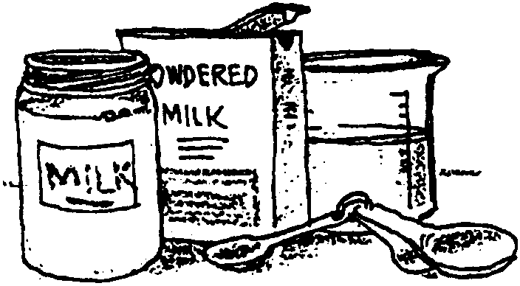
1. Start by making a milk solution. In a small jar, add two level teaspoons of powdered milk to 40 ml of water. Label this jar “milk”.

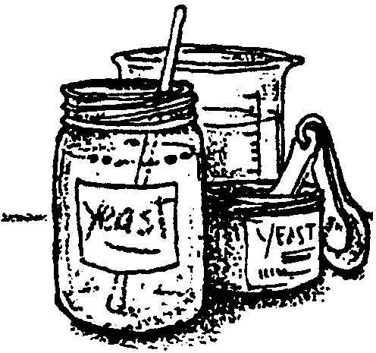
2. In another jar, make a yeast solution by mixing two level teaspoons of dry yeast with 40 ml of water. Be sure the yeast is well mixed. Stir it again just before you use it. Label this jar “yeast”.

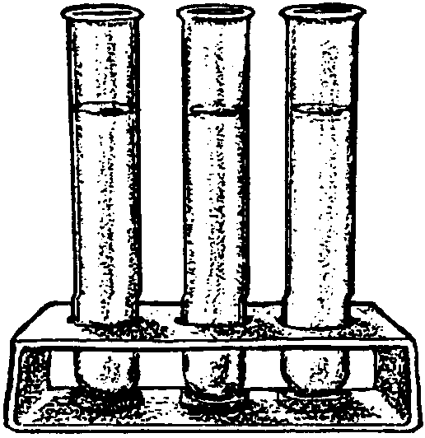
3. Now label three clean test tubes 1, 2, and 3 and place them in a test-tube rack.

4. Using two different syringes, or graduated cylinders, add the amounts of water and milk called for in Table 1 to the three test tubes.

Table 1 (partial)
Contents of Test Tubes
Test tube Milk (ml) Water (ml)
1 1.0 11.0
2 6.0 6.0
3 12.0 0.0

5. Add 20 drops of methylene blue solution to each test tube and mix thoroughly.

6. Set up a data sheet like the one shown below and RECORD the data and observations from this step.
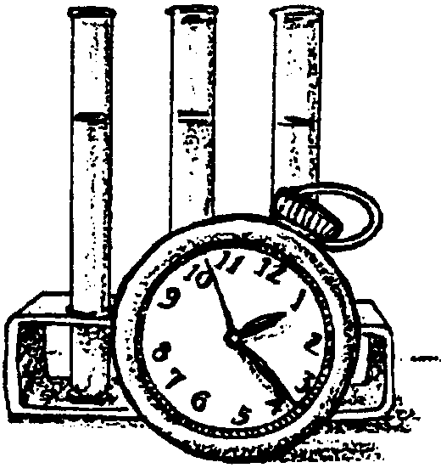
Add four ml of yeast solution to test tube 1, mix it well, and RECORD the exact time. Return the first test tube to the rack and do not disturb it (otherwise, air may get mixed with its contents). Follow the same procedures for the other two tubes. Observe carefully and continuously and RECORD the exact time when any changes in the tubes take place. This part of you experiment may take about 20 minutes.
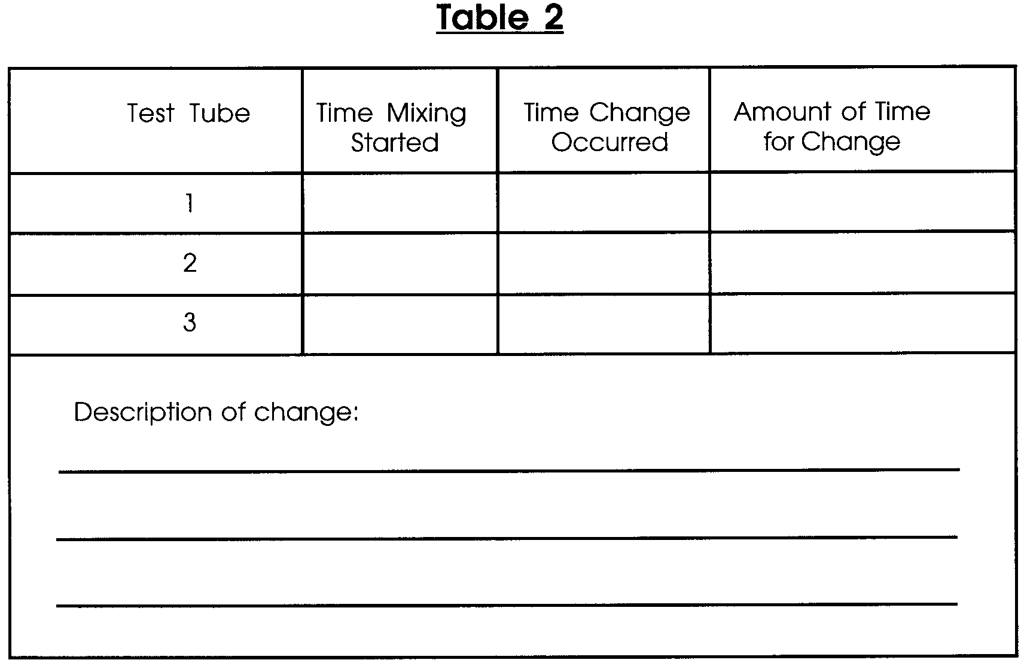

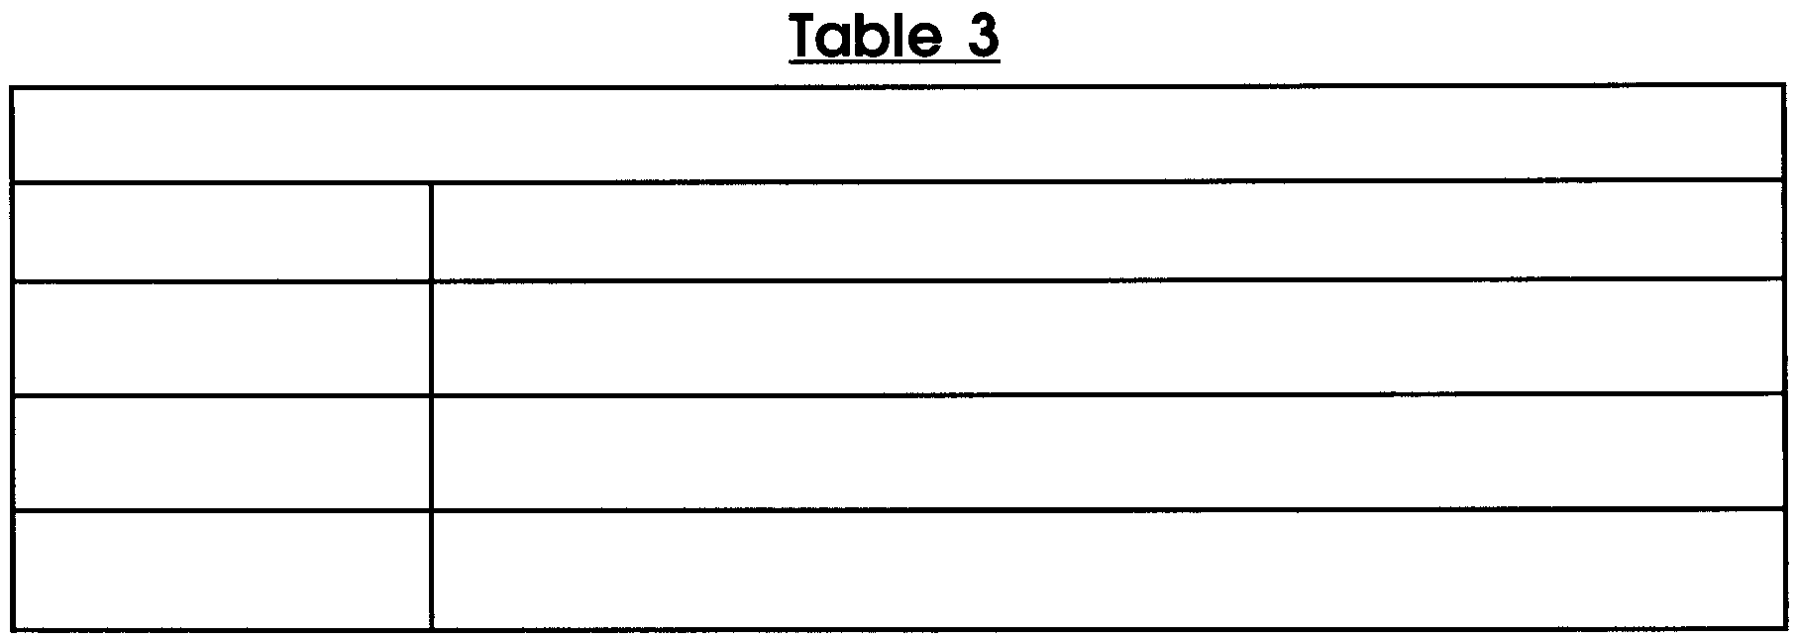
7. While you are waiting, think about what you have been doing and make some predictions about what will happen.

Analysis
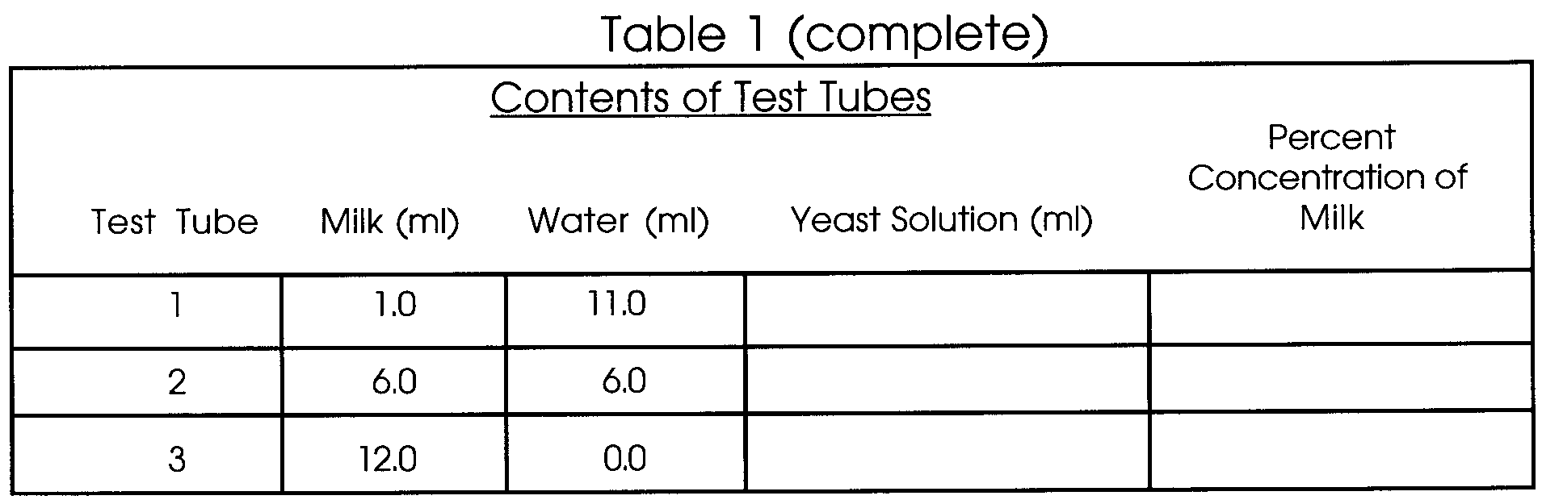
1 a. Complete table 1 by recording the ml. of yeast added and by calculating the percent of milk contained in each of the three test tubes.

b. Which test tube contained the most food for the decay organisms (decomposers)?

c. Which tube had the least food?

2. Your test tubes may have had a ring of blue color at the surface even after the remainder of the liquid had changed color. What might account for this?

3. In which tube did the change occur most rapidly? Is this what you expected? Why?

4. Develop an explanation that accounts for the differences in time needed for the change to occur in each of the three tubes.

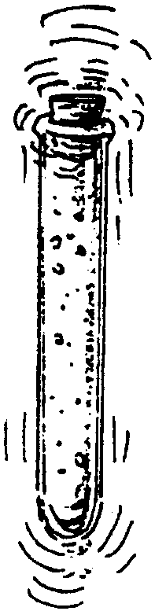
5. Cover the tops of the tubes and shake them rapidly so that air is mixed with the liquid. What change takes place? Why?

6. Each of your test tubes represented a sewage-water system. Each one contained a different concentration of sewage (milk). What effect would an increase in temperature have on these mini-systems? How could you find out?

7. How would your systems have been affected if more decomposers (yeast) had been present at the beginning of your experiment?

8. Decay organisms often reproduce rapidly when conditions are favorable and nutrients are plentiful. What do you think would happen to the supply of dissolved oxygen in a river if the decay organisms began to multiply?

Part 3 - Biochemical Oxygen Demand (BOD) Testing
As noted above, Biochemical Oxygen Demand (BOD) is an important measure of the health of our waters. The following procedure will enable you to measure BOD in water which you sample.

Materials
For each team of 4 students:
•1 glass-stoppered dissolved oxygen bottle
•1 glass-stoppered dissolved oxygen bottle covered with black plastic, foil or electrical tape
• Dissolved Oxygen Test Kit
• safety goggles
Sampling Procedure
1. Obtain a sample of the water to be tested. Record the depth at which the sample was taken. Remember, samples taken at or near the bottom may hold more oxygen-demanding materials and organisms. If you will only be sampling at one depth it is best to sample midway between the surface and bottom away from shore to obtain a representative sample. Be sure your sample is large enough to run at least two BOD tests.
If you will not be testing for dissolved oxygen immediately, wrap the sample container with foil or black electrical tape to shield the sample from light.
Like the Dissolved Oxygen tests, it is important to run all tests for comparison at the same time of day.

Test
1. Fill two glass-stoppered dissolved oxygen (DO) bottles (one clear and one black) with sample water, again holding them for two to three minutes halfway between the surface and the bottom if sampling by hand.

2. Stopper the bottles underwater if sampling from shore, ensuring no air bubbles are present in the bottles.

3. Prepare the clear sample bottle according to the directions for the Dissolved Oxygen test. Determine the DO level of this sample.

4. Place the black sample bottle in the dark and incubate for five days at 68° F. This is very close to room temperature in many buildings. If there is no incubator, place the blackened sample bottle in a “light-tight” drawer or cabinet. After five days, determine the level of dissolved oxygen of this sample by following the steps of the DO testing procedure.

5. The BOD level is determined by subtracting the DO level of the blackened sample from the original DO level found in the first sample above (taken five days previously).

BOD = dissolved oxygen (original sample) minus the dissolved oxygen (after incubation).

Record Your Answer: _________

The BOD measure is, the amount of oxygen consumed by organic matter and associated microorganisms in the water over a five-day period.

