Water Quality Monitoring: Dissolved Oxygen

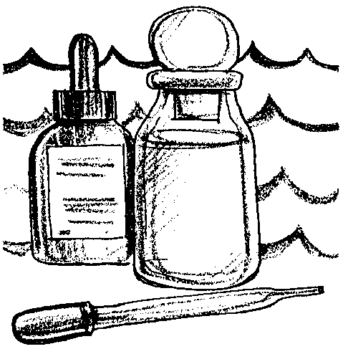
Key Concepts
1. Photosynthesis and mixing with air add oxygen to water.
2. Cold water holds more oxygen than warm water and less saline water holds more oxygen than more saline water.
3. Water quality parameters such as dissolved oxygen may be measured using standardized tests.

Background
From the standpoint of animal life, dissolved oxygen is one of the most important chemical substances in natural waters. As such, the measurement of dissolved oxygen is a key parameter assessed in water quality studies and dissolved oxygen levels are often used as an indicator of the health of aquatic ecosystems.
Many human activities which impact surface waters tend to decrease the amount of dissolved oxygen. For example, increases in dissolved organic matter entering waters from sewage overflows, agricultural runoff, food processing, industry and decaying plants and animals are a common cause of decreased dissolved oxygen. Prolonged decreases in dissolved oxygen can cause changes in species diversity.

Materials
Measuring Dissolved Oxygen
For each team of 2-4 students:
• Dissolved Oxygen Test Kit*
• thermometer
• safety goggles
• optional- starch solution
* Dissolved Oxygen Test Kit, Model OX-2p, Order Catalog Number 1469-00, Hach Equipment Co., P.O. Box 389, Loveland, Colorado 80539
One Step Further ...
For each team of 2-4 students:
• 3 500 ml Erlenmeyer flasks
• 1 stopper
• tap water
• activated sludge from a waste treatment plant or other decaying organic matter, such as rotting leaves in a stream

More One Step Further ...
For each team of 2-4 students:
• 4 1000 Erlenmeyer flasks
• 170 g salt (NaCl)
• balance
• tap water
For the class:
• incubator
• refrigerator

Teaching Hints
In “Monitoring Water Quality: Dissolved Oxygen”, oxygen, the second of the nine physical/chemical parameters presented is introduced. The determination of the oxygen content of seawater provides your students with practice in some fundamental chemical procedures while gathering data which can be used to discuss the general conditions necessary for life in the oceans.
The procedure used in “Dissolved Oxygen” is a Hach Chemical modification of the Winkler Titration method. You may have access to oxygen meters or other field kits, such as those produced by Lamotte Scientific, in which case you should refer to the directions provided by the manufacturer. Alternatively, we have provided directions for the standard Winkler technique.
Prior to performing the investigation, introduce your students to the role of oxygen in the marine environment. The first section of the activity may be assigned as background reading. If you are able to have your students collect the water for testing, demonstrate the use of the water sampler. Discuss the apparatus and demonstrate the techniques involved in determining the dissolved oxygen concentrations of aquaria in the classroom. Provide any help your students may need as they follow the procedure outline. Discuss the problems encountered in the use of the equipment and rectify the problems encountered. Emphasize the need for care in the performance of these tests. Plan to allow time for a discussion of the results and the procedure at the end of this activity.
Encourage good lab practices including the wearing of safety glasses. In case of accidental contact with any of the chemicals, flush any areas of contact liberally with water. Students should wash their hands after running these tests. First aid directions are included on the pillow containers in the Hach test kits.

A Word About Analytical Procedures:
Analytical procedures have been selected for high school students of varying abilities and background experiences. Experience has shown that students with little or no chemistry background often perform admirably with some initial supervision in laboratory techniques and an understanding of concentration and the units of concentration. It is desirable that students understand the theory and mechanics of the reactions themselves, however, it is not a requirement if the objectives center on the data and its application to the marine environment. Wherever possible it is recommended that the students:
1. inventory chemistry
2. determine order and reorder needs
3. assist with ordering
4. determine and make up needed quantities or reagents
5. conduct calibration and standardization called for in procedures
6. adhere as closely as possible to recommended procedure.
Selection of these specific procedures has been made with an attempt to use the most current up to date techniques with the following criteria in mind:
1. availability of equipment
2. equipment and reagent costs
3. comparability of optical procedures with the Bausch & Lomb Spectronic 20
4. student time limitations (typically one hour) every 24 hours
5. a minimum of chemical interferences
6. desirability of parameters to be monitored

Standard Winkler Determination of Dissolved Oxygen
While, the use of Hach test kits simplifies the determination of dissolved oxygen, a discussion of the standard Winkler procedure of the titrametric determination of dissolved oxygen concentration is included below.
The following is a discussion of the procedure for the titrametric determination of dissolved oxygen concentration. You may find that you will have to make certain compromises as you do your oxygen determinations. Each alteration in the procedure decreases the precision. This, however, should not be looked upon with great alarm. While the results you obtain with modifications may not be analytically accurate, with reasonable care your results should provide a good picture of the water studied and also provide a good springboard for discussion.

A. Outline of Method
The Winkler Titration method involves chemical treatment of the water sample in such a manner that one molecule of iodine is produced in the sample for each molecule of oxygen in the original sample. The concentration of iodine is then determined by titration. In the technique, a divalent manganese solution, followed by strong alkali, is added to the sample. Manganous hydroxide is precipitated out. The precipitate is agitated to evenly disperse it. The sample completely fills a stoppered glass bottle. Any dissolved oxygen in the water rapidly oxidizes an equivalent amount of divalent manganese to basic hydroxides. The solution is next acidified in the presence of iodide. The oxidized manganese liberates iodine. The amount of iodine is equivalent to the original dissolved oxygen content of the water. This iodine is titrated with standardized thiosulphate solution.

B. Sampling Procedure and Sample Storage
Three hundred milliliter Biological Oxygen Demand (BOD) bottles are rinsed twice with the sample being analyzed. If the sample is obtained from a reversing bottle, a length of rubber tubing should be taken from the tap to the bottom of the BOD bottle and seawater introduced in such a way as to minimize turbulence and agitation of the sample. The end of the rubber tube must always be kept beneath the surface of the water as the bottle is filled. Water is allowed to overflow with the top of the BOD bottle which is stoppered at once. A volume of water at least equal to the volume of the BOD bottle should be allowed to overflow, more if the oxygen content of the water is suspected to be very low. No air should remain in the bottle. When the sample is taken from a bucket (e.g., surface samples), rinse the bottle twice and then allow the water to flow in by submerging the bottle to the mouth and gently tipping it so that the sample enters with no bubbling and a minimum of turbulence. For work of the highest accuracy, the sample should be siphoned into the bottle.
Store the samples in the dark or in subdued light to minimize photosynthesis by any phytoplankton that may be present. If the analysis must be delayed, “pickle” the samples by adding the manganous sulphate and alkaline iodide azide solutions. The rest of the analysis may be completed at leisure.

C. Special Reagents

1. Manganous Sulphate Reagent
Dissolve 480 g of manganous sulphate tetrahyde, MnSO4.4H20, or 400 g of manganese sulphate dehydrate, MnS04.2H20, or 364 g of manganous sulphate monohydrate, MnS04.H20, in distilled water. Filter and dilute the volume to 1 liter.
2. Alkaline Iodide Solution
Dissolve 500 g of sodium hydroxide in 500 ml of distilled water. Dissolve 150 g. of potassium iodide in 200-300 ml of distilled water in a separate container. Mix the two solutions. A great deal of heat will be liberated. Dilute to 1 liter. To this solution, add 10 g sodium azide, NaN3, dissolved in 40 ml of distilled water. This reagent should not give a color with starch solution when diluted and acidified.

3. Sulfuric Acid
Use concentrated reagent grade sulfuric acid, H2S04. Handle with care!

4. Starch Solution
Prepare a paste of 5-6 g soluble starch in a small amount of distilled water. Pour this paste into 1 liter of boiling distilled water. Allow the paste and water to boil a few minutes and let settle overnight. Use the clear supernatant. This solution may be preserved with 1.25 g salicylic acid/liter or by the addition of a few drops of toluene.

5. Sodium Thiosulfate Stock Solution, 0.10 N
Dissolve 24.82 g Na2S203.5H20 in boiled and cooled distilled water and dilute to 1 liter. Preserve by adding 1 g NaOH/liter.

6. Working Sodium Thiosulfate Titrant, 0.025 N
Dilute 250 ml sodium thiosulfate stock solution to 1 liter.

7. For standardizing the sodium thiosulfate with K2Cr207 solution
Dissolve approximately 2 g KI, free with iodate, in an Erlenmeyer flask with 100-150 ml distilled water. Add 10 ml of 3.6N H2SO4 followed by exactly 20 ml of standard dichromate solution (reagent, step 8) and place in the dark for 5 minutes. Dilute to 400 ml and titrate with the 0.025N thiosulfate, adding starch toward the end of the titration when a pale straw color is reached. If the sodium thiosulfate is 0.025N, exactly 20 ml of this titrant will be required to reach the titration endpoint. If necessary, adjust the sodium thiosulphate to 0.025N by adding NA2S203.5H20 if the above titration required more than 20 ml. If the titration required less than 20 ml, add boiled and cooled distilled water. Again, check by titration.

8. Standard Potassium Dichromate Solution, 0.025N
Weigh out 1.226 g of K2Cr207, previously dried in an oven at 103° C for 2 hours. Prepare the solution in a volumetric flask by diluting the K2Cr207 to a liter. A solution of K2Cr207 equivalent to 0.025N sodium thiosulfate contains 1.226 g/liter K2Cr207.

Additional information may be found in:
Strickland, J.D.H. and T.R. Parsons, 1972, A Practical Handbook of Seawater Analysis, Fisheries Research Board of Canada: Bulletin 167, Ottawa.

The following books are most helpful:
Greenberg, Arnold, et al., editors. Standard Methods of the Examination of Water and Wastewater. 14th edition, 1975.
Hazen, James, Introduction to Spectroscopy. Bausch & Lomb #S-4035.
Martin, Dean, Marine Chemistry. Vol. 1 & 2. 1972.
Strickland, J.D.H. &Parsons, T.R., A Practical Handbook of Seawater Analysis. 1972.

Key Words
dissolve - to cause to go into solution
dissolved oxygen - oxygen which enters the water directly from the atmosphere (air) above the water; and, from plant photosynthesis during daylight hours
generalization - a general statement, idea, or principle
nomograph - a graph, usually containing three parallel scales graduated for different variable so that when a straight line connects values of any two, the related value may be read directly from the third at the point intersected by the line
precipitate - to chemically cause a solid substance to be separated from a solution; also the solid substance so separated
reagent - a substance used in a chemical reaction used to measure other substances
salinity - a measure of the salt concentration in a solution
solubility - the quality that substances have of dissolving or being dissolved easily; the relative capability of being dissolved
thermocline - a layer within a large body of water sharply separating parts of it that differ in temperature, so that the temperature gradient through the layer is very abrupt
titrant - the reagent added in a titration

Answer Key
Introduction
1. Students are likely to have heard the term solvent in connection with paint thinners, gasoline, kerosene, and the like. This question is designed to get them thinking about water as a solvent with a great ability to dissolve substances.
2. The common chemical compound referred to here is table salt.

Oxygen
1. Oxygen enters salt water in two ways: directly from the atmosphere above the water, and from plants via photosynthesis during daylight hours.
2. Respiration is important since it provides oxygen required for the energy deriving oxidation processes carried on by living organisms. The energy is used for all of life’s processes.
3. Pollution from the sources listed in the reading increase the quantity of dissolved organic wastes in the water resulting in a decrease of oxygen. The decrease in oxygen levels has a negative impact on many marine animals.
4. If the dissolved oxygen level in salt water decreases, the numbers of fish which require high levels of dissolved oxygen like the Coho salmon will decrease.
5. Water samples should be taken at several depths rather than at a single depth, since factors such as oxygen often change with depth.
6. Minimizing the mixing reduces the amount of oxygen that enters the water sample by diffusion at the surface.

Analysis and Interpretation
1, 2, 3. The answers depend upon the experimental results obtained.
4.Lowest concentration would be found when the water is the warmest, saltiest, and most full of dissolved organic matter. Most often, these conditions would occur in late summer or early fall.
5.Three factors that might be expected to lower the dissolved oxygen concentrations in water may be selected from the following:
• increase in sewage discharged into the body of water,
• urban and agricultural runoff from rain and melting snow carrying organic wastes into the water,
• discharge of food processing industries and meatpacking plants, and dairies into nearby waters
• discharge from lumber mills, paper plants and other industries into the water, and,
• decaying aquatic plants and animals
• increased temperature

One Step Further ...
“One Step Further ...” and “More One Step Further ...” offer your students an opportunity to employ the techniques learned in “Oxygen” to study the effect of various factors on the dissolved oxygen concentration of water samples.
Analysis and Interpretation

1. The answer depends upon the experimental results. Usually, the tap water solution will have the highest dissolved oxygen concentration.
2. The answer depends upon the experimental results. Usually, the stoppered flask with organic matter solution will have the lowest oxygen concentration.
3. A generalization might be: Decaying organic matter causes a decrease in the dissolved oxygen concentration of a water sample. This question might serve as a starting point for a refresher course on the process of science.
4 a. You would predict that the dissolved oxygen concentration near the discharge of the super sewer would decrease. The DO would be lower than that of surrounding waters.
b. As you move away from the outfall, you would predict an increase in the dissolved oxygen concentration of the water.
c. Plant and animal populations will change in the area of the sewer outfall. Organisms requiring a high oxygen content will no longer be found. Those that can survive in areas of low oxygen concentrations will become more numerous.
5. Constant or frequent monitoring of the waters near a sewer outfall can show us the point when the waters will no longer tolerate the addition of more organic matter. Once we determine the loading limits, we can hopefully regulate the discharge accordingly.

More One Step Further ...
Analysis and Interpretation
1. The graph depends upon the experimental results, but should have the following general appearance:
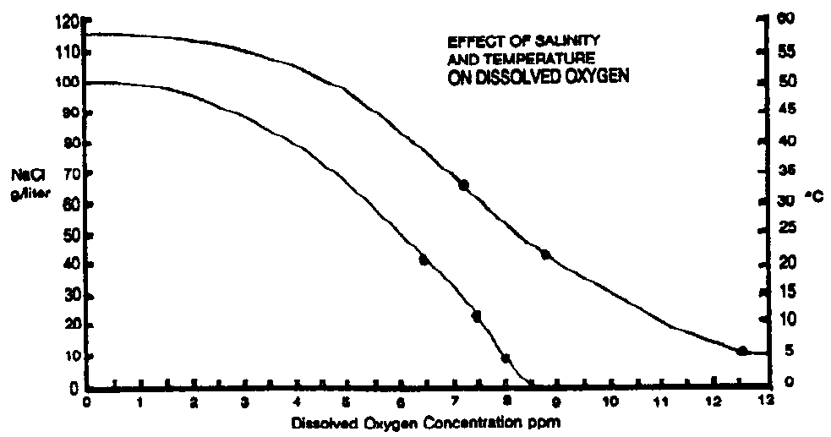
2. A generalization which may be derived form the experimental results might be phrased: Increased salinity decreases the ability of water to hold dissolved oxygen.

3. A generalization which may be derived from the second set of experimental results might be: Increased temperature decreases the ability of water to hold dissolved oxygen.
4 a. The increased temperature will tend to decrease the dissolved oxygen concentration.

b. The decreased salinity will tend to increase the dissolved oxygen concentration.

c. The decrease in dissolved oxygen concentration due to the increased temperature will be, at least partly, offset by the increase in dissolved oxygen concentration due to the decrease in salinity. The factors interact in such a way as to have the potential for decreasing the effect of the discharge on the dissolved oxygen concentration. This question provides a good opportunity for a discussion of the effects of interaction between environmental factors. While we normally only examine a single factor at a time (e.g., salinity or dissolved oxygen), in real life these factors all interact to influence the plants and animals living in an area. It is interesting to note that the number of interactions between factors increases according to the formula:
n(n-1)

N = 2 ²

where N is the number of interactions and n equals the number of factors being considered. For example, for five interacting factors, there are a possible 2¹⁰ or 1024 interactions. This sobering information should tend to make us cautious in our predictions regarding the effects of human-made projects on the ocean ecosystem.
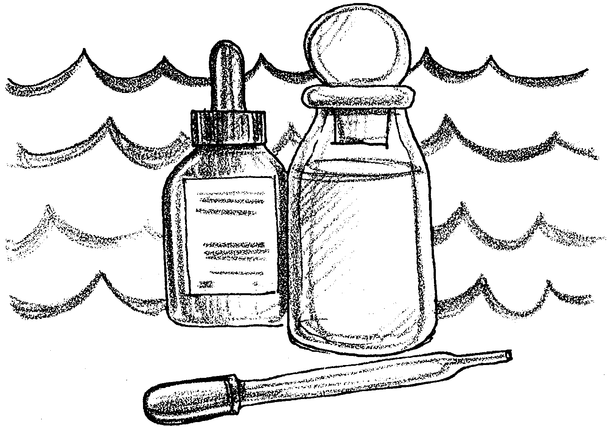
Water Quality Monitoring: Dissolved Oxygen

Water is what makes life on our earth possible. Water is able to dissolve more substances than most other liquids. The remarkable solvent (ability to dissolve things) properties of water are due to the way the atoms are arranged. The diagram below shows how the two hydrogen atoms and the one oxygen atom are joined. This arrangement tends to let water molecules combine strongly with each other as well as with molecules of other substances.
O=
H+
H+
105°

1. The solvent properties of water relate to water’s ability to dissolve things. With which other solvents are you familiar?

The fact that water is able to dissolve so many things is the reason we have seawater. Seawater is water with metals, organic material and gases dissolved in it. In fact, the saltwater we find in the oceans has atoms of most of the chemical elements dissolved in it. All life in the sea depends upon seawater in many ways.

2. What common chemical compound do we obtain from seawater?
(Hint: We use a lot of this on french fries.)

Some of the materials dissolved in saltwater are essential for life in the estuary. Other materials threaten life in the estuary. “Water Quality” measurements look at the balance of life supporting and life threatening materials in the water. Let’s begin the investigation of water quality with an element essential to life in the water, oxygen.

Oxygen
Of all the chemical substances in natural waters, oxygen gas is one of the most important to life. Estuarine animals and plants need oxygen for respiration. Respiration is the process of combining foods with oxygen to obtain energy for life’s activities. Factors that change the amount of oxygen dissolved in estuarine waters affect the growth of plants and animals.
Oxygen enters water in two ways: directly from the atmosphere (air) above the water; and, from plant photosynthesis during daylight hours. Since about 21% (210 ppt) of the air is oxygen, one might expect that the water would have a similar percentage of dissolved oxygen. Actually, we find that water will only hold about .001% (10 ppm) oxygen - 210 times less oxygen than air! It is not difficult to see that the primary life limiting gas in water is oxygen. Land dwelling animals seldom die from a lack of oxygen in the air. Water dwelling organisms often die from a lack of oxygen in the water.

1. How does oxygen enter water?

2. Why is respiration important for living things?
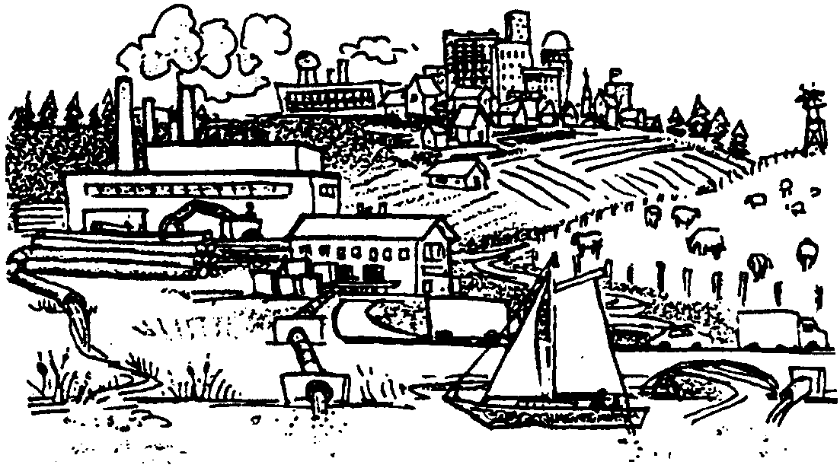
The amount of dissolved oxygen is affected by factors such as temperature, salinity and dissolved organic matter. Dissolved organic matter includes:

•sewage,
•urban and agricultural runoff from rain and melting snow carrying organic wastes into the water,
•discharge of food processing industries and meatpacking plants, and dairies
•discharge from lumber mills, paper plants and other industries, and,
•decaying aquatic plants and animals.

An increase in any of these factors tends to decrease the amount of oxygen the water can hold and, therefore, the amount of oxygen available to plants and animals. The oxygen is decreased because bacteria consume oxygen as they breakdown these organic materials.

3. The pollution sources listed above have been linked with declines in some marine animal populations. What specific changes would these pollution sources make in the water that might be harmful?

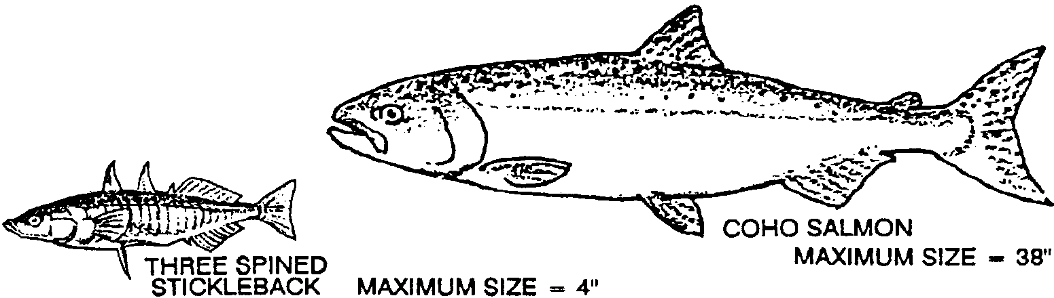
The dissolved oxygen level of water is one indicator of the health of aquatic ecosystems. High levels of dissolved oxygen usually indicate a healthy system. Decreases of dissolved oxygen can cause changes in the diversity of animals and plants in an area. This means that not only are there fewer individual animals and plants, there are fewer kinds of plants and animals. Severe decreases in dissolved oxygen eliminate most life from an area.

4. Some fish like the three-spined stickleback are able to withstand very low levels of dissolved oxygen. Other fish like the coho salmon require high levels of dissolved oxygen. If the dissolved oxygen level in saltwater decreases what is likely to happen to the numbers of fish like the Coho salmon?
Part 1 - Sampling the Waters
Unlike water in a fish tank where a sample taken at any portion would be similar in its properties to a sample of water taken from another portion, sea waters can vary considerably from area to area. Perhaps you have had the opportunity to dive into a lake or bay in the summer and have noticed that as you reach a certain depth you will contact a layer of very cold water. This is called the thermocline. Such layering of waters due to temperature is common. Variations of the other physical and chemical factors are also common. It is therefore necessary, when studying the properties of a water system, to analyze samples at different depths at the same station. Often populations of different animals and plants are restricted to different depths because of these environmental conditions. As you carry out tests to determine the various properties of water taken at a given station, it is important that you include information on the properties of the waters at the station at various depths.

5. Why should you take waters samples at several depths rather than at a single depth?

Since the water is to be analyzed for dissolved oxygen, your sample must be collected in such a fashion that air is not bubbled through the sample. Oceanographers and limnologists, those who study fresh water, have developed special equipment for gathering such samples. Your instructor will demonstrate the use of the equipment you will be utilizing.
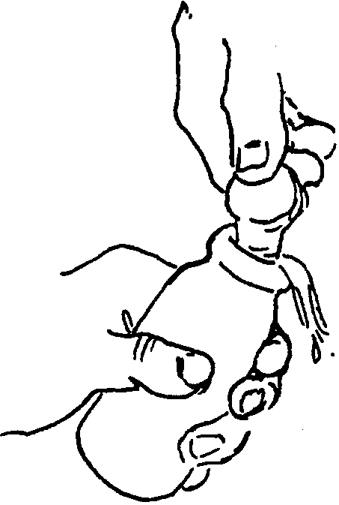
Once the sample is collected, a record of the water temperature in the sample must be taken and recorded for further use. In all samples, the water should be taken from the sampler in a fashion which prevents or minimizes mixing. The water sample of at least twice the volume of your collecting bottle should be carefully run into the bottle by inserting a delivery tube in the bottom of the bottle. The water should be allowed to overflow until the sample bottle has had several volumes of water passed through it to flush out the atmospheric oxygen. When the bottle is filled, the glass stopper is inserted carefully to avoid the introduction of any air bubbles. This can be easily accomplished by tipping the bottle slightly and then inserting the stopper at an angle with a quick downward thrust. The sample should be tested as quickly as possible.

6. Why do you want to minimize the mixing?
Part 2 - Testing the Sample
Materials
• dissolved Oxygen Test Kit
• thermometer
• safety Goggles
• optional- starch solution

Procedure:

Note: Avoid contact with any of the chemical reagents used in this and other water quality tests. If you come into contact with any powder or PAO titrant, rinse the area of contact liberally with water. Always wash your hands after performing water quality tests. First aid directions are included on the pillow containers. Wear safety goggles while shaking the dissolved oxygen (DO) bottle.

1. Carefully collect a water sample as previously described.

2. Record the water temperature.

3. Remove the glass stopper from the water sample bottle and add the contents of pillow one (manganous sulfate powder) and pillow two (alkaline iodide azide powder) to the sample in the DO bottle.
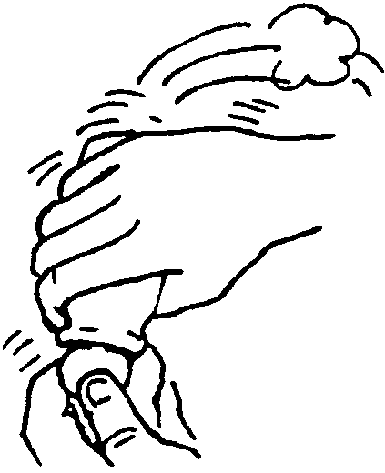
4. Carefully replace the stopper, being careful to avoid the introduction of air. This can be easily accomplished by tipping the BOD bottle slightly and then inserting the stopper at an angle with a quick downward thrust. Mix the contents by vigorously inverting the bottle 15 times. DO NOT SPLASH THIS MIXTURE; WASH YOUR HANDS IF YOU CONTACT THIS WATER.
If oxygen is present in your water sample, the chemicals will form a brownish precipitate (solid).

5. Allow the sample to stand for five minutes or until the top half of the solution in the DO bottle is clear, whichever comes first. Shake the DO bottle again as in step 4, and wait, again, for the settling.
Once you have completed this step, it is no longer critical to avoid adding air bubbles to the sample because the first two powder pillows contain chemicals that attach to the oxygen. They have fixed the oxygen in the sample. This means that the chemicals have bonded with the oxygen and are not available to attach to any additional oxygen.
6. Add the contents of pillow three (sulfamic acid powder) to the sample. Shake the DO bottle until the precipitate dissolves leaving a clear, yellow solution.
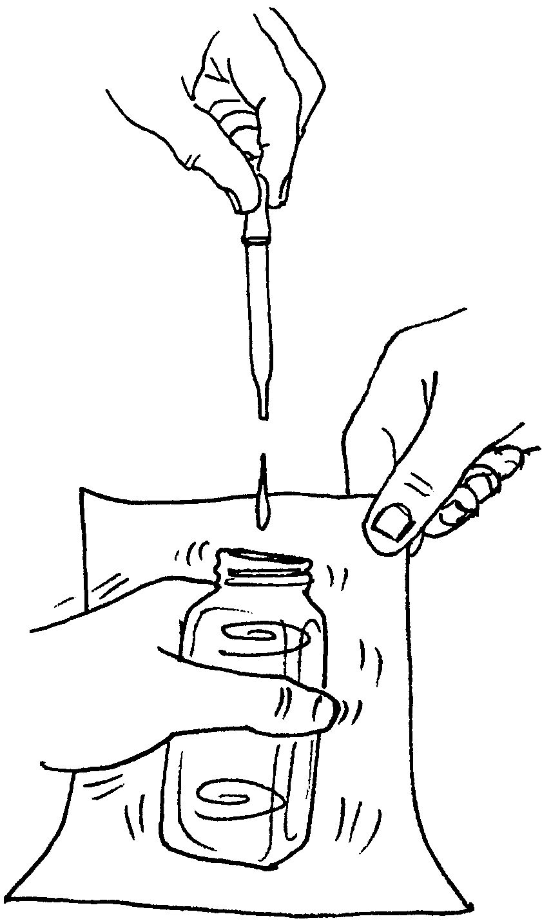
7. Carefully pour the sample into the measuring tube. Fill to the top of the tube. Pour the contents of the tube into the square mixing bottle. REPEAT this procedure. Your should now have TWO measuring tubes of solution in the square mixing bottle.

8. OPTIONAL - To the square mixing bottle, add one or two drops of starch solution. The water sample should become blue and the color change in the next step will be more visible.

9. While swirling the sample to mix, add PAO titrant one drop at a time to the sample. Be careful to hold the dropper straight up and down above the bottle. Count the number of drops needed to change the sample from blue to colorless. Proceed slowly since one drop will cause the change of color. To see the color change accurately, hold the bottle against white paper as you add drops one at a time.

Record the number of drops on your Data Sheet.

10. Each drop equals 0.5 mg/liter of Dissolved Oxygen. This can also be expressed as 0.5 ppm where ppm means parts of oxygen per million parts of water.

Calculate the dissolved oxygen concentration. (Hint: how many drops of PAO titrant did you use?)
Record the Dissolved Oxygen Concentration in ppm on your Data Sheet.

11. It is standard practice to obtain two identical samples from each depth. The ppm dissolved oxygen (DO) at each depth should theoretically be identical. In practice, small variations will occur. If the ppm DO values obtained from the matched sample are close, one is reasonably certain that the results are accurate. Repeat the above procedure on a second sample from the same sources. Average the paired results and RECORD for each set of samples.
Analysis and Interpretation:
While the dissolved oxygen concentration data you have obtained is interesting in itself, we are primarily concerned with the effect of this concentration on the organisms in an estuary. Again, the dissolved oxygen level can tell us much about the general “health” of the water and about its ability to support life. For example, low oxygen concentrations may mean high levels of sewage pollution since the breakdown of these wastes uses up (consumes) oxygen. Oxygen concentrations of 5 ppm or less can reduce fish growth and fish kills can occur as well. The minimum oxygen required for life depends upon the species of animal as well as other environmental factors such as temperature.
As water temperature increases, its ability to hold dissolved oxygen decreases. To compare dissolved oxygen concentrations from areas with different temperatures, scientists often use something called the percent saturation value. An oxygen saturation value of 90% is considered healthy.
Salinity also affects oxygen saturation. Use the following nomograph to compare your results to the maximum saturations expected for different temperatures and salinities. You will need to obtain the salinity or chlorinity figures either by experimentation or from your teacher. If no figures are available, assume a salinity of 34.5 parts per thousand (‰).
Nomograph illustrating the relationship between the saturation level or solubility
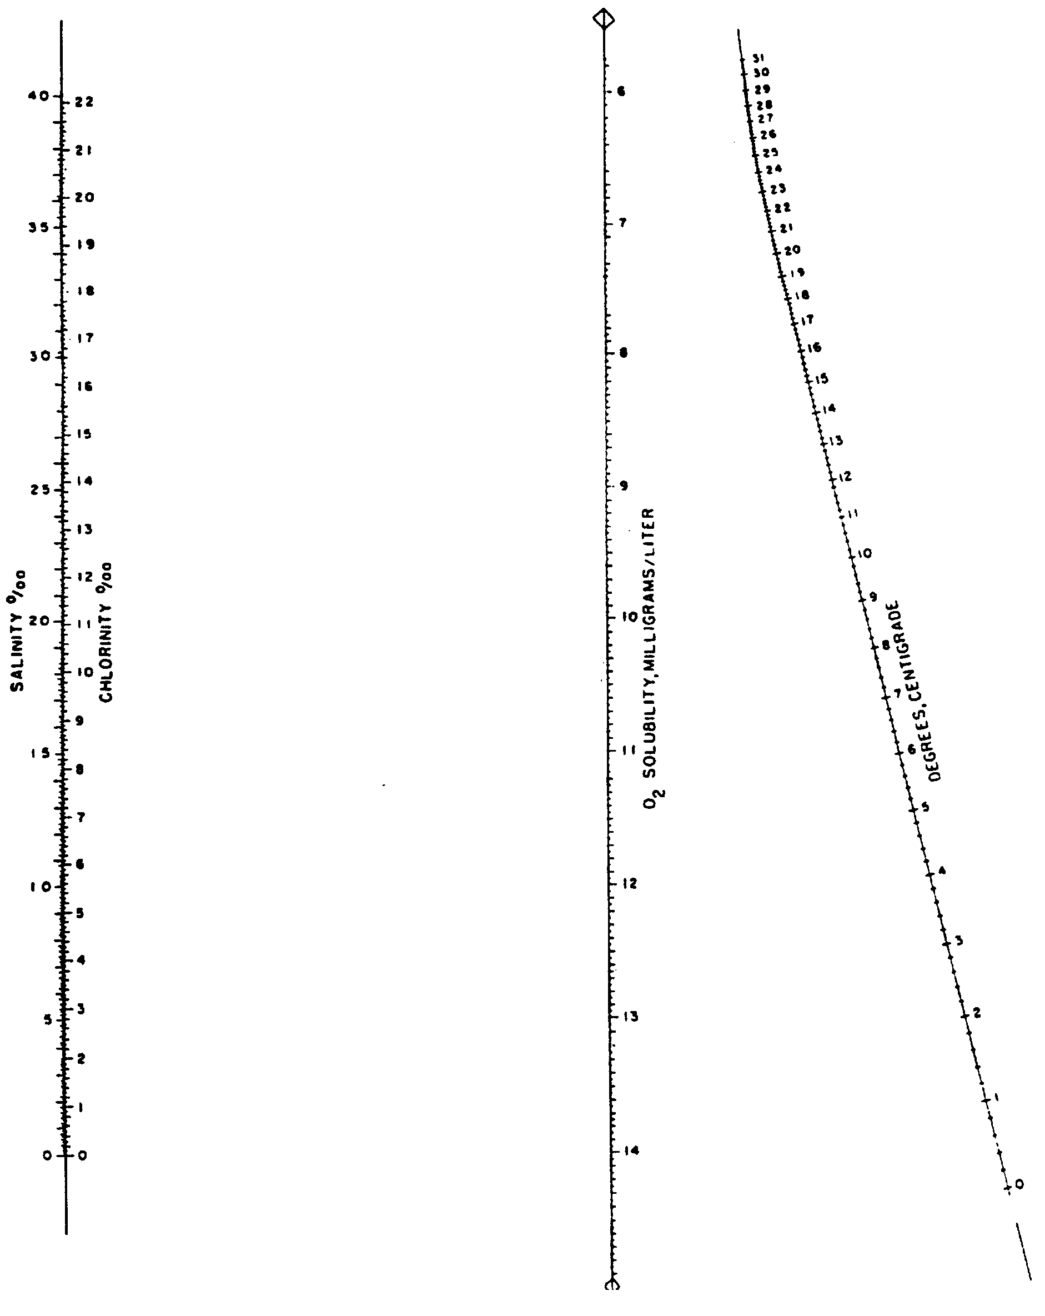
of oxygen and the temperature and salinity of the sample.

To use the chart, lay a ruler between the water temperature at your test site and the salinity (or chlororinity) measurement, and read the saturation percentage at the intercept on the sloping scale. The saturation percentage is the maximum dissolved oxygen you could expect to find at that temperature and salinity.

1. How do your dissolved oxygen figures compare with the maximum saturation expected for your temperature?

2. If they are lower, what factors at your site might help explain the observations?

3. If we assume that 5 ppm oxygen is the lower limit for survival of king salmon, would we expect to find any king salmon in the waters of your site?

4. At which time of the year would you expect to find the lowest oxygen concentrations? Why?

5. What are three factors which might lower oxygen concentrations in an estuary?

a.

b.

c.
OXYGEN DATA

SAMPLING DATE: ___________ SAMPLING TIME: ______________
(24 hour clock)

SCHOOL: ______________________ INSTRUCTOR:________________

TIDE: FLOODING ___ SLACK ___ EBBING ___

SAMPLING (BOTTOM) DEPTH ____ m

*WAVE HEIGHT ____ cm

TEMPERATURE:

WATER SURFACE _____°C

WATER BOTTOM _____°C

AIR (30 cm (ONE FOOT) ABOVE WATER SURFACE) ______°C

WEATHER CONDITIONS:
*WIND SPEED ____ km/hr
*WIND DIRECTION (circle one) N NE E SE S SW W NW
CLOUD COVER: ______ CLEAR ______ TO 50% _______ TO 90% _____ 100% COVERAGE
VISIBILITY ____ km

SAMPLE 1 SAMPLE 2
1. Record water temperature of sample.

2. Record depth at which sample was collected.

3. Record number of drops of titrant used.

4. Determine ppm dissolved oxygen
(each drop of titrant used = 0.5 ppm dissolved O₂.)

5. Determine the average dissolved oxygen
(average concentration = (#4 sample 1) + (#4 sample 2)
2

6. Determine the difference in dissolved oxygen
concentration (sample #1 minus sample #2)
One Step Further ...
Now that you have mastered the technique, you can use your knowledge to examine how various things affect the oxygen concentration of water. Let’s look at the effect of organic matter on dissolved oxygen. In addition to the materials required to perform the DO determination, you will need:

Materials
• 500 ml of Erlenmeyer flasks (3)
• stopper (1)
• tap water
• activated sludge from a waste treatment plant or other decaying organic matter, such as rotting leaves in a stream.

Procedure:
1. Add a 30 gram sample of organic matter to each of two of the Erlenmeyer flasks.

2. Fill all three flasks to the 500 ml line with tap water. Place a stopper in one of the flasks containing organic matter.

3. Set all three flasks aside and do not disturb for three days.

4. Fill labeled, dissolved oxygen bottles or 250-300 ml Erlenmeyer flasks with these samples.

5. Measure the dissolved oxygen content of each of the three solutions. RECORD your results.

Analysis and Interpretation
1. Which solution had the highest oxygen concentration?

2. Which solution has the lowest oxygen concentration?

3. State a generalization about the effect of organic pollution on the concentration of dissolved oxygen. A generalization is a statement that describes your results and lets you make predictions based upon your results.
4. People living around estuaries are concerned about sewage pollution. In an effort to handle increases in sewage, there is growing tendency toward consolidating municipal sewer systems. These systems treat the organic wastes for a large area and then discharge the treated wastes into the ocean or other body of water via a “super sewer”.

a. Predict what the effect of such a super sewer would be on the dissolved oxygen concentration near the discharge.

b. Predict what will happen to the dissolved oxygen concentration as you move away from the sewer outfall (the discharge site).

c. From your predictions of the dissolved oxygen concentrations, predict what will happen to the plant and animal populations living in the area of the discharge.

5. How might the test for dissolved oxygen be helpful in determining how much sewage waste can be discharged into an area without damaging the existing plant and animal populations?
More One Step Further ...
Can we determine the effect of salinity and temperature on the dissolved oxygen concentration of water samples? Sure. Just follow the steps below. In addition to the materials you will need for the dissolved oxygen technique, you will need:

Materials
• 1000 ml Erlenmeyer flasks (4)
• 170 g salt (NaCl)
• balance
• tap water
• refrigerator
• incubator

Procedure: The Effect of Salinity
1. Obtain four 1000 ml Erlenmeyer flasks.
2. Prepare four salt solutions of 10, 20, 40 and 100g NaCl/liter by dissolving the appropriate number of grams of salt in one liter of water. Label each solution as you make it.
3. Fill labeled dissolved oxygen bottles or 250-300 ml Erlenmeyer flasks with these solutions.
4. Measure the dissolved oxygen content of each salt sample. RECORD the dissolved oxygen content and the temperature for each sample. The temperature should be the same in all samples.

Procedure: The Effect of Temperature
1. Obtain four clean 1000 ml Erlenmeyer flasks.

2. Use the refrigerator and incubator to adjust four water samples to the following temperatures:

4°C (refrigerator)23°C (room temperature)

35°C (incubator)60°C (incubator or hot plate)

3. Fill labeled dissolved oxygen bottles or 250-300 ml Erlenmeyer flasks with these four solutions.

4. “Fix” each of the four samples by performing steps one through five of the dissolved oxygen determination. Perform these steps as soon as possible and measure the temperature of the sample at that time.
5. After all of the solutions are fixed, titrate each solution by adding PAO titrant according to steps 7-9 of the dissolved oxygen determination. RECORD your results, for each sample.

Analysis and Interpretation
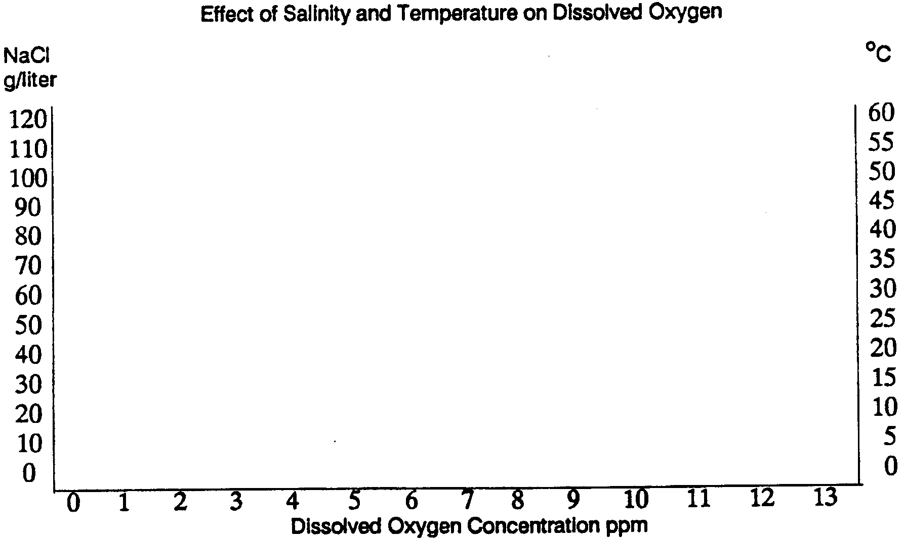
1. Use the graph axes to plot your results. Plot the salinity results by using the left hand scale and the bottom scale. Plot the temperature results by using the right hand scale and the bottom scale.

2. State a generalization relating to the effect of salinity on dissolved oxygen concentration. A generalization is a statement that describes your results and lets you make predictions based upon your results.

3. State a generalization relating to the effect of temperature on dissolved oxygen concentration.

4. An electric company discharges hot freshwater into the estuary.

a. What effect will the increased temperature have on the dissolved oxygen concentration?

b. What effect will the decreased salinity have on the dissolved oxygen concentration?

c. It is important to realize that in real life, factors such as dissolved oxygen concentration are influenced by and interact with many other factors. How do the salinity and temperature interact? Does their interaction increase or decrease the effect of the discharge on the dissolved oxygen concentration?

