Water Quality Monitoring: Temperature
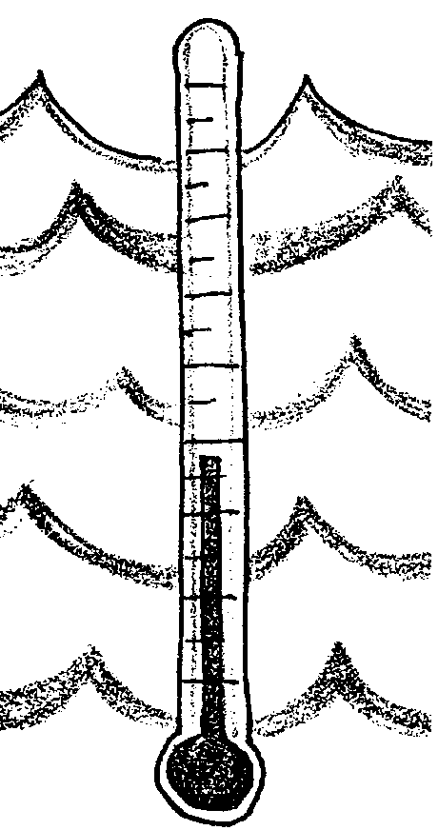

Key Concepts
1. Many physical, biological, and chemical characteristics are dependent upon the temperature of a body of water.
2. The sensitivity of plants and animals to toxic wastes, parasites, and diseases is related to temperature.

Background
“Water Quality Monitoring: Temperature” provides an introduction to water quality monitoring. Water quality has significant social, economic, and environmental implications, especially in the estuaries where humans tend to live and work. In an effort to provide your students with an opportunity for a comprehensive look at water quality, nine physical/chemical parameters forming a “Water Quality Index” are presented in this curriculum. It is the hope of the teachers authoring this project, that classes will select a site near their school for long-term monitoring. The data gained from these monitoring efforts can be shared with others through a variety of electronic networks.
Water temperature is vitally important to the life of an aquatic ecosystem. On the whole, the temperature of the world’s oceans is very constant, changing slightly with the seasons. Locally, however, changes may occur as water of different temperatures is added to estuaries from rivers. Similarly, in shallow bays and at the water’s edge, water temperature can be affected by warming or cooling of the land exposed at low tide. While water temperature is an important water quality parameter on its own, you will note that several of the other water quality tests included in this curriculum involve taking and recording water temperature.

Materials

For each student:

• one alcohol centigrade thermometer

Teaching Hints
“Water Quality Monitoring: Temperature” begins a series of ten lessons focusing on water quality monitoring. The lesson is designed to start your students thinking about the importance of temperature in aquatic systems.
A few comments may be in order to assure that your students accurately record the water temperature of their samples. First, students should take and record the temperature as quickly as possible after the sample is taken to avoid temperature changes. The thermometer needs to be left in the water for a sufficient period of time to allow it to come to equilibrium - two minutes is suggested, a time which will seem interminably long to most students. To avoid errors caused by parallax, caution students to read the thermometer by holding the thermometer at eye level. Finally, encourage students to record their findings immediately rather than trusting their memory.
Since it is likely your students will find variations in temperatures of the same water sample, you may have an opportunity to discuss the concepts of accuracy, variability, and experimental error.

Key Words
Dermo - a fungus disease that kills oysters
metabolic rate - rate at which an organism produces, maintains, and destroy its material substance and by which energy is made available
photosynthesis - a process which occurs in the presence of sunlight in which six carbon dioxide molecules (CO2) and six water molecules (H20) are combined to yield one molecule of a simple sugar (C6H1206) and six molecules of oxygen (02)

Answer Key
1. The thermometer is the most common instrument for measuring temperature.

2. Since the spread of “Dermo”, a fungus disease that kills oysters, is facilitated by high water temperatures, high temperatures would be expected to reduced the number of oysters in an oyster bed through mortality.

3. During the summer season one would expect water temperatures to be highest because of increased day length and warm air temperatures. In addition, summer low-low tides are during daylight hours, enabling the relatively darker colored land to warm in the sunshine and later warm the incoming water via radiation.
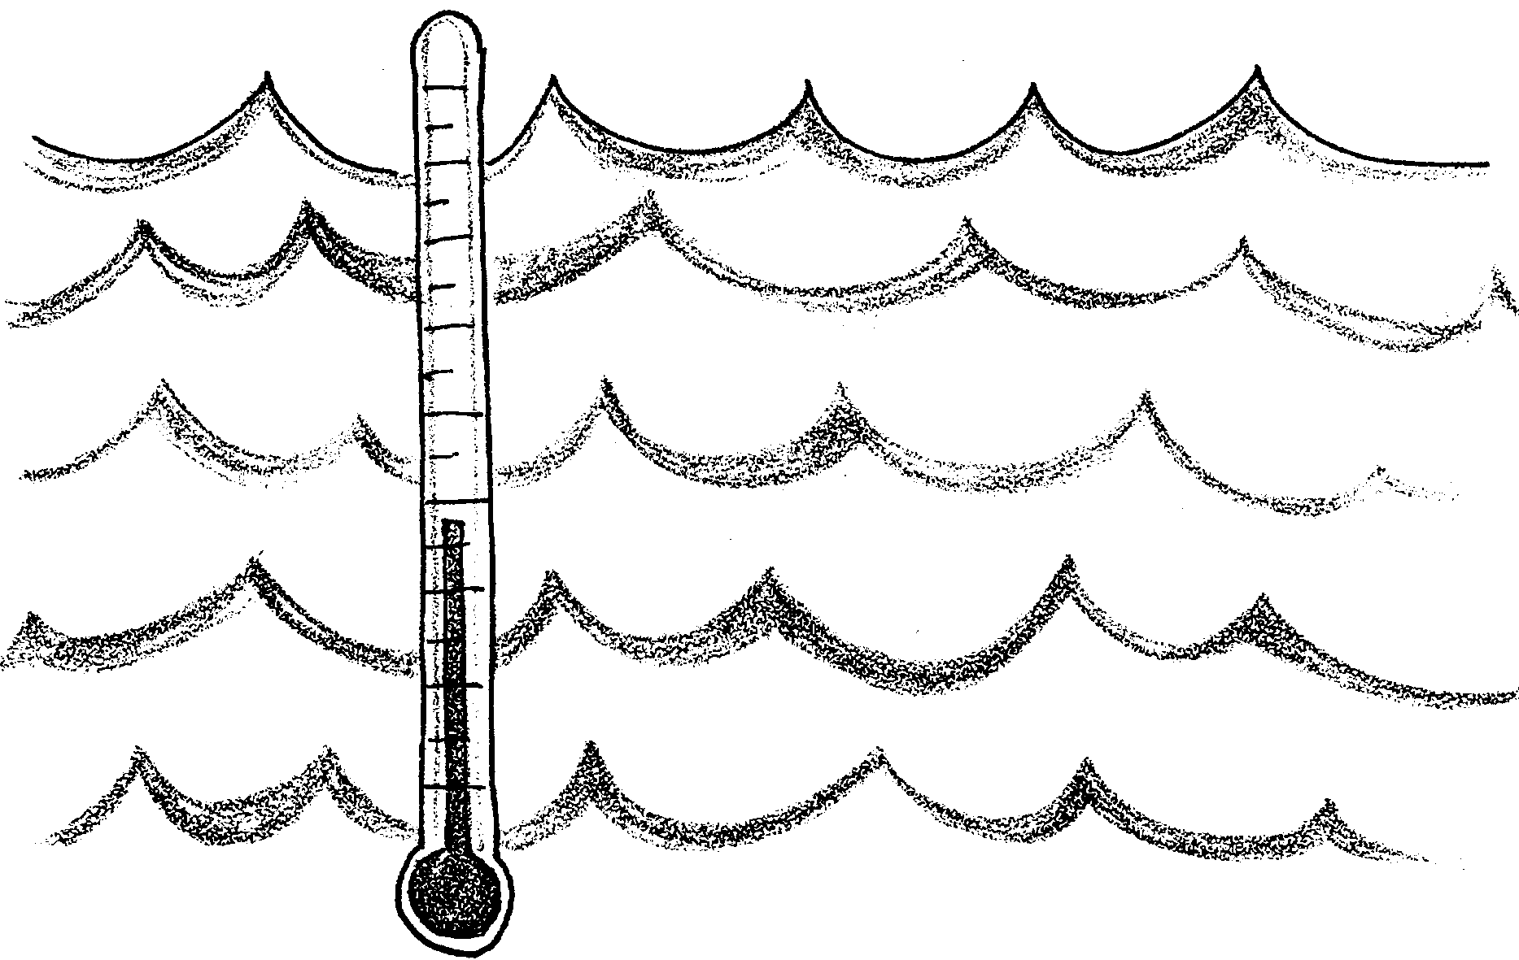
Water Quality Monitoring: Temperature

Estuaries provide sheltered harbors for shipping, industry and recreation. Their rich waters provide food and livelihood for the people who live along the shores. However, this intensive use of estuaries can lead to poor water quality. Many communities now monitor the health of their marine and fresh waters in an effort to plan the prevention and clean up of water pollution.

Just what is meant by “water quality”? This activity introduces one way scientists have defined water quality. It includes the first of nine tests used to measure water quality.

Aside from whether you want to go swimming, the temperature of a body of water affects many things. Many physical, biological, and chemical characteristics are dependent upon temperature. For instance, cold water holds more oxygen than warm water. The rate of photosynthesis and the metabolic rates of animals and plants increase as the temperature increases. Importantly, the sensitivity of plants and animals to toxic wastes, parasites, and diseases is also related to temperature.

1. What is the most common instrument for measuring temperature?
2. “Dermo” is a fungus disease that kills oysters. High water temperatures enable Dermo to spread. How might high temperatures, then, affect the number of oysters in an oyster bed?

What causes changes in temperature in bodies of water? On the whole, the temperature of oceans is fairly constant, changing slightly with the seasons. In estuaries, changes may occur as water of different temperatures is added to the estuaries from rivers. In shallow bays and at the water’s edge, water temperature can be affected by warming or cooling of the land exposed at low tide.

3. At what season would you expect water temperatures to be highest? Why?

As you compare the data you collect with that of other students, you may notice that different people get different temperature readings for the same water sample measured at the same time. While these differences may be due to careless reading of the thermometer scale, they are often due to real differences in the thermometers themselves. We say a thermometer is accurate when it gives the correct temperature. We say a thermometer is precise when it gives the same measurement on successive trials. A precise thermometer will give the same reading in the same circumstances over and over again even though that reading may not be correct. Classroom thermometers are usually precise and reasonably accurate. Since they are not totally accurate, they don’t all give the same reading in the same circumstance. We say that experimental variability exists between thermometers.

Materials
• one alcohol filled centigrade thermometer

Procedure:
1. Obtain the water sample. For temperatures measured during the dissolved oxygen test, sample at the same site, depth and time as the oxygen sample was taken. Note that some samplers retrieve more water than is needed for the DO test. This excess water is ideal for measuring the temperature.

2. Insert the thermometer into the water sample. Allow thermometer to reach a constant reading. Two minutes is usually sufficient.

3. Record your temperature reading along with location and depth.

