Pollution In Paradise

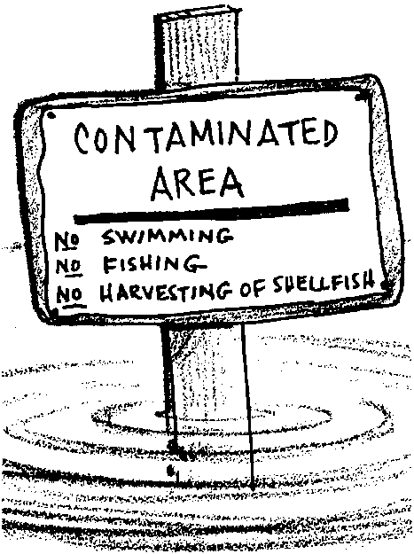
Key Concepts
1. The contamination of the water, sediments, and organisms in one place, can spread to impact other places.
2. A wide variety of contaminants enter and move throughout the waters of estuaries.

Background
For millennia, waters flowing into our estuaries have absorbed and carried the materials needed to support the incredible variety of plants and animals found in those estuaries. Today, those same waters carry more.
Every time we wash our hands, clean our drains, or water our lawns, we can add wastes to the water flowing into our estuaries. Excessive sediments from construction sites can threaten the aquatic life that depends on clean water to survive. Toxic products from our households and industries threaten fish, shellfish, and pollute the water in which we swim and boat. Fertilizers from our lawns, gardens, farms, and feedlots can increase aquatic plant growth in shallow bays and inlets, using up oxygen needed to support life.
A few years ago, it was common to point to business and industry as the sources of water quality problems. Regulation, information, and treatment are reducing the impacts from these sources. Yet the quality of many of our waters continues to be a concern. Many of our current water quality problems come from rapid population growth in the watersheds which feed into our estuaries. Increasing numbers of people increase the pressures on our waters. Each of our "little" environmental transgressions seems unimportant by itself. But when added to those of our growing number of neighbors, we create serious problems; small amounts of pollution from many different sources are adding up to a big problem.
A good overview of the issues facing our estuaries, including a description of the actions we each may take to ensure their health, may be found in: The Puget Soundbook (1991), available through Institute of Marine Science, P.O. Box 188, Indianola, Washington 98342.

Materials
For each student:
• 1 copy of “Pollution in Paradise” student pages
Teaching Hints

“Pollution in Paradise” looks specifically at contaminants and their movement through an estuary. It also serves as an introduction to the upcoming lessons on water quality monitoring. The activity is designed to point out that, in some ways, the estuary may be viewed as a living entity in which harm to one part causes harm to all parts. It is important in these discussions to avoid establishing an “us vs. them” tone which points fingers at industry and others. We are all responsible for the current state of our waters and, similarly, all needed to improve its quality. If some of your students are unwilling to accept this position, ask if their houses are made of wood, if they drive, where they drain their oil, etc. Establishing blame is not particularly helpful in these discussions; understanding the positive and negative impact of actions is.

Key Words
biological contaminants - in this case, pathogens (disease causing organisms) from sources such as municipal sewage systems, septic systems, discharges from boats, and run-off from farms, forests, and cities. The phytoplankton species which causes paralytic shellfish poisoning is another biological contaminant.
ecosystem - the non-living and living environment in a given space
Paralytic Shellfish Poisoning - paralysis or other symptoms caused from eating shellfish which have concentrated toxins contained in certain dinoflagellate plankton; mistakenly called red tide
sediments - in this case, mineral or organic matter deposited by water
toxic - having the effect of a poison

Answer Key
Part I

1. The term “integrated ecosystem” means a situation in which all the organisms in a place are interrelated in such a way that a change in the population of any organism affects the populations of all the other organisms. This definition is derived from the paragraph immediately preceding the question. As an aside, the term is a bit redundant since ecosystems by definition are integrated but is used to emphasize the point.

2. Two contaminants that might enter an estuary may be taken from the list that follows: sewage, pesticides, nutrients (nitrogen and phosphorous), pathogens (bacteria and viruses), petroleum products, PCB’s, heavy metals (copper, mercury, lead, zinc, arsenic), and sediments.

3. Fertilizer applied to farmlands can cause an increase in nitrates in estuaries through runoff from farmlands carrying nitrates directly into the saltwater or into streams which eventually flow into the saltwater.

4. As the oxygen levels decrease because the bacteria that break down the sewage consume the oxygen dissolved in the water the fish in the area face the choice of leaving or dying. If the decrease in oxygen is widespread, there may be no place to go, resulting in fish kills.

5. While most of the inorganic chemicals are naturally present in seawater in small quantities, these chemicals are considered to be “contaminants” when they are found in unnaturally high concentrations.

6. It is unsafe to eat shellfish from contaminated beaches because some shellfish take up and concentrate the biological contaminants in large quantities through filter feeding. Eating these shellfish passes the large quantities of contaminants on to the consumer.

7. Contaminants in sediments enter the living community of an estuary when the burrowing animals who have eaten particles with contaminants bound to their surfaces are eaten by other members of the food web. Once in the food web, the contaminants move from consumer to consumer. As you discuss this movement, remind your students that humans are also consumers in this process.

Part II

The correctly identified sources of contaminants are shown on the list below. Recall that number one was done as an example.

1 Atmospheric sources include lead and hydrocarbon exhausts from automobiles, and gases and particles from factory and power plant chimneys which enter the water directly or are carried by runoff.
4 Runoff from suburban and rural residential areas carries fertilizers, pesticides, particles eroded from soil and shorelines, and animal waste.
9 Shipbuilding, dry docks, and other marine industries contribute metals, organic chemicals, and other ship-related debris.
16 Municipal sewage treatment plants discharge large volumes of treated wastewater.
2 Forestry and logging contribute contaminants from soils eroded off roads and clear-cuts, and from herbicides.
5 Landfills can contaminate surface water and groundwater with virtually every material used and disposed of in society.
12 Recreational boating contributes fuel, sewage, and refuse spillage.
14 Waterfront industries discharge a wide variety of contaminants to rivers and bays.
7 Rivers, though not the source of contaminants, carry them into saltwater. The contaminants enter the rivers as direct discharges or as runoff.
8 Surface runoff from urban areas contains contaminants from streets and motor traffic, commercial and industrial activities, and human and animal inhabitants
3 Runoff from commercial and domestic agriculture carries fertilizers, pesticides, particles eroded from soil and shorelines, and animal waste.
6 Highways are significant sources of hydrocarbons, metals and contaminated particles.
10 Shipping can be a source of spillage or discharges of cargo, fuel, sewage, and refuse, and of metal contamination.
11 Dredging and dredge spoil disposal redistribute contaminated particles.
15 Waterfront forest products industries, such as pulp and paper mills and log-shipping yards, discharge wastewaters to the water.
13 Combined sewer overflows (CSO’s) combine surface stormwater runoff from urban and suburban areas with sewage and industrial wastewater and, during heavy precipitation, discharge some of the mixed stormwater and wastewater directly to the water.
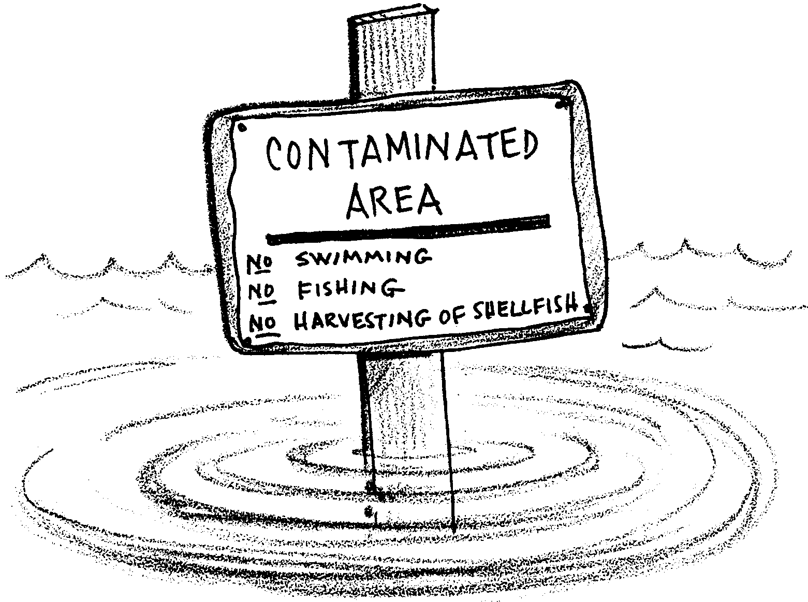
Pollution In Paradise

For thousands of years, people have chosen to live on the shores of estuaries. Today, we choose estuaries as the sites for our industries, our recreation and our homes because estuarine waters are protected and rich. The estuaries are as vital to humans as they are for plankton, salmon and the many other estuary organisms. How does what we do impact the estuary and its inhabitants?
The estuary is an integrated ecosystem. Over time, the effects of human activities can affect animals and plants throughout the area. The contamination of the water, sediments, and organisms in one part of the estuary, can eventually impact the entire estuary.
1. What is meant by the term “integrated ecosystem”?

Most contaminants are substances that are not naturally present in the environment.
2. What are two contaminants that might enter an estuary?

Some contaminants are substances naturally present in the environment. These substances can become contaminants if they are present in unnaturally high concentrations.

3. Nitrates and phosphates are chemicals naturally present in seawater. They are also the major components of fertilizers. How might fertilizer applied to farmlands cause an increase in nitrates in an estuary?

Human society produces, uses, and disposes of a tremendous variety of materials. Many of these materials come in contact with the water. Because there are so many contaminants, it is helpful to group the contaminants into categories. Four major categories of contaminants are:
• organic chemicals
• inorganic chemicals
• biological contaminants, and
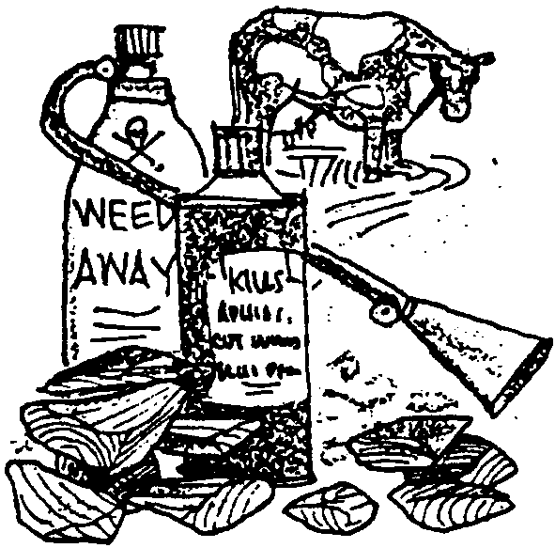
• sediments and other particles.
To a chemist, organic chemicals are those that contain carbon. This doesn’t help much. Almost all living things contain carbon. Generally, naturally occurring organic matter is not toxic. But naturally occurring organic matter may cause water quality problems in large amounts. Other organic chemicals include plastics, rubber, pesticides, and herbicides. These materials can be extremely toxic to life in an estuary.

4. In large quantities, human sewage can cause water quality problems. The bacteria that break down the sewage consume the oxygen dissolved in the water. What will happen to fish in the area as the oxygen levels decrease?
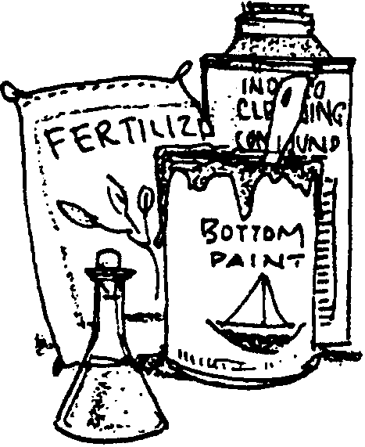
Inorganic chemicals are all the non-carbon containing chemicals. Metals such as arsenic, mercury, copper, lead, zinc, chromium, and cadmium are examples of inorganic contaminants. Fertilizers, acids, industrial drain cleaners, and other cleaning compounds are other inorganic contaminants.

5. Most of the inorganic chemicals are naturally present in seawater in small quantities. How can these chemicals then be considered to be “contaminants”?

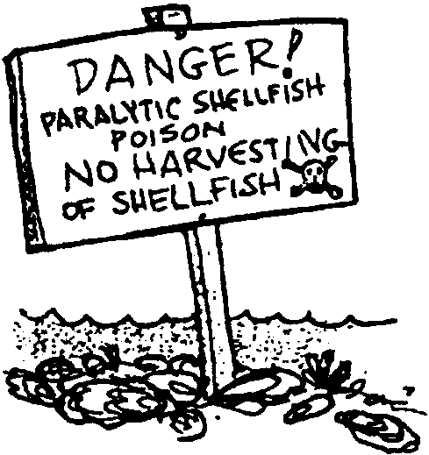
Biological contaminants include disease causing viruses and bacteria. These pathogens (disease causing organisms) find there way into the water from municipal sewage systems, septic systems, discharges from boats, and run-off from farms, forests, and cities. The phytoplankton species which causes paralytic shellfish poisoning is another biological contaminant.

6. Shellfish are good indicators of biological contamination. Some shellfish take up and concentrate the biological contaminants in large quantities through filter feeding. Why is it unsafe to eat shellfish from contaminated beaches?

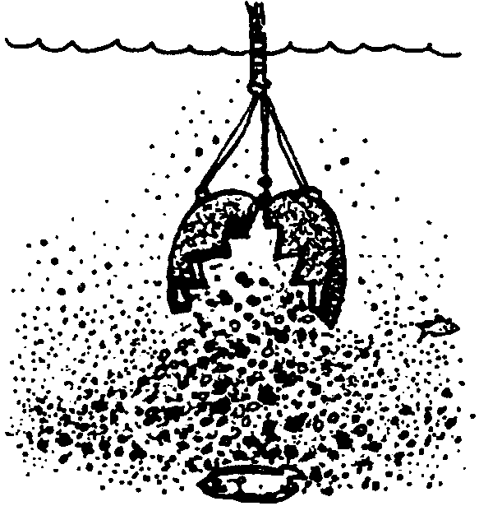

Sediments and other particles in the water are harmful in themselves. Sediments can cloud the water, limiting light to plants. They can also smother animals or damage their gills. Sediments and other particles also serve as a pathway for the movement of other contaminants. Small particles are particularly effective in taking up other contaminants from the water and concentrating them on the particle surfaces.
Eventually, many particles settle out on the bottom of the estuary. These particles may still have contaminants bound to their surface. Burrowing animals pass these particles through their bodies as they eat their way through the bottom sediments.

7. How might contaminants in sediments enter the living community of an estuary?

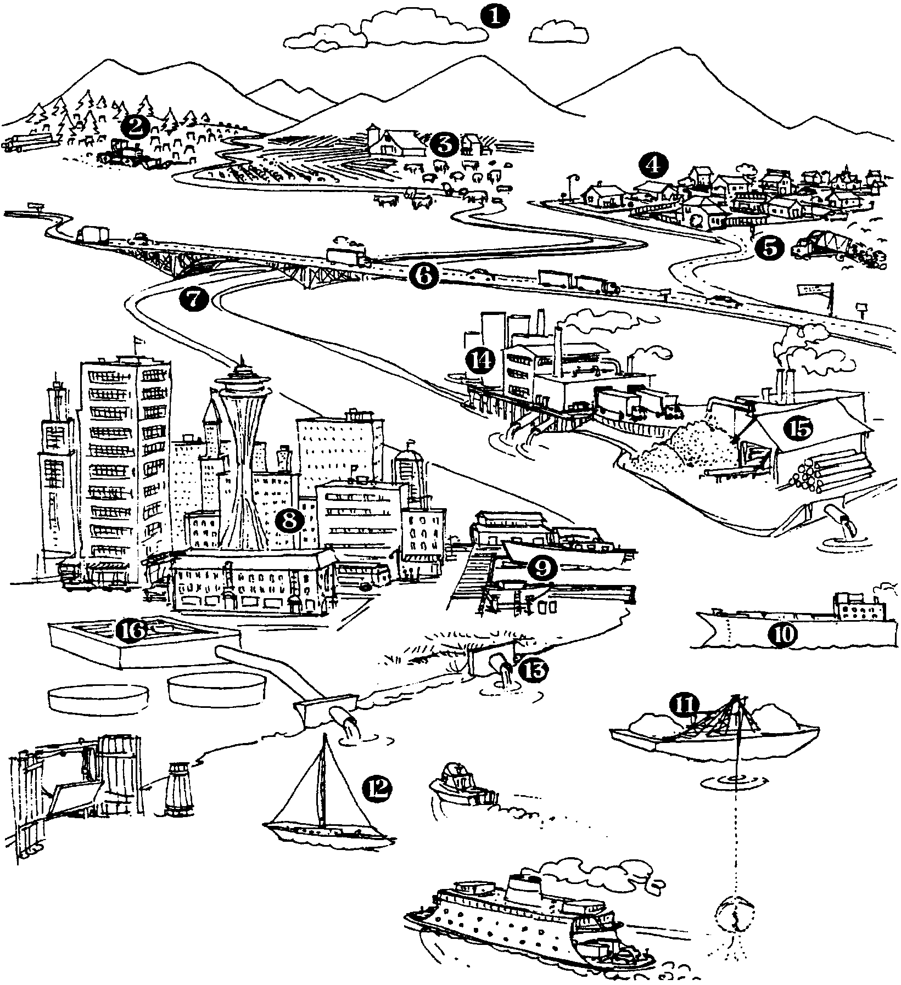
How do these various contaminants find their way into an estuary? This figure provides some answers. Which of these activities occur around waters where you live?
The following list of sources of contaminants identifies the numbers in the picture. Identify each source by placing the number of the source shown in the picture in front of the definition of that source on the list below. Number one is done for you, as an example.

1 Atmospheric sources include lead and hydrocarbon exhausts from automobiles, and gases and particles from factory and power plant chimneys which enter the water directly or are carried by runoff.
Runoff from suburban and rural residential areas carries fertilizers, pesticides, particles eroded from soil and shorelines, and animal waste.
Shipbuilding, dry docks, and other marine industries contribute metals, organic chemicals, and other ship-related debris.
Municipal sewage treatment plants discharge large volumes of treated wastewater.
Forestry and logging contribute contaminants from soils eroded off roads and clear-cuts, and from herbicides.
Landfills can contaminate surface water and groundwater with virtually every material used and disposed of in society.
Recreational boating contributes fuel, sewage, and refuse spillage.
Waterfront industries discharge a wide variety of contaminants to rivers and bays.
Rivers, though not the source of contaminants, carry them into the saltwater. The contaminants enter the rivers as direct discharges or as runoff.
Surface runoff from urban areas contains contaminants from streets and motor traffic, commercial and industrial activities, and human and animal inhabitants.
Runoff from commercial and domestic agriculture carries fertilizers, pesticides, particles eroded from soil and shorelines, and animal waste.
Highways are significant sources of hydrocarbons, metals and contaminated particles.
Shipping can be a source of spillage or discharges of cargo, fuel, sewage, and refuse, and of metal contamination.
Dredging and dredge spoil disposal redistribute contaminated particles.
Waterfront forest products industries, such as pulp and paper mills and log-shipping yards, discharge wastewaters to the water.
Combined sewer overflows (CSO’s) combine surface stormwater runoff from urban and suburban areas with sewage and industrial wastewater and, during heavy precipitation, discharge some of the mixed stormwater and wastewater directly to the water.

