Native Americans: Who Gets To Fish?

Key Concepts
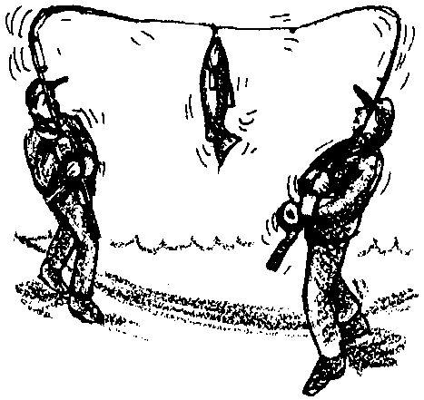
1. Native American cultures are very much alive in the Northwest today.
2. Native Americans of the Northwest maintain a strong cultural, spiritual, and economic relationship to salmon and other marine resources of the Pacific Northwest.
3. Legal protection of Native American claims to marine resources has helped preserve and revitalize Native American cultures in the Pacific Northwest.

Background
The 1974 landmark case called the “The Boldt Decision” radically changed the allocation of salmon between Indian and non-Indian fishers in the State of Washington. This important case set the precedent for later court cases which have repeatedly upheld Native American claims for rights to marine resources.
At the time of the Boldt Decision, many non-Indian fishers reacted with disbelief and outrage. Although some 20 years have passed since the initial ruling, tensions still surround the recurring questions of marine resource allocation.
One reason it has been so difficult for many non-Indians to understand Native American claims is that few non-Indians have direct knowledge of Indian cultures today. This is understandable, given that the classic textbook picture of Native Americans usually ends with the arrival of European settlers. On the surface, it might seem that Native Americans live the same life as non-Indians do; they fish with modern fishing gear, their cars and homes look like anyone else’s; their children often go to the same schools as non-Indians. Yet one must never underestimate the importance for Native Americans today of the cultural roots which link them with the early civilization. When one considers the degree to which Native American history and culture have been denied and invalidated in the past, it should be clear why this connection with their cultural roots is so important.
To understand the basis for the Boldt Decision, it may be helpful to look at some important historical events which set the stage for this ruling.
Early in the settlement of this country, the U. S. Government acknowledged that land could be homesteaded by settlers only after it had been legally acquired from the Indians. With the Northwest Ordinance of 1787, the U.S. Government adopted a policy which recognized, on paper, the rights of Indians to their land and livelihoods:
“The utmost good faith shall always be observed towards the Indians; their land and property shall never be taken from them without their consent; and in their property, rights, and liberty, they shall never be invaded or disturbed unless in just and lawful wars authorized by Congress; but laws founded in justice and humanity shall from time to time be made, for preventing wrongs being done to them, and for preserving peace and friendship with them.”
In 1854 and 1855, Territorial Governor Isaac Stevens negotiated a series of treaties securing from the Indians major land claims including extensive portions of Washington, Idaho, and Montana. In exchange, the tribes were guaranteed “the right of taking fish at usual and accustomed grounds and stations . . . in common with all citizens of the United States.” This right was evidently of enormous importance to the Indians, since it was practically all they received in exchange for more than 100,000 square miles of land.
Language barriers may have made much of the treaty incomprehensible to the Indians, but Stevens’ own verbal promise to Indians assembled along the shores of Puget Sound for the signing of the Point No Point Treaty was very clear: “This paper secures your fish.”
Initially, the Indians had little competition from settlers for the fish. Before new technologies of fishing were developed, Indians greatly surpassed white fishermen in fishing skills, and until the middle of the l9th Century, Indians supplied virtually all the commercial demand for salmon among whites. But the invention of the canning process changed all that. By the end of the l9th Century, canneries in Washington claimed considerably more salmon than the Indians did. Cannery-bound salmon was harvested primarily by non-Indians, using gill nets, purse seines, or on rivers with fish wheels and traps. Fishing became highly lucrative, and not surprisingly, competition broke out among newly arriving immigrant groups for this prized resource. Before long, fishing boats were pushing their competition further and further offshore in order to get at the fish before the others could. The Indians, working the rivers with traditional methods, became the losers.
Even before the turn of the century, it was evident that salmon runs were in danger from over-fishing. In 1877, the State of Washington began to regulate fishing by limiting the times and places where fishing could take place. Increasingly, however, the state chose to apply its strictest limitations to the places where Indians traditionally fished. It began by prohibiting fishing in and around each Washington river. Then it restricted the methods which could be used. In 1937, the passage of Initiative 77 eliminated all fixed gear: traps, fish wheels, beach seines and set nets; i.e., the methods used predominantly by Indians. It also closed the interior of Puget Sound to all commercial fishing except within the boundaries of the reservation themselves.
At the same time that the fishing catch was undergoing redistribution, other forces were threatening the runs themselves. Dams erected on rivers around the state were built without any provision for fish to pass, eliminating hundreds of square miles of spawning habitat. Entire runs of salmon were rapidly lost to the growing hydroelectric industry. Early logging practices were equally destructive. Spawning beds were devastated as streams were used to transport logs to open water. More recent methods, which create densely roaded clear-cuts have not been much better. Agriculture placed still a further demand on salmon through water diversion projects which have interfered with salmon migrations by causing water quality degradation. In short, both the salmon and the Indians who depended on them were becoming increasingly imperiled by development in the Northwest.
In spite of these obstacles, Northwest Indians continued to rely on subsistence fishing, resisting government efforts to assimilate them into other trades. Increasingly, they looked to the courts to help them re-establish their right to the salmon they felt they had been promised. The lawsuit brought by the Federal Government on behalf of 14 Washington tribes against the State of Washington, which resulted in the Boldt Decision, was the culmination of a series of lawsuits brought by Indians over the course of many years.
On February 12, 1974, after a lengthy examination of the entire history of the Indian fishing rights conflict, Judge Boldt announced his ruling. He had interpreted the original treaty phrase “in common with” to mean “sharing equally”. He directed the State not only to allow the tribes 50% of the fish, but to delegate to them an important role in managing the salmon fishery.
This ruling has had an enormous impact on Indian and non-Indian fishing interests alike. For non-Indians, it transformed fishing in Puget Sound overnight from a profitable occupation to a very marginal one, and many fishermen went out of business altogether. At the time of the ruling, non-Indian fishermen reacted with anger and often non-compliance. Resistance is still heard among some non-Indian fishers; however, with time, acceptance of the decision is slowly being achieved.
For Indians, the change has been important. The Boldt Decision has helped bring gradual economic improvement to a population previously outside the economic mainstream of the country. New employment opportunities have given Indian youth a future within their own communities, where previously they could only find work by leaving their reservations. A new spirit of purpose and pride is present on reservations today, as well as a cultural renaissance shared by Native Americans throughout the Northwest. Finally, the role Indians have taken in salmon management has brought increasing respect from whites who see them managing salmon resources effectively. The Boldt Decision helped open the door for these changes to take place.

Materials
For each student:

• copy of “Native Americans: Who Gets To Fish?”
Teaching Hints

“Native Americans: Who Gets to Fish?” affords students an opportunity to analyze a sensitive and controversial question in the northwest: the allocation of the salmon resource. Whether one looks at Indian vs. white fishers, at sports fishing vs. commercial interests, or at American boats vs. the fleets of other nations, there is much at stake.
Twenty years after the Boldt Decision, strong feelings about resource allocation issues are still present. If you live in the northwest, there is a possibility that students and their families may hold strong positions on these issues, and you may be tempted to avoid discussing them with your students at all. But these issues are very much a part of the current crisis in salmon management. Even more important is the value gained in recognizing that there are usually several valid sides to controversial issues and that resolution of conflict usually requires that all positions be heard and respected.
Exploring this subject with students is a highly challenging task, but one that also can be extremely rewarding. If strong personal disagreements should arise, try to maintain an atmosphere that welcomes diversity in outlook and encourages respect for all perspectives. Ask students to help provide information that will enable everyone to understand the issues better.
The following suggestions do not constitute a precise lesson plan, but they will prove useful in approaching this topic in a thoughtful way:

1. If you have had little contact with Native Americans, but you live in a part of the country where Indian tribal communities are active, keep in mind that the best resources are always the Native Americans themselves. Look for individuals in those communities who are willing to share an understanding of their culture with you and your students. Invite or hire a Native American artisan or story teller to introduce their art to your students. Try working with their materials; students find it enormously satisfying to learn to weave with cedar bark, to paint with traditional paints and to begin to have a personal relationship with traditional art forms. As your contacts and friendships grow, you may be invited to attend powwows, potlatches, and other tribal events.

2. Use literature to help explore Native American culture and the conflicts faced by young Native Americans in the 20th Century. Here are some titles:
The Education of Little Tree, by Forrest Carver
I Heard the Owl Call My Name, by Margaret Craven
Indian Lawyer and Fool’s Crow, by James Welch
Indian Tales, by Jaime de Angulo
Julie of the Wolves and The Talking Earth, by Jean Craighead George
The Listening Silence, by Phyllis Root
Other Council Fires Were Here Before Ours, by Jamie Sams and Twylah Nitsch
The Owl’s Song, by Janet Campbell Hale
Pigs in Heaven, by Barbara Kingsolver
Tales of Copper Woman, by Anne Cameron
The War Canoe, by Jamie S. Bryson

The above list includes some books for younger readers as well as some for mature students, so discretion is advised.
Also recommended are anthologies of traditional stories and modern Native American writing. Here are some good ones:

American Indian Myths and Legends, edited by Richard Erdos and Alfonso Ortiz
Voices of the Winds: Native American Legends, by Margot Edmonds and Ella E. Clark
Dancing on the Rim of the World, edited by Andrea Lerner
Talking Leaves: Contemporary Native American Short Stories, edited by Craig Lesley
The Whispering Wind: Poetry by Young American Indians, edited by Terry Allen.

3. Introduce treaty rights issues by reading aloud “Setting The Net” to students (or give them copies to read silently). In pairs or singly, ask them to discuss and write answers to the questions that follow.

Key Words
Boldt Decision - 1974 federal court decision affirming right of Washington Native Americans to take salmon in “usual and accustomed” locations with amount set at 50% of harvest
potlatch - a ceremonial festival among Native Americans of the northern Pacific coast at which gifts are bestowed on the guests and property is destroyed in a show of wealth that the guests later attempt to surpass

Extension
1. Have students research current treaty rights issues in your local region. Information can be obtained from newspapers, from local tribes and from Indian advocacy groups which you can locate through your local tribes.

Answer Key
1. Judge Boldt studied the history of Indians in Washington. He knew they lived by fishing before the arrival of white settlers. He reviewed the original treaty signed between the Indians and the U.S. Government over 100 years ago, in which the Indians had traded land for the continuing right to fish. He decided the intention of the treaty was to divide the fish equally between Indians and non-Indians. Judge Boldt’s ruling was consistent with this interpretation.

2. The Indians could argue that fishing was their traditional way of life. They could claim the government had not kept its promise to protect their right to fish established in the treaty of 1852. They could accuse the State of favoring white fishermen in its regulations about where and how salmon could be caught.

3. Non-Indian fishermen could claim that fishing was a tradition for them too. They could argue that the Indians were only a minority of the population. Why should such a small group have the right to such a large share of the fish? They could maintain that this decision discriminated against non-Indians.

4. The Boldt Decision has given the Indians a way of earning a good living within their own communities. It has also helped restore Indians pride in their history and culture.

5. Non-Indian fishermen have seen their share in the salmon fishery decline since the Boldt Decision. Non-Indians who fish in Washington State generally supplement their incomes with other work.

References
Russell Lawrence Barsh, Understanding Treaties As Law. Curriculum available from Superintendent of Public Instruction, Old Capitol Building, FG-11, Olympia, WA 98504.
Cohen, Fay. Treaties On Trial. Seattle: University of Washington Press, 1986.
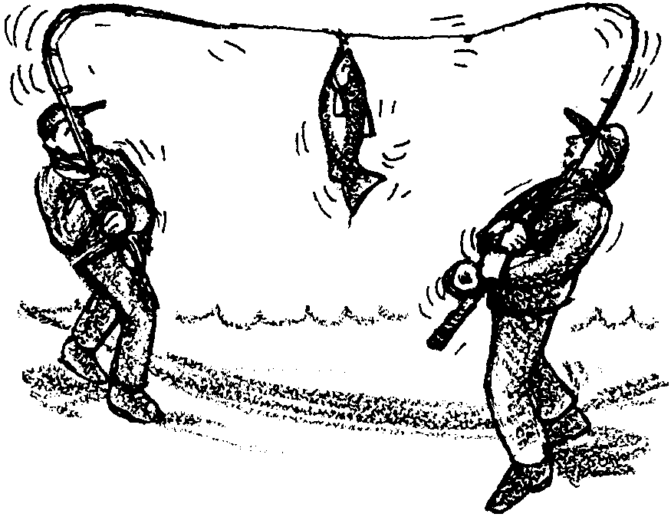
Native Americans: Who Gets To Fish?

Setting the Net
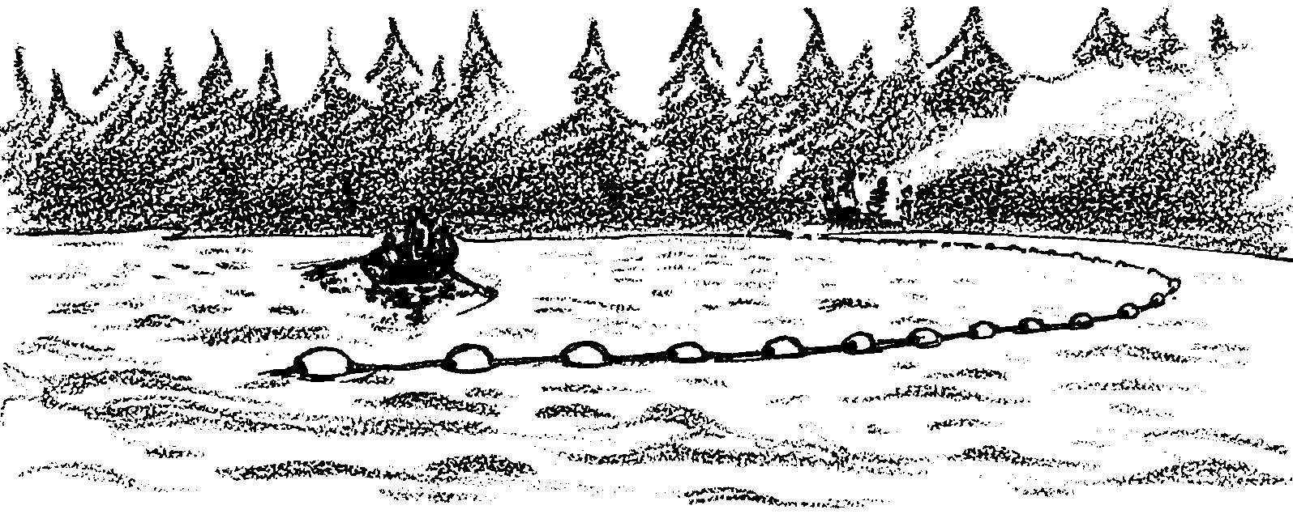
While his grandfather rows out into the river current, John carefully guides the gill net off the bow of the wooden skiff. When the net is fully paid out, John pushes overboard a large rock which will anchor that end of the net in the river channel. The other end of the net is tied to the shore. They examine the gentle curve of the net across one third of the river’s width. Its position is good. As the evening light dims, they row back to their campsite on the near shore. There they will wait for the fish to arrive. With other family members, they build their campfire, cook their supper, and quietly wait. They will share fishing stories from years past as they listen for the sound of fish in their nets.

John and his grandfather are Native Americans. Their ancestors were highly skilled fishermen who fished this river for thousands of years. In recent years it had not been so easy, however. In fact, during most of this century, it was very difficult for Indians to make a living fishing.
When white settlers first arrived in Puget Sound, salmon runs were bountiful. But as the Northwest was settled, over-fishing and environmental damage took its toll, and salmon runs declined throughout the region. To protect the salmon, the Department of Fisheries began restricting how and where people could fish. But very often, it was the Indians’ ways of fishing which were restricted most. John’s family and other Indians were left only a small part of the returning fish. Like many other members of his tribe, John’s father left the reservation because he could not find work at home. For years, he worked as a custodian for the U.S. Navy.

The Indians knew that in 1852, over 100 years ago, their people had signed a treaty with the U.S. Government, trading large amounts of Indian land for the right to continue fishing in the places their ancestors had always fished.

John’s uncle, Thomas, was among a group of Indians who were angry that Indians were no longer able to make a living as fishermen. Thomas felt that the State of Washington was ignoring the treaty agreement of 1852 by allowing white fishermen to catch most of the salmon -- and by allowing many salmon streams to be destroyed by development. Thomas and other tribal members hired lawyers, and in 1974 they sued the State of Washington. They demanded that the State honor the Indians’ right to a share of the fish.

This famous lawsuit has become known as the Boldt Decision, after the judge who heard the case. Judge Boldt studied the historical facts of the case for many months before making his decision. He carefully read the treaty of 1852, which stated that Indians would be allowed to fish:

“. . . in their usual and accustomed places, in common with the other citizens of the United States . . ”.

Judge Boldt decided this sentence meant that the salmon should be shared equally between Indian and white fishermen. He ruled that Indians would be allowed to catch one half the State’s salmon harvest.

John has held a tribal fishing permit since he turned 14 last year, allowing him to fish with his family. He and his family will probably not get rich as fishermen, but if they are careful to protect the region’s salmon runs, they can count on making a good living.

John’s grandfather is proud to have John and his other grandchildren showing so much interest in fishing. But he is also pleased with other things he sees. He sees John and his friends learning some of the fine art and woodworking skills which Northwest Indians have always practiced with such artistry. John has also become a very talented dancer, and his dancing will delight many guests at the Potlatch next week to welcome the first salmon. Many of John’s friends are learning to carve and race traditional canoes. They are rediscovering traditions and values from the earlier Indian culture, and best of all, they are feeling pride in being Indians today.

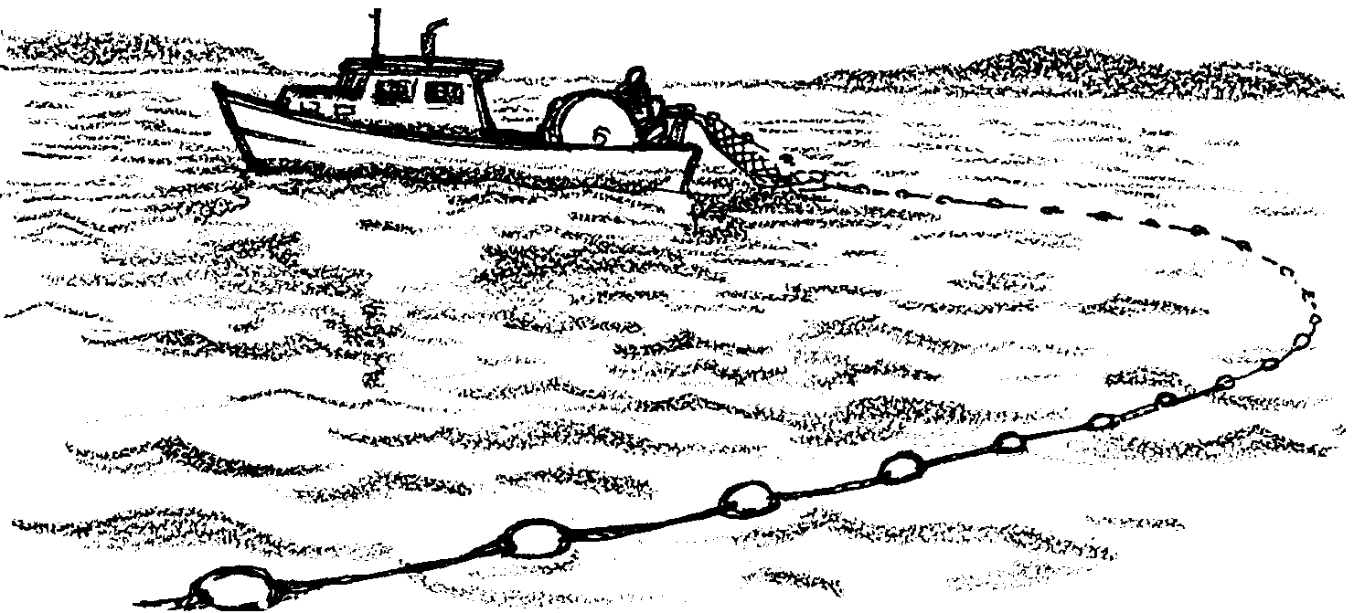
Todd and his dad have just finished setting their gillnet south of San Juan Island in northern Puget Sound. He too is preparing for a night with little sleep as they wait for the fish to arrive.

Todd and his dad fish throughout northern Puget Sound. Their net, like John’s net, is set to hang in the water and catch salmon of only a certain size. But Todd and his dad fish under different rules than John and his grandfather. Their net may only be set in open water and they may only fish at very specific hours on certain days during the fishing season.

Before the Boldt decision was handed down, Todd’s dad was allowed many more days to fish, and he was able to make a good living as a fisherman in Puget Sound. After the Boldt decision, he was not able to support his family fishing alone. He works as a carpenter at times when he cannot go fishing.

Although Todd enjoys helping his dad fish, he will probably not become a fisherman himself.

Questions:
1. Why did Judge Boldt rule that the Indians were entitled to half the fish caught in Washington?
2. What arguments do you think the Indians had in support of their side?

3. What arguments do you think the non-Indian fishermen had on their side?

4. What were some effects of the Boldt Decision on Washington’s Indians?

5. What were some effects of the Boldt Decision on non-Indians fishing in Washington?

