Native Americans: Early Contact

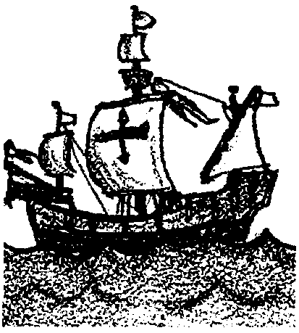
Key Concepts
1. Peoples of different cultures may have very different values and customs.
2. Ignorance of cultural differences can be the source of great misunderstanding.

Background
Fascinating historical accounts tell of the first contact between peoples of widely divergent cultures. At times these encounters were simply humorous, but more often they resulted in serious misunderstandings with sometimes tragic consequences.
When Indians on the eastern American seaboard first encountered Europeans taking their Victorian lace handkerchiefs from their pocket to blow their noses, then carefully folding them back into a breast pocket near their heart, they naturally assumed that nasal mucus was something white men cherished. (The Indians simply cleared their sinuses by pressing against one nostril and snorting the other toward the ground.)
Other encounters were far more serious. Violation of social customs could wittingly or unwittingly produce conflict. A classic case occurred on Haida Gwaii (The Queen Charlotte Islands) in 1789, when a Boston trader, Captain John Kendrick, returned to trade for furs with the Haidas. Although the first visit by Kendrick resulted in amicable trade, a minor incident on the second visit triggered years of bloody conflict.
Pilfering minor items from a ship’s deck was common practice by Indians boarding trading vessels at that time, and most captains overlooked these minor losses so as not to impede the lucrative trade in furs. Kendrick, however, awakening drunk to see that some of his personal laundry had disappeared from a clothesline, reacted irrationally. The Haida chief Koyah was taken hostage at gunpoint and publicly humiliated before his people. A rope was tied around his neck, his hair cut off, his face painted, and he was whipped until all the furs in his village were brought to Kendrick’s boat. To show that he was a “civilized” man, Kendrick paid a token fee for each of the furs before he released the chief and departed.
Koyah was no longer a chief now in his people’s eyes, but one of the lower class. The only way he could restore his rank was to seek revenge. A great loss of life ensued, involving many Haidas and some innocent trading vessels.
Materials
For each class:
• 12 butter knives
• 12 colored pieces of fabric, such as scarves
• 2 index cards or pieces of paper, each with cultural values of one of the two tribes listed, as in step A, below. (Multiple copies may be useful for large groups.)

Teaching Hints
“Native Americans: Early Contact” is a role playing activity which helps students realize that not all people share the same values, customs, and social mores. Any number of people can take part in this exercise as long as they are divided into two distinct groups, ideally with males and females present in each.
The object of the game is simply to engage in trading, but this can be tricky, given no common language between the groups and very different social values. A dozen kerchiefs and a dozen butter knives make good trade items. The group with the kerchiefs may choose to adorn themselves with the kerchiefs (headbands, wristbands, et cetera), to distinguish themselves from the group with the knives.
1. Assign each group a private village or trade ship location where they may speak freely amongst themselves without being overheard by the other group. Now give each group index cards with the name of their group and a set of cultural values by which they must abide. The index cards for Group A and Group B might read as follows:

Group A- Alcans

You are aggressive traders, very clever, always out to get the best possible deal. Men are usually dominant in trade negotiations.
Knives are a hot commodity--all the tribes people in this region want them.
You show your straight-forward willingness to trade using direct eye contact, a good firm handshake, and possibly a friendly pat on the back.
Each of you is out for yourself, trying to acquire as much cloth as possible, because it brings a good price back home.
Get as much as you can from these people: after all, they are uneducated savages in your mind. Their culture is certainly not as advanced as your own.

Group B--Bumbas

Your society is matriarchal. The eldest woman is the leader, and only she can engage in the direct act of trading. Others in your tribe can only bring traders to her.
The matriarch signals her willingness to trade by waving her hand back and forth between herself and the person she desires to trade with. (Demonstrate: like shooing away a dog.)
You do not look strangers directly in the eye, and no one outside your tribe must ever touch you. To break this taboo results in banishment from your people. It is especially important that your matriarch not be contaminated by the touch of others.
You always do everything as a group--even trading, and no one works toward personal gain.
You could use some knives for cutting food, but you are reluctant to trade too much cloth, for it is handwoven by your matriarch and very sacred to your culture.
You are a peaceful people, slow to anger, but you do have great pride and expect to be treated with utmost respect.
Note: These tribal names are fictitious, but the sets of cultural values closely parallel some real world cultures.

2. Once the Bumbas and Alcans have had a few minutes to review and discuss their values, they are given their respective trade items and signaled to come together for the first of three 2-3 minute trading sessions. (The designated trading area must be large enough to accommodate both groups as clearly distinct entities.) During trading, either group may use gestures and any sound short of actual language, to attempt to communicate.
At the end of each trade session, the Bumbas return to their village and the Alcans to their trade vessel, to discuss amongst themselves how to better facilitate the trading. Strategies may be devised, and a sensitive group might even begin to modify their customs to help facilitate the process.

3. The most important part of the exercise comes at the completion of the three trade periods when both groups sit opposite one another and Group A decides what they think the values of Group B were. Then Group B does the same for Group A. (Some refereeing may be in order here, as the exchange can get heated.) More often than not, each group developed a dislike for the other and considered their counterparts stingy, ruthless, and somewhat barbaric. On rare occasions, a level of understanding may emerge, with some successful trading completed and both parties satisfied.
Once the two groups have stated what they thought the values of the other were, have a person in each group read aloud their actual values.

Key Words
Haida - Northwest Indian tribe of the Queen Charlotte Islands of British Columbia
matriarch - female leader of family or tribe

Reprinted, with permission, from Rediscovery: Ancient Pathways--New Directions, a guidebook to Outdoor Education by Thom Henley, 1989. Published by Western Canada Wilderness Committee, 20 Water Street, Vancouver, B.C. V68 1A4. (604) 683-822

