Native Americans: Exploring Culture Through Mythology
Lesson by Judy D’Amore, Marine Science Centers,
Port Townsend and Poulsbo, Washington.

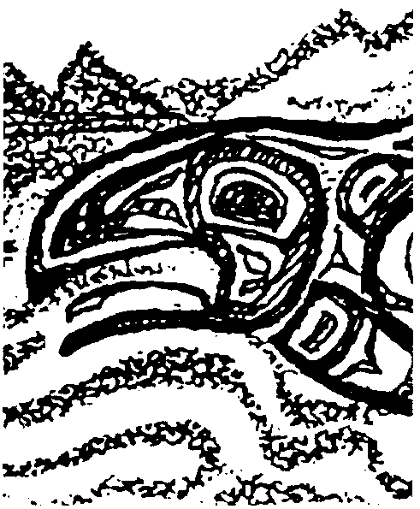
Key Concepts
1. Storytelling is a strong cultural tradition among Native Americans of the Pacific Northwest.
2. Native American myths and creation stories are avenues fir transmitting customs and values from generation to generation.
3. Native American stories reveal important relationships between the people and their environment.

Background
The historical art and mythology of Northwest Coast Indians strongly reflected the enormous value they placed on marine resources. No resource was more important than Pacific salmon.
In Native American stories of the region, salmon were often depicted as a race of supernatural beings who lived in the form of humans in a great house under the sea, feasting and dancing like the Native Americans themselves did. Each year the “Salmon People” voluntarily assumed the form of fish for spiritual purposes. Once the fish were dead, the Salmon People’s spirits returned home to be reborn in human form. Even though salmon were believed immortal, their appearance each year was not taken for granted. The Indians believed it was essential to return all of a salmon’s bones to the stream. If any were missing, when the salmon was reborn in human form, it would be missing part of its body. This transgression would offend the Salmon People and they might refuse to return to the stream where they has been mistreated.
Today, this story is still told in its many versions throughout the northwest, and each year it once again comes alive as tribes gather to celebrate “The First Salmon Ceremony”, honoring the annual return of the salmon. Following a feast, the fish’s bones are carefully put back into the water to insure that salmon will always return.
“Why the Salmon Come to the Squamish Waters” is based on a legend told among Squamish Indians of British Columbia. Although exact details and style may have varied somewhat from tribe to tribe, the central story was common to all maritime cultures of Washington and British Columbia. As with all northwest stories, “Why the Salmon Come to the Squamish Waters” was not written down, but was passed orally from generation to generation by a culture who have always cherished storytelling.

Materials
Part 1 - “Why the Salmon Come to the Squamish Waters”
For each student:
• copy of “Why the Salmon Come to the Squamish Waters”
• copy of “Creation Story Questions”

Part 2 - Native American Creation Stories
• access to library resources

Teaching Hints
In “Native Americans: Exploring Culture Through Mythology”, students read a northwest Native American myth and learn from it how values about salmon and how to preserve salmon was taught from one generation to the next.

Part 1 - “Why the Salmon Come to the Squamish Waters”
Preparation
1. Make enough copies of “Why the Salmon Come to the Squamish Waters” for you and each of your students.

On your copy, divide the text into the same number of reading blocks as students in your class. With a highlighter, mark a section of text on each of the students’ copies, so that every student has one or two paragraphs to read, and all of the text is used.

When students arrive:

1. Explain that stories are an important part of the Native American culture. They are passed from generation to generation to help members understand their relationship to the world around them and to encourage a common set of values. In this activity, we will look at one important story from Native Americans of the Northwest Coast region.

2. Pass out copies of “Why the Salmon Come to the Squamish Waters” and “Creation Story Questions”. Introduce “Creation Story Questions”, and tell students they will answer the questions after reading the story.

3. Have students read “Why the Salmon Come to the Squamish Waters” aloud. Singly, or in pairs, have them discuss and answer the accompanying questions. Later, discuss answers as a class.
Part 2 - Native American Creation Stories

1. Have students select two other Native American creation stories, using library resources. Have them analyze the two stories using “Creation Story Questions” once again.

2. Have students write an essay comparing and contrasting the important elements in the two stories, using the information outlined in step 1, above.

3. Have students choose one of their stories and create a visual display which tells the story. Some options might include posters, dioramas, story books, mobiles, dramatizations with actors or papier mâché puppets, or video productions.

Key Words
diorama - a scene, often in miniature, reproduced in three dimensions by placing objects, figures, etc. in front of a painted background
myth - in this case, traditional or legendary stories of the Native American culture passed from generation to generation to help members understand their relationship to the world around them and to encourage a common set of values
Extension
1. Obtain the poem, “Ceremony”, by Leslie Marmon Silko, from the book Ceremony, Viking Penguin, 1986 (ISBN 0-14-008683-8).
Read the poem aloud or have students read it. In groups or individually, have students discuss the following questions:
a. Who is the “they” who tries to destroy the stories? Why would “they” want those stories destroyed?
b. Whose evil is mighty? Why can’t it overpower the strength of the stories?
c. Think of stories that might be moving in our bellies. What stories have been important in the lives of students? How? Discuss the roles stories play in our families and culture.

Answer Key
“Creation Story Questions”, as applied to “Why the Salmon Come to the Squamish Waters”

1. In “Why the Salmon Come to the Squamish Waters,” the characters with “wonder working powers” are the four magical brothers.

2. The four brothers aren’t ordinary people themselves, but they apparently look like people when they want to. They are good at heart and have the power to improve the people’s lives. Their power isn’t so great that it always wins, however. Sometimes they have to resort to trickery.
3. The Squamish people are sometimes hungry. They want to bring the salmon people to their waters so they will always have enough to eat.

4. In the story, the brothers trick the sun to find out where the salmon people live, they take the people on a journey there to make an invitation to the salmon people, and the people discover an important rule they must follow to keep the salmon people returning each year. The story provides a metaphorical explanation for the arrival of salmon to the northwest, as well as a reminder that human actions are important in keeping salmon returning each year.

5. Salmon will keep coming to the northwest if they are happy and comfortable. They will stop coming if we do things that offend them.

6 a. In this story, salmon is clearly the resource that can keep the Indians from being hungry. Even Snookum the Sun is tempted by a salmon splashing in the water. (Whale is also tempting to Snookum, so presumably it is valued by the Indians too.)

b. Because the Indians valued salmon highly, they viewed salmon as people, much like themselves. As such, they were treated with great respect. To get the salmon people to come to their country it took magic and cunning, some strong medicine, and good will on the part of the people. To keep them coming the Indians must promise always to treat them with honor and respect.

7. Answers will vary.

“Why the Salmon Come to the Squamish Waters” has been very slightly adapted from the story as it was printed in Salmonids in the Classroom. Canadian Salmonids Enhancement Program.
Native Americans: Exploring Culture Through Mythology
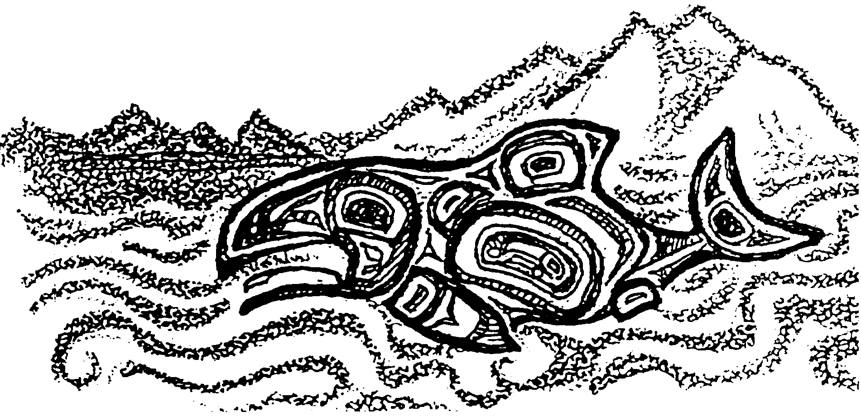
Why the Salmon Come to the Squamish Waters
Long ago, long ago, when animals and human beings were the same, there were four brothers with great wonder working powers, who went about the earth doing good. They usually traveled on the water in a canoe. This was not an ordinary canoe; it was really the youngest of the four brothers who had transformed himself into that shape.
Coming to the Squamish Indians one time, they were persuaded by the chief to stay awhile in his village. Knowing the wonder-working powers of the brothers, the chief said to them, “Won’t you bring the salmon people to our shores? We are often short of food. We know that salmon is good, but they never come to our waters.”
“We will persuade the salmon people,” replied the oldest brother, “if we can find out where they live. We shall have to ask Snookum, the Sun, for he can see everything.”
But it was difficult to get near enough to the Sun to ask him anything. He was a wily creature and seldom left the sky. The brothers knew that they would have to use craft and cunning to bring him down.
After much pondering and discussing, they transformed the youngest brother into a salmon and tied him to the shore with a fishing line. By sporting about in the water, the salmon soon attracted the attention of Snookum. But before coming down for the salmon, the Sun also used craft: he caused the three brothers to go into a deep trance. Then, in the form of an eagle, Snookum descended from the sky, pounced upon the salmon, and flew away with it, breaking the line as he flew.
When the three brothers awakened from their trance, they discovered the trick Snookum had played on them. Soon they made a new plan. Once again they used their wonder-working powers. They transformed the third brother into a whale and tied him to the shore. This time they used a rope which was stouter than the line they had used for the salmon.
Again the Sun cast the brothers into a trance and descended from the sky in the form of an eagle. He fixed his claws firmly into the flesh of the floating whale and started aloft with it. This time the rope did not break. Again and again Sun-Eagle tried to break it, but he could not. Neither could he free his claws from the whale’s flesh.
While he was still struggling, the two brothers awoke from their trance. They pulled the whale to the shore, dragging the Sun with it. They said to Snookum, “Don’t struggle, my friend. You cannot get away without our help, and we will not give it unless you do what we ask you to do.”
Knowing that they had outwitted him, Sun-Eagle struggled no more with the whale.
“What do you want me to do?” he asked.
“Tell us where the salmon people live,” said the oldest brother. “You can see all over the world when you are up in the sky.”
“The home of the salmon is a long way off in that direction,” replied the Sun, pointing towards the west. “If you want to visit them, you must first prepare much medicine and take it with you. Then all will be well.”
The brothers released Sun-Eagle, and he flew off into the clouds.
After gathering many herbs and making much medicine, the brothers said to the Squamish people, “Get out your canoes and make ready for a long journey. At sunrise tomorrow, we will set out for a visit with the salmon people.”
Next morning they all started westward. For many days they paddled, and finally they came near an island. On the far side of the island they saw what seemed to be a village. Smoke of all colors rose into the clouds.
“This seems to be the country we are looking for,” said the brothers. “Sun told us that this is the home of the salmon people.”
So the paddlers took the canoes to the beach, which was very broad and smooth. All the Squamish people went toward the village, the four brothers carrying the medicine with them. They gave some of the medicine to Spring Salmon, the chief of the village. As a result, he was friendly toward the whole party.
In the stream behind the village, Spring Salmon kept a fish-trap. Shortly before the visitors had landed, the chief had directed four of his young people, two boys and two girls, to go into the water and swim up the creek into the salmon trap. Obeying his orders they had drawn their blankets up over their heads and walked into the sea. As soon as the water reached their faces, they became salmon. They leaped and played together, just as the salmon do in the running season, and frolicked their way toward the trap in the creek.
So when the time came to welcome the strangers with a feast, Chief Spring Salmon ordered others of his people to go to the salmon trap, bring back the four fish they would find there, and clean and roast them for the guests. The visitors watched the salmon roasting above the flames on a kind of wooden gridiron. When the salmon were cooked, the chief invited his guests to eat.
“Eat all you wish,” he said, “but do not throw away any of the bones. Be sure to lay them aside carefully. Do not destroy even a small bone.”
The Squamish and the brothers gladly accepted the invitation and partook freely of the roasted salmon, but they wondered why they were asked to save the bones.
When all had finished eating, some of the young men of the salmon village carefully picked up the little piles of bones the guests had made, took them to the beach and threw them into the sea. A few minutes later, the four young people who had earlier gone into the water re-appeared and joined the others.
For four days the Chief thus entertained his guests with salmon feasts. But one of the Squamish visitors was very curious why such care was taken with the salmon bones. On the fourth day he secretly kept back some of the bones and hid them. At the close of the meal, the rest of the salmon bones were collected in the usual manner and cast into the sea. Immediately afterwards, four young people came out of the white water, but one of them, the visitors noticed, was covering his face with his hands.
Approaching the salmon chief, the youth said, “Not all of the bones were collected. I do not have any for my cheeks and nose.” Turning to his guests, Chief Spring Salmon asked, “Did any of you mislay any of your salmon bones? Some are missing.” And he pointed to the face of the young man.
Alarmed by the result of his act, the Squamish visitor who had hidden the bones brought them out, pretending that he had just found them on the ground. The salmon youth returned to the water with the missing bones. When he returned his nose and cheeks were back on his face.
Now all the visitors were certain that their hosts were the salmon people.
“We have come to visit you, Chief Spring Salmon, for a special purpose,” explained the oldest brother. “We came to ask you to let some of your salmon people visit Squamish waters, come up the streams of the Squamish people. My friends are poor, and they often go hungry. We shall be very grateful if your people will sometimes visit them.”
“I will do as you request,” replied the salmon chief, “on one condition: they must throw all the bones back into the water as you have seen us do. If they will be careful with the bones, my people can return to us again after they visit you.”
“We promise,” said all of the Squamish people. Then they made preparations to return to their home across the water toward the rising sun.
As they were leaving, the salmon chief said, “I will send Spring Salmon to you first in the season. After them I will send the Sockeye, then the Coho, the Dog Salmon, and last of all, the Humpback.”
Ever since that time long ago, five different kinds of salmon have come to Squamish waters in the order the chief promised. They go out to the sea, they come into the straits, and they swim up the streams. From that time on, there has always been food for the Squamish people. Mindful of their promise, the Indians have always been careful to throw all of the bones of the salmon back into the water.
Creation Story Questions
1. In most Native American stories there is a creature with cunning and magic powers to create the world, solve problems and sometimes also create mischief. Sometimes this character is Raven, sometimes Coyote. Who in this story has these powers? (Hint: There may be more than one creature.)

2. What is the relationship of the magic/creator character(s) to the people?

3. What problem exists at the beginning of this story? How is it resolved?

4. How does this story explain an event in history or a phenomenon of nature?

5. Native American stories were often used to communicate values and lessons to young people. Is there a moral or lesson in the story? If so, what is it?

6. Let’s see what clues this story gives us about the people who told it.

a. What resources in their environment were especially important to them?

b. How does this story reflect the values they placed on these resources?

7. Are any of the values reflected in this story relevant today? Explain.

