Native Americans: People of the Salmon
Lesson by Judy D’Amore, Marine Science Centers,
Port Townsend and Poulsbo, Washington.
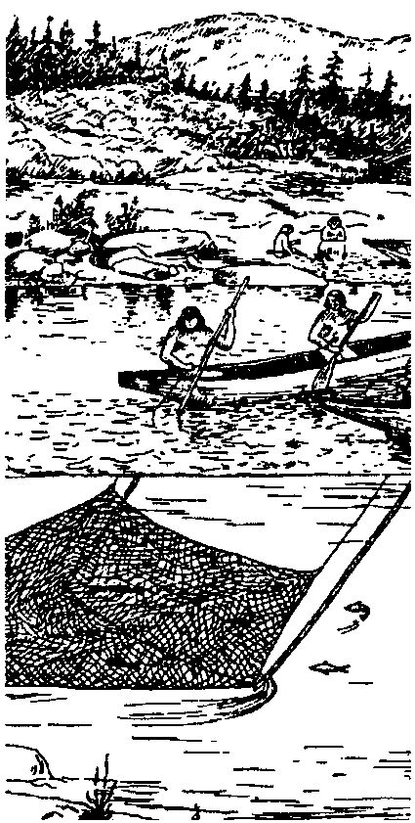

Key Concepts
1. Pacific salmon was the key resource for Native American Tribes of the North Pacific Coast.
2. Native American Tribes of the North Pacific Coast developed an elaborate technology for catching salmon at many points in their return migration.

Background
For thousands of years the mild climate and abundant resources of the Pacific Northwest have provided its human inhabitants a relatively easy living. Before the arrival of white settlers, native peoples living there maintained an elaborate culture whose cycles and rhythms mirrored those of the marine life on which they lived.
Although shellfish and halibut and, occasionally, deer made up part of their diet, it was salmon that kept the Indians well fed year round. Each summer, as the salmon returned to spawn in northwest rivers and streams, the Indians corralled the fish with traps, nets, spears and baited hooks. The sun-dried salmon sustained the Indians from one year’s harvest to the next.
Salmon held a position of importance in the lives of Northwest Coast Indians comparable to little else. Most material possessions were shared or given away freely, but salmon fishing grounds were valued so highly that they could only be inherited from one’s ancestors. When Captain James Vancouver ventured into Puget Sound in 1792, the only time his party encountered hostility from Indians was when he inadvertently trespassed on one of these private fishing sites.

Materials
For each student
• student pages, “People of the Salmon”
• student text, “Indians of the Pacific Northwest” by Ruth Underhill
Teaching Hints

In “Native Americans: People of the Salmon” students use a text to help research and present traditional northwest Native American technique for catching and using salmon.
To introduce students to the unique Native American culture of the northwest, selected chapters of “Indians of the Pacific Northwest”, a Bureau of Indian Affairs publication by Ruth Underhill, have been reprinted as a student text. You are encouraged to add other resources on Native Americans of the northwest from school and local libraries. Have students use these materials as resources in completing the student assignment.
Note: Teaching about Native American cultures today requires some special words of caution--and encouragement. For far too long Indians have been excluded and invalidated in the classroom by stereotypical treatment in texts and in teaching. Yet today more than ever, there is a need for all students, Indian and non-Indian alike, to learn about the Native American heritage, because it is the heritage of everyone living in the United States today. Native Americans and non-Natives alike are searching for ways to improve how we teach about Native cultures. Below are some of mistakes we’ve made in the past. You can help correct them.*
• Help eliminate the use of labels such as “Redskins” and “Braves” which turn Native Americans into “things”. Like all of us, Native Americans are individuals who deserve personal identities. If other ethnic groups were targeted with such labels, it would long ago have been recognized as racist.
• Don’t speak of Native Americans as though they only lived in the past. There are 1.8 million Native Americans living in the United States today, and they are very much a part of the modern world.
• Native American groups are not all the same. There are hundreds of distinct cultural entities. They are as different from one another as citizens of one European country are from another. As much as possible, acknowledge those differences in your teaching.
• Confront the stereotyping of Native Americans in television and movies by helping students spot them; ie., the savage warrior, the silent “dumb” Indian, the noble warrior. These images were created by the entertainment industry and have nothing to do with Indians either today or in the past.
• Understand that Native American students themselves may not be well acquainted with their heritage. Many Native groups have had their cultural identities destroyed through government policies and a social climate of racism. They may need to be taught about their native heritage along with their non-Native classmates.
• Don’t allow students to dismiss Indian traditions and values as meaningless today. Have them explore the relevance of Native American values for group cooperation rather than competition, harmony with nature rather than conquest of nature, and respect for the land rather than ownership of it.
*Adapted from an essay by Ruth Sark Heinrich in “Rethinking Columbus”, a special edition of Rethinking Schools.

Key Words
diorama - a scene, often in miniature, reproduced in three dimensions by placing objects, figures, etc. in front of a painted background
dip net - in this case, a net attached to a handle or rope used by Native Americans for catching salmon or other fish
potlatch - a ceremonial festival among Native Americans of the northern Pacific coast at which gifts are bestowed on the guests and property is destroyed in a show of wealth that the guests later attempt to surpass
weir - a fence of narrow boards, net, or brush set in a stream for catching fish
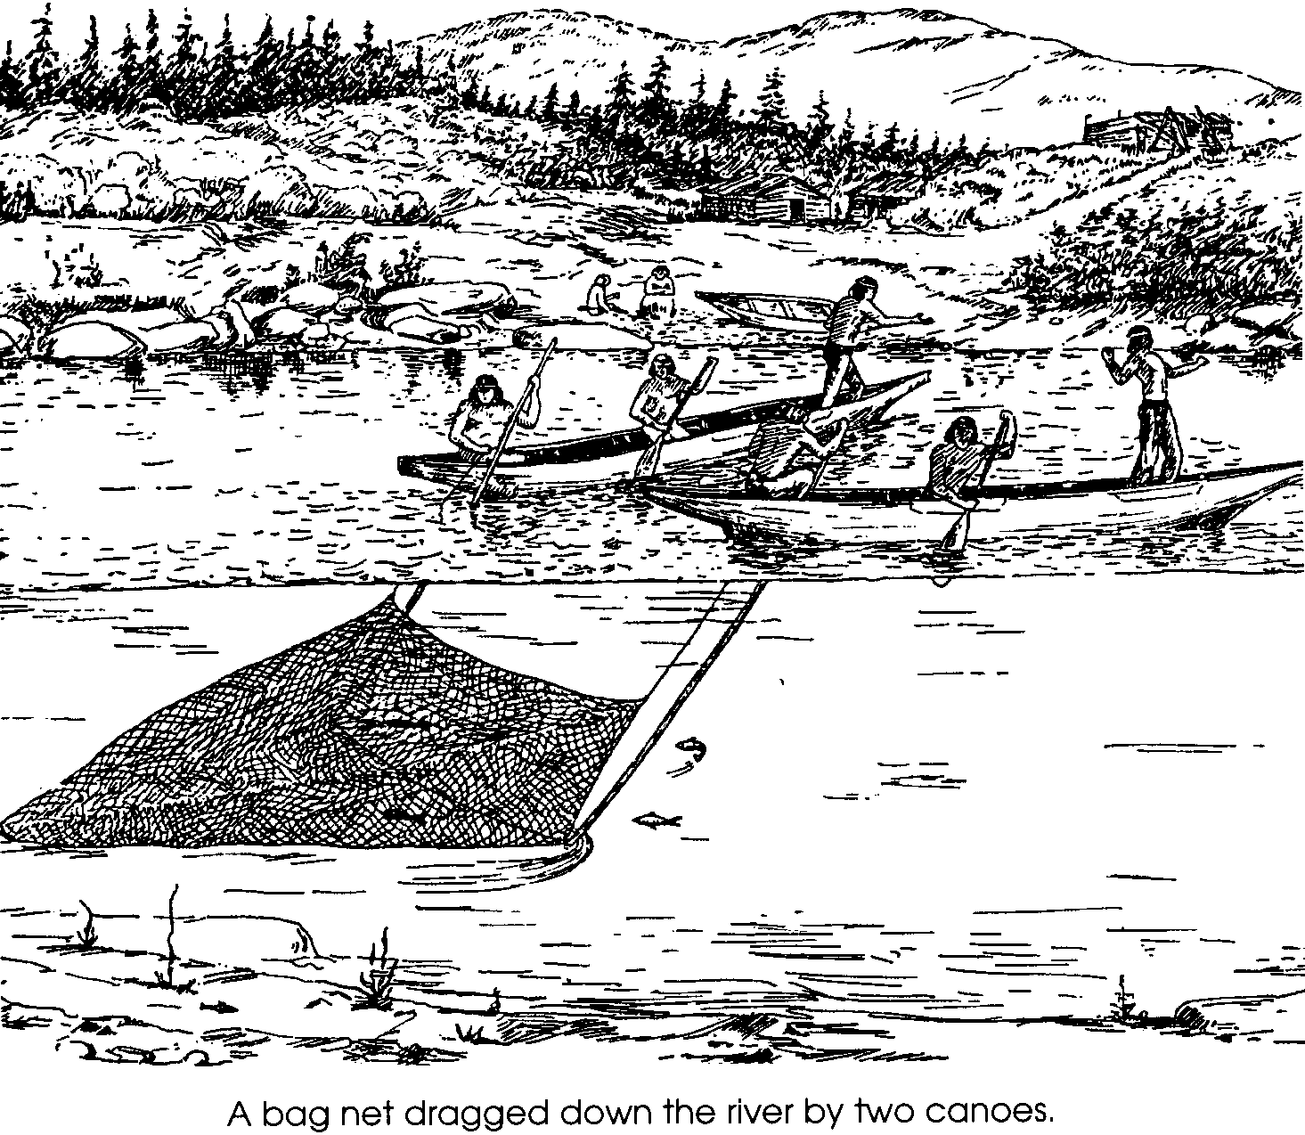
Native Americans: People of the Salmon

It is early in the 19th Century. You are an explorer traveling toward the Pacific coast down one of the river valleys of the northwest. Your party is very tired and is nearly out of food. As you descend out of the Cascade Mountains into the misty coastal valleys, you encounter its native people. Sensing you pose no threat to them, the Indians invite you to their village. They offer to teach you their methods to catch food, and they help supply you for your trip home

Record what you are able to learn about these people in one of the following ways:
• A series of journal entries in your Expedition Logbook.
• A dramatization of your encounter with these people
• A diorama or visual display which depicts their way of life.

Your presentation should include the following information:
1. The name of the river valley your expedition is following.
2. The name and language group of the tribe you encounter.
3. A description of their homes and their dress, including the materials from which they are made.

4. A discussion of their diet and a careful description of how they obtain their food.

5. Any other factual information you can learn about their customs and culture.

Use “Indians of the Pacific Northwest” as a resource. You are encouraged to use other references as well.

