Toothpick Fish
Toothpick Fish was adapted by Judy D’Amore, from an activity on genetics, also entitled “Toothpick Fish”, developed by Melinda Mueller and Barbara Williams and produced at the Pacific Science Center in cooperation with Washington Sea Grant and the Office of the Superintendent of Public Instruction. The latter “Toothpick Fish” is copyrighted by the Pacific Science Center, 1980.

Key Concepts
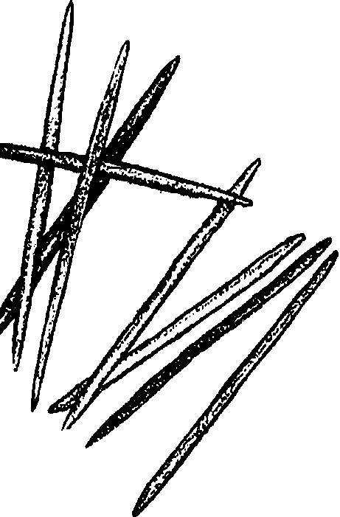
1. Organisms inherit their characteristics from their parents through the transfer of information in DNA molecules passed from one generation to the next.
2. Through natural selection, organisms best adapted to their environment tend to survive and to transmit their genetic characteristics. This differential reproduction gradually alters the genetic make-up of species from generation to generation, enabling them to adapt to conditions in their environment.
3. A diverse gene pool gives populations of organisms a rich and varied set of responses to environmental demands.
4. Domesticated animals, including salmon reared in hatcheries, tend to lose genetic diversity and thereby lose their ability to adapt to changing conditions in their environment.

Background
Early in this century, naturally spawning populations of Pacific salmon were severely threatened by a combination of stresses: over-fishing, damaging forestry practices, and the construction of hydroelectric dams over many northwest rivers. Pacific salmon have survived as a result of restrictions on fishing, improvements in timber harvest practices and through successes in the technology of salmon hatcheries. Hatcheries are now widely used as a substitute for maintaining the natural habitats which salmon need for spawning. Although in some places hatcheries may have helped maintain Pacific salmon as an economically viable resource, in many parts of the Northwest naturally spawning salmon populations have, in effect, been traded for hatchery reared populations. Scientists today are concerned that this practice may be causing genetic changes in the fish themselves.
Among experienced sports fishers, the differences between wild salmon and hatchery-reared salmon are legendary. Some say wild salmon are the most spirited fighters at the end of a hook and line. Others describe wild salmon as having far superior flavor to hatchery salmon. Whether or not these stories are true, hatchery salmon have probably undergone genetic changes from their wild relatives through the very nature of early hatchery practices.
To understand how these changes can come about, an introduction to some basic genetics concepts will be helpful. Although you may want to review genetics in greater depth through other resources, the following section provides a quick overview.

Genetics Basics

Most of our physical characteristics, such as the color of our eyes, are determined by the genetic material which make up our chromosomes. Chromosomes are long molecules of DNA carried in the nucleus of each of our body cells. These long molecules act as recipes for building all the chemicals in our bodies. Small sections of a chromosome contain information which determine individual characteristics. These sites along a chromosome which correspond to specific traits are called genes.
Humans have 23 pairs of chromosomes in each body cell. Other animals have a different number, but the number is constant for each species. For each pair of chromosomes, one came from our mother and one from our father, and because they code for the same characteristics, they contain duplicate information. In other words, we have two copies of each gene. But very often those copies are not identical. There may be many different versions (or alleles) of a gene, and we are, therefore, very likely to have received different alleles from our different parents.
In this lesson, the terms allele and gene are sometimes used almost interchangeably. In actuality, their meanings are different, gene referring to the specific location along a chromosome and allele being one of the variations possible at that location.
When the two alleles for a characteristic differ (if we carry one allele for blue eyes, say, and the other for brown eyes) one of those alleles will often be dominant over the other. In humans the allele for brown eyes is dominant over the allele for blue, meaning that when a person has both the blue-eye allele and the brown-eye allele, only the allele for brown-eyes will be expressed. The person carrying those alleles will have brown eyes himself, yet he is capable of passing either allele to his child. This is why some brown-eyed parents have blue-eyed offspring.
The characteristics actually expressed in an organism are known as the its phenotype. The organism’s hidden genetic characteristics are its genotype.

Materials
For each class:
• Diagram, Genes and Chromosomes, prepared as transparency
• Diagram, Fish Life Cycle, prepared as transparency
• Diagram, Student Data Sheets, prepared as transparency
• 5 paper cups per work station for organizing 5 colors of toothpicks for student access

For each pair of students:
• 100 toothpicks colored red, blue, green, white, and black (20 of each color)
• 1 small paper cup
• 1 set of Scenario Cards (or 1 set for each work table)

For each student:
• Set of Toothpick Fish data sheets
• “Toothpick Fish: Interpretation” student pages
• “Hatcheries: Solution-- or Problem?” student pages

Teaching Hints
The activities in “Toothpick Fish” investigates principles of natural selection through the use of colored toothpicks which represent pairs of alleles for the characteristic of color in a population of fish.
Students will test the effects of seven scenarios on fish populations represented by colored toothpicks. You may read the scenarios to them, prepare them as cards to place on their work tables, or make up transparencies to use on an overhead.
Although you can buy colored toothpicks, it is much more inexpensive to prepare your own. Soak plain toothpicks in diluted food coloring and dry in a warm oven. For black toothpicks, soak in India ink and oven dry. Use natural color toothpicks for white. Each pair of students or table group will need access to all five colors. A set of 5 paper cups per table, one for each color, is a good system.
The activities in toothpick fish are presented in a stepwise progression, each building on the concepts developed in the previous activity. You will need to adjust the pace of the lessons in response to your students’ comprehension.

Procedure
Step I: Introducing Genetics
1. Ask students to give an example of a species which humans have changed from its wild form through controlled breeding and artificial selection. (If students have difficulty, you may wish to prompt them with questions such as, "Do any of you have a pet dog at home? What kind?". For this discussion, a diagram depicting the genealogy of the dog, such as that found in the Life Nature Library (1964) volume "Evolution", prepared as transparency may be helpful.)
Explain that scientists are beginning to ask whether the Pacific salmon are undergoing important genetic changes today too. They wonder if the replacement of natural spawning with the rearing of fish in hatcheries is causing important characteristics of wild salmon to be lost.

2. To find out more about this issue, suggest students take a look inside their own cells to understand how genes influence our characteristics. Place the transparency, “Genes and Chromosomes” on the overhead. Point out the pairs of chromosomes inside the nucleus of the cell. Explain that DNA molecules are the road maps used by the body in making and repairing every part of us. Along each chromosome are bands of genetic material called genes, which contain the blueprint for individual characteristics, such as eye color, curly or straight hair, left or right handedness, etc.
Call attention to the fact that the chromosomes are in pairs. Explain that we inherit one of the chromosomes from each of our parents. Therefore, we have two copies of every gene, one from our mother and one from our father. For every characteristic, the body usually chooses to read only one of the road maps.
What happens when we receive very different genetic information from each of our parents? How does the body decide which road map to read?
We call these two versions of a gene “alleles”. If the allele from one parent codes for blue eyes and the allele from the other parent for brown eyes, one is dominant over the other. Explain that an individual with alleles for both brown and blue eyes will look brown-eyed, but he or she can still pass either the blue-eye or brown-eye allele to an offspring.

3. Fish also inherit their characteristics from their parents. Use the “Fish Life Cycle” diagram as a transparency to illustrate how the baby fish is formed by the union of one egg and one sperm cell, each containing just one copy of every gene. After the germ cells unite, the young fish will have two copies, one from each parent.

Step II: Dominant and Recessive Genes
1. Tell students that in the activities which follow, colored toothpicks are going to represent the gene for skin color in fish. Hold up a green and a blue toothpick. Explain that a green toothpick will be an allele for green color, and a blue toothpick is an allele for blue color.
Tell them: You will use a paper cup to represent the stream in which your fish spawn. When it’s time for your fish to spawn, you will place all your toothpicks into the cup. The toothpicks in the cup represent the fishes’ gene pool, or the alleles present in the eggs and sperm of all the fish spawning at the same time and place.
2. Demonstrate this by putting 4 green toothpicks and 4 blue toothpicks into a paper cup and shaking them gently.
Ask: After the eggs are fertilized, how many genes for color will each fish have? (They’ll have two.)
Ask a student to come up, close her eyes, and draw one or two pairs of toothpicks out of the cup to represent the pairs of genes inherited by each offspring.
In this case, the toothpicks will either be both green, both blue, or there will be one of each. Tell students that in this simulation the green allele is dominant over the blue allele, so a green/blue combination will always result in a green fish. Ask students to tell you the color of the fish represented by each pair of toothpicks. Record these totals on the overhead, using a transparency of Data Sheet #1.
Point out to the students that in this activity, whenever their fish spawn, they must determine the color each offspring will appear. But they will also be able to see the hidden genetic make-up of each individual, something we normally can’t detect in real life. (You may want to introduce the terms phenotype and genotype at this time.)

3. Ask students to work together in pairs. Distribute the following materials to students’ tables. (Pairs of students working at the same table can share canisters of colored toothpicks.)
• 5 cups or canisters of colored toothpicks
• 1 paper cup (their spawning stream)
• “Toothpick Fish” data sheets
Have students place 4 green toothpicks and 4 blue toothpicks in their cup. This represents 4 fish spawning in a stream. Tell them to shake the toothpicks gently, and without looking, draw from the cup four pairs of toothpicks and lay them on the table in front of them.
Have the student teams decide the color of each of their fish. Most of the fish will probably be green, since both the green/green combination and the green/blue combination produce a green fish. Ask students to record the observed color or phenotype of their fish on DATA SHEET # 1.
As students work, circulate around the room to check that all groups are identifying the colors of their fish correctly.

4. Ask for students’ attention and have them report their results to you. Wipe off the transparency of Data Sheet #1 and record their results on it. Total the numbers of green and blue fish of the first generation (or ask the students to do it.)
Discuss the ratio between the two colors. You can tell students that before the discovery of DNA, the scientist Gregor Mendell first studied genetics by crossing pea plants which carried the genes for two distinct characteristics, such as round seeds and wrinkled seeds. When he used pure strains as parents, Mendell discovered the cross always produced about three offspring with round seeds for every one with wrinkled seeds. Ask students if they can explain Mendell’s results. Then use a calculator to determine whether the ratio of green to blue fish from the students’ data agrees with the 3:1 ratio discovered by Mendell.

5. Have students return the toothpicks to their cups and produce a second generation. Again total their results on the overhead. Students may want to compare the ratio of the second generation with the first, or even to add the two together to obtain a greater sample size.
If you feel the need, you can have them produce a third generation with the two alleles. Otherwise, move on to the next activity.

Step III: Introducing Many Colors
1. Have students add to their cups 12 more toothpicks: 4 black, 4 red, and 4 white. These toothpicks also represent alleles for color. Like the blue and green toothpicks, each of these will also be expressed as either dominant or recessive to toothpicks of a different color.
Explain the following order of dominance to the students. Each color is dominant to all colors on the right, and recessive to colors on the left:

Green Blue Black Red White

In other words, green is dominant over all other colors. Blue is dominant over black, red, and white. Black is dominant over red and white, but recessive to green and blue, etc.

2. Now have students mix up the toothpicks and randomly draw 10 pairs, laying them on the table in front of them. As they determine the color of each fish, students should record this information on data sheet #2 in their packet.

3. Record a few of the student teams’ results on the Data Sheet #2 overhead, and discuss the color distribution in their data. Repeat with a second and third generation. Students should discover that most of the fish appear green, blue, and black.

Step IV: Natural Selection

1. Ask students whether, in real life, all the young would actually survive to adulthood. (Of course not. There are many factors which limit the number of young which survive.)
Ask students to consider what happens to a fishes’ genes if the fish dies before it has a chance to reproduce. What effect does this event have on the gene pool of future generations? (The genes are lost and will not be passed to future generations.)
Tell them: Let’s take a look at how the fishes’ environment might affect the gene pool of your toothpick fish.
2. Read the following scenario, or put it on an overhead:

Scenario A: A Green River

The fish are living in a dark river with lots of green plants. The white fish will be very visible. Predators will be able to spot them and eat them before they have a chance to reproduce.

Rule: Whenever a white fish (the white/white combination) appears, it will not survive. Discard its toothpicks by putting them back in the white canister.

Ask students to predict the effect such a scenario will have on their toothpick fish populations. Have them record their prediction on Data sheet #3 before going further. Then they can draw out three generations, each time discarding any white fish which appear. Students should describe their conclusions below their data chart. Ask students to follow this procedure, ie., predicting, testing, and concluding, when investigating each of the later scenarios.
Explain that the process at work here is called natural selection. Through natural selection individuals with non-adaptive traits produce fewer or no offspring so that the non-adaptive traits are less likely to reappear in future generations.
Discuss as a class what has happened to the white fish. Is there any likelihood that white fish might still appear? Are any white toothpicks still present? (Most likely, students still have a few white toothpicks.) You may want to compare the white toothpick with certain recessive alleles in humans which appear very rarely, but are deadly when they are expressed. Hemophilia is one such genetic disease. Ask students to consider why certain recessive alleles, which kill the organism whenever they are expressed, are not eliminated entirely from a population.

3. Next, share Scenario B with your students:

Scenario B: A Grey River

Factory waste has been dumped into the stream. It does not kill the fish, but it does kill the green plants. The remaining background is multicolored rocks, against which the blue, red, black, and white fish are well camouflaged, but the green are conspicuous. With this change of environment, the green fish are now eaten before they can reproduce.

Rule: Whenever a green fish appears, it will not survive. Discard its toothpicks.

Instruct students to predict the effect of this scenario on their populations, test their predictions and record their conclusions.
Again share results. Ask students to compare the very different effects of these two scenarios. Which scenario caused the most dramatic change in their population size? Their gene pools?

4. Ask students to tell you which is more likely to be maintained in a population, a harmful allele which is dominant or a harmful allele which is recessive. (Harmful recessive alleles can and are maintained within populations simply because they are so seldom expressed. A harmful allele which is dominant is quickly eliminated from the gene pool.)

Step V: Genetic Diversity

1. Tell students that occasionally a gene may affect more than one characteristic. The allele for sickle cell anemia is such a situation. When a person inherits this allele from both parents, his body will produce misshapen and poorly functioning red blood cells, causing sickle cell anemia. However, when it is present on only one chromosome, a person has resistance to malaria.

2. Now add some new rules to the simulation. Some of the alleles for color will confer special characteristics to fish populations. In each case, only one allele must be present in a fish for it to have a special attribute, and the fish does not need to have the color of that allele expressed.

Black gene -- can wait to spawn. A fish with even one black gene is flexible about when it spawns. If conditions aren’t right, it will wait until they are.
Red gene -- strong swimmer, powerful jumper. A fish with even one gene for red color will be an extremely strong swimmer and powerful jumper.
White gene -- resistant to disease. A gene for white color gives the fish resistance to certainly deadly diseases.

3. Before exploring the new scenarios, have your students establish a balanced population by again placing just four toothpicks of each color in their cups. Tell them to begin with this combination before testing every new scenario.
4. Provide students with scenarios C, D, E, and F. Have them test the effect of each scenario on their gene fish populations. As before, be sure students make predictions before performing the action on their populations, and have them record the outcomes on their data sheets.
5. Discuss the effect of each scenario on the students’ fish populations as needed. You might ask students to invent other scenarios which might impact their fish populations, and have them decide on particular effects these might have on particular alleles. Students should test these scenarios as well.
6. Read students a final scenario:

Scenario G: The Hatchery

A dam is being erected on the river where your fish spawn. Because your fish population spawn up-river from the site of the new dam, your fish population will go extinct unless you build a fish hatchery below the dam.

Rule: Draw two fish (four toothpicks) from the cup. These toothpicks are the brood stock for your hatchery. Discard all other toothpicks, since the dam prevents the rest of the fish from spawning. Through hatchery propagation, add four copies of the four toothpicks to the brood stock, making a total of 20 toothpicks in the new hatchery population.

Have the students predict the impact of this development on future generations. Then have them test the outcome as before.
Discuss the changes that have taken place. There is probably far less diversity in the students’ “gene pools”. Ask students to tell you which alleles are no longer present. What special abilities have their populations lost?

7. Use the student assignment “Toothpick Fish: Analysis and Interpretation” for assessment and discussion.

Key Words
allele - one of several variants of a gene, giving rise to contrasting traits
chromosomes - strands of genetic material found in the nucleus of all cells, always found in pairs (except in germ cells or when cells are dividing)
dominant - an allele is dominant when it is expressed in an organism’s appearance and prevents the expression of the other allele in the pair
gene - a section along a chromosome which controls one biological trait of an organism
gene pool - all the genes present and available in an interbreeding population
genotype - the invisible genetic characteristics of an individual
germ cells - the reproductive cells (the egg and sperm in animals) from the parents which fuse to produce an offspring. Germ cells normally have just one set of chromosomes.
natural selection - the perpetuation of beneficial genetic traits in future generations (and the elimination of unfavorable traits) through differential rates of survival and reproduction
phenotype - the visible or apparent characteristics of an individual
recessive - an allele is recessive when it is not expressed in the organism’s appearance because of the presence of a dominant allele
Extension

1. For insight into other issues surrounding hatchery rearing, follow this activity with the student reading, “Salmon Hatcheries: Solution--or Problem?”.

Answer Key
Toothpick Fish: Interpretation

1 a. Natural selection continually eliminates harmful genes and increases the ratio of beneficial genes in a population. This keeps natural populations adapted to their environments.
b. Human selection or artificial selection determined which fish would be used to start the hatchery, and artificial selection will continue to be present each year as humans select new parents for the next generation.
c. Yes, hatchery fish are still subject to natural selection while they are in the natural environment. Note, however, that hatchery fish bypass nearly all the natural selection that would normally take place from the time the adults arrive prepared to spawn and the hatchery juveniles are planted in the stream.

2. Genetic diversity gives a population of organisms the ability to adapt to environmental changes. When a variety of genes are present in a gene pool, there are more chances that some individuals will have the combination of traits needed to survive an environmental crisis like the ones explored in this lesson.

3. Consequences might include the loss of a great many alleles and trends toward more uniformity in the populations. Through loss of genetic diversity, there might be loss of resistance to disease and general lowering of the resilience and adaptability of the fish.

Salmon Hatcheries: Solution--or Problem?

1. Each of the six items listed in the text is a problem for wild salmon caused by hatchery release programs.

2. The purpose of this question is to promote further discussion. Answers may vary. You may want to discuss some of the ideas below with students.
Some states have begun closing hatcheries and placing more emphasis on restoring wild salmonid runs; however, a number of factors make it unlikely that hatchery propaganda will be phased out entirely:
• Loss of natural habitat for wild salmon has virtually eliminated wild runs from many parts of the northwest. It may appear easier to support hatchery programs than to tackle the enormous land-use issues which must be addressed in restoring lost salmon habitat.
• Public agencies and policy makers feel the pressure to “do something” to guarantee that fish will be there for us. It’s easy for public officials to get behind programs as concrete as hatchery programs. It’s also easier to continue supporting programs that are in place, whether or not they are operating effectively, than to look for better solutions in entirely new places.
• There is a common perception in our society that technology can solve all our problems. After all, if technology can continue to revolutionize agriculture, why can’t it work in fish hatcheries? The problem is that hatchery fish live not only in the controlled environment of the hatchery, they must also survive in the wild. We may be able to achieve further perfections in the hatchery environment, but in order for the fish to survive in the wild, they must rely on a complex set of adaptations and behaviors that we cannot help them with. Have we left them the resources for such a life?
For further information and discussion on topics raised in “Hatcheries: Solution--or Problem?”, see the following reference:
Ray J. White. 1992. "Why Wild Fish Matter: A Biologist’s View." Trout (Trout Unlimited), vol. 33, No. 3, pages 24-50
Scenario A: A Green River

The fish are living in a dark river with lots of green plants. The white fish will be very visible. Predators will be able to spot them and eat them before they have a chance to reproduce.

Rule: Whenever a white fish (the white/white combination) appears, it will not survive. Discard its toothpicks by putting them back in the canisters.

Scenario B: A Grey River

Factory waste has been dumped into the stream. It does not kill the fish, but it does kill the green plants. The remaining background is multicolored rocks, against which the blue, red, black, and white fish are well camouflaged, but the green are conspicuous. With this change of environment, the green fish are now eaten before they can reproduce.

Rule: Whenever a green fish appears, it will not survive. Discard its toothpicks.

Scenario C: Obstructions on the River

A major storm has washed out a bridge, leaving construction material in the river. Fish with a red gene are the only fish able to jump over the impasse and spawn upstream. Fish with a red gene now have an advantage over fish without a red gene.

Rule: Discard all fish which don’t carry a red gene. Double both genes of each fish which does carry a red gene.

Scenario D: Volcano

A volcano has just erupted, filling the streams with white ash. Any white fish will have a strong advantage, and black fish will be very conspicuous.

Rule: For each white fish in the new generation, add two new white toothpicks. Discard any black fish created in that generation.

Scenario E: Low Water

A drought has reduced the flow in all the rivers and the fall rains are especially late. The fish can’t reach the tributaries where they usually spawn because of low water. This year only fish with a black gene will be successful in spawning because none of the others can delay spawning until the rains finally come.

Rule: Discard all fish without a black gene and double the toothpicks of each fish which carries the black gene.

Scenario F: Deadly Illness

This season an outbreak of a deadly bacterial infection threatens the population. Only fish with the white gene are safe.

Rule: Discard all fish which don’t carry a white gene. Double the toothpicks of all fish which do carry the white gene.

Scenario G: The Hatchery

A dam is being erected on the river where your fish spawn. Because your fish population spawn up-river from the site of the new dam, your fish population will go extinct unless you build a fish hatchery below the dam.

Rule: Draw two fish (four toothpicks) from the cup. These toothpicks are the brood stock for your hatchery. Discard all other toothpicks, since the dam prevents the rest of the fish from spawning. Through hatchery propagation, add four copies of the four toothpicks to the brood stock, making a total of 20 toothpicks in the new hatchery population.

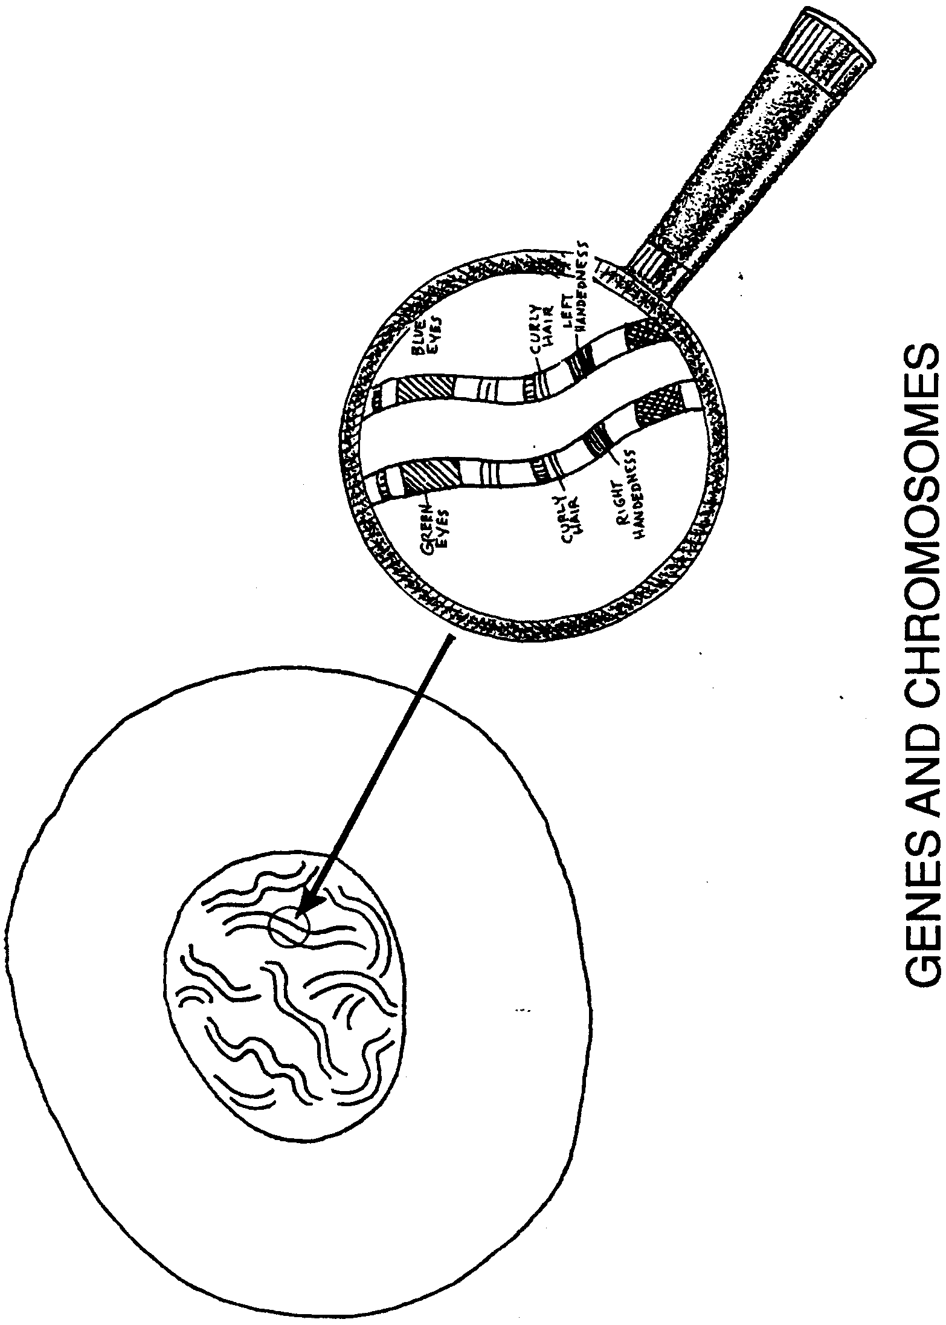
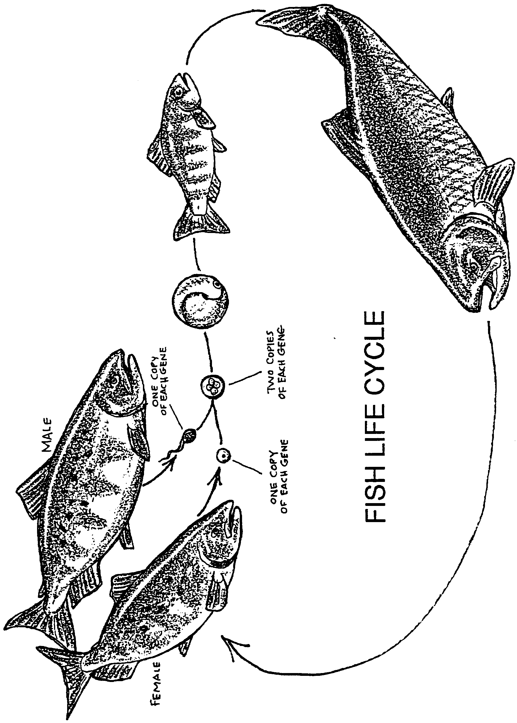
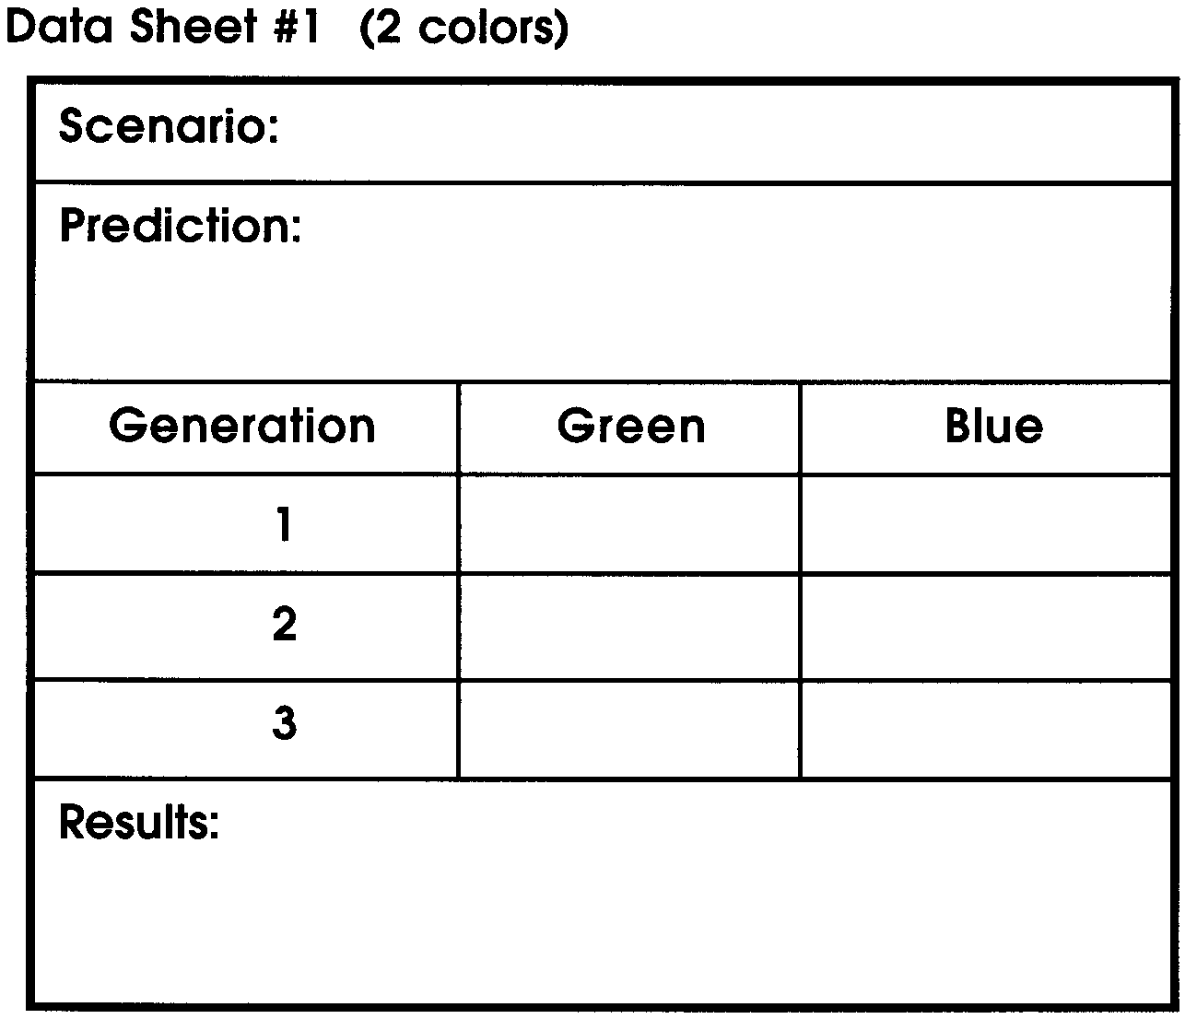
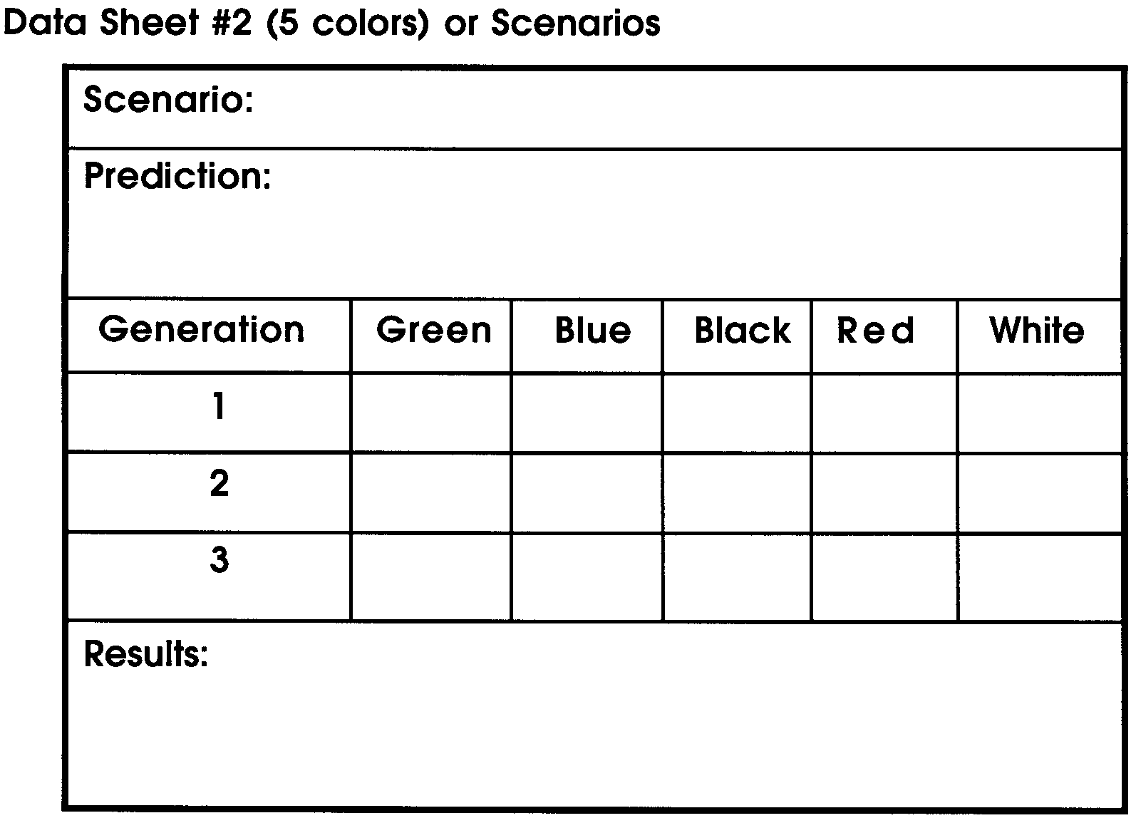
Toothpick Fish
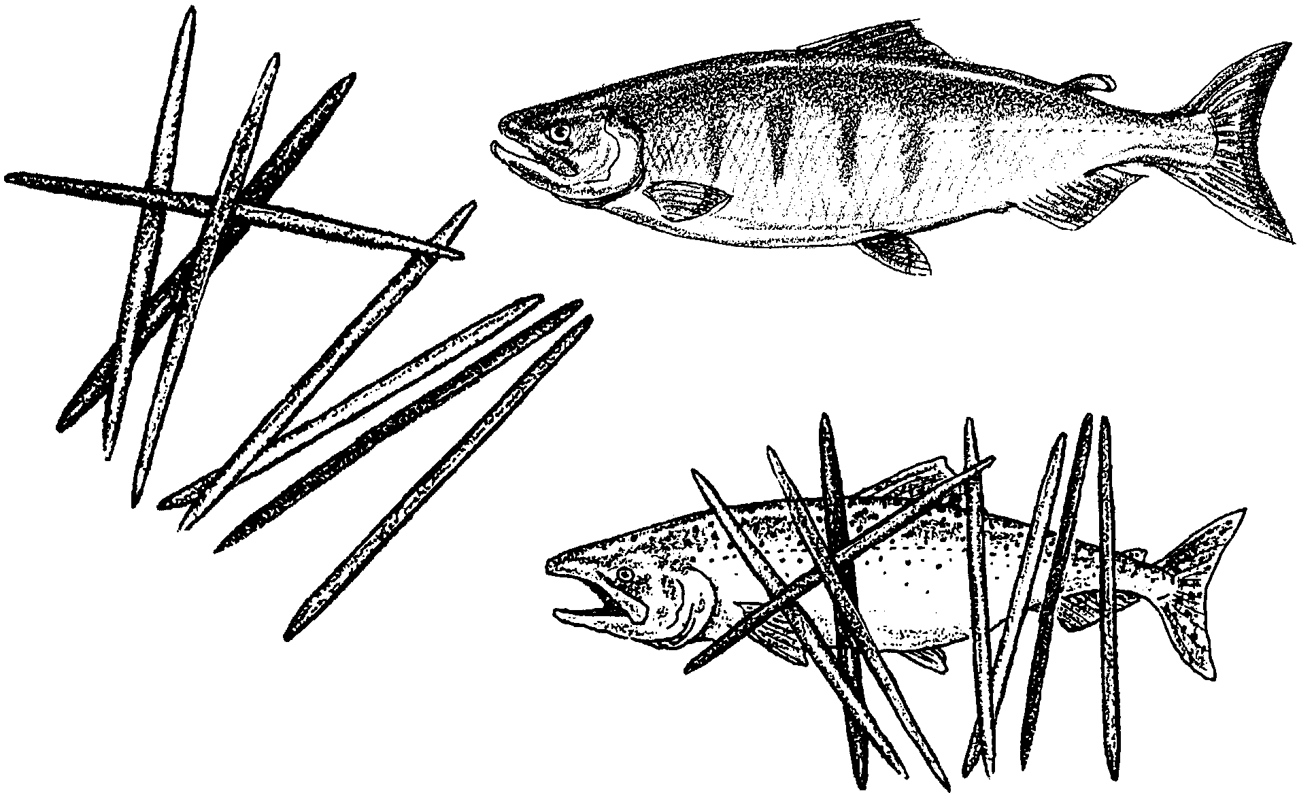
Interpretation
1. In all scenarios except the final one, the decision over whether a fish would survive to spawn again (and pass its genes to a new generation) was always caused by natural factors. Recall that when natural factors change the survival chances of an organism, this is called “Natural Selection.”

a. What is the benefit of natural selection to a population of an organism?

b. What new factor was introduced in the scenario, “Hatchery” which changed the survival chances of the fish?

c. Are the hatchery fish still under the influence of natural selection? When?
2. When a population of animals or plants has a high “genetic diversity,” this means it has a great variety of alleles present within the gene pool. How does this benefit the population?

3. What might be some genetic consequences to Pacific salmon if all wild stocks of salmon became extinct and we came to rely entirely on hatcheries for their propagation?
Salmon Hatcheries: Solution--or Problem?
On many rivers throughout the northwest, environmental problems prevent salmon from spawning naturally. At one time hatcheries looked like an easy remedy. But some scientists are beginning to question how well hatchery programs around the country are working. Some feel hatcheries are creating far more problems than they are solving. They cite problems such as these:

• When hatchery fish are released into streams, very large numbers are usually placed in a small stretch of stream which usually lacks the food resources for such high densities. Fish planted in this way suffer high mortality themselves, but they also compete heavily with wild fish for what food there is. They may even feed directly on wild fish in the stream.
• Fish raised in hatcheries become accustomed to extremely crowded conditions. In such a stressful environment they learn erratic and highly aggressive behaviors. When released into the wild, they may attack and harass fish already in the stream. As a consequence, both wild and hatchery fish suffer lower survival rates.
• Releasing fish to the wild in abnormally high concentrations can also attract predators, raising the death rates of wild and hatchery fish alike.
• In the wild, 95% of each generation dies within the first year. This mortality is part of the natural selection process which culls out the less fit and continually improves the species. By protecting the eggs and young from natural hazards, hatcheries are causing salmon to lose the benefit of natural selection. Scientists are concerned over long-term impacts of this on the species.
• Hatchery fish may interbreed with closely related wild fish. In this way, favorable genetic traits in wild fish may become diluted with less adaptive traits from hatchery fish. Wild populations may lose their adaptations to specific conditions in their environment.
• When both hatchery fish and wild fish return to the same river, they both tend to be caught by fishers in the same proportion. However, wild salmon require a far higher population of returning salmon to produce the next generation than do hatchery salmon. Fisheries management programs often overlook this, and fishery harvest quotas may preserve enough returning fish to stock the hatcheries but not protect wild populations.
1. Describe three problems the release of salmon from hatcheries creates for wild salmon.

2. If scientists recognize that hatcheries create such problems, what are some possible explanations for the wide use of hatcheries in managing Pacific salmon today?
