Hooks and Ladders
Lesson by Judy D’Amore, Marine Science Centers, Port Townsend
and Poulsbo, Washington. Adapted from Hooks and Ladders
Aquatic Project Wild, P.O. Box 18060, Boulder, CO 80308-8060

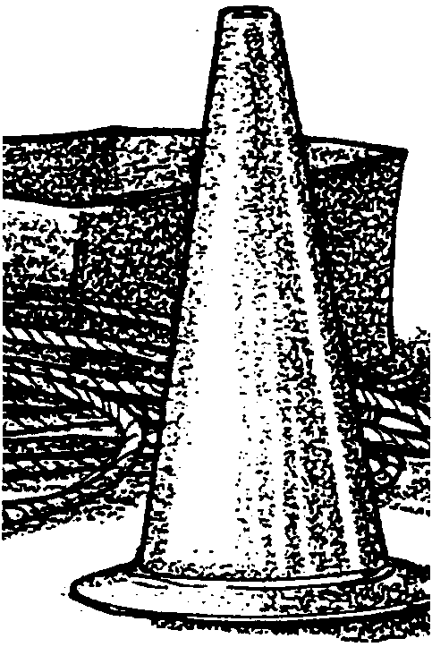
Key Concepts
1. The size of an animal's population depends on both the number of young it bears and "limiting factors" which affect how many young will survive to reproduce.
2. Salmon populations are controlled by a great many limiting factors, some a result of natural processes, some a result of human activities or environmental changes brought on by humans.

Background
Background for “Hooks and Ladders” which explores the salmon life cycles found in the activity “Salmon: Species in the Spotlight”.

Materials
• large playing area (100 x 50 feet)
• wooden stakes or traffic cones, and about 500 feet of rope or string for marking the course (helpful, but optional)
• a jump rope (10-15 feet long)
• 2 cardboard boxes
• 100 tokens - game markers, 3x5 cards, poker chips, etc.

Teaching Hints
“Hooks and Ladders” is a physically active outdoor activity which reinforces salmon life cycle concepts.

Procedure:
1. If necessary, review the life cycle of salmon and hazards faced by salmon in each of its life stages.

2. Explain to the students that they are going to model the life cycle of salmon with a game called Hooks and Ladders. Like the perilous journey made by salmon, this game is an obstacle course. Explain the game to them, and diagram the game course so that they can help you set it up.

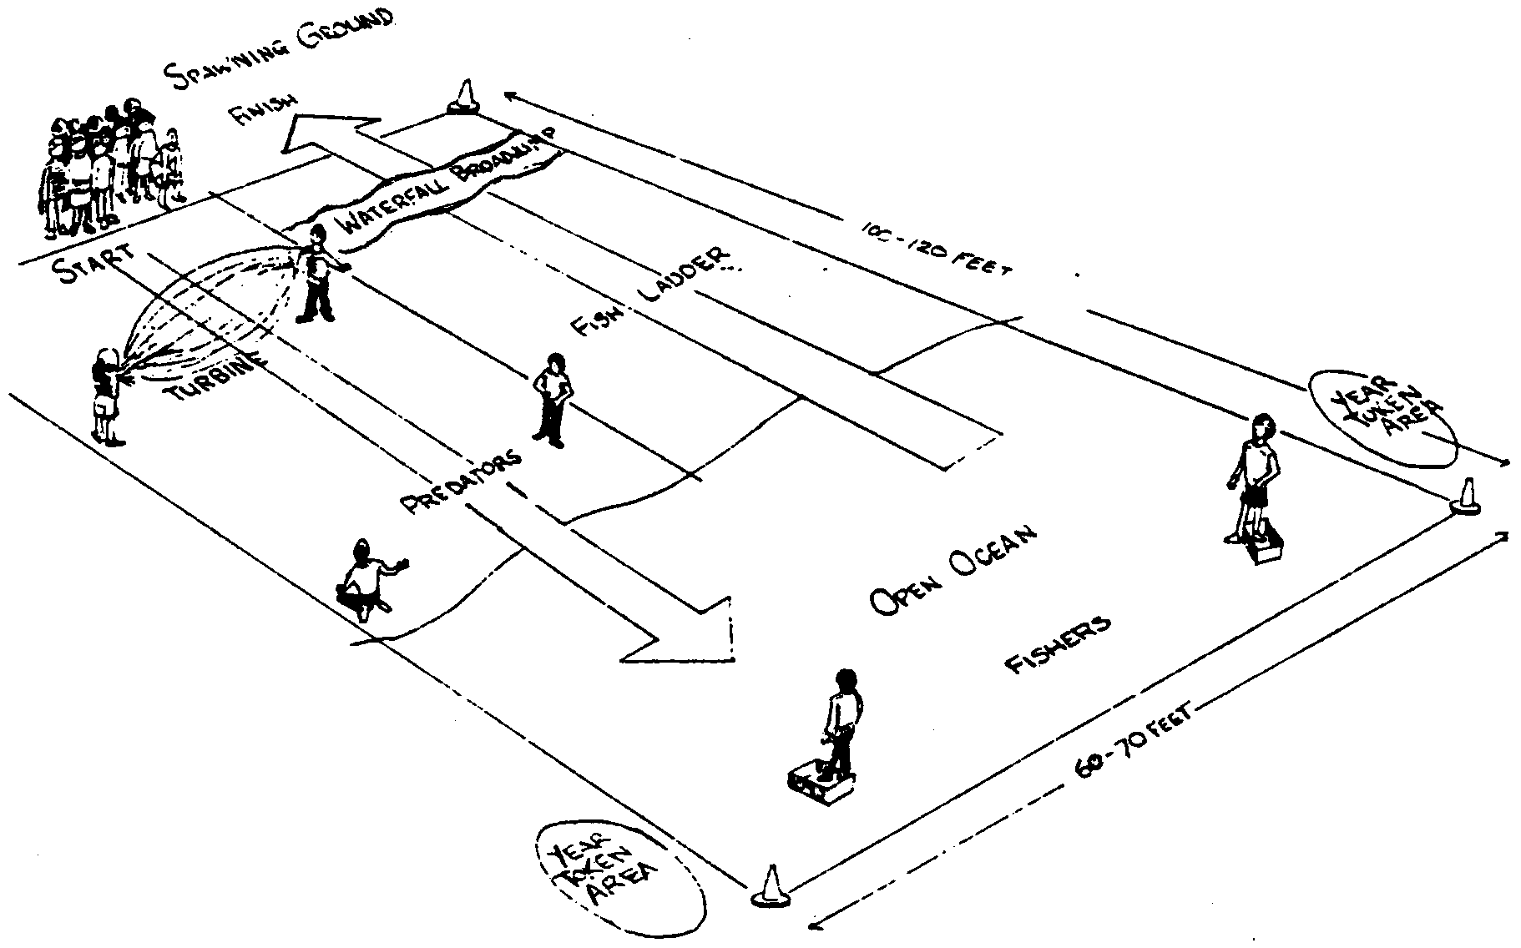
3. Set up the playing field as shown in the diagram below. The area should be about 100 x 50 feet, laid out with spawning grounds, the downstream river, the ocean, and the upstream river. Strings and stakes to mark the salmon’s route are helpful, but not essential.

4. Assign roles to each of the students, as follows:

Choose two students to be the turbine team. The will operate the jump rope which represents the turbines in hydroelectric dams. Later in the simulation, when all the salmon have passed the turbine going downstream, these students move to the upstream side to become monitors at the “waterfall” (broad jump).

Choose two students to be predatory wildlife. At the start of the simulation the predators will be below the turbines where they catch salmon headed downstream. Later in the activity, when all the salmon are in the sea, these same two predators will patrol the area above the waterfall. There they will feed on salmon just before they enter the spawning ground.

Choose two students to be humans in fishing boats catching salmon in the open ocean. These students must keep one foot In a cardboard box to reduce their speed and maneuverability.

All remaining students are salmon.
Note: These figures are based on a class size of 25 to 30. If your group is larger or smaller, adjust the number of people who are fishing and predatory wild animals accordingly.

5. Begin the activity with all the salmon in the spawning ground. The salmon then start their journey downstream. The first major hazard is the turbine at the dam, played by twirlers of the jump rope. At most dams there are escape weirs to guide emigrating salmon past the turbines. The student salmon cannot go around the rope swingers, but they can slip under the swinger’s arms if they do not get touched while doing so. A salmon dies if it is hit by the turbine (jump rope). The turbine operators may change the speed at which they swing the rope.
Any salmon which “dies” at this or any other stage in the game becomes part of the physical structure of the fish ladder later in the course. A fish ladder is a human-made ladder now used by migrating salmon to get past many dams and other obstacles. Later in the game, the salmon who survive life in the
open ocean will use the fish ladder to return to the spawning ground. Students who have “died” can move to the fish ladder and prepare to become part of It.

6. Once past the turbine, the salmon must get past some predatory wildlife. The predators below the turbine must catch the salmon with both hands--tagging isn’t enough. Dead salmon are escorted by the predator to the fish ladder.
This gets the predators off the field regularly to provide a more realistic survival ratio.

7. Salmon which escape the predators are in the open ocean. The salmon must move back and forth across the ocean area four times in order to collect four tokens, which represent four years at sea. You, an assistant, or a student can stand at the edge of the “ocean” handing tokens to students as they complete these trips. Make sure the students cross the entire ocean before collecting a token.
Meanwhile, the salmon can be caught by fishing boats in the ocean. Remember, people fishing must keep one foot in their cardboard box! When a salmon is caught by a fishing boat, he or she is again escorted to the fish ladder by the person fishing.

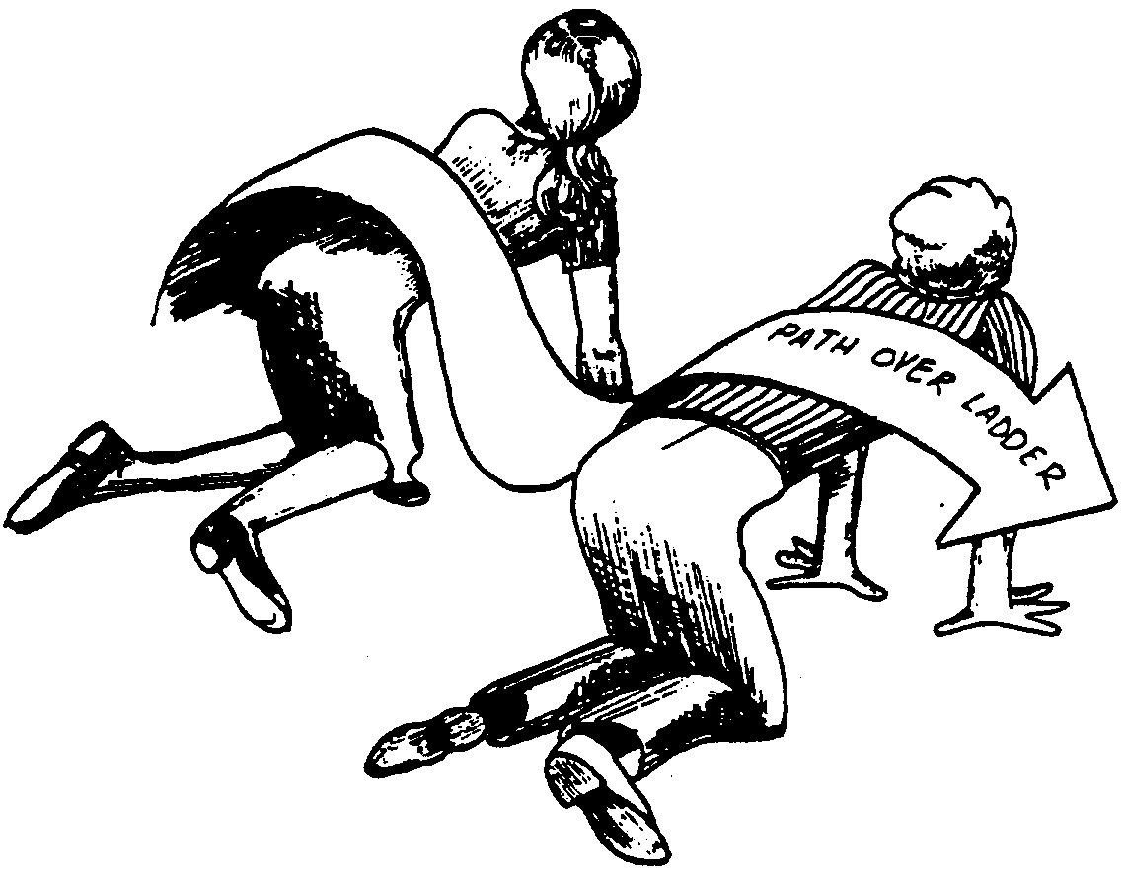
8. As soon as four “year” tokens are gathered, the salmon can begin upstream. They will now need to pass up the fish ladder. The fish ladder is formed by students kneeling side-by side on the ground in a row, with a body wide space between them. Salmon must step carefully over the backs of each of them to advance.
In the fish ladder, predators may not harm the salmon.

9. Once through the ladder, the salmon faces the broad jump waterfall. The waterfall represents one of the natural barriers the salmon must face while going upstream. Be sure the jumping distance is challenging but realistic. The two former turbine students will monitor the jump. The salmon must be able to jump the entire breadth of the waterfall in order to continue. If the salmon fails to make the jump, it must then return to the bottom of the fish ladder and come through again.

10. Above the falls, the two predators who started the simulation as predators below the turbines are now the last set of limiting factors faced by the salmon. They now represent bears, one more example of predatory wildlife. Again, remember that predators must catch the salmon with both hands. If they do catch a salmon, they must again take the student they caught to become part of the fish ladder.

11. The game ends when all surviving salmon reach the spawning ground, or when all salmon are gone in the event that none survive.
Feel free to experiment with other configurations of the game course to include different sets of hazards.

After playing the game, explore these questions with your students:
What was the survival ratio of your population? (Make this calculation:
survival ratio = survivors/total population)
How does this compare with the actual survival ratio in salmon? (A typical survival ratio would be two survivors out of 3000 eggs, or 2/3000)
Where were the losses the greatest?
Where were the losses the least?
What seemed realistic about this simulation and what did not?
What would be the consequences if all the eggs deposited made the journey successfully?
Introduce the term “limiting factors” as those environmental factors which limit population size.
What are some limiting factors for salmon? (Limiting factors include: predators, loss of habitat, dams and other barriers to migration, fishing, food shortages, etc.)
Are limiting factors important for other species? (yes)
What species? (all species)

Key Words
fish ladder - series of ascending pools constructed to enable salmon or other fish to swim upstream around or over a dam
hydroelectric - pertaining to the use of falling water (e.g., from dams) to generate electric power
limiting factors - environmental factors which limit the size of an animal population. For salmon some of these factors are predators, loss of habitat, dams and other barriers to migration, fishing, food shortages, etc.
simulation - representation of the behavior or characteristics of one system through the use of another system
turbine - in this case, any of various machines at hydroelectric dams having a rotor, usually with vanes or blades, driven by water to produce electricity

