The Homing Salmon—Three Level Guide
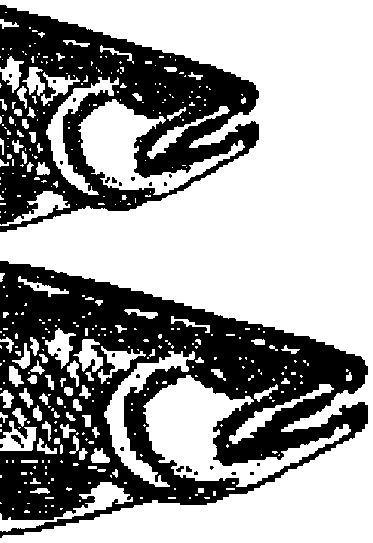

Key Concepts
1. Salmon use their sense of smell as one source of information to find their way to their birth stream.
2. Information about how salmon navigate may help humans make better salmon management decisions.

Background
For centuries humans have been fascinated by the migration of the salmon. The question of how salmon remember their birthplace and swim unerringly to it from a thousand miles away has been the subject of much scientific investigation.

Materials
For each student:
• one copy of article: “The Homing Salmon”(“Scientific American” Aug. 1955) (We are unable to include “Scientific American” articles in the CD ROM version of the FORSEA Guide. Please look for the article at your library.)
• one copy of “The Homing Salmon—Three-Level Guide” student pages

Teaching Hints
“The Homing Salmon”, an article from the “Scientific American” and an accompanying three-level guide, presents some of the pioneering work by investigators studying the homing of salmon. More recent research has expanded our knowledge of the process and you may wish to have your students locate and read current articles. The “Homing Salmon” article was chosen for the way in which it reveals the scientific process as well as for its content.
This article is difficult reading for many students. This article seems to typify a problem seen in teaching today: we can have articles that cover the material but are too difficult to read or we have articles that can be read but do not cover the material. The three-level guide presented here is one way to solve this seeming dilemma. Three-level guides are based on what seems to be the general agreement that comprehension can take place at different levels of cognition. Harold L. Herber has called these levels: l) literal, 2) interpretive, and 3) applied. With the exception of the literal level, each level requires the product of the previous level or levels in order to function. The literal level of comprehension produces knowledge of what the author said. We all recognize that it is quite possible to identify and even repeat what an author has said without understanding what the author meant by her statements. The interpretive level of comprehension depends upon the reading performed at the literal level but carries the process a step further. At this level the reader derives meaning from what the author has said. The meaning is determined by the way the reader perceives the intratext relationships. The applied level of comprehension takes the product of the literal, (what the author has said) and the interpretive (what the author meant by what he said) and applies it in some practical or theoretical exercise. At this level the reader is using his past experience and knowledge to produce new ideas which extend beyond those immediately identifiable in the reading selection. It must be borne in mind that the level at which a person reads does not reflect upon her intelligence and that the level can change as the material changes. The most advanced engineers and scientists often read at the literal level if they cross into other disciplines. When we read materials from an area with which we have little familiarity, our level of comprehension goes down. Your students are no exception to this observation. The three-level guide is a device used to improve a person’s comprehension by focusing on important concepts at each three levels. The three-level guide can be used with any material and is readily constructed. For aid in this regard please see:

Teaching Reading in the Content Areas. 1970. Harold L. Herber. Prentice-Hall, Inc., Englewood Cliffs, New Jersey. 296 pages.

Duplicate the pages of the three-level guide; one set per student. Spend a few minutes describing what is expected of the student. Suggest that the students read the statements in the three-level guide before they read the article. In this way, the statements serve as a preview and your students will be looking for and expecting to see certain concepts. You may elect to have your students compare their answers by meeting in small groups. The process of resolving differences in opinion can be very instructive. Upon completion of the reading of the three-level guide, discuss the guide by reference to the article. It is sometimes helpful to have your students note the page number and paragraph number where they found evidence supporting or refuting the statements in the guide. You can require your students to provide this information or you can offer extra credit for those that include it. Choose the technique that most appeals to you and best fits the needs and skills of your class.

One Step Further...

Authors, editors and publishers spend a great deal of time, effort, and money to produce the graphics which accompany printed works. The purpose of these graphics is, of course, to clarify and elaborate on the materials of the text. Unfortunately, many students do not use these aids to understanding. This exercise is designed to introduce the student to the utility of the figures included in “The Homing Salmon”.
Plan to allow time for a discussion of the graphics and to provide the correct answers upon completion of this exercise.

Key Words
generalization - a general statement, idea, or principle
interpretation - the act of making clear or explaining; the result of such an act
migration - periodic passage from one region or climate to another
paraphrase - to restate a passage of text giving the meaning in another form
spawn - to deposit eggs and sperm directly into the water, as in fish, where they fertilize and begin the life process

Answer Key
Level I

Directions: Read the statements carefully. Then as you read the selection, refer back to the statements in the guide and check those that you believe say what the authors actually said or paraphrase what they said in the selection. Indicate the page, paragraph and sentence on the statements checked for later reference. Also, be ready to explain what is inaccurate about the statements that you do not check.

x Experiments designed to determine how salmon return to their birthplace could reduce fish losses at dams.
Of the six common species of salmon, the Atlantic homes only once; after spawning they die.
x Research indicates that a salmon uses its sense of smell to identify the stream of its birth.
Using a specially designed aquarium that injected odors into the water, biologists proved that salmon were unable to distinguish the odors of different plants.
x Young salmon become conditioned to the smell of their birth stream and are able to remember the smell as adults enabling them to find and follow the waters of their birth stream.
Old fish remember odors better than young fish.
x Using odors to decoy homing salmon can help determine whether salmon migration is guided only by the sense of smell.
x Failure to decoy the salmon to a new stream, may mean that they will react only to a combination of odors in their parent stream.
Directions: Now compare your answers with those of others in your group. If there are many differences, find the page and paragraph that support your answer and write them next to the statement in question. When you finish your discussion, go on to the next level.

Level II
Directions: The statements below may or may not be true. Check each statement you believe is a generalization the authors themselves draw based on the information they give in the selection. Indicate the page, paragraph and sentence on the statements checked for later reference.
x An understanding of salmon homing will help insure the survival of the Pacific salmon.
x Each salmon stream is unique.
Little useful information can be obtained by marking young salmon and later recovering them as adults.
x The structures the fish uses for smelling can give us information about how the sense of smell functions in the life of the salmon.
x The salmon’s sense of smell is highly developed and located primarily in the nose.
x In the case of salmon homing, laboratory tests need to be coupled with field tests.
Directions: Now compare your answers with your group. As before, where there are differences, try to resolve them by reference to the selection. When you finish your discussion, go on to next level.

Level III
Directions: Read each statement below, relating the details and authors’ interpretations drawn from the selection to ideas and experiences you’ve had in reference to this topic. In column A, check the statements which Hasler and Larsen would have agreed with. In column B, check the statements you agree with.

A B
x Directing the migration of salmon may lead to serious ecological problems.
x Hydroelectric and irrigation dams pose a serious threat to the survival of salmon.
x A combination of careful observation of nature and simple experimentation can provide a great deal of information about fundamental biological questions.
x If humans are to survive in ever increasing numbers, we will have to learn to respect, understand, and preserve all other living things.
Directions: Again, compare your answers with your group. Where there are differences, try to resolve them.
One Step Further...
Experimental Tank
1. The arrows in the drawing show the direction of water flow.

2. Odorized water enters the tank through the de-aeration funnel.

3. Fish were conditioned to move toward one of the odors using food reward.

4. Fish were conditioned to move away from one of the odors by administering an electric shock.

5. The fish were blinded to make sure that they would not associate reward and punishment with the movements of the experimenters.

6. The experimenters should randomly alternate the sides from which the odors are released to make sure the fish would not associate a particular part of the tank with the reward or punishment. The answer to this question is not found directly in the drawing, but is a logical extension of the material included.

Four Runways
1. The effect upon the salmon fingerlings of an odor is judged by the observed distribution of the fish in the runways.

2 a. Odor II and IV attracts salmon fingerlings.

2 b. Odor III repels salmon fingerlings

2 c. Odor number I has no effect upon salmon fingerlings.

2 d. The authors needed a substance which initially would not be either attractive or repellent to salmon but to which they could be conditioned so that it would attract them.

2 e. Odor I fulfills the authors’ requirements for the substance needed for decoy conditioning.
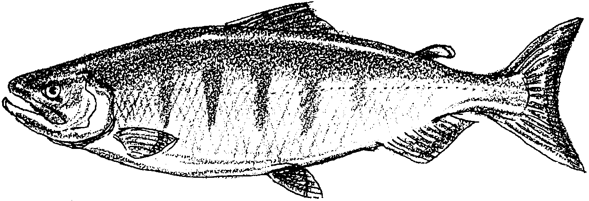
The Homing Salmon—Three Level Guide

Level I
Directions: Read the statements carefully. Then as you read the selection, refer back to the statements in the guide and check those that you believe say what the authors actually said or paraphrase what they said in the selection. Indicate the page, paragraph and sentence on the statements checked for later reference. Also, be ready to explain what is inaccurate about the statements that you do not check.

Experiments designed to determine how salmon return to their birthplace could reduce fish losses at dams.
Of the six common species of salmon, the Atlantic homes only once; after spawning they die.
Research indicates that a salmon uses its sense of smell to identify the stream of its birth.
Using a specially designed aquarium that injected odors into the water, biologists proved that salmon were unable to distinguish the odors of different plants.
Young salmon become conditioned to the smell of their birth stream and are able to remember the smell as adults enabling them to find and follow the waters of their birth stream.
Old fish remember odors better than young fish.
Using odors to decoy homing salmon can help determine whether salmon migration is guided only by the sense of smell.
Failure to decoy the salmon to a new stream, may mean that they will react only to a combination of odors in their parent stream.
Directions: Now compare your answers with those of others in your group. If there are many differences, find the page and paragraph that support your answer and write them next to the statement in question. When you finish your discussion, go on to the next level.
Level II
Directions: The statements below may or may not be true. Check each statement you believe is a generalization the authors themselves draw based on the information they give in the selection. Indicate the page, paragraph and sentence on the statements checked for later reference.

An understanding of salmon homing will help insure the survival of the Pacific salmon.
Each salmon stream is unique.
Little useful information can be obtained by marking young salmon and later recovering them as adults.
The structures the fish uses for smelling can give us information about how the sense of smell functions in the life of the salmon.
The salmon’s sense of smell is highly developed and located primarily in the nose.
In the case of salmon homing, laboratory tests need to be coupled with field tests.
Directions: Now compare your answers with your group. As before, where there are differences, try to resolve them by reference to the selection. When you finish your discussion, go on to next level.

Level III
Directions: Read each statement below, relating the details and authors’ interpretations drawn from the selection to ideas and experiences you’ve had in reference to this topic. In column A, check the statements which Hasler and Larsen would have agreed with. In column B, check the statements you agree with.

A B
Directing the migration of salmon may lead to serious ecological problems.
Hydroelectric and irrigation dams pose a serious threat to the survival of salmon.
A combination of careful observation of nature and simple experimentation can provide a great deal of information about fundamental biological questions.
If man is to survive in ever increasing numbers, we will have to learn to respect, understand, and preserve all other living things.
Directions: Again, compare your answers with your group. Where there are differences, try to resolve them.

One Step Further ...
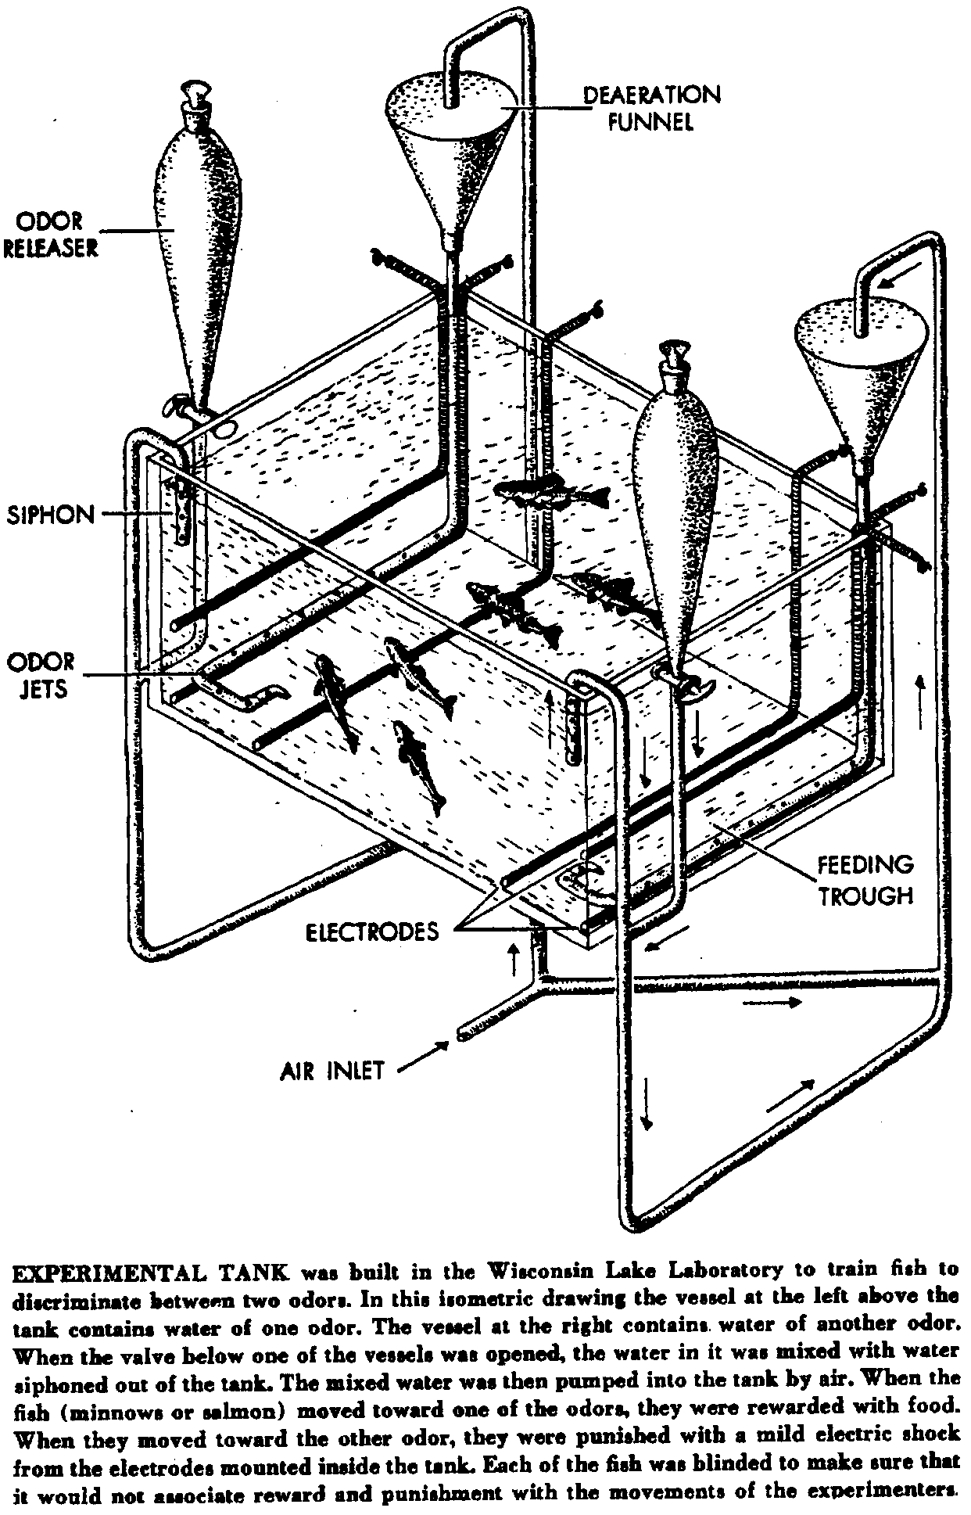
Arthur D. Hasler and James A. Larsen have provided us with several illustrations to help explain and expand upon the material in the text. Two of these illustrations are reproduced below. Use these copies to answer the questions which follow.

l. What do the arrows in the drawing show the reader?

2. Odorized water entered the tank through the odor releaser/de-aeration funnel (circle the correct answer).

3. How were the fish conditioned to move toward one of the odors?

4. How were the fish conditioned to move away from one of the odors?

5. Why were the fish blinded?

6. Why should the experimenters randomly alternate the sides from which the odors are released?

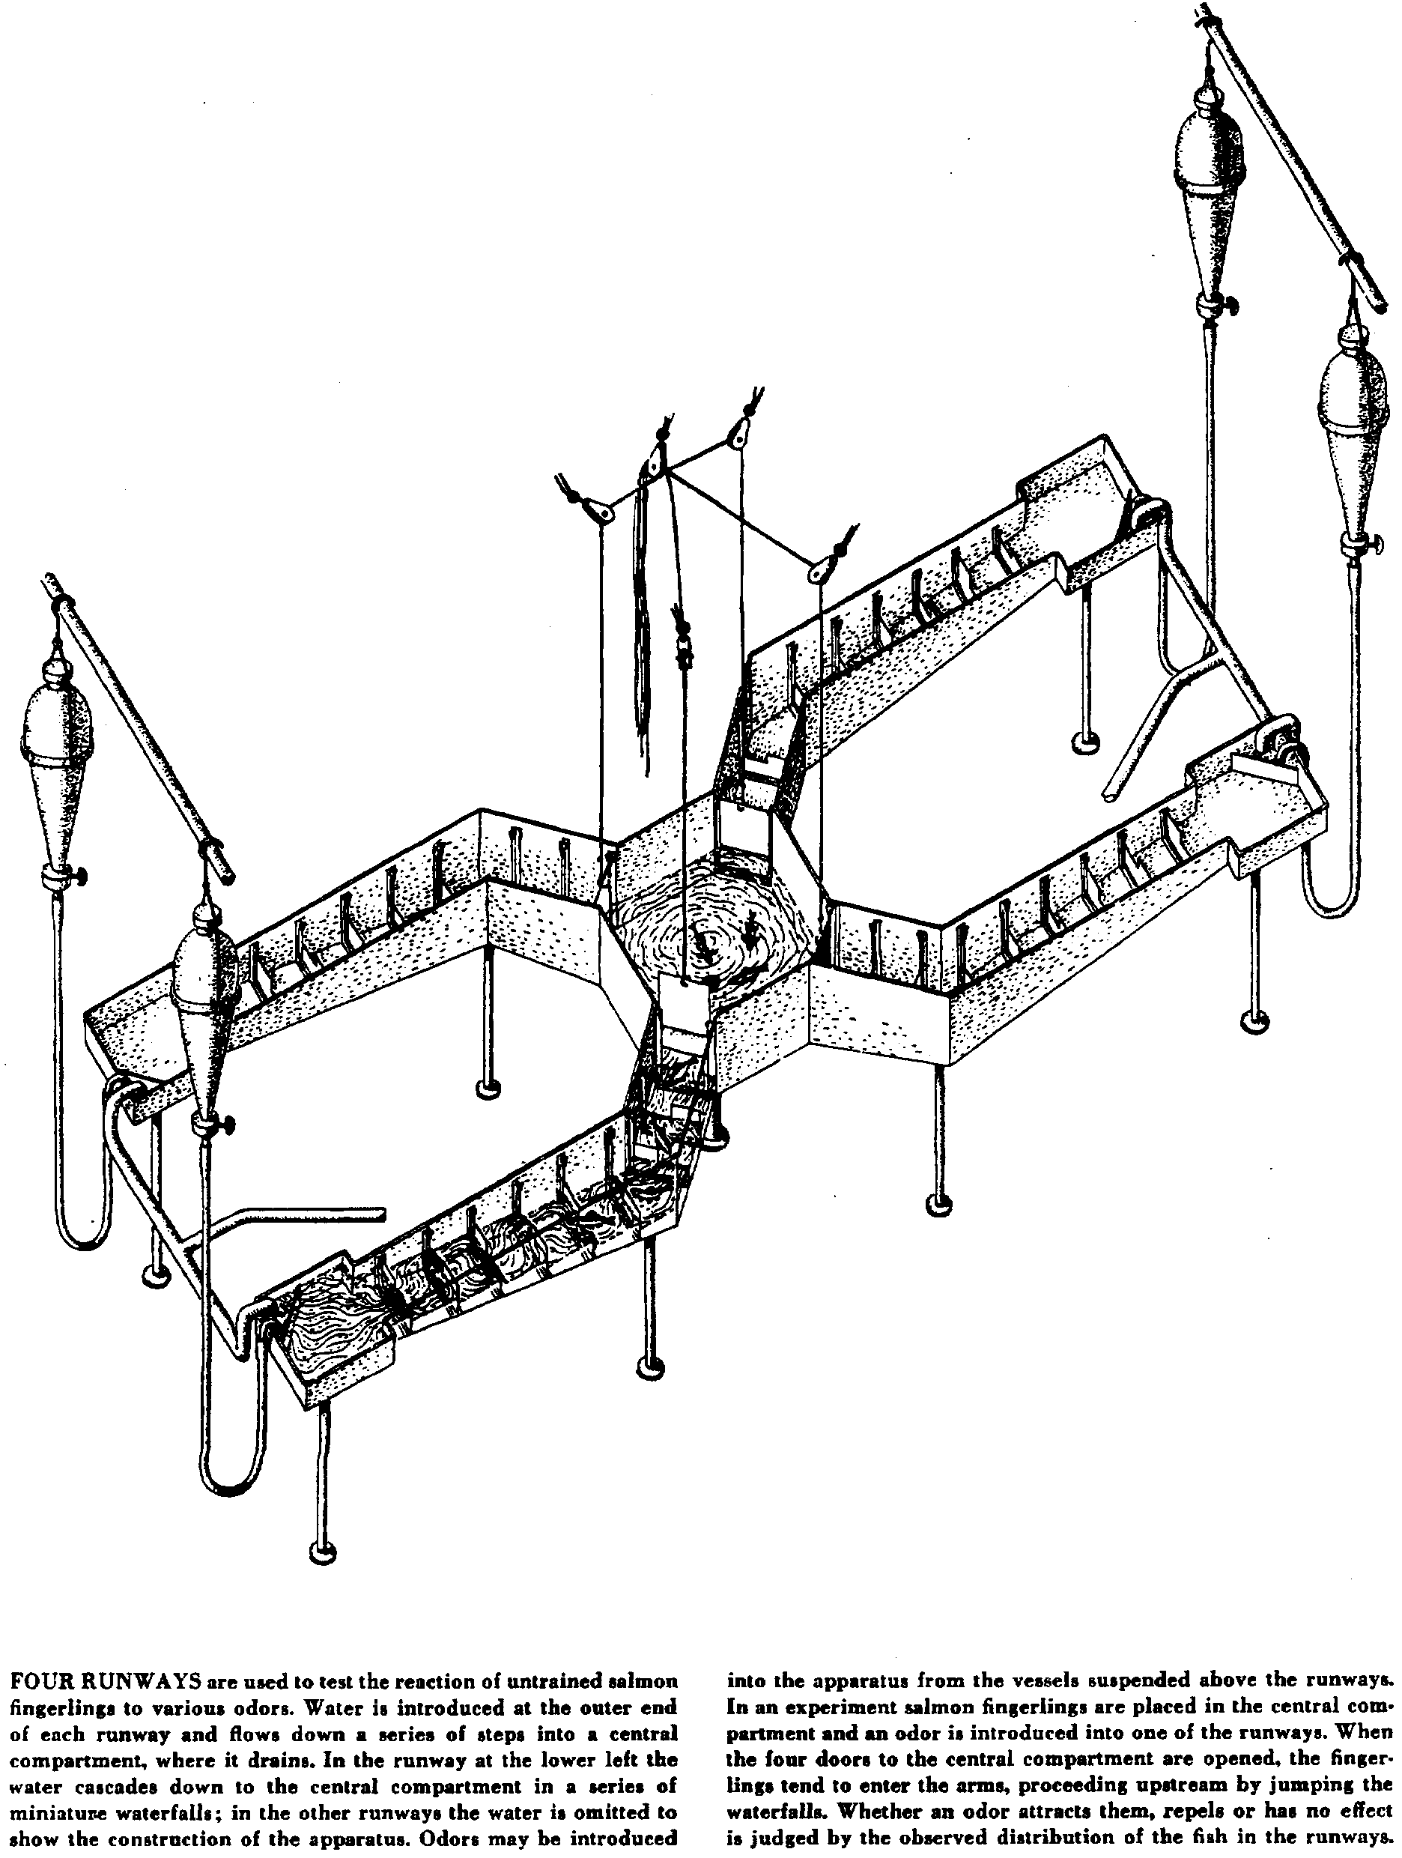
1. How does the experimenter determine if an odor attracts, repels, or has no effect upon the salmon fingerling?

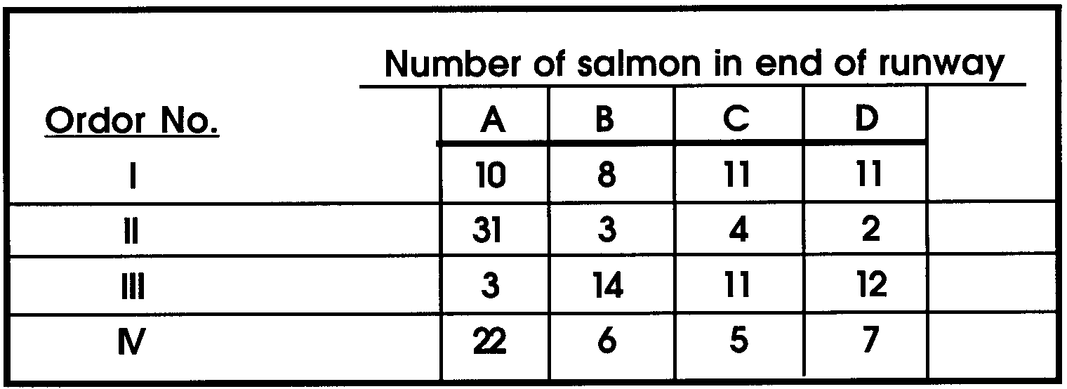
2. Over a period of time, a number of different odors were introduced into Runway A. Each odor was allowed to flow until no further movement of the salmon was observed. The final distribution of the salmon after the various flows is shown below:

a. Which odor(s) attract salmon fingerlings?

b. Which odor(s) repel salmon fingerlings?

c. Which odor(s) has (have) no effect upon salmon fingerlings?

d. From the text, what were the characteristics required by the authors for a substance to be used in conditioning the fish in order to decoy them to a stream other than that of their birth?

e. Which odor number fulfills the authors’ requirements for the decoy conditioning mentioned in d. above?

