Name That Salmon
Lesson by Judy D’Amore, Marine Science Centers, Port Townsend and Poulsbo. Adapted from Name That Salmon by Laurie Dumdie, from Alaska Sea Weeks, Grade 5.

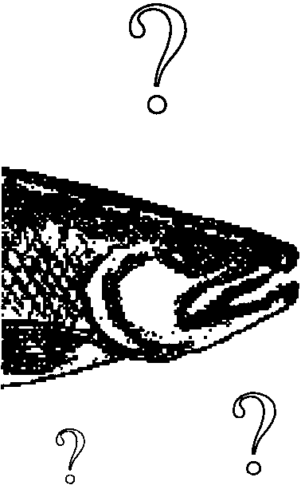
Key Concepts
1. There are seven species of salmon in Pacific Northwest waters. They differ slightly in when and where they spawn, where their young live, what they eat, how big they get, etc.
2. These differences allow them to use the same habitat, but compete minimally for food, shelter or spawning beds.

Background
The abundance of plankton in estuaries makes estuaries vital habitat and feeding grounds for a wide variety of marine life including crustaceans, fish, seabirds and even gray whales. One of the most impressive and most celebrated of these animals is the salmon. These magnificent fish migrate across the vast Pacific Ocean only to return to the estuary to spawn in the streams where they were born. Humans prize salmon for economic, spiritual and aesthetic reasons, but humans, who also live along estuaries, also threaten the marine and fresh waters upon which the salmon depend.
There are seven species of Pacific salmon on the west coast of the United States. These fish are all species within the genus Oncorhynchus. Five are commercially important salmon: Chinook, coho, chum, sockeye, and pink. Two trout species, steelhead (or sea-going rainbow) and sea-going cutthroat have recently been reclassified as Oncorhyncus as well. These latter fish are popular sport fishing species, and steelhead is an important subsistence fish for the Native American fisheries as well.
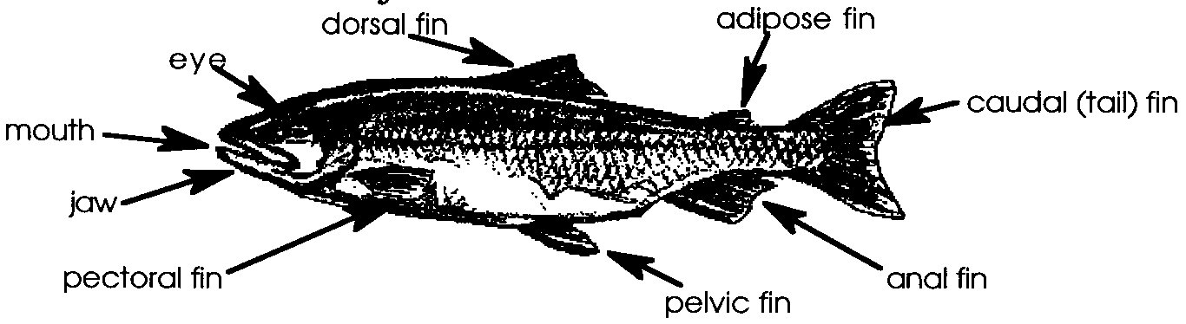
Each of the Pacific coast salmon species is described in the section, Pacific Salmon, later in this lesson. In order to discuss differences between the species, some names of the external features of a salmon may be useful.
Like other fish, salmon have two sets of paired fins: the pectoral and the pelvic fins, and three single fins: the dorsal, anal and caudal (tail) fins. Unlike most other fish, they also have an adipose fin, a small, soft fin on the upper body behind the dorsal fin. Salmon species can be distinguished by size, coloration and fin markings, and by characteristics of the mouth, jaws and eye.
These species and some of their relatives are anadromous fish. Anadromous fish hatch from eggs in fresh water, travel to salt water to mature and feed, and return to fresh water to deposit their own eggs. Their life cycle is diagramed and a full description of salmon life cycle can be found in the lesson “Pacific Salmon, Species in the Spotlight”.
Although these fish share a similar lifestyle and many physical characteristics, they are different in some interesting and important ways. These differences enable seven species of fish to occupy some of the same waters but compete minimally with one another for food or space.

Materials
For a class of 32:
• “Salmon Life Cycle” graphic

Recommended but not essential:
• Posters of Pacific salmon species (name, available from U.S. Government Printing Office, Washington, DC)
• Reference books on salmon or Pacific coast fishes, encyclopedias, etc.

For each student:
• Salmon Species Cards , duplicated and cut, one card per student (students will have different cards)
• Salmon Identification Chart, one copy per student
• Pacific Salmon, one copy per student
• Ocean Migration, one copy per student
• Salmon Questions, Parts 1 AND 2, one copy per student

Teaching Hints
The next eight lessons focus on the biology of salmon and human interactions with this prized species.
“Name That Salmon” is an exercise which will help students discover these differences which enable salmon species to occupy some of the same waters but compete minimally with one another, and to become familiar with at least one of the Pacific salmon.

Before students arrive:
Duplicate the salmon pictures and cut into individual cards, making sure that there is at least one card per student. If you plan to repeat the activity with several classes, you may want to copy the salmon pictures onto card stock and have them laminated. Make copies of the Salmon Identification Chart, Ocean Migration, Pacific Salmon, and Salmon Questions, part 1 and part 2 for each student. Prepare the diagram Salmon Life Cycle as a transparency if you plan to use it in this lesson.

When students arrive:

1. Create a context for “Name That Salmon” by asking your students how many have eaten salmon. (If you live in an area with salmon runs, ask how many have fished for salmon or seen them in a creek.) Explain that salmon depend on and live parts of their lives in all parts of the estuary. They live as adults in the ocean that feeds salt water to the estuary, they travel though the estuary itself, and they are born and later spawn and die in the fresh water creeks that flow into the estuary.
Explain that the salmon are large, magnificent fish. They are a critical part of estuarine ecosystems and humans place a high value on them. Yet salmon populations are dwindling.
Share with students that this activity introduces the seven species of Pacific salmon and explores how they can coexist in the same estuary systems. This is critical information for fisheries biologists deciding how to protect declining salmon populations.

2. Shuffle the salmon pictures so that they are in random order and distribute them to your students. Ask them to carefully examine their picture; to help them focus, you may want to have them find three ways their picture differs from that of a student sitting near them. Ask them to share with the class the characteristics which seem most useful in distinguishing one picture from another.

3. If students are not familiar with the names of a salmon’s fins, have them assist you in drawing and labeling the parts of a salmon on the board.

4. Explain that each of them has a picture of one of the seven species of Pacific salmon. If you are using this lesson to introduce a study of Pacific salmon, have them share their prior knowledge of the salmon life cycle, or if necessary, introduce it briefly yourself.

5. Tell them that when salmon make their migrations, they school together with members their own species. Have the students stand up and move about the room to find other students with salmon exactly like their own. As they search, move among them, helping them notice differences and similarities in their cards. Keep them looking among each other’s cards until they have formed into seven groups.

6. Ask for their full attention. If practical in your room, have them seat themselves together in their species groups. Tell them to work together to try to find out what species they have. Pass out copies of the Salmon Identification Chart, and make available any reference books. Call attention to any posters you have which might be helpful. Students may have difficulty making the identifications from black and white pictures, and if this is the case, move on by passing out copies of the Pacific Salmon student hand-out.
Note: To make identification easier, salmon cards can be colored in advance to match written descriptions, prior to lamination.

7. When groups have identified their salmon species, provide them with copies of Pacific Salmon and Salmon Questions, Part 1. Have them work together to become experts on their salmon species and answer the questions, using these new resources and any materials they used before.
As groups finish, ask them to prepare a brief oral presentation on their fish species to share with the entire class.

8. Finally, have students return to their original seats, or mix them up so that they are seated with students who worked on a different salmon species. Have them share information among themselves and use reference materials as needed to answer Salmon Questions, Part 2.

9. In closing, you might tell the class that when a number of related animals species share the same habitat, they often use it in very different ways. They might feed on different prey or at different times of the day. Ask: how are Pacific salmon an example of this? How does this enable so many species to co-exist in the same area?

Key Words
adipose fin - a small, soft fin on dorsal surface of salmon, behind the dorsal fin
anadromous - fish which live part of their lives in fresh water and part in salt water
anal fin - an unpaired fin on the ventral (under) surface of a fish
caudal fin - the tail fin of a fish
dorsal fin - an unpaired fin on the dorsal (upper) surface of a fish
pectoral fins - paired fins on a fish, usually on the sides behind the gill cover
pelvic fins - paired fins on a fish, usually on the ventral surface behind the pectoral fins
spawn - to deposit eggs and sperm directly into the water, as in fish, where they fertilize and begin the life process
species - basic category of biological classification composed of related individuals that resemble one another, are able to breed among themselves but are not able to breed with members of another species

Answer Key
Salmon Questions, Part 1

1. Answers will vary

2. Spawning:
Chinook--the main channel of rivers (never in small streams)
Chum--medium sized streams very close to the river mouth
Coho--shallow pools in small to medium-sized streams as far upstream as they can migrate
Pink--very small streams close to the river mouth
Sockeye--streams and small rivers above or below a freshwater lake
Steelhead--riffles in medium-sized streams
Cutthroat trout--fine gravel in smaller streams

3. Months of spawning:
Chinook-July to September
Chum--September to November
Coho--October to January
Pink--August to December
Sockeye--August to December
Steelhead--January to April
Cutthroat trout--January to March

4. Time before migration of juveniles:
Chinook--90 to 100 days
Chum--a few days
Coho-- 1 year
Pink--a few days
Sockeye-- 1 to 3 years
Steelhead--2 to 3 years
Cutthroat trout--2 to 4 years

5. Average length and weight:
Chinook--36 inches, 22 lbs
Chum--25 inches, 10-15 lbs
Coho--24 inches, 6-12 lbs
Pink--20 inches, 4 lbs
Sockeye--25 inches, 6 lbs
Steelhead--24 inches, 8-10 lbs
Cutthroat trout--12-15 inches, 2-3 lbs
6. Primary human use:
Chinook--Sport fishing and commercial, fresh or frozen
Chum--Commercial, fresh or frozen
Coho--Sport fishing and commercial, fresh, frozen, canned or smoked
Pink--Commercial, canning
Sockeye--Commercial, canning
Steelhead--Sport fishing and tribal subsistence fishing
Cutthroat trout--Sport fishing

Salmon Questions, Part 2

1. Chinook Salmon
2. Steelhead
3. Chum and Pink Salmon
4. Cutthroat Trout
5. Chinook Salmon
6. Sockeye Salmon
7. Coho Salmon
8. Chum Salmon
9. Pink Salmon
10. At least one of the species is spawning each month from July to April, so they could only be caught in the rivers between June and March. The Indians would need to eat dried salmon the months of April and May.
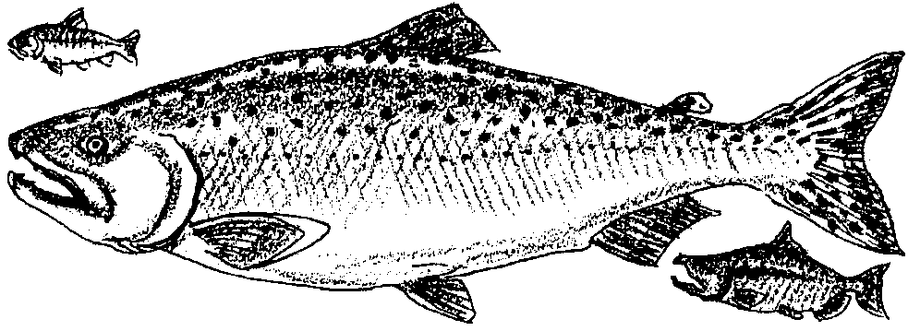
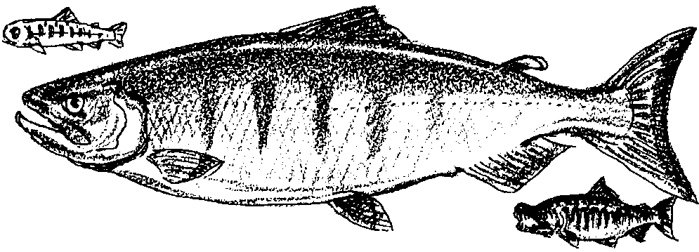
Chinook Salmon
Oncorhynchus tshawytscha

Chinook (also called King Salmon, Tyee, or Blackmouth) are the largest of the Pacific Salmon, averaging 22 lbs. and 36 inches in length as adults, with reports of fish reaching 50-100 lbs in some areas. After hatching, the young stay in fresh water for a few weeks up to a year before migrating to the ocean. There they pass 3 to 4 years or longer before returning to spawn. Most Chinook return to spawn from August to September and are known as "Fall Chinook". However some return much earlier, arriving in the spring and spawning in July. These are known as "Spring Chinook". Chinook only spawn in larger rivers, but they may go inland as far as 600 miles.

Distinguishing characteristics:

In salt water: Dark greenish-blue on the back with silvery, spotted sides. Caudal fin spotted on both lobes. Black gums around teeth in the lower jaw.

In fresh water: Color darkening to brownish or rust color.
Chum Salmon
Oncorhynchus keta

Chum (also called Dog Salmon) spend very little time in fresh water. They spawn only a short distance inland, and their juveniles return to salt water almost immediately after hatching. Chum make extensive ocean migrations, returning to spawn after 3 to 5 years. They average 10-15 lbs. and about 25 inches in length at maturity. Chum spawn from September through November.

Distinguishing characteristics:

In salt water: Steel-blue and silver, with a few black speckles on the back and faint gridlike bars on the sides. Anal fin usually has a white tip.

In fresh water: Male has vertical patterns of black, yellow and purple on the sides and fierce teeth. Female has dark purple stripe along sides.
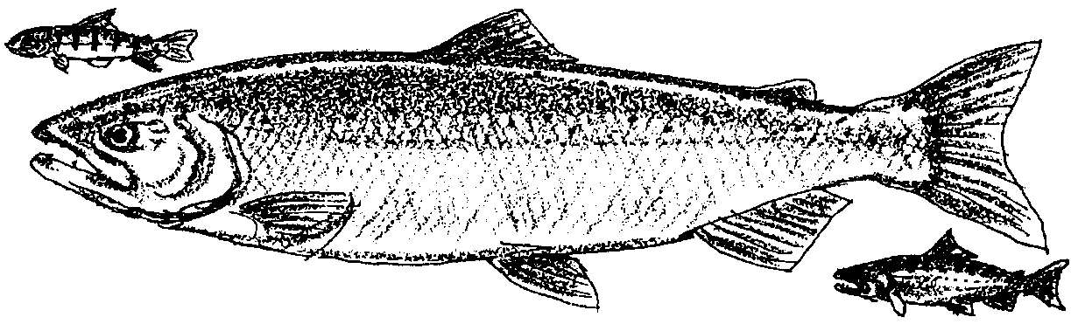
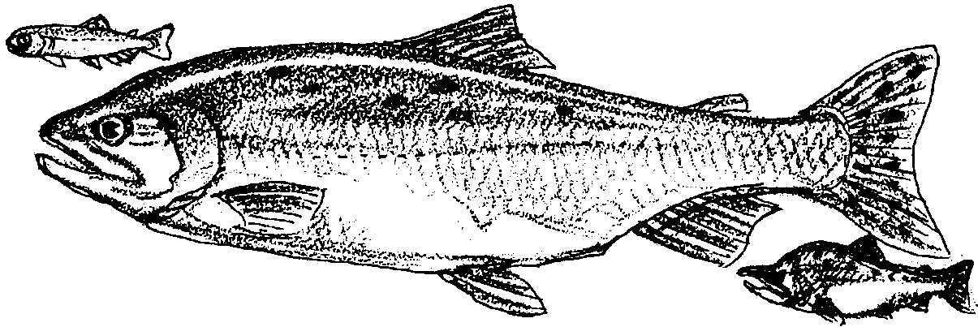
Coho Salmon
Oncorhynchus kisutch

Coho (or Silver Salmon) are creek fish. The young spend a year in fresh water streams before migrating to the sea; there they live for another 2 years. Returning Coho will swim hundreds of miles up streams, overcoming obstacles such as beaver dams, logs and shallows. They spawn in shallow pools of medium sized streams from October to January. Coho salmon are magnificent jumpers, and are prized as a sports fish. At maturity, Coho average 6-12 Ibs. and about 24 inches in length.

Distinguishing characteristics:

In salt water: Dark, metallic blue on the back, with black spots down the back and a few on the upper surface of the caudal fin (tail). Gums and nostrils white, but tongue black.

In fresh water: Color turning red-black with broad, red lateral stripe. Males develop hooked upper jaw.
Pink Salmon
Oncorhynchus gorbuscha

Pinks (also known as Humpies) are the smallest of the commercial Pacific salmon, averaging 4 Ibs. and about 20 inches in length as adults. The young migrate to salt water in April and May, almost as soon as they emerge from the gravel stream bed. They stay in salt water only until the fall of the following year, returning to spawn from August to September. Their other name, "Humpy" or "Humpback" comes from the prominent hump which forms on the backs of male spawners. Pinks spawn in small streams very close to the river mouth. They live exactly 2 years, and in many places they are only seen during odd numbered years.

Distinguishing characteristics:

In salt water: Tiny scales, silver sides, and dark, oval spots on upper body and tail.

In fresh water: Colors darken, bright Pink edge to gill covers. Males develop prominent dorsal hump.
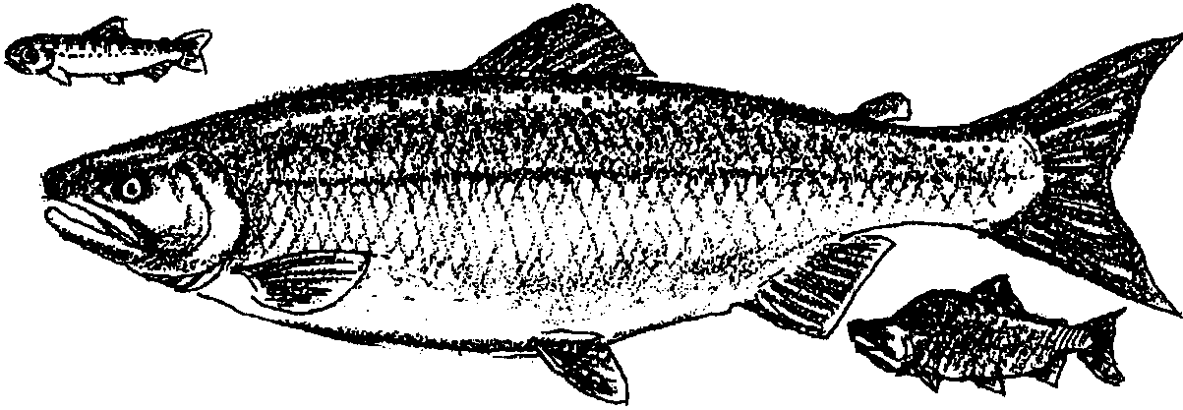
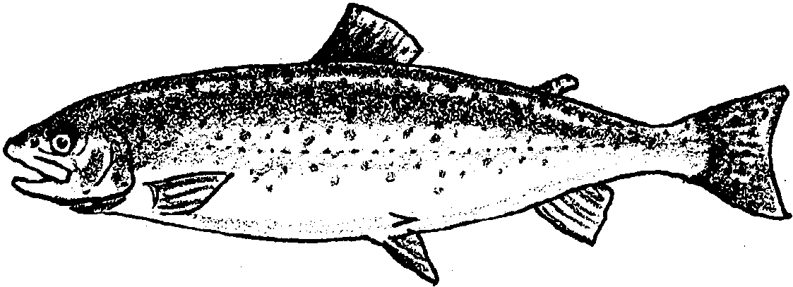
Sockeye Salmon
Oncorhynchus nerka

Sockeyes (or Red Salmon) spawn only in streams which have a major lake somewhere in the watershed. After hatching, the young Sockeye move into the lake, where they will stay for at least l year and often up to 3. They then move out to the ocean where they spend 1 to 4 years before returning again to spawn. They spawn in the fall from August to December near or at the edges of a lake. Some Sockeye populations are landlocked and reproduce without making an ocean migration. These landlocked Sockeye are known as Kokanee Salmon. Sockeye average 6 Ibs. in weight and about 25 inches in length.

Distinguishing characteristics:

In salt water: Almost toothless, with prominent glassy eyes. Backs dark, greenish-blue with fine black specks, bellies silver.

In fresh water: Heads green, shading to red on rest of body. Male has humped back, female with broad. dark stripe along sides.
Steelhead
Oncorhynchus mykiss

Steelhead are the same species as rainbow trout, only Steelhead migrate to salt water while Rainbows remain their entire lives in fresh water. Steelhead spawn January to April in riffles (shallow areas of turbulence) in medium sized streams. The fry remain in the stream for 2-3 years, but once in the ocean they make extensive migrations. Unlike most other Pacific salmon, the adults may survive spawning and reproduce for several years. Steelhead average about 8-10 lbs. and are about 24 inches in length. They are an important game fish for sport fishers, and they are used by Native Americans as a subsistence fish.

Distinguishing characteristics:

In salt water: Bluish back, silvery below, with small black spots on back, sides and fins. Sometimes a red to pinkish side stripe. Inside of mouth white.

In fresh water: Greenish back, less silvery below.
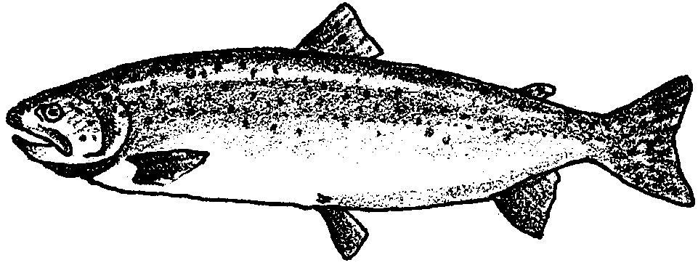
Cutthroat Trout
Oncorhynchus clarki

Cutthroat Trout are primarily a freshwater fish, but along the coast many populations make migrations to salt water. They are the smallest of the Pacific salmon, averaging 2-3 lbs and running 12-15 inches in length, although populations which stay in fresh water may get much bigger. Cutthroats spawn from January to March. Their juveniles stay in the stream for 2-4 years before making a brief ocean migration lasting only a few months. Like the Steelhead, but unlike other Pacific Salmon, Cutthroat adults usually survive spawning. Their importance to humans is primarily as a sports fish.

Distinguishing Characteristics:

In salt water: Bluish above, silvery below, with a red or orange "cutthroat" mark on lower jaw. Body and fins have dark spots.

In fresh water: Greenish back, with light sides and silvery below.
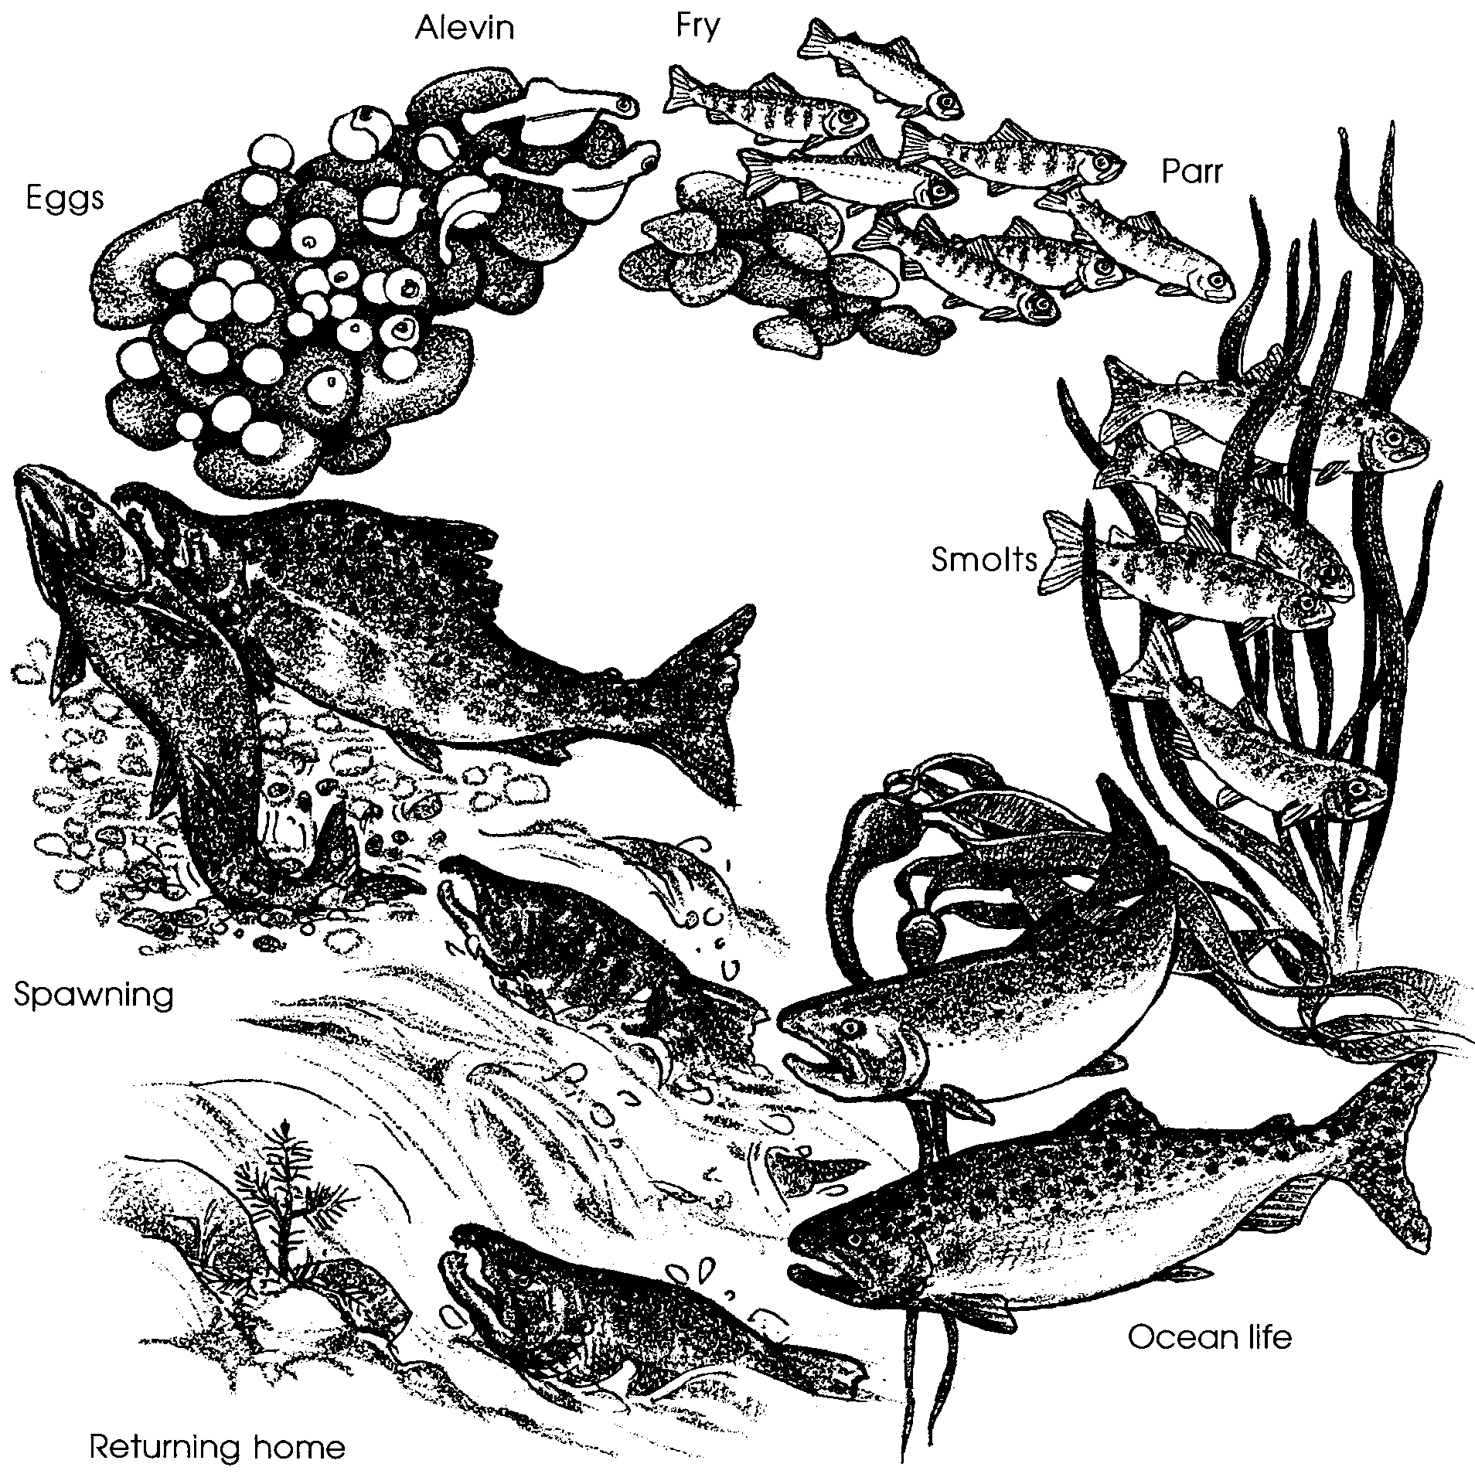

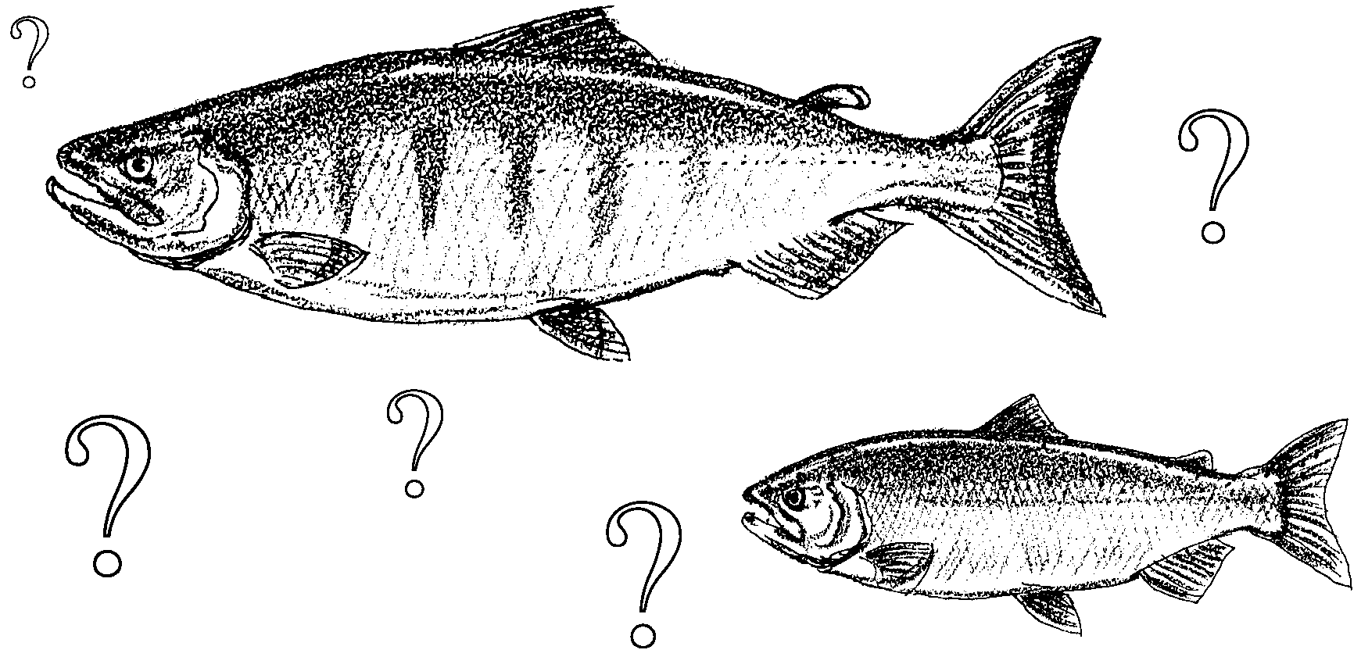
Name That Salmon

SALMON QUESTIONS, Part 1

Common names of your salmon

Scientific name

1. How is your species unique? What are some characteristics which distinguish your salmon from other species?

2. Where does your salmon lay its eggs: in rivers close to the ocean or far upstream? Does it prefer streams near fresh water lakes? Large rivers or small streams?
3. During what months does your salmon typically spawn?

4. How long do the juveniles (young fish) stay in fresh water before they migrate to the sea?

5. What is the average length and weight of the adult salmon?

6. What are the primary ways humans use this species?
SALMON QUESTIONS, Part 2

1. If you caught a 25 lb. salmon in the spring with black gums and a spotted tail, which salmon would it likely be?

2. If you caught an 8 lb. salmon in the fall with a blue back, silver sides, white gums, small black spots on back and fins, and a pinkish stripe on its sides, which salmon might this be?

3. In which two salmon species do the young go to sea almost immediately after emerging from the streambed?

4. Which is the smallest species of salmon?

5. Which is the largest?

6. Which salmon species spawns only in rivers connected to a lake?

7. Which salmon fights its way hundreds of miles up a stream to spawn?

8. Which salmon travels the farthest in the ocean?

9. Which salmon are known for the humped back on the spawning males?

10. In centuries past the Indians living along the Northwest coast ate fresh
or dried salmon year round. Assume that they could only catch salmon entering rivers during the month before the salmon spawned. During which months did the Indians have to eat dried salmon? (Hint: During which months could the Indians not catch any of the seven salmon species?)
