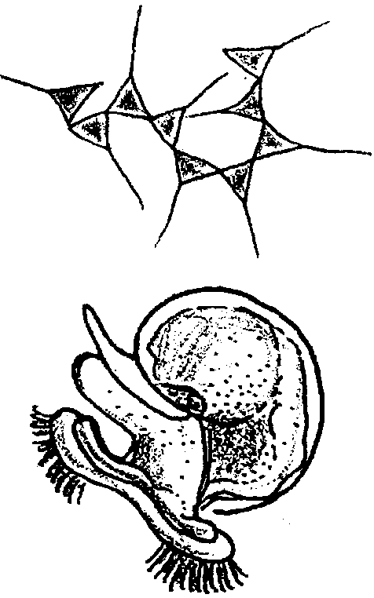
Plankton I, II, III

Key Concepts
1. Estuarine water contains an abundance of phytoplankton and zooplankton including permanent plankton and temporary plankton.
2. There are a variety of methods, each with its own advantages and disadvantages, for quantifying plankton populations in a given body of water.

Background
The world of life available within a drop of sea water can be truly remarkable. The variety and abundance of plankton is especially astounding in estuaries where proximity to land and fresh water run-off adds nutrients to the salt water.
Plankton blooms in estuaries follow seasonal cycles. Copepods and a few other zooplankton dominate winter populations. Many plankton are in spore stages, resting in the mud at the bottom of the estuary. With the arrival of spring, long days and spring run-off fuels high production of phytoplankton. Blooms of zooplankton follow as animals feed on the phytoplankton and grow and reproduce. Many estuarine animals spawn at this time, adding to the variety and density of plankton populations.
Estuaries not affected by human activity typically experience a sharp decline in nutrients in late summer as phytoplankton exhaust nutrient stocks and there is little rainfall to bring new fertilizers to the water. Bacteria proliferate, decomposing the now spent plankton and reducing oxygen levels in the process. Human activity around estuaries are altering this cycle as sewage and garden and farm run-off adds nutrients to the water even in late summer. Some dinoflagellates, including those that cause toxic red tides, thrive in this nutritious, but warm and low oxygen water.
Fall storms cool and mix the water. During this period, nutrients are mixed into the water column from the sediment and oxygen levels rise again. Typically, there are new blooms of plankton, though not as dense as those of spring.
As an aside, the color of marine waters is related to the abundance of phytoplankton. The green of estuarine and coastal waters indicates waters rich in phytoplankton. The blue of “the deep blue sea” is due to the low abundance of phytoplankton.
Materials
For each student of pair of students:
Plankton I -
• compound microscope
• dissecting microscope
• petri dish
• slide and cover slip
• eye dropper
• sample bottle and label
• concave slide
• preservative
• plankton sample
Plankton II -
• preserved plankton sample
• compound microscope
• slides and cover slips
• ruler
Plankton III -
Method A
• petri dish
• centimeter grid or centimeter graph paper
• dissecting microscope (10x)
• plankton sample
Method B
• previously collected plankton samples
• Millipore Filtration Apparatus
• H.A. Grid Filters 47 mm, with a 0.45 micron pore size
• 300 ml of isotonic saline solution
• forceps
• immersion oil
• petri dish
• compound microscope
• 1 ml pipette
Method C
• preserved plankton sample
• graduated cylinder (size depends on size of sample)

Teaching Hints
In “Plankton I, II, III”, your students will use a concentrated plankton sample and magnification to study this world within a world. Since the plankton are fascinating in and of themselves and since they are so strongly connected to the conditions of the estuary and to other marine life, the study of plankton can provide enough material for a life time of scientific work. These exercises present some of the basic techniques of plankton study and introduce the student to a new world. If time is available or for special projects you may elect to do comparative studies outlined in the “Extension” section below.
There are several activities which may be done sequentially. It is also possible to do some of the activities and omit or substitute others. Please read through the procedures and tailor a program that best suits your particular needs. Plankton samples may be taken in any marine or fresh water system. If possible, the sample needed for these activities should be taken in the early morning before school on the day needed. This plan will almost insure students the opportunity to observe living plankton. Place the sample in a large jar or bucket and aerate gently. Be sure to record the distance the net is towed or moved through the water. In addition record and make available to the students the following information:
a. date and general location of sampling
b. time of day
c. wave activity and temperature
d. tide
e. depth of sample
f. diameter of net opening (in meters)
g. mesh size
h. estimated distance towed
Each activity requires a separate period for completion. To preserve the sample for use after the first day, add alcohol and glycerin. The first activity, “Plankton I” involves simple observation of the living plankton sample. “Plankton II” involves identification and measurement of plankton. “Plankton III” involves estimating the density of plankton within the water sampled by the plankton net.
In “Plankton III”, three methods for determining density are presented. Two methods yield information about the numbers of plankton per unit volume of water and one gives information about the volume of plankton per unit volume of water. It is well to remember that each of these techniques has serious shortcomings. For example, the mesh size will allow smaller organisms to escape. The volume calculations are open to criticism because, in reality, not all of the water through which a plankton net is hauled will pass through the net (some back pressure is caused by net resistance and some water therefore does not enter the net)! The absolute numbers probably have a very slight chance of reflecting what is actually occurring in the sea. These figures are useful, however, in terms of establishing relative abundances of plankton. Relative abundances can be very helpful in determining the productivity of different areas of the sea.
“Plankton III”, Method B, uses a Millipore Filtration System. A detailed description of the apparatus may be found in the activity “Analysis of Water for Bacterial Pollution”.
Duplicate the laboratory materials. One set per student is recommended. These exercises are best completed in small groups. Before you begin, review with your class the basics of microscope care and caution them to be careful to wipe up spills on the equipment since salt water is very corrosive. Also review how to estimate the size of objects seen through the microscope. As the exercises are performed, be available to answer questions and be alert to students having problems. Students sometimes tend to have a rather low frustration level for microscopy. This exercise can help overcome these frustrations since the abundance and variety of planktonic organisms is great. Provide an opportunity upon completion of these activities for a discussion of the techniques and to provide the correct answers to the questions presented in the “Analysis and Interpretation” section.
Note that the figures provided for identification are not intended to represent a definitive study of the plankton. They provide for only the most general identification. For more complete identification and for additional drawings and aid consult one or more of the following:
Newell, G. E., and R. C. Newell. 1963. Marine Plankton - A Practical Guide. Hutchinson Education. London. 244 pages.

Smith, Deboyd L. 1977. A Guide to Marine Coastal Plankton and Marine Invertebrate Larvae. Kendall/Hunt Publishing Company; Dubuque, Iowa. 161 pages.

Key Words
current - in this case, a body of water moving in a certain direction within a larger body of water
micron - a unit of measure equal to one thousandth of a millimeter, or one millionth of a meter
nannoplankton - plankton with a size range from 2 to 20 microns (i.e. 500,000 nannoplankton could line up side by side on a meter stick)
phytoplankton - plant plankton; the primary producers of the sea
plankton - the mostly microscopic plants and animals that drift in water; singular = plankter
zooplankton - animal plankton
Extensions
1. The following comparative studies make good special projects or whole class extensions if time permits:
a. individual samples are taken from the same area;
b. samples are taken from different areas,
c. samples are taken at different times during the day or season, or,
d. samples are taken at different depths.

Answer Key
Analysis and Interpretation
Plankton I -
1. The copepod crustaceans are the most abundant and widely distributed zooplankton group.

2. Diatoms are the most numerous phytoplankton group.

3. Plankton are important to other life forms in the sea because plankton are at the base of most of the ocean’s food chains. All forms of life depend either directly or indirectly upon plankton for their food.

4a. Phytoplankton will likely die since light is reduced by 95% and phytoplankton will not have enough light energy to photosynthesize.

b. The herbivorous zooplankton will die from lack of phytoplankton to eat, and the carnivorous zooplankton will die from lack of prey.

c. Phytoplankton will be the first group affected because they rely on the sun’s energy directly for photosynthesis.

d. Since the planktonic organisms are the basis of the food chain, their decline would be expected to cause declines in the other sea life in the vicinity either through death or through individuals leaving the area..

5. The answers depend upon the experimental results. Since the phytoplankton are producers, one would expect them to be more numerous in ocean waters. They may or may not be most numerous in the sample, however, since depth of tow and mesh size are important factors in determining what is captured.

Plankton II -
1. The two major groups of phytoplankton are: diatoms and dinoflagellates. Diatoms differ from dinoflagellates in that diatoms have a precise “skeleton” made of silicon while dinoflagellates have a cellulose cell wall. Dinoflagellates also have flagella that are used for movement.

2. The two major groups of zooplankton are: permanent zooplankton and temporary zooplankton. The permanent zooplankton spend their entire existence as drifters while the temporary zooplankton, largely eggs and larvae of various animal phyla, spend only part of their lives as drifters.

3a. The answer depends upon the experimental results. See number 5 (Plankton I).

b. Answer depends upon the experimental results.

c. Since question asks for the student’s expectations, accept any reasonable answer. Most plankton populations do not remain uniformly abundant throughout the year, but exhibit “blooms”, periods of rapid, abundant growth. As such, the most common organism in today’s sample is unlikely to hold that title throughout the year.

d. Since question asks for the student’s expectations, accept any reasonable answer. Because of variations in environmental conditions in different parts of the ocean, one would not expect to have a single plankton organism be most common everywhere in the oceans.

5. Since phytoplankton are the producers and zooplankton depend either directly or indirectly upon them for food, one would expect to find more phytoplankton in a plankton sample. The fact that zooplankton are often most common may be an indication of imperfections in the capturing process. The plankton net may not be giving us a random sample of the plankton present in the sea.

Determining the Volume of Water Sampled
1a. The number of holes in the net decreases as the net fills with plankton because plankton the diameter of the mesh size will tend to clog the holes.
b. It is more difficult for water to pass through the net as the net begins to become clogged. (The correct answer is underlined.)
c. The clogged net causes back pressure that can prevent some of the water from entering the net. As such we are not safe in assuming that all of the water passes through the net. In practice, a small propeller or similar device is mounted at the mouth of the net and used to record the volume of water that actually enters the net. For our purposes the calculations used to determine density assume that all of the water passes through the net.

Determining the Number of Plankton - Method A
1. There are several possible dangers involved in using one species or group (for example, copepods) as an indicator of the abundance of other organisms. The assumption is made that there is a fixed ratio of copepods to other plankton forms. This may or may not be true. The number of copepods is assumed to remain constant over time. The sample is assumed to be representative of the entire planktonic realm. Copepods are assumed to be uniformly distributed. These and other problems which your students will suggest should be discussed in light of the practical considerations involved in counting and identifying all of the myriad organisms present. Sampling one species as an indicator is a trade off and a calculated risk. This technique is often useful where a rapid determination of the plankton population is necessary.

2. The simplest way to improve the estimate would be to count more squares in the grid.

3. There are many possible sources of error including: recording errors, sampling errors, identification errors, and transcription errors. This is a good opportunity to discuss the procedure and possible problems encountered with same.

4. The answers depend upon the experimental results. It is possible but unlikely that all of the results are the same. The variation can provide material for a discussion of statistical sampling and of the value of sampling more than three grid squares to obtain a more reliable result.

5. Answer depends upon experimental results.

6. The class average will tend to be more accurate than any of the individual estimates since the averaging process minimizes the high and low estimates and is based on a larger sample size.

7. Answers will vary. Most students will recommend choosing an organism with low tolerance to pollution since that organism would quickly respond to changes in water quality. In practice, hardy organisms are selected because they can be raised in a laboratory setting.

Determining the Number of Plankton - Method B
1. The largest plankter that could fit through the pores of the type H. A. Grid filter would have a diameter slightly less than 0.45 microns.

2. Steps 3, 4, and 5 are concerned with assuring that the small sample taken with the pipette is representative of the larger sample.

3. While it is possible that all of the results are the same, it is not likely. Again, there are many sources of error that might account for the differences. For example: incomplete mixing, counting errors, observation errors, recording errors, a non-uniform distribution of the sample on the grid, etc. Use this opportunity to discuss the types of errors that can occur in an investigation like this.

4. Answer depends upon experimental results.

5. The class average will tend to be more accurate than any of the individual estimates since the averaging process minimizes the high and low estimates and is based on a larger sample size.

6. The answer depends upon experimental results. One would expect Method II to yield higher figures since it is an estimate of the total plankton population while Method I only counts copepods. You may find, however, that expectations and reality do not coincide. If the two methods were employed on different samples, the results may vary widely.

7. Answers will vary. Most students will recommend choosing an organism with low tolerance to pollution since that organism would quickly respond to changes in water quality. In practice, hardy organisms are selected because they can be raised in a laboratory setting.

Determining the Volume of Plankton
1. Errors in reading the volumes, calculation errors, recording errors, incomplete settling, etc. are all possible sources of error that might influence the results obtained.

2. Method I (counting over a grid) and Method III (volume) would allow further study of the plankton after the number or volume is determined.

3. Answers will vary. Method III which determines the volume of plankton would be most useful to the captain since it is the easiest and quickest method to determine relative abundances. The relative abundance of plankton in the three areas is what the captain is interested in determining.

4. Answers will vary. The scientist needs to determine not only the relative abundance of plankton but also differences in species composition between the areas. As such Method II would probably be preferred although Method II tends to make identification of the different types difficult. The good doctor would probably need to use a variety of methods to achieve her goals.

5. Plankton numbers and densities are important as an indicator of the health of the oceans and their productivity. Since plankton are the basis for all life in the sea, their health determines the health of the ocean ecosystem.


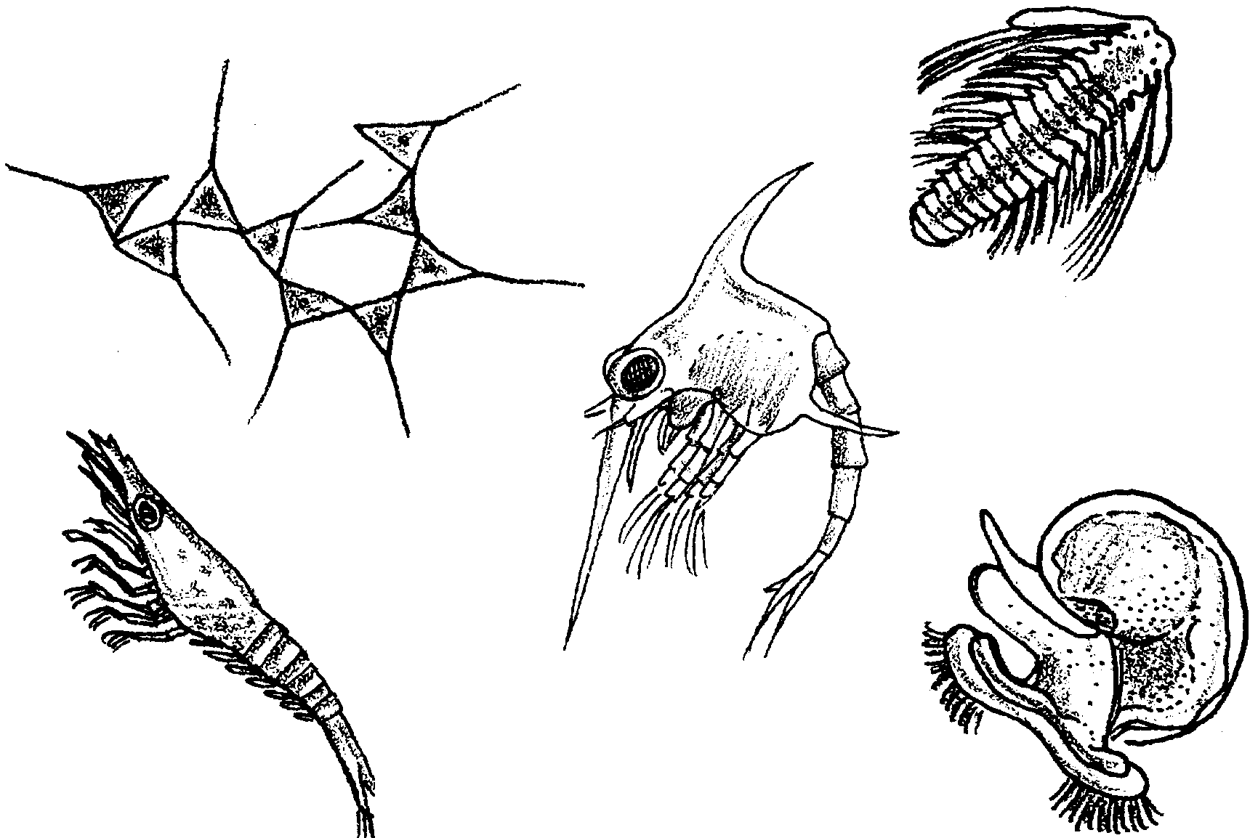
Plankton I, II, III

Plankton I - An Overview
An estuary is a particularly fertile environment for plankton. Cold salt water entering the estuary adds detritus, or decayed organic material, to the bay. At the same time, the creeks and rivers add minerals and their own decaying matter. These abundant nutrients serve as fertilizer for plant plankton. The plankton, in turn, provide a rich food source for animal plankton.
During the spring, when spring storms stir up the nutrients and when long spring days provide ample sunlight for the plants, the animals of the estuary spawn, sending clouds of tiny larvae into the water where they will drift and feed in the rich estuarine soup. The estuary is a nursery, then, supporting not only plant plankton and the animal plankton that spend their entire lives drifting in the water, but also an abundance of temporary plankton. These temporary plankton are drifting larvae that will grow to be much larger inhabitants of the estuary.
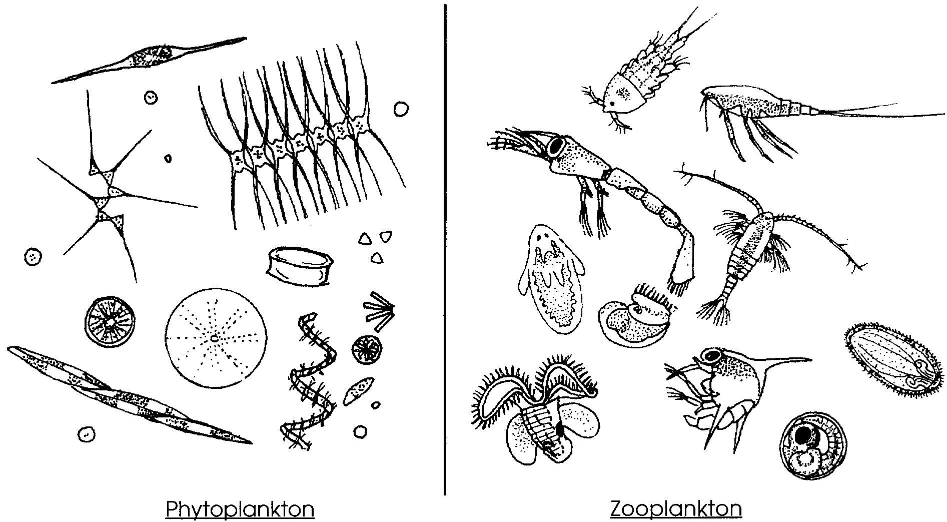
If we add these “part time” drifters to those plants and animals that spend their entire existence as drifting plankton we see a population of organisms so immense that it seems to defy counting. In this exercise you will have an opportunity to examine this vast assemblage of plankton, identify the plankton you see and quantify the density of plankton in the waters you have sampled. While you will be observing microscopic plankton, remember that some of the plankton are as large as two or three feet. Among the members of the animal plankton (zooplankton) eggs, larvae, and juvenile forms of most invertebrates and fishes are common. Copepod crustaceans (related to crabs and shrimp) are the most abundant and widely distributed zooplankton.

Phytoplankton (plants) are more numerous than zooplankton and are best represented by the diatoms that form the vast bulk of the ocean's vegetation.
Plankton form the basis of life in the sea. All forms of life in the marine world depend either directly or indirectly upon them for food. Without plankton the seas would be barren. In this activity you will have a chance to analyze a sample of these dynamic little creatures.

Materials
• compound microscope
• dissecting microscope
• petri dish
• slide and cover slip
• eye dropper
• sample bottle and label
• concave slides
• preservative (10% ethyl alcohol)
• plankton sample
Procedure:
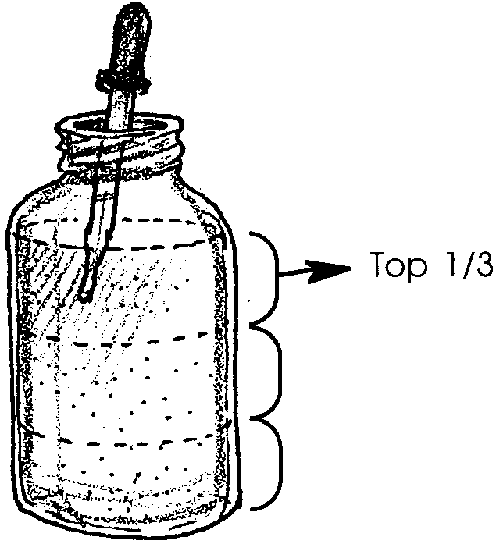
1. Record the conditions under which the plankton sample was made on the data sheet provided.

2. Use the eye dropper to draw up a few drops of the concentrated plankton. Take the sample from the top one third of the bottle of concentrated plankton.

3. Place one drop in each of four or five locations on your petri dish.

4. Observe each drop with a dissecting microscope. Since the plankton can move up and down in the drop, you will need to focus up and down with your microscope to see the plankton at different levels.

5. Many organisms are too small to be seen with the dissecting scope. Prepare wet mounts of the sample and observe under a compound microscope with low and high power objectives. Do not discard any part of the sample. Empty wet mounts back into petri dish. Rinse with medicine dropper of water.

6. Do not record any observations today. Look for:
a. most abundant organisms
b. variations in shape, color and swimming abilities
c. types of appendages
d. chlorophyll-containing organisms
e. eggs
f. larval and juvenile forms of crustaceans and fish (see “Pictorial Guide to the Plankton”, which follows).

7. Preserve sample in 10% ethyl alcohol before leaving. Use 10 ml of alcohol per 100 ml of plankton sample. Label sample bottle with your name and period.
Recall that the two major divisions of plankton are phytoplankton (plants) and zooplankton (animals). Within these two groups exists a number of subgroups.

I. Phytoplankton - able to produce their own food through photosynthesis.

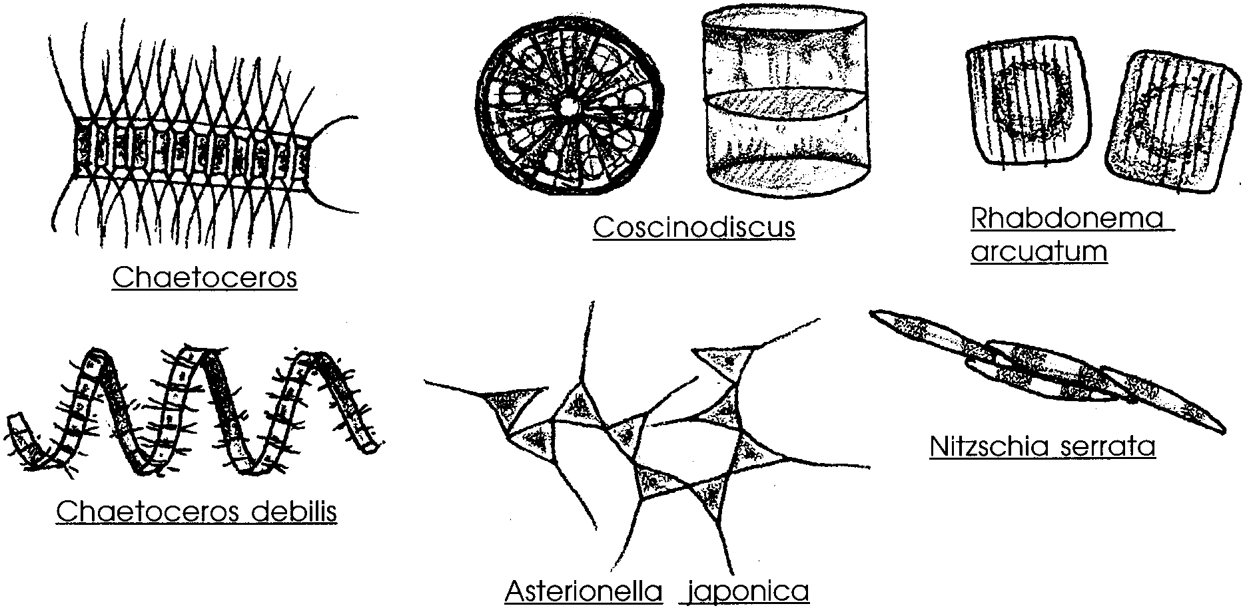
A. Diatoms - often called the golden-brown algae have two hard outer shells shaped like pillbox halves. The shells, called frustules, are made of silicon and have a precise geometric design.

B. Dinoflagellates - have a cellulose cell wall and, in most species, two whip-like flagella used for mobility. Most dinoflagellates have a body plan resembling two cones joined at their bases, with a groove in between. Because of their ability to move and other characteristics some zoologists think these organisms should be classed as zooplankton.
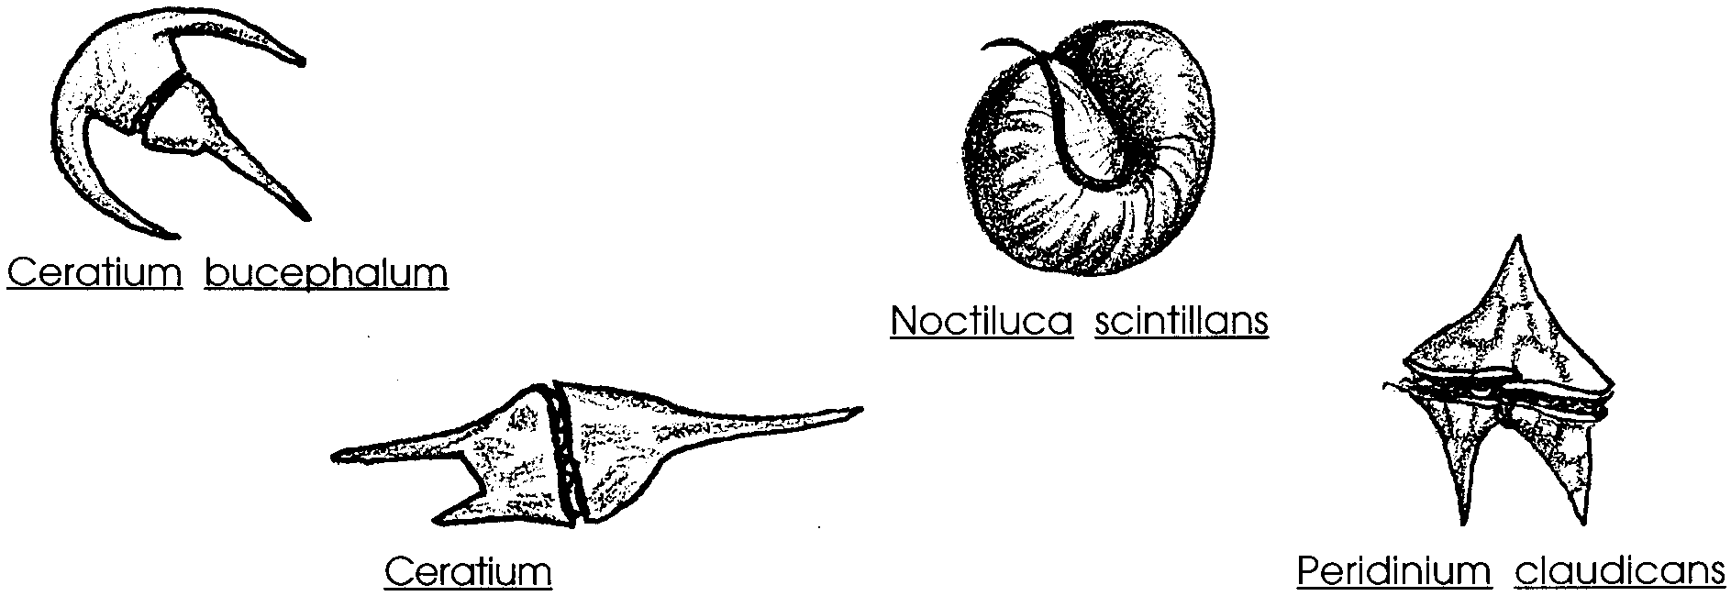
II. Zooplankton - Obtain their food by eating phytoplankton or other zooplankton. As animals, they must have senses to detect, means to pursue, catch, ingest, and digest food. All of the major groups of animals are found within the zooplankton.

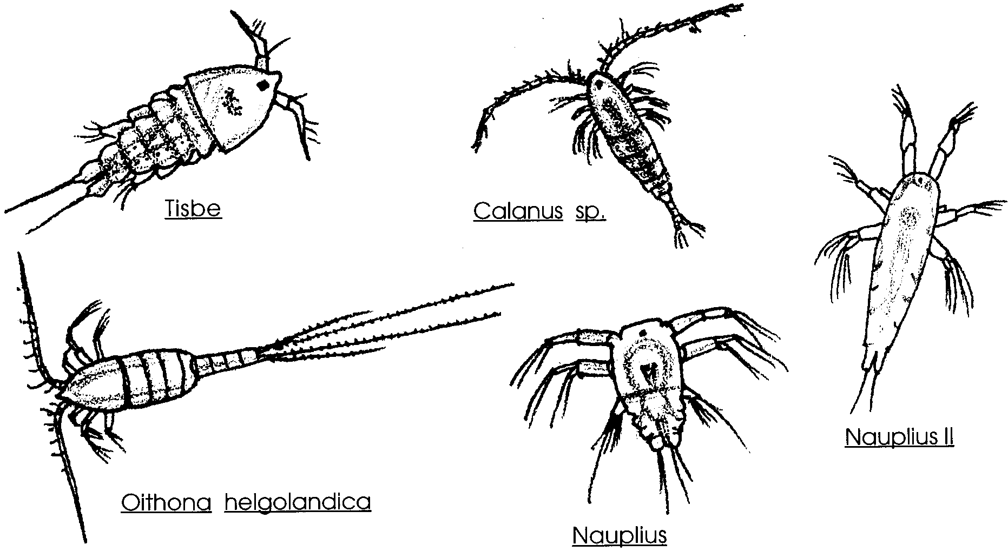
A. Permanent zooplankton - spend their entire existence as drifters. Most of the permanent zooplankton, including the numerous copepods, are crustaceans (belonging to the same group as the crabs and shrimp).

B. Temporary Zooplankton - spend part of their life cycle as drifters. The most common temporary zooplankton are the larvae (in some ways equivalent to “baby”) forms of the following groups:

(Note: each larval form has one or more specific, descriptive terms which are in boldface type).

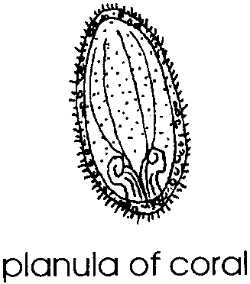
1. Cnidaria or Coelenterate larva (corals, jellyfish, sea anemone) - planula larva. Coelenterates capture prey with poisoned darts, called cnidoblasts, attached to thin cords.
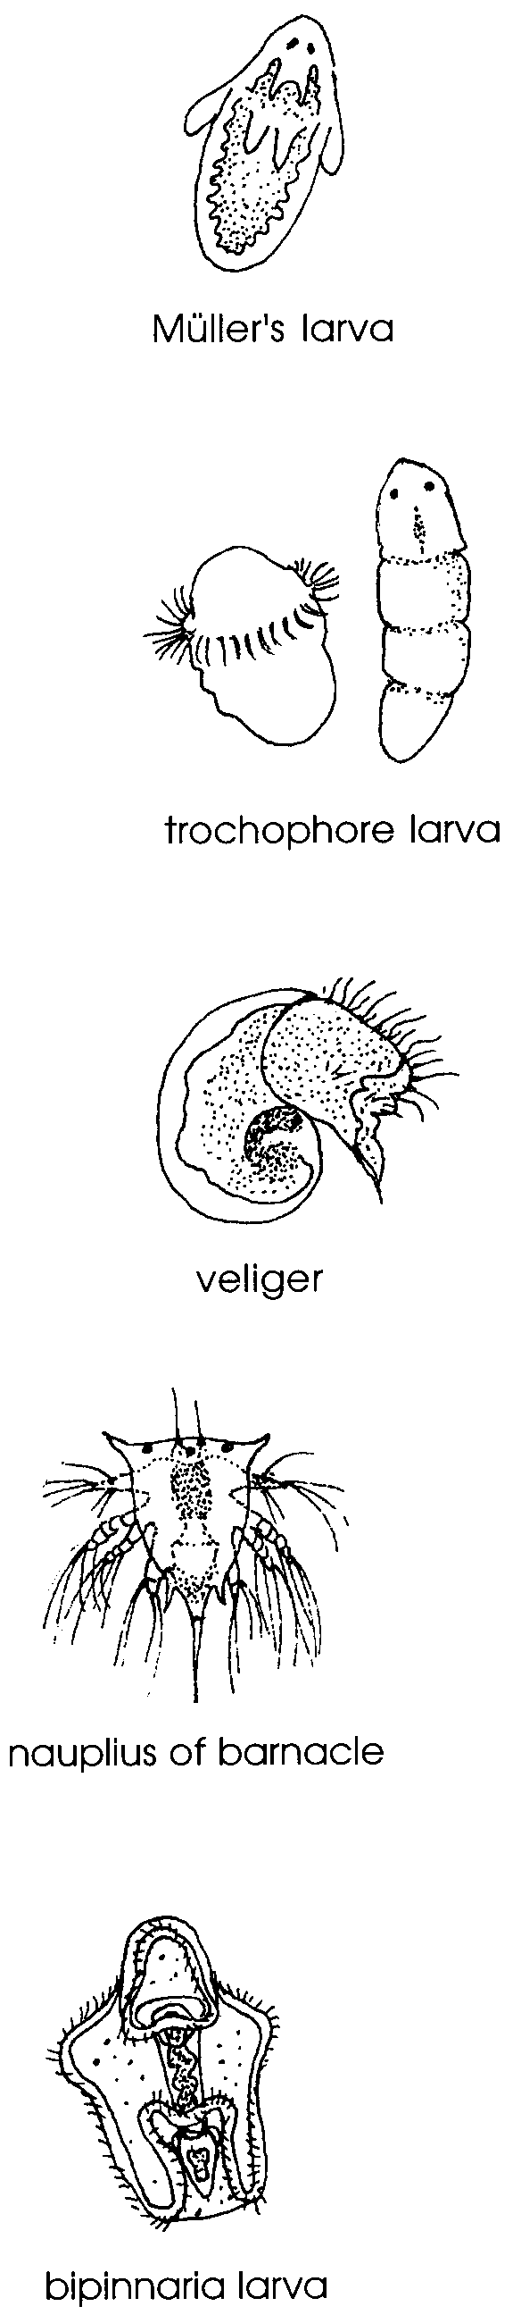
2. Platyhelminth larva (flatworms) - non-segmented worms with a planktonic larva - Müller's larva.

3. Annelid larva (segmented worms) - young of many of the segmented worms which spend their adult lives in bottom sands and in rocky outcrops - trochophore larva.

4. Molluscan larva (oysters, squid, octopi, mussels, snails, clams, chiton) - veliger larva.

5. Crustacean larva (barnacles, crabs, shrimp) - nauplius.

6. Echinoderm larva (sea star, sea cucumber, sea urchin) - bipinnaria larva.
Analysis and Interpretation
Plankton I -

1. Which zooplankton group have scientists found to be most numerous?

2. Which phytoplankton group have scientists found to be most numerous?

3. How are plankton important to other life forms in estuaries?

4. A transfer pipe at “Super Slick Processing Company” ruptures sending 10,000 gallons of “Super Slickeze II” into the bay. “Super Slickeze II” floats on the surface and reduces the light reaching the water by 95%.

a. What is likely to happen to phytoplankton under the spill? Why?

b. What is likely to happen to zooplankton under the spill? Why?

c. Which group, phytoplankton or zooplankton, will be affected first? Why?

d. How might the change in planktonic organisms affect other sea life in the vicinity of the spill?

5. From your observations of your plankton sample, which kind of plankton (zooplankton or phytoplankton) seemed to be most numerous?

Plankton II - Identification
The descriptions and the figures from Plankton I will help you identify the organisms in your plankton sample.

Materials
• preserved plankton sample from day one, or fresh sample
• compound microscope
• slides and cover slips
• ruler

Procedure:
1. Select the most common organism from your preserved sample. Prepare a wet mount and view with low power (or high power).

2. Record the following information on your data sheet:
a. a detailed penciled drawing of the specimen
b. measured actual size, in microns
c. measured drawing size, in microns
d. magnification of drawing (equals size of drawing
actual size of animal)
e. identification

3. Repeat this procedure with as many different specimens as time permits. Do at least:
a. two different kinds of phytoplankton
b. four different kinds of zooplankton
c. include at least one diatom, one dinoflagellate, and one permanent zooplankton form.
Record all observations on your data sheet.

4. Do not discard any portion of your sample. Empty wet mounts back into sample bottle. Rinse with dropper of water.
Analysis and Interpretation
Plankton II -
1. What are the two major groups of phytoplankton? How do they differ?

2. What are the two major groups of zooplankton? How do they differ?

3 a. Which organism was most common in your sample?

b. Is the most common organism a phytoplankton or zooplankton?

c. Would you expect this organism to be the most common at all times of the year at the location sampled? Explain.

d. Would you expect this organism to be the most common everywhere in the oceans? Explain.

5. Which would you expect to be most common in a plankton sample, phytoplankton forms or zooplankton forms? Explain.
PLANKTON LABORATORY DATA SHEET - Plankton II

Record the following conditions pertaining to the sample under study.

1. Date 4. Tide 7. Diam. net opening meters

2. Location 5. Depth 8. Distance net towed meters

3. Time of day 6. Mesh size

Phytoplankton

Organism# 1 Diatom 2 Dinoflagellate

Drawing

Actual size

Drawing size

Magnification

Identification

Outstanding features?

Coloration?

Common and/or
Scientific name

Zooplankton
Permanent Zooplankton
Organism# 3

Drawing

Actual size

Drawing size

Magnification

Identification

Outstanding features?

Coloration?

Common and/or
Scientific name
Plankton III - Density
Populations of individual plankton species in saltwater vary considerably during the course of a year. As the waters warm in the spring and summer, many larval forms of invertebrates and fish appear in great numbers. Biologists study these changes to obtain information about the productivity of ocean waters. Productivity is related to the density of plankton (number of plankton in a given volume of water) and gives biologists an idea of how much life an area will support. In this activity you will determine the density of plankton in terms of the number of plankton or the volume of plankton per cubic meter of sea water.

Determining the Volume of Water Sampled

To compute the volume of water sampled as you towed your net through the water, you will need to know the total distance towed and the diameter of the opening of the net. Use the following diagram, formula, and example to help you.

Volume of water sampled = π (radius)² of net x (total distance towed)
in cubic meters (m³) opening in meters in meters

Total Distance of Net Tow 10.00 m

Diameter of Net in Meters 0.24 m

Radius of Net in Meters = diameter 0.12 m
2

Volume of water
Sampled in m³ = π r² (tow distance in meters)

= (22) (.12m)2 x (10m)
7

= (22) (.0144) x (10m)
7

= 0.4526 m³
1. Now calculate the volume you sampled:

Total Distance of Net Tow _____ m

Diameter of Net in Meters _____ m

Radius of Net in Meters = diameter _____ m
2

2. Record the volume in B on your data sheet.

Analysis and Interpretation
Plankton III - Determining the Volume of Water Sampled
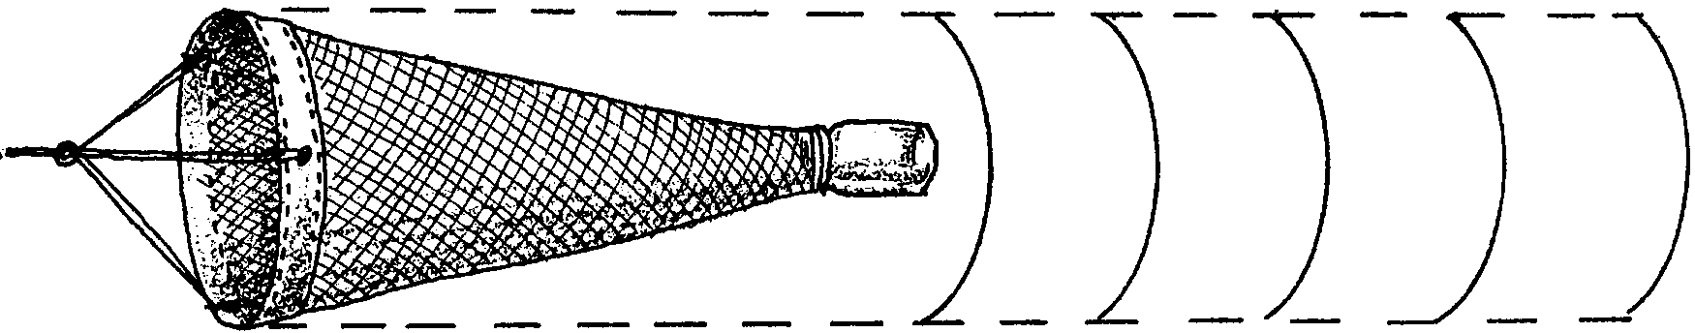
1. The calculations that you performed gave you the volume of a cylinder, the diameter of your net and the length of the tow. This assumes that all of the water passes through the net.

a. What happens to the number of holes in the net as the net begins to fill with plankton?

b. It is easier/more difficult for water to pass through the net as the net begins to become clogged. (Circle the correct choice.)

c. In view of your answers to (a) and (b) above, how safe are we in assuming that all of the water passes through the net? Explain.
Determining the Number of Plankton - Method A
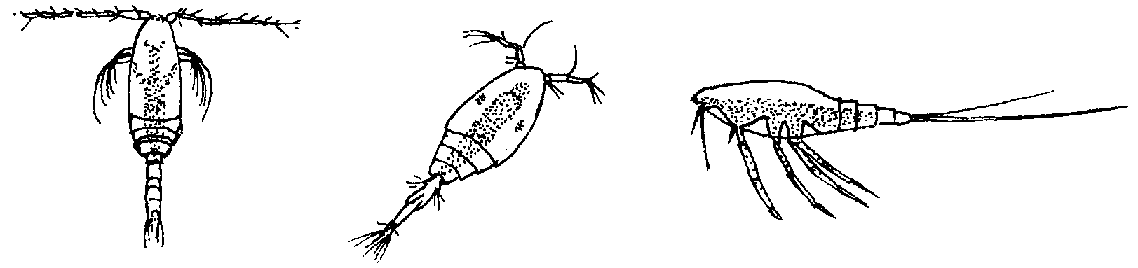
Because of the difficulty encountered in attempts to count all of the different sizes and kinds of plankton species in a sample, we will estimate the abundance of a single type of plankton, the copepod. The copepod can serve as an indicator species because copepods are the most abundant and obvious representatives of the surface plankton. Copepods have the following general shapes:

Materials
• petri dish
• centimeter grid or centimeter graph paper
• dissecting microscope (10x)
• plankton sample

Procedure:
1. Pour your sample (1 ml or 5 ml) into a petri dish.

2. Determine the area of the dish by using the following formula:

A = π r²

Where: A = number of sq. centimeters covered by dish

π = 22
7

r = radius of dish in centimeters (radius = diameter in cm)²

3. Place petri dish over a centimeter grid or graph paper with centimeter squares clearly marked. Distribute sample evenly over bottom of dish.
4. To estimate the total number of copepod organisms in the dish:

a. count the number of copepods in any one square, and

b. multiply by the total number of squares (area). You can use the following formula:

Estimate of total = number in x total number of
number of copepods one square squares (area)

Record this number on your data sheet.


5. In order to determine a more accurate count, select the three squares indicated in the diagram.

The three pre-selected squares will give an “unbiased” count. To find the average number per square, divide the total number of copepods in the three squares by three.
To obtain an estimate of the total number of organisms in your dish, multiply your average by the total number of squares (area) in the dish.

Example: Sixty six (66) copepod organisms were counted in the 3 grids.

The area of the dish covered 63.5 squares or 63.5 cm²

Using these results, the

Total number of = no. counted in 3 grids x no. of squares (area)
copepod organisms 3

= 66 x 63.5 cm²
3

= 1397 copepod organisms on the sample

Calculate the number of copepods in your sample. You can use the following formula:
Total number of = no. counted in 3 grids x no. of squares (area)
copepod organisms 3

= 66 x 63.5 cm²
3

= 1397 copepod organisms on the sample

Record the number of copepods in your sample in C. 2. on your data sheet.

6. Now let’s compute the total number of copepod organisms in the original concentrated sample. Use the following formula:
Q = T x V
v
where. . . .

Q = total copepods passing through plankton net.

T = total number of copepods in your sample.

V = Total volume of original concentrated sample.

v = volume of your sample

Example: A ten (10 ml) of sample was strained from 30 cubic meters (m³) of sea water. You received 1 ml of the sample, and from sampling the three pre-selected squares found 1397 copepod organisms/ml.

Using this information, the total copepods passing through plankton net is:

Q = T x V
v

Q = 1397 copepods x 10 ml. conc. sample
1 ml. (your sample vol.)

Q = 13,970 copepods passing through plankton net

7. Compute the total number of copepod organisms passing through your plankton net. You can use the following formula:

Total copepod organisms in = Total # of copepods x Total volume of original
original concentrated sample in your sample concentrated sample
volume of your sample

Q = T x V
v

8. Record the total number of copepods in original concentrated sample in C. 3. on your data sheet.

9. Now, compute the total number of copepod organisms per cubic meter.
(Hint: What was the volume of water which flowed through your plankton net?)

10. Record the total number of copepod organisms per cubic meter in C. 4.

Analysis and Interpretation
Plankton III - Determining the Number of Plankton - Method A
1. What is one possible danger of using copepods as an indicator species in determining plankton abundance?

2. How could you improve your estimate of the total number of copepods using the same technique?

3. What are two possible sources of error inherent in this procedure?

4. Compare your results with those of others in your class. For the same sample, what is the range of estimates? (The range is the difference between the highest estimate and the lowest estimate).
5. Calculate a class average for your estimates of the total number of copepod organisms per cubic meter.

6. Is the class average more or less likely to be accurate than your individual estimate? Explain.

7. Recall that an indicator species is used by scientists as a means of assessing the health of a body of water.

a. In selecting an indicator species for use in studying the effects of pollution on a body of water, would you recommend choosing an organism with high or low tolerance to pollution?

b. Provide one reason which supports the choice you made.
Determining the Numbers of Plankton - Method B
Method B is a more refined way to determine plankton numbers. As with Method A the numbers of plankton in a small sample are determined. The small sample is assumed to be representative of the plankton collected in the net. The equipment used in this experiment must be handled with care.

Materials
• Previously collected plankton samples
• Millipore Filtration Apparatus
• H. A. Grid Filters 47 mm, with a 0.45 micron pore size
• 300 ml of isotonic saline solution
• Forceps
• Immersion oil
• Petri dish
• Monocular microscope or dissecting microscope
• 1 ml pipette

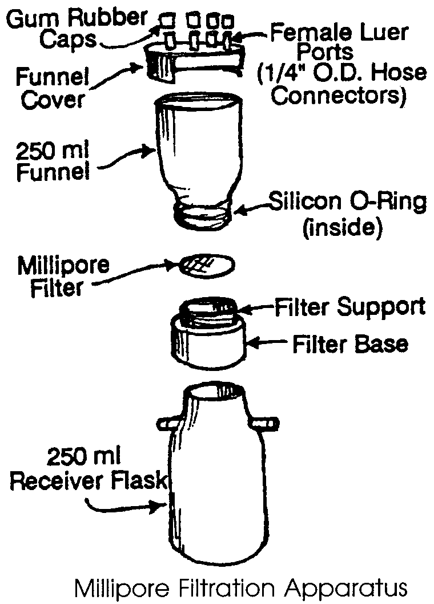
Procedure:
1. Prepare a Millipore Filtration Apparatus using a Type H. A. Grid filter with a 0.45 micron pore size.

2. Add approximately 100 ml of isotonic salt solution to the top portion of the filtration apparatus.

3. Shake the plankton sample well to insure that the plankton are uniformly distributed and quickly pipette out 1.0 ml.

4. Add the 1.0 ml sample into the filtration apparatus. Rinse the pipette with isotonic salt solution to make certain that all the plankton are transferred into the apparatus.

5. Swirl the salt solution and sample carefully to insure uniform mixing.

6. Using the syringe, suction the water into the lower part of the filtration apparatus.

7. Rinse down the sides of the upper half of the filtration apparatus with approximately 50 ml of salt solution to insure that no plankton adhere to the sides.
8. Again using the syringe, suction the solution through the filter. This will leave the plankton evenly distributed on the filter surface.

9. Open the filtration apparatus and carefully remove the filter using the forceps. Place the filter on a towel or blotting paper, plankton side up, to dry. This should take approximately 5 minutes.

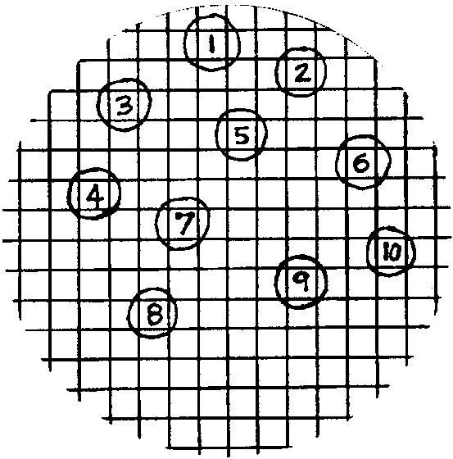
10. When dry, take a ballpoint pen and gently circle the samples as shown below. Be careful to make your circles large enough so they do not come near any line on the square you will count.

11. Float your filter on a thin layer of immersion oil in a clean petri dish. This will render it transparent for microscope use.

12. Transfer the filter to a glass slide for counting the particles in each sample square.

13. Use low power of your microscope. If a part of an organism touches the top or left-hand line of the square, count it; if it touches the bottom or right hand line of the square, do NOT count it. Why is this necessary? Tabulate the number of plankton in each square. If you have too many to count or can't find enough to count, see “Note” below.

Record your results in D. 1. on your data sheet.

NOTE: At this point, you may observe that the plankton are so densely packed that you cannot obtain an accurate count. If this is the case, it will be necessary to go back to step 4. Decide how much greater a dilution will be necessary to provide you with a sufficiently diluted sample. If you wish to dilute by 10% more, take a well mixed 10 ml portion of the previously diluted plankton sample you prepared, place it in 100 ml graduated cylinder, and add saline to the 100 ml mark.
If you find that there are too few organisms on the filter, go back to step 5 and proceed. Instead of taking a 1.0 ml sample from the plankton sample, take the necessary amount which will give you a reasonable number of organisms to count, i.e., if you wished to increase the number 10 fold, take 10 ml from the plankton sample and add this to the filtration apparatus.
14. The number of plankton counted is then used to calculate the count which would have been found had the entire surface of the filter been scanned. This formula is:

the number of plankton = 145 total squares x Number of Plankton
on the filter 10 grid squares counted

Example: Twenty two (22) plankton were counted on the ten grid squares.

the number of plankton = 145 total squares x Number of Plankton
on the filter 10 grid squares counted

the number of plankton = 145 total squares x 22 plankton
on the filter 10 grid squares counted

the number of plankton = 319
on the filter

Determine the number of plankton on your filter.

the number of plankton = 145 x Number of Plankton
on the filter 10 grid squares counted

15. Record this figure in D.2. on your data sheet as the total number of plankton on the filter.

16. To estimate the number of plankton in the original sample we first have to determine the dilution factor. The dilution factor is determined by dividing the original sample volume by the size of the sub-sample you pipetted (either 1 ml or 5 ml).

Example: One (1) ml was pipetted from a sample with a volume of 100 ml, the dilution factor would be:

Dilution factor = sample volume
pipette volume

Dilution factor = 100 ml
1 ml

Dilution factor = 100
For your sample, calculate the dilution factor:

Dilution factor = sample volume
pipette volume

Record the dilution factor in D. 3. on your data sheet.

17. Knowing the number of plankton on the filter and the dilution factor, it is easy to estimate the number of plankton in the original concentrated sample. The following formula shows you how:

Number of plankton = Number on x Dilution
in the concentrated sample the filter Factor

Example: The dilution factor was 100 for the example above for which 319 plankton were counted.
Number of plankton = Number on x Dilution
in the concentrated sample the filter Factor

Number of plankton = 319 plankton x 100
in the concentrated sample

Number of plankton = 31,900 Plankton
in the concentrated sample

For your sample, calculate the number of plankton in the concentrated sample.

Number of plankton = Number on x Dilution
in the concentrated sample the filter Factor

Record the number of plankton in the concentrated sample in D. 4. on your data sheet.

18. Finally, let’s calculate the number of plankton in the original water sample. To calculate the Number of Plankton per m3, also called the density, simply divide the number of plankton in the sample by the volume of water sampled originally.

You can use the following formula:

Density = Number of Organisms in Sample = Number of organisms
Volume of Sample in m³ m³

Example: The volume of water sampled is .4526 m3. We found that the number of plankton in the sample is 31,900.
Density = Number of Organisms in Sample
Volume of Sample in m³

Density = 31,900
0.4526m³

Density = 70,481 Plankton/m³

For your sample, calculate the density of Plankton.
Density = Number of Organisms in Sample
Volume of Sample in m³

Density = = (your number)
(your volume)

Density = plankton/m³

Record your density in D. 5. on your data sheet.

Analysis and Interpretation

Plankton III - Determining the Number of Plankton - Method B
1. What is the largest plankter that could fit through the pores of the Type H.A. Grid filter?
2. Which steps of the procedure are concerned with making sure the small sample taken with the pipette is representative of the larger sample?

3. Compare your results with those of others in your class. Are all of the results the same? If not, what are two possible sources of error that might account for the differences?

4. Calculate a class average for your estimates of the total number of organisms per cubic meter.

5. Is the class average more or less likely to be accurate than your individual estimate? Explain.

6. If you also did the procedure out lined in Method A, how do your results from Method A compare with your results using Method B. How can you explain any differences between the estimates?

7. Recall that an indicator species is used by scientists as a means of assessing the health of a body of water.

a. In selecting an indicator species for use in studying the effects of pollution on a body of water, would you recommend choosing an organism or organism with high or low tolerance to pollution?

b. Provide one reason which supports the choice you made.
Plankton III - Determining the Volume of Plankton - Method C
The volume of plankton can be determined by settling. Since live plankton spend their lives trying to keep from settling, this determination is made with a preserved plankton sample. The preserved plankton sample is allowed to settle in a graduated cylinder. The results obtained using this method have some inherent inaccuracies. Nevertheless, the technique gives some idea of plankton abundance and is useful for comparing plankton densities in various areas. It is also simple and fast.

Materials
• plankton sample (preserved in 10% ethyl alcohol)
• graduated cylinder (size depends upon size of sample)

Procedure:
1. Pour the sample into a graduated cylinder and let the sample settle for at least one hour. You can allow the sample to settle until the next class period if the schedule allow.

2. Read the volume of the plankton settled (in milliliters).
______________ ml. of plankton.

3. Record the volume of plankton settled in E. 1. on our data sheet.

4. Plankton abundance may be calculated by dividing the volume of plankton in millimeters by the volume of water sampled in cubic meters:

Plankton abundance = volume of plankton (ml)
volume of water sampled (m³)

Calculate and record the plankton abundance for your sample:

Plankton abundance = volume of plankton (ml)
volume of water sampled (m³)

Plankton abundance = (ml)
(m³)

Plankton abundance = ml/m³

5. Record the plankton abundance for your sample in E. 2. on your data sheet.
Analysis and Interpretation
Plankton III - Determining the Volume of Plankton
1. As with any experiment, there are many possible sources of error in this activity. What are two sources of error that might influence the results obtained?

2. Which of the three procedures outlined in Plankton III would allow further study of the plankton after the number or volume is determined?

3. To improve his fish take, a local fish boat captain is interested in determining the plankton abundance in three different areas where he might choose to fish. He is most interested in finding the area with the greatest abundance of plankton.

a. Of the three procedures outlined in Plankton III, which method would you recommend that he use?

b. Why?

4. A local scientist is studying the effect of the discharge of hot water on the numbers of plankton in a local bay. She wants to sample plankton at various distances from the outflow.

a. Which method of the three procedures outlined in Plankton III would you recommend that she use?

b. Why?

5. What is the major reason people are interested in determining plankton numbers and densities in saltwater?
Plankton Laboratory Data Sheet - Plankton III Page 1
A. Record the following conditions pertaining to the sample under study:

1. Date 4. Tide 7. Mesh size

2. Location 5. Depth 8. Diam. net opening meters

3. Time of day 6. Tow time 9. Distance net towed meters

10. Dillution of your sample 11. Volume of your sample ml

B. Determining the Volume of Water Sampled

volume of water sampled (m³) = π radius of net (m) x distance towed

volume = π ( m) x ( m)

volume of water sampled = m³

C. Determining the Number of Plankton - Method I

1. Total number of copepods in dish = (number in one square) x (number of squares in dish)

Total number of copepods in dish = ( ) x ( )

Total number of copepods in dish =

2. Total number of copepods in dish = number counted in 3 grids x number of squares (area)
3

Total number of copepods in dish = ( ) x ( )
( )

Total number of copepods in dish =

3. Total number of copepods in (Total number of (volume of your original
original concentrated sample = copepods in dish) x concentrated sample)
(volume of your sample)

Total number of copepods in
original concentrated sample = ( ) x ( ml )
( ml )
Total number of copepods in
original concentrated sample = ( )

4. Number of copepods per cubic meter = (total number of copepods in original sample)
(volume of water sampled (from 3 above))
Number of copepods per cubic meter = ( )
( m³ )
Number of copepods per cubic meter =
Plankton Laboratory Data Sheet - Plankton III Page 2
D. Determing the Number of Plankton - Method III

1. Number of plankton in each square 1 6
2 7
3 8
4 9
5 10

2. Total number of number of plankton 145 grid squares in dish
plankton on filter = counted (sum of 1-10) x 10 grid squares counted

Total number of 145
plankton on filter = ( ) x 10

Total number of
plankton on filter =

3. Dilution factor = (sample volume)
(pipette volume)

Dilution factor = ( ml)
( ml)
Dilution factor =

4. Number of plankton in (total number of
concentrated sample = plankton on filter) x (dilution factor)

Number of plankton in
concentrated sample = ( ) x ( )

Number of plankton in
concentrated sample =

5. Number of plankton per m³ = (number of plankton in the concentrated sample)
(volume of water sampled (from B above))

Number of plankton per m³ = ( )
( m³)

Number of plankton per m³ = = density

E. Determining the Volume of Plankton
1. Volume of plankton settled = ml of plankton

2. Plankton abundance = (volume of plankton)
(volume of water sampled)

Plankton abundance = ( ml)
( m³)

Plankton abundance = ml/m³

