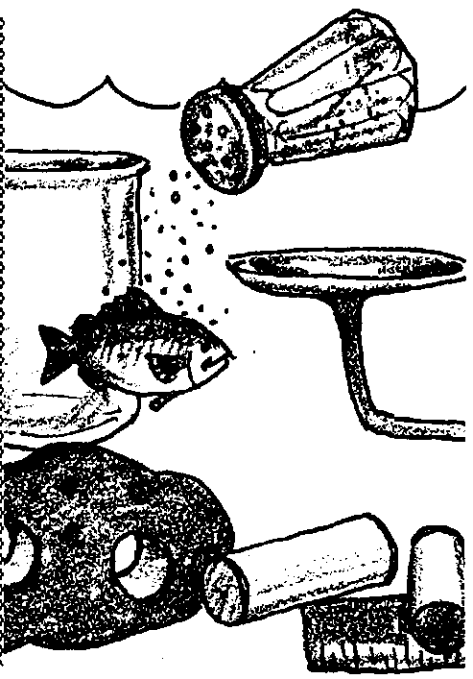
Dealing With Salt
Edited by Jerry Mohar, Lyle High School, Lyle, Washington

Key Concepts
1. Some marine organisms are better than others at surviving salinity changes in the estuary.
2. Marine organisms which can survive salinity changes do so by regulating osmosis in their tissues.

Background
Estuarine organisms are unique in their ability to survive the stresses of a mixed marine and fresh water environment. The marine plants and animals are able to regulate their body fluids to maintain the osmotic balance they need in the ever-changing waters of the estuary. Osmoregulation is the process by which animals and plants deal with the movement of water into and out of their cells.
Molecules tend to move from areas of high concentration to areas of low concentration until an even distribution is reached. This movement is called diffusion and is essentially a passive process. Diffusion occurs because of the random movement of molecules. In living organisms, a special type of diffusion called osmosis takes place. The membranes of animal and plant cells readily allow water to pass through, but frequently hold back or retard the passage of larger molecules including salts. Under normal conditions, the concentration of salts on both sides of these membranes is the same. Water molecules pass randomly in and out of the cells, and, on the whole, as many molecules pass in as pass out.
If the concentration of salts inside a cell is greater or less than the concentration on the outside, the cell may be in trouble. The side of the membrane that has less salt also has proportionally more water molecules. In other words, this side of the membrane has a higher concentration of water. Since the water can readily pass through the membrane, it will gradually diffuse, as described above, from the more concentrated side to the less concentrated side. The salts, however, being unable to readily pass through the membrane, stay where they are, causing the water molecules to continue to diffuse across the membrane.
If the liquid inside of an organism’s cells is saltier than the water around them (for instance, if an animal accustomed to living in salt water is suddenly immersed in fresh water), water will pass into the cells until the cells swell and burst. If the liquid inside of the cell is less salty than the outside (as when a fresh water animal is placed in salt water), water will flow out of the cells until the cells dehydrate and shrivel up.
Many marine invertebrates have little trouble maintaining salt-and-water balance as long as they remain in normal salt water. Lacking any well-developed excretory organs, they exchange waste products, water, and salt with the surrounding water directly across their surface membranes. Their body fluids are essentially isoosmotic (having the same osmotic concentration) with the salt water. This means they neither take in nor lose much excess water.
If these animals move into the brackish water of an estuary, however, they will immediately begin to gain water, until their body fluids have the same salinity as the surrounding water. They normally will not survive long under such conditions.
Some animals are able to maintain their salt-and-water balance even if the surrounding water has a higher or lower concentration of salts. These organisms are capable of osmoregulation. By actively moving salts or water across their surface, gills, or excretory organ membranes against the osmotic gradient, they can keep their body fluids at a constant concentration. Osmoregulation requires an expenditure of energy, and the amount of energy usually increases with the osmotic gradient.
Organisms with little or no osmoregulatory abilities remain isotonic with the surrounding solutions. In other words, if the salinity outside increases, the salinity within the animal or plant also increases. Organisms with high osmoregulatory abilities maintain their body fluids at or near a constant level. The internal salinity remains constant in spite of changes to the external environment.
Additional background information is found in the activity “The Effects of Salinity on Living Tissue”.

Materials
For each pair of students:
- living shore crab or sea star
- paper towels
- balance or access to a balance
- “Dealing with Salt” student pages

For each class:
- 3 aquariums or holding tanks, each with saltwater of a different salinity (40 ‰, 30 ‰, and 20 ‰)
- a few jars of fingernail polish for marking crabs, if necessary
- “Dealing with Salt” class data sheet

Teaching Hints
In “Dealing With Salt”, students immerse sea stars and shore crabs in waters of differing salinities and measure any weight changes. In general, sea stars are poor osmoregulators and shore crabs are good osmoregulators. However, since there are many potential sources of experimental error and the animals are complex enough to behave differently from one individual to the next, it is important for the students to have a chance to analyze data from all the trials in the class so that they will be able to see trends in the animals’ abilities (or lack of abilities) to osmoregulate.
While shore crabs and sea stars work well, you may carry out this experiment with nearly any aquatic organism. You also may increase the range of salinities (e.g. from fresh water to greater than 40 ppt), but you should conduct some trial tests to determine how long your experimental animal should be immersed in each solution before weighing. Obviously, it is wise to avoid salinities that might subject your specimens to undue stress or risk of mortality.
To make the solutions required for this experiment, mix the amount of salt in grams equal to the salinity of the solution you wish to obtain with enough water to make1000 grams salt water. For example, to get a solution of 30 parts per thousand, mix 30g of salt with enough water to equal 1000 grams of salt water.
You can also dilute natural sea water with distilled water or add salt to get the proper salinities. For example, mix two parts sea water (35 ‰) with one part fresh water to make a water solution of about 24 ‰. The salinities of the solutions can then be measured using one of the methods described in this book. For the purposes of most student studies, use the simple hydrometer method described in “The Determination of Salinity- Hydrometer Method.”
Aquarium Systems, Inc., 33208 Lakeland Boulevard, Eastlake, Ohio 44094, makes a sea water mix called Instant Ocean Synthetic Sea
Salt. Instructions for mixing this salt to different salinitiescome with the package. Artificial sea salts are available at pet stores and through laboratory supply catalogs.

Answer Key
Text questions
1. Since the water is without salts, the inside and outside concentrations will never equal as long as the jellyfish remains intact.

2. The jellyfish will swell and eventually burst.

3. The shrinking of the jellyfish will stop when the salt concentration on the inside equals that of the water surrounding the jellyfish.

4. Osmoregulation regulates the water movement into and out of living cells.

5. Large weight changes indicate poor osmoregulation because they indicate a large movement of water into or out of the living cells. Good osmoregulators would maintain a constant weight because little net movement of water would occur.

Analysis and Interpretation
1. Answers depend upon the experimental results.

2. Answers depend upon the experimental results.

3. While the specific answers depend upon the experimental results, a typical graph might look like the following:

10
Weight changes for
Shore Crab
9
8
7
6
5
4
3
2
•
•
•
1
0 | | | | | |
15 20 25 30 35 40 45
Salinity in ppt
1
2
3
4
5
6
7
8
9
10

Percent
weight
in grams

10
Weight changes for
Sea Star
9
8
7
•
•
•
6
5
4
3
2
1
0 | | | | | |
15 20 25 30 35 40 45
Salinity in ppt
1
2
3
4
5
6
7
8
9
10

Percent
weight
in grams

4 a. Answer depends upon the experimental results.

b. While the answer depends upon the experimental results, the salinities the animal is best able to tolerate are probably those at which it lost or gained the least amount of weight. These salinities are probably those at which the animal would normally be found in nature.

5 a. Answer depends upon the experimental results.

b. Varying data may be due to errors of measurement (misrecording, weighing errors, etc.), errors in technique (inconsistencies in how long animals were immersed in a given water solution and inconsistencies in how well animals were towel dried before they were weighed), and to physiological differences between different animals of the same species (e.g. due to age, size, genetics, temperature, etc.).

6 a. Answer depends upon the experimental results. The animal with the least weight change is likely to be the best osmoregulator.

b. From the discussion above, it would seem to follow that the animal that turned out to be the best osmoregulator probably could best survive the salinity changes in an estuary at the mouth of a river. This is the answer to expect from students based on experimental results alone. However, in the discussion, emphasize that real ecological systems are much more complex. While the animal with the highest ability to osmoregulate could theoretically best deal with the changing salinities of the intertidal zone, in reality other factors also influence where an animal can live. For example, some animals from the intertidal zone are very poor osmoregulators, but have a very high tolerance to changes in internal salt concentrations. While there may be no “right” answer for this question, it can serve as a basis for discussion of the concepts involved in osmoregulation and survival.
7. The sea star collected from the intertidal zone and placed in a fresh water goldfish tank will gain weight because there will be a net movement of water into the sea star. The sea star will swell and death will likely result because of the sea star’s poor osmoregulatory abilities.
Shore crabs % weight change % weight change % weight change
at 20 ‰ at 30 ‰ at 40 ‰
+ or - + or - + or -

+ or - + or - + or -

+ or - + or - + or -

+ or - + or - + or -

+ or - + or - + or -

+ or - + or - + or -

+ or - + or - + or -

+ or - + or - + or -

Sea Stars % weight change % weight change % weight change
at 20 ‰ at 30 ‰ at 40 ‰
+ or - + or - + or -

+ or - + or - + or -

+ or - + or - + or -

+ or - + or - + or -

+ or - + or - + or -

+ or - + or - + or -

+ or - + or - + or -

+ or - + or - + or -

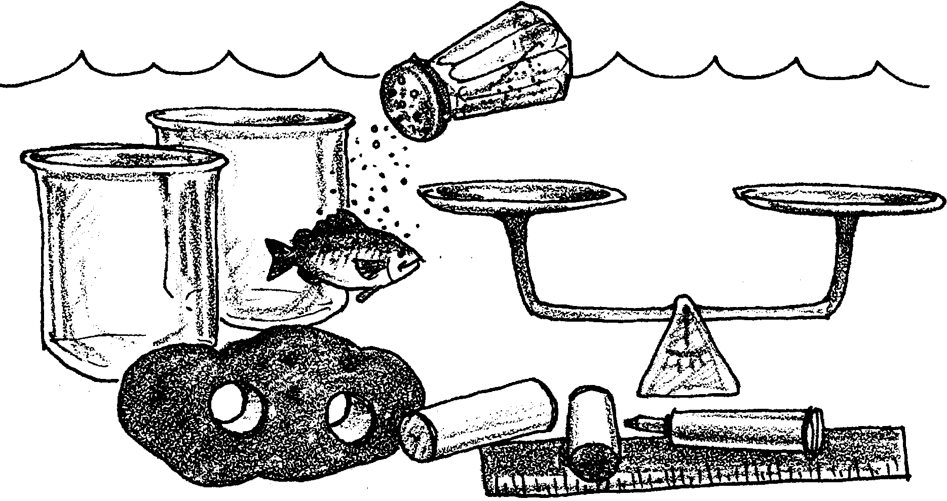
Dealing With Salt

Animals and plants that live in the ocean are affected by the salt concentration of sea water. Organisms differ in their ability to tolerate changes in salinity. Some organisms can withstand a wide range of salinities and can tolerate the large variation found in estuaries, tide pools, salt marshes and brackish areas. Other organisms find a small change in salinity intolerable. All animals and plants have a limit to their tolerance.
How does salinity affect living things? Living cells are largely water with a few dissolved salts and other materials. The materials inside the cell, for the most part, stay there. Water, however, can move into and out of the cell. How is this important? In living cells the water tends to move into or out of the cell until the concentration of salts, the “salinity”, inside the cell equals the concentration of salts outside the cell. What does this mean? Let’s look at a jellyfish and see.
Our jellyfish is floating peacefully in the sea. The salt concentration within its cells is equal to the salt concentration in the water around it. The same amount of water enters its cells as leaves them.
Collected by an oceangraphy class, the jellyfish is placed accidentally in a fresh water aquarium. The salt concentration within the cells of the jellyfish is now greater than the salt concentration in the distilled water of the aquarium. The SALT cannot move out of the jellyfish. In an effort to equalize the concentrations, water begins to move into the cells of the jellyfish. The concentration of salts in the cells is reduced but it is still higher than in the water. More water moves into the jellyfish and the jellyfish begins to swell.
1. Will the concentration on the outside ever equal the concentration on the inside of the jellyfish?

2. What will eventually happen to our jellyfish?

The students are panicked! Thinking quickly, they move the jellyfish into a tank of salt water. Unfortunately, the salt concentration is 70 parts per thousand (‰), about twice what the jellyfish is used to. How can the inside and outside concentration be made more equal?
In this situation, water moves from the jellyfish cells out into the surrounding water. This movement of water makes the salt inside of the cells more concentrated and makes the outside water slightly less concentrated. Our poor jellyfish begins to shrink as it loses water. This shrinking is called dehydration.

3. When will the shrinking of the jellyfish stop?

The movement of water into and out of cells is called osmosis. The body fluids of most marine organisms are just as salty as seawater. As a result, they have no problem maintaining their salt balance. However, if the salinity of the surrounding water changes, the organism must adjust or die. Some organisms are unable to control or regulate their salt-and-water balance. They quickly lose or gain water and die if placed in water having a salinity to which they are not adapted.
In the real world, the situation is often more complex. Some organisms are able to regulate the amount of water passing by osmosis through their body membranes, a process called osmoregulation. Some drink water to make up for water loss or excrete water in their urine to get rid of excess water.

4. What does “osmoregulation” regulate?

In the following procedure, you will weigh an organism before and after it has been immersed in water baths having different salt concentrations. Large weight changes will indicate poor osmoregulation. Small weight changes will indicate good osmoregulation.

5. How are large weight changes an indication of poor osmoregulation?
These are the materials you will need to do this investigation:
Materials:
• living marine animal (e.g. shore crab, sea star)
• paper towels
• balance
• fingernail polish
• 3 saltwater aquariums or holding tanks, each with different salinity salt water (40 ‰, 30 ‰, and 20 ‰)
Procedure:
1. Obtain a crab or a sea star. Blot the animal as dry as possible with paper towels. Weigh the animal and record this initial weight on the table below.

2. Use fingernail polish to put a distinctive mark on the animal so that you will be able to recognize it if the animal gets mixed up with others.

3. Place the animal in one of the containers or aquariums with saltwater. After 15 minutes, remove the animal, blot it dry, and re-weigh it. Record on the table the ending weight and the number of grams the weight increased or decreased. Repeat this procedure with the other water samples of different salinities.

DATA TABLE

Type of animal
Salinity Starting weight Ending weight Change
20 ‰ grams grams + or - grams?
30 ‰ grams grams + or - grams?
40 ‰ grams grams + or - grams?

4. When you are finished, return the animal to the holding tank.
Analysis and Interpretation:
1. Determine the percent weight loss or gain in the animal in each water solution. This is easy:

change in weight
percent weight change =
x 100
beginning weight

This equation may also be written like this:
(Hint: The change in weight is the weight at the end of a given trial minus the beginning weight found in step 1.

(change in weight ÷ start weight) x 100 = % weight change

Calculate the percent weight change for each salinity in the spaces below:
Salinity
20 ‰ ( ÷ ) x 100 = + or - %
30 ‰ ( ÷ ) x 100 = + or - %
40 ‰ ( ÷ ) x 100 = + or - %

2. Record your percentage weight changes on the backboard or on a class data sheet.

3. Number each axis on the graphs located at the back of this lesson to accommodate the data from your class. Then plot your percentage weight changes. Label your graph by completing the title “weight change for ” with the name of your animal.

4. Use your graph to answer the following questions:

a. Does your animal seem to be able to regulate its water balance at different salinities? (Hint: The better an animal is able to regulate its water balance, the smaller the weight changes are).

b. What salinities do you think your animal is best able to tolerate? Explain your choice.
5. Compare your graph to those of other students who used the same kind of animal.

a. Did most of the students with the same animal as you measure a weight change or did their animals stay the same?

b. What are two possible reasons for any differences you observe?

1.

2.

6. Compare your graph to those of other students who used the other animals. Did most of those students measure a weight change or did their animals stay the same?

7 a. Which animal, the crab or the sea star, is the best osmoregulator? Explain your reasoning.

b. At the mouth of a river, the salinity is quite low at low tide when there is more river flow than salt water. The salinity increases when the salt water returns at high tide. Which animal would you most likely find in the estuary near the mouth of a river?

8. What is likely to happen to a sea star collected from the intertidal zone and placed in a fresh water goldfish tank? Why?
Weight changes for

| | | | | |
Salinity in ppt

Percent
weight
in grams

Weight changes for

| | | | | |
Salinity in ppt

Percent
weight
in grams

