Symbiosis in the Deep Sea
—Three Level Guide
Lesson by Holly Shewbridge, Monterey Peninsula School District, Monterey, California.
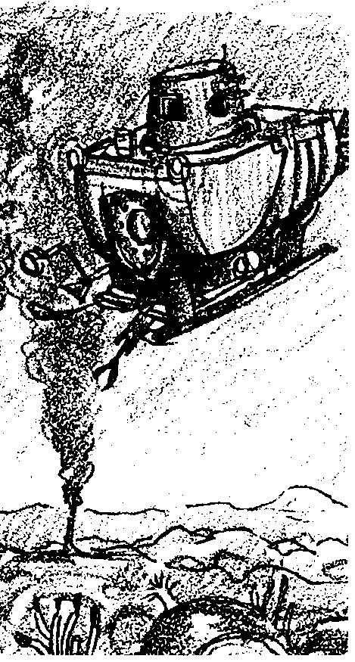

Key Concepts
1. In the deep sea, life exists in the absence of sunlight and photosynthesis.
2. Sulfur-oxidizing bacteria are the primary producers of hydrothermal vent communities.
3. Hydothermal vent animals such as tube worms, clams, and mussels have developed symbiotic relationships with sulfur-oxidizing bacteria.

Background
The marine snow that descends into the deep sea supports many unusual forms of life, but the density of life is limited. The detritus cannot support the prolific ecosystems of the rocky shore or the kelp forest.
However, there are special habitats in the deep sea, hydrothermal vents, that do support incredible densities of life. With the use of submersibles, scientists have been able to explore these hydrothermal vents.
The vents, discovered in the 1970’s, are found at the bottom of the ocean where the earth’s crustal plates are spreading apart. Under conditions of amazing pressure, nearly freezing surrounding water, and total darkness, these vents are mineral-rich oases where previously unknown species of marine organisms thrive.

Materials
For each student:
• a copy of the article “Symbiosis in the Deep Sea” by James J. Childress, Horst Felbeck and George N. Somero (“Scientific American”, May, 1987, Vol. 256, No.5.) “Scientific American” articles are not available for inclusion in this CD ROM version of the FOR SEA Guide. Please look for them in your library.)
• a copy of the “Symbiosis In the Deep Sea” Three-Level Guide
Teaching Hints
“Symbiosis in the Deep Sea” reviews an article by the same name from the May, 1987, issue of “Scientific American” which will introduce your students to the fascinating world of hydrothermal vents and the organisms adapted for life under the amazing environmental conditions of the deep sea vents.
The article provides background information about the hydrothermal vent communities and how they are studied. It is appropriate for students who can read at the 10th grade reading level and above. The accompanying questions are grouped into three levels. Level one questions refer to literal comprehension from the text. Level two includes interpretive questions, and level three questions are based on applied comprehension. The questions become more difficult as the reader reaches levels two and three. For additional information about Three-Level Guides, see Teacher Background for the activity “Meanwhile, in the Pacific . . .”, unit 2.
Here are some ways to help students get through this difficult reading. You can suggest that students read the statements in the three level guide before they read the article. In this way, the statements serve as a preview and the students will be searching for specific concepts. You may elect to have students compare their answers by meeting in small groups. It is sometimes helpful to have students note the page number and paragraph where they found supporting evidence or refuting statements. Choose the technique that most appeals to you and best fits the needs and skills of your class.

Key Words
chemosynthesis - the synthesis of organic compounds by some living organisms, especially some forms of bacteria, using the energy from chemical reactions such as the oxidation of hydrogen sulfide
hydrothermal vents - deep-sea hot springs situated at seafloor spreading centers
hydrothermal vent communities - self-sufficient communities of marine animals that survive on energy derived from the earth’s interior via chemosynthesis
spreading centers - locations where the tectonic plates are moving away from each other

Answer Key
Level I:
Directions: Read the statements carefully. Then as you read the selection, refer back to these statements in the guide, and place a check by those statements that are actually stated or paraphrased in the selection. Be prepared to explain what is inaccurate about the statements that you do not check.
X 1. Hydrothermal vents are hot springs on the bottom of the ocean floor where seafloor spreading occurs.
2. The biological diversity found at hydrothermal vent communities in 1977 was expected and not significant.
X 3. Life is able to survive at hydrothermal vents due to the presence of sulfur bacteria that are primary producers.
X 4. The tube worms receive food from the bacteria, and the bacteria receives the raw materials necessary for chemosynthesis from the tube worms.
5. High concentrations of hydrogen sulfide are not harmful to most life forms.
X 6. The hemoglobin of the tube worms is adapted for transporting large amounts of oxygen to cells of the tube worm and the symbiotic bacteria.
7. The large white clams of vent communities use hemoglobin to transport hydrogen sulfide to the bacteria.

Level II:
Directions: The following statements may or may not be true, based on what the author implies. Check those statements that you think can be supported by the selection. Be prepared to support your opinion.
1. Without sunlight and the process of photosynthesis, life in the oceans cannot exist.
X 2. The tube worms of hydrothermal vent communities could not survive without the presence of the sulfur-oxidizing bacteria.
X 3. Although the sources of energy are different, the products of photosynthesis and chemosynthesis are the same.
4. Hydrothermal vent communities are productive and stable.
5. The symbiotic relationship between the vent clams and sulfur oxidizing bacteria is unique.

Level III:
Directions: Read each statement below, relating the details and your interpretations drawn from the selection to ideas and experiences you have had in reference to this topic. Check the statements with which you agree.
1. Hydrothermal vent communities are productive and can be harvested by humans.
2. Hydrothermal vent communities are not affected by pollution produced by humans.
Note: Answers may vary in this section.
Symbiosis in the Deep Sea
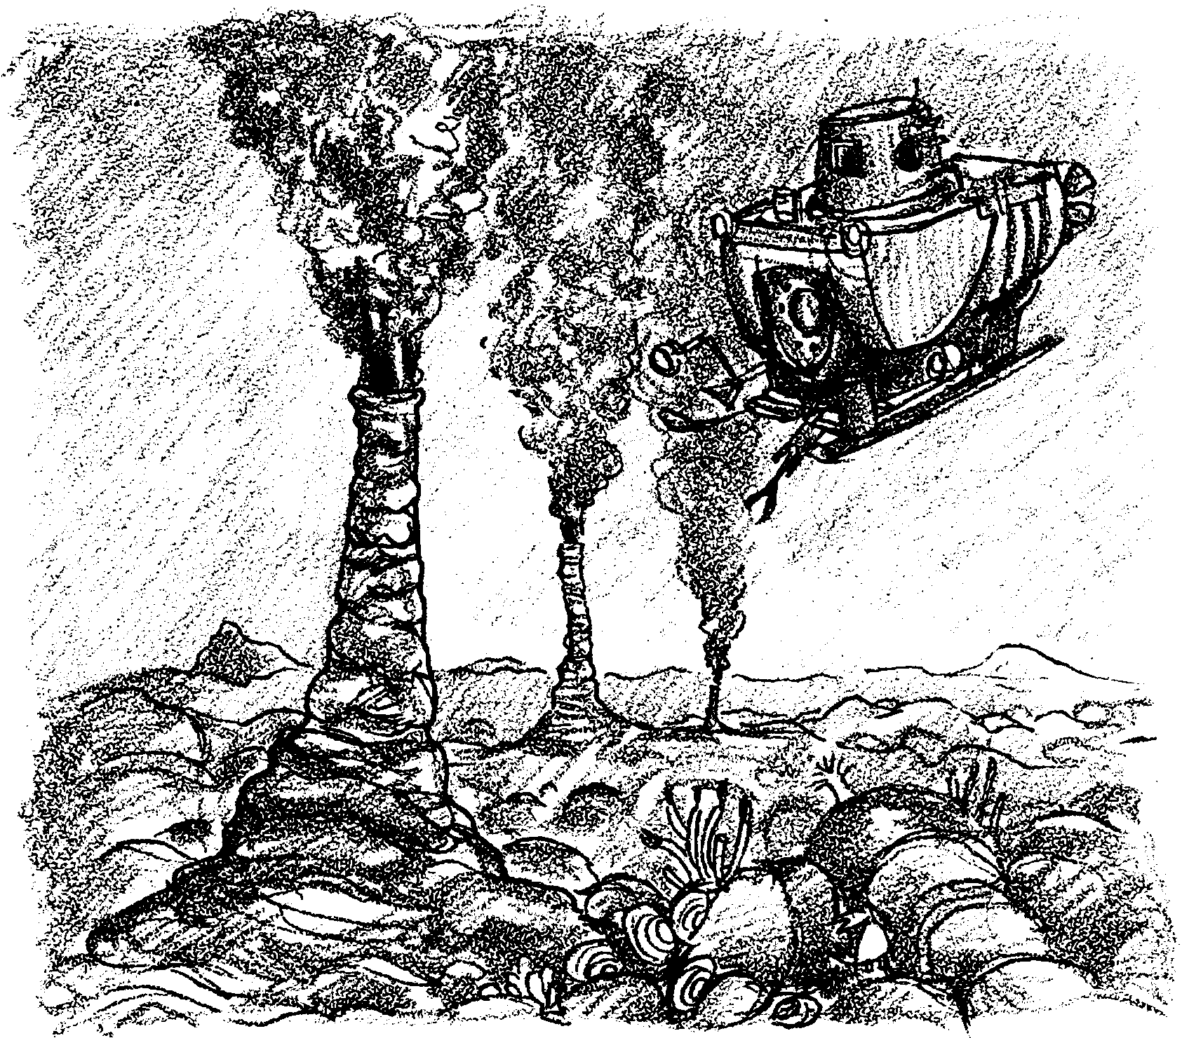
—Three Level Guide
Level I:

Directions: Read the statements carefully. Then as you read the selection, refer back to these statements in the guide, and place a check by those statements that are actually stated or paraphrased in the selection. Be prepared to explain what is inaccurate about the statements that you do not check.

1. Hydrothermal vents are hot springs on the bottom of the ocean floor where seafloor spreading occurs.

2. The biological diversity found at hydrothermal vent communities in 1977 was expected and not significant.

3. Life is able to survive at hydrothermal vents due to the presence of sulfur bacteria that are primary producers.

4. The tube worms receive food from the bacteria, and the bacteria receives the raw materials necessary for chemosynthesis from the tube worms.

5. High concentrations of hydrogen sulfide are not harmful to most life forms.

6. The hemoglobin of the tube worms is adapted for transporting large amounts of oxygen to cells of the tube worm and the symbiotic bacteria.

7. The large white clams of vent communities use hemoglobin to transport hydrogen sulfide to the bacteria.

Level II:

Directions: The following statements may or may not be true, based on what the author implies. Check those statements that you think can be supported by the selection. Be prepared to support your opinion.

1. Without sunlight and the process of photosynthesis, life in the oceans cannot exist.

2. The tube worms of hydrothermal vent communities could not survive without the presence of the sulfur-oxidizing bacteria.

3. Although the sources of energy are different, the products of photosynthesis and chemosynthesis are the same.

4. Hydrothermal vent communities are productive and stable.

5. The symbiotic relationship between the vent clams and sulfur oxidizing bacteria is unique.

Level III:

Directions: Read each statement below, relating the details and your interpretations drawn from the selection to ideas and experiences you have had in reference to this topic. Check the statements with which you agree.

1. Hydrothermal vent communities are productive and can be harvested by humans.

2. Hydrothermal vent communities are not affected by pollution produced by humans.

