Marine Bacteriology
Lesson by Barbara Baldwin Los Gatos, California.

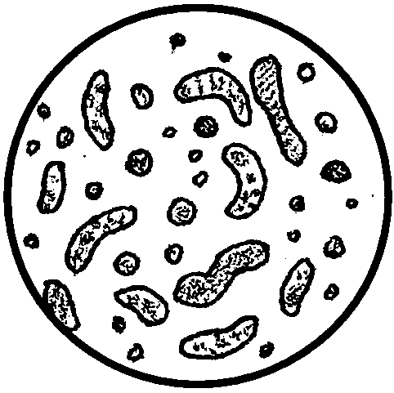
Key Concepts
1. Bacteria are widely distributed in the sea.
2. Marine bacteria play an important role in the liberation of nutrients by decomposing marine plant and animal remains.
3. Many marine bacteria are bioluminescent.

Background
Marine bacteria are the recyclers of the sea, decomposing dead plants and animals and liberating the nutrients bound in their carcasses. A considerable number of these marine bacteria are bioluminescent, producing their own light.
For additional background information, see the preceding activity, “Glowing in the Dark: Bioluminescence”.

Materials
To prepare the sterile agar requires the following materials:
• glass marking crayons
• heat source (hot plate or stove)
• distilled water
• graduated cylinder, 500 ml
• 2-4 Erlenmeyer flasks, 1 liter size
• balance scale
• sterile plastic or glass petri dishes
• large cook pot
• spatula or wood spoon
• non-absorbent cotton plugs for Erlenmeyer flasks
• autoclave or pressure cooker with ceramic screen or wire rack on bottom
In addition to the above, each of the two media requires its own special ingredients:
Marine Bacteria Agar Medium
To prepare 60 plates use:
• 1 liter sterile seawater
• 10 grams peptone
• 15 grams agar
To prepare 50 plates use:
• 750 ml distilled water
• 41.3 grams Bacto-Marine Agar from Difco #2216

Marine Yeast Agar Medium
To prepare 60 plates use:
• 1 liter sterile seawater
• 20 grams agar
• 23 grams dextrose
• 1 gram peptone or equivalent
• 1 gram yeast extract
• 100 ml Chloromycetin or Terramycin
To prepare 50 plates use:
• 750 ml sterile seawater
• 15 grams agar
• 17.25 grams dextrose
• .75 grams peptone protein
• .75 grams yeast extract
• 75 ml (37.5 mg) chloromycetin

Teaching Hints
“Marine Bacteriology” provides experience and rationale for the bacteriological and sterile techniques required in the preceding activity, “Glowing in the Dark: Bioluminescence”. It is a complex investigation but it is worth the effort. The benefit comes more from appreciation than from specific knowledge. The activity provides a good test of the degree to which your students have learned to understand and follow directions, to work together in teams and to analyze the outcomes of their experimentation. The activity also provides a test of your ability to master laboratory logistics.

Preparation:
Considerable materials are required. Check your supplies beforehand and organize your groups in such a way that your materials will suffice. Each class of 30 requires: 30 test tubes, 30 petri dishes, and 9 slides for team sizes of 2. If you have more than one class performing this activity, you might want to stagger the dates they begin so that you can reduce the materials required, or have teams of 3 students.
Duplicate the activity the day before beginning this activity, review sterile technique, bacteria transfer and plate streaking, equipment identification, and safety procedure. To provide an overview of the technique, it is recommended that you demonstrate all steps in the procedure. If your students are unfamiliar with bacteriological techniques, have students practice these techniques with unsterile supplies. While it is possible to have the students prepare the medium, it is more efficient to prepare the medium yourself. Little learning is sacrificed since media preparation is a cookbook procedure.

Procedure to prepare Bacteria Agar Medium:
1. Measure water quantity and place in large cooking pot.
2. Place pot on heat source and heat water.
3. Add agar and peptone and stir to dissolve, reducing heat and stirring until completely dissolved.
4. Fill one liter Erlenmeyer flasks to the 500 ml mark or less.
5. Plug flasks with non-absorbent cotton plugs.
6. Place flasks on rack in autoclave or pressure cooker and sterilize at 15 psi for 20 minutes. Allow sterilizer to cool, reducing pressure to zero, and then open. The agar medium should remain sufficiently warm to pour.
7. Pour medium into sterile petri dishes just covering the bottom of the dishes.
8. When agar solidifies, invert dishes. Label dishes.
9. Store in plastic bags (inverted) on shelf or in refrigerator. Medium may be made several days before being used.

Procedure to prepare Yeast Agar Medium:
1. Measure water quantity and place in large cooking pot.
2. Place pot on heat source and heat water.
3. Add agar, reduce heat and stir until completely dissolved.
4. Cool to hand touch, then add yeast and dextrose, and stir well.
5. Fill one liter Erlenmeyer flasks to the 500 ml mark or less.
6. Plug flasks with non-absorbent cotton plugs.
7. Place flasks on rack in autoclave or pressure cooker and sterilize at 15 psi for 20 minutes. Allow sterilizer to cool, reducing pressure to zero, and then open.
8. Cool approximately 5 minutes and then add chloromycetin.
9. Pour medium into sterile petri dishes just covering the bottom of the dish.
10. When agar solidifies, invert dishes. Label dishes.
11. Store in plastic bags (inverted) on shelf or in refrigerator. Medium may be made several days before being used.
It is desirable that the cultures be incubated at an even temperature. Generally, room temperature is sufficient, but you may use a bacteriological incubator if you desire to maintain an higher and more even temperature. Be sure to include a container of water to maintain the humidity in your incubator should you decide to use this approach. Adjust the incubator temperature to 27° C.

Procedure to prepare sterile seawater:

To make sterile seawater, fill one quart canning jars with seawater. Screw on Kerr canning lids until they are finger tight, and then back off 1/4 turn to loosen. Place on rack in autoclave or pressure cooker, and sterilize at 15 psi for 20 minutes. Allow sterilizer to cool and then open. Check Kerr lids to be sure seal is complete and tighten bands. Enough sterile seawater can be made at one time to last 2-3 years.

Procedure for collecting sand:

The sand for this lab may either be collected from ocean areas where detritus is present, or “made” by inoculating any type of beach sand. To “make” sand, wet sand with either water from a salt water aquarium, or seawater from sea salts. Place several pieces of algae in and on top of sand. Store in refrigerator for several days before using. Regardless of method used, keep all sand wet and store in refrigerator to maintain normal temperature until ready to use.
To reduce costs and materials, use two petri dishes for bacteria and yeast as class controls. Have controls on table in front of room for students to check. These control plates may be used by several classes. Tape control dishes closed so in handling they do not open and become contaminated.

A word about sterile technique:

Although the bacteria being cultured are ordinarily harmless, sterile procedures should be observed throughout the work, not only because the demonstration of safe handling of micro-organisms is one of the purposes of the investigation, but also because it is possible for pathogenic organisms to accidentally get into the medium and multiply. Therefore, at the end of the work, petri dishes must be sterilized at 15 psi for 20 minutes in an autoclave or pressure cooker before the medium is cleaned out of the glassware. Flood non-autoclavable plastic petri dishes with Lepol or chlorine bleach, tape, and allow to soak for 60 minutes before cleaning. Additional information can be found in the references cited below. The procedure is involved, but the results in terms of student enthusiasm and learning, justify the extra work.
Procedure for Student Activity:

The exercise in “Microscopic Forms” is designed to take three or four class periods. The exercise on luminescent bacteria can be run concurrently by extending the time to five days, plus or minus one day. Plan your starting date with these time requirements in mind.
Before handing out the student text, introduce the students to the proper use of microscopes. Also describe the differences in the mixtures of agar.
Circulate through the room as your students perform the activity. Anticipate any problem areas beforehand and move to eliminate them before they occur. Plan to devote a few minutes to a discussion of the results and to provide answers to the questions.
Also, during analysis, recognize that the organisms that appear to be thriving in the cultural setting may not be the most important in their natural habitat - they are successful under lab conditions. It has been noted that marine bacteria do not survive unusual changes in environmental factors (heat, chemicals) as well as terrestrial bacteria. You may wish to have students discuss factors that might differ between the beach sediment environment and the culture environment (e.g. temperature, availability of oxygen, immersion in air versus periodic immersion in seawater).

Answer Key
Text Questions

1. Three roles that marine bacteria play in the life of the sea include:
a. The liberation of nutrients for plants by decomposing marine plant and animal remains (reduction of complex organic molecules into simpler ones more usable by plants);
b. A direct food source for many small marine animals;
c. Bacteria action influences oxygen levels of sea waters.
2. If bacteria did not break down the complex organic compounds into simple compounds that can be used by plants, the plants would soon run out of the raw materials they require to grow and live. Without plant life, the animals would soon be without food (either directly or indirectly). The nutrients tied up in plant and animal wastes and carcasses would not be recycled. The whole nutrient cycling process would come to a halt and life, as we know it, would cease. The point to stress is that all life is interdependent.
3. There is considerable speculation over the benefits of bioluminescence. This question lets your students add their theories to the speculation. It is not certain that the light emission has a definite purpose (especially in the bacteria), but some hypothesize that it may be used as illumination or as a warning or attractant. In higher organisms, it may be used to attract members of the opposite sex or as species identification. You might ask your students to design experiments that might prove or disprove their hypothesis.

4. Sterile technique is required if one hopes to make statements about the origin of the micro-organisms in question. To say that the bacteria came from the sand, we must minimize the chance that they entered with the water or the air, etc. Sterile technique also becomes important in protecting the investigator when he/she is dealing with pathogenic micro-organisms.

5. The number of micro-organisms present in the original drop of water equals the number of colonies present on the agar plate. This, of course, assumes that each micro-organism present in the water droplet was able to establish a colony.

6. Since all of the members of the colony are descendents of one micro-organism, in a single colony you would expect to find only one type of micro-organism. An inoculating loop full of material from one colony plated on a single agar plate results in a pure culture.

Analysis and Interpretation:

1. Answer depends upon experimental results.

2. Answer depends upon experimental results.

3. The two media contain different compounds because each of the two groups of micro-organisms (bacteria and yeast) have different nutrient requirements. Each plate has a medium that favors a particular kind of micro-organism.

4. The experimental intervention occurred to the other two plates; they were inoculated with the seawater from the sand solution. In theory, a control and an experimental plate should only differ by one variable; in this case, the plating with the water from the sand solution.

5. Answer depends upon experimental results.

6. Many things can be cited as possible sources of the micro-organisms found in the control. All of the sources reflect failures to maintain sterile technique. These include: unclean glassware, failure to flame mouth of test tube, contamination from air while the petri dish was open, etc.

7. Answer depends upon the experimental data. This question provides a check on the success of the sterile technique.

8. Any failure in sterile technique (e.g. those cited above in question 6) could account for colonies in locations other than along the streaked path.

9. The points when contamination by micro-organisms from other sources is most likely to occur happen when the petri dish is open during the pouring and streaking procedures, or if the dish is opened to observe or count the colonies.

10. The micro-organisms were most likely in the sand since the seawater used was sterile. The micro-organisms may, however, have come from contamination in the ways mentioned above.

11. The roles played by these micro-organisms include:
a. a direct food source for other marine animals;

b. reducing complex wastes and dead organism into simple compounds usable by plants;

c. the determination of the oxygen levels of the water due to oxygen use by the micro-organisms.

12. Their role as decomposers, breaking down dead animals and plants and wastes, might help explain why they are so numerous in the sand. The detritus steadily falls to the sand on the bottom.

13. Their role as decomposers and recyclers of nutrients is probably the most important in maintaining the life of the sea.
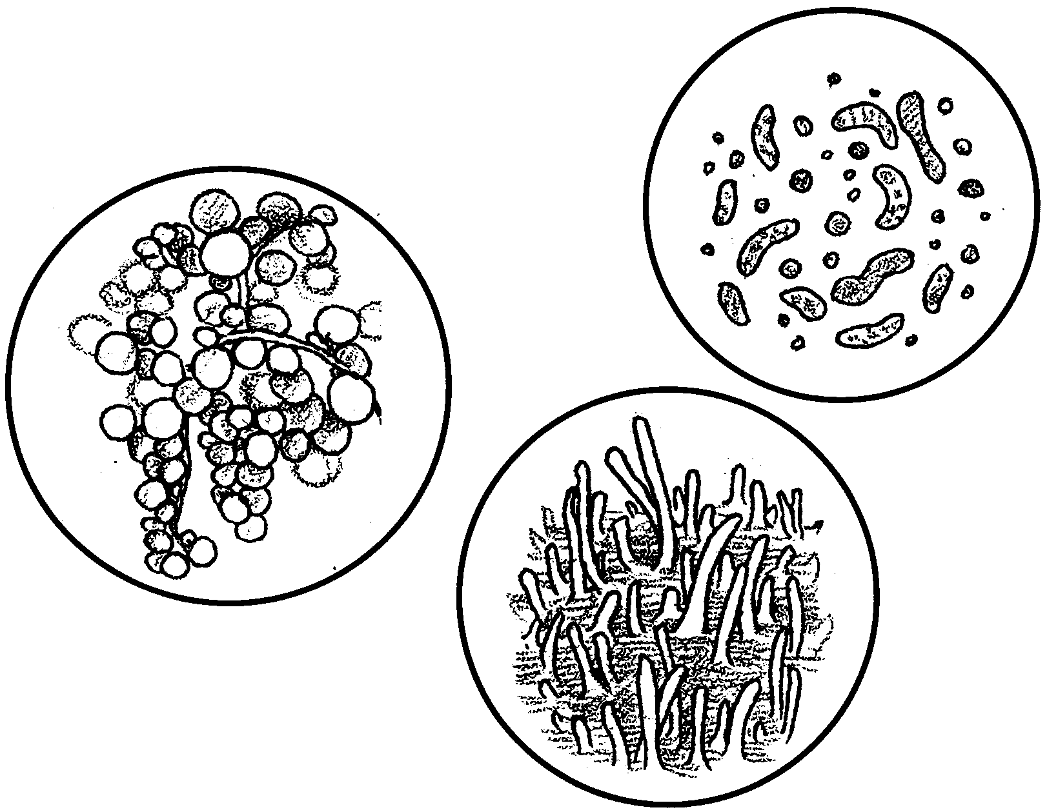
Marine Bacteriology

A deserted beach or a liter of seawater appear to be without life. A close examination of these, however, will offer surprises. The abundance of life in beach sand or seawater is amazing. Many of the life forms are microscopic bacteria, yeasts and molds. Bacteria are especially widely distributed in the sea and on grains of beach sand. How are these tiny forms important to the life of the sea? What is their role?
Marine bacteria play an important role in the liberation of nutrients for plants by decomposing marine plant and animal remains. The bacteria reduce the complex organic molecules found in this detritus to simpler compounds like phosphates and nitrates that living marine plants can use for their growth. These micro-organisms are the recyclers of the sea. The bacteria also serve as a direct food source for many small marine animals. Since bacteria use oxygen as they break down plant and animal wastes, they play an important role in determining the oxygen levels of sea waters.

1. What are three roles that marine bacteria play in the life of the sea?
a.

b.

c.
2. What would happen to plant and animal life in the sea if bacteria did not break down the complex organic compounds into simple compounds that can be used by plants?

While marine bacteria are found everywhere in the oceans, the largest populations occur near the shore at the mud-water interface. In these areas the number of bacteria may range from 50,000 to 400,000 bacteria per milliliter! Unlike terrestrial bacteria, most marine bacteria are colored. A considerable number are bioluminescent; they produce their own light, usually a greenish hue.

3. What are two possible benefits of bioluminescence to bacteria?

In this activity, you will have an opportunity to observe the bacteria, molds, and yeasts present in beach sand. While bacteria can be collected in water samples, the problems are more complex than collecting them in sand or mud samples. The bacteria sample you will use comes from a two centimeter deep by 30 centimeter square sand sample taken from the low tide line.
Since bacteria are found in the air, on your hands, and on the glassware you will use, certain special techniques will have to be followed to help ensure that the bacteria you grow actually are from the sand/sea water sample and not from your hands, etc. These procedures are commonly labeled “sterile technique” and you will follow them if you carefully read and perform the experimental section as it is written.

4. Why is “sterile technique” important in the study of bacteria?

The experiment you will perform involves plating out (smearing) a small drop of micro-organism containing water onto a surface which will provide the things necessary for the micro-organisms to grow. The surface is called a nutrient medium. Different kinds of micro-organisms require different nutrient media. The nutrient medium, inside of the petri dish, is placed in an environment conducive to the growth of the micro- organisms. If all goes well, the micro-organisms will grow. Each single micro-organism will multiply until it forms a colony of similar organisms that is visible to the naked eye. In other words, each colony that you see represents one micro-organism present in the original small drop of water you plated out on the nutrient medium.
5. How could you determine the number of micro-organisms present
in the original drop of water?

6. How many different kinds of micro-organisms would you expect to find in one single colony?

Sterile technique requires the use of a considerable amount of heat. Use care in handling of equipment and materials. Remember: Hot glass looks the same as cold glass!

Materials
For each group of two:
• microscope
• Bunsen burner and flint, or alcohol lamp and matches
• slides and coverslips
• crystal violet stain 2% and staining tray
• sterile seawater
• inoculation loop, or sterile “Q Tip”
• wet beach sand and scoop
• grease pencil
• 2 sterile test tubes, with stoppers, in test tube rack
• 2 pairs safety glasses
• 3 - 250 ml beakers
• distilled water
• dropper bottle with seawater (non-sterile)
• 1 sterile petri dish containing marine bacteria agar and labeled “S.W.A.”

Recipe:
• 1 liter sterile seawater
• 10 grams peptone
• 15 grams agar
• 1 sterile petri dish containing marine mold agar and labeled “M.A.”
Recipe:
• 1 liter sterile seawater
• 17 grams agar
• 1 gram yeast extract
• 10 grams dextrose
• 100 ml Chloromycetin, Terramycin, or Penicillin

Procedure:
1. Obtain a sterile test tube:
a. Fill 1/3 with sterile seawater.
b. Add 1/3 tube of the sand sample (to the sterile seawater).
c. Plug the tube and agitate thoroughly.
d. Permit the sand to settle in the tube.
e. Decant (pour off) several milliliters of the liquid into the other sterile test tube.
2. Streak the two petri dishes with the seawater sample by following these steps:
a. Light the burner.
b. Flame (pass the loop slowly through the blue portion of the flame) the inoculation loop.
c. Remove the stopper from the sample bottle.
d. Flame the mouth of the bottle.
e. Slowly insert the wire loop and withdraw a loopful of the sample. Be careful not to touch the sides of the bottle. Flame the bottle mouth and replace the stopper.
f. Use the technique shown to streak the plate, being careful not to break the surface of the agar medium. Again, one side of the petri dish lid should be raised only as far as needed to allow you to streak the agar.
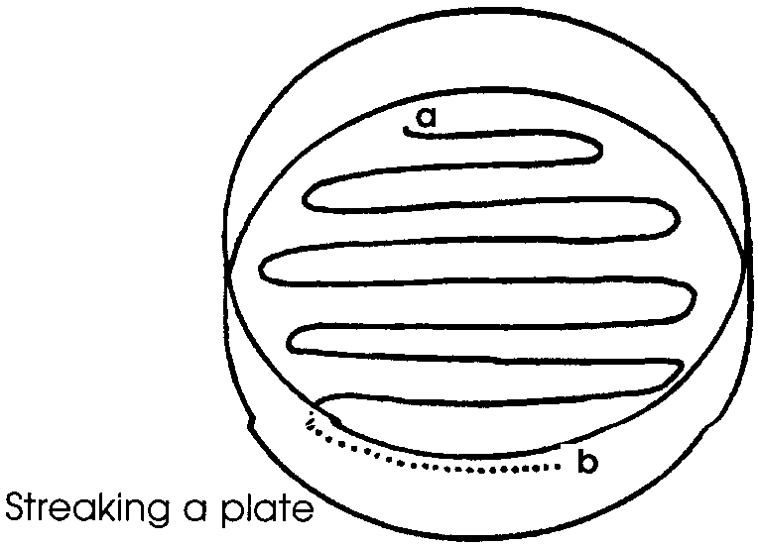
Begin at position “a” with the inoculating loop and lightly draw the loop across the agar surface in the illustrated pattern, being careful not to break the surface of the agar. On finishing at position “b”, the plate should be closed immediately and the inoculation loop flamed.
The inoculation loop should be passed through the blue portion of a flame before and after each use. The mouth of a test tube is to be flamed before and after each opening of the tube, and the tube held at a downward angle when open to prevent contamination falling into the tube from the air currents.
g. The glass control plates are at the front of the room and should not be opened.
h. Tape the sides of the petri dishes, label the edge with your name and period.

3. The dishes of inoculated agar plates are to be kept in a warm, humid atmosphere for the next 4 days, preferably in an incubator with a dish of water to provide humidity.

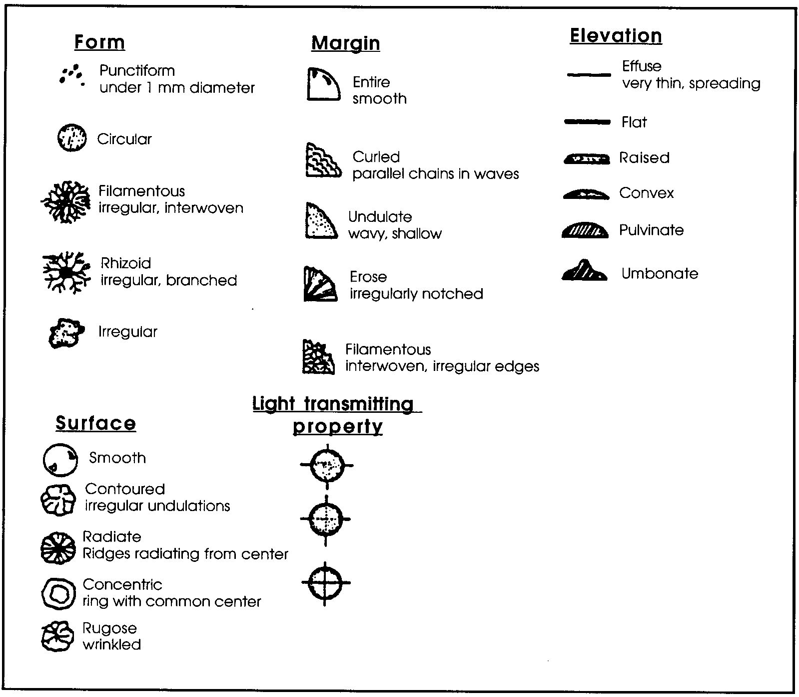
4. The following observations are to be made each day and recorded on the chart provided: (Use the reference diagrams to help you complete your chart).

a. number of colonies present;
b. color, shape, and size of each colony;
c. growth pattern for each colony

5. At the end of four days, make a smear of each type of colony found
on each plate:
a. Place a drop of seawater on a clean slide.
b. Flame the inoculating loop.
c. Pick off a small amount of a colony with the cooled loop and mix it into a small drop of water on the slide. Allow this smear to dry.
d. Pass the slide (smear side up) rapidly through a flame 3-4 times to fix the bacteria to the slide.
e. Let the slide cool to room temperature.
f. With the slide on a staining tray, gently flood the smear with 2-3 drops of crystal violet.
g. Allow the stain to remain on the slide for 30 seconds, then pour off the excess.
h. Rinse in a beaker of distilled water by immersing the slide gently several times.
i. Remove the water left on the slide by blotting gently with a paper towel. DO NOT RUB.
j. Repeat this procedure for as many different kinds of colonies as may be growing on the agar medium. (Remember, cover the petri dish immediately after picking a colony.)
6. The slides are now ready for observation with the microscope.
a. Place a drop of immersion oil directly onto the smear and carefully focus under the oil immersion lens.
b. Make a rough sketch of each type of bacterial cell you observe on binder paper and attach.
c. Repeat the procedure for each prepared slide that your group has done. Identify each organism according to the medium upon which it was grown. Record your results.
d. To clean off oil, use lens tissue and wipe in one direction only.

Analysis and Interpretation (Answer on binder paper and attach).

1. Which type of medium had the most colonies?

2. Which type of medium had the most different kinds of colonies

3. Why do the two media used contain different things?

4. The third plate served as a control. What was done to the other two plates that was not done to the control?

5. Did your control plates have any colony growth? If yes, which one(s)?

6. Groups that have performed this experiment in other classes have occasionally observed colony growth on the control plates. What might be the source of the micro-organisms observed in the control plates?

7. Did any of your plates show colony growth in the areas outside of the streaked path pattern?

8. What might account for colonies that grew in a location other than along the streaked path?

9. At what point(s) in the procedure is contamination by micro- organisms from other sources most likely to occur?

10. Were the micro-organisms present originally in the sand or in the seawater? Explain your answer.

11. What are the roles of these organisms in the food chains of the ocean ?

12. Which of the roles played by these micro-organisms might help explain why they are so numerous in the sand?

13. Which role is probably most critical in maintaining the life of the seas?

