Diver Underboard!
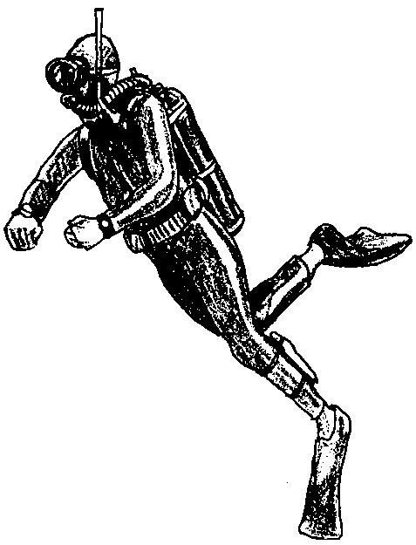

Key Concepts
1. The pressure found at depths below the water's surface creates dangers for human divers.
2. Nitrogen narcosis and decompression sickness are two diving illnesses caused by water pressure.

Background
While humans have descended far into the ocean in special apparatus like the bathysphere, humans are effectively limited to a shallow band at the surface if we are to spend long periods or do much real work in the oceans. Humans have not evolved the physiological adaptations necessary to recolonize the sea. We have, however, compensated for our physiological shortcomings through the development and construction of mechanical hardware such as SCUBA gear.

Materials
For each student:
• one copy of “Diver Underboard!” student pages

Teaching Hints
“Diver Underboard!” expands upon some of the concepts introduced in “The Pressure’s On” by placing humans into the ocean depths. Duplicate the activity pages. One set is recommended per student. This activity is best accomplished on an individual basis with group or class discussion as a follow-up. Upon completion, allow time for discussion and review of the correct answers.

Key Words
air embolism - occlusion of a blood vessel by an air bubble
asphyxia - extreme condition caused by lack of oxygen and excess carbon dioxide in the blood
atmosphere - a measure of pressure equal to the weight of the Earth's atmosphere at sea level, about equal to 14.6 pounds per square inch
bends - an accute condition caused by a rapid substantial decrease in atmospheric pressure characterized by the formation of nitrogen bubbles in the blood, severe pain in the lungs and joints, and neurological impairment; also called aeroembolism, caisson disease, and decompression sickness
caisson disease - the bends
nitrogen narcosis - lightheadness, euphoria, or semistupor experienced by deep sea divers when nitrogen from air enters the blood at higher than atmospheric pressures
pressure - exertion of force upon a surface of an object or organism
scuba - acronym for Self Contained Underwater Breathing Apparatus, a portable breathing device for free-swimming divers
stage decompression - stepwise, gradual reduction in atmospheric pressure experienced by divers after working in deep water or breathing compressed air which involves coming to the surface in stages with a pause at each stage which allows the nitrogen to diffuse out of the blood

Answer Key
1. The percentage of the deepest ocean scuba divers can explore before they become useless is:
250 feet useless depth x 100 = .69%
36,200 deepest spot

In scuba gear, humans can safely explore less than 1% of the ocean depths. Even so, scuba has given humans a real tool for ocean exploration.

2. At a depth of 30 meters, a pressure of 3 atmospheres is forcing the nitrogen into the bloodstream. At 75 meters, a pressure of 7.5 atmospheres is forcing the nitrogen to dissolve in the bloodstream.

3 a. The symptoms of caisson disease are pain in the joints sometimes followed by paralysis, blindness, dizziness, unconsciousness and convulsions, air emboli, asphyxia and even death.

3 b. The cause is a release of nitrogen bubbles in the bloodstream due to a rapid reduction in pressure.

4. A skilled diver can safely work at 100 feet without stage decompressing on her return to the surface for 25 minutes.

5. To be totally at home in the marine environment, humans must conquer:
a. caisson’s disease or the changes due to pressure differences;
b. breathing in an aquatic environment;
c. maintaining a constant body temperature in a medium (water) that conducts heat away from the body at a much faster rate;
d. eating in an aquatic environment.
Your students may recognize other problems are possible. The question asks for two problems.

6. Designs will vary. Most people will transplant a piece of our terrestrial environment into the aquatic world. This is, in fact, the approach we have used in both our deep sea exploration and our deep space exploration programs. Reward creative solutions to the problems posed. Use this question to stimulate thought and discussion on future environments, a subject which will be dealt with in later activities.
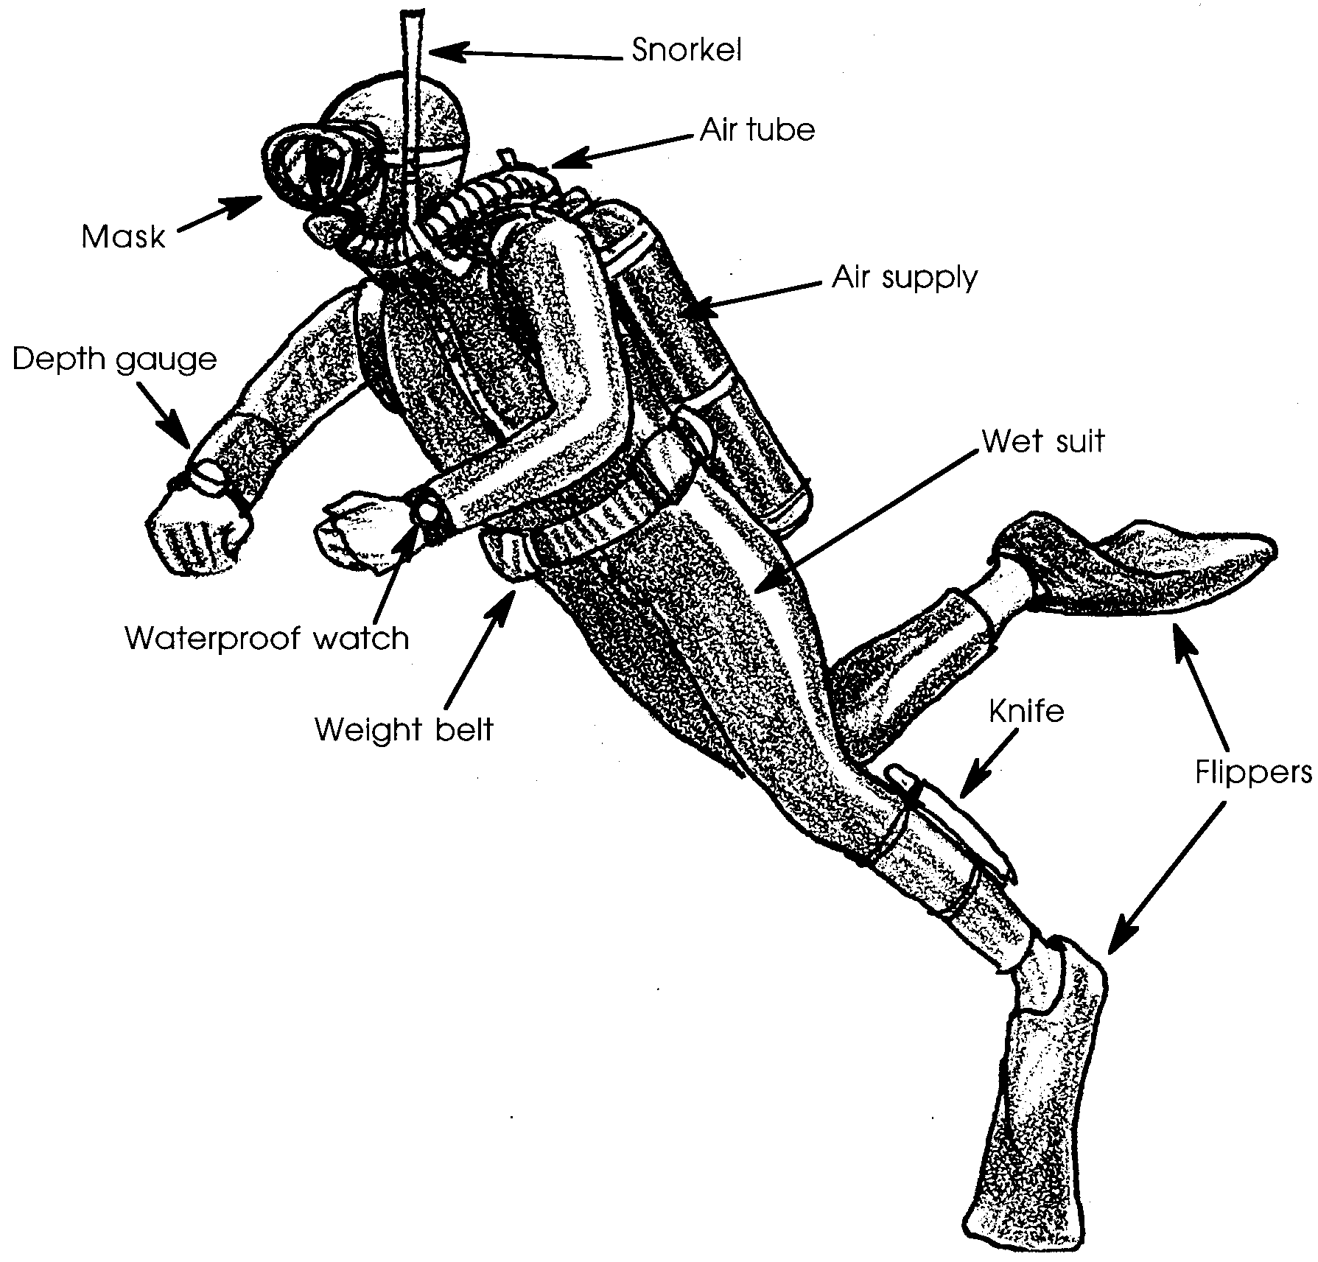
Diver Underboard!

What happens to humans when we enter the world of water? Do our cells adjust to the changes of pressure? Let’s take a look and see. Average scuba divers become useless at about 250 feet of depth (they often become worse than useless, they become a hazard) a far cry from the 11,500 foot depth at which we find the angler fish fishing. What happens to humans as they descend into the ocean?

1. The deepest spot discovered is 36,200 feet. What percentage of this depth can scuba divers explore before they become useless?
We need oxygen to survive. Oxygen makes up about 21% of the air we breathe. About 78 per-cent of the air we breathe is nitrogen gas. Nitrogen is relatively inert, it is more or less chemically inactive. The oxygen and nitrogen are carried in the bloodstream. At sea level the nitrogen presents no problem for humans. But what happens to these gases as we descend into the ocean depths?
The increased pressure allows more oxygen and more nitrogen to dissolve into the blood. A strange thing now happens. At about 100 feet the pressure will cause enough nitrogen to dissolve in the blood for the nitrogen to become a dangerous drug, a narcotic. Nitrogen narcosis eventually results in stupor and sleep (not a good condition 100 feet below the surface). Before the stupor stage, divers become dizzy, their ability to make even simple mental decisions (like tell time) is reduced, sometimes they decide they no longer need to breathe through their mouthpiece. The precise symptoms and the depths at which the symptoms appear vary with each individual and with each dive. Diving below 100 feet requires special skills and is dangerous. Returning to the surface reduces the nitrogen content and reduces the symptoms.

2. We have seen that one atmosphere equals about 14.6 pounds per square inch pressure. The pressure increases 1 atmosphere for every 10 meters of depth. How many atmospheres are forcing the nitrogen into the blood stream at 30 meters (about 100 feet)? at 75 meters (about 250 feet)?

Nitrogen narcosis is not the only problem human divers face. Interestingly enough the second major danger faced by divers was not discovered beneath the water’s surface. The 19th century was a period of rapid industrial expansion. Roads were needed to carry manufactured goods. Some of these roads needed to cross rivers. In some cases, engineers decided going under the river was better than building a bridge over it. As the tunnel builders worked, the tunnels were pressurized to keep the water in the river from flowing into the working areas. At the end of the day’s work, the workers surfaced to ordinary atmospheric pressure. Many of the workers developed pain in their joints. Some became paralyzed. Their symptoms were given the name “caisson disease”. ( A caisson is a watertight enclosure inside which people can do construction work under water).
The symptoms were recognized and the disease had a name. The causes, however, remained a mystery. In 1907, Dr. J. S. Haldane discovered a way to prevent the disease. By placing the sufferer in a pressurized room and gradually reducing the pressure, the disease did not occur. Now a way to prevent the disease was known, but the cause was still uncertain.
Maybe we should open some champagne to celebrate the cure? Pop! Out flies the cork. “Eureka, I have it! The cause of the disease!” The cork flies out because the gas in the champagne bottle is under pressure. The pressure is released and the gas in the champagne bubbles out. The nitrogen in the blood stream is also under pressure. A quick rise to the surface is just like popping the cork. The pressure is released and the nitrogen in the bloodstream forms bubbles. “Carbonated blood” affects the whole body. Bubbles in the brain tissue can cause blindness, dizziness, paralysis, unconsciousness and convulsions. Extreme pain is experienced in the joints and muscles as the bubbles form. The bubbles can cause air emboli which block the circulation. Bubbles in the spinal cord can cause paralysis of legs and arms. Asphyxia (lack of oxygen) and choking are signs of bubbles in the lungs. Severe cases can result in death.

3 a. What are the symptoms of caisson disease?

b. What is the cause of caisson disease?

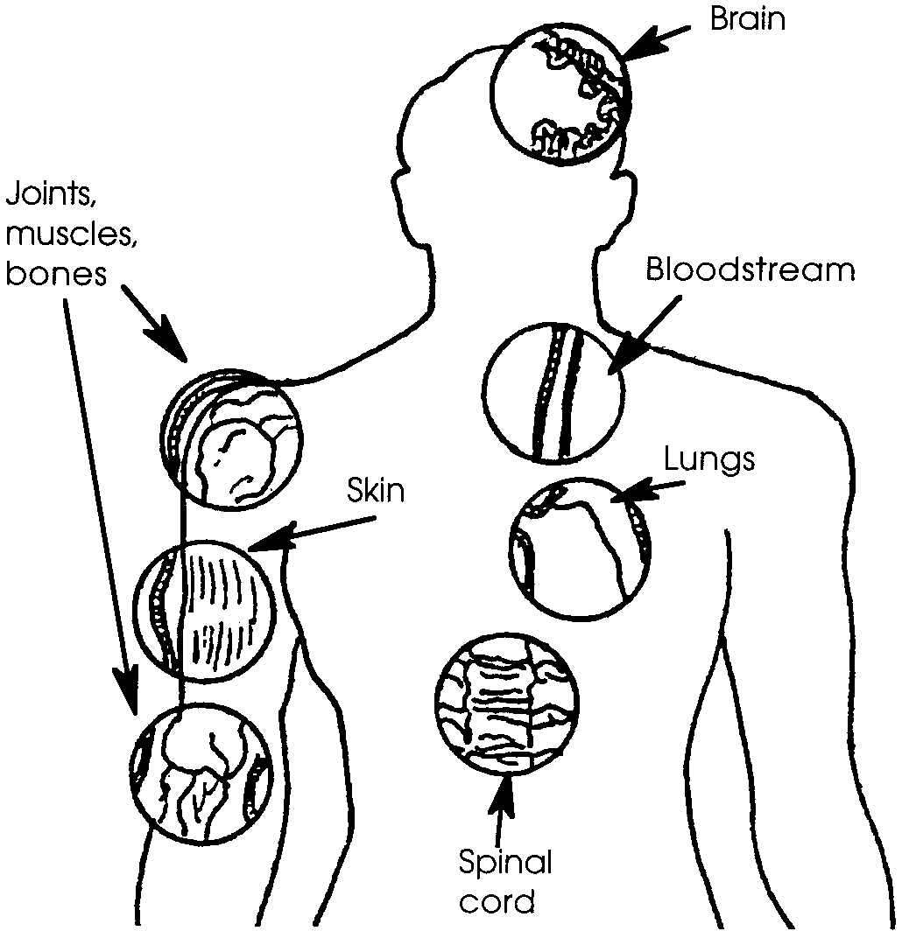

Caisson disease is now also called decompression sickness or the bends. Divers can avoid the disease by limiting the time and depth of their dives. Coming to the surface in stages (stage decompression) with a pause at each stage allows the nitrogen to diffuse out of the blood. The length of time a diver can stay at a certain depth without stage decompressing decreases with depth.
Depth Limits (min)

10 No Decompression
15
20
25
30
35 310
40 200
50 100
60 60
70 50
80 40
90 30
100 25
110 20
120 15
130 10
140 10
150 5
160 5
170 5
180 5
190 5

4. How long can a skilled diver safely work at a depth of 100 feet without having to stage decompress?

We differ from fish and most other aquatic animals in that we breathe using lungs rather than gills. Even so, aquatic animals including whales and other diving mammals must deal with the problems of dissolved gases. The aquatic animals have evolved mechanisms to handle these problems that we face. Humans are not yet able to be totally at home in the marine environment.

5. To be totally at home in the marine environment, what are two problems humans must conquer?

6. Design a system that will enable humans to overcome the two problems you stated in question number 5.

