Creatures of the Abyss
Lesson by Karen Mattick, Marine Science Center, Poulsbo, Washington.

Key Concepts
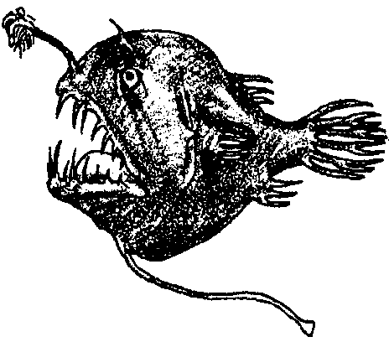
1. Light does not penetrate deep enough to provide energy for photosynthesis in the deep sea.
2. Food webs in much of the deep sea are fueled by detritus (decaying organic material) drifting down from the lighted layers above,
3. Many unique animals do populate these dark waters, feeding on detritus and each other.
4. Deep sea organisms are often small, gelatinous and bioluminescent.

Background
Sunlight is the original source of energy for photosynthesis. Though one might expect the vast, dark regions of the deep sea to be unable to support life without sunlight, they are, in fact, connected to the solar based food webs of the shallows by the fall of detritus, or “marine snow”. The animals that inhabit the dark regions of the ocean survive by feeding on the marine snow or on each other. They live in dark, very cold waters under extreme pressures.
Though the deep sea fish tend to look fierce, most, but not all, are quite small. Their fierce appearance comes from adaptations that allow them to eat anything that comes their way in the sparsely populated waters. Many have sharp fang-like teeth to hold prey. Many have greatly expandable stomachs and jaws that unhinge to allow them to swallow prey larger than themselves. Some have photophores, pockets of bioluminescent bacteria, that they may use as fishing lures to attract prey close to their hungry mouths.
Photophores may also function as identification tags so fish can find others of their species in order to reproduce. Special adaptations for reproduction must be important in an unlighted sea where fellow fish may be few and far between. The male anglerfish, for example, is much smaller than the female, and attaches to the female, literally feeding off her blood. In return, he provides sperm to fertilize her eggs.
These deep sea creatures also tend to have fairly soft bodies. The ferocious looking dragonfish, for example, actually has a small, gelatinous body.
Materials
For each student or team of students:
• 1 copy of student pages, “Creatures of the Abyss”
• 1 set Deep Sea Animal picture cards
• 1 set Deep Sea Animal information cards

Teaching Hints
“Creatures of the Abyss” reviews the flow of energy and nutrients in food webs and introduces the animals that inhabit the dark regions of the ocean which students have been mapping in earlier lessons in this unit. Your students are sure to find these animals bizarre and incredible.
Duplicate the “Creatures of the Abyss” reading, the Deep Sea Animal pictures and the Deep Sea Animal information cards. You may wish to cut them apart into separate cards or have your students do the work for you. It is important, however, that students go through the process of trying to match the right information cards to the right animal pictures. You will know that they are actually reading the information cards and studying the pictures when you begin to hear questions about the animals.
You can help satisfy some of your students’ curiosity by supplementing the Deep Sea Animal cards with video of deep sea creatures. Monterey Bay Aquarium and Sea Studios sell two videos, “Monterey Bay Aquarium” and “The Worlds Below”, which include footage of deep sea creatures taken from a submersible in the Monterey Bay canyon. In addition, Monterey Bay Aquarium has a Deep Sea slide set with script available for sale. You can reach the Teacher Programs and Education Departments at the aquarium at 886 Cannery Row, Monterey, CA 93940-1085, 408-648-4850.
Since so many of the animals shown in the Deep Sea Animal cards have photophores and bioluminesce, students may be curious about what causes the light of bioluminescence. You may want to follow up this activity with the lab “Glowing in the Dark: Bioluminescence.” If you do not have time for the whole lab, the activity provides background information you may share with your students.

Key Words
bioluminescence - the production of light by living organisms
cellular respiration - oxidation of organic compounds such as glucose that occurs within cells, producing energy for cellular processes
detritus - in this case, decayed organic material
nutrients - in this case, minerals and other substances needed for phytoplankton growth
photosynthesis - a process which occurs in the presence of sunlight in which six carbon dioxide molecules (CO2) and six water molecules (H20) are combined to yield one molecule of a simple sugar (C6H1206) and six molecules of oxygen (02)
phytoplankton - plant plankton; the primary producers of the sea
plankton - the mostly microscopic plants and animals that drift in water; singular = plankter
submersible - device designed for underwater work or exploration
zooplankton - animal plankton

Answer Key
1. Living organisms use energy to move, grow, reproduce and keep other functions of their bodies operating.
2 a. The ingredients for photosynthesis are carbon dioxide and water. Solar energy is also an ingredient for photosynthesis.
b. Oxygen is a waste product of photosynthesis.
c. Glucose is the desired product of photosynthesis. It is valuable because it stores energy from the sun in energy-rich chemical bonds.
3 a. The ingredients for cellular respiration are glucose and oxygen.
b. The waste products of cellular respiration are water and carbon dioxide.
c. Cellular respiration breaks apart glucose, releasing the energy stored in the molecule’s chemical bonds so the organism can use the energy.
4 a. Living organisms use nutrients as pieces to form their structure and parts. Nutrients are building blocks.
b. Animals get nutrients from their food.
c. Plants get nutrients from the soil or water around them.
5 a. The following deep sea animals are 10 cm or less and would fit in the palm of the hand:
anglerfish- 10 cm
bristlemouth- 8 cm
hatchetfish- 6 cm
deep sea shrimp- 4 cm
jellyfish- 4 cm
larvacean- 0.4 cm
tadpole snailfish- 6 cm
b. The following deep sea animals are about 1.5 meters or more and are larger than many humans:
slender snipe eel- 1.4 m
siphonophore- 20 m
6 a. The following deep sea animals bioluminesce:
black dragon
hatchetfish
pacific viperfish
anglerfish
bristlemouth
deep sea shrimp
jellyfish
deep sea squid
amphipod
shining tubeshoulder
lanternfish

Students can determine which bioluminesce by reading the information cards and looking for photophores on the animal pictures.

b. Students may suggest a variety of purposes for bioluminescence. The animals may bioluminesce to attract prey or to identify themselves to potential mates.
7 a. The following deep sea animal feeds on detritus:
larvacean

Most of the animals in the Deep Sea Animal card set feed on each other or on small zooplankton that filter detritus from the water.

b. All of the deep sea animals in the card set except the larvacean feed on other animals.

c. These deep sea animals are connected to sunlight-based food webs in that the beginning of these deep sea food webs is decaying materials that sink down from the surface waters. The decaying materials were once part of living organisms that either photosynthesized their food or fed on other organisms that depended on photosynthetic plants.
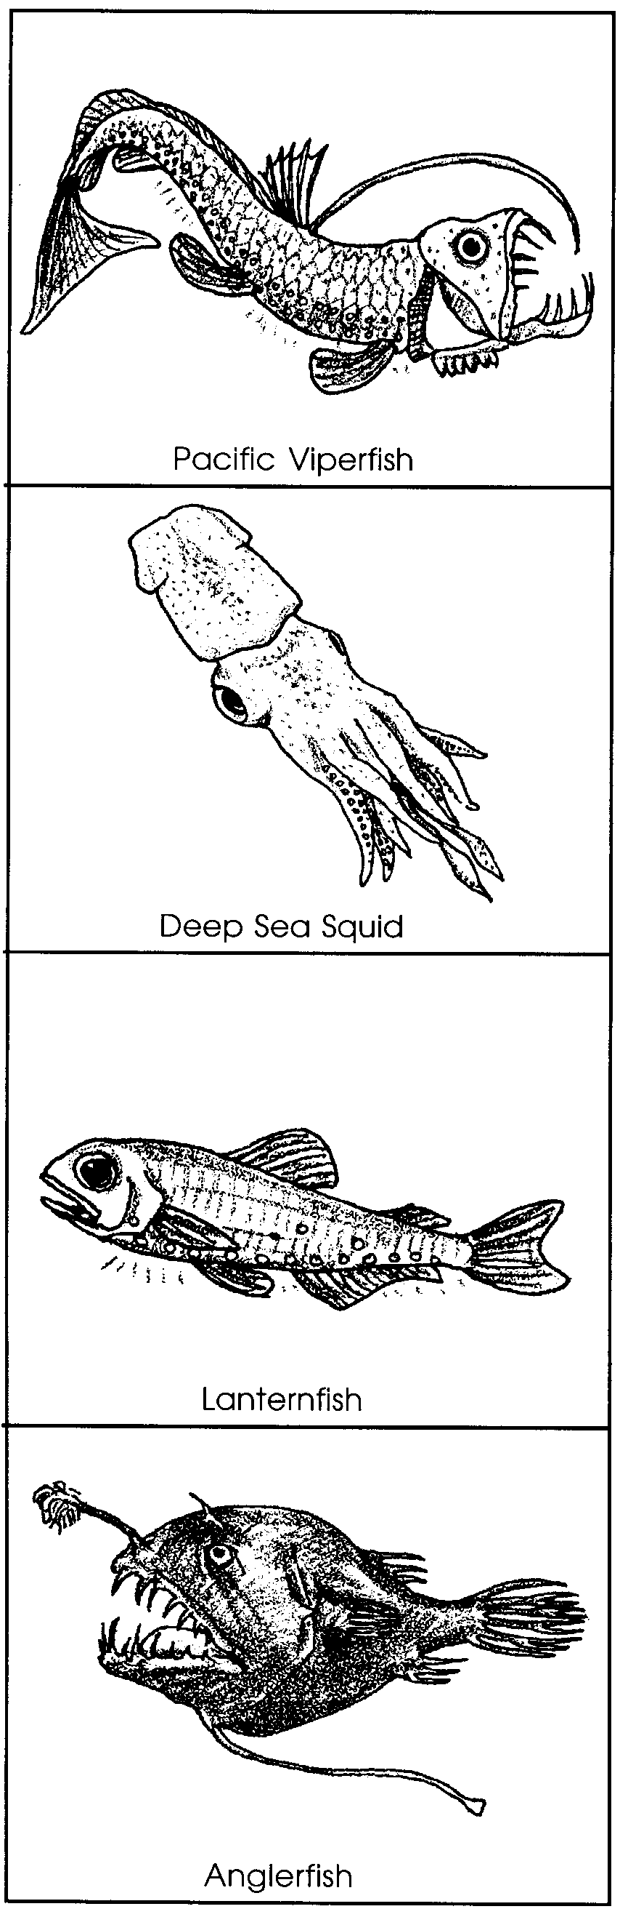

Pacific Viperfish
The Pacific viperfish feeds on lanternfish and squid. It has a very large mouth and fang-like teeth. Once the viperfish catches something, it won't get away. Its size ranges from 22-30 cm. Notice the two rows of photophores. Look at the long, thin ray on the back (dorsal) fin. How might the ray help attract a tasty meal?

Deep Sea Squid
This squid can grow to 30 cm in length. Its photophores adjust to match the ocean twilight. It can move very quickly forward or backward. The two longest tentacles grab and hold its prey. The smaller tentacles move the prey to its mouth. The eyes are of different sizes. Scientists don't know why. Do you have any ideas?

Lanternfish
The lanternfish is very common in the deep water. It lives where there is some light. It has very large eyes. The lanternfish swims up and down every day. It stays in the deep water during the day. It moves closer to the surface at night. Scientists think lanternfish may move like this to feed. They are not sure. Its photophores may help it find and communicate with other lanternfish. It grows to about 13cm in length.

Anglerfish
The anglerfish can grow to 10 cm in length. It has an appendage that looks like a fishing pole and lure. The "lure" is a large photophore. It may help attract prey. It is hard to find and keep mates in the deep sea. The anglerfish has a solution. The adult male anglerfish attaches himself to the female by biting on to her. Once attached, his body becomes part of hers. They mate for life.

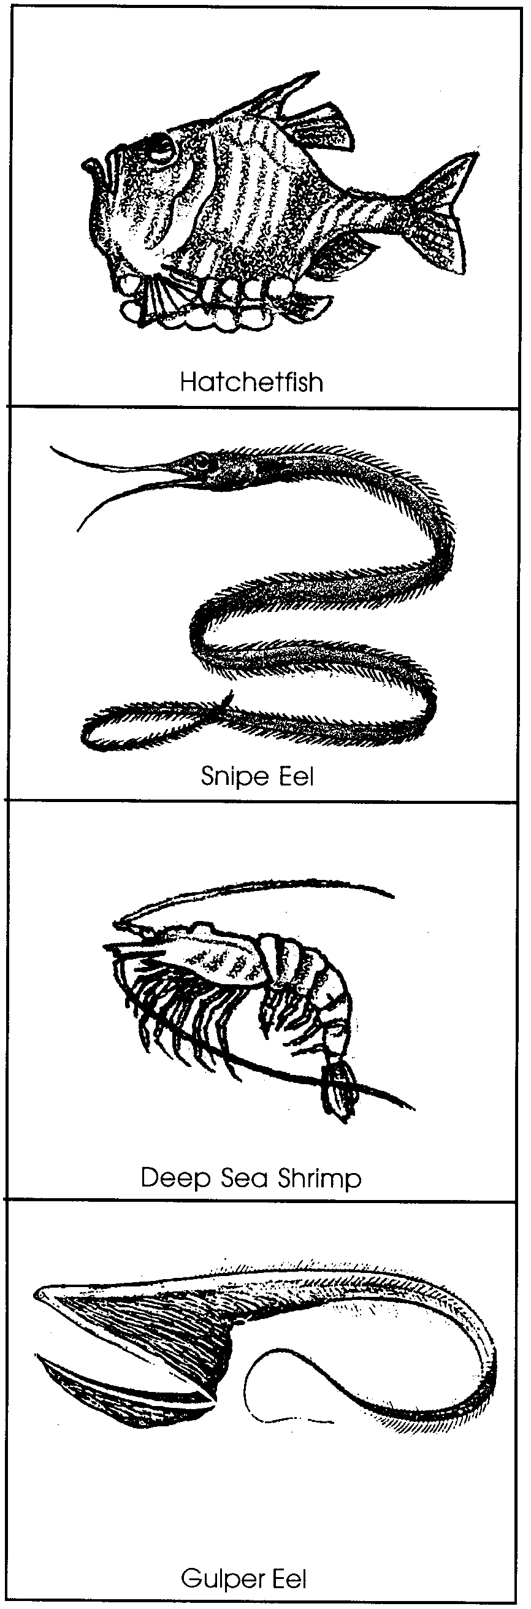
Hatchetfish
The small hatchetfish (to 6 cm) has upward facing eyes. They allow it to see its food in the dimly lit waters above. Once food is spotted, the hatchetfish makes a couple of quick strokes. Then its upward facing mouth can grab its prey. The hatchetfish has photophores on the bottom side. The light helps hide its outline. Other fish swimming below the hatchetfish see the light and not the hatchetfish's silhouette. This kind of coloring is called countershading.

Snipe Eel
The snipe eel grows to 140 cm in length. It is among the biggest deep sea fish. It has a very long beak-like mouth. The mouth has bristles along the edges. For a long time scientists wondered how the snipe eel used these bristles. Finally, they observed the snipe eel feeding. The snipe eel waves its head back and forth in the water. The bristles act like Velcro to snag deep sea shrimp by the antennae.

Deep Sea Shrimp
The bright red Deep Sea Shrimp is only 4 cm long. It seems much longer because of its very long antennae. These antennae may sense different chemicals in the water. The chemicals help the shrimp find food and mates. They may also help it avoid predators. The Deep Sea Shrimp has red photophores on its underside. The photophores countershade the shrimp.

Gulper Eel
The gulper eel has a very large mouth. It also has a stomach that can stretch. This lets the gulper eel eat prey equal to itself in size. The gulper eel can grow to 76 cm. Most gulper eels are about 40 cm long.

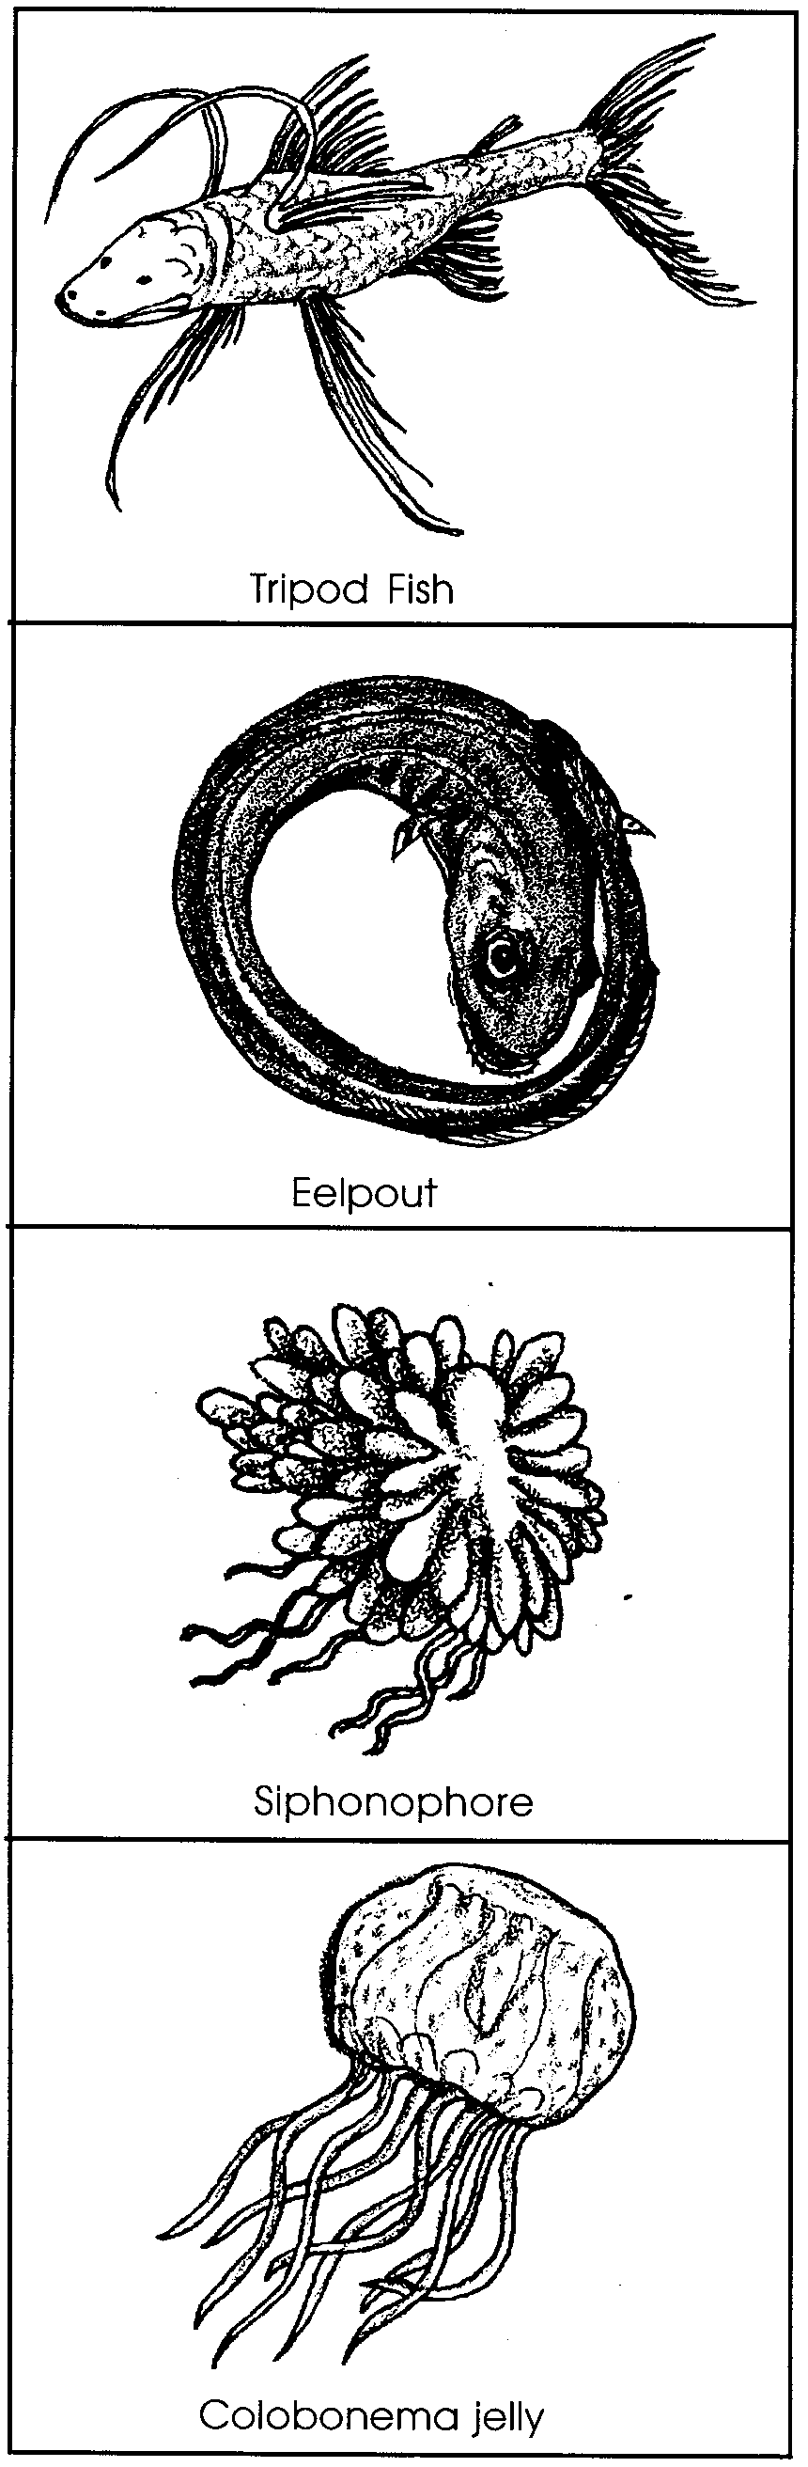
Tripod Fish
The dull brown tripod fish lives on the ocean floor. The pelvic fins are very long, about half the length of these fish which can grow to 29 cm. The pelvic fins and long tail help the tripod fish skim along the ocean floor. Tripod fish eat zooplankton. Threads on the fins sense the zooplankton in the water when they brush into the fins.

Eelpout
The translucent eelpout is a common deep water fish. It has a very uncommon behavior. When this fish is startled, it rolls up into a donut shape. Scientists wonder how this helps them survive. Some think it makes the eelpout look like a stinging jellyfish. The eelpout grows to 18 cm. It eats any animal it can fit into its mouth.

Siphonophore
Many different kinds of siphonophores live in the deep sea. This one can grow to 20 meters in length. A siphonophore is one animal made of many individual animals. Scientists call it a colony. The tentacles act as fishing lures. The lures attract the prey. The tentacles sting it. Then they pull it into one of the mouths.

Colobonema jelly
This 4 cm long jelly can glow (bioluminesce). Its tentacles pulse blue and red. They change color as it swims through the water. When a predator appears, the colobonema increases light output. Then, in an instant, it separates its lighted tentacles. The jelly swims off in a different direction. The predator is left with some stringy tentacles. The jelly is free.

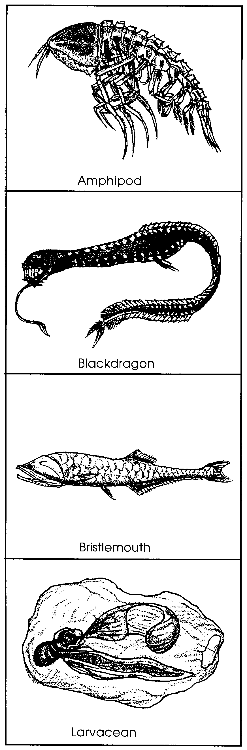

Amphipod
A large (up to 15 cm) relative of the common beach hopper, this amphipod flits around the deep sea. Its giant compound eyes help it search for food. Glowing with a cool, white light, its body is transparent. The light may help it find a mate.

Blackdragon
In spite of the long whisker, this is a female blackdragon. She feeds at the sea surface, swimming hundreds of feet up and back each night. Females may grow to 38 cm, males are smaller. Male blackdragons do not feed at all. They don't even have a stomach! They only live long enough to mate.

Bristlemouth
Growing to about 8 cm in length, these are the most abundant fishes in the world. A bristlemouth eats tiny plankton which it catches on the thousands of fine bristles that line its mouth. A row of photophores on its underside help it hide from predators below.

Larvacean
Smaller than a standard pencil width, this animal builds a transparent slime-house. Its wagging tail pumps water through its home. In a clever way to feed, it builds a net to catch detritus or marine snow in the water it pumps. When the net clogs, it flicks it off and builds a new one.

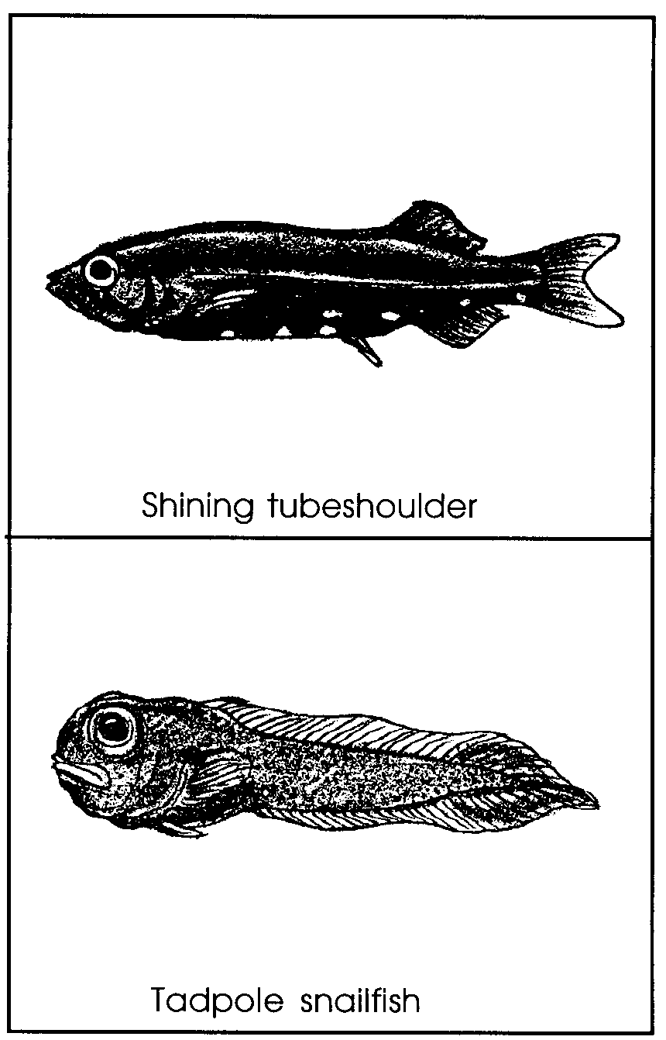

Shining Tubeshoulder
Photophores light the belly of this shiny black fish. Growing to 33 cm in length, this fish has an odd tube on each shoulder. The tubes can release a glowing slime. The slime may confuse its predators. At night, the young of these fish swim upwards to feed on shrimp.

Tadpole snailfish
Looking very much like a frog tadpole, this small fish (up to 6 cm) scoops up shrimp as it swims. Its soft body makes it a favorite meal for other deep sea fish.
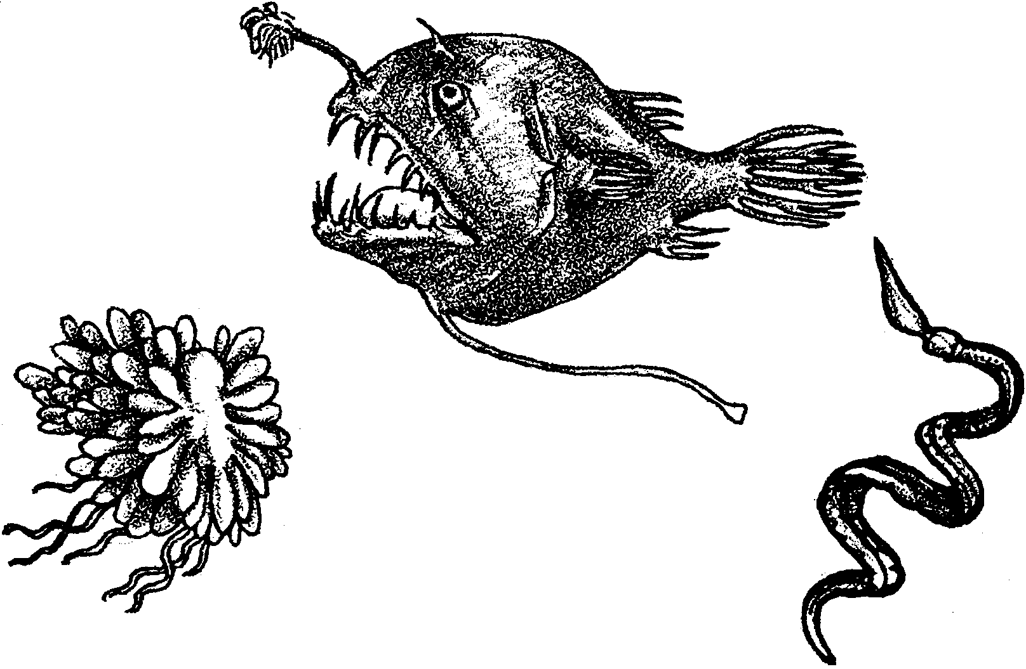
Creatures of the Abyss

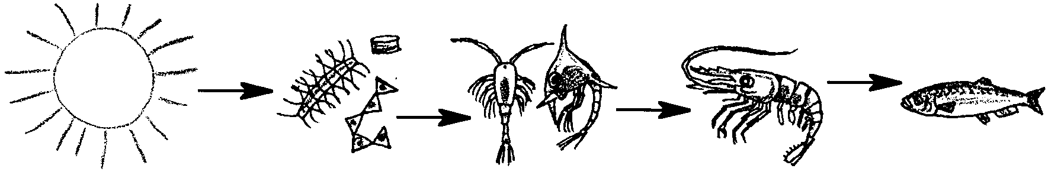
Sunlight is the source of energy for the phytoplankton that drift in the great ocean currents and that feed the zooplankton, fish, sharks and great baleen whales that cross the oceans. The sun fuels food webs in rocky shore tidepools and along wave swept sandy beaches, too. The giant kelp forests and all their inhabitants could not survive without the energy of the sun.
Sun Phytoplankton Zooplankton Shrimp Fish

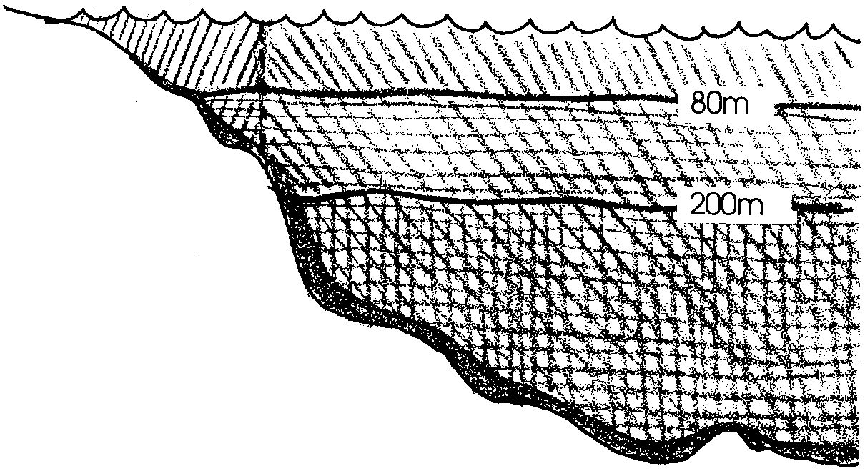
That sunlight, however, cannot penetrate deeper than a few hundred feet into the water, yet the deepest areas of the ocean are thousands of feet deep. These are the regions scientists long thought of as dark and lifeless. Without sunlight for phytoplankton or seaweeds, it seemed there could be no life in the abyssal regions of the oceans.

Let’s look at why sunlight is so important. Sunlight is energy. All living things need ENERGY and NUTRIENTS. Food is like a battery, storing ENERGY.

All living things are able to break the bonds that hold molecules of food together so that they can get the energy stored in the food. This process of breaking food apart to get energy is called cellular respiration. All living things respire all the time.

Living organisms use this energy they get from food to grow, to move and to keep functions in their bodies operating. For example, humans need energy to breathe, fight disease, think, reproduce and keep many other similar functions in their bodies operating.

In sunlight-based food webs, plants harness light energy through photosynthesis. The plants are the battery makers; they make the food that stores the sun’s energy.

This formula depicts photosynthesis:

carbon dioxide + water → glucose + oxygen

or, written another way:

CO2+ H2O → C6H12O6 + O2

The plant takes in carbon dioxide and water. It harnesses sunlight energy and uses it to rearrange the atoms in the carbon dioxide and water to make glucose and oxygen. The oxygen is a waste product. The glucose is an energy rich molecule. Glucose stores the energy from the sun.

Plants later use this glucose, breaking it apart so the plant can use the energy stored in the glucose for growth or some other activity.

When animals feed on plants or on each other, they digest their food until it is broken back into glucose molecules. Then, just like plants, they break the glucose apart so they can use the energy stored within. This process, in both plants and animals, is cellular respiration. The glucose is broken into carbon dioxide and water and the energy released.

The formula for cellular respiration looks like this:

C6H12O6 + O2 → CO2 + H2O

1. What do living things use energy for?
2 a. What are the ingredients for photosynthesis?

b. What are the waste products of photosynthesis?

c. What is the valuable end product of photosynthesis and why is it important?

3 a. What are the ingredients for cellular respiration?

b. What are the waste products of cellular respiration?

c. What do living things get from cellular respiration that they need to stay alive?

Living organisms use NUTRIENTS as building materials.

If we took any living thing apart into molecules and atoms, we would find that every organism is built almost entirely of carbon atoms. A few of many other atoms make up the rest of the organism. These include, for example, calcium, iron, magnesium, sodium, and potassium. Do any of these sound familiar? You may have taken a vitamin today that included some of these nutrients. We try to eat a variety of foods that include these nutrients, these building blocks that our bodies use to build bone, muscle, blood, skin and all the other parts of our bodies.

All living things need NUTRIENTS. Carbon atoms and other atoms will make the parts of the organism. While animals get nutrients from the food they eat, plants must absorb nutrients from the water or soil in which they live. This is why plants do better in our gardens when we fertilize them. We are providing nutrients the plants will use as building blocks.

4 a. What do living things use nutrients for?

b. Where do animals get nutrients?

c. Where do plants get nutrients?
Most of the life in the ocean, then, is ultimately dependent on sunlight. Phytoplankton and algae capture solar energy and then are food for zooplankton, fish and so many other animals of the sea.

Now consider the deep sea. In those vast waters, there is no light. It would seem, then, that there would be no organisms to begin food chains, no source of energy and no flow of nutrients.

This is almost true.

When surface organisms die, their bodies decompose. The resulting decayed organic material, called detritus (dee-try-tus), sinks. One can see this falling detritus in videos filmed on submersibles exploring the deep sea. It looks so much like falling snow that biologists call it “marine snow.”

Detritus is like slightly used batteries. There’s still some energy and some nutrients stored in that marine snow.

So, who lives in these dark waters? Who makes a living feeding on the marine snow?

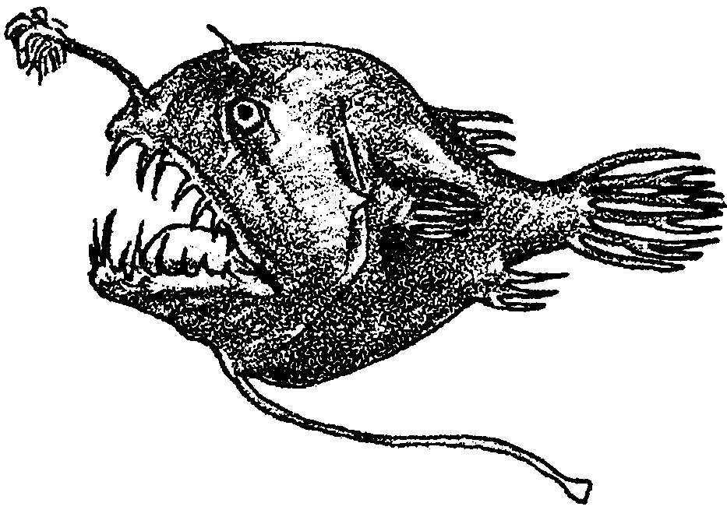
Every once in awhile, fishermen trawling for their catch and oceanographers on research vessels have dredged up bizarre fish from deep waters. The fish never survive the drastic temperature and pressure changes of the trip up from the depths. Now, with the development of submersibles, biologists have visited these creatures in their own habitat and brought back footage of bizarre beings that inhabit the deep, dark, cold waters. Let’s take a look at some of those animals.

Obtain a set of Deep Sea Animal picture cards showing an assortment of animals researchers have discovered in the deep sea. Also obtain a set of Deep Sea information cards.

Now, see if you can match the picture cards with the correct information cards. These are the creatures of the real abyss.

When you have matched all your cards, start to look for patterns in these deep sea animals. Notice their shapes, sizes and colors. Look for typical body parts. Think about what an animal must be like to survive in the deep.
5 a. Which of the deep sea animals could fit in the palm of your hand?

b. Which of the deep sea animals are larger than you are?

6 a. Which of the deep sea animals bioluminesce?

b. Why do you think these animal bioluminesce?

7 a. Which of the deep sea animals feed on detritus, or marine snow?

b. Which of the deep sea animals feed on other deep sea animals?

c. These deep sea animals are part of sunlight-based food webs. Explain how this can be so when they live in the dark regions of the oceans?

