Name That Place!
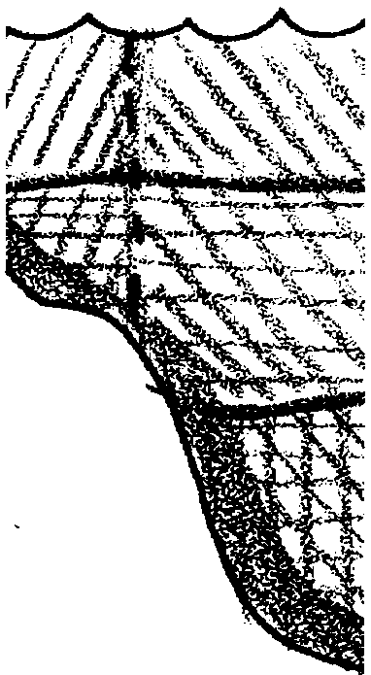

Key Concepts
1. Scientists have identified ocean zones based on the amount of light which penetrates the water to fuel food webs.
2. Scientists have also classified marine life into groups of organisms adapted to live in the specific depth zones.

Background
In observing the ocean realm, scientists have recognized differences in animal assemblages and physical properties found at different depths. They have given a variety of names to these areas in an effort to both distinguish them from each other and to recognize the relationships between them. Photic divisions, based on the penetration of sunlight, have proven useful in studying the distribution of plants and animals in the sea. Divisions based on depth are also widely used especially in studying physical features and processes of the ocean basin.

Materials
For each student:
• one copy of “Name That Place” student pages

Teaching Hints
“Name That Place” introduces your students to some of the terminology they will need for future discussions of the life of the sea. This section introduces several unfamiliar, yet similar, terms used to describe different areas of the marine realm and the creatures found therein. Activities designed to reinforce the learning of these terms are included. Incorporate the terminology into your teaching vocabulary to give your students an opportunity to become familiar with the terminology.
Duplicate the activity pages. One set is recommended per student. This activity may be performed individually or in small groups. Alternatively, the first section may be assigned for individual completion and the crossword puzzle may be done in small groups. Choose the plan that works best with your class. Set aside some time upon completion of the activity for a review of the answers to the questions and the crossword puzzle.

Key Words
aphotic zone - a major division of the ocean realm based on light penetration and extending from about 200 meters to the ocean floor, the area in which light is absent
benthic zone - the bottom of the sea laying beneath the oceanic and neritic zones
benthos - bottom dwelling animals, representing the slow moving or sometimes sessile (non-moving) forms. In the coastal zones, chiton, barnacles, crabs, sea anemones, and the like, are part of the benthos. In the deeper abyss, specialized sea stars, urchins, snails, and bivalves are examples.
disphotic zone - a major division of the ocean realm based on light penetration and extending from the 80 meter boundary to about 200 meters, an area of dim blue-green light
euphotic zone - a major division of the ocean realm based on light penetration and extending from the surface to a depth of about 80 meters, the light penetration is great enough for photosynthesis
neritic zone - one of two major divisions of the ocean realm based on depth and extending from the intertidal zone out to about the edge of the continental shelf or to a depth of about 200 meters
oceanic zone - one of two major divisions of the ocean realm based on depth and extending beyond the edge of the continental shelf or a depth of about 200 meters; the oceanic province is very large and very deep
photic zones - major divisions of the ocean realm based on light penetration
photosynthesis - a process which occurs in the presence of sunlight in which six carbon dioxide molecules (CO2) and six water molecules (H20) are combined to yield one molecule of a simple sugar (C6H1206) and six molecules of oxygen (02)
nekton - organisms capable of directed locomotion and which can swim against the currents, roaming over vast areas of the ocean, including the fish, whales, seals, sea turtles and some invertebrates such as the squid and shrimp
phytoplankton - plant plankton; the primary producers of the sea
plankton - the mostly microscopic plants and animals that drift in water; singular = plankter
zooplankton - animal plankton

Answer Key
1. Answers will vary. This question is designed to start the students thinking about food relationships in the vast ocean. The animals which live below 80 meters have several sources of food. They may swim up to the lighted zones and feed. They may eat dead organisms as they fall from the lighted zones into the darkness. They may eat animals that swim up into the lighted zones, etc. Encourage discussion but do not get sidetracked at this time. The concepts introduced here will be expanded upon in later activities.

2. The two photic zones found within the neritic zone are the euphotic zone and the disphotic zone. It is important to point out to your students that these terms are arbitrary and were created to help scientists converse about the ocean. The particular term used depends upon what the scientist is emphasizing in the discussion.

3. This question calls for speculation. One would probably find more variety in shallow benthic areas because of the penetration of light. The light would allow plant growth which in turn would support a variety of animal types. Accept answers which are coupled with reasonable explanation.
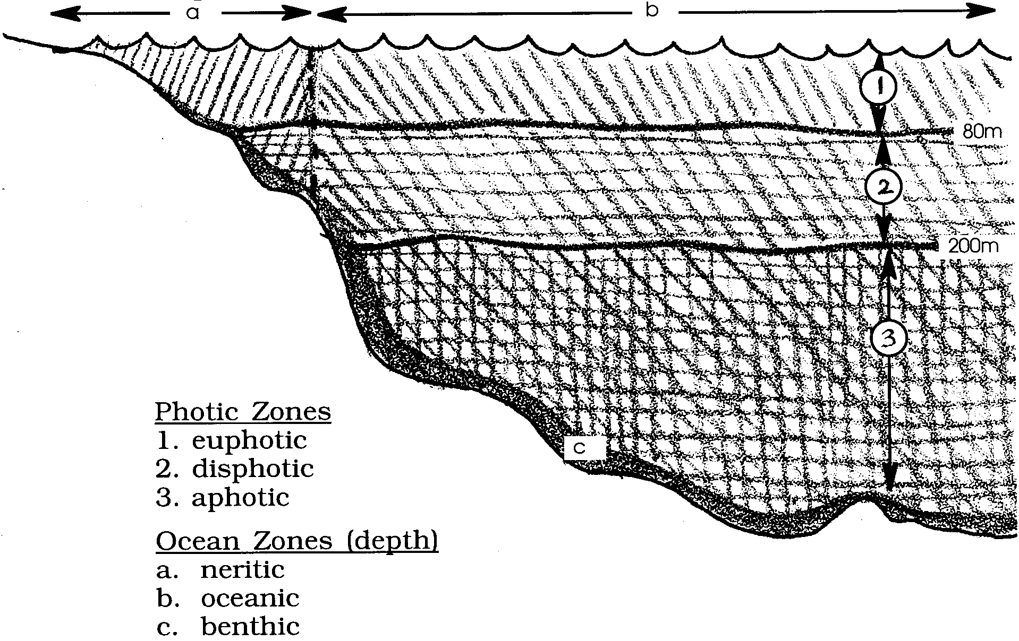

4.

5. One would expect to find phytoplankton in the euphotic zone since they require sunlight to photosynthesize.

6. An ocean desert is an area in the ocean with small numbers of plankton and hence small numbers of other organisms which depend upon plankton. The term seems to be a contradiction because “desert” usually refers to a lack of water - something we do not find in the ocean!

7. This question calls for speculation. Nekton are found in all of the depth zones: neritic, oceanic, and benthic.

8. One possible source of food for benthic organisms in the abyss is other benthic organisms! However, this source of food could only last for a limited time without additional input. The input comes from the continual rain of detritus (small dead organisms) and from the occasional large carcass that falls to the bottom of the sea.

9. The seemingly confusing terms were developed so that people could converse about specific parts of the sea with a common set of terms. In spite of initial appearances, these terms aid conversation and understanding of the marine environment.

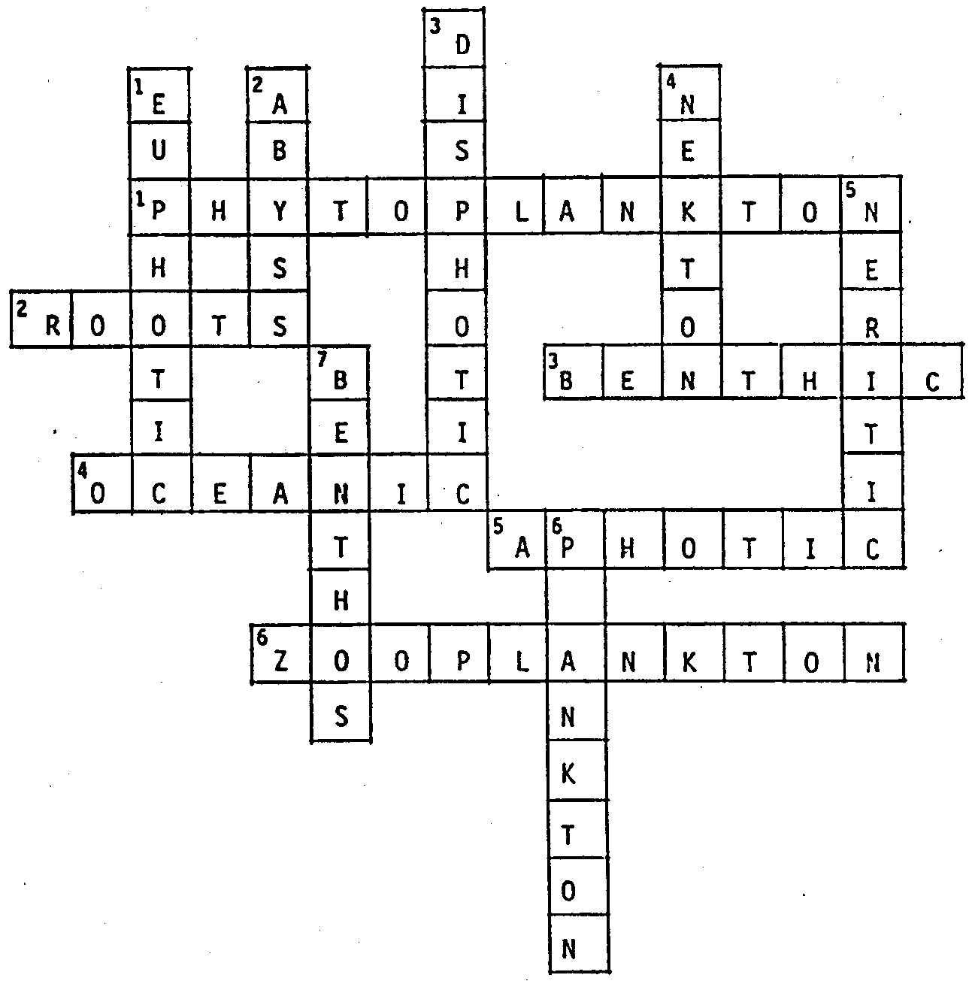
Crossword Key:
L

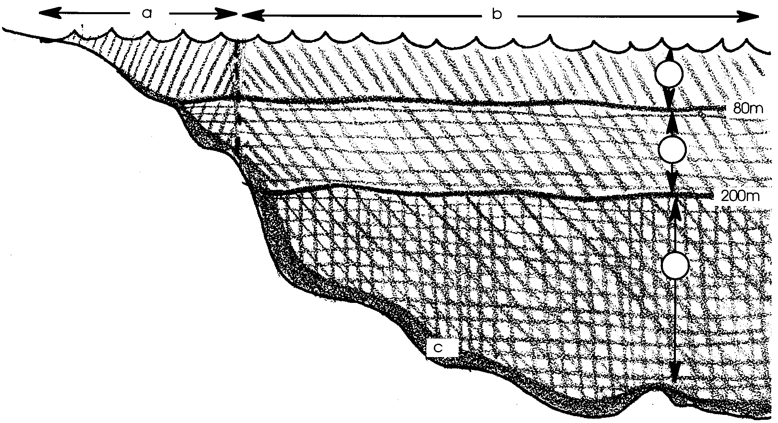
Name That Place!

The ocean is such a vast kingdom that ocean scientists have found it useful to divide it into smaller areas as a way to help them to study the life of the seas. Two major types of divisions have been made: one based on sunlight penetration and the other on depth. The divisions based on light penetration are called the photic (fo tik) zones (from the Greek word for light). Light is necessary for green plant growth. From the surface to a depth of about 80 meters, the light penetration is great enough for photosynthesis. We call this area the euphotic zone (meaning “true light”). Extending from the 80 meter boundary to about 200 meters, the disphotic zone (meaning “away from light”) is an area of dim blue-green light. Finally, the area in which light is absent is called the aphotic zone (meaning “without light”).

l. Below the 80 meter euphotic zone, almost no plant growth occurs. In spite of this, there are many animals which live below 80 meters. What is one possible way these animals find enough food to eat?

Oceanographers have also divided the ocean into two great areas based upon depth: the neritic and the oceanic. The neritic extends from the intertidal zone out to about the edge of the continental shelf or to a depth of about 200 meters.

2. Which two photic zones would you find in the neritic zone?
Beyond the neritic zone lies the oceanic. The oceanic province is very large and very deep. The abundance and variety of life in the oceanic zone is less than in the neritic. What lies beneath these ocean zones? Life that is on or near the bottom of the sea is found in the benthic division. The very depths of the ocean are the abyss.

3. Where might you expect to find more variety in living things, in a shallow benthic area or in an abyssal area? Explain your reasoning.

4. Use the diagram below. Fill in the blanks with the name of the zone indicated by the corresponding letter or number.
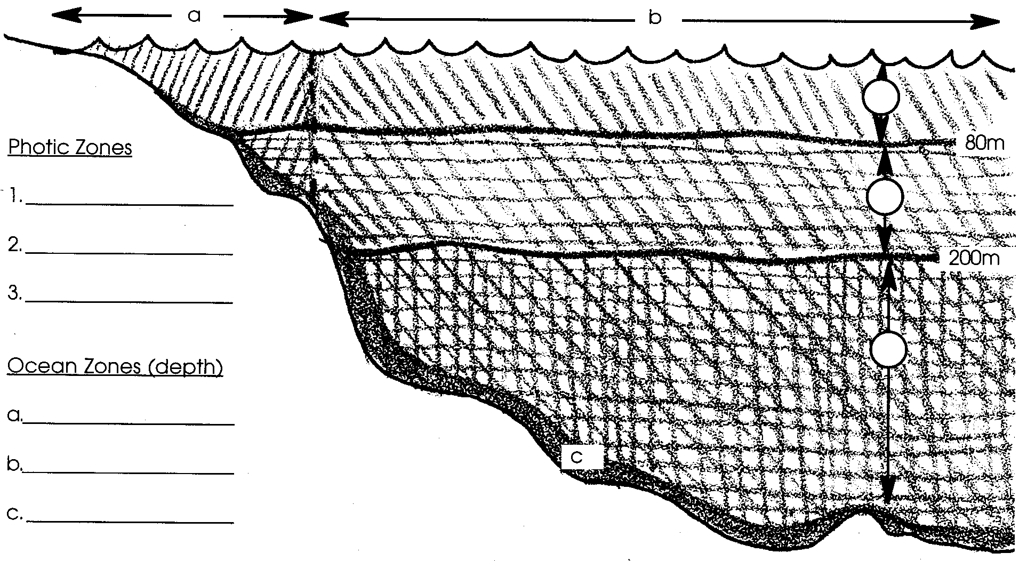

The plants and animals that are found within these divisions are also classified. The three groups of oceanic plants and animals are:

I. Plankton
Plankton are plants and animals that drift at the mercy of the currents for locomotion. The free-floating microscopic plankton are responsible for the colors of the sea. When you see clear blue water, it indicates an ocean desert, or the lack of planktonic life. Plankton can be subdivided into two categories, the plant plankton or phytoplankton, and the animal plankton or zooplankton.
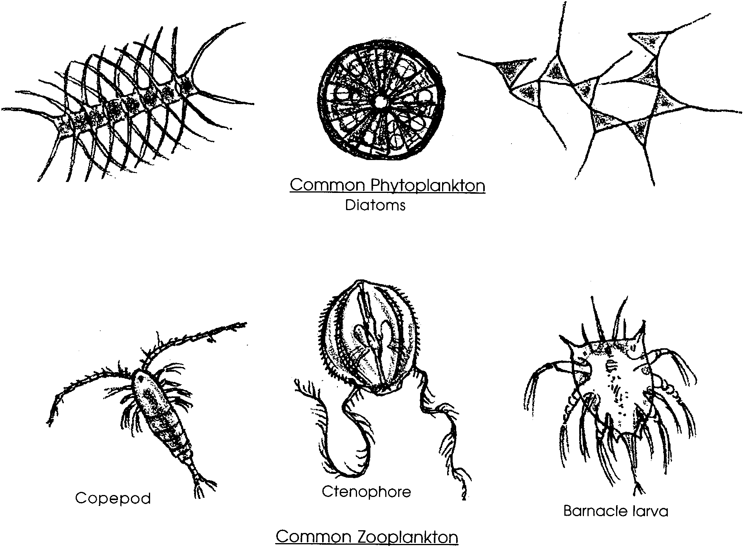
The phytoplankton can be called the “grass of the sea”. These small plants depend upon sunlight to produce the food which becomes the basis for most of the life in the seas.

5. In which photic zone would you expect to find phytoplankton?

6. What is meant by the seemingly contradictory term “ocean desert”?
II. Nekton
Nekton are the fish, whales, seals, sea turtles and some invertebrates such as the squid and shrimp. These organisms are capable of directed locomotion and can swim against the currents, roaming over vast areas of the ocean.

7. In which of the depth zones would you expect to find members of the nekton?

III. Benthos
Benthos, or bottom dwellers, represent the slow moving or sometimes sessile (non-moving) forms. In the coastal zones, chiton, barnacles, crabs, sea anemones, and the like, are part of the benthos. In the deeper abyss, specialized sea stars, urchins, snails, and bivalves are examples.

8. What is one possible source of food for benthic organisms in the abyss?

9. Benthic, abyss, photic, etc.! Why do you suppose scientists have developed so many terms to describe the sea and the things that live in it?

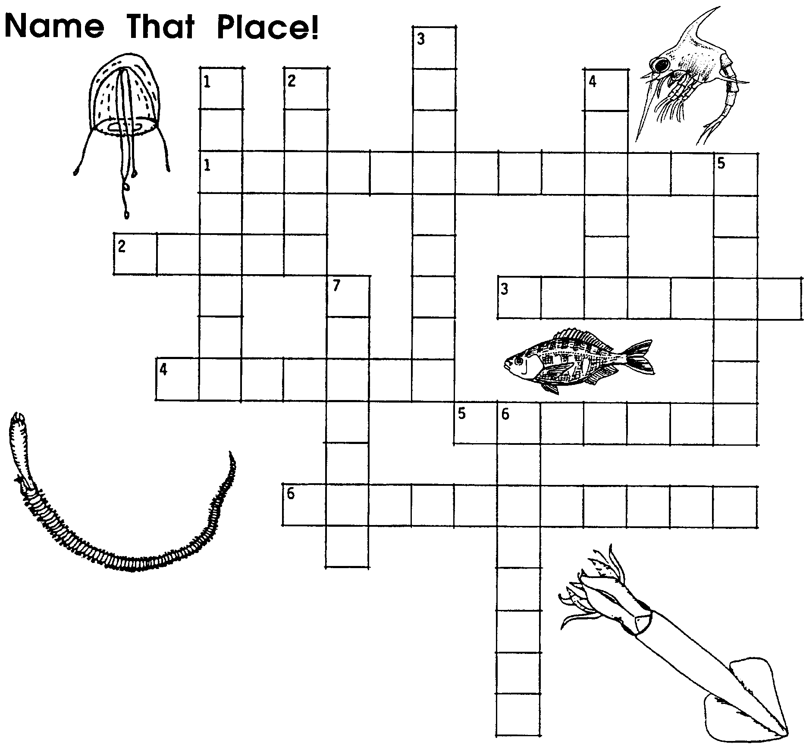

Down
1. This "true light" zone extends from the surface to a depth of about 80 meters.
2. The very depths of the benthic zone.
3. This zone is an area of dim blue-green light.
4. These organisms are capable of swimming against the currents to get where they want to go.
5. This zone extends from the intertidal zone out to about the 200 meter depth at the edge of the continental shelf.
6. These free-floating organisms are at the mercy of the currents for locomotion.

Across
1. The "grass of the sea".
2. Even though they are plants, phytoplankton do not have any of these to hold them in a single spot.
3. This division is the bottom of the sea.
4. This oceanic province contains the largest expanses and the deepest depths of the ocean.
5. This zone is perpetually dark.
6. Free-floating animals that are at the mercy of currents.

