If I Can’t See It, How Do I Know It’s There?
Lesson by Gene Williamson, Whitford Intermediate School, Beaverton, Oregon.
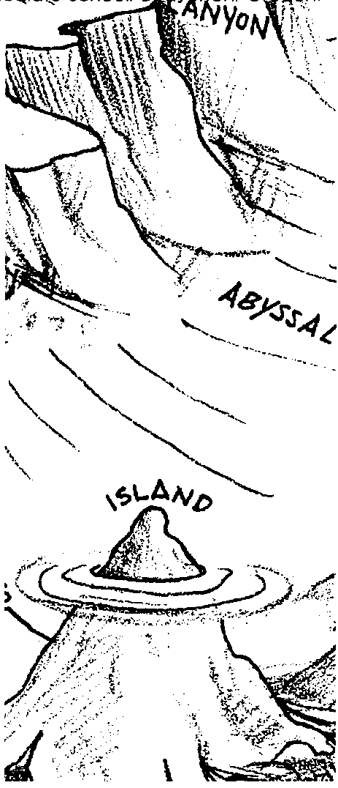

Key Concepts
1. It is possible to know what something looks like without seeing it.
2. Most models of the sea floor are vertically exaggerated.
3. Topographic maps can show a three dimensional surface on a flat sheet of paper.
4. Land forms on the sea floor are similar to land forms on the continents.
5. Many factors affect the accuracy of scientific investigations.

Background
Oceanographers have discovered the shape of the ocean floor by measuring the depth of the ocean in many places. Early tools included lead weights, lowered on marked ropes or cables to the ocean floor. From such depth readings, scientists gradually built a picture of the ocean floor they could not see. These methods were very slow and eventually were replaced by sonar systems which bounced sound waves off the bottom.
Today, sophisticated side-scan sonar and satellite data are fed into computers that are giving us the most detailed pictures of the ocean floor ever obtained. All of the methods allow us to “see” the bottom of the ocean.
Every good model of the ocean floor shows all features as both taller and steeper than they actually are. This occurs for a very practical reason. If the model or sketch were prepared to exact scale, it would need to be very large. Vertical exaggeration is the price we pay to get the model down to a workable size.
Additional background information is found in the preceding activity “The Ocean Floor”.

Materials
For each pair of students:
• 1 shoe box model, sealed with masking tape, and with a grid of holes on top
• 1 bamboo probe, or the equivalent, to be used in sounding the model
• 2 copies of all student pages
• plenty of 1/4" quadrille graph paper
• tag board or old manila folders for mounting cut-out graphs
• large (11"x17" min.) sheets of drawing paper or tag board for topographic maps
• tape for fastening graphs to tag board

Teaching Hints
“If I Can’t See It, How Do I Know It’s There?” provides students with an experience close to the real process of sounding the ocean floor. Each pair of students builds a model of the seafloor inside a shoebox. They trade completed and covered shoeboxes and use skewers as probes to measure someone else’s shoebox creation. The students use the data they collect to map the shoebox ocean floor without actually seeing what is at the bottom of the shoebox.
This three-part activity assumes that students have a working knowledge of the topography of the sea floor that goes beyond having done the activity titled “The Ocean Floor”. Students should know the size and shape of the sea floor features listed here, and should understand their location with regard to the three major divisions of the ocean floor discussed in the previous activity. The FOR SEA grade 8 curriculum, Ocean Studies, Ocean Issues , contains additional activities dealing with ocean basin topography.
Building a model of the sea floor in a shoe box is a way to acquire and demonstrate an understanding of the structure of the sea floor. Have ocean bottom maps, models or globes available so students may pattern their boxes after real ocean floor features and patterns. A small map of a fictional ocean floor is included in this lesson. Students may choose from the following features in building their shoe box models of the sea floor:
abyssal hills
abyssal plains
atoll
bay
continental rise
continental shelf
continental slope
fan
fracture zone
gulf
guyot
island arc
mid-ocean ridge
rift valley
seamount
submarine canyon
trench
It is certainly not necessary to use all items on this long list. Students should have at least 10 objects from which to choose as they build their models. Note that models with considerable relief will be easier to map.
You may find it necessary to build some shoe box models both to demonstrate different construction techniques and to use in class if you do not get enough acceptable models from the students.
The following hints will help assure the mechanic part of this activity goes smoothly.
1. Building the shoe box model is a very important part of this lab. Each pair of students will need to secure a sturdy shoe box complete with top. The top will need to have small holes (a compass point works well for this) punched every centimeter to provide a grid through which the ocean model may be probed. A centimeter grid template is included with this activity. The requirements for an acceptable student model, as well as some aids and suggestions for constructing the model are included in the student pages.
Let students share ideas and ask questions about the process. They may use any materials that fulfill the requirements outlined in the student pages. Successful models have been constructed out of everything from plywood to Legos™ to home-made play dough.

2. Demonstrate every step. Do not assume that students will know what to do, but do be ready to accept student suggestions for making things go faster and easier. Most of this activity has been developed by students with an instructor wise enough to keep his ears open and his mouth shut.

3. Bamboo skewers are available at most grocery stores and virtually all Asian markets. They make ideal probes. Students seem to have the most trouble with the concept of “to the nearest half centimeter” when reading the probe. They will either round off to the nearest centimeter, or will try to read to the nearest millimeter.

4. Do not expect all students to complete all parts. Some will be better at one part than another. Let them teach each other. Since they should be working in pairs, you need to decide whether they will pair themselves or you will assign pairs.

5. Analysis of an unknown shoe box develops the ability to make careful observations and measurements, organize data, display data in new ways, and make inferences based on the data collected.

6. Topographic mapping is a new skill for most students. It can be a great deal of fun, but it can also be a trying and, therefore, a learning experience.
A practice topographic map is included to help you and the students learn this new skill. To avoid having students deal with unnecessary lines in their topographic maps, use the 0.5 inch grid provided. Have students place the grid behind their map paper and then copy their data sheet by placing the numbers at the intersections of the grid. Have them write the data in hard, sharp pencil. The numbers should be written as small and as lightly as possible. This will facilitate not only the construction of the map, but also the removal of the data numbers when the map is finished.

7. You may involve students in any of the phases of the project you and they have time for and think are worthwhile. They may be involved in the relatively simple building of the ocean floor models, probing through the lids of the shoeboxes to collect data, constructing graphs and three-dimensional models of their data, and in the more difficult construction of topographic maps of the shoebox floors. Do not string the activity out too long. Here is a suggested schedule:
1 day - Describe or demonstrate the building of models and requirements for an acceptable model. Plan to collect the models one week after they are assigned. You will need overnight to seal up boxes and put identifying numbers on each.
2 days - Hand out boxes and have students collect data.
3 days - Students graph data, cut out graphs, and prepare 3-D models.
1 day - Students should prepare grids for topographic maps.
1 day - Give instructions on topographic mapping and do demonstration. Use an overhead projector to go through mapping process on step at a time. This may take more than one day when you are starting out.
3 days - The students work on topographic maps. They will need a great deal of help and encouragement. You will need many aspirin.
1 day - Students report findings, write conclusions and when completed projects are submitted, open the shoe box. They will want to open the box earlier than this. Be strong. Remember that our first objective is to teach students to see without looking.
This is twelve class periods if everything goes smoothly. Should you choose to skip topographic mapping, the abbreviated activity can be completed in about eight class periods.

Key Words
calibrate - to adjust or systematically standardize the graduations on any quantitative measurement instrument
grid - any set of intersecting parallel lines, a piece of graph paper is an example
interval - in this case, the space between any two marks on a measuring instrument
probe - in this activity, a bamboo stick which is used to measure the depth at each “station”
side-scan sonar - a type of sonar which is capable of taking depth data for a wide swath of the sea floor beneath a research vessel
station - the position of a research vessel at the time data is collected
vertical exaggeration - an effect caused by using different scales for vertical and horizontal distances in models of the ocean floor, it makes models of features steeper than they are in reality

Extensions
1. Feed depth data into any of a number of computer graphing programs to draw the cross-section maps. More sophisticated programs could be used to show three dimensional views.

2. Have students color the topographic maps to show relief in much the same way that computer generated maps of the sea floor are drawn. Colors represent the range of depths between adjacent lines, and should be added only after the topographic map is completed satisfactorily. This works best if the colors become darker as the water gets deeper. For example, shading from white to pastel blue to blue to navy blue works well.

3. Have students use the library or other research facility to find out how modern oceanographers are using satellites to measure ocean depths. It is a first class “science fiction” story of satellites, lasers, and computers. We have come a long way from the lead weight and rope.

Answer Key
Analysis Questions
1. Answers will vary, but most students will see distinct similarities.

2. Answers will vary, but in general smaller objects are harder to locate and identify. Also objects near the edge of the box may have distorted data caused by the probe contacting the sides of the box.
3. The most obvious ways to improve accuracy would be to use more accurate measurement and to use more stations and gather data at smaller intervals. This is the advantage of sonar which can collect continuous data along the ship’s track.

4. Modifications might include a hollow boring tip or some type of sticky substance attached to the point of the probe. Accept any reasonable answer.

5. The measurement of depth with rope and lead weight was slow and exceedingly tedious. Sonar allowed for virtually unattended and constant measurement of the water depth under the hull. The accuracy and the availability of maps increased dramatically with the introduction of sonar.

6. Trawl fishermen are interested in detecting environments that fish like to frequent, and they are also interested in not allowing expensive nets to become entangled in unseen hazards.

7. The captains of ocean going vessels seldom worried about the depth of the water under their hulls until they arrived “close upon the land”, at which time an accurate understanding of water depth became a matter of life and death. Also, given the tedious nature of depth measurement, there were very few measurements being made in deep water. Magellan, on his final voyage around the world (the ship made it, Magellan did not) used every available foot of line and still could not reach the bottom of the Pacific.
If I Can’t See It, How Do I Know It’s There?
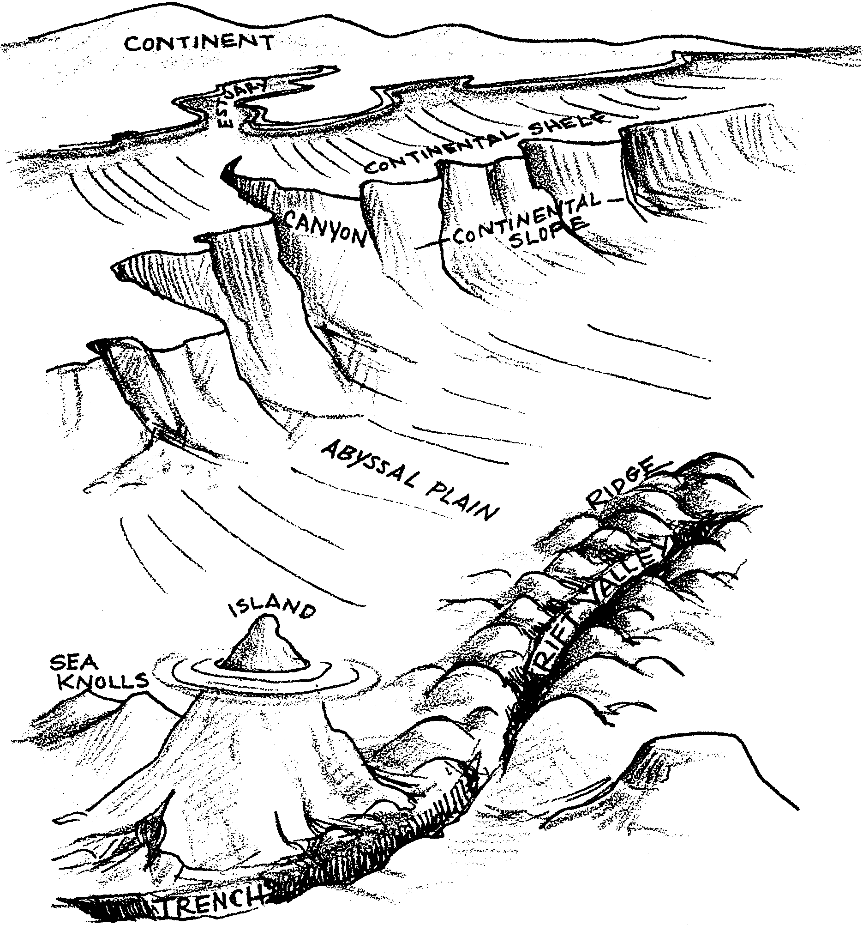

Oceanographers have a problem. Everyone from mineral companies trying to cash in on the ocean’s riches, to military experts trying to guard our coasts, to engineers trying to build structures on the sea floor want to know exactly what the ocean floor looks like. Unfortunately, the ocean floor is covered by an average of over two miles of water. Deep submergence teams cost hundreds of thousands of dollars per day to do sea floor exploration. How can the oceanographers learn what the ocean floor looks like and be certain that their picture of the bottom of the sea is accurate?
The answer lies in the careful analysis of literally billions of data points generated by satellites, side-scan sonar, and other measurement instruments. The accuracy of the picture reflects the care the oceanographers take to see that instruments are properly calibrated and that data are gathered systematically and carefully analyzed. This activity will involve you in a similar project in which your success will depend on the same factors.

Part One: Building a Model Ocean

Your first assignment is to build a model of some part of the ocean floor in a shoe box. This is not as difficult as it may sound. There are some rules to be followed, but you will have a lot of latitude to decide what your model will look like and how you will construct it. Your shoe box should be a “normal” size. No baby shoes, and no logging boots. The box should be fairly sturdy, and must have a top. If you do not have an extra shoe box at home, any shoe store can provide one.
It is not possible to fit a model of the entire ocean floor into a shoe box without making everything extremely small, so you should settle on a portion of the sea floor. It is not necessary to include the continental margin in your model, but many students do because the margin is relatively easy to build and helps the investigating scientist determine orientation for the model.
Your choice of materials for building the model is almost unlimited. Some of the more popular choices are papier-mâché, home-made play dough, plywood or cardboard pieces that can be stacked and glued to form ocean floor features, or even Legos™. The trick is to build a model that fits all the requirements, but doesn’t cost more than a few pennies. (Hint: If you are using play dough or papier-mâché, be sure to get an early start so that these materials have time to dry before the project is due. Drying usually takes two to three days!) Papier-mâché can be placed over some common objects to help form features. For example, two paper cores from hand towels or toilet paper placed side by side will create a mid-ocean ridge complete with rift valley. One inverted egg cup from any paper egg carton will create a seamount or guyot. Use your imagination.
Begin by sketching a picture of what you would like to build in the model. Next, have your drawing checked by your teacher to see that you have placed objects in the correct locations and that they are about the right size. Use all of the resources available to you in the planning stage.
All models of the sea floor are subject to vertical exaggeration. This means that slopes are steeper and higher in the model than in the real ocean. Your model will have some other size distortions as well. This is expected and acceptable. Do the best you can.
When you have a plan and your materials, follow these rules to build a great model.

1. Choose between seven and ten ocean features from those you have studied.

2. Be sure that you build your features where they would be found in the real ocean. For example, submarine canyons should only appear in the continental margin.

3. Any object you expect to have recognized by the team that will probe your box must be at least 2 cm across and 1 cm high. Objects smaller than this will be missed by the sounding instrument.

4. Make sure that the material you are using will produce a hard, solid surface. This usually means four to five layers of papier-mâché, and it eliminates some materials, such as modeling clay, which never does develop a hard surface. It is best if the surface is slightly rough. The texture keeps the depth probe from slipping sideways. If your surface is very smooth, paint it with a little white glue mixed with water, and then sprinkle it with sand or salt.

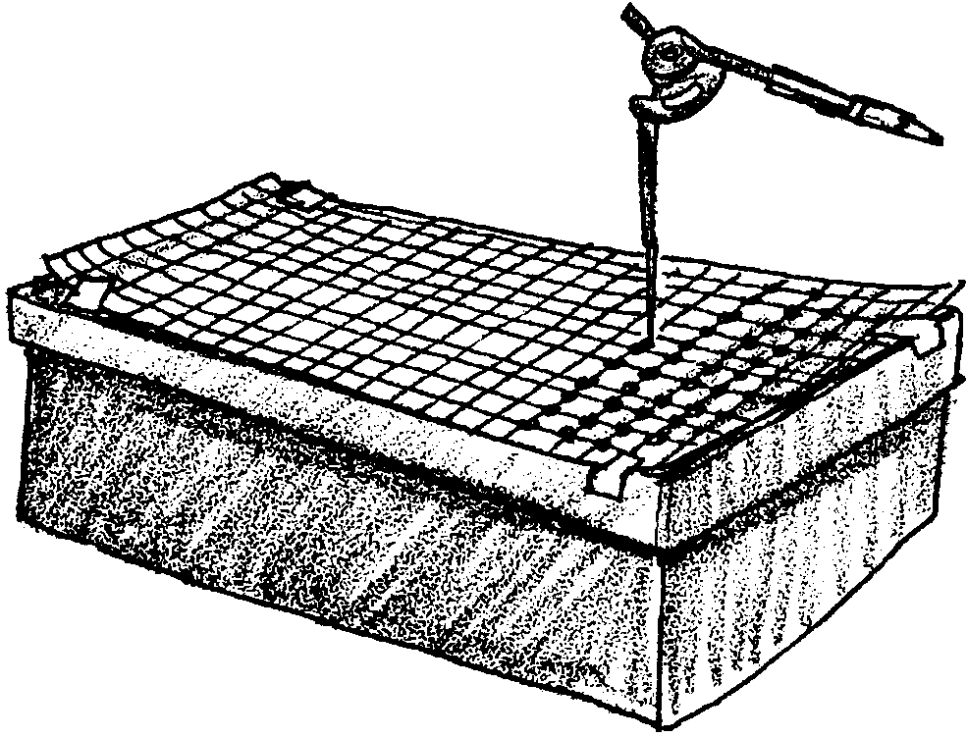
5. Tape the piece of 1 cm graph paper to the top of the shoe box, and use a compass point or small nail to punch a 1 cm grid into the box top. (Hint: Wear a leather glove on the hand that is holding the box top, and be careful!)
When complete, be sure your name is on the inside of your model and turn it in to your teacher. Your teacher will seal the model, and redistribute them. For Part Two, you will be getting another group's model to analyze.

Collecting and Displaying Data:

You and a partner have been assigned a model of the ocean floor. Your job is to investigate the model and describe its appearance without opening the box. (Yes, if you insist, you will be able to look in the box, when the project is completed.) This is precisely the problem faced by oceanographers trying to describe the appearance of the ocean floor. Like an oceanographer, you will need to calibrate your measuring device, collect data carefully, and then analyze the data to reveal the shape of your ocean floor.
The materials you will need are:
• your shoe box model
• a measuring probe
• two data collection sheets
• several sheets of graph paper
• scissors
• tape
• a piece of manila tag board

Please check the number on your shoe box model and write it down. This number must be placed on everything you produce so that your project is compared to the correct box.

Here is what you do:
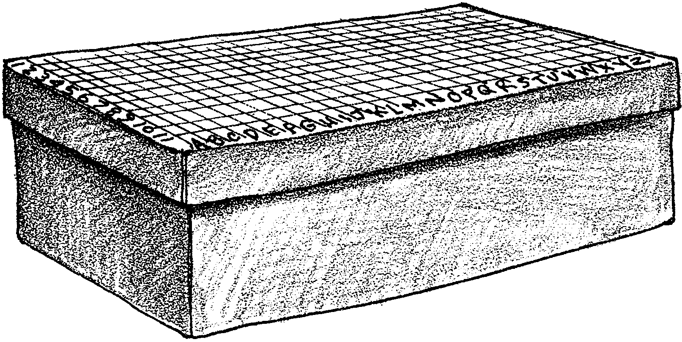
1. Start by labeling the rows of holes in the shoe box. Across the long side of the shoe box, label the rows “A”, “B”, “C”, etc. Along the short end of the box label the rows “1”, “2”, “3”, etc. This will leave each hole or “station” with a number and letter as coordinates. If you later wish to measure hole “F4” again, you will be able to locate it quickly.

2. Now prepare your measurement probe. The probe should be marked at one cm. intervals to match the depth of your shoe box model. Make the marks in ink or other permanent material. Pencil marks quickly smear and become unreadable. To make counting easier, make the marks for five and ten centimeters a different color from the rest. The probe should look like this:

3. Look at the data sheet. It may not match the size of your box exactly. If not, change it to match your model. It is extremely important that you keep two copies of the data sheet, and that each partner keep one of the two sheets. If the person holding the data is absent, the other person would have to start over collecting data. When you have the depth data for hole “A1” enter that data in the space labeled “A1”. It is not necessary to write cm on your measurement since all measurements will be in this unit.

4. It is usually easier to gather data by working across the box, doing row 1 and then row 2, but you may use any system you wish.

5. To measure the depth of any station, be sure the probe is vertical, and record the depth the first time you feel the probe touch the model. Record all depths to the nearest 0.5 cm. If you think the depth is 5.75 cm, you may decide to call it either 5.5 or 6 cm, but be consistent.

6. Since many shoe box tops bow down toward the center, a ruler should be laid across the box and measurements should be read where the probe touches the ruler. This will provide a consistent “sea level” for your model.

7. When you have gathered data from all the stations you are ready to start construction of a three-dimensional model of the ocean floor. This will be very useful in helping you find the features of your sea floor.

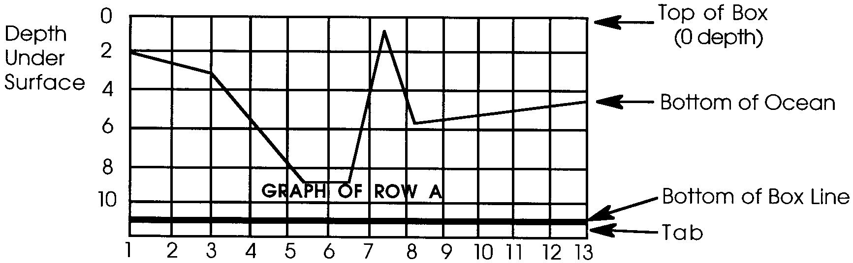
8. Watch the demonstration of how to draw cross-sectional graphs from the data you have collected. You should look over your entire data sheet and locate the deepest point in your entire model. Let’s say that the deepest point is 11 cm. You then add one cm to this. The total of 12 cm becomes the bottom edge of every graph you will draw. If the deepest point is not a whole number, perhaps 9.5 cm, then you would round up and add one cm. In this case, you would use 12 c. as the bottom edge of your graphs. The extra depth is added so that when the graph is cut out it will stay in one piece. A typical graph might look like this:

9. Draw a graph for each lettered row from your data sheet. Be sure you label each graph (on the “land” portion) as you go. They all look somewhat alike, and you will need to know which one is which after they have been cut out.
10. Cut out each graph as demonstrated. (Check to be sure your label is on the “land” portion of the graph - the part you keep!) Bend over the last square at the bottom edge of each graph as illustrated. This will give you both a foot to stand the graph on edge, and a measurement to space the graphs the correct

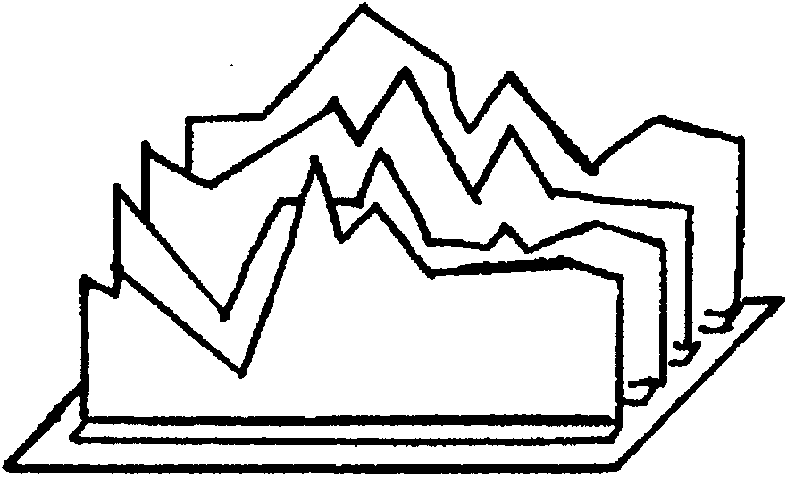
11. Making sure that the graphs are in the correct order, and facing the right direction so that they match the data you collected, tape the graphs to a piece of tag board as illustrated. Be careful to get the graphs aligned properly before taping them down. When all of your graphs are taped in place, you should begin to recognize some of the features that are hidden inside the shoe box.

12. If you are ahead of the group, or have some extra time to spend outside class, repeat this same procedure using the lettered rows. This set of graphs will show you any features that may lie lengthwise in the model. Such features will not show up well in the first set of graphs.

13. Be sure to label your graphs with your names and the box number. If you are going to be drawing topographic maps of your model, pick up the instructions and begin to prepare the data for your map.

Topographic Mapping

You are now ready to undertake one of the most effective displays of ocean depth data. This is the topographic map. Some of you will have had experience with “topo” maps. If you have done any backpacking, surveying, orienteering, or other similar activity, you may have used a topo map. Topo mapping looks confusing at first glance, but, if you can count from one to ten without making any mistakes, you can draw a topo map.

Here’s what you will need:
• a copy of your data sheet on a 1/2 inch grid, as demonstrated
• a sharp pencil, preferably #3 or harder
• a set of “Topographic Map Instructions”
• a fine-tipped marker, such as a Flair pen

Practice Topographic Maps

1. Work through the practice topo maps to be sure you understand the basic rules of map drawing. Start with the Practice Map, below.
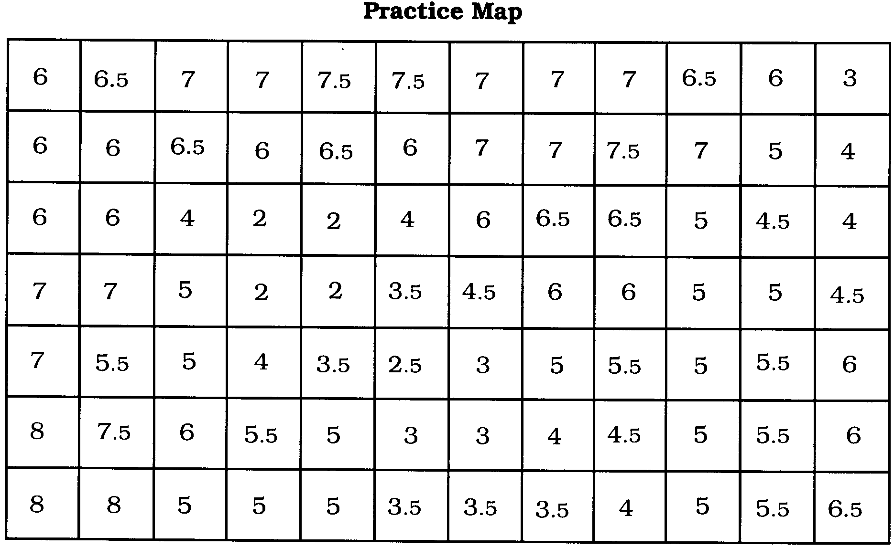
Begin with a high point shown by shallow water or a low point where there is deep water. For example, if you look at a high point in this sounding data, you will find that “2” is the smallest measurement. The water is most shallow there. Connect the 2s by starting at one 2 and drawing from that 2 to the next until all are connected. Label the line clearly with its depth. Make sure your lines never cross. In this case, you get a round feature, perhaps a seamount, or underwater island.
2. Your Practice Map should look something like the Practice Map 2, below. Look at the map and think about what the numbers mean. Where does the ocean floor drop off steeply, going from the 2 cm deep seamount to very deep numbers, say 6 or 8 cm deep? Where does the ocean floor angle away at a gentle slope, going gradually from the 2 cm deep seamount to 3 cm, then 4 cm, the 5 cm and so on?
You will draw many close together contour lines where the ocean floor is steep and far apart contour lines where the ocean floor is sloping gently. Continue on your Practice Map by connecting the 3 cm depth numbers.
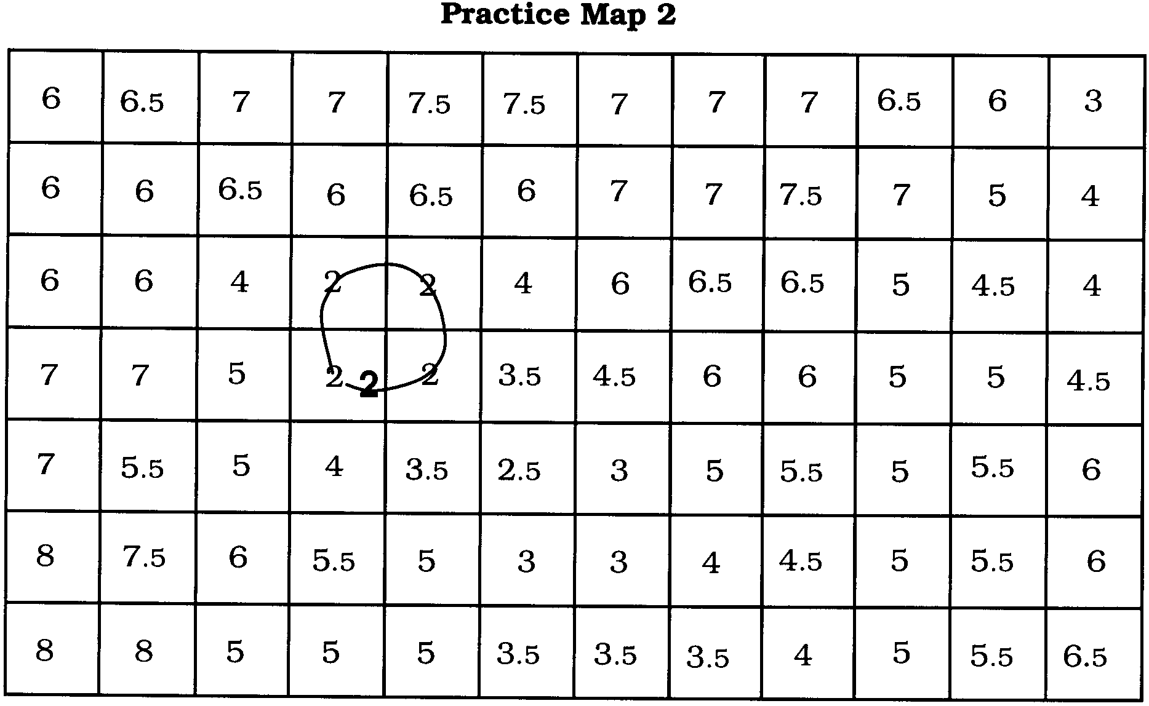
Remember, lines surround other lines you have already drawn. They fence off areas of the same depth and disappear off the map when possible.

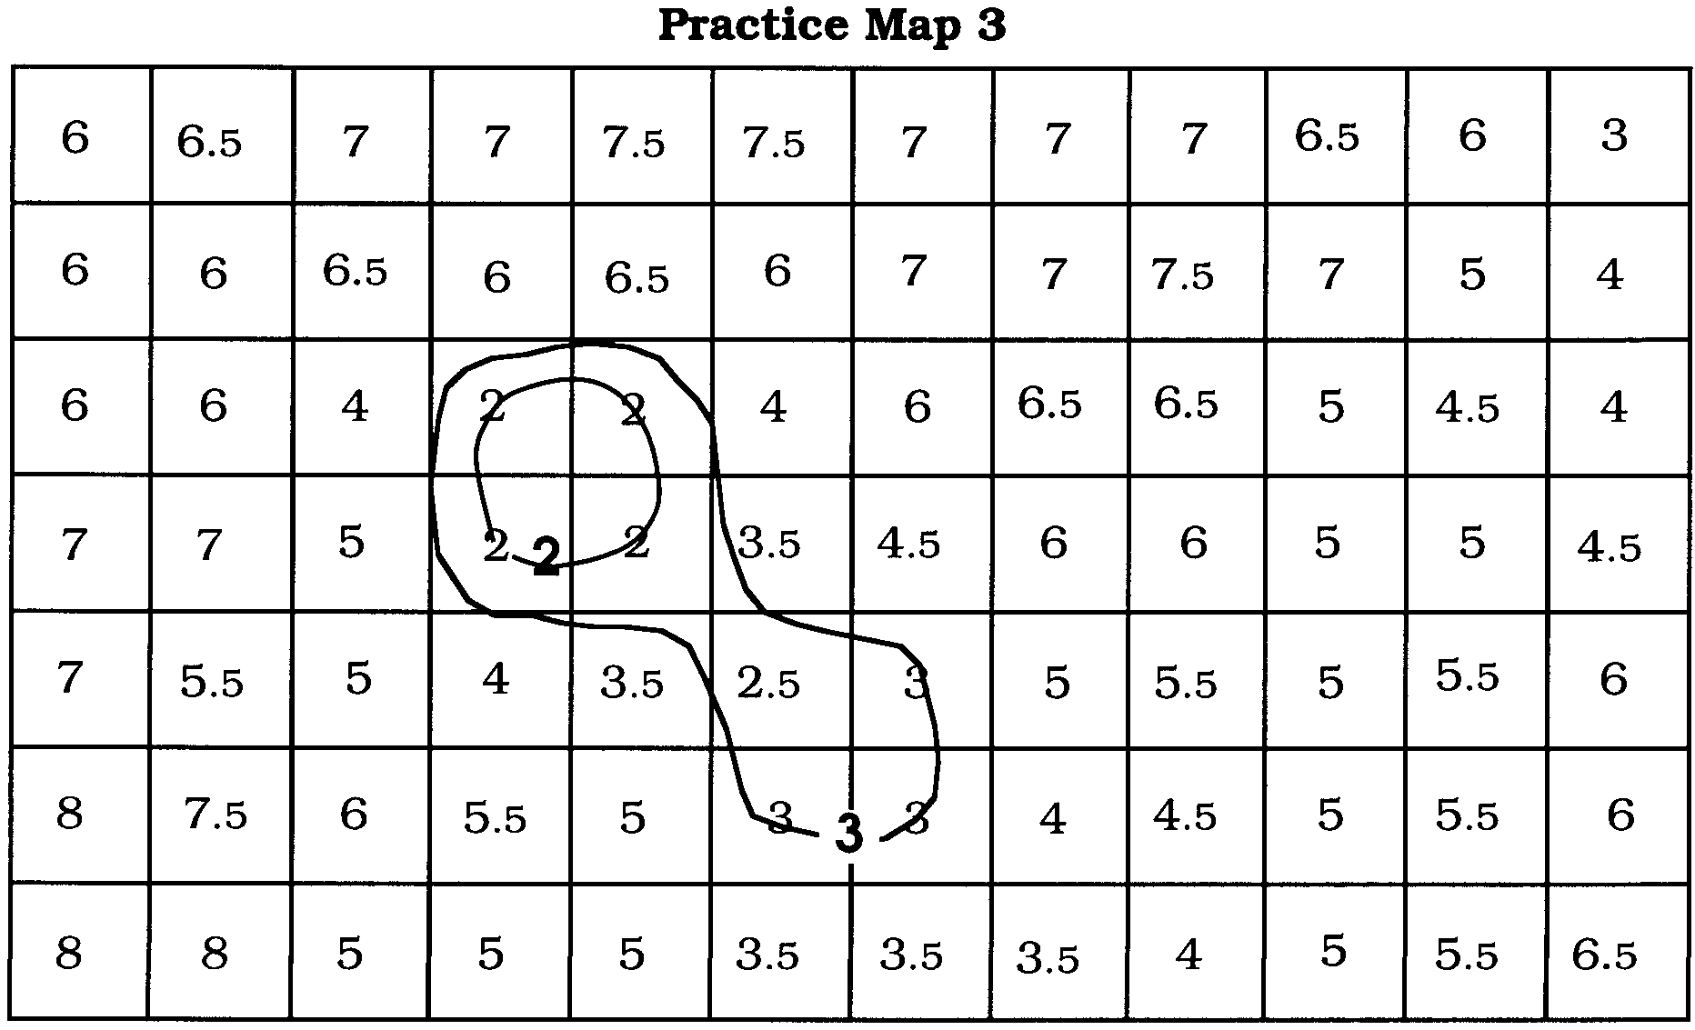
3. Your Practice Map now should look something like the Practice Map 3, below. Continue on your Practice Map by connecting 4 cm depth numbers. Be sure to label the depth at both ends of any line that leaves the map.

4. Your Practice Map now should look something like the Practice Map 4, below. Continue by connecting other depth numbers.
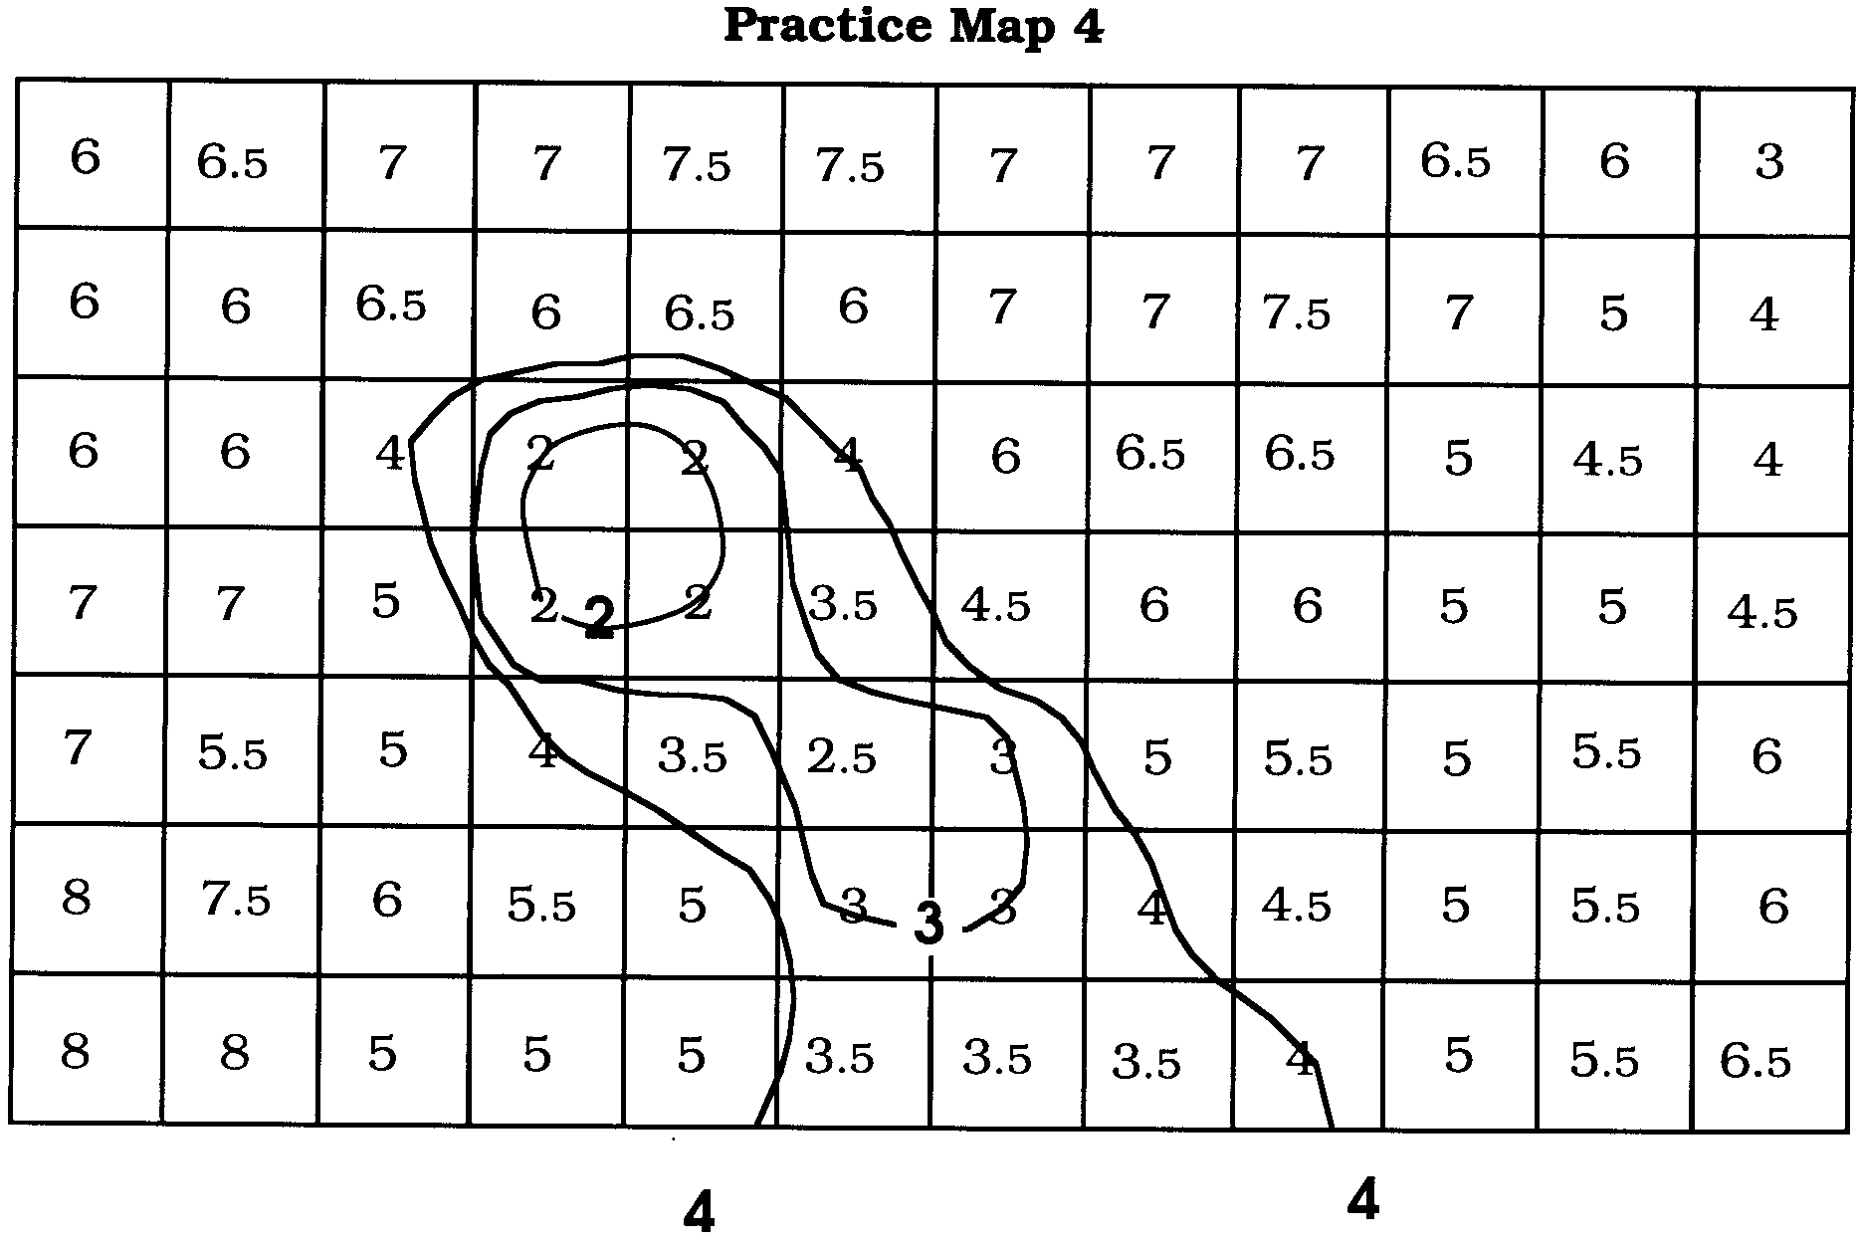
There are a lot of places where you must estimate depth. For example, when you try to connect all the 6s, you will find a place as you draw where there is a 5 and a 6.5, but no 6. Well, the 6 must be in between those numbers, so estimate where you should draw.

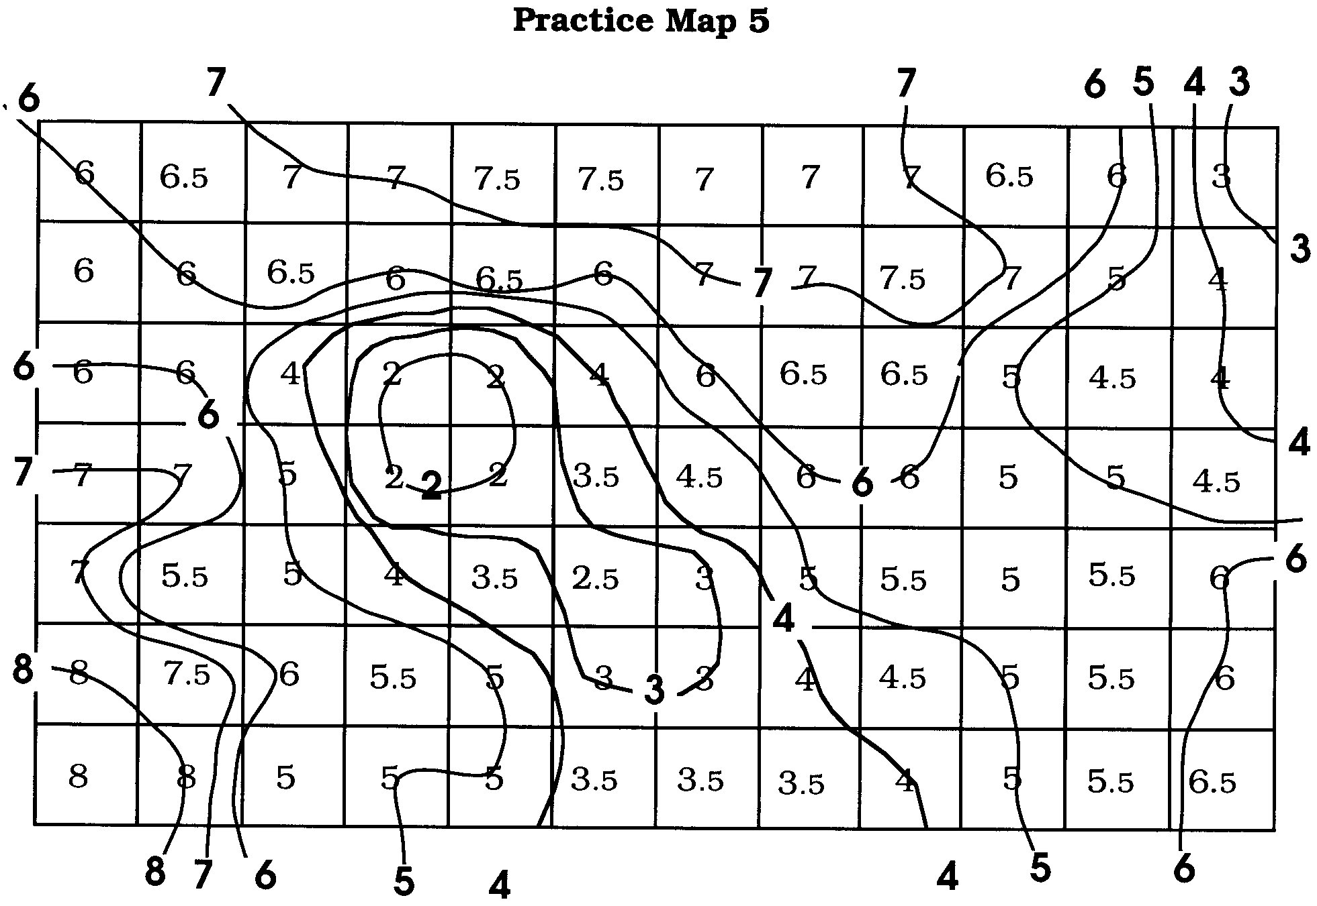
5. Wow! That's a lot of lines to keep track of. When you've finished, your completed Practice Map should look something like the Practice Map 5, below.

Note: There are numerous, slight variations to the solution on Practice Map 5, all of which are acceptable if the rules have been followed.

Frequently Asked Questions:

1. What about the 2.5 cm line? If you mapped correctly, the 2.5s should be between the 2 line and the 3 line. It is not necessary to connect them, but you may if you like.

2. When I'm drawing, say the 6 line, is it necessary that the line pass through every 6 on the map? No. The line should define the outer limit of a given depth. There may be many measured points contained within the line. Sometimes there even will be 6.5 cm measurements inside the line. This is acceptable since you don't need another line until you get the depth of 7, or 5 if you are moving into a shallow region.

3. Can I have more than one line with the same number? Yes. You can use as many lines as necessary to define all the areas of the map. In this map you will have one 3 line in the center and a separate one in the upper right hand corner.

4. Do I have to draw a line for all the half centimeter measurements? Usually, no. Some maps may need to do so, especially if the model does not have much relief.

5. How do I know when the map is finished? You are finished when you can go across the map in a straight line, or around the edge of the map and find no numbers missing or improperly repeated.

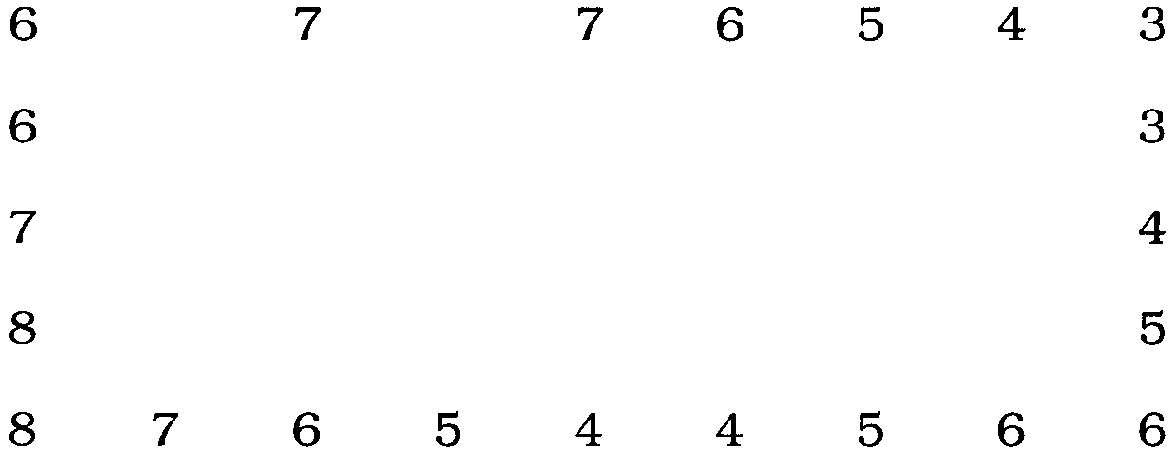
For example: Start in the upper right hand corner of the map and count the line ends all the way around the map. Going clockwise, the sequence is:

If you've missed a line, your number sequence will have a gap (e.g., 4, 6, 7, instead of 4, 5, 6, 7). The lines will come off the map at the points where the gaps occur.

Note that whenever a number is repeated, the direction changes. If the depth has been decreasing, a repeated number signals that the depth will begin increasing. This must happen anytime the direction changes. If it does not, the map is not completed! If a number is repeated three times, there is no direction change. If the number is repeated four times, there will be a change. Odd number of repeats, no change. Even number of repeats, change.

You may also check your work by placing a ruler across the map at any point and counting the lines as they intersect the edge of the ruler. Anywhere you count should yield a proper number sequence, with no skips and no improper repeats.

Rules and Helpful Hints for Topographic Mapping

Purpose and Rules:
a. The purpose of a contour map is to show a three dimensional surface on a two dimensional sheet of paper.
b. This purpose is accomplished by construction of a series of contour lines
which show the shape or contour of the land.
c. Contours are lines of equal depth. There may be more than one line with
the same depth on a contour map.
d. All points on a given contour are the same depth. It is important to keep in mind that the line does not have to touch every point. The line needs to touch or enclose one kind of number. Sometimes a 4.5 will end up inside a 4 line. While this is technically not correct, it will not affect your map. Most of the 4.5 data points will end up exactly where you would expect to find them, between the 4 line and the 5 line.
e. Two contour lines may never join, and they may never cross, even if they have the same depth.
f. A contour line never branches.
g. A contour line never ends in the middle of the map.
h. Usually a contour line will surround a given parcel of land, and thus form a continuous line.
i. If a line does not surround a parcel of land, it must disappear off the edge of the map. Whenever a line is taken off the map, the end of the line must be labeled to indicate its depth.
j. Contour lines should not make sharp angles if it can be avoided. Rather they should make smooth, regular changes of direction.
k. If one point shows a depth of 1 cm and the next point shows a depth of 3 cm, the contour line for 2 cm must occur between the two points. Likewise, if one point measures 4.5 cm and the next measures 7 cm, contour lines for 5 cm and 6 cm must occur between.

Hints:

a. Always begin at the deepest or shallowest point of any feature and work outward until it becomes impossible to tell where the next line will go. Then stop and go to work on another area of the map.
b. Save the hardest lines for last. Completing other features first will guide you in deciding where the last lines belong.
c. If you have a choice of taking a line off the map or running it up the side of the map, in 99 out of 100 cases, getting off the map is the right choice. Don’t forget to label every line.
Making a Topographic Map of Your Shoe Box Data

Construct the topographic map for your shoe box data following the rules and hints above and the steps used to make the practice map. When you are sure your map is complete, carefully ink over the contour lines, being sure to label each with the depth it represents. When all lines are inked and labeled, carefully erase the data numbers and your topo map is complete.
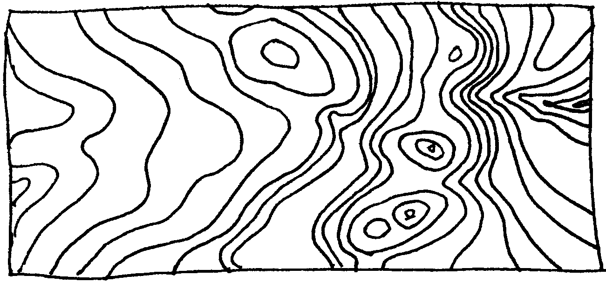
As the conclusion to your shoe box investigation, draw an aerial view sketch of your section of the ocean floor and label as many features as you think you can identify from your graphs and maps. The final product might look something like this:

Label this final drawing with your name and shoe box number, and prepare all parts of this activity to be handed in. Congratulations! You are now ready to open your shoe box and answer the final analysis questions.

Analysis and Interpretation

1. In general, did your graphs and map match what you found inside the box? Explain.

2. Did you miss any features? What kinds of features are easiest to miss? Do you think oceanographers have similar problems when investigating the ocean floor?

3. How could you have improved the accuracy of your results?
4. Suppose you wanted to know what the bottom was made of. How could you modify your probe to give you this information?

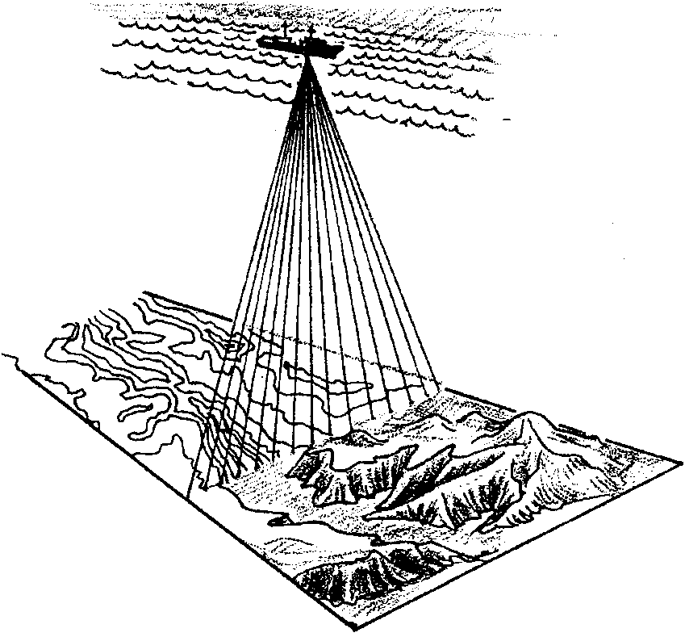
5. The “probe” used by early navigators and oceanographers was a lead weight on a rope or cable. Based on your experience, why do you think oceanographers were very happy to see the development of sonar equipment for measuring ocean depths? What do you think happened to the accuracy of ocean floor maps after sonar was introduced?

6. Imagine that you are a trawl fisherman. You drag nets behind your boat to catch fish such as red snapper, which live near the bottom. Give at least two reasons you would want to study a contour map before you began fishing.

a.

b.

7. The first bathymetric charts were prepared for coastal areas. What are two reasons which might account for this fact?

a.

b.
Shoebox Data Sheet
1 2 3 4 5 6 7 8 9 10 11 12 13 14 15
A
B
C
D
E
F
G
H
I
J
K
L
M
N
O
P
Q
R
S
T
U
V
W
X
Y
Z
Shoebox Data Sheet
1 2 3 4 5 6 7 8 9 10 11 12 13 14 15
A
B
C
D
E
F
G
H
I
J
K
L
M
N
O
P
Q
R
S
T
U
V
W
X
Y
Z
