The Ocean Floor
Lesson by Gene Williamson, Whitford Intermediate School, Beaverton, Oregon.

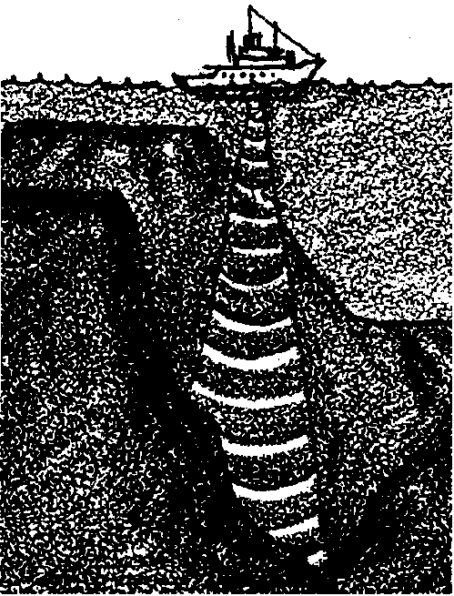
Key Concepts
1. The ocean floor has a varied and dramatic topography including abyssal plains, mid-ocean ridges and slopes and trenches near the edges of continents.
2. Scientists have developed increasingly sophisticated technology to discover the topography of the bottom of the ocean.

Background
Our knowledge of the sea floor has increased tremendously in the last few decades. Geologists are now busy studying the ocean floor in a search for clues to the origin and evolution of the continents. They have discovered new features such as the deep sea hydrothermal vents. In the summer of 1993, scientists recorded for the first time a deep sea volcanic eruption.
As voting citizens, today’s students may face the problems arising from increased exploitation of the mineral deposits from the ocean bottom. The ocean floor has traditionally been viewed as a “commons”, an area which all people from all countries may use, but which none may own. This view is being challenged as ocean mining companies lay claim to vast tracts of the ocean floor and simultaneously ask their governments to protect the miners’ interests in these claims. While debate at the United Nations takes place over division of the resources of the ocean floor, great consortia of mining companies are exploring and laying claim to the mineral rich areas of the ocean bottom. The differences between these claims and the wishes of the developing nations have yet to be resolved. The role of the United States in these deliberations is constantly being redefined, and our government has found itself squarely in opposition to the wishes of developing nations on more than one occasion.
Coupled with increased information about the geology and chemistry of the sea bottom, the rush to exploit the ocean floor has just begun. We can be sure that the problems that arise from that rush will have to be faced and answered by our students at some future date.
Materials
For each student:
• a copy of “The Ocean Floor” student pages

Teaching Hints
“The Ocean Floor” serves as an introduction to physical oceanography. It takes a look at how humans probe the ocean floor and at the ocean bottom features they have discovered.
In this unit, students will have the opportunity to learn about new discoveries in the burgeoning field of oceanography, discoveries some of them may help further in their careers.
Recent oceanographic research also may affect students even if the students do not plan to be scientists.
If possible, display maps, models and globes of the ocean floor so students can see concrete images of the ocean floor features about which they will read.
To create a context for “The Ocean Floor” reading, share with students' recent news stories about ocean floor discoveries or describe the general issues posed by deep sea mining. As an alternative, you may wish to use this reading as an information source for the next activity, “If I Can’t See It, How Do I Know It’s There?" in which students probe models of ocean features enclosed in shoeboxes. Explain that students will be constructing ocean floor models and will need to know the general lay-out of the ocean floor and specific features they might choose to put in their models.

Key Words
abyssal plain - the very deep, very flat portion of the sea floor that extends from the bottom of the continental rise out to the mid-ocean ridge
basin - the entire depression in which the ocean resides
continental margin - the relatively shallow portion of the ocean that surrounds the continents resulting from a flooding of the continental edges by rising sea level
continental rise - the accumulated sedimentary deposits that mark the juncture between the continent and the deep sea floor
continental shelf - the shallow and flat area abutting the continents, its width varies from a few miles to a few hundred miles
continental slope - the steep decline from the edge of the continental shelf (shelf break) to the deep sea floor
echo sounders - devices, used to measure ocean depth, which emit sound waves and detect their reflection
lead lines - a line by which a lead is lowered into the water to take soundings; these were among the earliest devices used to measure the depth of the ocean
mid-ocean ridges - tectonic spreading centers found in each major division of the ocean
seamounts - underwater volcanic peaks, varying from 600 to 30,000 feet in elevation
sonar - acronym for “sound navigation and ranging”, a device for measuring ocean depth as well as for detecting underwater objects
sounding - any method of determining ocean depth or the data point so obtained
topography - the general shape of a geographical area such as the sea floor.

Answer Key
1. Sounding the depths of the ocean means measuring the depth of water over a particular spot. Sounding was traditionally done with lines weighted with lead.

2. Topography of the ocean floor refers to its shape or contour.

3. The three major divisions of the ocean basins are: the continental margin, the abyssal province, and the mid-ocean ridge.

4. The continental slope begins at a depth of about 250 meters or 0.25 kilometer (800 feet). The answer comes from the illustration.

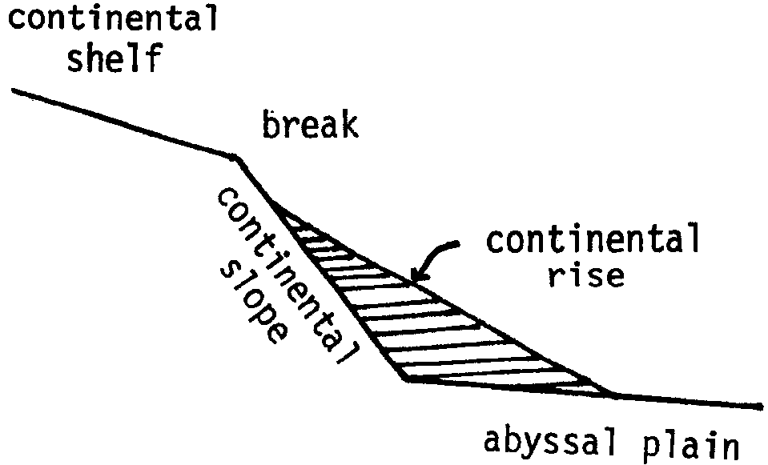
5. The continental margin runs into the deep sea floor at about 4.75 kilometers in depth (about 15,400 feet). This schematic diagram may be helpful in illustrating the relationship of the three parts of the continental margin:
The boundary between the continental shelf and the continental slope is marked by a sharp break in contours. The continental rise is actually a wedge of sediment from the continents built up between the continental slope and the abyssal plain.

6 a. The deepest area shown is about 3000 fathoms (18000 feet).

b. The Andes are about 3000 fathoms high (18,000 feet).

c. If we put the highest Andes mountains in the deepest part of the cross section they would just reach the surface.

d. The mid-Atlantic ridge rises to within about 1200 fathoms of the surface.
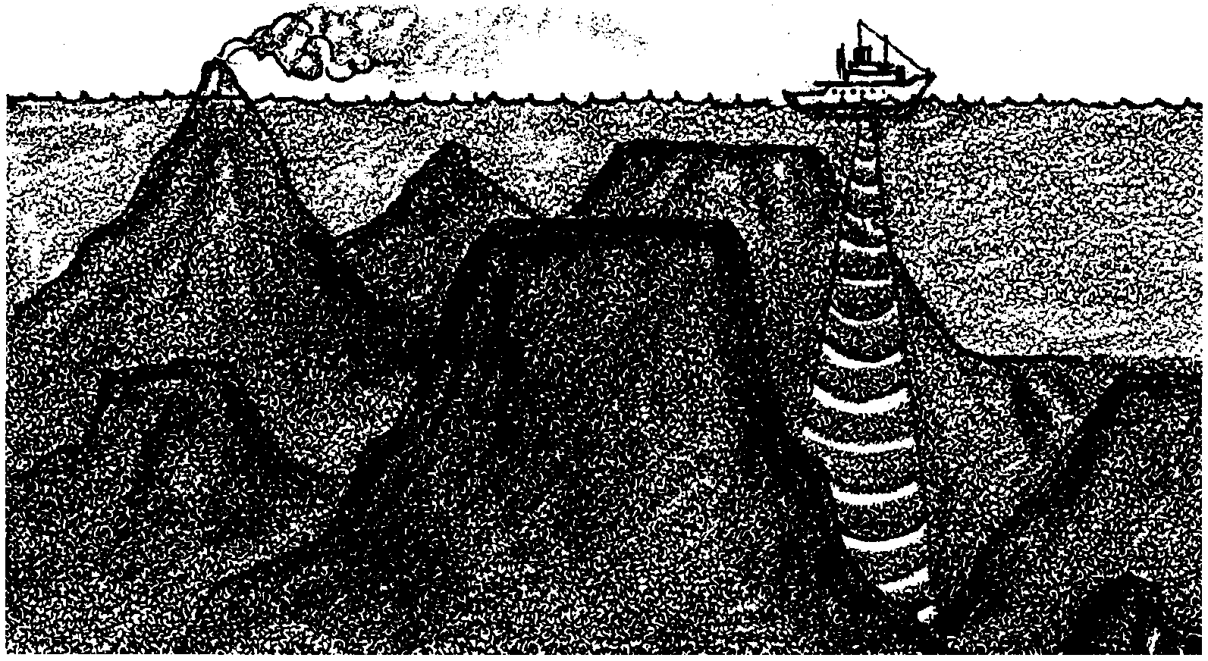
The Ocean Floor

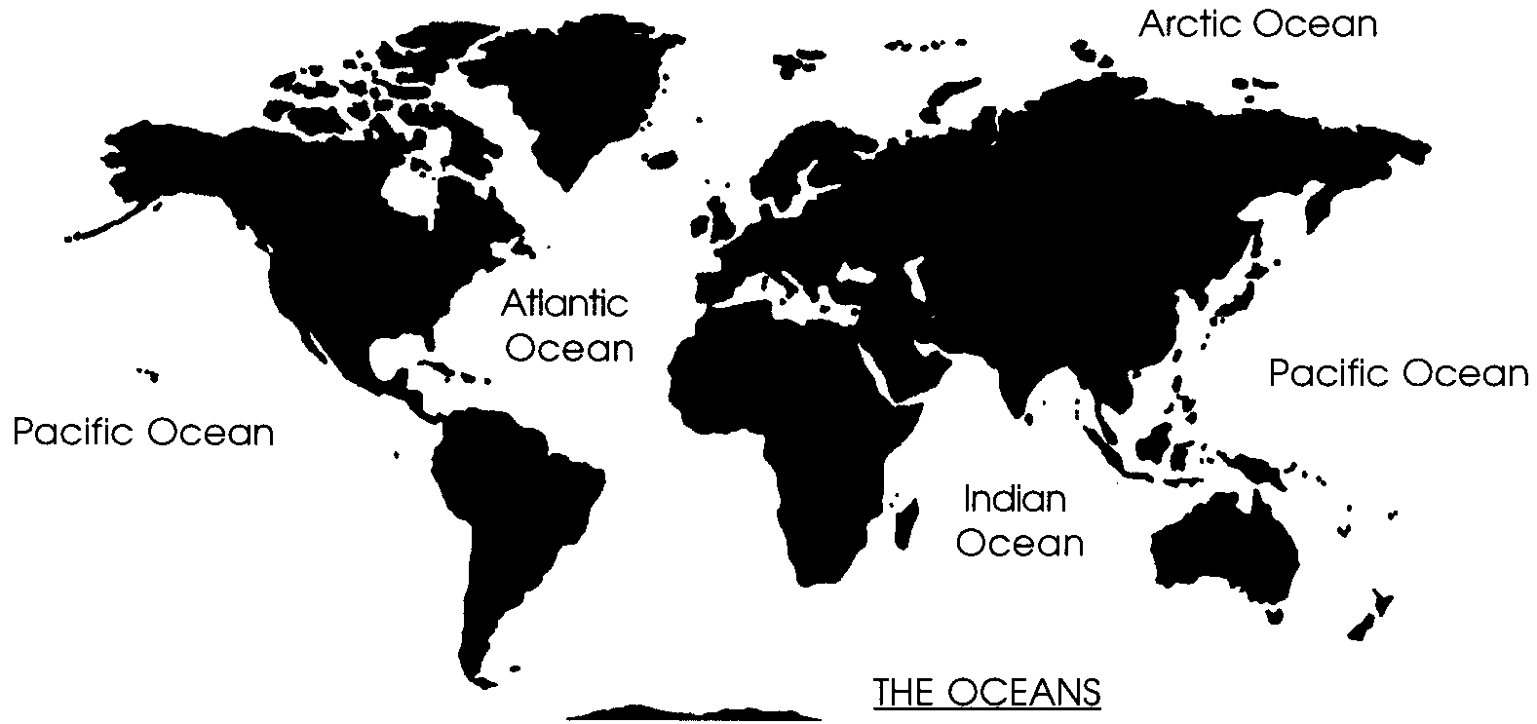
For hundreds of years, sailors have crossed the oceans. Yet, it is only within the last few years that it has been possible to chart the topography over which they traveled.

Pioneer ocean scientists sought to discover the shape of the ocean bottom by sounding with lead lines. A rope marked in meters and with a weight on one end was lowered over the side of a vessel. When the weight hit bottom, the length of the rope over the side was noted. The length of rope was equal to the depth at that point.
Sounding with a rope was difficult and time consuming. The ship had to stay in one spot so the rope would be straight. Since the average depth of the oceans is over two miles, the lowering of the rope took a long time. Storing the rope was also a major problem. In addition, the rope began to stretch when the total weight over the side became too great. Scientists began to use piano wire to solve this problem. While the wire helped to some extent, the process of sounding was still painstakingly slow.

1. What is meant by “sounding” the depth of the ocean?

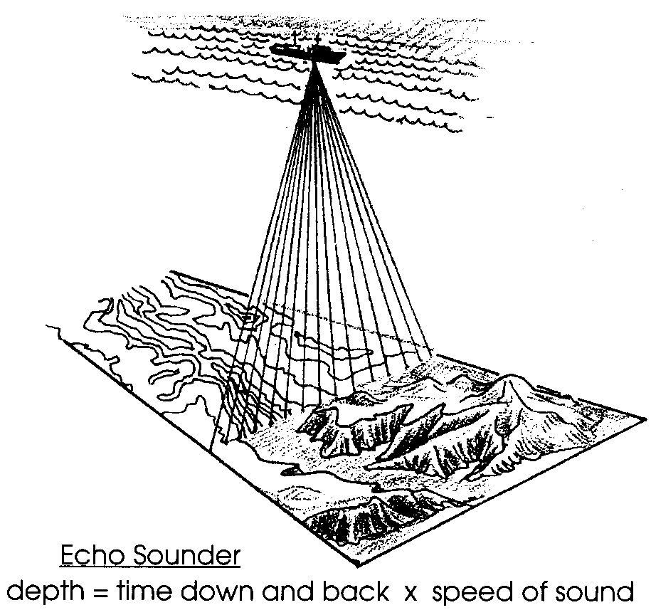
If we had to rely on lead line soundings to determine the shape of the ocean floors, we would still know very little about its topography. After World War I, a major breakthrough occurred: sonar, or echo sounders, used sound waves in place of the line. A sound wave is produced on board the ship. The wave travels to the bottom, is reflected and returns to the ship. The amount of time for the wave to make the round trip is recorded. Since we know how fast sound travels in sea water, we can determine the depth.

Most depth sounders employ a strip-chart recorder on which a continuous graph of ocean bottom topography is drawn while the ship steams on its course. Some of the newest technology available includes side-scan sonars that record the depths of entire swaths of the ocean floor at once. The data they collect is mapped by computers to give us some of the most detailed maps ever made of the sea floor.
Perhaps the most amazing device of all is the satellite system which reads distortions in the sea surface caused by the gravitational distortion of under sea features and uses this data to map the ocean floor from space.

2. What is meant by “topography of the ocean floor”?

What have we found? The floor of the oceans is not flat. It is covered with mountains, valleys and plains similar to what we might see above the surface of the seas. The ocean basins are separated into three major divisions called the continental margin, the abyssal province, and the mid-ocean ridge.
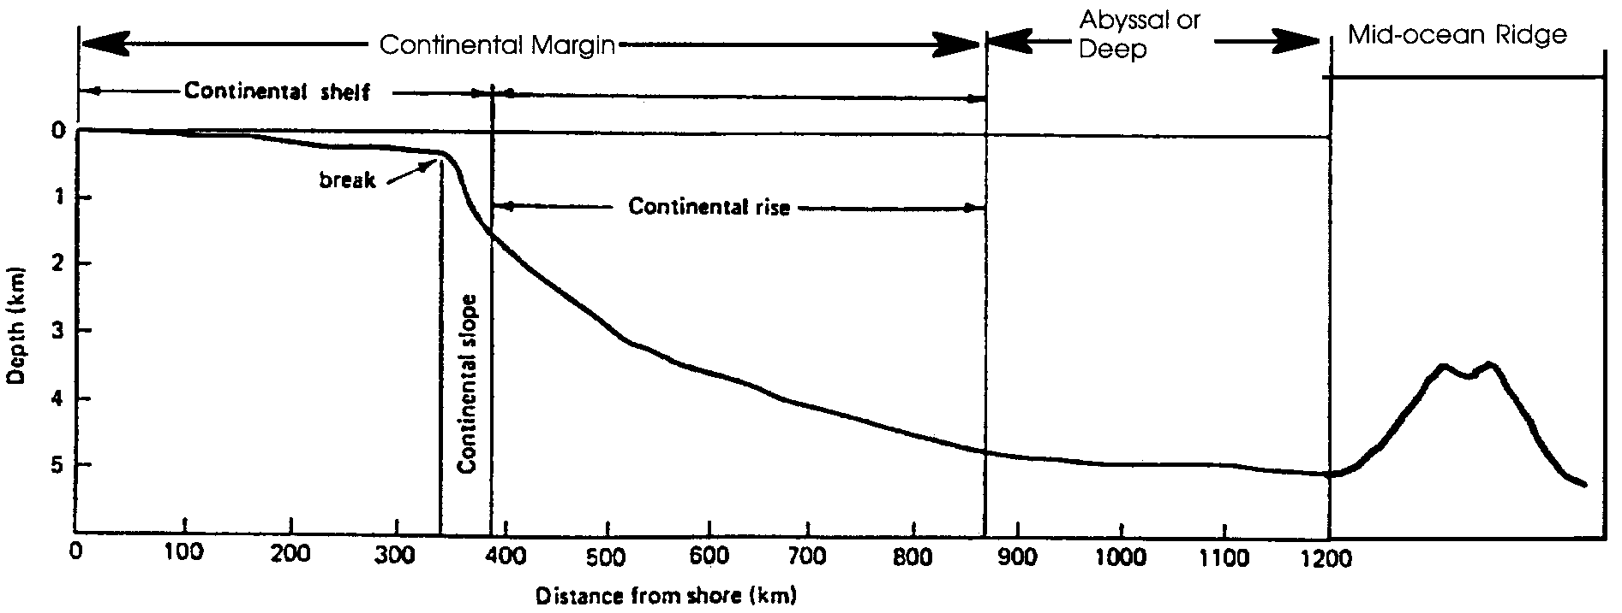
The continental margins are the areas where the continents merge into the oceans. The world’s continents are surrounded by a relatively flat platform that extends into the ocean about 350 kilometers (210 miles). This platform is called the continental shelf.

3. What are the three major divisions of the ocean basins?

At the edge of the continental shelf, the downhill slope increases abruptly. Beyond this edge, the continental slope and the continental rise run downward to the deep-sea floor.

4. At about what depth does the continental slope begin?

5. At about what depth does the continental margin run into the deep sea floor?

Deep Sea Floor
The deep sea floor is not uniform. Mountains called seamounts rise from the floor. Some rise above the surface forming islands. There are trenches deeper than Mt. Everest is high. Flat abyssal plains rise to form oceanic ridges. In some areas the surface is cracked and folded. The picture below shows a cross section of the land and ocean bottom from South America to Africa. The surface of the ocean floor is often more rugged than the surface of the continents.
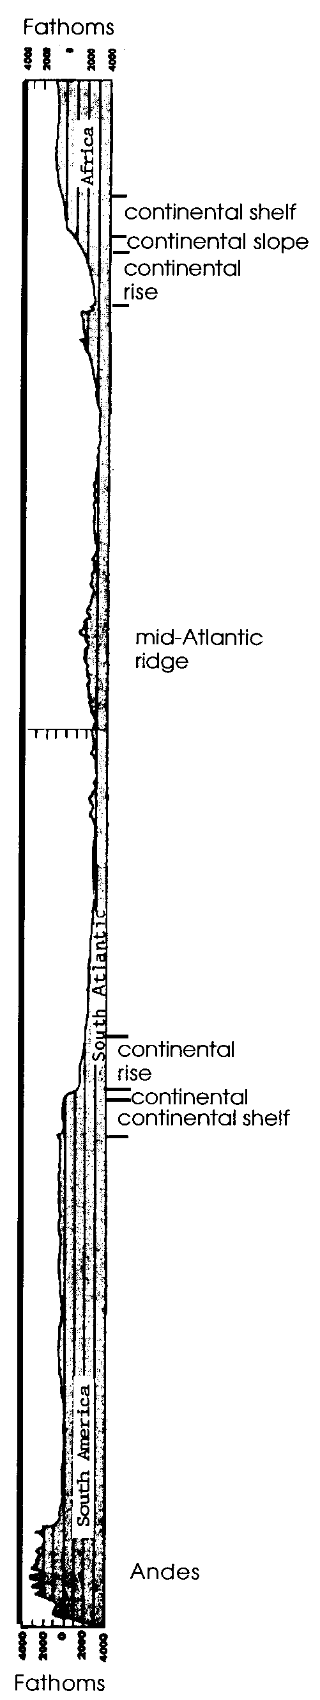
6. Use the South America to Africa cross section the right to answer the following questions.

a. How deep is the deepest area shown?

b. How tall are the Andes mountains?

c. How does the height of the Andes compare with the deepest part of the ocean shown?

d. How near the surface does the mid-Atlantic ridge rise?

Knowledge of the ocean floor is giving us information that may help explain the history of the continents and oceans. In addition, knowledge of the resources of the ocean floor is becoming increasingly important as humans look to the sea for minerals and for food.

