Hydrothermal Vent Food Webs
Lesson by Karen Mattick, Marine Science Center, Poulsbo, Washington. Adapted from JASON Project, National Science Teachers Association.

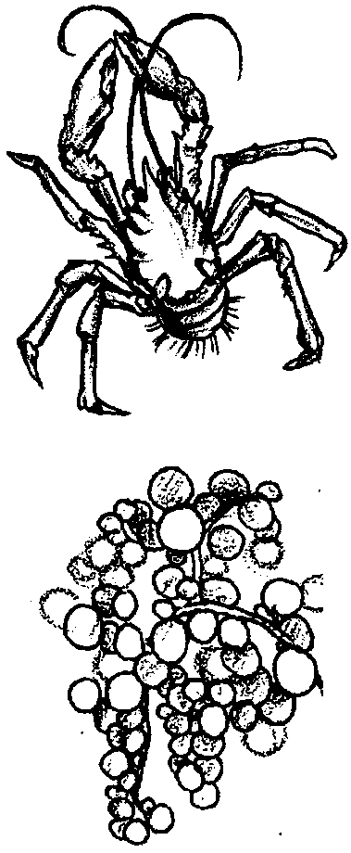
Key Concepts
1. Food webs at hydrothermal vents are fueled, not by sunlight energy, but by chemical energy.
2. Bacteria around hydrothermal vents oxidize hydrogen sulfide, releasing energy from the hydrogen sulfide which the bacteria then use to synthesize sugars.
3. A wide variety of animals lives around the vents, eating each other or the bacteria or the bacteria's products.

Background
While photosynthetic food webs are powered by energy from the sun, hydrothermal vent food webs are powered by the geothermal heat within the earth. In some areas of the deep sea, near ocean floor ridges, water circulates under the sea floor and is superheated by molten rock in the sea floor crust. Where it emerges from under the crust, it forms hydrothermal vents.
This very hot water is able to dissolve minerals which cold sea water normally cannot dissolve. The chemical compounds formed in these superheated waters include hydrogen sulfide (H2S), a very energy-rich compound.
Hydrothermal vent food webs depend on chemosynthetic bacteria. The bacteria are able to release the energy in hydrogen sulfide so it can be utilized by organisms living around the vent. The bacteria oxidize the hydrogen sulfide, resulting in hydrogen sulfate (SO4) and a release of energy. The bacteria then use the released energy to create sugars out of the hydrogen atoms and carbon dioxide. Sulfate is released as a waste product. Chemosynthesis differs from photosynthesis in that the energy source is the oxidation of hydrogen sulfide instead of sunlight and the source of hydrogen atoms for the construction of glucose is from hydrogen sulfide instead of water. The two processes both convert a form of energy into high energy glucose molecules.

Materials
For each student or team of students:
• one set of hydrothermal vent food web pictures
• craft materials such as paper, scissors, glue...

Teaching Hints
In “Hydrothermal Vent Food Webs”, students use vent animal pictures to create food webs depicting feeding relationships existing in hydrothermal vent communities.

Procedure:

1. Ask the students to cut out the vent animal pictures and arrange them on their desks in groups of organisms that feed at the same trophic (feeding) level. Students should group all the producers together in one group. The first order consumers who feed on the producers or waste products of the producers should be in a second group. The second order consumers who eat first order consumers should be in another group.
As students work, circulate around the room and listen for students’ comments and questions. If students are interested, you may share with them background information about how the bacteria use chemical energy to synthesize food.

2. Now have the students create a vent food web from the pictures. They may glue the pictures onto paper or draw their own illustrations. Have them draw arrows from the prey to the predator to depict the flow of energy and nutrients in the food web.

3. Ask the students to analyze their food web and identify the organisms that they think are most critical to the success of the community. Have them write their responses as notes on their food web creations.

Key Words
chemosynthesis - the synthesis of organic compounds by some living organisms, especially some forms of bacteria, using the energy from chemical reactions such as the oxidation of hydrogen sulfide
consumer - organism that cannot produce its own food, but eats other organisms to obtain the energy necessary to sustain life
first order consumer - organism that eats producers
food chain - outline of who eats whom showing path of energy transfer in an ecological community
food web - interlocking food chains existing because most consumers eat more than one type of food and are themselves eaten by more than one consumer
hydrothermal vents - deep-sea hot springs situated at seafloor spreading centers
hydrothermal vent communities - self-sufficient communities of marine animals that survive on energy derived from the earth’s interior via chemosynthesis
photosynthesis - a process which occurs in the presence of sunlight in which six carbon dioxide molecules (CO2) and six water molecules (H20) are combined to yield one molecule of a simple sugar (C6H1206) and six molecules of oxygen (02)
producer - organism that can make its own food, using inorganic nutrients and energy from the sun
second order consumer - organism that eats first order consumers

Extensions
1. Have the students create drawings or models of a vent community, depicting the physical setting as well as food web relationships. Some students might be in charge of creating vent animals while others are responsible for placing prey near the animals that feed on them.
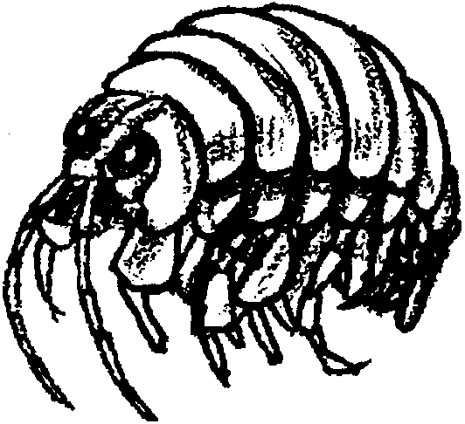
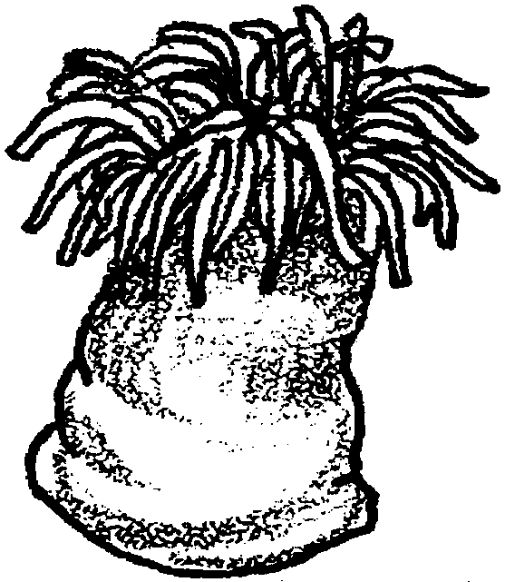
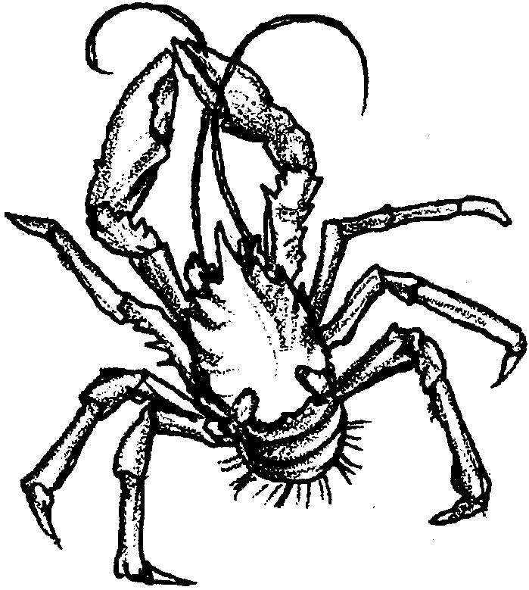
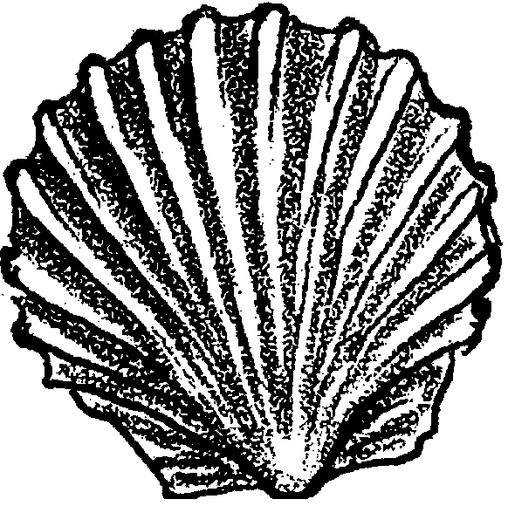
amphipod
The amphipod is a small crustacean which may feed on zooplankton. It grows to about 5 mm (about 1/4 ") in length and is gray in color. It is found crawling around in the mats.
anemone
This white anemone can be seen attached to rocks at fringes of the hydrothermal vent community. As in the tidal and subtidal zones where anemones are common, this anemone also captures zooplankton with tentacles.
squat lobster
Found up to 50cm (20") wide, including its legs, this large, white, scavenging crab really does resemble a lobster. It is found throughout the vent community eating whatever it can find.
scallop
Hydrothermal vent scallops grow to about 3cm (about 1" )in length and are found in a variety of colors. Using their gills, they filter out particles of food floating in the water.
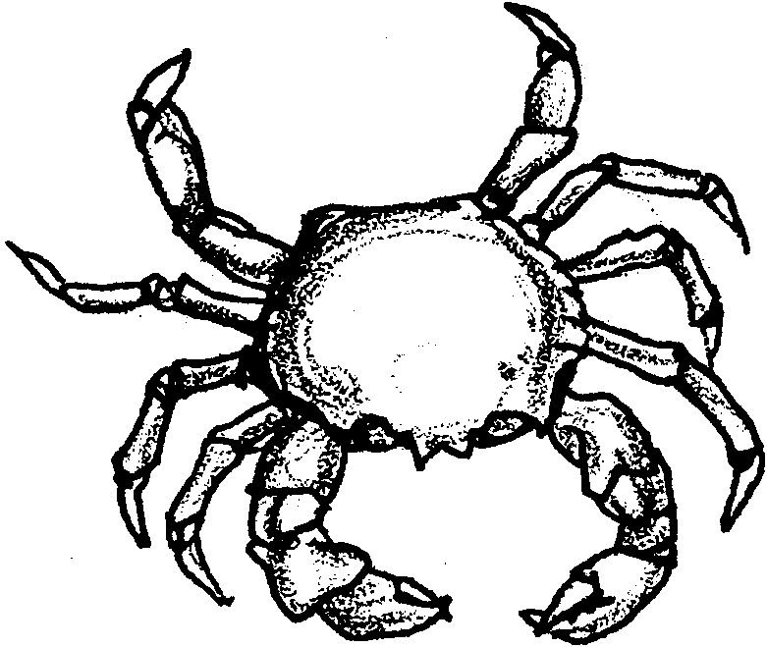
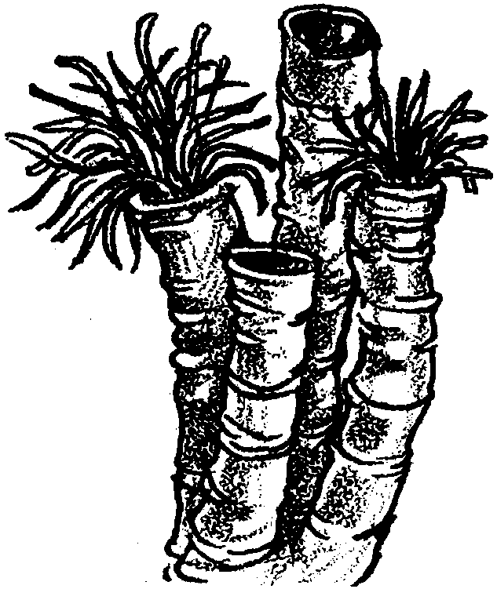
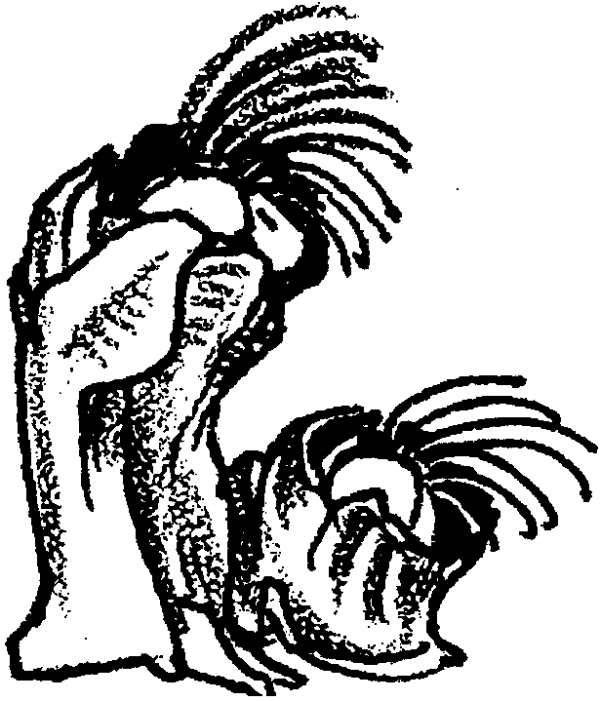
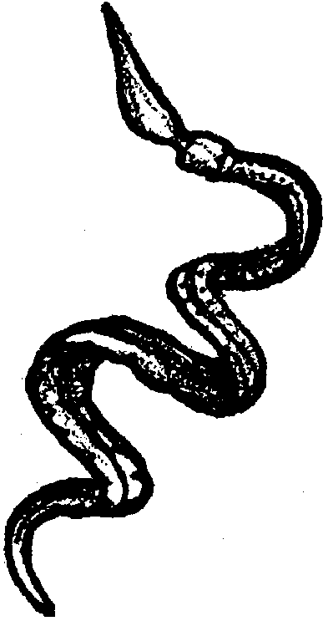
brachyuran crab
The brachyuran crab is found throughout the vent community scavenging whatever it can find. Growing up to 20 cm (8") wide, the crab may become a predator on tubeworms and other animals.
serpulid worms
These tiny, 5mm (about 1/4"), worms live in tubes on the rocks of active hydrothermal vents. They are whitish in color and filter particulate matter out of the water for food.
barnacles
These gray, filter-feeding relatives of the rocky shore barnacles live on rocks on the fringes of the vent community. They grow to about 2 cm (about 1") in diameter.

enteropneusts
It is easy to see why these worms are also called spaghetti worms. Growing to 30cm (12") in length, thin, and light-colored, they look just like spaghetti. The worm drapes itself over rocks while its head end drifts freely, filter-feeding on zooplankton.
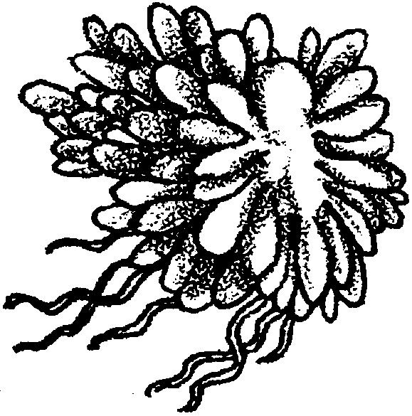
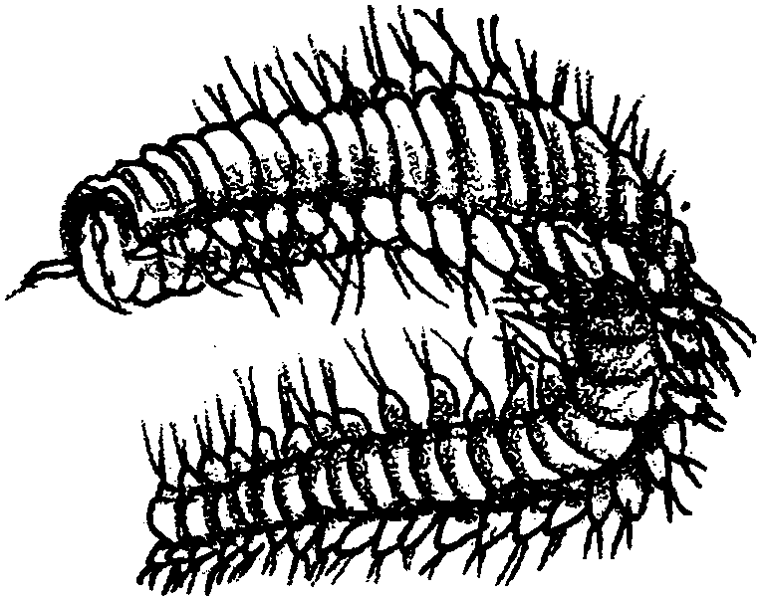
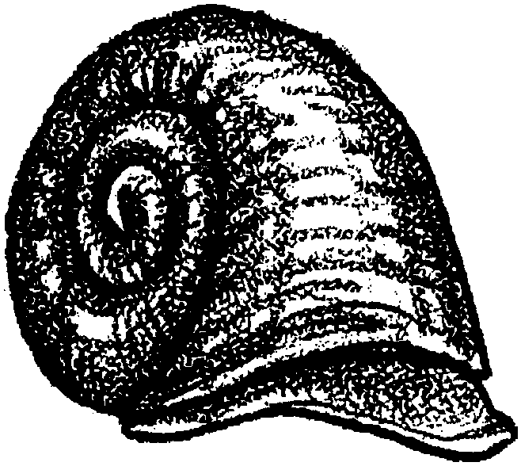
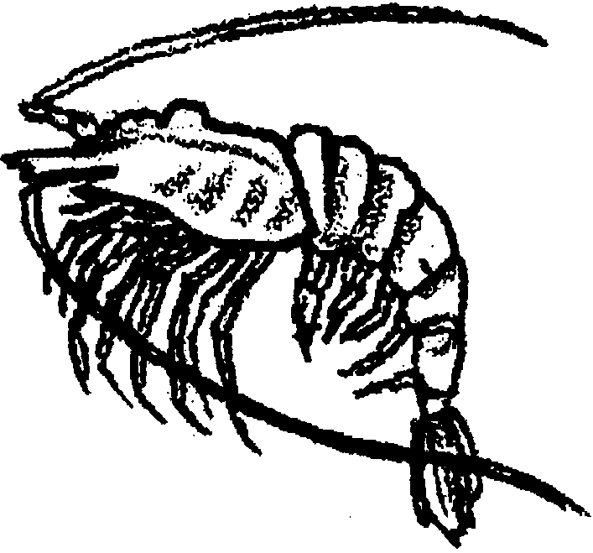
siphonophore
This siphonophore is an unusual relative of the Portuguese man-of-war. It is actually a colony of individual organisms. When grown to its full size of 5cm (2"), it resembles a dandelion in color, shape, and size. The siphonophore uses its tentacles to catch zooplankton.
polychaete worm
These tiny worms grow to only 2mm (about 1/8") in length. They are segmented and have bristles on their segments. These red worms feed on mat bacteria.
coiled snail
These coiled snails grow to about 2.5 cm (1") and are found in various colors. They cling to the rocks near the vent, where they scrape off the mat-forming bacteria with their radulas.
shrimp
These pink shrimp cluster around the vents, feeding mostly on mat-bacteria. Their size ranges from 5 to 12 cm (2" to 5") in length.
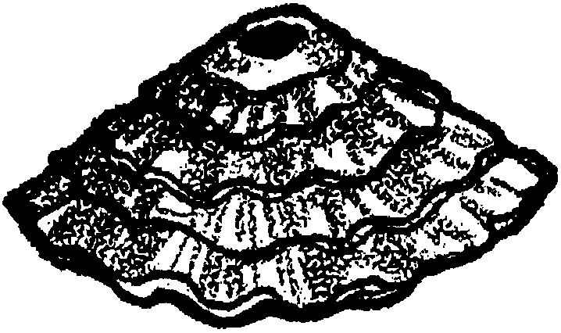
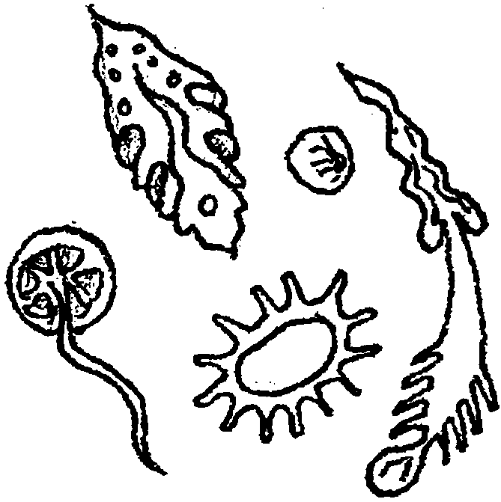
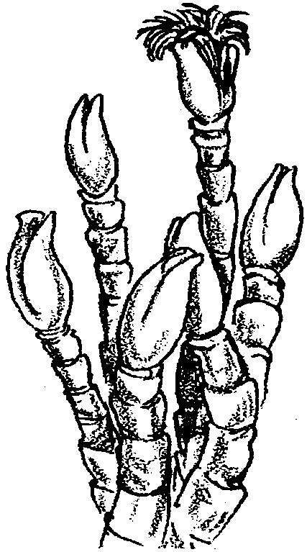
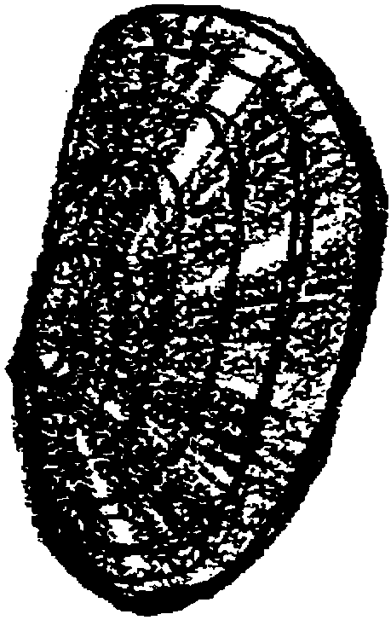
limpets
These limpets are quite similar to those found in the rocky intertidal. They grow to an average of 3cm (about 1") in diameter and cling to the rocks near the vents. Limpets graze on mat-forming bacteria.
zooplankton
Microscopic zooplankton swim in the plume waters and feed on plume bacteria or other zooplankton.
tube worms
These tube worms can grow up to an amazing 2 meters in length. Their bright red, soft bodies are supported by white tubes. These worms have no mouth, no gut, and no digestive system. They absorb H₂S from the vent waters to support the endosymbiotic bacteria living in their tissues.
mussels
These rust-colored mussels grow up to 19cm (8") in length. They grow rapidly in clusters around the vents. They feed on food produced by endosymbiotic bacteria living in their gills.

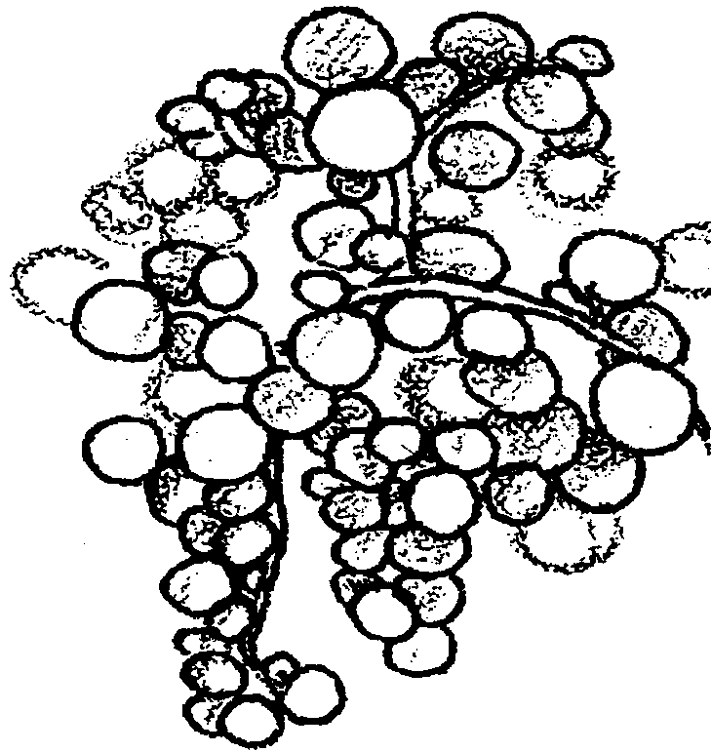
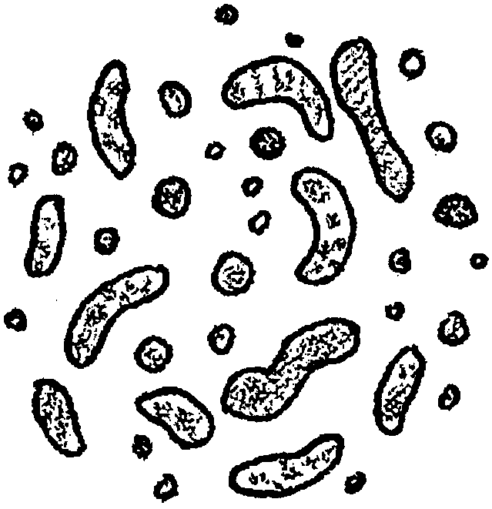
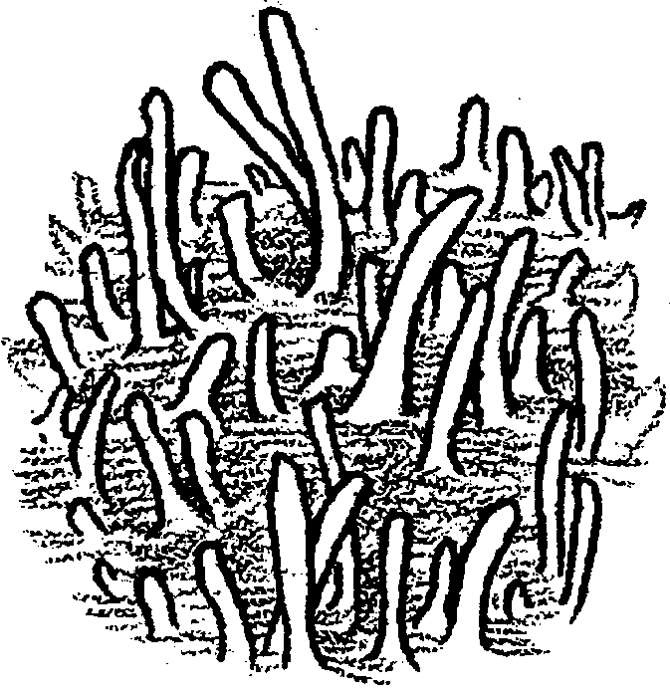
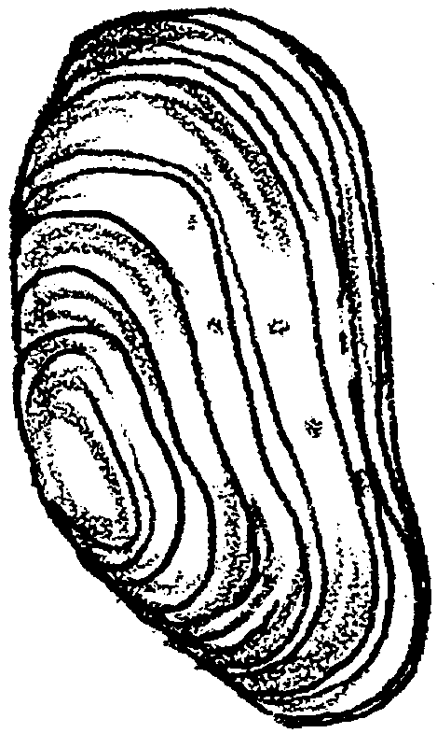
symbiotic bacteria
These ball-shaped bacteria live in tissues of tube worms, clams, and mussels. They burn H₂S and use that energy to combine H₂ with CO₂ to make food for themselves and host.
plume bacteria
These peanut-shaped bacteria
live in the hot water plume which escapes from the vent. They burn H₂S and use that energy to combine H₂ with CO₂ to make food for themselves.
mat-forming bacteria
These bacteria form slimy mats on most surfaces around vents where there is H₂S. These bacteria grow in multi-celled filaments. They burn H₂S and use that energy to combine H with CO₂ to make food for themselves.
giant clam
This large white clam can grow up to 24 cm (10") in length. It grows quite rapidly and lives along cracks at vents. It feeds on food produced by endosymbiotic bacteria living in its gills.

