Practicing With Keys
Edited by Holly Shewbridge, Monterey Peninsula
School District, Monterey, California.
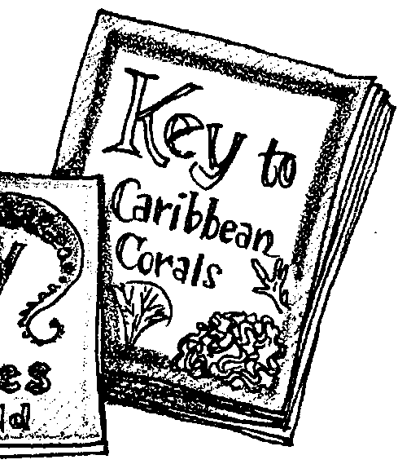

Key Concepts
1. Keys are important tools for the identification of organisms.
2. Keys can be based on a variety of distinguishing features that lead from general to more specific identification.

Background
Classification is a way of separating a large group of closely related organisms into smaller subgroups. The scientific name of an organism is based on the classification systems of living organisms. To classify an organism, scientists often use a key. A key is a listing of specific characteristics, such as anatomical features and behaviors, organized so that an organism can be identified. The most common type of key is a dichotomous key that is based on pairs of opposing statements. For example, the first set of statements may read “1 a. The item is red” and “1 b. The item is not red”. Only one of these statements can be true for a given organism. The statement you choose directs you to another pair of statements in which another choice must be made. Each succeeding pair of statements is more specific in describing the organism. Statements often include discriminating features that can be verified by direct observation (e.g., “the item is 1/2 inch or longer in length” vs. “the item is less than 1/2 inch in length”). Also, the alternatives should be quantifiable (e.g., “1/2 inch or longer”) rather than descriptive (e.g., “big”). Crafting statements can sometimes be tricky. For example, characteristics that are not true under all conditions but change with age, growth, sex, etc. of the organism can be not only confusing but misleading.
It is important to emphasize that many keys are restricted to the organisms found in a particular area. Local keys are useful because the restricted number of organisms treated reduces the number of very fine distinctions which would have to be made if large numbers or many similar organisms were included on a single key. Since keys are an artificial construct, different keys can be designed to “key out” the same group of organisms.

Materials
For class of 32:

• one set of objects found on a desk:
a thumb tack, pencil, eraser, paper clip, fountain pen, stapler, pair of scissors.

For each student or each team of students:

• a copy of “Practicing with Keys” student sheets

• an assortment of 10 or more different hardware items such as nuts, bolts, matching screws, wood screws (flat head, round head, Phillips head), nails, washers, wing nuts, cotter pins, lock washers, etc.*

*Note: To increase the challenge, you can include a number of specialty hardware items with which your students have little familiarity such as: escutcheon pins, roofing nails, rivets, wire nuts, etc. Also, several items can vary only in size (e.g., washers differing in size of opening, wood screws of the same length but varying thicknesses, etc.). This will help the students to observe closely and identify quantitatively the characteristics necessary to separate the items.

Teaching Hints
In “Practicing with Keys” your students will have an opportunity to examine two keys and to construct a key of their own. A good way to introduce the concept of dichotomous keys is by helping a class construct a key that discriminates between the various members of the class. Ask for volunteers and elicit the distinguishing features from your class to further increase the interest and participation. In theory, this class key could be so complete that every member of class would have their name at the end of a branch. In practice, this detail is not necessary. It is helpful to key at least one volunteer student all the way to the end. The steps might be as follows:
Step Descriptions Go to
l a Students female (list female names) 2
l b Students not female (list other names) (fill in number later)

2 a Five feet seven inches tall or less (list names) 3
2 b More than five feet seven inches tall (fill in number later)

3 a Green eyes Mary Bailey
3 b Non-green eyes (list names) 4

In the above example, you would want to emphasize the fact that, in that class, the only green-eyed female whose height is five feet seven inches or less in the class is Mary Bailey. To avoid making students self-conscious about their bodies, you could use one shoe from each student (or volunteer!) to follow the same procedure. To help your students understand how keys are constructed, it is recommended that you have available a variety of scientific keys for your students to observe. This display of keys will also show your students the tremendous number, variety and importance of keys in the life sciences.
Duplicate the activity pages for “Practicing With Keys.” One set is recommended per student. Students may do these activities individually or in pairs or small groups. You may wish to introduce the activities briefly on the day prior to their use and assign the reading of the introduction and activity sections as homework.

Activity 1

In “Practicing With Keys,” the first two activities and keys refer to items found in a teacher’s desk. In activity #1, the teacher helps identify the objects displayed on the front desk and/or shown in the picture in the text. Have your students quickly read through the key so that they have a general idea of its use.
Next, students will decide which steps in Key #1 will lead to the correct naming of the item. Assign different groups the responsibility of identifying one of the objects by following the key. For example, one group might begin with the pencil and follow it from number 1 until it is identified.
Provide scratch paper and have your students write down the numbers of the steps they follow from number 1 through identification. The name of the item and the steps chosen can then be recorded by groups on the chalkboard. The students should be able to identify the type of information the writer used in preparing the key to separate these objects. In this particular case, the objects were separated on the basis of physical characteristics. Ask the students to suggest how the key could be varied while still using physical characteristics so that a different sequence could be followed. For example, they might suggest the following:
l a. Object has a sharp point at one end.
l b. Object does not have a sharp point at one end.

It is important that the student realize that in an artificial key there is no one right way to begin. However, it is usually helpful to start with characteristics that rapidly narrow the groups.
Activity 2

Following the same procedure as before, ask the students to look through the Key #2 and designate different groups to trace the various items. Again, have them write down the numbers of the steps they follow.
When the students have completed the activity, again ask them to identify the basis the writer used in preparing the key to separate the objects in the key. This key is based on the function of the object as opposed to the physical characteristics. This key has several built-in weaknesses. Ask the students to discuss what problems they had with the key. The following problems may be identified and discussed.
1. The terms “large” and “small” are relative and, hence, vague.
2. The process of attaching papers in sections 4, 5, and 6 is confusing.
3. In the initial separation of the groups in #1, the term “implement used for writing” is used. Whether an eraser can be considered a writing tool is questionable, but possible.
4. The numbering sequence in this key is different from that in the first key and is basically more difficult. Various letter combinations could be used or a mixture of numbers and letters.
5. The vocabulary used in any key needs to be appropriate for the people who will be using it.
6. A key for many organisms should be brief but clarity is most important and should not be sacrificed.

Activity 3

In this activity, the students apply their understanding of keys by constructing a key that discriminates between various hardware items. Hardware was chosen to show the arbitrary nature of keys and to show that the use of keys is not limited to living things. Students or groups of students will need their own set of items to sort as they construct their keys. Generally, four students working together form a good group. It is helpful to make a board with each of the items fixed and labeled so that all the groups use the same name for their objects. Another alternative is to encourage students to come up with their own creative names.
After the keys are prepared by the students they should be exchanged with other groups. The new students should attempt to use the key. Have the “user” groups prepare a written evaluation of the key they received. The evaluation should include: the number of items they were correctly able to identify using the key; strengths in the key, and improvements which should be made.
In your discussion of the keys point out the various ways in which the keys have been started indicating again that in an artificial key there is not one way which is necessarily correct.
Key Words
characteristic - a distinguishing feature or attribute
classification - the assignment of closely related items or organisms to groups within a system of categories distinguished by structure, origin, etc.; a system of separating a large group of closely related items or organisms into smaller subgroups
dichotomous key - key that is based on pairs of opposing statements
key- a tabular listing of specific characteristics, such as physical attributes and/or behaviors, of a member of a group of organisms organized to facilitate identification and comparison
organism - any living thing
projection - a protruding part

Answer Key
Activity 1: Key #1: thumb tack 1 a, 2 b, 3 a
Stapler 1 a, 2 b, 3 b
paper clip 1 a, 2 a, 4 a
scissors 1 a, 2 a, 4 b
eraser 1 b, 5 a
pencil 1 b, 5 b, 6 a
fountain pen 1 b, 5 b, 6 b

Activity 2: Key #2 fountain pen 1 a, 2 a
Pencil 1 a, 2 b, 3 a
Eraser 1 a, 2 b, 3 b
paper clip 1 b, 4 a, 5 a
stapler 1 b, 4 a, 5 b
thumb tack 1 b, 4 b, 6 a
scissors 1 b, 4 b, 6 b

Activity 3: Hardware Key
1. - 5. Answers will vary by group.

This activity originally appeared in: Guide to Marine Ecology Research.... a curriculum for secondary students. A Marine Ecology Research Project publication.
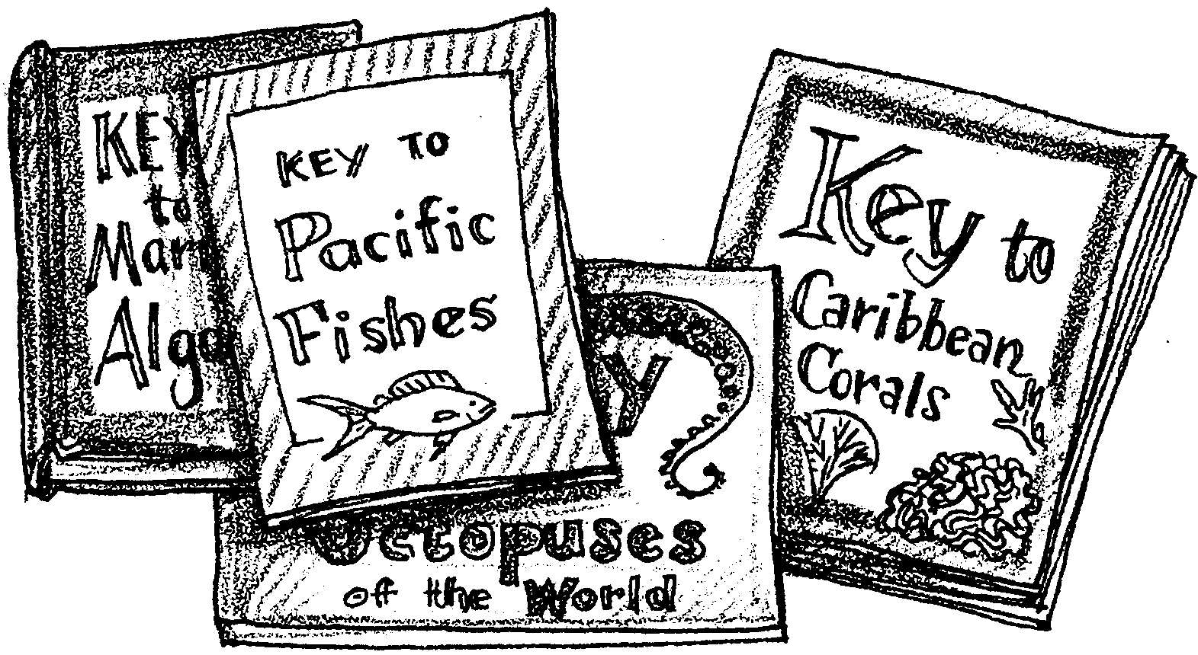
Practicing With Keys

In order to understand the ecology of a biological community, to understand the relationships among organisms, it is important to be able to identify individual organisms present in a study area. Biologists have developed various systems for grouping organisms and methods for identifying them easily and efficiently. Once a preliminary survey of an area has been made, a device called a “key” is developed for classifying the plants and/or animals in a study area.
A key is a listing of specific characteristics, such as physical features and behaviors, organized so that an organism can be identified. Just as door keys only open certain locks, identification keys will only work for the organisms and in the area for which they were designed.
Keys are very handy. For example, you can use an appropriate local key to identify a fish which you may find , rather than sorting through thousands of pictures of fish or a key to all of the fishes of the whole Pacific Coast. Using a key is a simple and efficient procedure when you understand how a key is organized and how to use it.
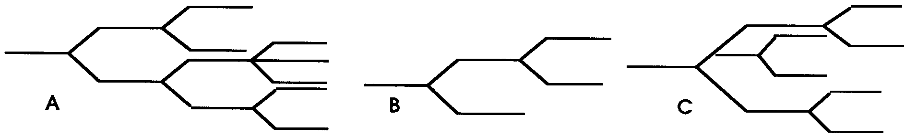
Keys can be designated in different ways, but the most common are called dichotomous (di-kot-e-mus) keys. The term means double branching. In a dichotomous arrangement, you always are offered two choices at every level. Which of the following diagrams would be dichotomous?

The following activities are designed to help you understand how a dichotomous key is organized and how to construct one. With this background, you should have few problems using dichotomous keys to common forms of sea life.

Activity 1
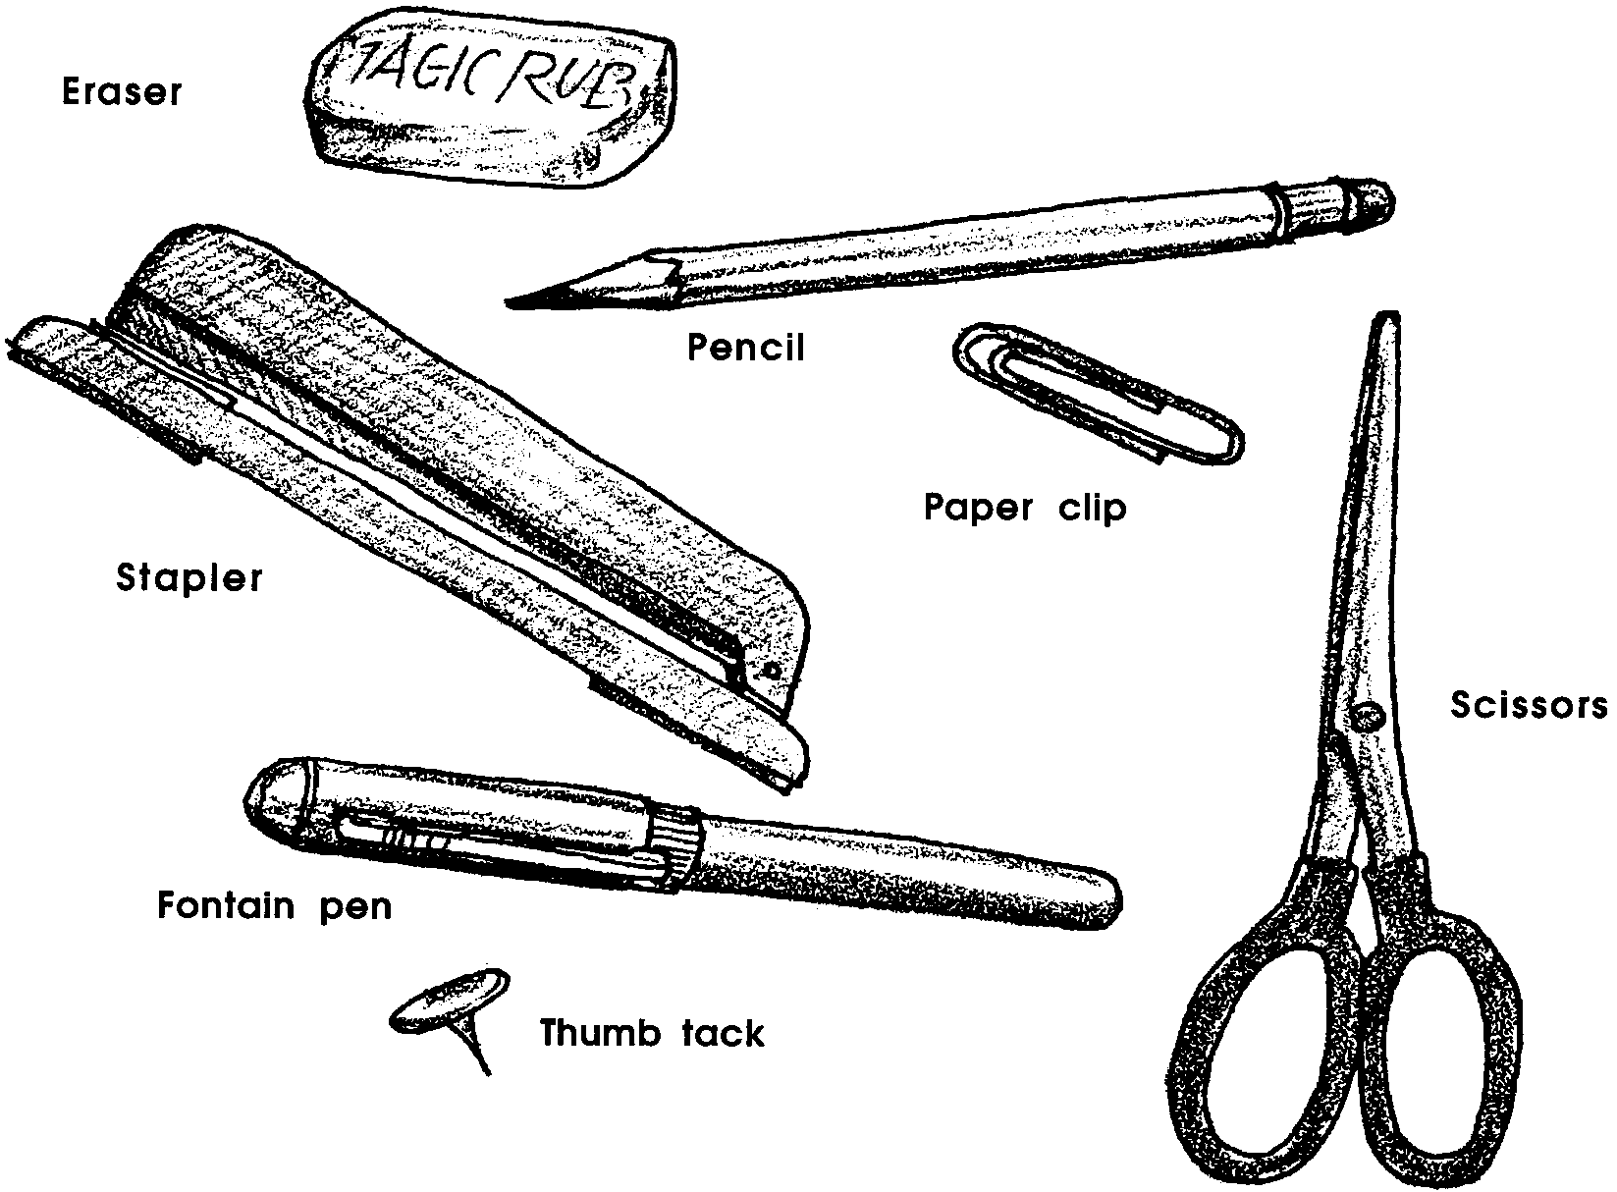
Materials: Key #1: A Key to Common Objects Found on a Desk

Procedure:
Following your teacher’s instructions, analyze Key #1: A Key to Common Objects Found on a Desk.

KEY #1
A Key to Common Objects Found on a Desk

l a Object made entirely of metal 2
l b Object not made entirely of metal 5

2 a Object has no small,thin metal projections 4
2 b Object has a flat base and contains thin metal projections 3

3 a Flat end is no larger than 1cm thumb tack
3 b Flat end (base) is at least 5cm long stapler
4 a Object is made of bent wire paper clip
4 b Object has a handle and two sharp edges scissors

5 a Object made entirely of rubber eraser
5 b Object may have rubber in part 6

6 a Object is long, thin, has graphite inside and has
rubber at one end pencil
6 b Object is long, thin, has removable cap, but does not
have rubber at either end fountain pen

Activity 2
Materials: Key #2: A Key to Common Objects Found On a Desk

Procedure:
Following your teacher’s instructions, analyze Key # 2, Key to Common Objects Found on a Desk.

KEY #2
A Key to Common Objects Found On a Desk
1 a Object is used in the process of writing 2
1 b Object is not used in the process of writing 4

2 a Object has a cap and contains a fluid which is imparted
to paper with the process of writing fountain pen
2 b Object does not contain fluid 3

3 a Object is long and slender, containing a dark, solid material
used to mark paper in the process of writing pencil
3 b Object is made of rubber and used to “eradicate” or remove
lines in the process of writing eraser

4 a Object is used to attach papers to each other 5
4 b Object not used to attach papers to each other 6

5 a Object is small and metal and used to keep small numbers
of paper sheets together paper clip
5 b Object releases thin metal projections which can hold
many papers together stapler

6 a Object used to attach papers to wall or hard surface thumb tack
6 b Object used to cut paper apart scissors
Activity 3
Your teacher will give you a set of objects which you may consider to represent a collection of common life forms found in a lake, river or bay. Based on the knowledge gained in Activities #1 and #2, you will prepare a “Key to Common Hardware Objects” which would be appropriate for any student in your class. Your success is directly related to the ease with which others in the class can use your key.

Materials:
an assortment of 10 or more different hardware items such as nuts, bolts, machine screws, wood screws (flat head, round head and Phillips head), nails (including specialty nails), washers, wing nuts, cotter pins, lock washers, etc.
binder paper and pencil for recording answers

Procedure:
1. Look at your life forms. Choose one major difference between the life forms. What characteristic did you choose? This will determine the first step of your key.

2. Separate the life forms into two groups based on this characteristic.
Be sure that all the forms in the same group have the same characteristic.

3. Continue to separate the life forms groups into two subgroups based on different characteristics. Record the characteristics used as you divide the groups. Keep doing this until you run out of differences between the life forms. Be sure to name the life forms identified in this key.

4. Write your key on binder paper. To check the key, choose one life form and see if the key gives the correct identification.

5. When you have completed your key, find another group that has finished and trade keys. Now use and write an evaluation of the key made by the other group. The evaluation should include: the names of the people in your group, the number of items you were correctly able to identify using the key; strengths in the key, and improvements which should be made in the key.

