Observing Algae
Written by Holly Shewbridge, Monterey Peninsula
School District, Monterey, California.
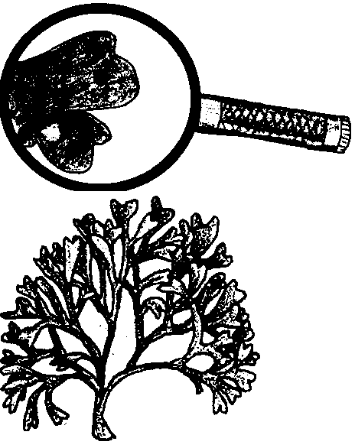

Key Concepts
1. Marine algae come in a variety of shapes, colors, sizes, and textures.
2. Microscopic algae can be classified by observable features.

Background
Macroscopic marine algae, or seaweed, can be a fascinating group of plants to investigate. The three main groups are the green algae, brown algae, and red algae. Observations of preserved or fresh drift algae can be an enjoyable way for to learn about the variety and importance of these marine ecosystem members.
Green algae: representatives include sea lettuce, moss weed, tube algae, and dead man’s fingers. Green algae vary in color from yellow-green to dark green.
Brown algae: representatives include the rockweeds and kelp. Plants include blades, stipes, holdfasts, and pneumatocysts.
Red algae: representatives include nori, coralline algae, sea grapes, and Turkish towels. The colors vary greatly.
For greater detail, refer to the Background information found in the activities “Sea Forest” and “Keys to Identification of Some Common Marine Plants”.

Materials
For each group of 2-3 students:
• trays or plastic bags to hold the seaweed
• live and/or pressed specimens of drift green, brown, and red algae
• hand lens or dissecting scope
• a piece of sketch paper
• sample of edible algae such a nori
• a set of colored pencils (optional)
Teaching Hints
“Observing Algae” gives students the opportunity to make observations about macroscopic marine plants without the use of microscopes or detailed scientific keys. Students are asked to use their senses to make observations and generalizations about green, brown, and red algae. You may choose to give students the worksheet and have them answer the questions or you may give them time to observe and draw algae samples and then ask them the worksheet questions as a check of what they noticed.
It is best to use fresh drift specimens if possible. If you are able to collect fresh specimens of drift marine plants, be sure to check state and local restrictions. You will need to collect a sufficient portion of a plant to allow identification.
Plants can be kept in plastic bags overnight in a refrigerator. You may want to put specimens in separate plastic bags before refrigeration. Also, be sure to keep fresh specimens of Desmarestia (see Key to Identification) separated from other specimens. This alga is very acidic and may bleach other specimens. Do not add Desmarestia to an aquarium because the acid it releases is likely to kill any animals in the tank. Fresh specimens may become very slimy, so rinsing them with fresh water before use in lab is desirable.
Since it is not always possible or convenient to obtain fresh algae specimens, you may want to consider making a class set of pressed algae herbarium specimens following the suggestions given in the activity “Pressing Algae”.
With the help of an algae key, separate several specimens of green, brown, and red algae for each group of 2-3 students. Because color of algae can sometimes be misleading, it is recommended that the algae be sorted for students into trays or plastic bags. Have hand lenses or dissecting scopes, sketch paper, edible algae samples, and colored pencils (optional) available. The lab is organized so students make observations about the green algae, the brown algae, the red algae, and then all of the representatives.

Key Words
algae - one-celled or many celled aquatic plants that have no root, stem, or leaf systems
blade - broad, leaf-like portion of algae
frond - the blade(s) and stipe of an algae
holdfast - the rootlike portion of the algae that holds it to a rock or surface. Unlike a true root, it doesn’t gather water and nutrients from the soil.
kelp - any large brown, cold water algae of the family Laminariaceae, used as food and in various manufacturing processes
pneumatocyst - air filled bladder found in some algaes allowing for positive buoyancy
stipe - the stalk arising from the holdfast and to which the blades attach
Answer Key
A. Green Algae
1. - 4. Shades, shapes, textures, and types of algae will vary.
5. Sketches will vary.

B. Red Algae
1. - 4. Colors, shapes, textures, types will vary.
5. Sketches will vary
6. Tastes described.

C. Brown Algae
1. - 4. Colors, shapes, textures, features will vary.
5. Sketches will vary.

D. All Algae
1. Brown algae include larger representatives, including some of the fastest growing plants on earth.
2. Holdfast drawing and description.
3. The pneumatocysts help keep the plant buoyant and lift the blades to receive sunlight.
4. Flexibility allows the plant to withstand the strong waves, storms, and currents that can tear plants apart. In withstanding these elements, kelp plants dissipate energy of waves, thus providing a sheltered area shoreward. Waves and currents are vital for transporting fresh gasses and nutrients required for photosynthesis.
5. Algae categories will vary.
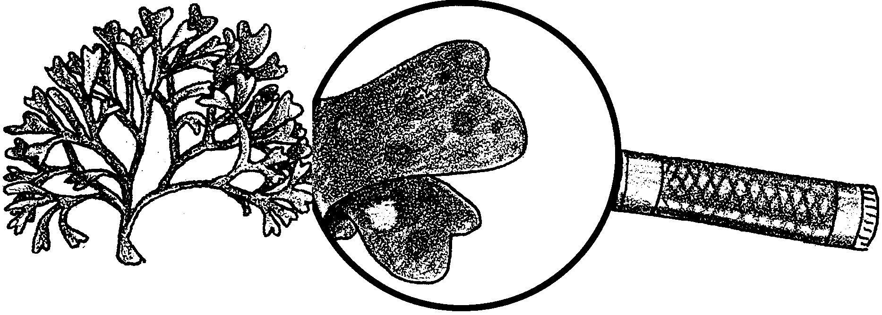
Observing Algae

Large algae, or seaweeds, are plants that grow in the ocean. Algae have no true roots, stems, leaves, or flowers. They are multicellular and contain chlorophyll. Chlorophyll is a pigment that captures light energy. (A pigment is a chemical that gives something color.) Besides chlorophyll, some of the algae have other pigments that can also capture light energy. These other pigments make some algae look brown or red.

Scientists have classified marine algae into three groups: green algae, brown algae, and red algae. In this lab, you will observe, touch and even taste specimens in these three groups. As you work, look for characteristics the three groups have in common and for characteristics that can be used to tell them apart. Summarize your observations below.

Materials:
• separated specimens of green, brown, and red algae
• hand lense or dissecting scope
• sketch paper
• edible algae such as packaged nori and seaweed crackers
• color pencils (optional)

Observations:
A. Green Algae
1. Do all of the specimens look the same shade of green? Describe some of the shades that you see.

2. What shapes do these algae have? (examples: lots of branches, long strands, flat, bushy, leafy, rope-like, and so on.)

3. What are the textures of these algae? (examples: smooth, bumpy, tough, rubbery, slippery, and so on.)

4. How many different types of green algae are shown?

5. On the back of your paper, make a sketch of each kind of green algae. If possible, include names.

B. Red Algae
Most algae used in food products belong to this group. (Note: when not sure if unidentified algae is brown or red, it is probably red.)

1. Describe the different colors shown in this group.

2. What are some shapes of these algae?
3. What are some textures that you can feel?

4. How many types of red algae are shown?

5. On the back of your paper, make a sketch of each kind of red algae shown. Include names if possible.

6. If possible, describe the tastes of some packaged algae samples.

C. Brown Algae
This is the fastest growing type of algae. Kelp are large brown algae and belong to this group. Giant kelp can grow up to ten inches a day.

1. Describe the colors of these algae.

2. What shapes do you notice?

3. Describe the textures that you feel.

4. What do some of these brown algae have that you don’t see in the green algae or in the red algae?

5. On the back of your paper, make a sketch of some of the brown algae. Include names if possible.
D. All Algae

1 a. Which group of algae has the largest members: green, brown, or red?

b. Which group has the smallest members?

2. Look for algae that still has the bottom, or holdfast attached to it. The holdfast helps the algae attach to surfaces. On the back of your paper, describe and draw a holdfast.

3. The bulb-like bladders on the kelp are filled with a gas. These bladders are called pneumatocysts. How do you think these pneumatocysts are helpful to the algae? (Hint: From what direction does the light these algae need come?)

4. You may have noticed how flexible, or bendable, the algae samples are. How is flexibility helpful for a plant growing in the ocean?

5. On the back of your paper, vote for the algae that is most easy to hide in, beautiful, gross, flexible, slippery, and edible. Make up some other categories and vote for them too!

