Marine Ecology and the Kelp Forest
Edited by Holly Shewbridge, Monterey Peninsula
Unified School District, Monterey, California
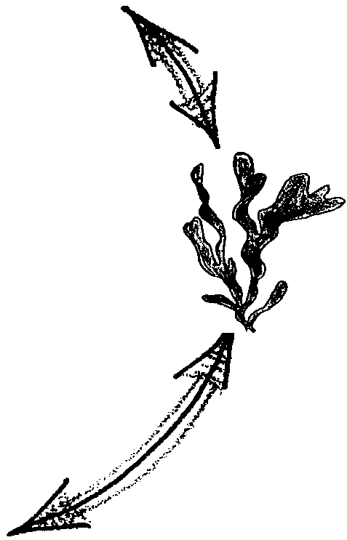

Key Concepts
1. An ecosystem is composed of the living and non-living components within a given space.
2. The living and non-living components are interdependent and influence each other.
3. Energy and nutrient flow can be traces through an ecosystem such as a kelp forest.

Background
The kelp forest is one type of biological community that thrives along open coastal shores in cool waters. The kelp forest benefits from wave surge. This wave action provides oxygen and nutrients and washes away wastes. Periodic storms rip away kelp and other organisms opening up new living spaces for colonizing seaweeds and animals. At the same time, the kelp forest absorbs much of the wave energy enabling a wider variety of organisms to live in these coastal waters.
“Marine Ecology and Kelp Forests” uses a kelp forest ecosystem to introduce some of the basic concepts of ecology. The kelp forest has a greater variety and higher density of plants and animals than almost any other marine community. Kelp forests are complex communities that provide food and habitat for a variety of mobile and attached animals.
“Marine Ecology and Kelp Forests” is the first of seven activities dealing with kelp forests and marine plants. Additional background information may be found, therefore, in the following activities: “Observing Algae”, “Practicing with Keys”, “Key to the Identification of Some Common Marine Plants of Puget Sound and Monterey Bay”, “Pressing Algae”, “Sea Forest”, and “Farming Four Feet Under”.
For more information about kelp forest ecology and human efforts to preserve these vital ecosystems see “Kelp: Keeping a Forest Afloat,” National Wildlife, June/July 1992, pages 5-10.

Materials
For each student or group of 2-3 students:
• a large piece of construction or poster paper (larger than 8.5" x 11")
• a pencil
• tape or glue

Teaching Hints
In “Marine Ecology and Kelp Forests”, students study a simplified kelp forest ecosystem and design a diagram with various living and nonliving components.
The first section of this activity involves an introduction to ecology with terms applied to a kelp forest ecosystem. The material is heavy in new terminology and vocabulary. Many of the terms are defined within the reading, and questions are included to check for understanding. It is helpful to have additional resources about kelp forests available for use in class. For example, books on marine invertebrates and plants will help students to understand the basic structure and diet of organisms mentioned in this activity. Additional kelp forest resources are available from the Education Department of Monterey Bay Aquarium. These resources include a kelp forest slide set and script, caption cards that have pictures and descriptions of twelve common kelp forest organisms, background information and glossary sheets, a kelp forest crossword puzzle, and a book called Kelp Forests by Judith Connor and Charles Baxter. Contact the Monterey Bay Aquarium at 886 Cannery Row, Monterey, CA 93940 (408) 648-4937.
Each student or group will need a copy of this activity. To save on copy costs, you may want to copy the class set of the pages with questions and have students write answers on binder paper. Each group, though, will need its own set of pages from the section called “Building a Kelp Forest Ecosystem”.
In the second portion of this activity students are asked to design a diagram that shows the various components of a kelp forest. They will cut out and arrange various physical and biological components to show the structure of a simplified kelp forest. They may want to add drawings or descriptions of other animals. Provide additional resources for student reference. It is helpful to check and review designs with students before taping or gluing pieces. Once the kelp forest is designed and relationship between physical and biological components are added, give students one (or more, if time allows) “what if” situation card. Ask students to describe, on binder paper or on their kelp forest, what they think will happen to the kelp forest if that particular situation occurs.

Key Words
biological community - the living environment; a group of organisms living together; any group of interacting organisms
consumer - organism that cannot produce its own food, but eats other organisms to obtain the energy necessary to sustain life
decomposer - organism that cannot produce its own food but breaks down dead material from which it derives its needed energy and nutrients
ecology - the study of relationships in among and between living organisms and the nonliving environment.
ecosystem - the nonliving and living environment in a given space
nutrients - minerals and other substances needed for life and growth
omnivore - an organism that eats both plants and animals
organic - composed of carbon compounds, usually referring to those existing in or derived from plants or animals
producer - organism that can make its own food, using inorganic nutrients and energy from the sun
substrate - the base on which a sessile (nonmotile) organism lives or grows
turbidity level - a measure of the particles suspended in water

Answer Key
Part 1 - Ecology and Ecosystems
1. Ecology is the study of three general types of relationships we see in nature:
a. relationships among organisms of the same kind;
b. relationships among organisms of different kinds; and
c. relationships between organisms and the non-living environment.

2. An ecosystem is all of the living and non-living factors found in a given space.

3. The two major parts of an ecosystem are the non-living environment and the living environment or the biological community.

4.
water temperature
amount of nutrients in the water
type of material at the sea floor (e.g., sand, rocks, or...?)
Characteristics of the environment surrounding the kelp forest

low turbidity to allow sunlight to reach bottom
level of turbidity (cloudiness) of the water

amount of sunlight penetrating through the water

What does this characteristic have to be like for the kelp forest to do well?
cool water with temperature below 70↓F (21↓C)
rich in carbon, nitrogen, phosphorous, and trace elements
rocky, hard substrates (surfaces)
at least 1% of the sun's light energy must be available for photosynthesis.

5. The kelp forest offers animals protection against strong water current, provides a variety of living spaces among the holdfasts and blades, provides new living space for attached animals when the holdfasts are torn away, and adds oxygen which animals need to the water.

6 a. A kelp plant can grow more than 25 centimeters a day. A line 25 cm (about 10") long should be drawn on the student page.

b. Answers will vary depending on height. The problem could be set up like this:
student height in cm x 1 day = number of days
25 cm

7 a. Kelp plants are important in the food web as producers, photosynthesizing and producing oxygen.

b. Producers mentioned in the text include phytoplankton, oarweed, feather boa kelp, coralline algae, and Turkish towel. Other green, brown, and red algae are also possible answers.

8 a. Hopefully, the definition states that “omnivores eat all things”, in other words they eat herbivores and carnivores and decomposers or a combination thereof.

b. Answers can be any animal that eats both plants and animals. For example, people are omnivores.

9. There may be arrows from giant kelp to both the turban snail and the sea urchin. Arrows from all of the animals to bacteria are also needed.

10. The ultimate source of the energy that ecosystems use is the sun. Hydrothermal vent communities are a notable exception. The ultimate source of energy in these communities is oxidation of hydrogen sulfide and other sulfides that issue from the vents by chemosynthetic bacteria.

11. It is possible and, in fact guaranteed, that the nutrients that make up your body were once incorporated into the body of some other organism. It is possible, for example, that you ate some salmon or other fish that ate herring that ate copepods that ate phytoplankton. Also consider that the nutrients in our bodies will be cycling into and through other creatures long after we’re gone.

12. The phrase "Nutrients cycle" means that nutrients are recycled from one living thing to another as organisms eat, are eaten, die and decompose. Nutrients are not "used up", they move through the food chain from organism to organism.

Key to ECOGRAM
1. AUTOT R OPHS
2. D E COMPOSERS
3. ECO L OGY
4. BIOLOGIC A L
5. NU T RIENTS
6. ENV I RONMENT
7. EC O SYSTEM
8. E N ERGY
9. HERBIVORE S
10. H ETEROTROPHS
11. I RREVERSIBLE
12. PHOTOAUTOTRO P HS
13. CARNIVORE S
Building a Kelp Forest

Designs may vary greatly. Check to see if arrows show appropriate connections between producers, herbivores, carnivores, decomposers, etc. You may want to establish a minimum number of arrows between different components.

“What If” situations:

Oil Spill - canopy layer organisms will be negatively impacted. Locally, shorebirds and marine mammals may die from ingesting oil. Oil may also block sunlight needed by phytoplankton and large algae. Non-canopy layer organisms will also be affected as oil moves downward or the organisms move upward.

Warm water - Plants will degenerate. Marine organisms may die or try to emigrate to cooler areas.

Sewage spill - Organic waste is added, providing food for bacteria. As a result, bacterial blooms will occur, depleting oxygen supplies. Nitrogen levels in the sewage may be toxic for local organism. Toxic chemicals may also enter the water as part of the sewage.

Storm - Organisms living on the plants will be swept away. In fact, about ninety percent of the kelp which becomes food for other organisms is kelp which is swept to the beach or deep water where it is eaten by decomposers. Only about ten percent is eaten within the kelp forest. Organisms may survive or die (particularly if swept onto a beach).

Disease kills off the season’s kelp forest - Other plants may support some of the organisms for a time. It is likely many organisms will suffer from lack of shelter and food.

Otter population decrease - Other predators (such as the sheephead fish) may feed on the urchins, but they may graze more extensively and eat a lot of the kelp plants. Areas where sea urchins are prolific and unchecked by predators are known as urchin barrens because the urchins eat nearly all the available kelp.

Canopy harvest - Canopy organisms living up to 3 meters below the surface and taken in the harvesting equipment are killed. The frond regrows.

Shifting sands - Settling animal larvae and plant spores are scraped off or prevented from attaching to substrates. New growth on the substrate is greatly decreased.
“What If” Situations
Shifting sand sweeps through
the kelp forest and scours
surfaces of rocks and plants.
Strong storm sweeps away half of the kelp plants in the forest.
Sewage spill; lots of organic waste added to water.
The canopy of the kelp forest is harvested for commercial use.
Warm water current above 70*F (21*C) sweeps through the kelp forest.
Otter population decreases,
sea urchin population
increases.
Oil spill: oil swept
through the kelp forest.
Disease kills off the kelp plants this season.

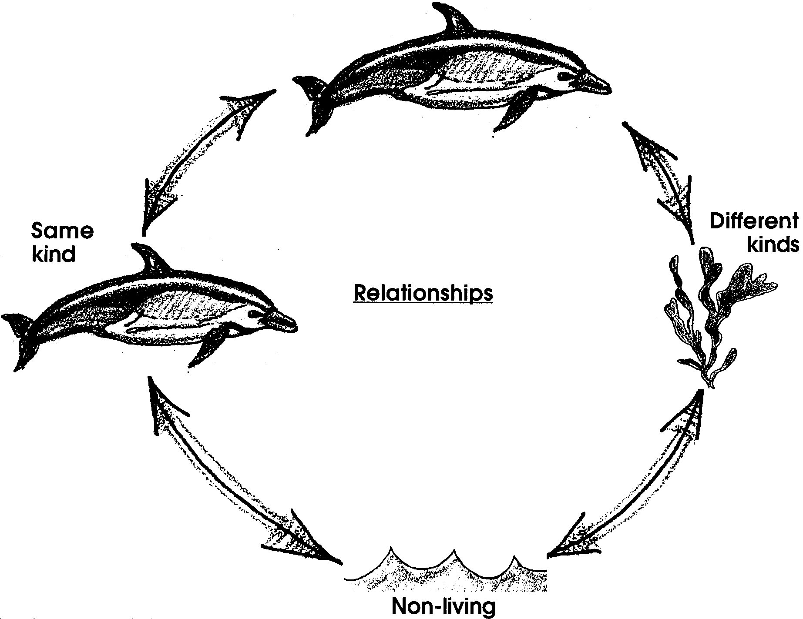
Marine Ecology and the Kelp Forest

Ecology and Ecosystems
Ecology......hmmm, a popular word. What is ecology? Does ecology mean recycling paper and aluminum cans? Is it the balance of nature? Is it something to be “for” or “against”? Maybe we can tell by looking at the word itself. “Ecology” comes from two Greek words “oikos”, which means “house”, and “logic”, which means “the science or study of.” So ecology means the “study of house,” but what does this mean? Ecology is the study of the relationships that occur in our house, the earth. Ecology is the study of three general types of relationships that we see in nature: (1) relationships among organisms of the same kind; (2) relationships among organisms of different kinds; and (3) relationships between organisms and the nonliving environment.
Ecologists study these three types of relationships as they occur in a particular volume of space called an ecosystem. An ecosystem is all of the living and nonliving factors in a given space. Because ecosystem boundaries are defined by humans on different size scales, the world can be considered one big ecosystem in which all the living and nonliving factors affect each other to some degree. We could also look at the oceans as an ecosystem. We can further define the boundaries of an ecosystem by calling the kelp forest an ecosystem.
1. What are the three relationships described by “ecology”?

2. What is an ecosystem?

What does it mean to study an ecosystem? An ecosystem is composed of two major parts: the nonliving environment which are the physical surroundings, and the living environment which is the biological community. The nonliving environment includes the energy, nutrients, and living space that members of the biological community require for their existence.

3. What are the two major parts of an ecosystem?

Physical Surroundings of a Kelp Forest
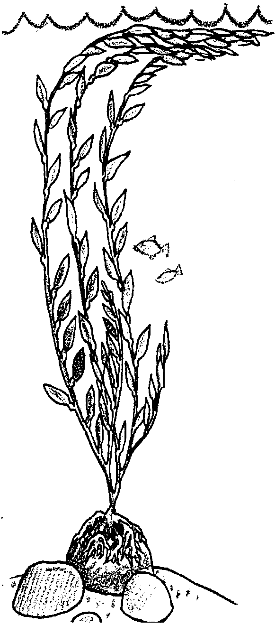
Let’s take a look at the physical components of an ecosystem called the kelp forest. Kelp forests grow in cool, nutrient-rich waters along temperate coasts. In general, the kelp plants do well where water temperatures do not exceed 70°F (21°C) during the year. This may be due to the relationship between water temperature and nutrient capacity: as temperature rises, the amount of nutrients dissolved in sea water decreases. Nutrients required by kelp forests include carbon, nitrogen, phosphorus, and other trace elements necessary for biochemical reactions. Kelp forests are found along the west coast of North America from California to Alaska. They are also found off the coasts of Chile, New Zealand, northern Europe, and Japan.
Water motion from currents and waves is also an important physical component. Kelp plants thrive near cool, nutrient-rich currents. During strong storms water motion and shifting sand may be strong enough to rip plants right off the bottom, resulting in the tangling and death of many kelp plants. In general, kelp plants attach their holdfasts to rocky, hard substrates (surfaces).
The growth of kelp plants also depends on how clear the water is. When large amounts of sediment (non-living particles) are suspended in sea water, the water is said to be highly turbid. If the water is very turbid, sunlight won’t penetrate very deep into the water. Kelp plants are autotrophs, organisms that manufacture their own food (auto=self + troph=food). Since they use sunlight to produce their own food, plants are sometimes called photoautotrophs (photo=light). Kelp plants need to have at least 1% of the sun’s light energy available in order to photosynthesize. Photosynthesis is the process of manufacturing food from inorganic molecules, carbon dioxide, and water (photo=light,synthesis=place together). Depending on water clarity, kelp can grow at depths between 10 and 100 feet (3 and 30 meters).

4. Please complete the following table:
Characteristics of the environment
surrounding the kelp forest
What does this characteristic have
to be like for the kelp forest to do
well?
water temperature
amount of nutrients in the water
type of material at the sea floor
(e.g., sand, rocks, or...?)
level of turbidity (cloudiness) of
the water
amount of sunlight penetrating
through the water

While the kelp forest is affected by the environmental conditions around it, so the growth of the kelp forest changes the physical environment. A dense growth of plants can provide protection against strong water motion. Kelp and other algae also provide living spaces for small organisms that hide among the holdfasts and blades. In addition, the hard surfaces left vacant when storms rip kelp away, provide new living space for small seaweeds and attached animals such as sponges and bryozoans to colonize. Kelp and other algae in the kelp forest also add oxygen to the water as they photosynthesize. The surface growth, or canopy, of kelp can influence the amount of sunlight that reaches the sea floor, which in turn influences the growth of other marine plants in the forest. In many ways the physical presence of the kelp plants influences the structure of the biological community.

5. What are some of the good things kelp forests do for the animals that live there?

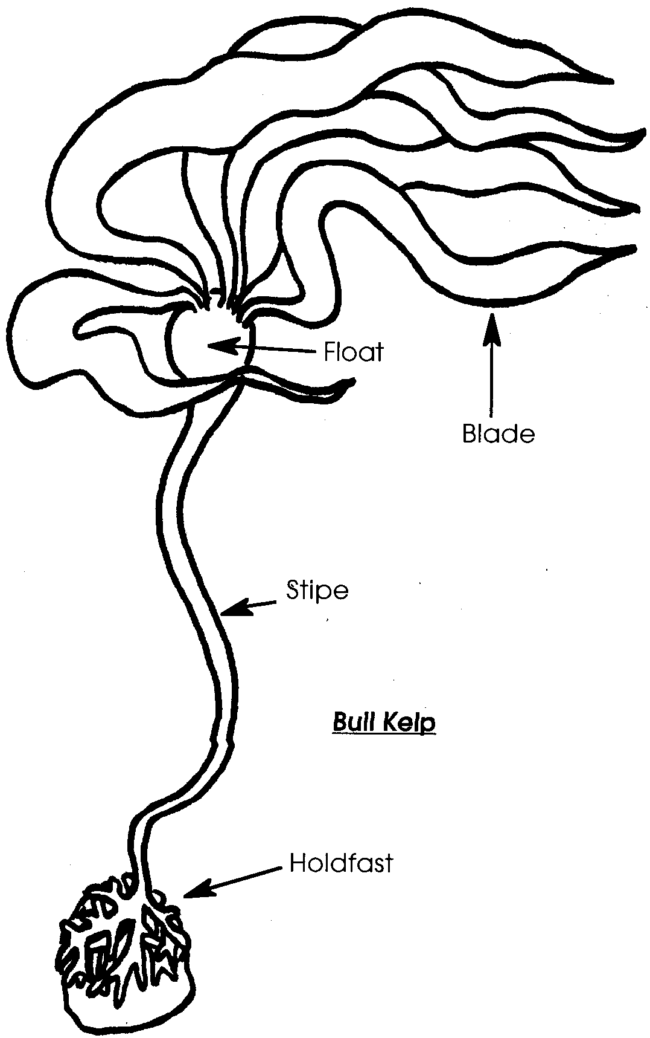
The Biological Community of a Kelp Forest
The largest and fastest growing plants in the world, kelp plants are well-suited for life near temperate shores. Since these seaweeds are bathed in seawater and the water contains the oxygen, carbon dioxide and nutrients the algae need, the algae are able to exchange nutrients and gases through any part of the plant. They do not need roots to pick up these materials from soil. The branched holdfast looks like a root, but it simply serves to attach the plant to hard surfaces.

6 a. How many centimeters a day can a kelp plant grow?

Draw a line that long on this paper.

b. How long would it take a kelp plant to grow as tall as you are? Please show how you figured out the time.

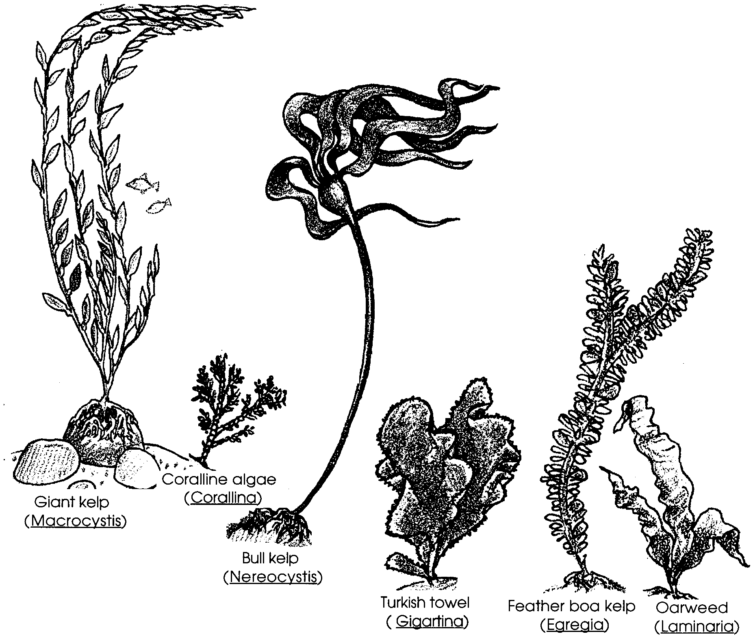
Because kelp plants can photosynthesize (make food and oxygen), these producers are important members of the food web. Producers in the kelp forest include the phytoplankton (microscopic marine algae), kelp plants including giant kelp (Macrocystis), bull kelp (Nereocystis), oarweed (Laminaria) and feather boa kelp (Egregia), and red algae such as coralline algae (Corallina) and Turkish towel (Gigartina).

7 a. How are kelp plants, as producers, important members of the food web?

b. Name two examples of producers found in a kelp forest community.

Important members of the food web of any ecosystem are the heterotrophs, organisms that eat other organisms (hetero=other + troph=feeding). These consumers depend on other animals and plants for their food source. Heterotrophs fall into three categories: herbivores, carnivores, and decomposers. Each group has its own special way to obtain the energy and nutrients necessary for maintenance, growth, and reproduction. Herbivores are plant eaters. Carnivores eat meat in the form of plant eaters or other meat eaters. Decomposers are organisms that use dead plant and animal materials as food. An example of a decomposer is bacteria. Decomposers play an important role in recycling nutrients. They break down organic substances (carbon containing compounds such as sugars), and use the energy and some of the nutrients stored in the “food.” They return the remaining nutrients to the environment where they are available for use by other animals and plants.

8 a. “Omni” is from the Latin word meaning “all.” What do you suppose omnivores eat?

b. Name an example of an omnivore.

The heterotrophs within a kelp forest feed on a variety of plant and animal life. Herbivores, or plant eaters, in a kelp forest include turban snails, kelp crabs, and some fishes such as the halfmoon and opaleye. They feed on a variety of algae found in the kelp forest. Broken fronds of kelp that drift to the bottom become food for abalones, sea urchins, and bat stars. Sea urchins graze on kelp and can strip a plant clean when present in the large numbers that sometimes occur when the predators that eat urchins, like sea otters, are scarce. Animals such as sea cucumbers, brittle stars, and tube worms feed on various drift algae is that is broken down into finer pieces (detritus). Drift algae is also an important food source for the deep reef and sandy seafloor ecosystems.
In a kelp forest, the carnivores, or meat eaters, include sea stars, rockfishes, crabs, otters, and sea lions. Other kelp forest organisms are plankton eaters. Some feed on phytoplankton (drifting microscopic marine plants), some on zooplankton (generally microscopic, drifting animals), and some on both. Plankton eaters include larval invertebrates, filter feeders such as barnacles, and juvenile fishes (e.g., rockfishes, senorita, kelp and surfperch). Adult kelp bass feed on jellyfish that are swept by currents and trapped in the kelp forest.

9. Some members of a kelp forest community are listed below. Write these names on your paper and draw arrows to show who eats whom. Arrows will point from the eaten to the eater.

giant kelp turban snail sea urchin bacteria
In thinking about the biological community, keep in mind that kelp forest plants and animals select their environment. If they make a poor selection, they either don’t survive or survive poorly. The distribution of life in a kelp forest occurs in layers along the kelp plants. The surface layer, or canopy, provides shelter and food for otters and shorebirds. Hydroids, bryozoans, turban snails, crabs and isopods live on the blades and stipes. Small fishes such as the senorita and kelp surfperch, and shrimplike mysids, and plankton can be found near and among the fronds. A variety of amphipods, brittle stars, sea urchins, crabs, colorful sponges, and the young of fish, clams, and octopus live within and near the tangled, rootlike holdfast. Nearby crevice dwelling animals include the red octopus and wolf eel.

Energy and Nutrient Flow in an Ecosystem

It is important to realize that an ecosystem operates as a whole unit; change to one ecosystem component will inevitably cause other changes in the ecosystem. Energy flow and nutrient movement are two ecological processes which lie at the heart of ecosystem structure and dynamics.
Both energy and nutrients move from one member of a biological community to another as food. For example, when a small fish nibbles a tiny copepod, it gets its energy from its meal so it can move, grow and carry out all the other functions that keep it alive. It also gets nutrients such as amino acids, calcium and nitrogen from the copepod. The fish uses the nutrients as building blocks to make body parts or chemicals it needs.
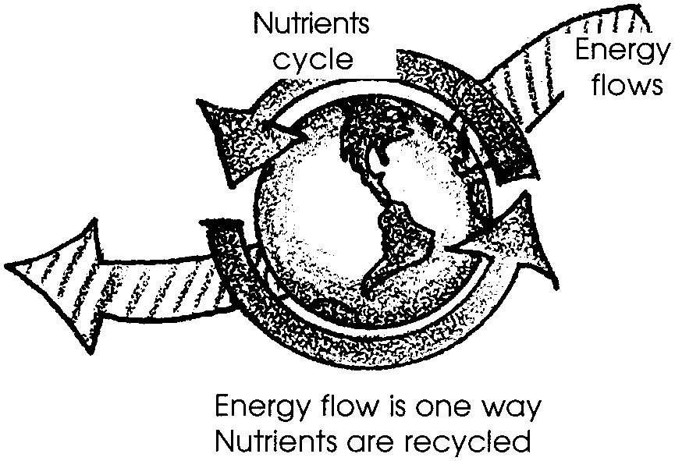
What is the difference between the movement of energy and the movement of nutrients through an ecosystem? Energy flows through a system, whereas nutrients or matter cycles through a system. Once energy enters a system, it passes through that system and is lost. For example, when the fish uses energy to swim, the energy is dissipated. No other organisms can catch the expended energy and utilize it. Nutrients, however, are recycled from one living thing to another. Another organism could eat the fish and make use of the nutrients the fish got from the copepod. Nutrients remain in the “world ecosystem” also called the biosphere or ecosphere.

10. What is the original source of energy that most ecosystems use?

11. Describe a nutrient cycle in which carbon atoms once present in phytoplankton, or plant plankton, are now in your body even though you never ate any phytoplankton directly.

12. Look at the drawing above. What does the phrase, "Nutrients cycle" mean?
Ecogram

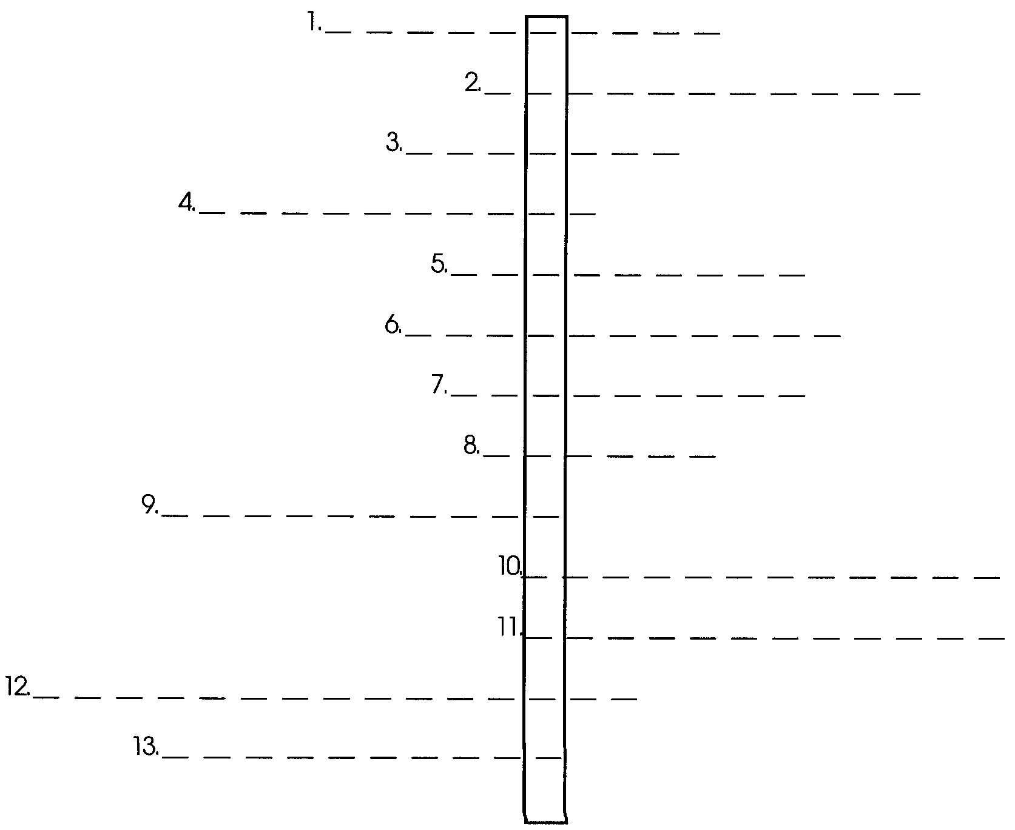
Use the clues given below to find the words to fill the thirteen lines. The correct answer will have the same number of letters as there are blanks in the ecogram. When you have filled in all of the lines correctly, an important ecological term will appear as if by magic!

Clues:
1. These organisms can produce their own food.
2. This group of organisms recycles nutrients by breaking down dead organic substances.
3. The study of the three general types of relationships we see in nature
4. The living environment of an ecosystem is also called the community.
5. The raw materials of food
6. An ecosystem is made up of the nonliving and the living or surroundings.
7. All of the living and nonliving factors in a given space
8. In living systems, its source is the sun.
9. Plant eaters
10. Organisms that obtain their food from other sources
11. The process of manufacturing food from inorganic molecules, carbon dioxide, and water.
12. This group of organisms uses sunlight to manufacture food from simple organic molecules.
13. Meat eaters
Part 2 - Building a Kelp Forest Ecosystem

With the help of the previous reading and available references, you will now make a model of a kelp forest ecosystem.

Materials:
• scissors
• “Components of the Kelp Forest Ecosystem student sheets
• large construction paper or poster paper
• pencil
• glue or tape

Instructions:
1. Cut out the components listed on the “Components of the Kelp Forest Ecosystem” pages.

2. Arrange them on a large sheet of construction or poster paper. You may want to lay out physical surroundings and kelp plants first and add other organisms later. Add drawings as needed to show the various components of your kelp forest.

3. Once you have designed your kelp forest, use glue or tape to fasten the components onto the sheet of paper.

4. Using pencil, draw arrows to show the feeding relationships within the system. Remember to draw arrows from the eaten to the eater. (The arrows show the flow of energy and the transfer of materials.) You can also add arrows or other symbols to show the relationship between the physical components and the biological community.

5. Now obtain a “What If” situation card for your ecosystem. On a piece of binder paper, describe what affect the situation described could have on your kelp forest. You can also add descriptions and drawings to the kelp forest that you have designed.

Components of a Kelp Forest Ecosystem

Water temperature below 21°C (70°F).

Canopy: the surface layer of the kelp forest.

Nutrients including carbon, phosphorus, nitrogen, other trace elements.

Blade: the large leaflike surface where photosynthesis occurs.

Water motion: flow rateof 1-2 inches (2.5-5 cm) per second.

Float: gas-filled bladder at the base of the blade.

Hard subtidal substrate such as granite.

Stipe: flexible ropelike structure where blades attach.

Turbidity level and light energy water clear enough to allow 1% of the surface light penetration.

Frond: the stipe and blades of the algae.

Sunlight: provides energy used in process of photosynthesis.

Holdfast: the rootlike structure that attaches algae to a substrate.

Producers: organisms that maketheir own food.

Consumers: organisms that eat other organisms.

Herbivores: organisms that feed onplant material.

Decomposers: organisms that break down organic substances.

