The Living Crab
Edited by Holly Anne Foley and Karen Mattick,
Marine Science Center, Poulsbo, Washington.

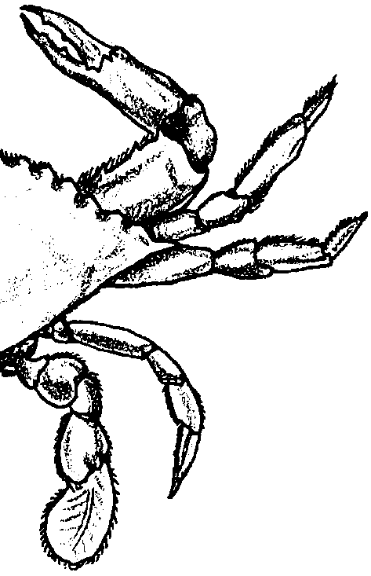
Key Concepts
1. Crabs have a jointed exoskeleton and legs which offer protection. Allow movement, and enable the crabs to bury themselves in the sand.
2. Some crab appendages are modified for eating, some for protection, and some for sensing their environment.

Background
Crabs are another familiar inhabitant of the sandy shore. While some crab species prefer life in the nooks and crannies of rocky tidepools, some are adept at making a living in sandy habitats. They spend much of their time buried in the sand with only their eyes and antennas exposed. They can scurry about the surface of the sand as well, scavenging the beach. Some literally scavenge the sand grains, removing and eating any decaying material on the sand. In the following exercise, your students will have an opportunity to observe a living crab and observe its adaptations.

Materials
For each team of 2 or 3 students:
• living crab
• hand lens or dissecting microscope
• finger bowl
• salt water
• forceps
• pencil
• ruler (transparent, flexible rulers are best)
• aquarium or other container for holding crabs, with sand on the bottom

Teaching Hints
Groups of two or three students per crab work well. Living shore crabs work best for this activity. If you live near the coast, you may be able to collect live crabs for use in this lab. Recognize that many states require a permit to collect even small shore crabs or fiddler crabs. Collecting permits are usually available from the Department of Fish and Game, Department of Fisheries, or equivalent. Shore crabs can be obtained by turning over rocks at low tide (please turn all rocks back to their original position). With a little work, Dungeness or rock crabs can be taken with a scoop or crab pot. Be sure to check local regulations for size and number limits and for season length. Crabs may also be obtained from fish wholesalers. A live crab is best, but a frozen crab will allow much of the exercise to be completed. Biological supply houses also supply live crabs at a reasonable cost. For example: Carolina Biological Supply, 2700 York Road, Burlington, North Carolina 27215.
Crabs need to be kept moist. They can be entirely submerged in salt water, but they will also do well if they are partly submerged. Crabs have a rather strong grip. Avoid being gripped! Grasp the crab across the back. Watch the action of the pinchers. A preview of crab handling is recommended before doing this exercise with your class.

Key Words
appendage - any member of the body diverging from the axial trunk; e.g. arms, legs, antennae, etc.
exoskeleton - any hard, external covering or structure which protects or supports the body such as the shell of a crab
recreationally harvested - in this case, crabs which are collected for personal consumption as opposed to collected for later sale
scavenger - an organism that feeds on dead organic matter

Extension
Many crabs and related crustaceans have significant economic value. The attached articles, “Cashing in On Chiton” and "Getting Started With Prawns” may be used to provide your students with an introduction to the “dollar and cents” side of crustaceans.

Answer Key
1 a., b., c., d. Student descriptions of crab movement will vary.

2 a. Student drawings or descriptions of crab coloration and texture will vary.

b. Student descriptions of backgrounds in which the crab may camouflage itself will vary. Note that while crab coloration is highly varied, specimens often show countershading - dark on top and light below. The dark dorsal side helps the animal blend in with the bottom.
3 a. Students will come up with differing counts of crab appendages depending on how they count the feeding and sensory appendages. They should note a minimum of 2 pinchers, 6 to 8 walking legs, 2 eye stalks, and 2 to 4 or so antennas. They may count a number of swimmerettes and feeding appendages.

b. The crab uses its 3 or 4 pairs of legs for walking.

c. The number of appendages growing back will vary from crab to crab.

4 a. Student sketches of the cheliped will vary.

b. The crab uses its chelipeds to pinch predators and to pick up and tear food.

c. The next three pairs of appendages are for locomotion.

d. In some species (e.g. the eastern blue crab, some Cancer species) the fourth pair of appendages is modified for swimming with flattened ends. In other species such as hermit crabs, these last appendages are used to hold on to a shell or some other shelter.

5. Student sketches of the crab carapace will vary.

6 a. Widths of carapaces will depend on individual crabs.

b. Crab regulations will vary from species to species and from one area to another.

7 a., b., c. Average carapace widths will depend on the measurements of crabs you are using.

8 a. In general, the crab will withdraw its eye when an object approaches.

b. Withdrawing the eye provides protection against loss or damage.

9. The crab is likely to have sensory hairs on its pinchers, walking legs and antennas.

10. Students should note here the sex of the crabs they are observing.

11 a., b., c., d. Students should calculate the ration of male to female crabs in the class.

e. Ratios vastly different from one male per one female might arise from many causes: differential fertilization may cause an initial difference; differential mortality at some state of development; sampling or catching procedure that favored the selection of one sex over another; etc. Since it is not possible to
provide a “correct” answer, use this question to generate testable hypotheses.

12 a. Student drawings of swimmerets will vary.

12 b. The appendages in the abdominal flap of the male are modified swimmerets. There are two pairs of shaft-like processes, the smaller pair fitting into grooves on the larger pair. These are used to pass the sperm from the male into the genital openings of the female. The broad abdomen of the female has several pairs of feathery swimmerets on which the egg cluster is attached.
c. Students should note here and sketch any eggs present on their crab.

Extension —“Getting Started With Prawns”
1. Fixed costs are costs that are the same for a large or small operation.

2. If the drilled well was 400 feet deep instead of 300 feet deep, the estimated construction outlay would be $108,000. See below:
400 feet x $150.00 per foot = $60,000.00
Pond design preparation, access road,
drainage system and pipes 45,000.00
Storage shed x 3,000.00
Total $108,000.00

3. The total equipment cost in October, 1980, would be $25,047.00.

$20,700 x 10% for 1979 = $2070.00; $2070 + $20,700 = $22,770 in 1979
$22,770 x 10% for 1980 = $2277.00; $2277 + $22,770 = $25,047

4. Since the stocking level is 70,000 prawns per acre, the value of the gift is:
$7.50 x 70,000 prawns = $525.00 per acre
1,000 prawns acre

5. If you had to purchase brood stock for your entire 10 acre pond, the total start up capital requirement would be:

$525.00/acre x 10 acres = $5,250 plus $181,300 start up cost = a total start up cost of $186,550.

6. The revised total would be:

Construction Cost $108,000 (increase from well)
Equipment Cost $25,047 (increase from inflation)
Other $72,850 (increase due to prawns)
Total $205,897

7.If the wholesale price drops to $3.50 per pound the expected profit would be:
$3.50/pound x 2,250 pounds per acre x 10 acres = $78,750 minus $67,600 expenses = $11,150 profit

8. If costs rose to $78,000 per year the break even price would be:
78,000 costs = $3.46 per pound
22,500 pounds

9. If expenses dropped to $60,000 the new rate of return would be:
annual profit = $16,775 = .28 or 28%
annual operating cost $60,000

10. If the price went up to $5.00 per pound the annual profit would be:
2,250 pounds x 10 acres x $5.00 = $67,600 operating expense = $44,900 annual profit
acre pound
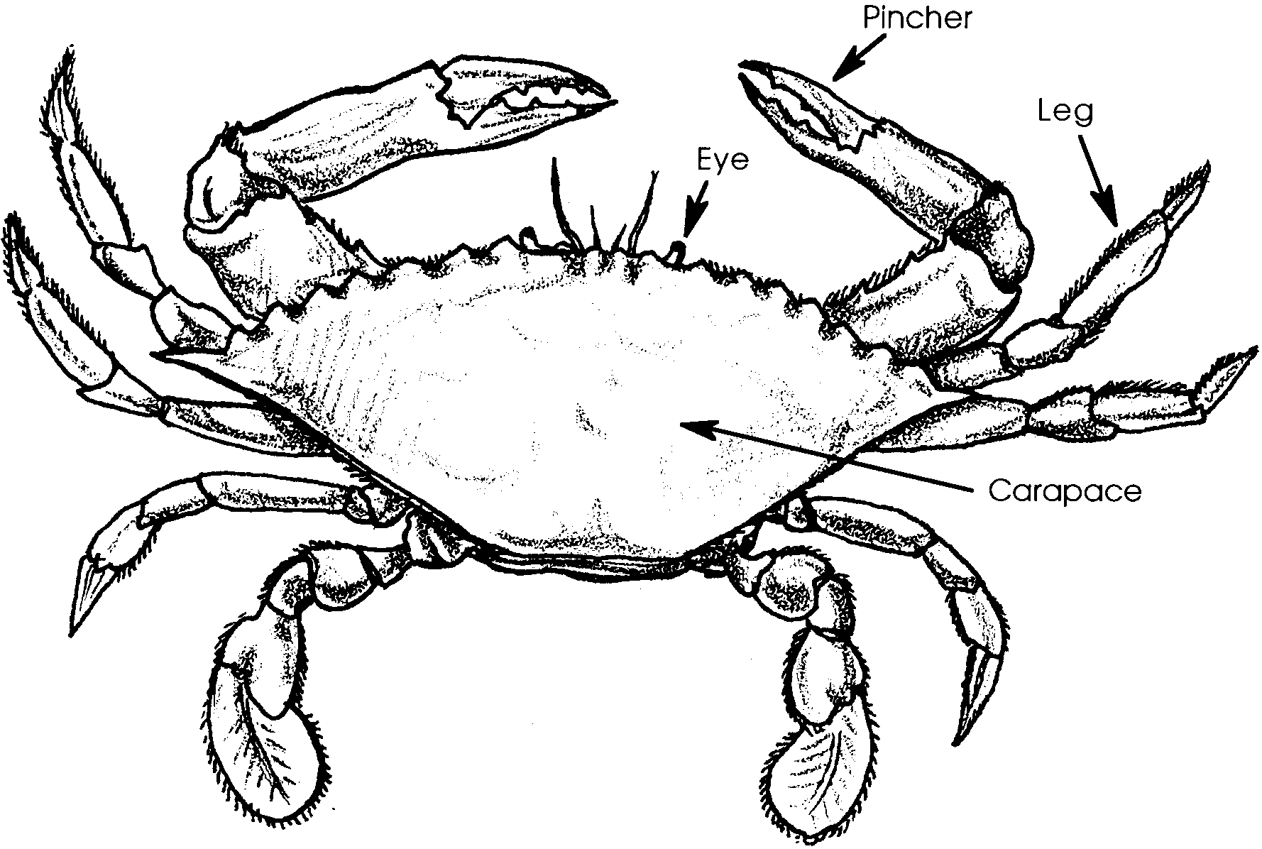
The Living Crab

While clams bury and anchor themselves in the sand and wait for their food to drift to them on the currents, crabs are mobile scavengers. In the following exercise, you will have an opportunity to examine the structure of a living crab and to observe some of its behaviors.

Materials:
• living crab
• hand lens or dissecting microscope
• finger bowl
• salt water
• forceps
• pencil
• ruler (transparent, flexible rulers are best)
• aquarium or other container for holding crabs

Movement
1. Observe a live crab in an aquarium or similar container. Use your observations to answer the following questions:

a. Describe how the crab moves. Explain the body parts it uses and what the motion looks like.
b. Can your crab swim? If so, describe how it does this.

c. How does the crab dig in the sand? What body parts does it use?

Color
2. Obtain one of the crabs and place it in a finger bowl of sea water. Use this crab to make the observations necessary to answer the following questions:

a. Describe or draw the colors and textures of your crab.

b. Describe the kind of natural background you think it would use for camouflage.

Body Parts
The crab’s body is encased in a jointed exoskeleton, like a suit of armor. The joints allow the appendages to move. Some appendages are for walking, some for protection, some for grinding food, and some for sensing the environment.

3 a. How many appendages (legs, etc.) does your crab have?

b. Which appendages does the crab use in walking?

c. Is your crab forming any new appendages? If so, which one(s)?

A crab has four or five pairs of appendages depending on the species. The first appendage is called a cheliped and bears strong claws or pinchers. The muscles controlling the appendages are anchored inside the body on the inner surface of the shell.
4 a. In the space below, sketch one cheliped.

b. What are two functions of the chelipeds?

c. What is the primary function of the next three pairs of appendages?

d. Is the fourth pair of appendages identical to the three pairs preceding it?

If not, what might be the role of the modifications you observe?

5. The head and soft body of the crab is fused into the cephalothorax. The cephalothorax is completely enclosed in a hard shell. The top of the cephalothorax is called the carapace while the segmented abdominal part of the body underneath is called the apron or abdomen. In the space below, diagram the shape of the carapace.
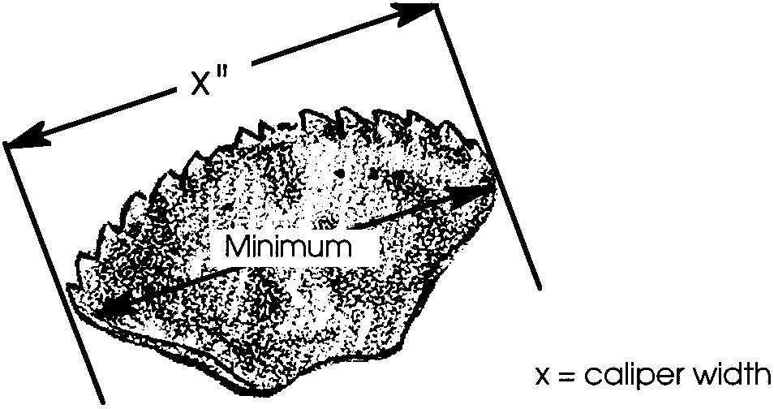
6. Crabs are measured across the back of the carapace (from “point to point”) to determine their size. This measurement is called the caliper width. Use the drawing below as an aid to determining the caliper width of your crab.

a. How wide is your crab (caliper width)?

State regulations limit the minimum size of a crab that can be kept.

b. What is the regulation caliper width of a recreationally harvested crab in your state?

7. Record the width of your crab on the blackboard in the appropriate space.

a. How wide is the widest crab in the class?

b. How wide is the narrowest crab in the class?

c. What is the average width of the carapaces of the crabs in your class? Show your work.

8. Crabs have a pair of well developed eyes, mounted upon moveable stalks. The stalks project from the front of the carapace.

a. Gently move your finger near the eye stalk. What is the response of the crab?
b. What might be the advantage of such a behavior?

9. Which appendages on your crab appear to be covered with tiny sensory hairs?

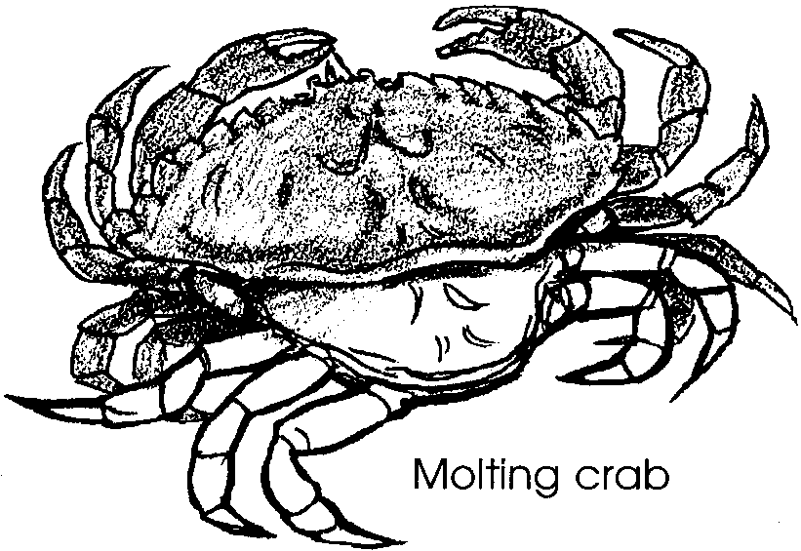
Reproduction
As crabs grow, they must molt their old exoskeletons and grow new, larger ones. Many crab species mate when the female crab has molted and is soft-shelled. The male often protects her from predators and then, after mating and after her new exoskeleton has hardened, the two crabs separate.
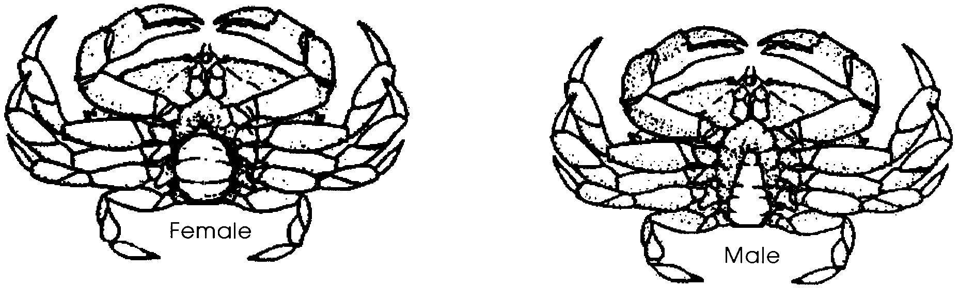
Female and male crabs may be easily distinguished by looking at the shape of the apron or abdomen, a shell flap on the ventral side. As you can see from the drawings below, the female crab has a wide apron while the male has a narrow triangular shaped apron.

The ability to sex crabs is important to sport and commercial fishermen alike since crabbing regulations often specify which sex crabs as well as which size crabs may be legally taken.

10. Look at the shape of the abdomen of your crab. What sex is your crab? Note the sex here and on the chalkboard in your room.

11 a. What is the total number of crabs observed in your class?

b. How many are females?
c. What is the ratio of males to females?
( Hint: ratio = number of males
number of females )

d. Find the number of males per female by dividing out your ratio in the space below.

e. Is the ratio close to one male per one female? If not, how might you account for your observations?

12. Use the forceps to gently lower the abdomen flap. The pairs of appendages in the flap are called swimmerets. The swimmerets function in swimming in young crabs and in reproduction in females as the eggs are “glued” to the swimmerets.

a. In the space below, sketch the swimmerets in your crab.

b. Compare your drawing to some of your classmates. Is there a difference between the swimmerets of a male and female crab?

c. In the female crab, the many feathery swimmerets hold the egg cluster. Are eggs present in your crab? If so, describe and sketch the egg mass.

Return your crab to the saltwater aquarium and clean-up all of your materials.

