Shellfish and Paralytic Shellfish Poisoning

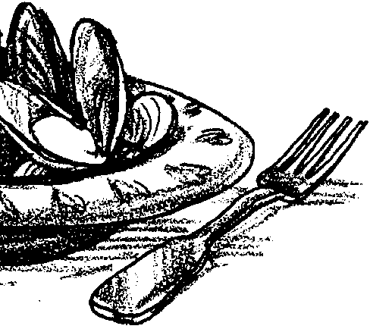
Key Concepts
1. Shellfish are often unfit for human consumption due to toxins produced by some species of plankton which cause Paralytic Shellfish Poisoning (PSP).
2. Paralytic Shellfish Poisoning is sometimes mistakenly called "red tide", but it does not necessarily color the water red and it can occur at the same time as non-toxic organisms which do color the water red.

Background
Humans are a major predator of clams and other shellfish. However, the threat of poisoning from paralytic shellfish poisoning (PSP) is enough to halt the most avid clam eater in mid-bite. The article reprinted here gives your students an introduction to shellfish and PSP.

Materials
For each student:
• copy of “Shellfish and Paralytic Shellfish Poisoning” student pages
• copy of “Shellfish and the Red Tide” article by Louisa Norris, Kenneth K, Chew and Alyn C. Duxbury (Washington Sea Grant Program WSG-AS 73-2) **

Teaching Hints
“Shellfish and Paralytic Shellfish Poisoning” involves identifying main ideas and their supporting details in the accompanying journal article. Main idea identification is a primary reading skill and one that is critical to the reading of the fact-filled literature of science. Unlike some authors who seem to delight in hiding the main idea, Norris et al. have chosen to emphasize the main ideas in bold type. This activity, while giving your students factual information on PSP, provides practice in sorting subordinate ideas from main ideas.
Duplicate the activity pages. One set is recommended per student. Before you discuss the article with your class and provide answers for the activity questions, you may elect to have your students meet briefly in small groups to discuss and share their findings.

Key Words
main idea - in this case, the thought in a paragraph that links all the facts within that paragraph together
Paralytic Shellfish Poisoning - paralysis or other symptoms caused from eating shellfish which have concentrated toxins contained in certain dinoflagellate plankton; mistakenly called red tide
plankton - the mostly microscopic plants and animals that drift in water; singular = plankter

Answer Key
MAIN IDEAS 1 - 6 are found in bold type in the text. The supporting details will vary somewhat but should all come from the paragraph(s) following the bold type. During the discussion, it is sometimes helpful to list the supporting details and construct a simple hierarchy which shows their relative importance.
A. It is likely the authors emphasized the main ideas to facilitate understanding and to aid people in finding the information they desire as they skim the article. This question may be used as a springboard for a discussion of the other manners in which authors help the reader to comprehend the material (graphics, glossary, etc.).
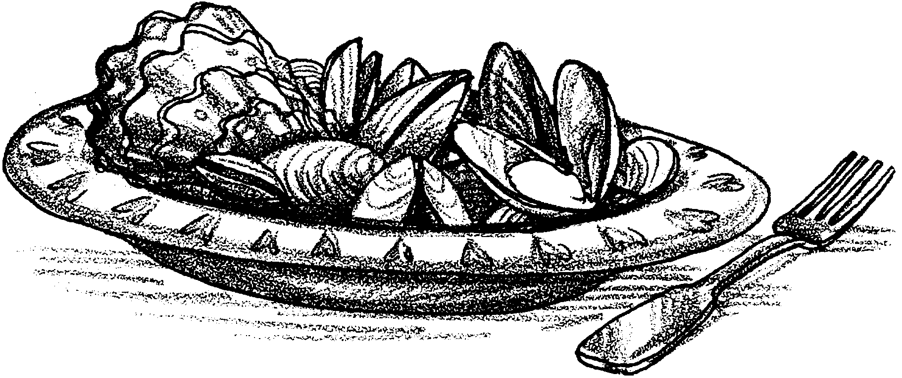
Shellfish and Paralytic Shellfish Poisoning

Have you ever gone clam digging? Have you ever eaten clams or other shellfish? Clams and other shellfish are a common menu item around the world anywhere humans live near the sandy shore. One hazard of eating clams and other filter feeders is Paralytic Shellfish Poisoning (PSP). Clams are so successful at filtering plankton from sea water that when toxic plankton are present, they accumulate large quantities of the plankton in their tissues. Although the clams may not be harmed and may appear normal, eating the clam meat may give us Paralytic Shellfish Poisoning.

The following journal article describes Paralytic Shellfish Poisoning, also mistakenly called Red Tide. Use this paper to outline the main ideas in the reading.

Finding the main idea in a paragraph is an important step towards getting information from your reading. The main idea in a paragraph contains the thought that links all the facts together. Main ideas can be found in different parts of a paragraph. In the article “Shellfish and the Red Tide”, the main ideas are given in bold type (darker print).

Main ideas are supported by important details. The details may be examples or facts. As you read the article, fill in the main idea and the important details in the diagrams on the following page:
MAIN IDEA 1:
Detail 1:
Detail 2:
Detail 3:

MAIN IDEA 2:
Detail 1:
Detail 2:

MAIN IDEA 3:
Detail 1:
Detail 2:

MAIN IDEA 4:
Detail 1:
Detail 2:
Detail 3:

MAIN IDEA 5:
Detail 1:

MAIN IDEA 6:
Detail 1:
Detail 2:

A. Why might the authors emphasize the main ideas by placing them in bold type?

