Burrowing and Burying - Life on the Sandy Shore
Edited by Holly Anne Foley and Karen Mattick,
Marine Science Center, Poulsbo, Washington.
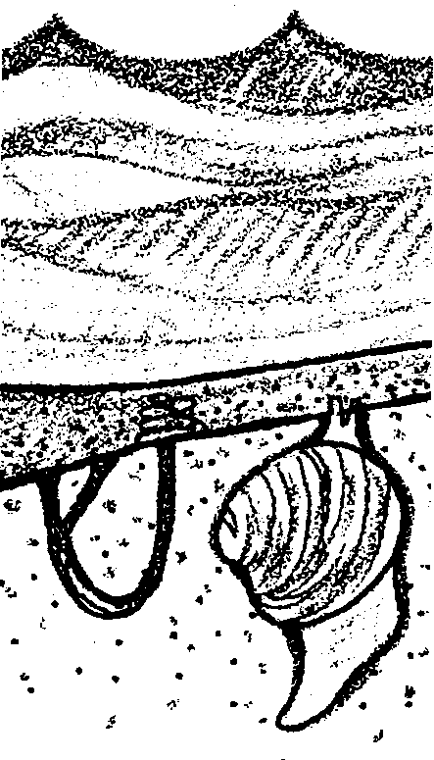

Key Concepts
1. The wedge shape of the clam's shells helps anchor the clam in the sand.
2. The clam has a muscular foot it uses to bury itself in the sand.
3. The clam extends siphons above the sand to take in and expel water. Its gills extract oxygen and food from the water.

Background
Water movement has profound effects on marine organisms. Currents, for example, move nutrients and plankton and shape the open ocean environment of pelagic fish, sharks and mammals. The coming and going of the tides creates a wide variety of niches for intertidal organisms. The receding tide presents special stresses, but, at the same time, gives animals adapted to upper tidal zones places to escape less hardy predators. Waves also shape marine habitats, carving, for example, the sandy shore. Organisms that live in wave surge must be adapted to survive the relentless force of the waves. At the same time, the organisms benefit from plentiful oxygen and plankton in the moving soup of nutrients and plankton.

Materials
For each student or student team:
• live clam
• dissecting kit or tools
• microscope slide and cover slip
• compound microscope
• methylene blue stain
• filter paper

Teaching Hints
In "Burrowing and Burying - Life On the Sandy Shore", students take a close look at a clam, one animal that can survive the pounding surf and moving sands of the sandy shore.
Clam dissection is a fairly standard laboratory activity found in many high school and college courses. While there is much to be learned from such dissection, dissection of the clam tends to be frustrating for most students. The internal organs are difficult to locate, similar in color, and rather shapeless. This lab minimizes these frustrations by focusing more on how the clam makes a living than on names of many structures.
If you use live clams, special caution is needed when using sharp knives to open the clams. Be sure to alert your students to the potential danger of the knives slipping. To remove this danger you can use clams that are steamed open for all but the gill observations. The steaming will open the clams and make the tissues firmer and more distinct. For the gill observations you could have the students share a few clams you open , or set up a demonstration clam alive on the halfshell under a scope. If you are using a demonstration clam you can use carmine red powder on the gills to see the ciliary motion. Note that, because the "gills" in bivalves and members of the Pelecypoda function in both respiration and feeding, they are often called "ctenidia" rather than "gills".
Have your students place the clams in a container you provide for that purpose. Plan to allow time for a discussion of the activity and to provide answers for the questions found in the text.

Key Words
adaptation - hereditary characteristic of an organism in a population that improves its chances for survival
mucus - a viscous, slimy mixture secreted by glands and serving to protect and lubricate surfaces
plankton - the mostly microscopic plants and animals that drift in water; singular = plankter
radula - a kind of toothed tongue, found in the mouth of most molluscs, which is a chitinous band set with numerous, minute, horny teeth and drawn backward and forward over the floor of the mouth in the process of breaking up food

Answer Key
1. Student sketches of their clams will vary.

2. Most clams have a wedge shape which helps anchor them in the sand. They literally are "wedged" in the substrate.

3 a. Student estimates of clam age will vary.

b. The clam is probably younger than the estimate. Changes in the factors listed will increase the number of sets of rings making the clam appear older than it really is.
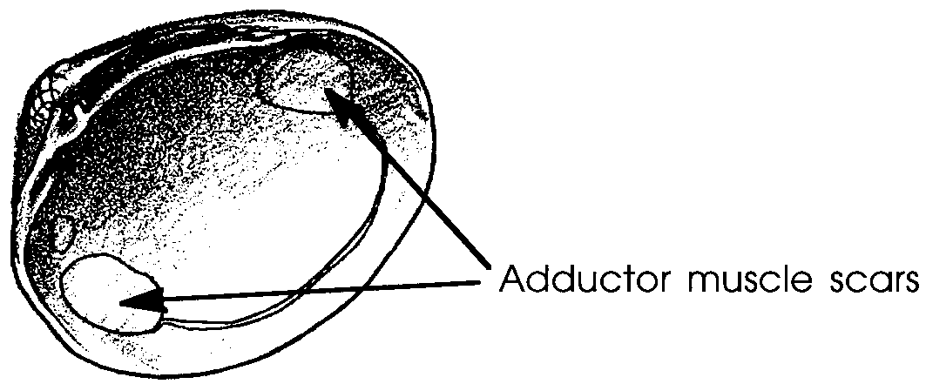
4.

5. One obvious advantage is that the smooth inner surface reduces the likelihood of tissue damage when the soft inner tissues of the clam are moved across the hard shell lining. Your students may see other advantages.

6. Student sketches of internal anatomy will vary.

7. Students should have added a sketch of their clam's foot to the drawing in #6.

8 a. The clam has two siphon openings, an incurrent siphon and an excurrent siphon.

b. A simple experiment to show the path of water flow through a clam might involve placing dyed water in front of one siphon opening and observing the results.

9. Students should add the gills to their internal anatomy sketch in #6.

10 a. Oxygen is being picked up by the blood in the gills.

b. Carbon dioxide is being carried to the gills for disposal.

11. Student sketches of the dye movement will vary. Often the dye moves along the grooves in the gill tissue giving the appearance of lines of blue.

12. The ciliary-mucoid method of feeding is more common among attached marine animals. These sessile creatures cannot chase their prey so they need a system that will trap food when it comes near. The number of calories provided by this type of feeding might not be sufficient to support a free-swimming organism which, because of locomotion, requires more calories than an attached organism.
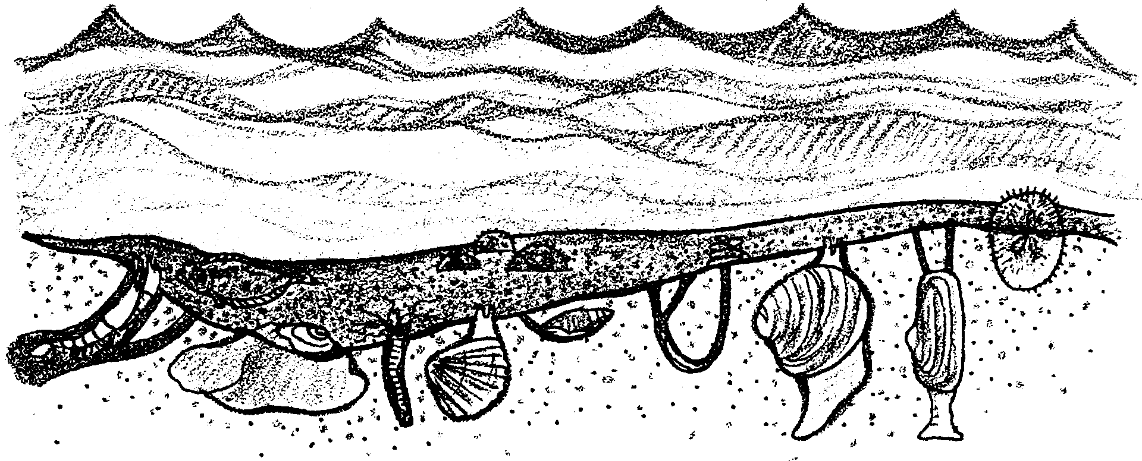
Burrowing and Burying—Life on the Sandy Shore

Imagine living where waves crash onto the shore. Imagine trying to survive in or on the ever-shifting sands. What could survive in these conditions?

A multitude of animals do live in sandy habitats.

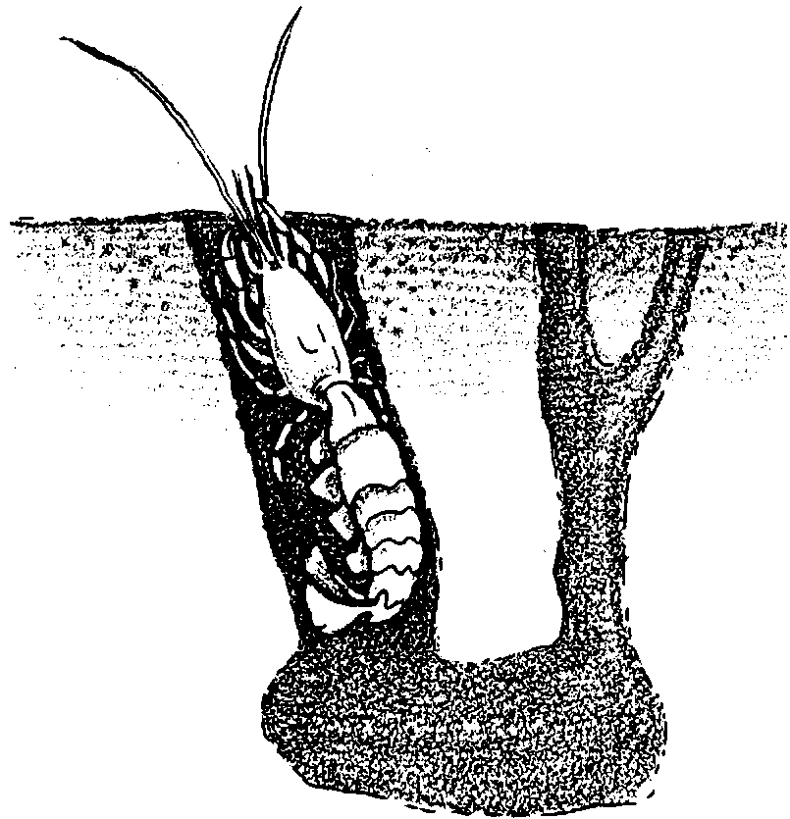
These animals have special adaptations (structures, shapes and behaviors) which either anchor them in shifting sand or enable them to burrow and crawl among the sand grains. They have adaptations that allow them to collect food and oxygen despite the moving sands which threaten to suffocate them.

Burrowing shrimp and worms, for example, dig tunnels in the sand and then line the tunnel with mucus to hold the sand grains in place. The shrimp and worms pull water through the burrows to obtain fresh oxygen and food particles. Wastes exit with the outgoing current flow.
The most familiar animal in this seascape is the clam. In this activity, you will observe a clam and the structures that allow it to bury, anchor itself, and obtain food and oxygen.

Materials
• living clam
• dissecting tools
• microscope slide and cover slip
• compound microscope
• methylene blue stain
• filter paper

External Structures
1. The following illustration shows the external anatomy of a butter clam. As you observe your clam, sketch the external anatomy you find in your clam in the box below. Your clam probably will look somewhat different from this illustration. Draw and label what you see on your clam.

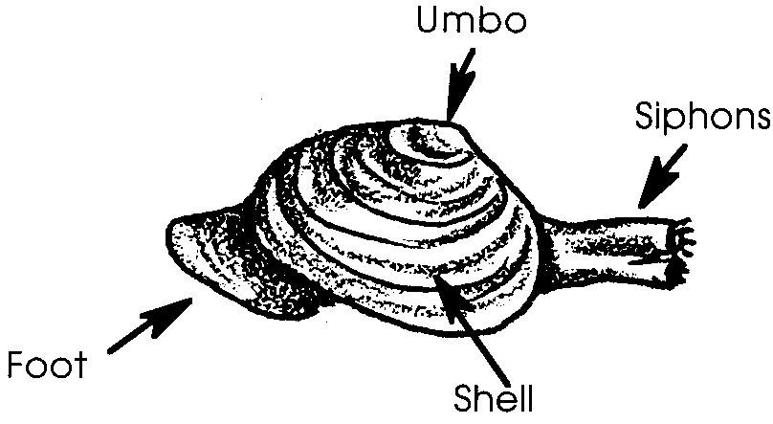

Your clam

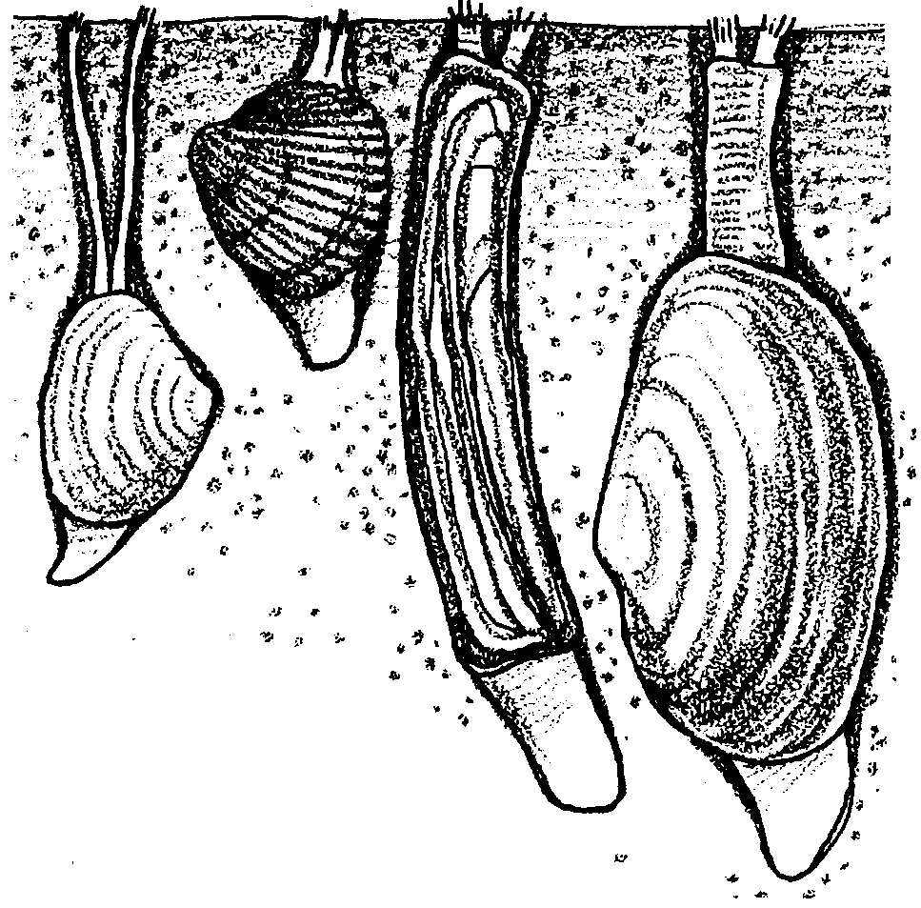
Anchoring in the Sand
Observe the clam and this illustration of buried clams.

2. How does the clam’s shape help it stay in place in the sand? (Hint: Imagine trying to pull the clam up out of the sand. How would its shape make that hard to do?)
3 a. The concentric rings you see on the clam shells are growth rings. Much like tree growth rings, growth lines on the shell are more closely spaced during the winter than during the summer because conditions are less favorable in the winter and the clam doesn’t grow as quickly. According to this theory, each set of close rings and wide rings represents one year’s growth. Estimate the age of your clam:
b. Changes in clam rings can be produced by sudden changes in temperature, lack of food, disease or other stress. Considering these possibilities, is your clam probably younger or older than your estimate of age?

Explain your reasoning.

Clamping Shut
When a clam is alive, it can clamp its shells tightly closed when threatened. Only the most tenacious predators can open the shells. Sea stars pull on the shells with their suction cup feet until the clam tires. Snails use their toothed tongue, or radula, to scrape a hole through the shell to get to the clam meat. Gulls and crows drop the clams from the air onto any hard surfaces they can find, cracking the shell open.

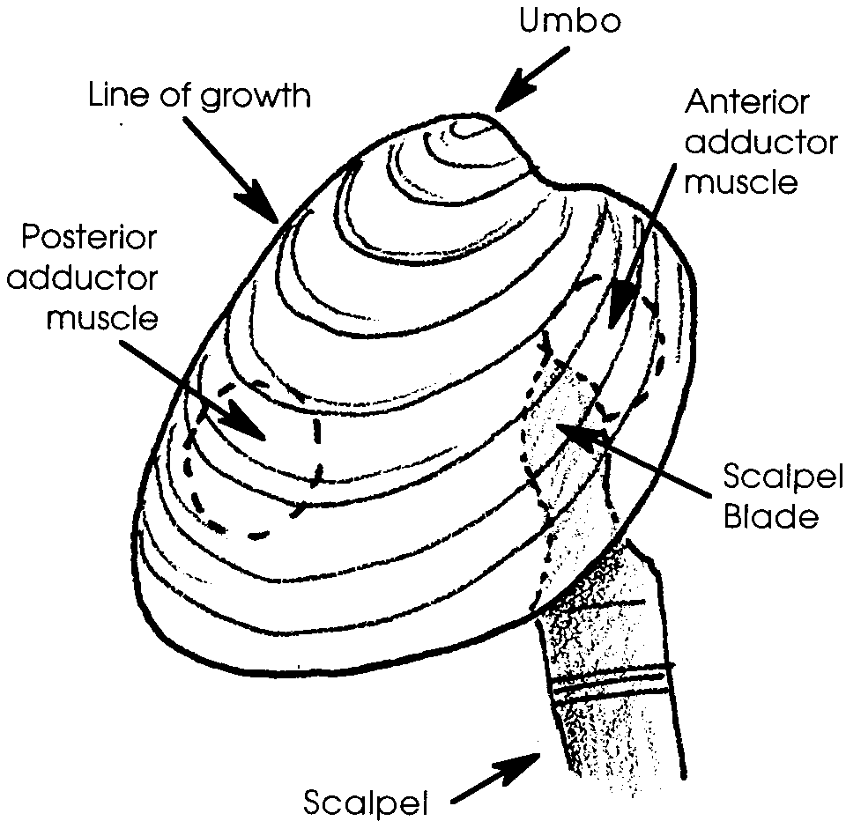
Carefully open your clam. (Skip these directions if your clam is steamed.) You may open the clam by inserting the scalpel blade between the two shells (CAUTION: THE BLADE IS VERY SHARP and the shells are tightly held together.) Patience will be rewarded since the clam will get tired and you will be able to insert the blade farther and cut the muscles holding the shells together. (Hint: Careful cutting of the rubbery tendons holding the hinge together can sometimes make it easier to insert your scalpel.) The diagram to the right shows the techniques.
4. Sketch the inside of the shell, showing the location of the scars where the muscles were attached to the shells. Known as adductor muscles, these muscles hold the shells closed.

5. Note the smooth, fine-grained inner surface of the shells. The shell lining is called mother-of-pearl. What is an advantage to having this smooth inner shell surface?

Internal Anatomy
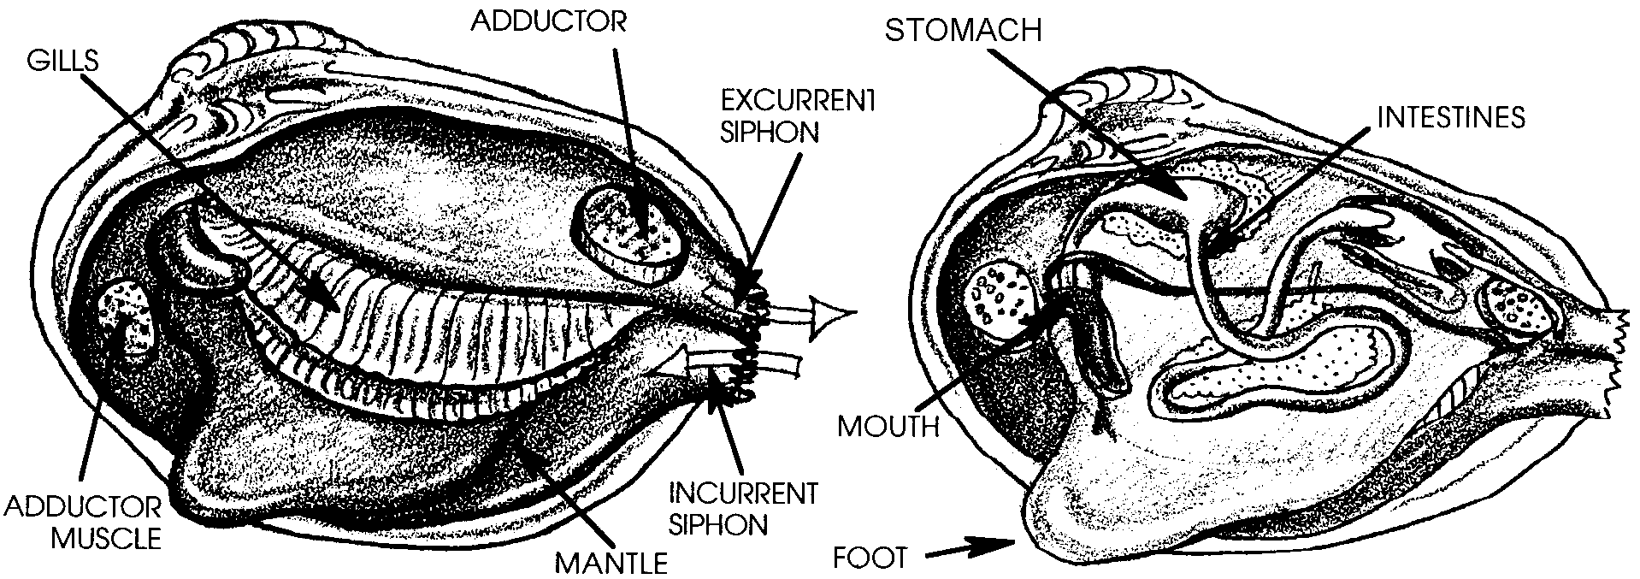
6. The following illustrations show the internal anatomy of a butter clam. As you observe and dissect your clam, sketch the internal structures you find. Your clam probably will look somewhat different from these illustrations and it may be quite difficult to find all these parts. Draw and label what you see in your clam on the next page.

Inside your clam:

The internal organs will be inside a sack-shaped layer of thin tissue called the mantle. The mantle uses calcium carbonate in seawater to make the shells. It adds new shell at the outside edges of the shells causing the rings you counted earlier.

Structures for Burying in the Sand
7. Locate the foot, the muscular structure which makes up a large part of the body. This is a very tough and rubbery piece attached to the lower edge of the internal organs. The clam alternately extends and contracts the foot to dig into the sand. Many clams can re-bury in this way if uncovered by would-be predators or storm action. Be sure to add the foot to your sketch of the clam’s internal anatomy.

Structures for Obtaining Oxygen and Food
8. The clam lives buried in the sand and yet it feeds on plankton and gets oxygen from the water above. Clams accomplish this feat by using special structures, called siphons, to collect the water from above the sand.

a. Find the siphons, tube-like structures, which extend out from one side of the clam’s body. These structures regulate water flow through the clam. The siphons may be retracted deep into the mantle tissue. How many siphons does your clam have?
b. How could you find out in a living clam which siphon is the incurrent siphon, taking water in, and which is the excurrent siphon, expelling water and wastes?

Once the water is siphoned into the clam’s body, it circulates across the clam’s gills. The gills absorb oxygen and trap food.

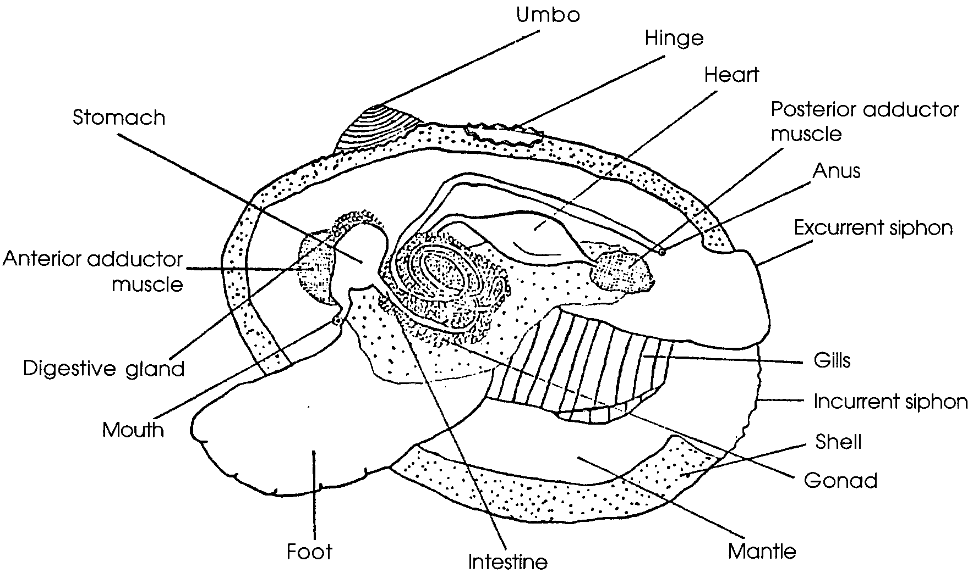
9. Find the gills, sets of very thin, ribbed tissue. They lie on either side of the body. You may need to remove part of the mantle to reveal the gills. The gills often are retracted up close to the hinge. Be sure to add the gills to your internal anatomy sketch.

10 a. Use your scissors or scalpel to cut a 4 mm x 4 mm piece of gill tissue. Place the tissue on a clean microscope slide, add a drop of clean salt water and a cover slip. Observe the gill tissue under low and high powers. Draw what you see:
The gills exchange oxygen and carbon dioxide. What gas is the blood picking up in the gills?

c. What gas is being carried to the gills for disposal?

11. Add a drop of methylene blue dye to the edge of the cover slip. By placing a small piece of filter paper or paper towel at the opposite edge of the cover slip you can pull the drop of stain under the cover slip. Observe the direction of water flow by following the movement of the blue dye. Sketch what you see.

12. The gills serve a food gathering function as well as a gas exchange function. The gills produce a mucus covering which traps small particles of food and then cilia move the food to the stomach. In which group of animals, free-swimming marine animals or sessile marine animals, would you expect to find the “ciliary-mucoid” method of feeding more common? Why?

Clean up all your materials and return your clam to the container provided by your teacher.

