Beach Sand—Littoral Sediments, Literary Sentiments
Written by Mike Vollmert, Hueneme High School,
Oxnard, California.

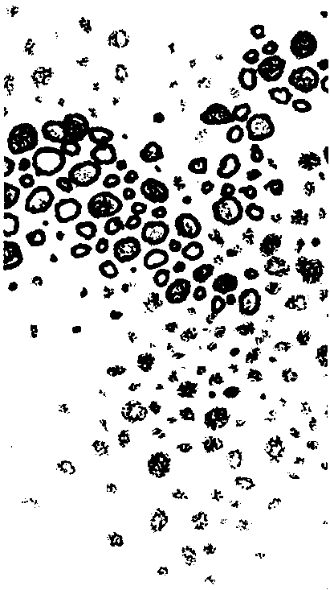
Key Concepts
1. The origins of most sands can be inferred by observing the physical characteristics of the sand grains.
2. Beach sand can be eroded from islands or continents, near its present location or far away, by water or wind.
3. Poetry can be used to convey both the beauty and the science of sand.

Background
Ocean waves slowly but relentlessly expend their power on shorelines, changing the shape of beaches and grinding reefs, shells and rock to sand.
Sand, so common, yet so unique. Hidden on every sandy shore is a mystery waiting to be solved. Where did the sand come from? How far did it travel, and through what lands did it pass? Did it come from a blazing volcano, a wave-battered coral reef, or a calm lagoon?
Careful observation and thought can answer these and other sand questions. An arenologist, a marine geologist specializing in the study of sand, can tell the source of the sands, the climate in the source area, the distance and environments through which the sands have passed, and the character of the environment in which they were found.
Just what is sand? Sand is usually defined as a mass of unconsolidated, granular material with grain sizes between 0.0625 mm and 2.0 mm in diameter. Particles smaller than these are called silt or clay, while larger particles are called gravel. The type of "unconsolidated, granular material" differs widely.
There are four common sources for sand: weathering of continental granitic rocks, weathering of oceanic volcanic rocks, skeletal remains of organisms, and grains precipitated from the water. Scientists often differentiate between "abiotic" or "abiogenic" sands, those formed from eroded pieces of rocks, and "biotic" or "biogenic" sands, those formed from the skeletal remains of plants and animals. Most sands are formed by the weathering of rocks.
Continental Sands
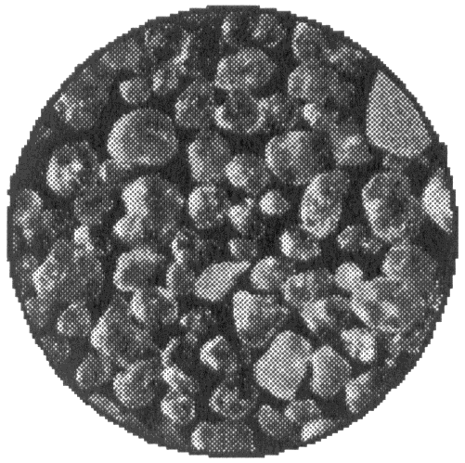
As the name implies, continental sands come from the weathering of the rocks which comprise the earth's continental crust. Granite and other igneous and metamorphic rocks form the bulk of the continental crust. Water, chemicals, and temperature changes breakdown these rocks into quartz, feldspar, mica, and other minerals.
Quartz (and to a somewhat lesser degree, feldspar) resists further chemical and physical breakdown. As a result, sands derived from weathering of granites gradually become enriched in quartz and feldspar as the other grains are dissolved and broken down. This chemical purification may require thousands of miles of transport. The recycling (deposition and later erosion) of sands through several geologic periods may form pure quartz sands, called glass sands. Quartz sand grains are clear or opaque.
The darker colored grains found in most continental sands vary depending on the source rocks and can be used to trace sands back to their origin.

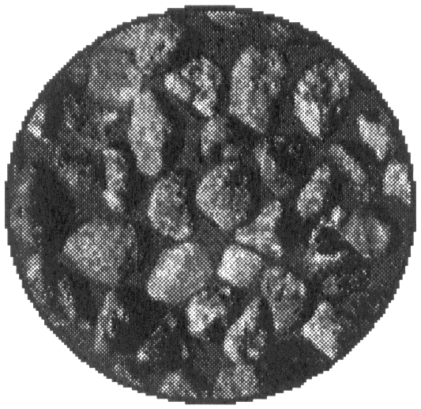
Oceanic Sands
Just as continental sands come from the weathering of the rocks which comprise the earth's continental crust, oceanic sands are derived from the weathering of the earth's oceanic crust. Most of the oceanic crust is comprised of basalt, volcanic rocks that have few sand-sized crystals. Volcanic islands, lava from volcanic eruptions, and the bottom substrate of the ocean basins are all made of basalt.
Basalts are more dense than granite and have either a glassy or very finely crystalline texture. They also tend to be darker in color (black, gray, or brown) than granite. Resistant to weathering, volcanic glass (obsidian) and the transparent, greenish olivines are common components of oceanic sands.
Water and wind carry the grains released by the weathering of continental and oceanic rocks to the sea. Grains moved by wind collide with each other and are etched with microscopic scratches, giving them a frosty-looking appearance. Waterborne grains also collide, but the lubricating effect of the water gives them a polished surface. At the coast, sands are moved by waves and longshore currents along the shore. Throughout this travel, the grains are increasingly smoothed and polished and become more spherical in shape. The rate of grain rounding depends on the grain's durability, the grain's size, the size of other grains in the sand, the energy of the environment, and the duration of transport. As a result, a sand grain's shape and appearance give clues to its history.
Skeletal Sands
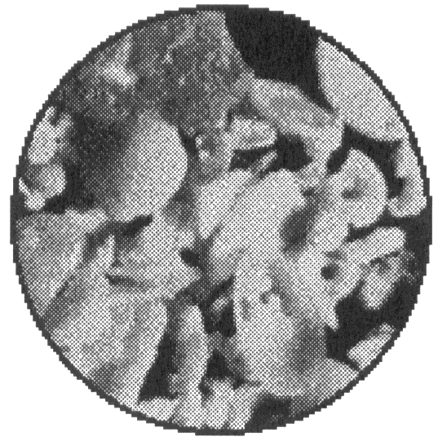
A third source of sand is the skeletal remains of plants and animals. Many invertebrate animals and a number of algae possess skeletons made of calcium carbonate or silica. In contrast to sands weathered from granites and basalts that may have traveled thousands of miles from their source, skeletal grains are usually produced near their site of deposition and are a record of nearby environments. As might be expected, the size and shape of skeletal sand grains are strongly defined by the size and shape of the skeletons of the resident organisms.
Fragments of corals, coralline algaes, and mollusks are often common in skeletal sands. Starfish and sea urchin spines and sponge spicules are also durable enough to show up in these sands. Foraminifera, a simple animal that produces a sand-sized shell called a test, are abundant in many lagoons and nearshore. Tests of foraminifera are a very common and beautiful component of beach sands.
Although skeletal sands are physically less durable than most land-derived sands, most beaches contain some skeletal grains. Young skeletal grains still possess the surface marks characteristic of the organisms from which they came. The degree of preservation of these marks is an indication of the abrasion to which the sand has been subjected and, hence, to the age of the grains.


Precipitate Grains
A fourth, and much less common, type of grain is one that precipitates from mineral material dissolved in the water. In many shallow, tropical areas, warm ocean water enhances the normal rate of precipitation of calcium carbonate. The precipitated calcium carbonate forms egg-shaped grains called ooids. When cut open, an ooid looks much like an onion. The "onion's" layers are formed by the gradual precipitation of calcium carbonate on the grain's outer surface.
Of course, not all sand is found on beaches. In fact, the bulk of the world's sand is found in deserts, or buried in underground deposits. It has been estimated that the world's sand could cover the entire United States with a layer 5 kilometers thick. A small hand lens or magnifying glass is all that is needed to begin reading the intriguing stories of our planet stored in just a handful of this ocean of sand.
Additional information about sand may be found in the following articles:
Palmer, Alfred C. "Sandy Science" Science Scope, November-December 1987, pages 22-23.
Vandervoort, Frances S. "Sands-on Learning". The Science Teacher, April 1989, pages 52-55.
Wanless, Harold R. and Leonore P. Tedesco. "Sand Biographies." Sea Frontiers, July-August 1988, pp. 224-230.

Materials
For each student:
• 1 each of 5 beach sand samples, as prepared slides
• 1 hand lens, dissecting or compound microscope
• Beach Sand Packet (Student pages, Observation Sheet, Haiku page)

Teaching Hints
“Beach Sand: Littoral Sediments, Literary Sentiments” provides students th
opportunity to look at a seemingly simple thing, sand, in a very detailed way. Aside from what they can learn about sand in particular, there are some more general points about science that they should become aware of -- the utility of keen observation, and the idea that small details can yield significant bits of information.
There are two parts to this exercise: one is left brain oriented, and one is decidedly right brain. The first exercise (the left-brain oriented) is a straightforward analysis of five samples of beach sand. The beach sand samples should provide a good mixture of different kinds of sand - island and continental, biotic and abiotic, etc. Begin collecting the samples early for best results. Ask people you know who are going to visit various beaches around the world to collect samples for you, or write to schools or other institutions in areas from which you would like sand. (For guaranteed results, send them a film canister and a self-addressed, stamped envelope!) A film canister or two is sufficient for an entire class. Prepare the samples by placing a dab of white glue in the center of a glass slide, then carefully drop a dash of sand into the glue and let it dry. Label the slide with a code that is meaningful to you but not to your students! (You may reveal the location of each sample after the lab is concluded.) Students can examine the slides with a hand lens, a dissecting scope, or even the low power objective of a compound microscope (caution students against using higher power objectives which could be damaged by grinding the lens into the sand. Dissecting scopes work best. Be sure to encourage students to write their reasoning for each conclusion in the data boxes. Encourage them to hypothesize!
The second part of the exercise (the right-brained part), is to write a brief poem, in Japanese Haiku form, about beach sand. Poet William Blake claimed that a keen observer could see the world in a grain of sand. Haiku originated in Japan about 700 years ago, as a form of poetry that could serve as a vehicle for heightening both the writer’s and the reader’s perception of the world around them. Some students may have difficulty with this exercise and may require considerable encouragement. As pointed out on the student sheet, the rules for writing the Beach Sand Haiku are simple -- three lines, of 5, 7, and 5, syllables. The poem must mention a season or time of day, and it must teach the reader something about beach sand. The best Haiku generates some feeling of emotion in the reader.
The Haiku page is designed to afford lots of room for creative expression. A student may write his or her poem inside the box (space is provided for a by-line at the bottom of the box) and decorate the margins outside the box with imagery that relates to the poem. The use of color should be encouraged! (Students who are uncomfortable with drawing may wish to cut pictures out of magazines or the like.)
It may be helpful to write the rules for Haiku on the board.

Key Words
abiotic - in this case, sand formed from non-living materials, e.g., quartz or feldspar
biotic - in this case, sand formed from pieces of living things such as shells or coral
continental sand - sand which is generally composed of eroded rocks
Haiku - a form of poetry in which each poem has three lines: the first line has exactly 5 syllables in it, the second line has 7, and the third line has 5
island sand - sand which is generally composed of either biotic material (pieces of living things, such as shells or coral), or volcanic lava
littoral - of or pertaining to the shore
littoral sediment - beach sand
sand - more or less fine debris of rocks consisting of small, loose grains
temperate sand - sand from beaches in the temperate zones
tropical sand - sand from tropical zones usually identified by pieces of coral

Extensions
1. Have students write a short essay about their thought process in analyzing each sand sample. They could discuss how their thinking helped them in the samples they got right, and how they erred in the ones they got wrong.

2. Have students write an essay on the back of the Haiku page explaining their poem.

3. Geologists use the composition and texture of sand in layers buried under coastal marshes to create a record of prehistoric earthquakes and tsunamis. For example, a sand layer below a marsh may have the qualities of river sand, deposited by flooding, or of beach sand, deposited by a tsunami washing inland. For more information to share with your students or for them to research, explore these references:

Answer Key
1. This question is provided to get students thinking critically about the information which may be derived from a critical observation of sand. Origin and distances traveled may be determined from the composition of the sand grains and by comparing their composition to similar island or continental rock formations. The present shape and size of the sand grains provide information regarding the forces which have acted upon the grains.

2 a. The “little tiny” pieces must be smaller than 0.125 mm in size.

b. The “big giant” pieces must be larger than 2.56 mm or so in size.
These questions are included to emphasize the ambiguity inherent in such relative forms as “little tiny” and “big giant”.

3 a. mostly quartz and feldspar - From the text information, origin is most likely the continental United States.

b. mostly volcanic lava - Origin is most likely a tropical island.
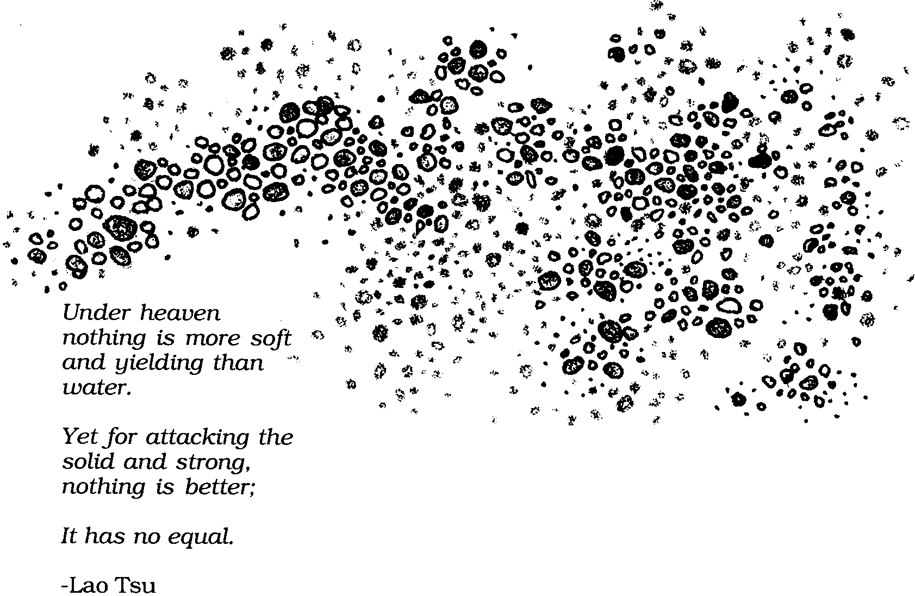
Beach Sand—Littoral Sediments, Literary Sentiments

The sun’s energy powers the winds. The winds, in turn, generate the surging, plunging, crashing waves of the ocean. When these mighty waves crash on beaches, they expend their energy, scouring the surfaces they strike. The ocean, then, can grind immense cliffs to piles of sand.
The grains in a handful of sand tell the story of their creation, of the powerful forces which crushed rock or reef or shell into powder. One can examine the sand grains and tell what kind of place the sand came from, the distance the sand has traveled and the forces that have buffeted it.

1. How might one tell what kind of place the sand came from, the distance the sand has traveled, and the forces that have buffeted it?

Beach sand is technically referred to as littoral sediment (littoral for “at the shore”, sediment for “things settling out of water”). These sediments can be made up of any material that is available in large quantities and that can be brought by some means to the shoreline and carried along the shore by wave action. For example, on continents, beaches are typically made up of rocks, eroded and ground up by streams and rivers, carried to the shore and deposited there.
Only sand grains of a certain size range will stay on the beach. “Little tiny” pieces will be carried out to sea and dropped beyond where the waves break. “Big giant” pieces will stay near where they are deposited. The size of beach sand ranges from cobble or rock size, 256 mm or so, to particles about 0.125 mm in size in very protected bays.

2. “Little tiny” and “big giant” are not very useful terms by themselves.

a. From the text, the “little tiny” pieces must be smaller than what size?

b. The “big giant” pieces must be larger than what size?

In the continental United States, beach sand is composed mostly of two kinds of rock: quartz and feldspar. Some beaches have bits of other minerals in them which give the sand different colors and textures. Some may have bits and pieces of shells or other remains of living things. However, the sand will be composed primarily of quartz and feldspar. If you look at the grains carefully, say with a magnifying lens or microscope, you will see clearish pieces (the quartz) and darker pieces (the feldspar).
In England, there are white beaches where the grains of sand are bits of skeletons from previously living things called diatoms, eroded from cliffs. The beaches around Dover, for example, are made from waves eroding away the white cliffs, which are made almost entirely of diatoms. In Tunisia, and in some beaches around the Bahamas (and in some places near Padre Island, in Texas, and in the Great Salt Lake in Utah) there are beaches made from oolites, bits of calcium carbonate (limestone) that have precipitated out of solution from the warm water, then washed up on shore. (Oolite beaches are rare because it takes a very special set of circumstances to form them - very salty, very warm water, saturated with calcium carbonate).
Around tropical islands, beaches tend to be composed of one of two materials: bits of shell or coral from the reef surrounding the islands, or volcanic lava that has been eroded into sand-sized bits by the waves.

3. Where is the likely origin of the following sand samples?

a. mostly quartz and felspar

b. mostly volcanic lava

With practice, you can learn to read the stories sand grains tell. You can tell the origin of the sand (continental or island, tropical or temperate, biotic or abiotic), the nature of the beach (heavy surf or protected shore), how the sand was eroded (wind or water) and how far the beach is from the source of the sand.
In the following activities, you will examine several samples of sand. Each sample comes from a different beach. Using the “Some Characteristics of Beach Sand” chart, fill in the table on the Observation Sheet for each of your samples. Then compare your conclusions with the actual origin of the sand (your teacher has this information) to see how well you read each Beach Sand Story!

SOME CHARACTERISTICS OF BEACH SAND

Origin: Is the sand from a continent or from an island?

Continental: Continental sand is generally formed from eroded rocks. Clear grains of quartz and dark grains of feldspar are obvious. Other minerals can be seen as well.

Island: Island sand is generally composed of either biotic material (pieces of living things, such as shells or coral), or volcanic lava (black or grayish grains, typically shiny, often with pits or air bubbles).

Origin: Is the sand from a tropical or temperate area?

If the sand contains pieces of coral, it is from a tropical beach.

Absences of pieces of coral does not provide enough information to be able to tell if the sand is from tropical or temperate areas.

Distance from origin: Is the sand far from its source or near its source?

Far from source: Sand far away from its source will have grains of uniform size that are rounded, smooth, and polished. Continental sand will have almost all quartz grains, with relatively few other minerals present.

Near source: Sand near its source will have grains of different sizes and will be more coarse, with rough edges. If it is continental sand, there will be a lot of minerals besides the clearish quartz grains present.

Method of erosion: Was the sand eroded by water or wind or volcanic action?

Water: rounded, polished, smooth grains

Wind & volcanic action: angular, pitted, frosty-looking grains

Beach Sand Data Sheet
Directions: Examine each beach sand sample carefully, and fill in the boxes below. In each box, write the reasoning you used to determine how to classify the sand.

Beach Sand: Literary Sentiments

We spend a lot of time in science classes analyzing, classifying, sorting, and concluding - all left-brained activities. Sometimes, it increases our understanding and appreciation for things if we engage in some creative activity around a subject - a right-brained activity. In this exercise, you will use an ancient form of Japanese poetry, called Haiku, to express your understanding of beach sand.
The idea of Haiku is deceptively simple. You write three lines of poetry: the first line has exactly 5 syllables in it, the second line has 7, and the third line has 5. Traditionally, Haiku makes use of the seasons or the time of day to help the reader understand what the writer is trying to say. Make use of this feature in your poems. Finally, make your Haiku teach the reader about some characteristic of beach sand. Here’s an example:

Winter breaking waves -
sand grains barely eroded.
Their source is nearby.

Or another:

A blank page of sand -
at the water’s cutting edge
the pattern shaping.

Basho, a great Japanese poet, said that Haiku is a poem recording the essence of a moment keenly perceived, which depicts some aspect of physical nature and links it to human nature. William Blake, a famous British poet, said a truely observant person could see the world in a grain of sand. What better way to gain insight into beach sand, then, than this! Good Haiku (in this case about beach sand) teaches the reader something, or paints a picture for the reader, such that the more the reader thinks about it, the more the reader understands.
Write your Haiku on the sheet provided, inside the box. Decorate the page, if you wish, to help the reader understand the nature of your poem. (Basho said no Haiku is ever finished, it is only abandoned. The artwork helps the reader keep going where the poet stopped.)

A Haiku by

